Supplemental Material
for

Targeting microglia-Th17 feed-forward loop to suppress autoimmune neuroinflammation
Jun Xiao, et al.

Corresponding authors:
Zhi Yao, E-mail: yaozhi@tmu.edu.cn
Yingchi Zhang, E-mail: zhangyingchi@ihcams.ac.cn
Long Li, Email: Long.Li@tmu.edu.cn

The PDF file includes:
Supplementary Figures 1-12
Supplementary Tables 1-4

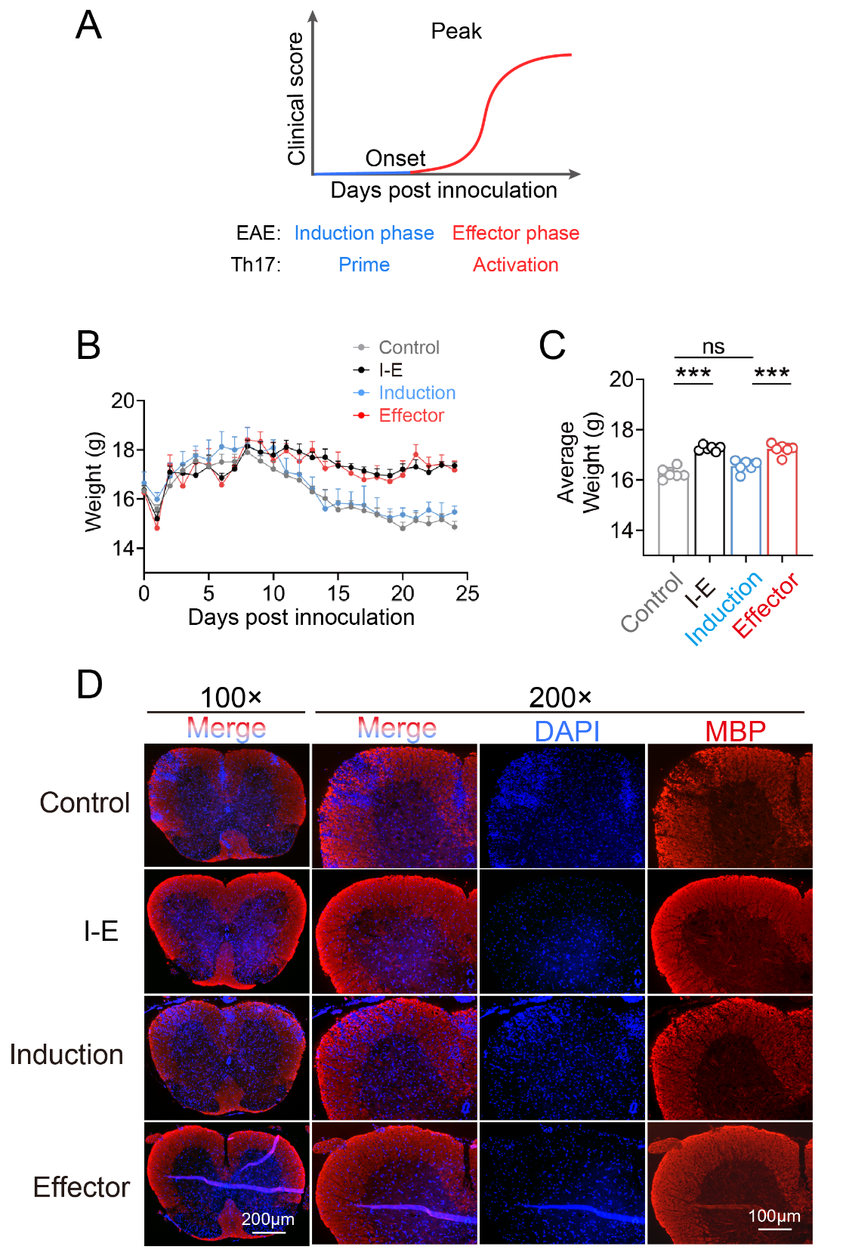
Figure S1. ACT001 alleviates the severity of EAE and reduces inflammatory cell infiltration in the spinal cords. Related to Figure 1.
(A) The diagram illustrates the correspondence between the phases of EAE and the priming-activation phases of Th17.
(B-C) The severity of EAE in C57BL/6 mice subjected to different time-point treatments of ACT001 (n = 6 per group). (B) Mean daily weight score of the mice. (C) Cumulative weight score of the mice.
(D) Representative immunofluorescence staining images of the infiltration of inflammatory cells in the SCs. DAPI (blue) was used as a nuclear marker. Myelin basic protein (MBP, red) is a crucial component of spinal cord myelin and is utilized here as a marker to assess the integrity of the myelin sheath in the SCs.
Statistics were calculated using one-way ANOVA with Tukey’s correction. Error bars represent the mean ± SEM with ns indicating not significant, ***p<0.001.

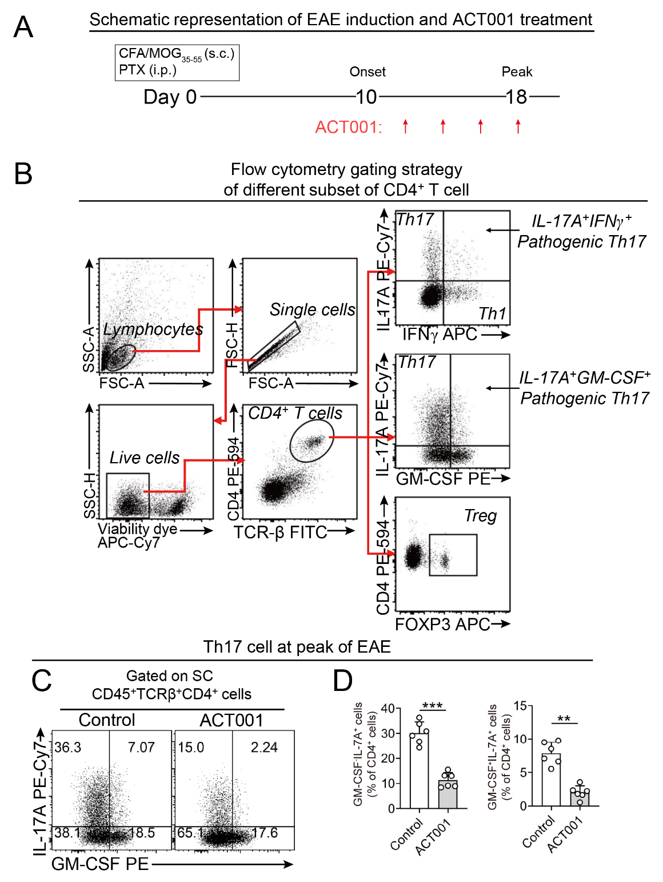
Figure S2. ACT001 dampens Th17 activation during the effector phase of EAE. Related to Figure 2.
(A) Schematic representation of EAE induction in Figure 2. Following the induction of EAE, ACT001 was administered during the effector phase of the disease.
(B) Representative analysis and flow cytometry gating strategy of different subsets of CD4⁺ T cell for Figure 2.
(C-D) Flow cytometry analysis of IL-17A and GM-CSF double-positive Th17 cells in SCs at the peak of EAE. (C) Representative flow cytometry results of IL17A⁺GM-CSF⁺ Th17 cells. (D) Statistical analysis of the frequencies of IL17A⁺GM-CSF⁻ and IL17A⁺GM-CSF⁺ Th17 cells in (C).
Statistics were calculated using the unpaired sample t-test. Error bars denote the mean ± SEM, **p<0.01 and ***p<0.001.

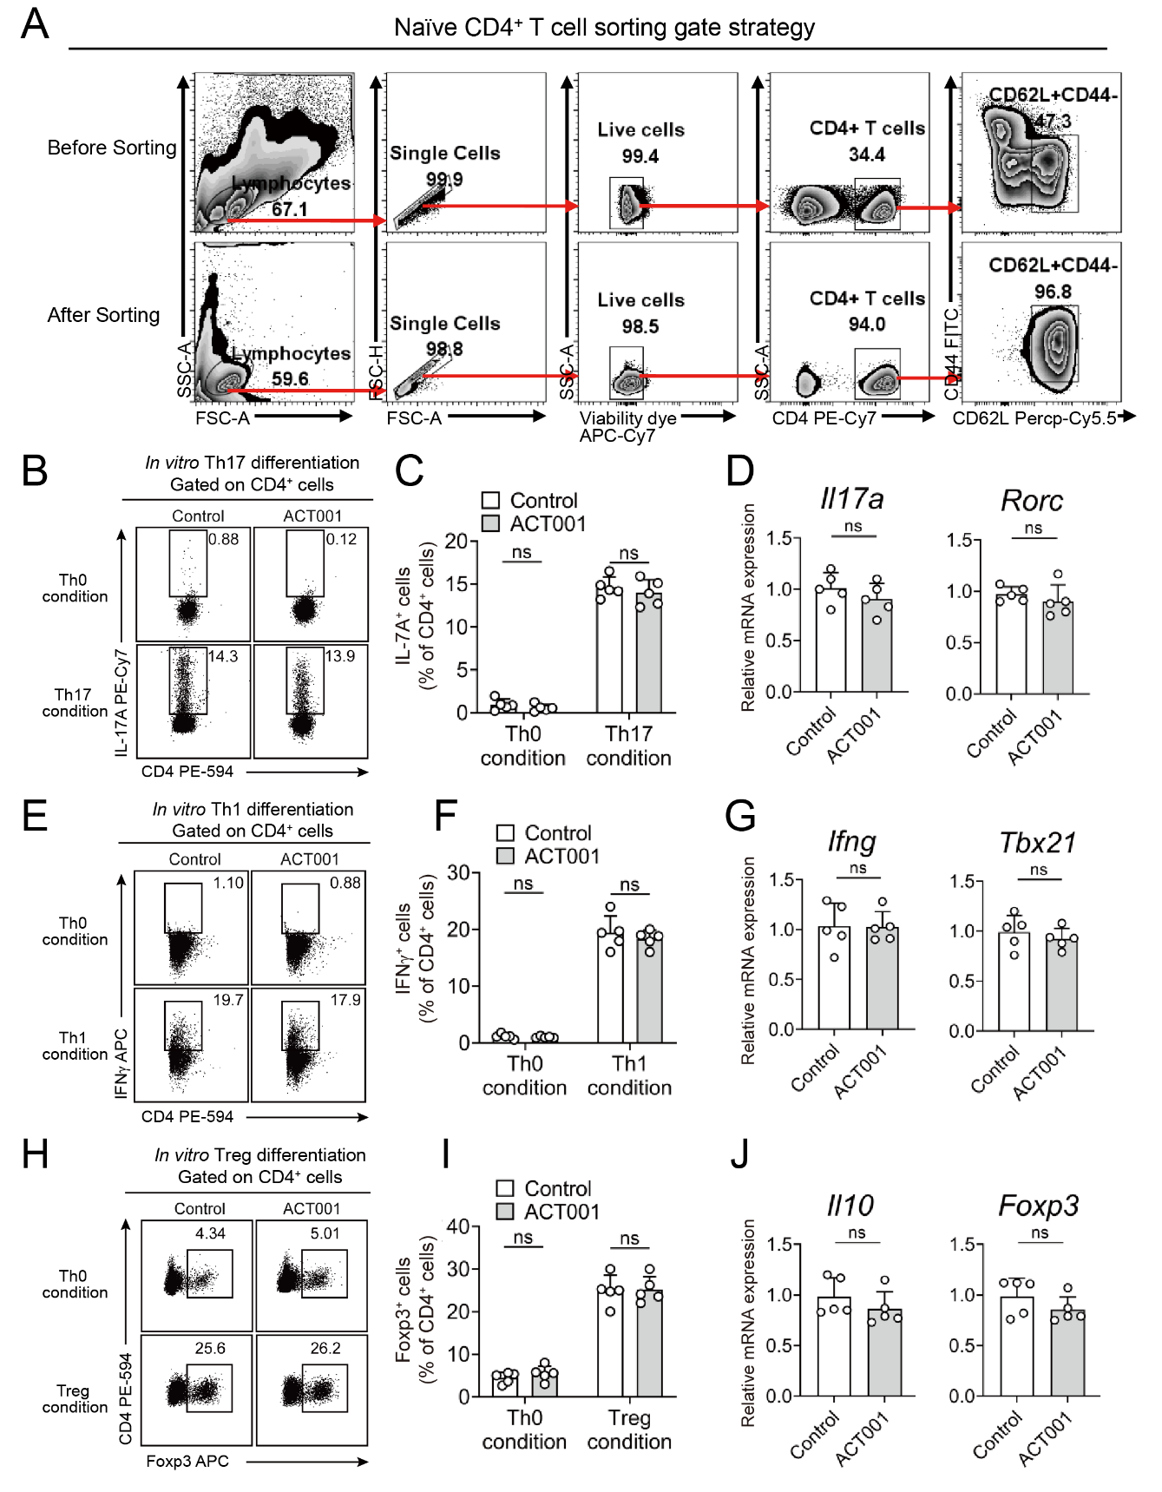
Figure S3. ACT001 does not modulate the in vitro differentiation of CD4⁺ T cells. Related to Figure 3.
(A) FACS gating strategy for isolating CD4⁺CD62L⁺CD44⁻ naïve T cell for in vitro differentiation into Th17, Th1, and Treg cells.
(B-D) The effect of ACT001 on the in vitro differentiation of Th17 cells. Representative flow cytometry analysis (B) and statistical analysis (C) of the frequencies of differentiated Th17 cells derived from naïve CD4⁺ T cells. (D) Subsequently, the differentiated Th17 cells were subjected to gene expression analysis to assess the Th17 effect program.
(E-G) The effect of ACT001 on the in vitro differentiation of Th1 cells. The data analysis followed a similar approach as that used for Th17 cells (B-D).
(H-J) The effect of ACT001 on the in vitro differentiation of Treg cells. The data analysis followed a similar approach as that used for Th17 cells (B-D).
Statistics were calculated using the unpaired sample t-test. Error bars denote the mean ± SEM, ns = not significant.

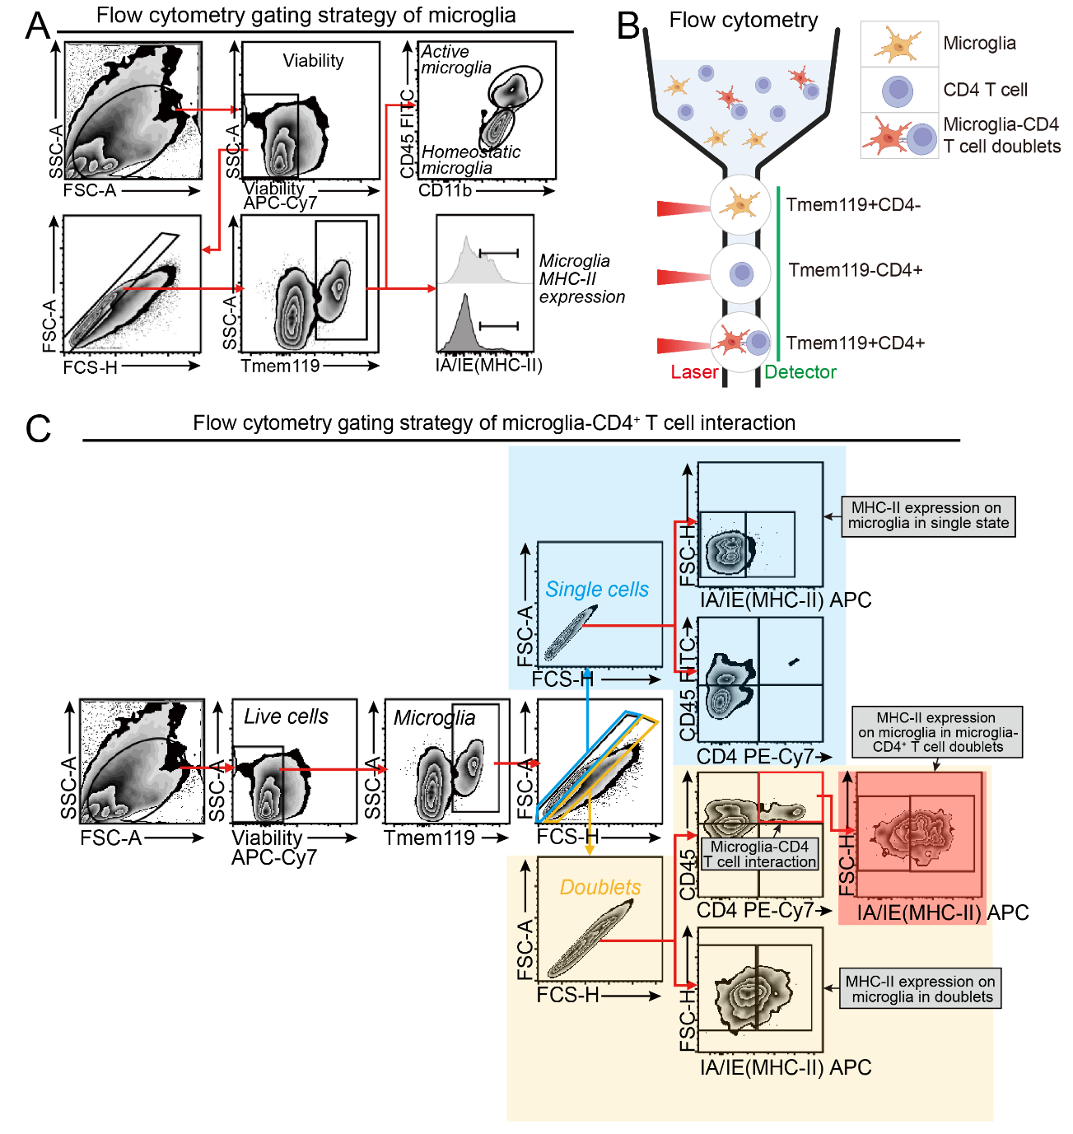
Figure S4. Gating strategy for analysis of the interactions between microglia and CD4⁺ T cells in the CNS of EAE mice. Related to Figure 4.
(A) Flow cytometry gating strategy for analyzing microglial activation status.
(B) A cartoon for detection of the interactions between microglia and CD4⁺ T cells in Figure 4. In the single-cell state, microglia are identified as Tmem119⁺CD4⁻ in flow cytometric analysis. The single-cell CD4⁺ T cell is identified as Tmem119⁻CD4⁺. The interacting microglia-CD4⁺ T cell is in a doublet state, and they are identified as Tmem119⁺CD4⁺.
(C) Flow cytometry gating strategy for analyzing microglia-CD4⁺ T cell interaction. The colors in the gating strategy shown in (C) correspond to the colors of the subtitles of Figures 4E-G.
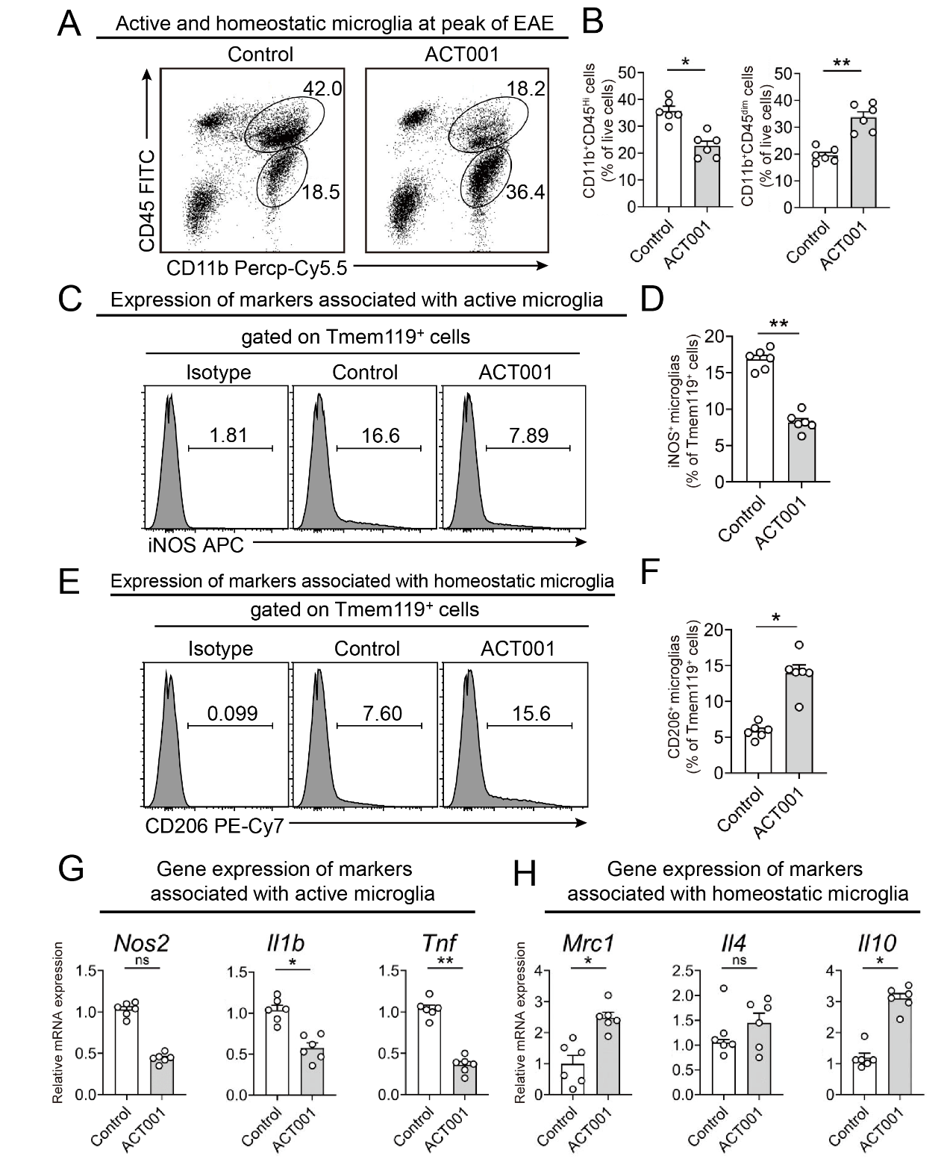
Figure S5. ACT001 inhibits microglial activation and maintains them in a homeostatic state. Related to Figure 4.
(A-B) Flow cytometry analysis of the frequence of CD11b⁺CD45^{Hi} active microglia and CD11b⁺CD45^{dim} homeostatic microglia in the SCs at the peak of EAE (n = 6 per group). (A) Representative flow cytometry results. (B) Statistical analysis of the frequency of the microglia in (A).
(C-D) Flow cytometry analysis of iNOS expression in microglia. (C) Representative flow cytometry results of iNOS expression gated on Tmem119⁺. (D) Statistical analysis of the frequency of iNOS expression in microglia in (C).
(E-F) Flow cytometry analysis of CD206 expression on microglia. (E) Representative flow cytometry results of CD206 expression gated on Tmem119⁺. (F) Statistical analysis of the frequency of CD206 expression in microglia in (E).
(G-H) Normalized mRNA expressions of genes related to active microglia (G) and homeostatic microglia (H).
Statistics were calculated using the unpaired sample t-test. Error bars denote the mean ± SEM, ns = not significant, *p <0.05 and **p<0.01.

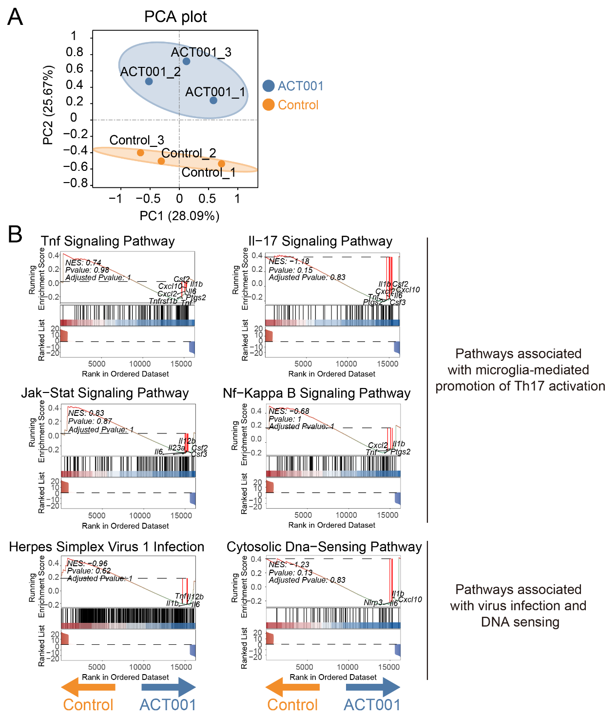
Figure S6. Pathways enriched in the lesion-associated microglia from EAE mice receiving ACT001 treatment. Related to Figure 5.
(A) PCA plot derived from RNA-seq results of sorted single live Tmem119⁺ cells in CNS lesions, with three samples each from the EAE-Control and EAE-ACT001 groups at the peak of EAE. Each dot represents microglia from an individual mouse.
(B) Gene set enrichment analysis (GSEA) plots showing pathways associated with microglia-mediated promotion of Th17 activation (top) and pathways related to cytosolic DNA sensing and HSV-1 infection (bottom) for Control and ACT001-treated gene sets. NES, normalized enrichment score.
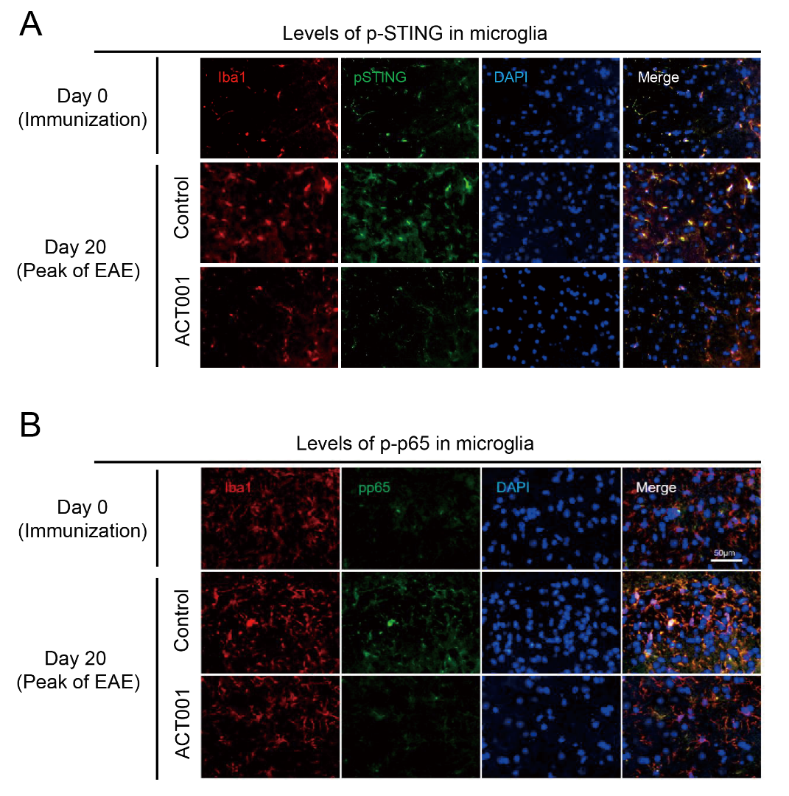
Figure S7. ACT001 reduces the phosphorylation of STING and p65 when administered during the effector phase of EAE. Related to Figure 5.
(A) Immunofluorescence staining images displayed in a single color as related to Figure 5E, analyzing the levels of phosphorylated-STING (pSTING, green) in Iba1⁺ (red) microglia in the SC tissues from the mice.
(B) Immunofluorescence staining images displayed in a single color as related to Figure 5F, analyzing the levels of phosphorylated-p65 (p-p65, green) in Iba1⁺ (red) microglia in the SC tissue as described in (A).

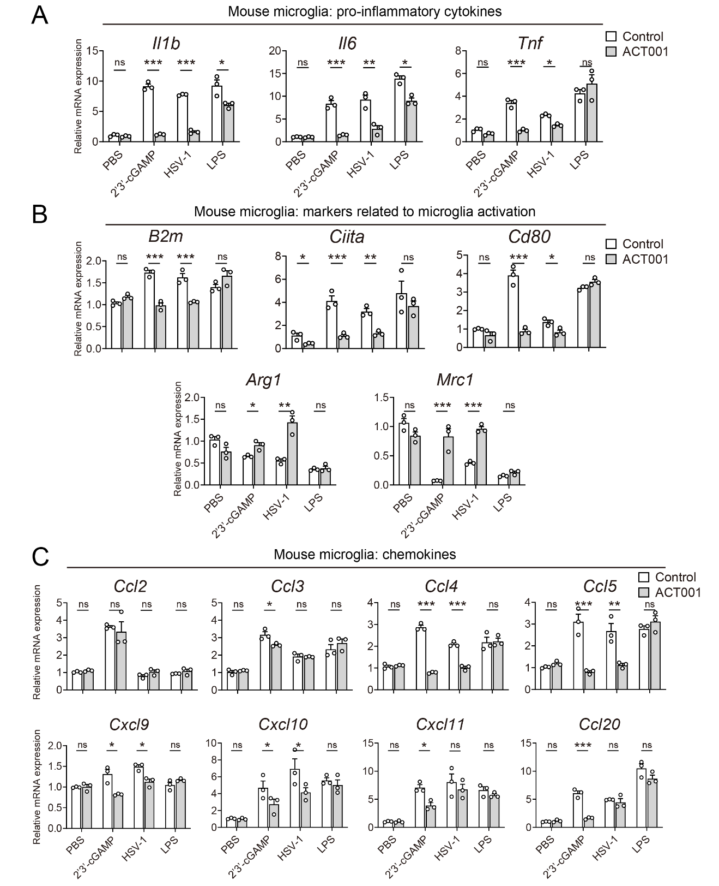
Figure S8. ACT001 suppresses STING-mediated activation of the NF-κB pathway in microglia. Related to Figure 5.
Normalized mRNA expressions of pro-inflammatory cytokines (A), homeostatic /activation markers (B), and chemokines (C) in mouse microglia stimulated with 2'3'-cGAMP, HSV-1 and LPS (n = 3 per group).
Statistics were calculated using two-way ANOVA with Tukey’s correction. Error bars represent the mean ± SEM with ns indicating not significant, *p <0.05, **p<0.01, and ***p<0.001.

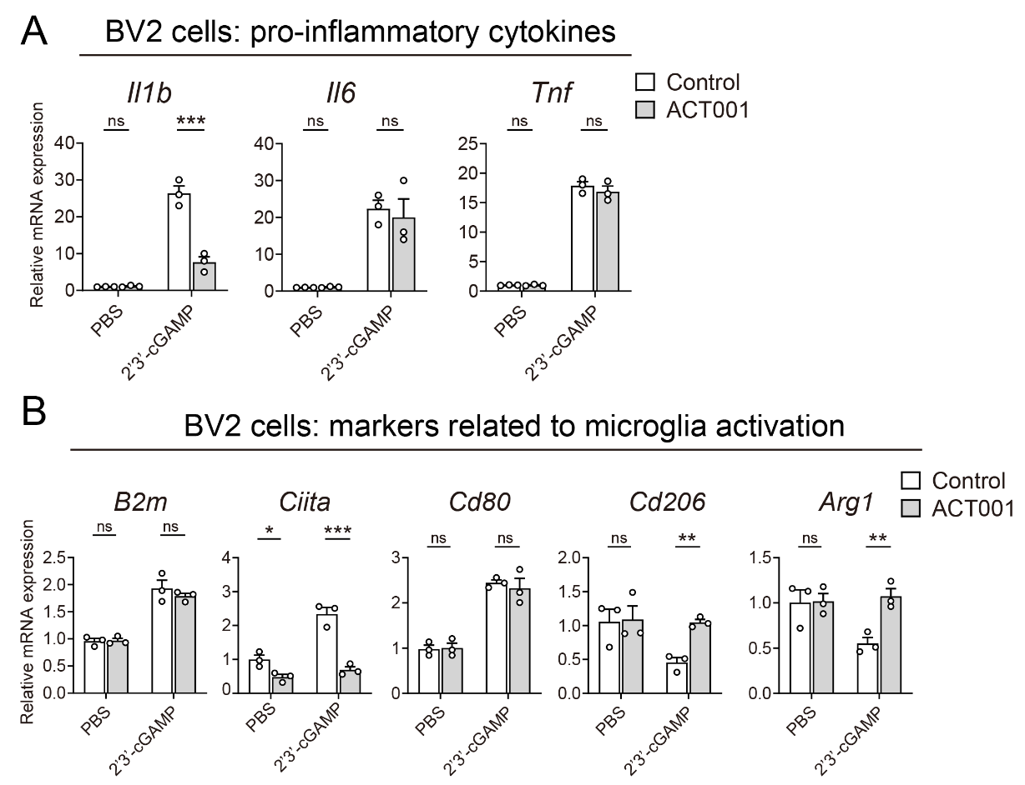
Figure S9. ACT001 reduces STING-mediated activation of the NF-κB pathway in BV2 cells. Related to Figure 5.
Normalized mRNA expressions of pro-inflammatory cytokines (A) and homeostatic /active markers (B) in BV2 cells stimulated with 2'3'-cGAMP (n = 3 per group).
Statistics were calculated using two-way ANOVA with Tukey’s correction. Error bars represent the mean ± SEM with ns indicating not significant, *p <0.05, **p<0.01, and ***p<0.001.

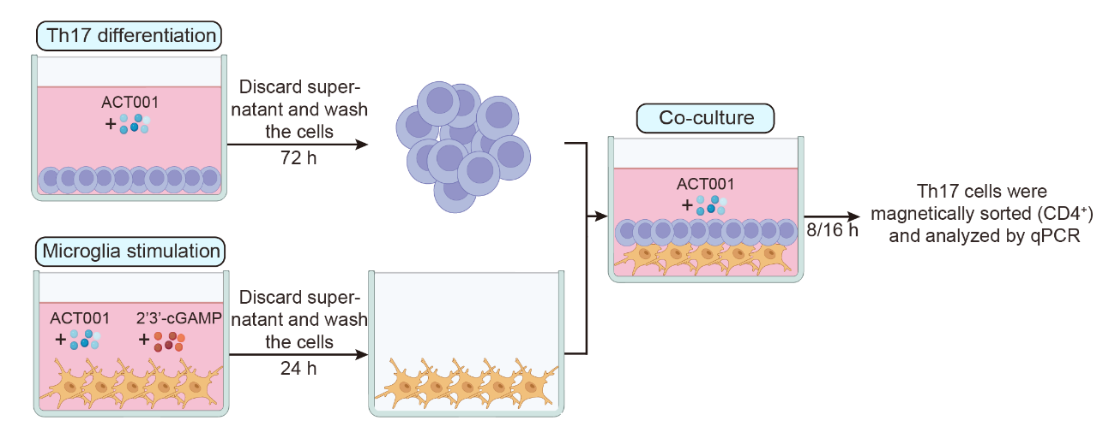
Figure S10. The diagram illustrates the experimental design for co-culturing microglia and Th17 cells. Related to Figure 7.
2D2 CD4⁺ T cells were FACS-sorted using the method outlined in Figure S3 and cultured in Th17 differentiation medium for 72 h to initiate their differentiation into Th17 cells. Concurrently, primary microglia were isolated and cultured in vitro with ACT001/2'3'-cGAMP and MOG₃₅-₅₅ peptide for 24 h. Then, the cells were washed by PBS twice. The Th17 cells and drug-treated microglia were plated in the same co-culture system. After the co-culture, cells were isolated using magnetic sorting and analyzed. The 2'3'-cGAMP stimulation was performed exclusively in the system where microglia were stimulated alone, while ACT001 was applied to the individual cultures of Th17 cells and microglia, as well as to the final co-culture system.

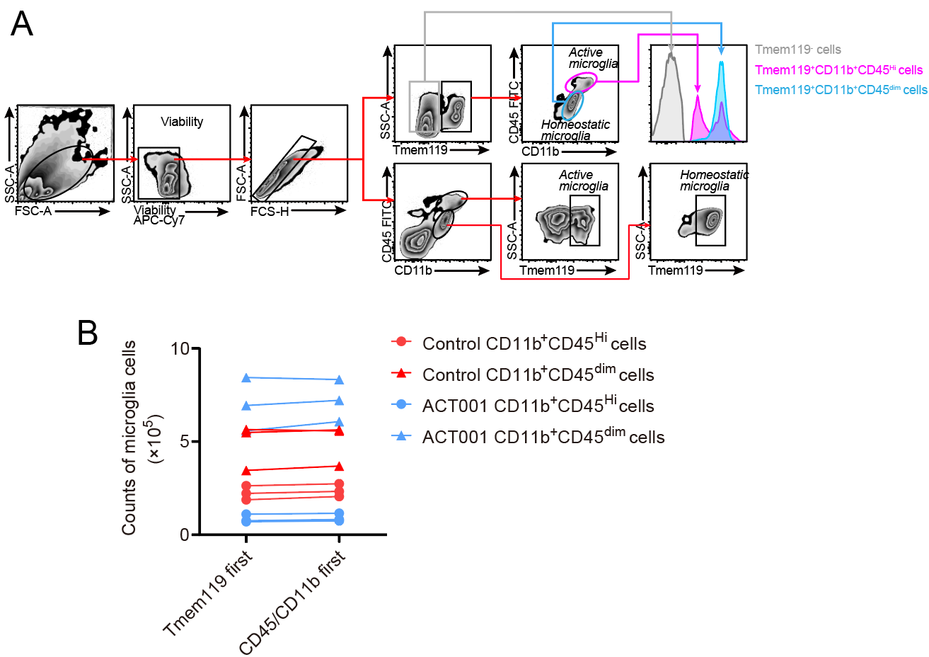
Figure S11. Comparison of gating strategies in flow cytometry for analysis of microglia in EAE mice.
(A) Gating strategies for flow cytometry analysis of microglia using either CD11b/CD45 gating first or TMEM119 gating first.
(B) Comparison of numbers of microglia between the two gating strategies shown in (A).

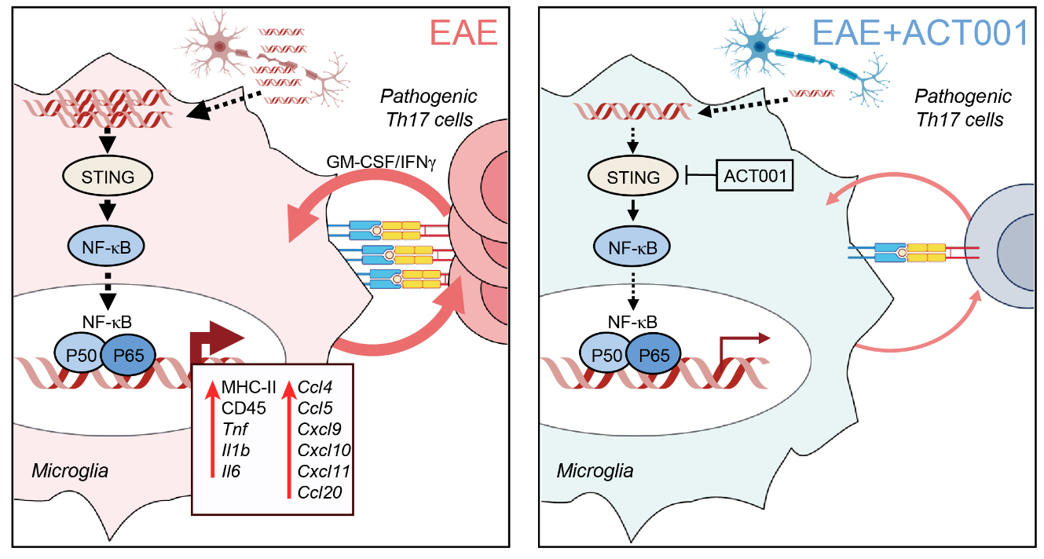
Figure S12. Graphic abstract.
During the progression of EAE, pathogenic Th17 cells are generated in the peripheral lymph nodes and migrate into the central nervous system, where they exert pro-inflammatory effects. DNA released from damaged cells in the CNS could stimulate homeostatic microglia, activating the STING-mediated NF-κB pathway and converting them to active microglia. Our findings show that these active microglia then upregulate genes associated with MHC-II and co-stimulatory molecules to activate the inflammatory Th17 cells, further stimulating local inflammations. Additionally, the inflammatory Th17 cells could reinforce microglial activation, creating a feed-forward activation loop between Th17 and microglia at the lesion sites that accelerates disease progression. We identified a small molecule, ACT001, that inhibits STING→NF-κB pathway in microglia, maintaining the homeostatic state of the cells and reducing their ability to enhance the effector program of Th17 cell. The attenuation of the inflammatory feed-forward activation loop at the CNS lesion sites provides an effective therapeutic effect in EAE.
Table S1. List of antibodies used for flow cytometry analysis
Marker | Channel | Clone | Catalog | Source
Zombie NIR  Viability Dye | APC-Cy7 | - | 423106 | Biolegend
Ant-CD45 | FITC | 30-F11 | 103108 | Biolegend
Ant-TCRβ | FITC | H57-597 | 109206 | Biolegend
Ant-CD11b | Percp-Cy5.5 | m1/70 | 101228 | Biolegend
Ant-Tmem119 | PE | V3RTIGOSZ | 12-6119-80 | Invitrogen
Ant-GM-CSF | PE | mp1-22E9 | 505405 | Biolegend
Ant-IA/IE MHC-II | APC | M5/114.15.2 | 107614 | Biolegend
Ant-IFNγ | APC | XMG1.2 | 505810 | Biolegend
Ant-Foxp3 | AF647(APC) | 150D | 320014 | Biolegend
Ant-CD4 | PE-Cy7 | GK1.5 | 100422 | Biolegend
Ant-CD206 | PE-Cy7 | C068C2 | 141719 | Biolegend
Ant-IL-17A | PE-Cy7 | eBio17B7 | 25-7177-82 | Invitrogen
Ant-CD4 | PE-594 | GK1.5 | 100456 | Biolegend
Ant-CD62L | Percp-Cy5.5 | MEL-14 | 45-0621-82 | Invitrogen
Ant-CD44 | FITC | IM7 | 100306 | Biolegend
Rat IgG2b, κ Isotype | APC | RTK4530 | 400611 | Biolegend
Rat IgG2a, κ Isotype | PE-Cy7 | G013C12 | 402311 | Biolegend
Rat IgG2a, κ Isotype | PE | RTK2758 | 400508 | Biolegend

Table S2. List of antibodies/cytokines used for in vitro Th cell differentiation
Item | Catalog | Source
Th1
rmIL-12 | 419-ML | R&D
Anti-mIL-4 | AB-404-NA | R&D
Th17
rmIL-6 | 406-ML | R&D
rhTGF-β1 | 100-21-10 | Peprotech
rmIL-23 | 1887-ML | R&D
rmIL-1β | 401-ML | R&D
anti-mIL-4 | AB-404-NA | R&D
anti-mIFNγ | MAB485 | R&D
Treg
rmIL-2 | 402-ML | R&D
rhTGF-β1 | 100-21-10 | Peprotech
T cell activation
InVivoPlus anti-mouse CD3e | BP0001-1 | Bio X Cell
InVivoMAb anti-mouse CD28 | BE0015-1 | Bio X Cell

Table S3. Primers for qPCR analysis
Gene | Sequence
Il17a | Forward: 5'- TTTAACTCCCTTGGCGCAAAA -3'
 | Reverse: 5'- CTTTCCCTCCGCATTGACAC -3'
Tnf | Forward: 5'- AATGGCCTCCCTCTCATCAG -3'
 | Reverse: 5'- AGCCTTGTCCCTTGAAGAGA -3'
Il1b | Forward: 5'- ACTCATTGTGGCTGTGGAGA -3'
 | Reverse: 5'- GAACGTCACACACCAGCAG -3'
Il10 | Forward: 5'- GCTCTTACTGACTGGCATGAG -3'
 | Reverse: 5'- CGCAGCTCTAGGAGCATGTG -3'
Foxp3 | Forward: 5'- CCCATCCCCAGGAGTCTTG -3'
 | Reverse: 5'- ACCATGACTAGGGGCACTGTA -3'
Tbx21 | Forward: 5'- AGCAAGGACGGCGAATGTT -3'
 | Reverse: 5'- GGGTGGACATATAAGCGGTTC -3'
Rorc | Forward: 5'- GACCCACACCTCACAAATTGA -3'
 | Reverse: 5'- AGTAGGCCACATTACACTGCT -3'
Ifnr | Forward: 5'- ATGAACGCTACACACTGCATC -3'
 | Reverse: 5'- CCATCCTTTTGCCAGTTCCTC -3'
Nos2 | Forward: 5'- AGCTCATCTTTGCCACCAAG -3'
 | Reverse: 5'- GAAGTCATGTTTGCCGTCAC -3'
Mrc1 | Forward: 5'- ATTGTGGAGCAGATGGAAGG -3'
 | Reverse: 5'- TGCAATGGACAAAATCCAAA -3'
Il4 | Forward: 5'- AACGAGGTCACAGGAGAAGG -3'
 | Reverse: 5'- ACCTTGGAAGCCCTACAGAC -3'
Gapdh | Forward: 5'- AATGGATTTGGACGCATTGGT -3'
 | Reverse: 5'- TTTGCACTGGTACGTGTTGAT -3'

Table S4. List of other reagents/resource
Reagent or resource | Source | Catalog
Antibodies
IBA1 Recombinant antibody | Proteintech Group | 81728-1-RR
Phospho-STING (Ser365) (D8F4W) Rabbit mAb | Cell signaling technology | 72971
STING (D2P2F) Rabbit mAb | Cell signaling technology | 13647
Phospho-IKKα/β (Ser176/180) (16A6) Rabbit mAb | Cell signaling technology | 2697
IKKβ (D30C6) Rabbit mAb | Cell signaling technology | 8943
Phospho-IκBα (Ser32) (14D4) Rabbit mAb | Cell signaling technology | 2859
IκBα (L35A5) Mouse mAb | Cell signaling technology | 4814
Phospho-NF-κB p65 (Ser536) (93H1) Rabbit mAb | Cell signaling technology | 3033
NF-κB p65 (D14E12) XP® Rabbit mAb | Cell signaling technology | 8242
Beta Actin Monoclonal antibody | Cell signaling technology | 66009-1-Ig
Myelin basic protein Polyclonal antibody | Proteintech Group | 10458-1-AP
Anti-rabbit IgG (H+L), F(ab')2 Fragment (Alexa Fluor® 594 Conjugate) | Cell signaling technology | 8889
Anti-mouse IgG (H+L), F(ab')2 Fragment (Alexa Fluor® 488 Conjugate) | Cell signaling technology | 4408
Goat anti-Rat IgG (H+L) Cross-Adsorbed Secondary Antibody, Alexa Fluor™ 488 | Invitrogen | A-11006
Chemicals, peptides, and reagents
ACT001 | Accendatech Co., Ltd. (Tianjin, China) | N/A
Incomplete Freund’s adjuvant (IFA) | Sigma-Aldrich | F5506
MOG₃₅₋₅₅ peptide  (MEVGWYRSPFSRVVHLYRNGK) | QYAOBIO | N/A
Pertussis Toxin from B. pertussis, Lyophilized (Salt-Free) (PTX) | List Biologicals | 181
Paraffin wax | LEICA | 39601095
Fetal Bovine Serum | ExCell Bio | FSP500
2′,3′-cGAMP sodium salt | Sigma-Aldrich | 1441190-66-4
LPS | Sigma-Aldrich | L4516
RPMI 1640 Medium | Gibco | 11875093
Percoll™ density gradient media | GE Healthcare | 17089101
PBS, 10× | Solarbio | P1022
Penicillin-Streptomycin Solution, 100× | Beyotime | C0222
Trypsin-EDTA Solution with phenol red, 0.25 % | Beyotime | C0203
β-mercaptoethanol | Gibco | 21985023
Cell Activation Cocktail with Brefeldin A | Biolegend | 423304
Paraformaldehyde, 4% | Solarbio | P1110
Sodium citrate-EDTA antigen retrieval solution | Beyotime | P0086
Normal Goat Serum | Solarbio | SL038
Bovine Serum Albumin V | Solarbio | A8020
DAPI solution (ready-to-use) | Solarbio | C0065
Hank's Balanced Salt Solution (HBSS) | Solarbio | H1025
NP-40 | Solarbio | N8032
Protease inhibitor cocktail | Roche Applied Science | 4693132001
5×SDS-PAGE Sample Buffer | Genstar | E153-10
PVDF membranes | Millipore | IPVH00010
Tween-20 | Solarbio | T8220
Enhanced chemiluminescence (ECL) | Genstar | E171-500ml
TRIGene Reagent | Genstar | P118-05
10× TBS buffer | Solarbio | T1084
PMSF(100mM) | Solarbio | P0100
96 Well Cell Culture Plate | 701101 | NEST
15 ml Centrifuge Tube | 601002 | NEST
50 ml Centrifuge Tube | 602002 | NEST
24 Well Cell Culture Plate | 702001 | NEST
48 Well Cell Culture Plate | 748001 | NEST
Critical commercial assays
EasyScript® One-Step gDNA Removal and cDNA Synthesis SuperMix | TransGen Biotech | AE311-03
2×RealStar Power SYBR qPCR Mix | Genstar | A301-10
H&E staining kit | BASO | BA-4224
CD4⁺ T Cell Isolation Kit, mouse | Miltenyi Biotec | 130-104-454
Experimental models: Cell lines/Bacterial and virus strains
BV2 microglia cell line | Procell | CL-0493
Mycobacterium tuberculosis Des. H37Ra (Non-viable) | BD | 231141
HSV-1 | Prof. QiuJin Yu  University of Electronic Science  and Technology of China  ¹ | N/A
Experimental models: organisms/strains
Mouse: C57BL/6 | SiPeiFu Biotechnology Company | N/A
Mouse: C57BL/6NCya-Sting1^{em1} /Cya (named Sting1^{-/-}) | Cyagen Biosciences | N/A
Mouse: C57BL/6-Tg (Tcra2D2, Tcrb2D2)1Kuch/J (named 2D2) | The Jackson Laboratory | N/A
Software and algorithms
Prism | GraphPad | RRID: SCR_002798
Adobe Illustrator | Adobe | RRID: SCR_010279
ImageJ | NIH Image | RRID: SCR_002285
FlowJo | BD biosciences | RRID: SCR_008520
BD FACSDiva Software | BD biosciences | RRID: SCR_001456
HISAT | https://daehwankimlab.github.io  /hisat2/manual/ | N/A
Bowtie2 | https://bowtie-bio.sourceforge.net  /bowtie2/index.shtml | N/A
SAMtools | https://www.htslib.org/ | N/A
Rsubread | https://bioconductor.org/packages  /release/bioc/html/Rsubread.html | N/A
biomaRt | https://bioconductor.org/packages  /release/bioc/html/biomaRt.html | N/A
DESeq2 | https://bioconductor.org/packages  /release/bioc/html/DESeq2.html | N/A
SRplot | https://www.bioinformatics.com.cn/srplot | N/A
Instrument
FACS Canto II | BD biosciences | N/A
FACS arial II | BD biosciences | N/A
LightCycler® 96 system instrument | Roche | N/A

Reference
1. Shen, L. et al. Serine metabolism antagonizes antiviral innate immunity by preventing ATP6V0d2-mediated YAP lysosomal degradation. Cell Metabolism 33, 971-987.e6 (2021).

