Fig. S1.
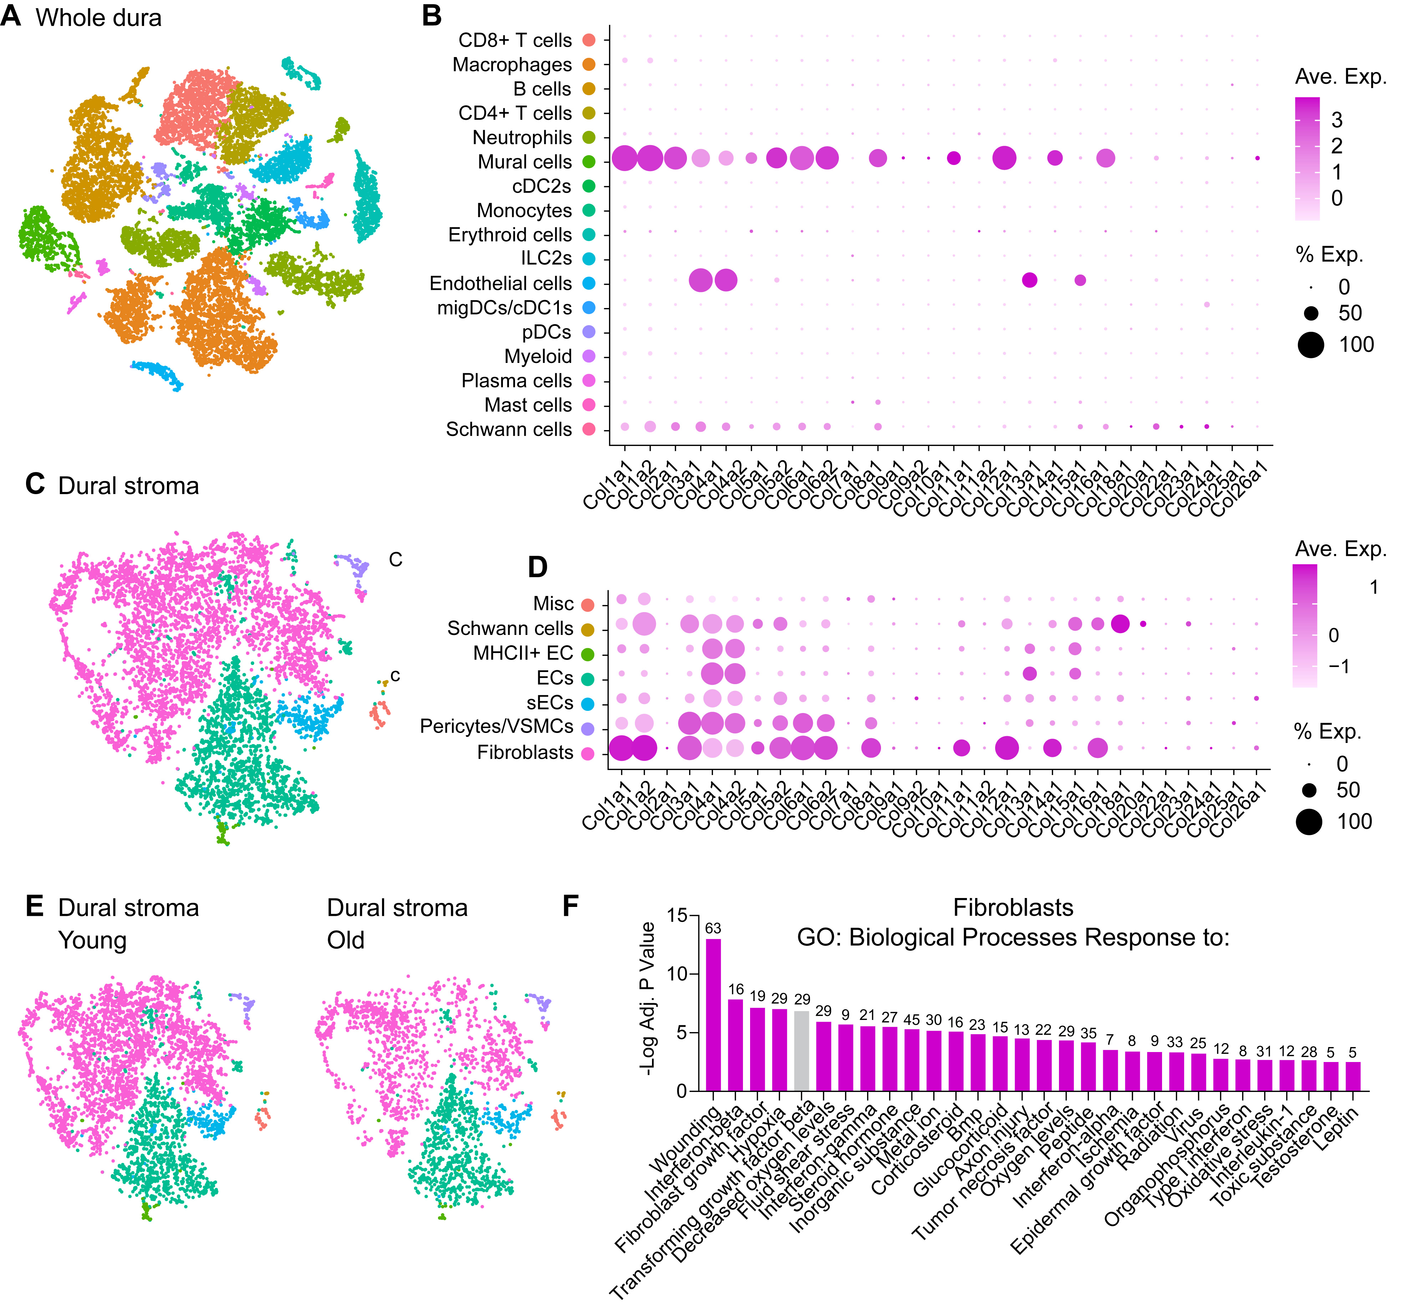
Figure S1: Characterization of ECM production and fibrosis related signaling pathways in dural fibroblasts. (A) t-SNE visualization of scRNA-seq of cells isolated from young (2–3 mo) and old (20–24 mo) mouse dura. Data from Rustenhoven et al. (2021); n = 5 individual young and old dura per experiment, n = 2 independent experiments, 10 dura samples per age total. (B) Dot plot showing scaled expression and percentage of cells expressing these genes in mouse dural stroma populations from reanalysis of scRNA-seq data in [16]. (C) t-SNE visualization of scRNA-seq of stromal (CD31⁺ and CD13⁺ sorted) cells isolated from young (2–3 mo) and old (20–24 mo) mouse dura. Data from Rustenhoven et al. (2021); n = 5 individual young and old dura per experiment, n = 2 independent experiments, 15 dura samples per age total. (D) Dot plot showing scaled expression and percentage of cells expressing these genes in mouse dural stroma populations from reanalysis of scRNA-seq data in [16]. (E) t-SNE visualization of scRNA-seq of stromal (CD31⁺ and CD13⁺ sorted) cells isolated from young (2–3 mo) and old (20–24 mo) mouse dura. Data from Rustenhoven et al. (2021); n = 5 individual young and old dura per experiment, n = 2 independent experiments, 15 dura samples per age total. (F) Analysis of upregulated gene ontology pathways for DEGs in old dural fibroblasts compared to young dural fibroblasts. Presented are the top “Biological Processes Response to” pathways.

Fig. S2.
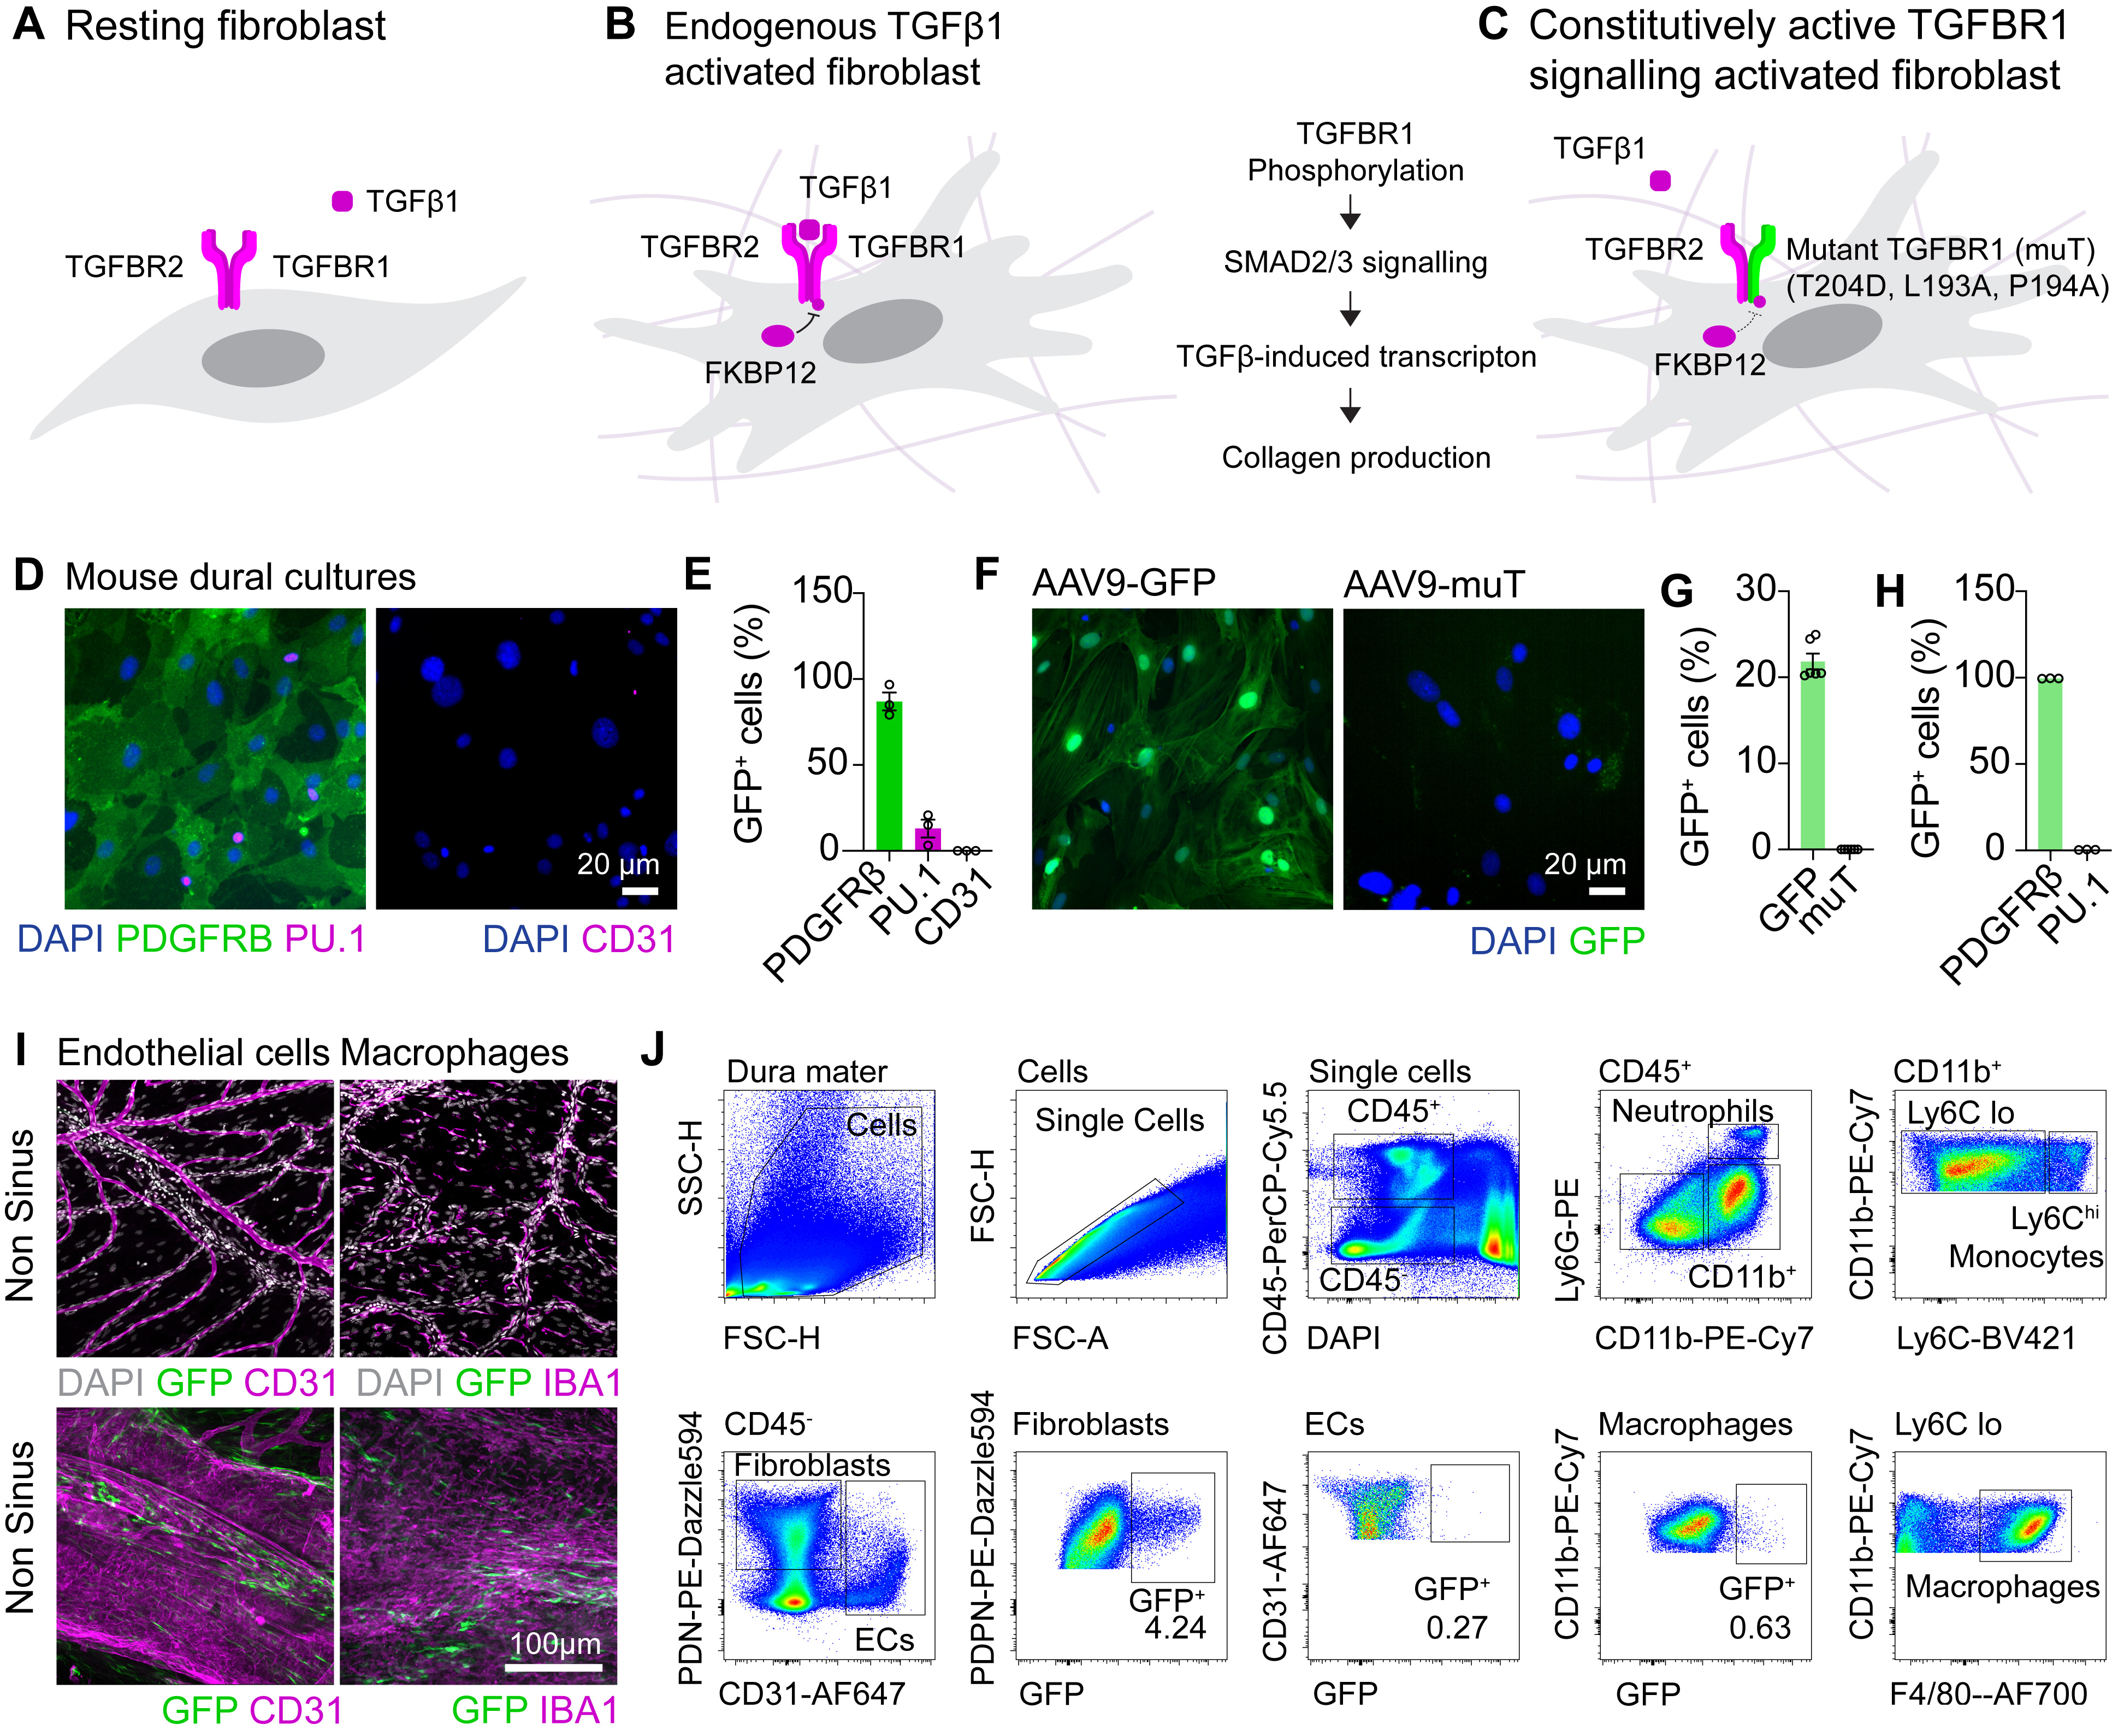
Figure S2: Description of the muT fibrosis model and validation of AAV9 targeting in dural fibroblasts. (A-C) Summary schematic for the use of the muT model to deliver a constitutively active TGFβR1 to fibroblasts to drive constitutive TGFβ1 signaling and collagen production. (D, E) Characterization of mouse dural cultures by immunostaining displaying predominantly PDGFRβ⁺ fibroblasts, some PU.1⁺ macrophages, and no CD31+ vasculature. (F) Immunocytochemistry and quantification for GFP expression in PDGFRβ⁺ fibroblasts or PU.1⁺ macrophages one week following AAV9 transduction with 1x10¹⁰ GC/mL AAV9-GFP or AAV9-muT, n = 6 independent mouse dura cultures per group. (J) Flow cytometry gating strategy for the identification of GFP expressing cells in dura one month after delivery of AA9-CMV-GFP (3 μL of 1x10¹³ GC/mL).

Fig. S3.
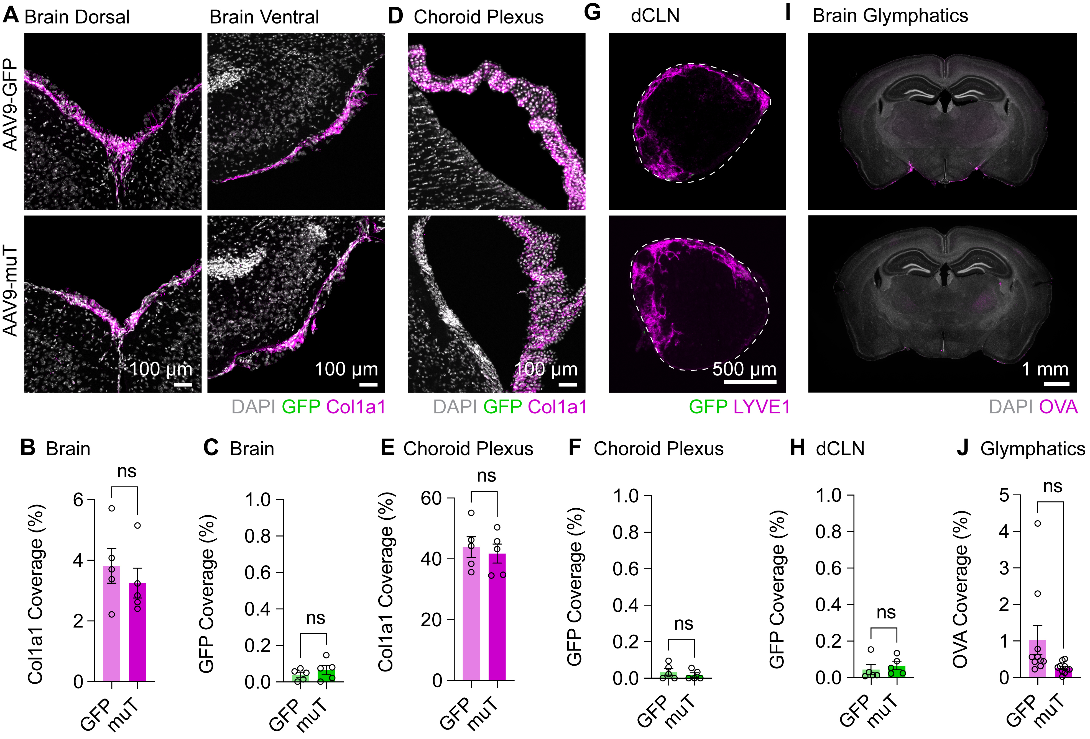
Figure S3: Lack of AAV9-targetting in brain, leptomeningeal, or choroid plexus and glymphatic influx in the muT model. (A-C) Immunohistochemistry and quantification for Col1a1 coverage and GFP expression in the brains/leptomeninges one month after CSF delivery of AAV9-GFP or AAV9-muT (3 µL of 1x10¹³ GC/mL). NS, P>0.05 (Student’s t-test), n = 5 mice per AAV. (D-F) Immunohistochemistry and quantification for Col1a1 coverage and GFP expression in the choroid plexus one month after CSF delivery of AAV9-GFP or AAV9-muT (3 µL of 1x10¹³ GC/mL). NS, P>0.05 (Student’s t-test), n = 5 mice per AAV. (G, H) Immunohistochemistry and quantification for GFP expression in the dCLNs one month after CSF delivery of AAV9-GFP or AAV9-muT (3 µL of 1x10¹³ GC/mL). NS, P>0.05 (Student’s t-test), n = 5 mice per AAV. (J, H) Immunohistochemistry and quantification for OVA-A594 drainage (2.5 µL of 1 mg/mL stock) one hour post injection one month after CSF delivery of AAV9-GFP or AAV9-muT (3 µL of 1x10¹³ GC/mL). NS, P>0.05 (Student’s t-test), n = 10 mice per AAV.
Fig. S4.
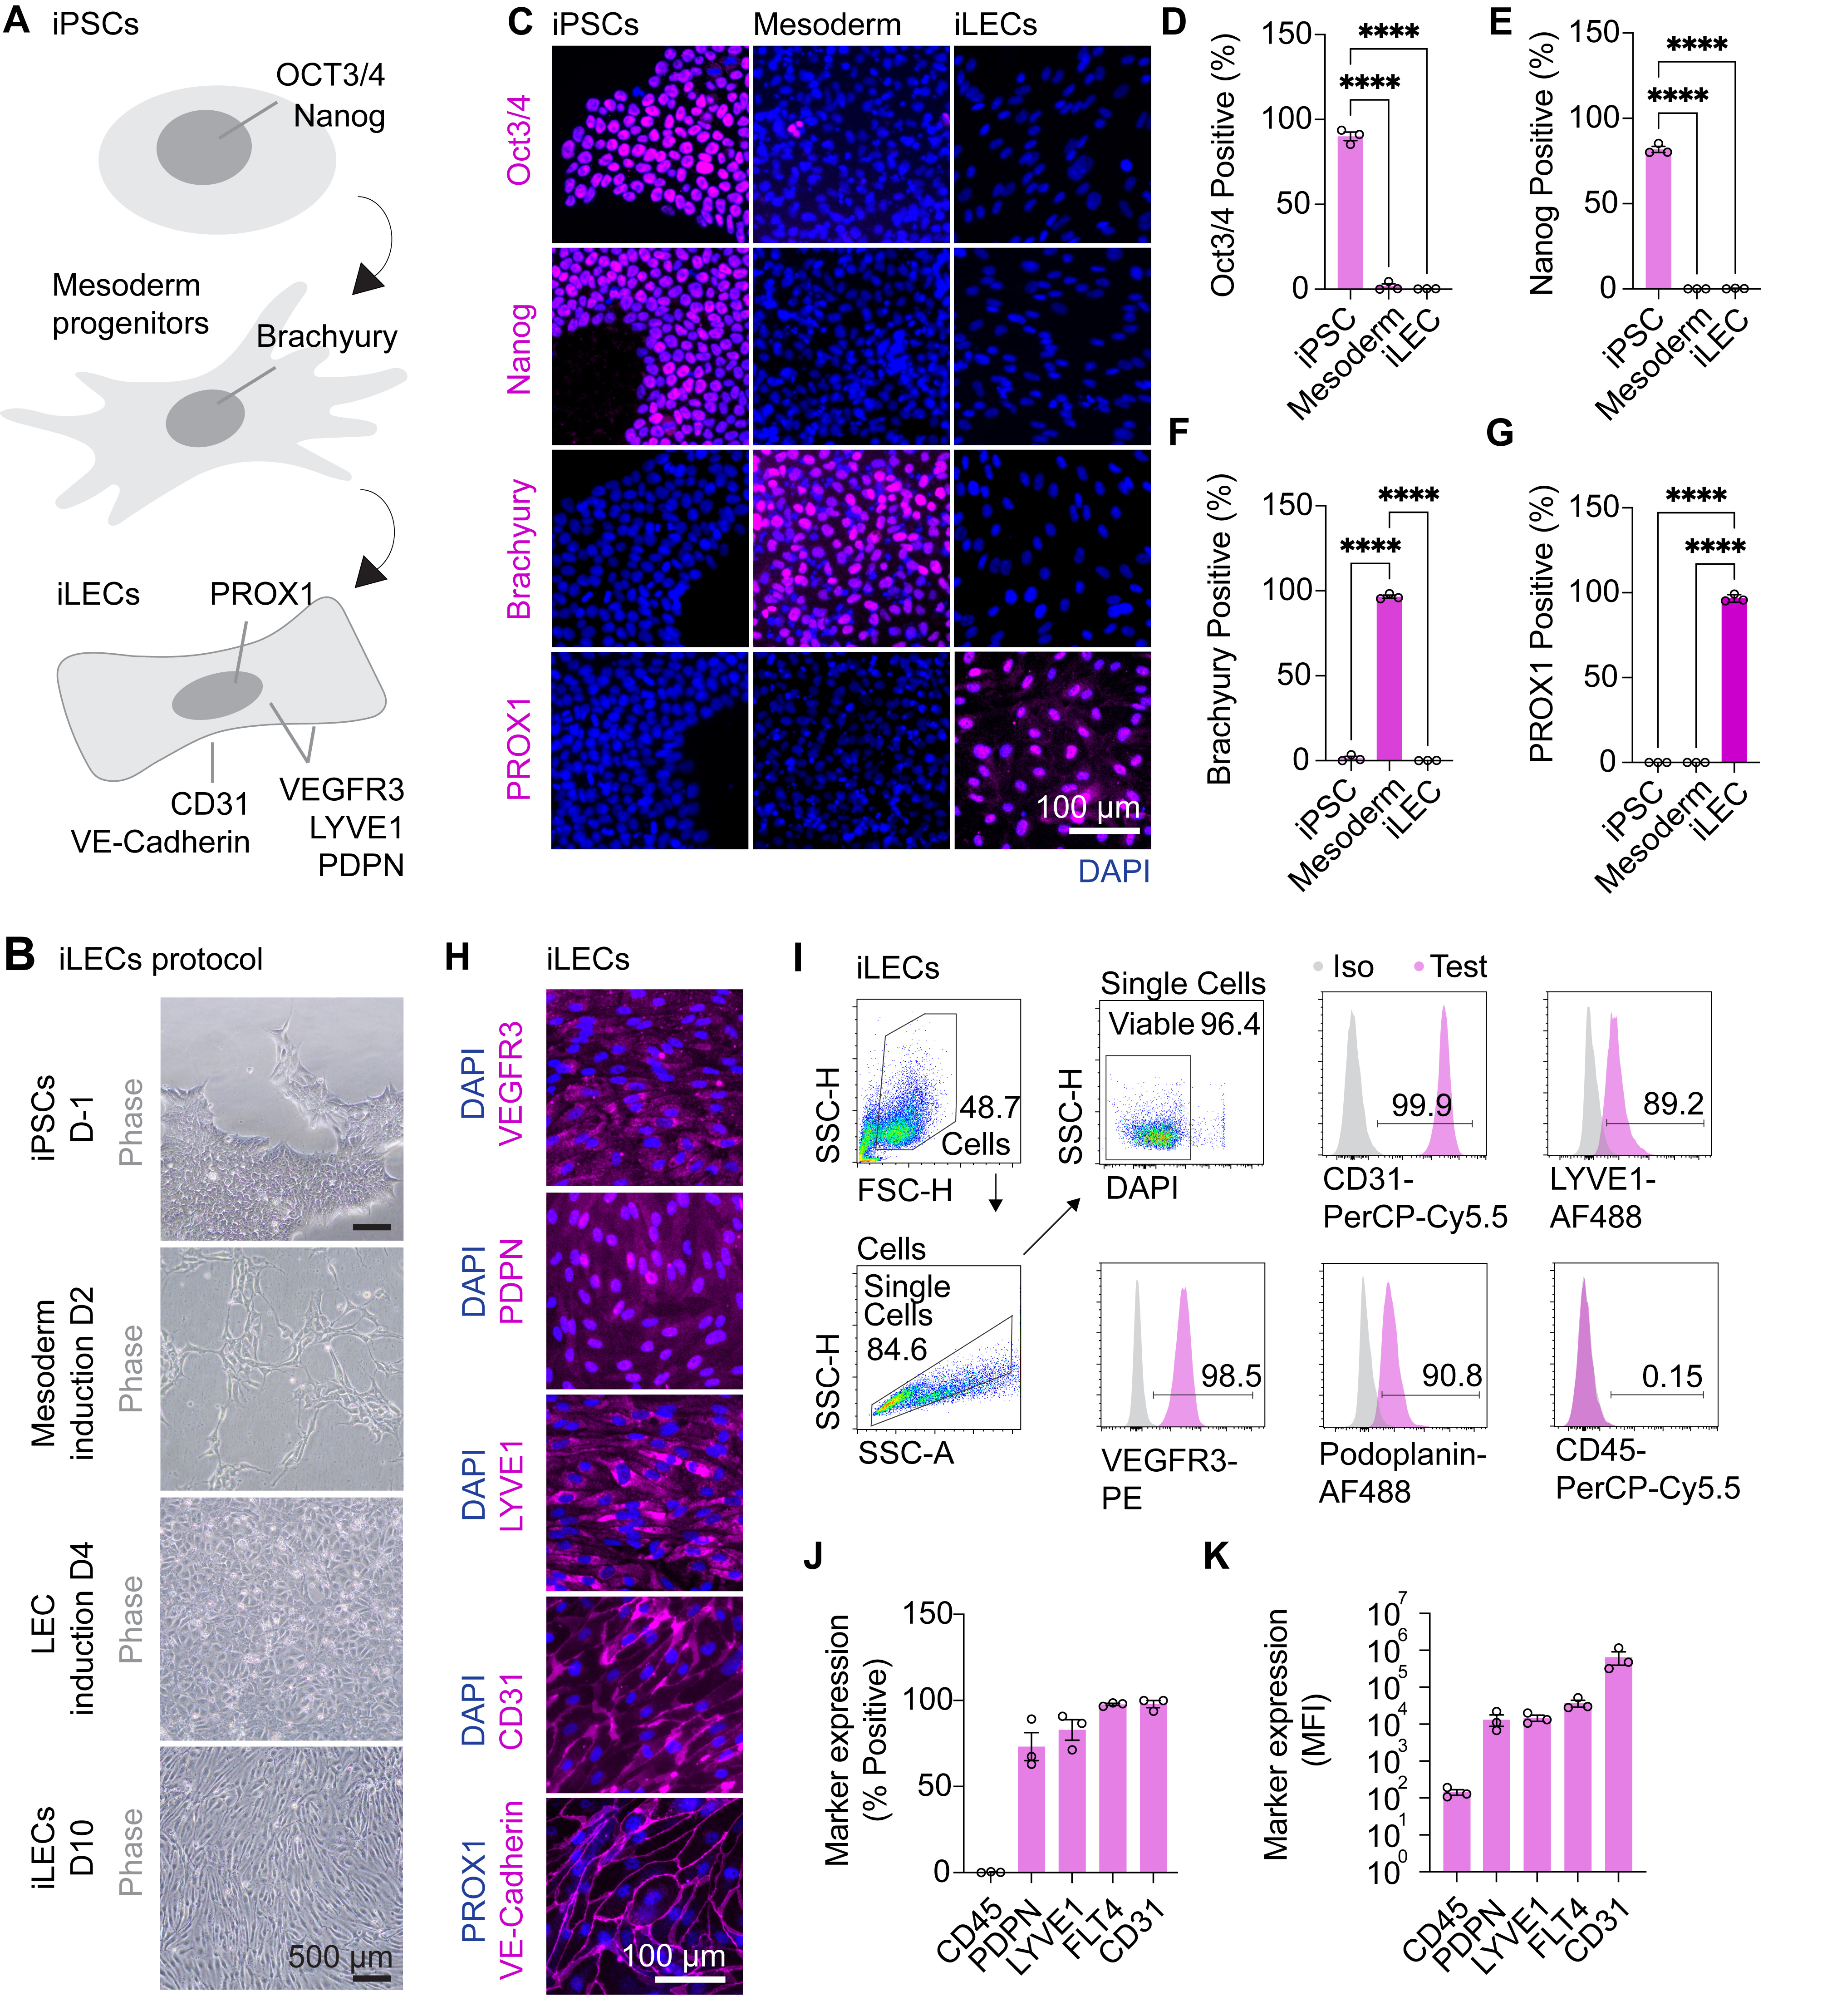
Figure S4: Characterization of iPSC-derived LECs (iLECs). (A) Summary schematic detailing the differentiation approach for the generation of iLECS from iPSCs via a mesoderm lineage and expected markers and localization at individual stages. (B) Phase contrast microscopy and immunocytochemistry detailing expected morphologies and phenotypes of cells at selected stages of differentiation. (C-G) Immunocytochemistry and quantification for state-specific markers in iPSCs, mesoderm progenitors, and iLECs. ****p<0.0001 one-way ANOVA with Tukey’s post-hoc test, n = 3 independent differentiations, from 3 different iPSC lines. (H) Immunocytochemistry for select LEC marker genes on iLECs. (I-K) Flow cytometry gating strategy and analysis and quantification of LEC markers on iLECs, n = 3 independent differentiations, from 3 different iPSC lines.

Fig. S5.
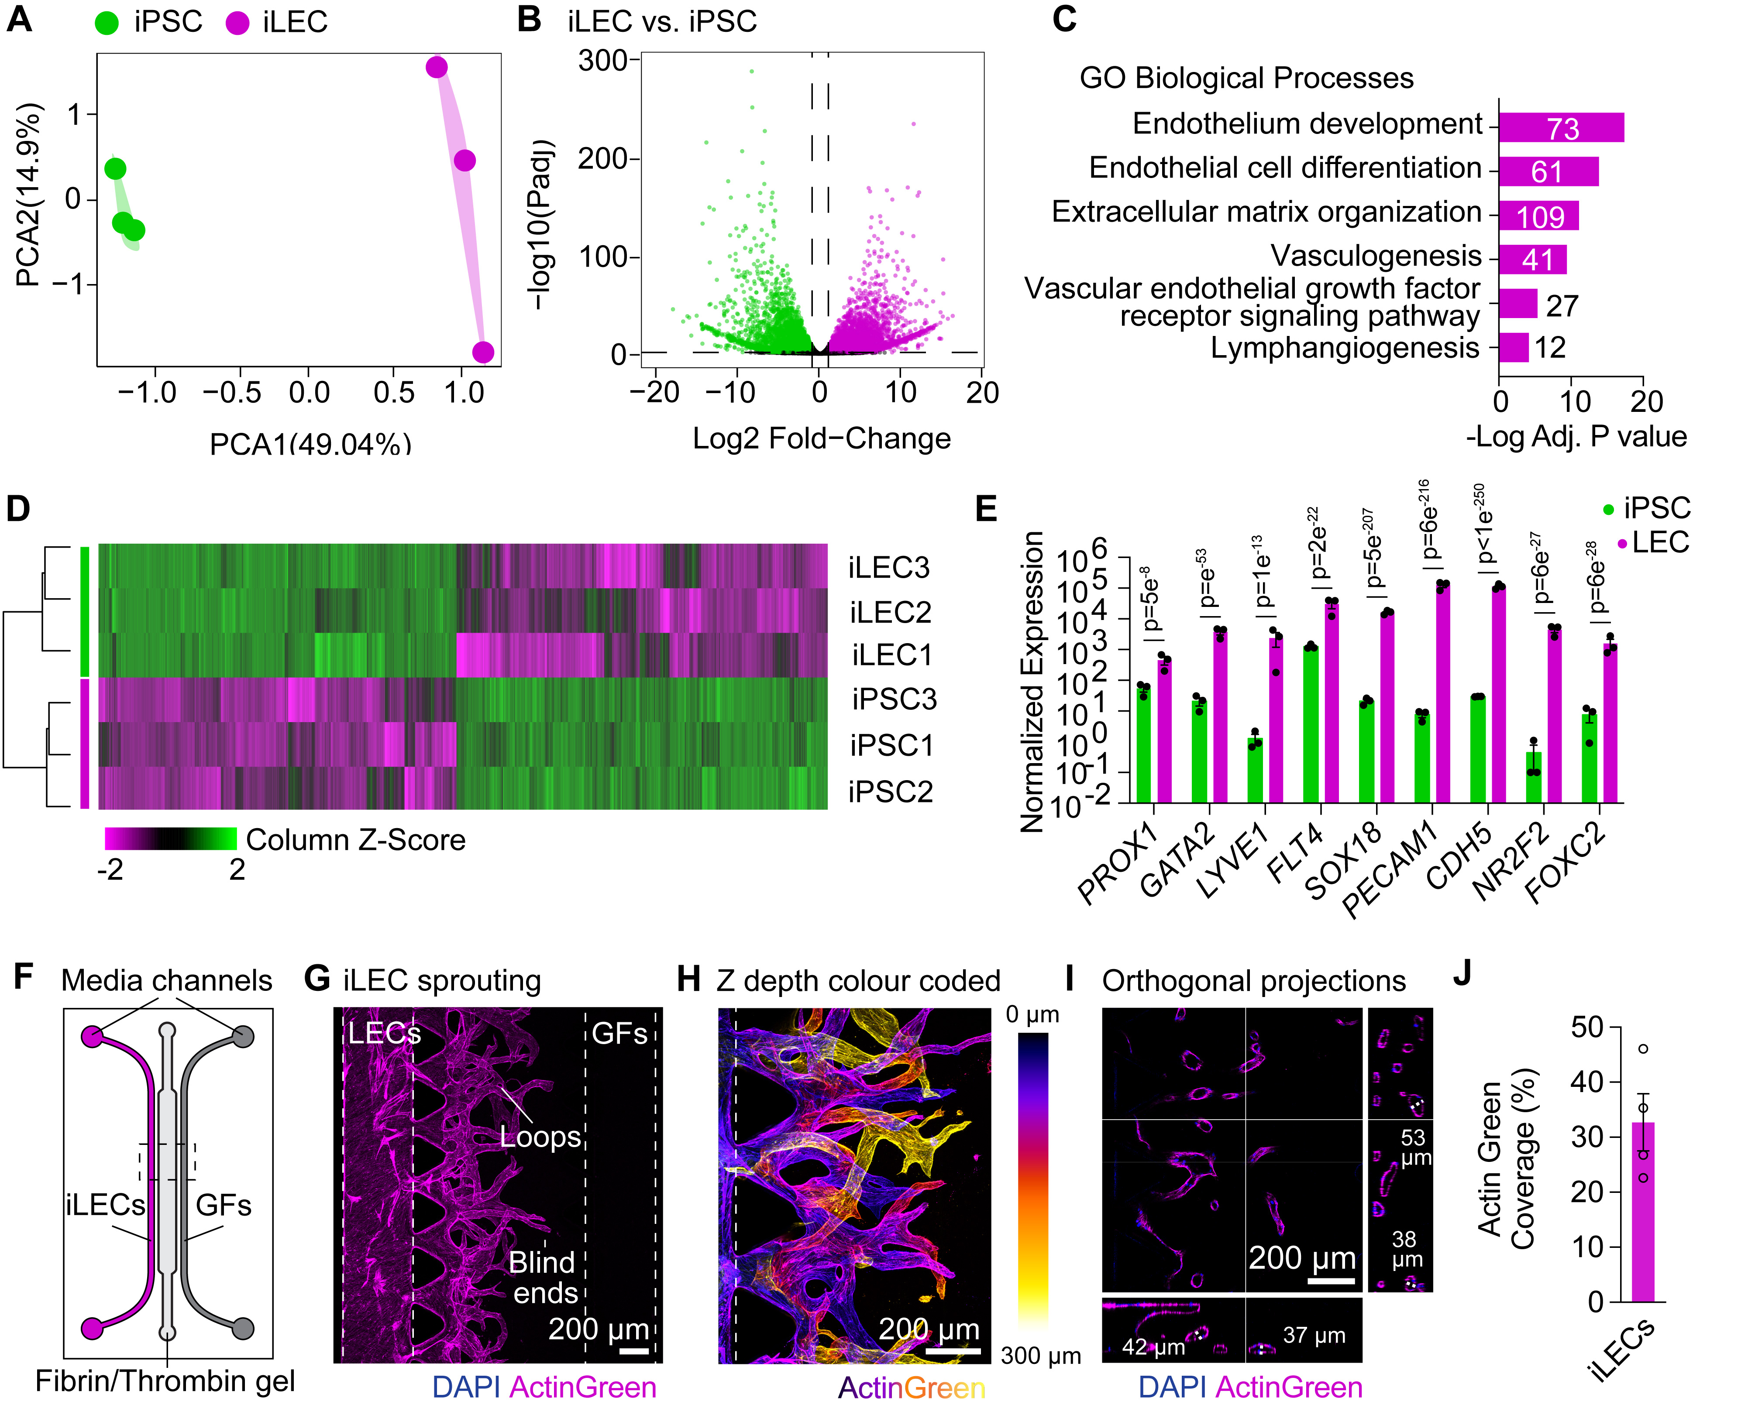
Figure S5: RNA-seq validation of iLECs and characterization of the lymphangiogenesis sprouting assay. (A) PCA plot showing clustering of iPSCs or iLECS based on the first two principal components from RNA-seq analysis. Data represent 3 independent differentiations, from 3 different iPSC lines. (B) Volcano plot showing significantly DEGs for iLECs compared to iPSCs. (C) Select GO biological processes enriched in iLECs compared to iPSCs. Numbers represent the number of genes involved. (D) Heatmap for DEGs showing unsupervised dendrogram clustering of iPSCs and iLECs. (E) Normalized expression values for canonical LEC marker genes, fate-defining transcription factors, and endothelial genes. P = False-discovery rate-adjusted p values. (F) Summary schematic for iLEC sprouting assays into a fibrin/thrombin gel using identX microfluidic devices. iLECs are seeded in the left media chamber, the fibrin/thrombin gel in the central chamber, and growth factors VEGF-C, Ang1, and HGF are applied to the right media chamber. GFs = growth factors. (G) ActinGreen staining for iLECs sprouting into fibrin/thrombin gels, 6 days after daily administration of 100 ng/mL VEGF-C, Ang1, and HGF to the right media chamber. GFs = growth factors. (H) Color coding of ActinGreen staining of iLEC sprouts into fibrin/thrombin gels, 6 days after daily administration of 100 ng/mL VEGF-C, Ang1, and HGF to the right media chamber, by confocal imaging based on Z-depth within the fibrin/thrombin gel. (I) Orthogonal projections of iLEC sprouts from (H) stained with ActinGreen and DAPI showing fully lumenized vessels with physiological diameters. Selected diameters of lymphatic vessels are shown. (J) Quantification of iLEC sprouting area by ActinGreen staining, n = 4 independent differentiations, from 2 different iPSC lines.

