Supplementary figure 1

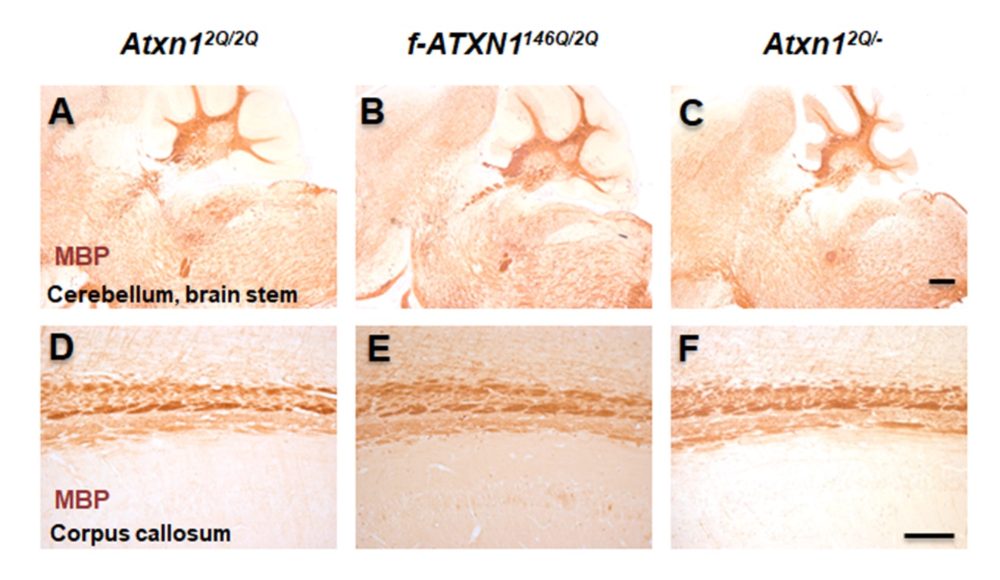

Supplementary figure 2

Supplementary figure 1. No alterations in myelination in cerebellum, brain stem, and corpus callosum of f-ATXN1^{146Q/2Q} and Atxn1^{2Q/-} mice. MBP IHC was used to assess the myelination N = 4 animals each. Scale bars: 200 μm (A–C) and 100 μm (D–F).
Supplementary figure 2. Cell body areas are approximately normally distributed, warranting parametric statistics. Outliers greater than 1.5 interquartile ranges above quartile 3 were excluded from analysis. The line describing a perfectly linear relationship (correlation coefficient of 1) between theoretical, normally distributed quantiles and the dataset's quantiles is displayed in red, whereas observed data points are displayed in black.

