Original gels used in the main figures and supplementary figures

Calnexin, HSP70, TSG101 and CD81 in Fig. 2b
(45 kDa)
(26 kDa)
(70 kDa)
(90 kDa)

NFIA in Fig. 3b
NFIA(55 kDa)
β-actin(42kDa)
CHOW1 HFD1 CHOW2 HFD2 CHOW3 HFD3 CHOW4 HFD4 CHOW5 HFD5 CHOW6 HFD6
CHOW1 HFD1 CHOW2 HFD2 CHOW3 HFD3 CHOW4 HFD4 CHOW5 HFD5 CHOW6 HFD6
NFIA(55 kDa)
β-actin(42kDa)

NFIA in Fig. 3h
β-actin(42kDa)
NFIA(55 kDa)
NFIA(55 kDa)
β-actin(42kDa)

NFIA in Fig. 3i
NFIA(55 kDa)

NFIA in Fig. 7b
β-actin(42kDa)
NFIA(55 kDa)

NFIA in Fig. 7c

NFIA(55 kDa)

Syn, PSD95 and α-tubulin in Supplementary Fig. 3e

Calnexin,CD63 and CD81 in Supplementary Fig. 8b
(26kDa)
(40-60kDa)
(90kDa)

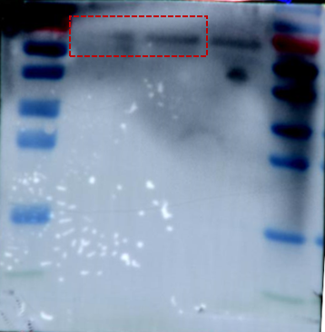
NFIA in Supplementary Fig. 8e
NFIA(55 kDa)

