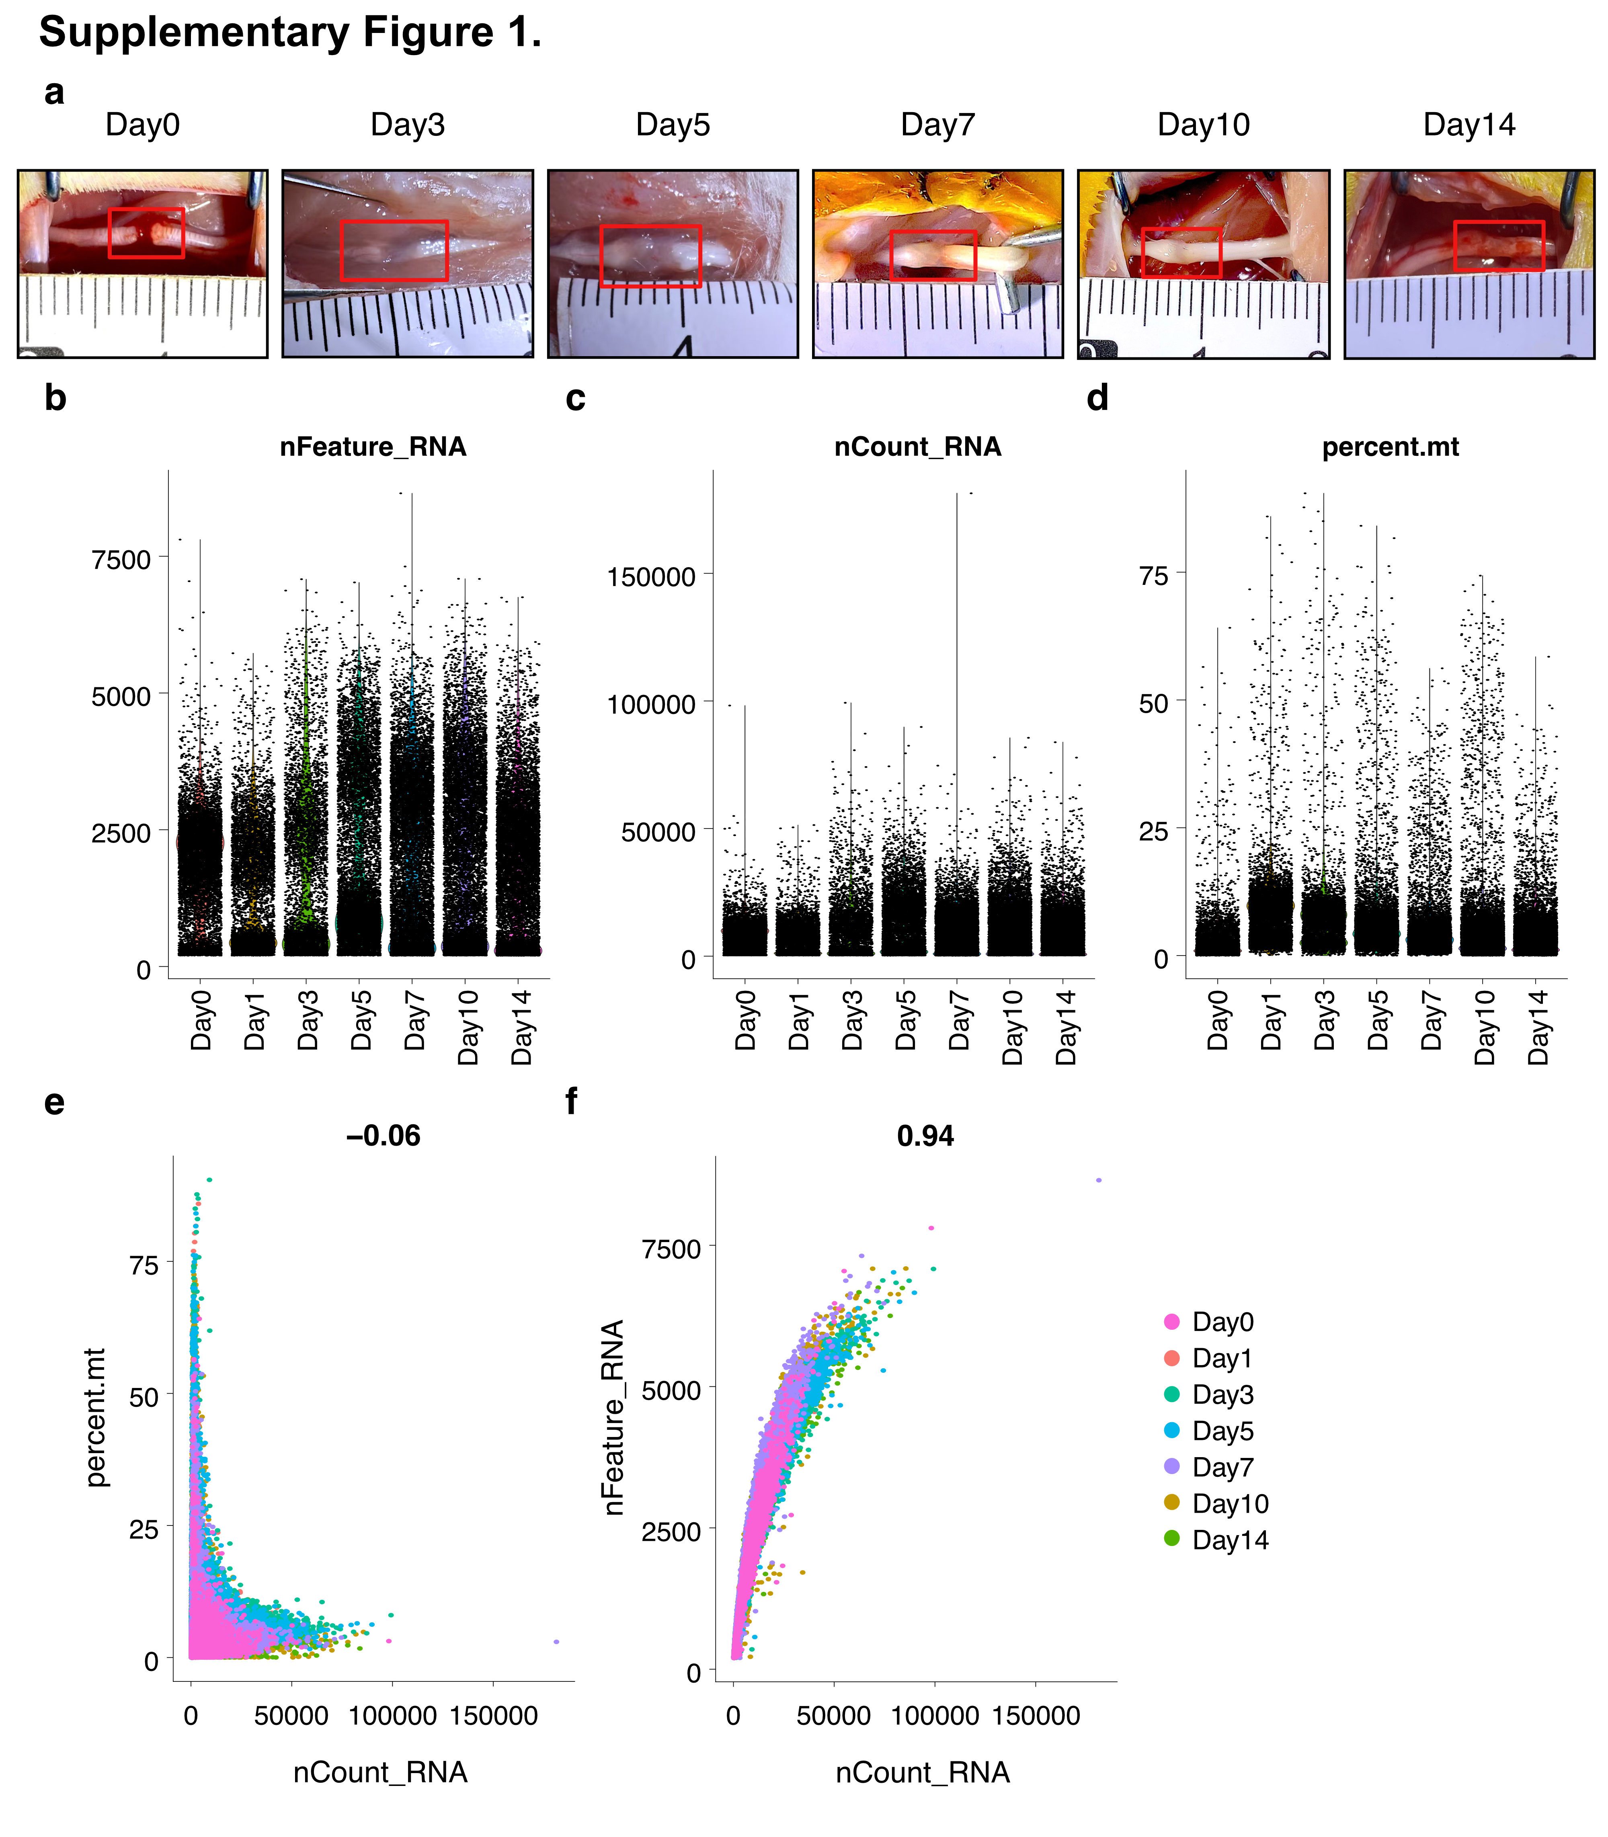

Supplementary Fig. S1. Tissue Sampling and Quality Control Metrics of Single–Cell RNA Sequencing (scRNA–seq) Data.
(a) Representative images of sciatic nerve tissue dissection at Days 0, 3, 5, 7, 10, and 14 post–transection, showing the formation and extension of the regenerating nerve bridge between the proximal and distal stumps. (b–d) Violin plots displaying scRNA–seq quality control (QC) metrics across seven time points: (b) Number of detected genes per cell (nFeature); (c) Total UMI count per cell (nCount); (d) Percentage of mitochondrial gene expression (percent.mt) across annotated cell types. (e–f) Scatter plots of QC relationships: (e) nCount vs. percent.mt showing a weak negative correlation (R = −0.06); (f) nCount vs. nFeature showing a strong positive correlation (R = 0.94).

