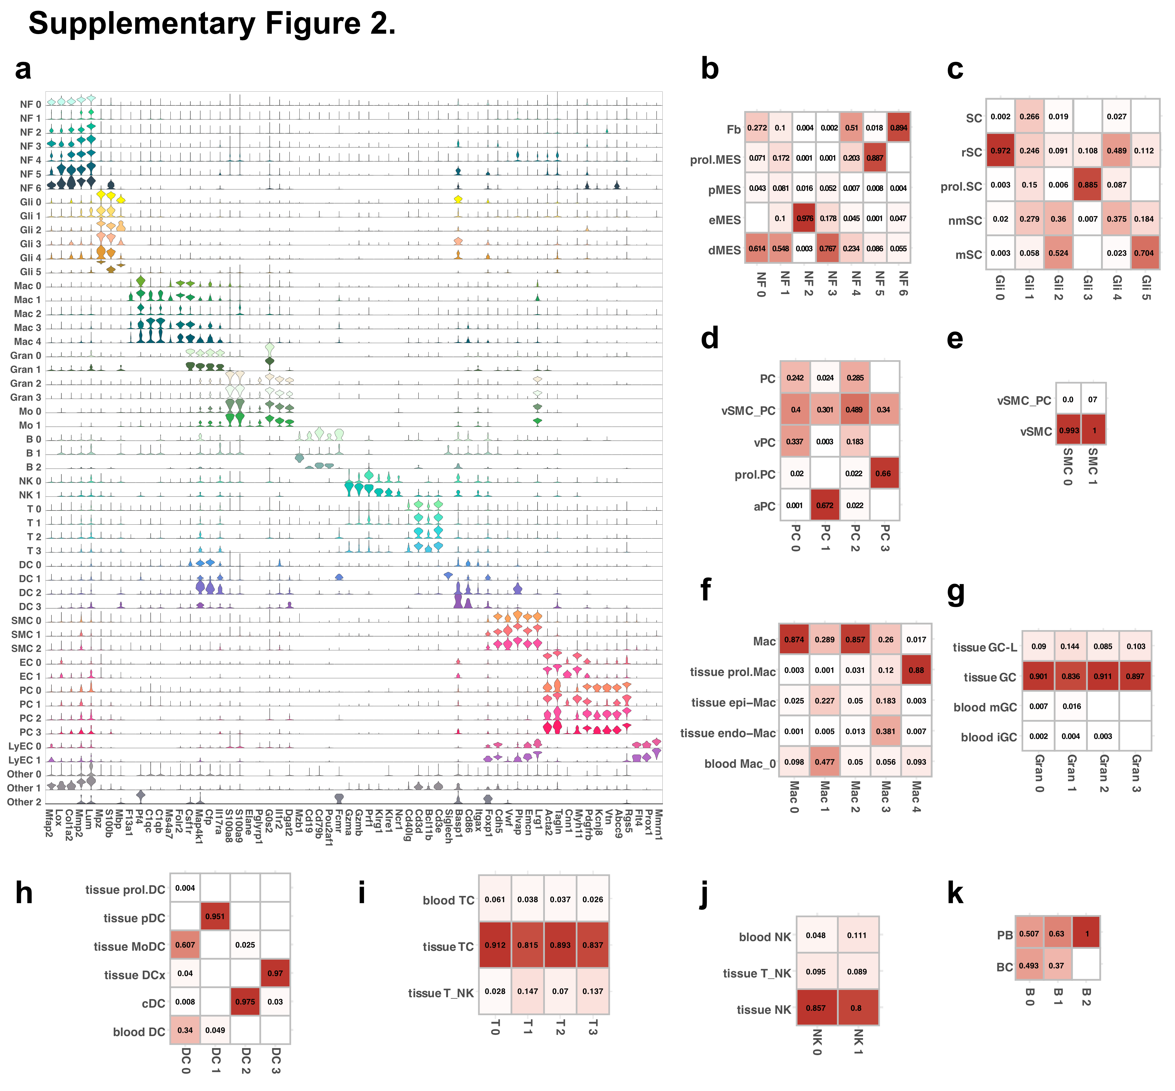

Supplementary Fig. S2. Reference–Based Annotation of Single–Cell Clusters.
(a) Violin plots of canonical marker gene expression across major cell clusters. (b–k) Heatmaps showing cell subtype assignment using SingleR with GSE198582 as the reference. Columns represent cell clusters; rows represent cell subtypes. (b) Neurofibroblasts (NF): fibroblasts (Fb), differentiating mesenchymal cells (dMES), proliferating mesenchymal cells (prol.MES), endoneurial (eMES), and perineurial (pMES) cells. (c) Glial cells (Gli): non–myelinating (nmSC), myelinating (mSC), repair (rSC), and proliferating Schwann cells (prol.SC). (d) Pericytes (PC): venous (vPC), arterial (aPC), proliferating (prol.PC), and vascular SMC–like pericytes (vSMC_PC). (e) Smooth muscle cells (SMC): vascular SMCs (vSMC). (f) Macrophages (Mac): tissue proliferating (tissue prol.Mac), epineurial (epi–Mac), endoneurial (endo–Mac), and blood–derived macrophages. (g) Granulocytes (Gran): tissue GC–like (tissue GC–L), tissue GC, blood immature (iGC), and mature granulocytes (mGC). (h) Dendritic cells (DC): monocyte–derived (MoDC), conventional (cDC), proliferating (prol.DC), plasmacytoid (pDC), mature/migrating (DCx), and blood DCs. (i) T cells: blood T (blood TC), tissue T (tissue TC), and tissue T/NK cells. (j) NK cells: blood NK, tissue NK, and tissue T/NK cells. (k) B cells: B cells (BC) and plasma blasts (PB).

