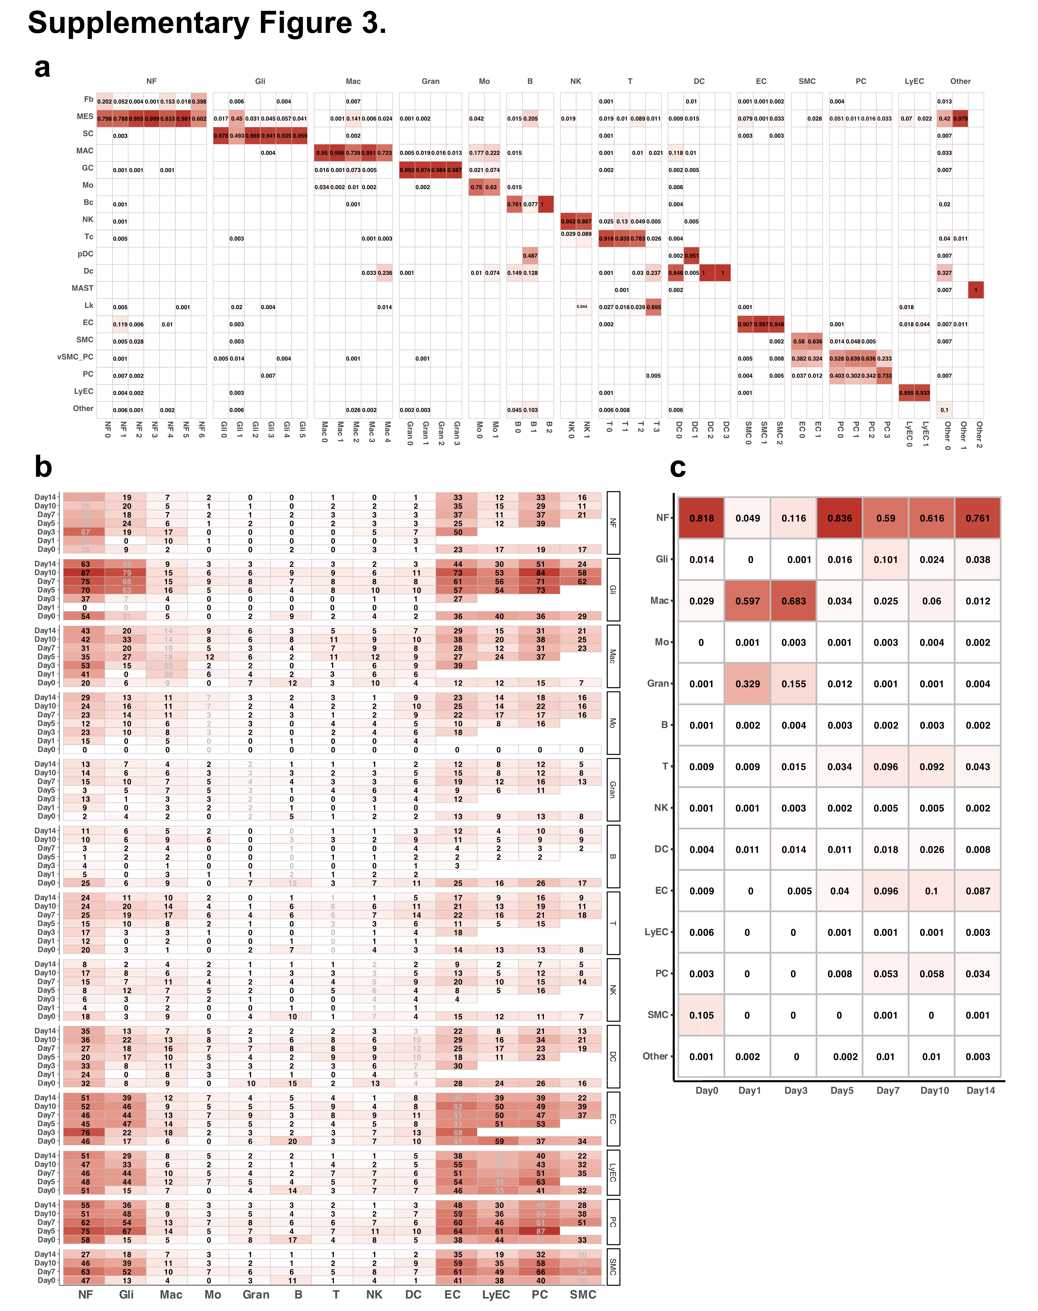

Supplementary Fig. S3. Cell Type Classification, Interactions, and Temporal Dynamics.
(a) Heatmap of cell type assignments from SingleR, with clusters on columns and cell types on rows. (b) Heatmap of overall cell–cell communication intensity across cell types and time points, measured by the number of predicted signaling pathways (more intense color = stronger interaction). (c) Heatmap showing temporal proportions of major cell types at each post–injury time point.

