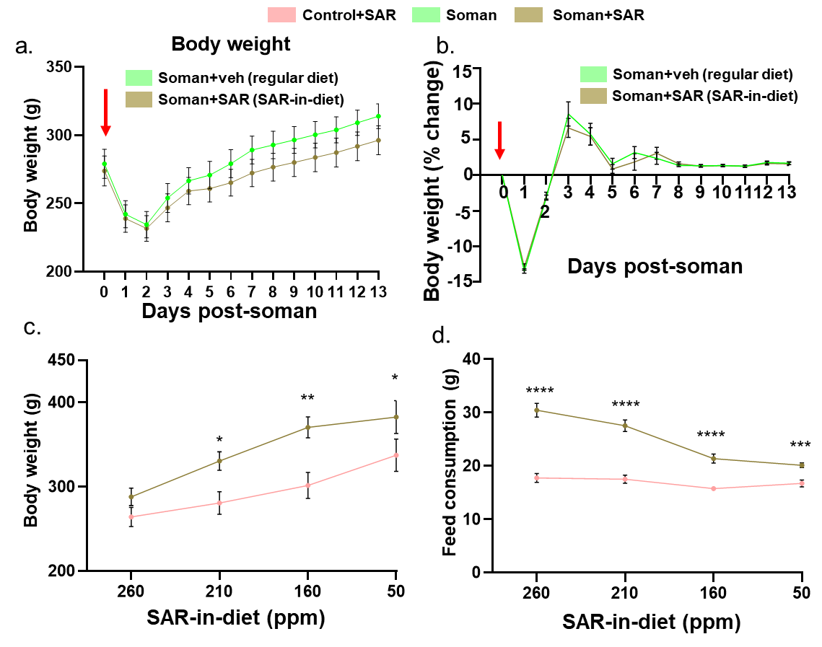
Supplementary Figure 1. Body weight recovery after soman exposure and trends in SAR-incorporated diet intake. Body weight progression in rats following soman exposure (day 0) fed with regular or SAR-in diet is shown (a-b). SAR incorporated diet intake at different concentrations and the corresponding body changes are shown in rats with and without soman exposure (c-d). Normality was assessed with the Shapiro-Wilk test. *indicates soman effect (soman vs veh+SAR). Bars represent mean ± SEM, n = 23-24 (11-12/sex). *p<0.05, **p<0.01 ***p<0.001, and ****p<0.0001 by two‐way ANOVA with Sidak’s multiple comparisons (C-D). No sex differences were observed, and data was pooled together.

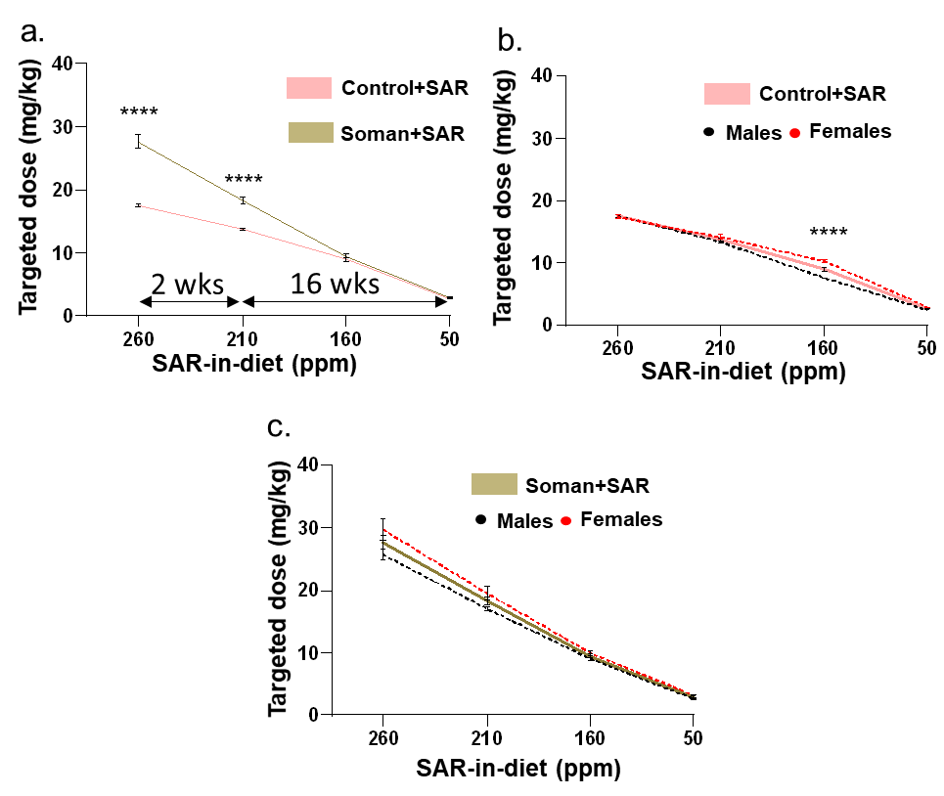

Supplementary Figure 2. Targeted SAR dose and serum SAR concentration following SAR-in diet consumption. A comparative analysis of the SAR dose (mg/kg) received following SAR-incorporated diet consumption is shown in different groups as mixed-sex cohorts and individual sexes (a-c). Normality was assessed with the Shapiro-Wilk test. *indicates soman effect (soman vs veh+SAR). Bars represent mean ± SEM, n = 9-10 (4-5/sex). *p<0.05, **p<0.01 ***p<0.001, and ****p<0.0001 by two‐way ANOVA with Sidak’s multiple comparisons (a). No sex differences were observed, and data was pooled together.
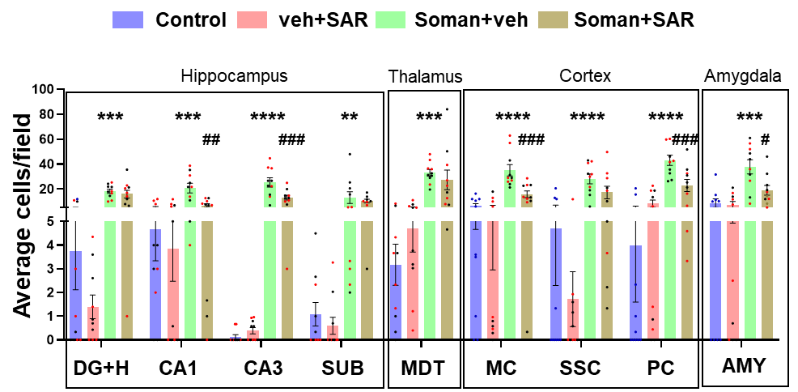
Supplementary Figure 3. Neurodegeneration following soman exposure. Analysis of cell counts for FJB⁺ & NeuN⁺ colocalized cells from dentate gyrus+ Hilus (DG+H), CA1, CA3, Subiculum (SUB), medial dorsal thalamus (MDT), motor cortex (MC), Somatosensory cortex (SSC), Piriform Cortex (PC), and amygdala (AMY) are shown. Normality was assessed with the Shapiro-Wilk test. *indicates soman effect (soman vs control) and # represents SAR effect (soman+SAR vs Soman). Bars represent mean ± SEM, n = 10 (5/sex). */#p < 0.05, **/##p < 0.01, ***/###p < 0.001, ****/####p < 0.0001 by two way ANOVA (mixed effects model) with Tukey’s multiple comparisons. No sex differences were observed.
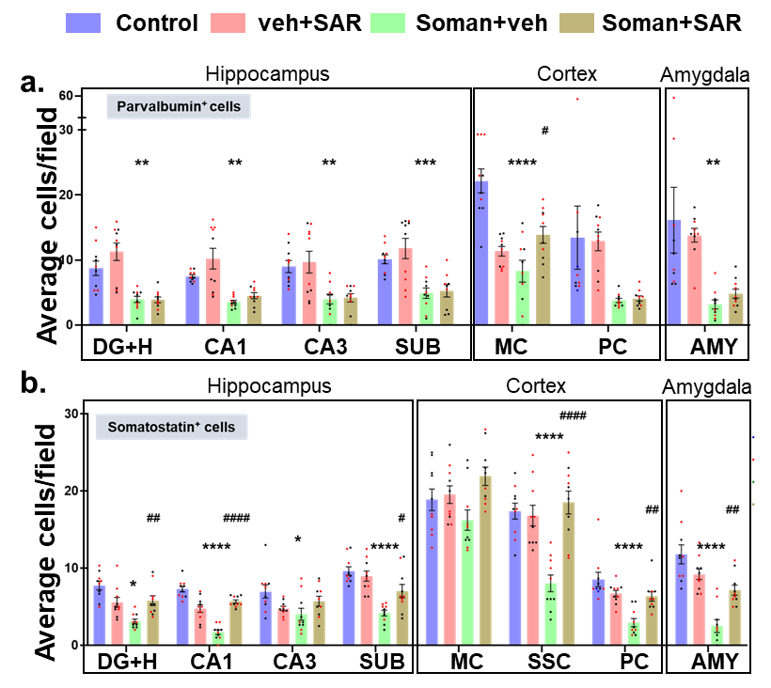
Supplementary Figure 4 Parvalbumin and somatostatin positive inhibitory neuronal expression following soman exposure. (a) Analysis of cell counts of parvalbumin+ cells from dentate gyrus+ Hilus (DG+H), CA1, CA3, Subiculum (SUB), motor cortex (MC), Piriform Cortex (PC), and amygdala (AMY),) are shown. (b) Analysis of cell counts for somatostatin+ cells from Hilus (H), CA1, CA3, Subiculum (SUB), motor cortex (MC), Piriform Cortex (PC), and amygdala (AMY),) is shown. Normality was assessed with the Shapiro-Wilk test. *indicates soman effect (soman vs control) and # represents SAR effect (soman+SAR vs Soman). Bars represent mean ± SEM, n = 10 (5/sex). */#p < 0.05, **/##p < 0.01, ***/###p < 0.001, ****/####p < 0.0001 by two way ANOVA (mixed effects model) with Tukey’s multiple comparisons. No sex differences were observed.
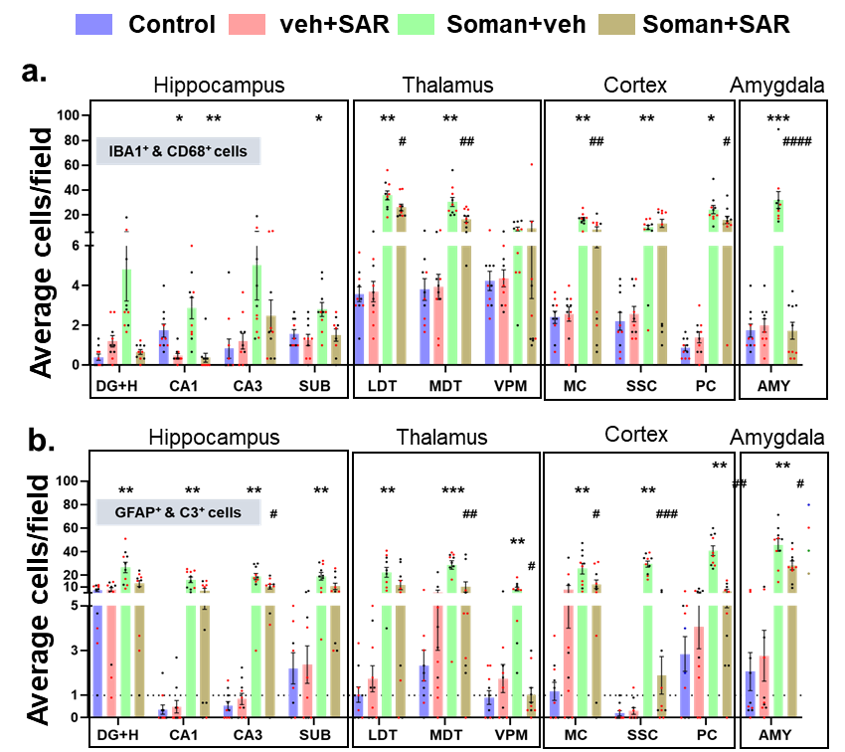
Supplementary Figure 5. (a) Microgliosis and CD68 expression following soman exposure. Analysis of cell counts for IBA1⁺ & CD68⁺ colocalized cells from Hilus (H), CA1, CA3, Subiculum (SUB), lateral dorsal thalamus (LDT), medial dorsal thalamus (MDT), Ventral posteromedial thalamus (VPM) motor cortex (MC), Somatosensory cortex (SSC), Piriform Cortex (PC), and amygdala (AMY) is shown. (b) Astrogliosis and C3 expression following soman exposure. Analysis of cell counts for GFAP⁺ & C3⁺ colocalized cells from Hilus (H), CA1, CA3, Subiculum (SUB), lateral dorsal thalamus (LDT), medial dorsal thalamus (MDT), Ventral posteromedial thalamus (VPM) motor cortex (MC), Somatosensory cortex (SSC), Piriform Cortex (PC), and amygdala (AMY) is shown. Normality was assessed with the Shapiro-Wilk test. *indicates soman effect (soman vs control) and # represents SAR effect (soman+SAR vs Soman). Bars represent mean ± SEM, n = 10 (5/sex). */#p < 0.05, **/##p < 0.01, ***/###p < 0.001, ****/####p < 0.0001 by two way ANOVA (mixed effects model) with Tukey’s multiple comparisons. No sex differences were observed.

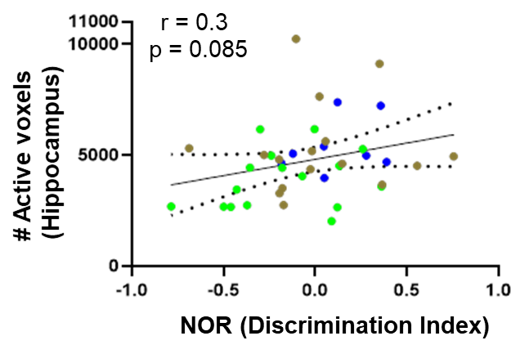
Supplementary Figure 6. Correlational analysis between Hippocampal rsFC and novel object recognition test. Correlation analyses between hippocampal fMRI and Discrimination index is shown as Pearson correlation coefficient ‘r’ with a corresponding p-value for each graph. n = 8-16 (4-8/sex)

Supplementary Table 1. Sex interaction by 2 way ANOVA (mixed model effects) statistics.
Figure | Sex  differences /interaction | Statistical analysis  Descriptive stats |  | Descriptive stats
2e | Yes |  |  | Refer to Supplementary Figure 2
2f | No
2g | No
Figure | Source of Variation | % of total  variation | P value | P-value summary | Significant?
3b | Interaction | 0.5396 | 0.8908 | ns | No
 | Treatment | 24.46 | <0.0001 | **** | Yes
 | Sex | 0.9866 | 0.2887 | ns | No
3c | Interaction | 3.536 | 0.3450 | ns | No
 | Treatment | 10.42 | 0.0242 | * | Yes
 | Sex | 0.1025 | 0.7556 | ns | No
3d | Interaction | 1.290 | 0.7241 | ns | No
 | Treatment | 15.13 | 0.0025 | ** | Yes
 | Sex | 0.9065 | 0.3376 | ns | No
3f | Interaction | 0.7469 | 0.8171 | ns | No
 | Treatments | 30.17 | <0.0001 | **** | Yes
 | Sex | 0.7455 | 0.3369 | ns | No
4b | Interaction | 4.175 | 0.1288 | ns | No
 | Treatment | 34.14 | <0.0001 | **** | Yes
 | Sex | 0.5752 | 0.3727 | ns | No
4c | Interaction | 3.808 | 0.2708 | ns | No
 | Treatment | 15.92 | 0.0016 | ** | Yes
 | Sex | 0.1708 | 0.6736 | ns | No
4d | Interaction | 3.808 | 0.2708 | ns | No
 | Treatment | 15.92 | 0.0016 | ** | Yes
 | Sex | 0.1708 | 0.6736 | ns | No
5b | Interaction | 1.583 | 0.4376 | ns | No
 | Treatment | 41.72 | <0.0001 | **** | Yes
 | Sex | 5.903 | 0.0019 | ** | Yes
5g | Interaction | 0.5006 | 0.9280 | ns | No
 | Treatment | 13.07 | 0.0108 | * | Yes
 | Sex | 0.6864 | 0.4311 | ns | No
6b | Interaction | 3.054 | 0.5045 | ns | No
 | Treatment | 21.69 | 0.0131 | * | Yes
 | Sex | 2.086 | 0.3356 | ns | No
6d | Interaction | 0.6127 | 0.7878 | ns | No
 | Treatment | 80.67 | <0.0001 | **** | Yes
 | Sex | 0.1625 | 0.6001 | ns | No
6e | Interaction | 3.686 | 0.4496 | ns | No
 | Treatment | 52.87 | <0.0001 | **** | Yes
 | Sex | 1.579e-006 | 0.9991 | ns | No
6f | Interaction | 3.267 | 0.0421 | ns | No
 | Treatment | 82.30 | <0.0001 | **** | Yes
 | Sex | 3.045 | 0.0063 | ** | Yes
6g | Interaction | 5.205 | 0.3120 | ns | No
 | Treatment | 51.03 | <0.0001 | **** | Yes
 | Sex | 0.7144 | 0.4802 | ns | No
7cii | Interaction | 1.184 | 0.6270 | ns | No
 | Treatment | 0.7675 | 0.6953 | ns | No
 | Sex | 0.8055 | 0.6883 | ns | No
7dii | Interaction | 2.849 | 0.6793 | ns | No
 | Treatment | 4.833 | 0.2949 | ns | No
 | Sex | 0.5382 | 0.3004 | ns | No
7g | Interaction | 3.750 | 0.3455 | ns | No
 | Treatment | 8.588 | 0.1592 | ns | No
 | Sex | 7.322 | 0.1921 | ns | No
8b
Hippocampus | Interaction | 1.281 | 0.6979 | ns | No
 | Treatment | 68.90 | <0.0001 | **** | Yes
 | Sex | 1.400 | 0.2184 | ns | No
Cortex | Interaction | 6.960 | 0.0855 | ns | No
 | Treatment | 62.01 | <0.0001 | **** | Yes
 | Sex | 0.1750 | 0.6729 | ns | No
Amygdala | Interaction | 1.529 | 0.6965 | ns | No
 | Treatment | 62.39 | <0.0001 | **** | Yes
 | Sex | 2.308 | 0.1490 | ns | No
8c
Hippocampus | Interaction | 0.1135 | 0.9878 | ns | No
 | Treatment | 68.39 | <0.0001 | **** | Yes
 | Sex | 3.468 | 0.0552 | ns | No
Cortex | Interaction | 9.270 | 0.1004 | ns | No
 | Treatment | 42.95 | <0.0001 | **** | Yes
 | Sex | 4.031 | 0.0956 | ns | No
Amygdala | Interaction | 11.37 | 0.0949 | ns | No
 | Treatment | 33.37 | 0.0011 | ** | Yes
 | Sex | 2.766 | 0.2034 | ns | No
9c | Interaction | 0.5987 | 0.7353 | ns | No
 | Treatment | 48.49 | 0.0107 | * | Yes
 | Sex | 0.5987 | 0.7353 | ns | No
10c
Hippocampus | Interaction | 4.634 | 0.4364 | ns | No
 | Treatment | 40.75 | 0.0003 | *** | Yes
 | Sex | 1.601 | 0.3329 | ns | No
Thalamus | Interaction | 5.118 | 0.0946 | ns | No
 | Treatment | 70.02 | <0.0001 | **** | Yes
 | Sex | 1.268 | 0.1991 | ns | No
Cortex | Interaction | 0.4594 | 0.7937 | ns | No
 | Treatment | 85.28 | <0.0001 | **** | Yes
 | Sex | 0.01289 | 0.8660 | ns | No
Amygdala | Interaction | 7.047 | 0.1089 | ns | No
 | Treatment | 56.70 | <0.0001 | **** | Yes
 | Sex | 1.874 | 0.1960 | ns | No
10d |  | 0.8469 | 0.7710 | ns | No
Hippocampus | Interaction | 75.05 | <0.0001 | **** | Yes
 | Treatment | 0.06095 | 0.7776 | ns | No
 | Sex
Thalamus | Interaction | 3.475 | 0.2579 | ns | No
 | Treatment | 67.93 | <0.0001 | **** | Yes
 | Sex | 2.300 | 0.1041 | ns | No
Cortex | Interaction
 | Treatment | 2.340 | 0.1364 | ns | No
 | Sex | 84.34 | <0.0001 | **** | Yes
 |  | 0.7301 | 0.1827 | ns | No
Amygdala | Interaction | 4.400 | 0.0611 | ns | No
 | Treatment | 77.35 | <0.0001 | **** | Yes
 | Sex | 0.9625 | 0.1914 | ns | No
11
Serum nitrite | Interaction | 5.804 | 0.1256 | ns | No
 | Treatment | 47.65 | <0.0001 | **** | Yes
 | Sex | 7.473 | 0.0083 | ** | Yes
ROS | Interaction | 0.8858 | 0.7470 | ns | No
 | Treatment | 72.51 | <0.0001 | **** | Yes
 | Sex | 0.4661 | 0.4275 | ns | No
GSH | Interaction | 4.030 | 0.4074 | ns | No
 | Treatment | 55.67 | <0.0001 | **** | Yes
 | Sex | 4.543 | 0.0762 | ns | No
GSSG | Interaction | 2.718 | 0.6494 | ns | No
 | Treatment | 43.94 | 0.0002 | *** | Yes
 | Sex | 0.9996 | 0.4404 | ns | No
GSH/GSSG | Interaction | 0.7269 | 0.8130 | ns | No
 | Treatment | 75.54 | <0.0001 | **** | Yes
 | Sex | 0.3467 | 0.5059 | ns | No
12 (Serum)
MCP1 | Interaction (treatment x sex) | 7.088 | 0.0398 | * | Yes
TNF-α | Interaction (treatment x sex) | 4.067 | 0.3528 | ns | No
IL-17A | Interaction (treatment x sex) | 17.43 | 0.0003 | *** | Yes
IL-1β | Interaction (treatment x sex) | 7.734 | 0.2559 | ns | No
IL-6 | Interaction (treatment x sex) | 0.6358 | 0.9039 | ns | No
IL-18 | Interaction (treatment x sex) | 12.38 | 0.0093 | ** | Yes
IL-1α | Interaction (treatment x sex) | 2.395 | 0.5363 | ns | No
12 (CSF)
MCP1 | Interaction (treatment x sex) | 0.8198 | 0.1807 | ns | No
TNF-α | Interaction (treatment x sex) | 5.509 | 0.1584 | ns | No
IL-17A | Interaction (treatment x sex) | 1.855 | 0.1220 | ns | No
IL-1β | Interaction (treatment x sex) | 13.33 | 0.0008 | *** | Yes
IL-6 | Interaction (treatment x sex) | 0.2845 | 0.5688 | ns | No
IL-18 | Interaction (treatment x sex) | 4.483 | 0.0231 | * | Yes
IL-1α | Interaction (treatment x sex) | 0.2141 | 0.6493 | ns | No

