Supplementary Material – Blots and gels

Coexistence of CN1A autoantibodies in GAD65 encephalitis exacerbates neurodegeneration
Delara Kamalizade¹, Annika Breuer¹, Tobias Baumgartner¹, Juliane L. Berns¹, Thoralf Opitz², Franziska S. Thaler^{3,4}, Susanne Schoch^{1,5}, Lars Komorowski⁶, Christoph Helmstaedter¹, Rainer Surges¹, Albert J. Becker^{5#}, Julika Pitsch^{1#}

Related to Figure 1A:
Immunoblot (IB)
Patient #1
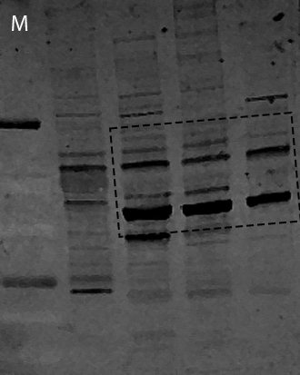

Immunoblot (IB)
Patient #2
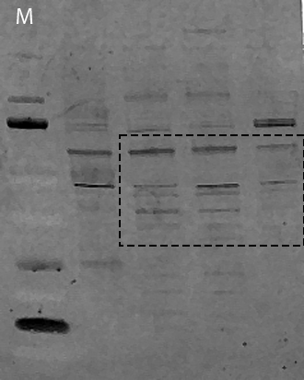
Original images acquired with the Odyssey CLx (Li-Cor) of representative immunoblots (cropped parts shown in Figure 1A) of immunoblots on brain lysates of rat and mice brains incubated with patient-derived serum samples.
1st line (M) = Bio Rad, 161-0374, Precision Plus Protein Dual Color Standard.

Related to Figure 1B:

Immunoblot (IB)
M Pat #1 ctr
Original images acquired with the Odyssey CLx (Li-Cor) of representative immunoblots (cropped parts shown in Figure 1B) of immunoblots on brain lysates of mice brains incubated with patient-derived serum samples. Please note: As the blots are incubated with individual serum, these blots must be cut before incubation with the serum. M = Thermo Scientific™ PageRuler™ Plus Prestained Protein Ladder, 10 bis 250 kDa.

Coomassie
M Pat #1
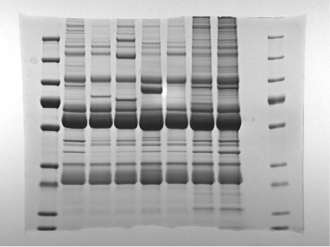
Original images acquired with the Odyssey CLx (Li-Cor) of representative immunoblots (cropped parts shown in Figure 1B) of Coomassie gel on brain lysates of mice brains incubated with patient-derived serum samples. M = Thermo Scientific™ PageRuler™ Plus Prestained Protein Ladder, 10 bis 250 kDa.
Related to Figure 1D:

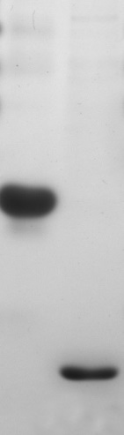
Coomassie neg. ctr commercial anti-CN1A Pat #1 Pat #3
Original images acquired with the Odyssey CLx (Li-Cor) of representative immunoblots (cropped parts shown in Figure 1A) of immunoblots on human Drebrin protein incubated with patient-derived serum samples.
M = Thermo Scientific™ PageRuler™ Plus Prestained Protein Ladder, 10 bis 250 kDa.

Related to Figure 1E:

M Pat #1 neg Pat
Pat #3

Original images acquired with the Odyssey CLx (Li-Cor) of representative immunoblots (cropped parts shown in Figure 1A) of immunoblots on human Drebrin protein incubated with patient-derived CSF samples. Please note: As the blots are incubated with individual serum, these blots must be cut before incubation with the serum. M = Thermo Scientific™ PageRuler™ Plus Prestained Protein Ladder, 10 bis 250 kDa.

