Figure S1. Impact of HFD on metabolic parameters and inflammation in mice fed HFD for 8 weeks. (A) Indicates energy intake as kcal/kg of Chow(C) and HFD fed mice; (B) indicates body weight gain from T0 to 8 weeks; (C) indicates white adipose tissue mass in the two groups; (D), (E) and (F) indicate plasma levels of adiponectin, leptin and insulin, respectively. (G) and (H) indicate GT and ITT, respectively. Total RNAs were prepared from different tissues of mice fed Chow or HFD and subjected to RT-PCR using specific primers as indicated in the figures. (I), (J) and (K) indicate the expression levels of SOCS3 and PTP1B in liver, muscle and adipose tissue, respectively, in Chow and HFD mice. (L), (M), (N) and (O) indicate the expression levels of pro-inflammatory factors in liver, muscle, adipose tissue and hypothalamus, respectively, in Chow and HFD mice. Data are means ± SEM (n = 6-8). Significant difference at * P<0.05, ** P<0,01 and *** P<0,001.

Figure S2. Resistin treatment upregulates NPY and downregulates POMC in the hypothalamus of mouse.
Quantification by RT-qPCR of NPY (A) and POMC (B) in the hypothalamus of wild type and TLR4^{-/-} (TLR4-KO) mice in response to three days resistin or placebo ICV treatment. Data are means ± SEM (n = 6). Significant difference at *** P<0,001.

Fig.S3
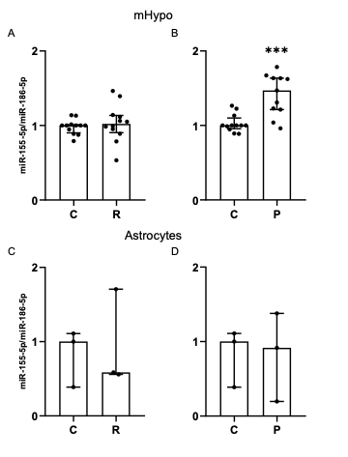
Figure S3: Resistin does not increase miR-155-5p expression in mHypo neuronal cell line nor astrocytes. mHypo neuronal cell line (A and B) and primary cultured mice astrocytes (C and D) were treated with placebo, resistin, or palmitate for 16 hours. Then, miR155-5p expression was measured by RT-qPCR and normalized to miR-186-5p. Data are median with interquartile range (n = 3 independent experiments, experiments were performed with 3 technical replicates for mHypo and 3 technical replicates for astrocyte primary culture). Significant difference at *** p<0,001.

Fig. S4

Males
Females

Figure S4. Schema showing biological process of the identified miR-155-5p targets (listed in table S3) using ShinyGO 0.82 (STRING 2.0) software.

Fig.S5

C

Figure S5. Validation of miR-155-5p knockdown and co-localization with IBA1-positive microglia.
(A) miRscope was used to detect and quantify miR-155-5p expression in the arcuate nucleus of miR-155-5p^loxP/loxPmice fed a high-fat diet (HFD) and treated with either control AAV8 or AAV8-Cre. miR-155-5p is shown in red, and nuclei are counterstained with DAPI (blue).
(B) Quantification of miR-155-5p puncta per surface unit. p < 0.05.
(C) Co-localization of miR-155-5p (green, detected by miRscope) with IBA1-positive microglia (red, detected by RNAscope using IBA1-specific probes). DAPI (blue) marks nuclei.

Table S1-1. Table extracted from the miRnome of mouse hypothalamus: Wild-type (WT, treated by ICV with placebo, WT Resistin (wild type treated by ICV with resistin), TLR-4KO (treated by ICV with placebo), and TLR-4KO Resistin (treated by ICV with resistin).

miRNA Name | WT Placebo | WT Resistin | TLR-4KO Placebo | TLR-4 KO Resistin
mmu-miR-7087-5p | 1 | 18.03 | 1.00 | 1.00
mmu-miR-3963 | 1 | 6.45 | 1.00 | 1.00
mmu-miR-21a-3p | 1 | 6.08 | 1.00 | 1.00
mmu-miR-8101 | 1 | 5.92 | 1.00 | 1.00
mmu-miR-155-5p | 1 | 5.81 | 1.00 | 1.00
mmu-mir-6240-3p_novel | 1 | 4.67 | 1.00 | 10.87
mmu-miR-1291 | 1 | 4.63 | 1.00 | 1.00
mmu-miR-2137 | 1 | 3.77 | 1.00 | 1.00
mmu-miR-5099 | 1 | 3.27 | 1.00 | 1.00
mmu-miR-146a-5p | 1 | 3.02 | 1.00 | 2.22
mmu-miR-6937-5p | 1 | 0.14 | 1.00 | 1.00
mmu-miR-29b-1-5p | 1 | 0.03 | 1.00 | 1.00
mmu-miR-96-5p | 1 | 1.00 | 2065.11 | 1.00
mmu-miR-183-5p | 1 | 1.00 | 1101.91 | 1.00
mmu-miR-211-5p | 1 | 1.00 | 529.92 | 1.00
mmu-miR-184-3p | 1 | 1.00 | 247.15 | 1.00
mmu-miR-182-5p | 1 | 1.00 | 146.73 | 1.00
mmu-miR-122-5p | 1 | 1.00 | 54.47 | 1.00
mmu-miR-6240 | 1 | 1.00 | 1.00 | 329.05
mmu-miR-6238 | 1 | 1.00 | 1.00 | 211.64
mmu-miR-3963 | 1 | 1.00 | 1.00 | 6.82
mmu-miR-141-3p | 1 | 1.00 | 1.00 | 5.38
mmu-miR-99a-5p | 1 | 1.00 | 1.00 | 2.85
mmu-miR-124-3p | 1 | 1.00 | 1.00 | 2.76
mmu-miR-30a-5p | 1 | 1.00 | 1.00 | 2.47
mmu-miR-5106 | 1 | 1.00 | 1.00 | 0.11
mmu-miR-7049-5p | 1 | 1.00 | 1.00 | 0.09

Table S2. Targets of miR-155-5p identified by HITS-CLIP in SIMA9 microglia cell line.

Geneid
ENSMUSG00000000317 | Bcl6b
ENSMUSG00000022311 | Csmd3
ENSMUSG00000024201 | Kdm4b
ENSMUSG00000026971 | Itgb6
ENSMUSG00000027965 | Olfm3
ENSMUSG00000040725 | Hnrnpul1
ENSMUSG00000045095 | Magi1
ENSMUSG00000046500 | Tafa4
ENSMUSG00000049252 | Lrp1b
ENSMUSG00000085779 | Atcayos
ENSMUSG00000033420 | Antxr1
ENSMUSG00000029338 | Antxr2
ENSMUSG00000041112 | Elmo1
ENSMUSG00000048249 | Crebrf
ENSMUSG00000027189 | Trim44
ENSMUSG00000059173 | Pde1a
ENSMUSG00000062078 | Qk
ENSMUSG00000063052 | Lrrc39

Table S3. Targets of miR-155-5p identified by HITS-CLIP in the hypothalamus of male and female mice.

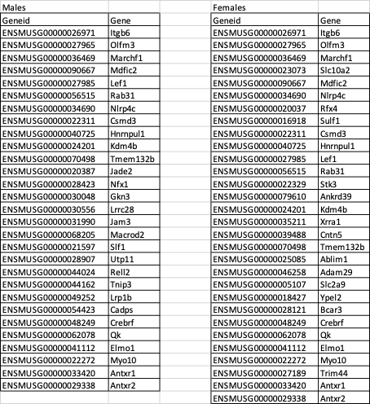

Table S4. List and sequence of the used primers.

