Table S1: Micromon quality control report for distal colon
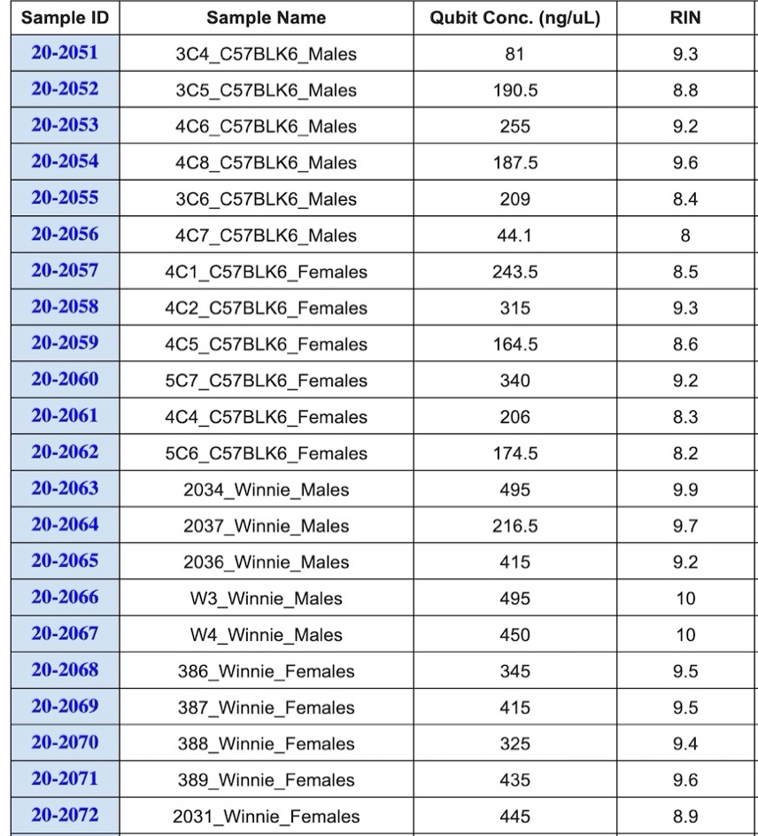
Table S2: Micromon quality control report for midbrain
Sample ID | Sample Name | Qubit Conc. (ng/uL) | RIN
21-0138 | BL6M1 | 850 | 8.6
21-0139 | BL6M2 | 820 | 9.3
21-0140 | BL6M3 | 590 | 9.1
21-0141 | BL6M4 | 610 | 8.9
21-0142 | BL6M5 | 660 | 8.4
21-0143 | BL6F1 | 790 | 9.5
21-0144 | BL6F2 | 790 | 9.1
21-0145 | BL6F3 | 710 | 9.3
21-0146 | BL6F4 | 700 | 8.9
21-0147 | BL6F5 | 820 | 9.2
21-0148 | WinneM1 | 750 | 8.9
21-0149 | WinneM2 | 790 | 9
21-0150 | WinneM3 | 640 | 8.9
21-0151 | WinneM4 | 890 | 8.7
21-0152 | WinneM5 | 780 | 8.7
21-0153 | WinnieF13 | 820 | 9.3
21-0154 | WinnieF14 | 810 | 9.2
21-0155 | WinnieF15 | 770 | 8.8
21-0156 | WinnieF16 | 690 | 9.1
21-0157 | WinnieF17 | 750 | 8.8

