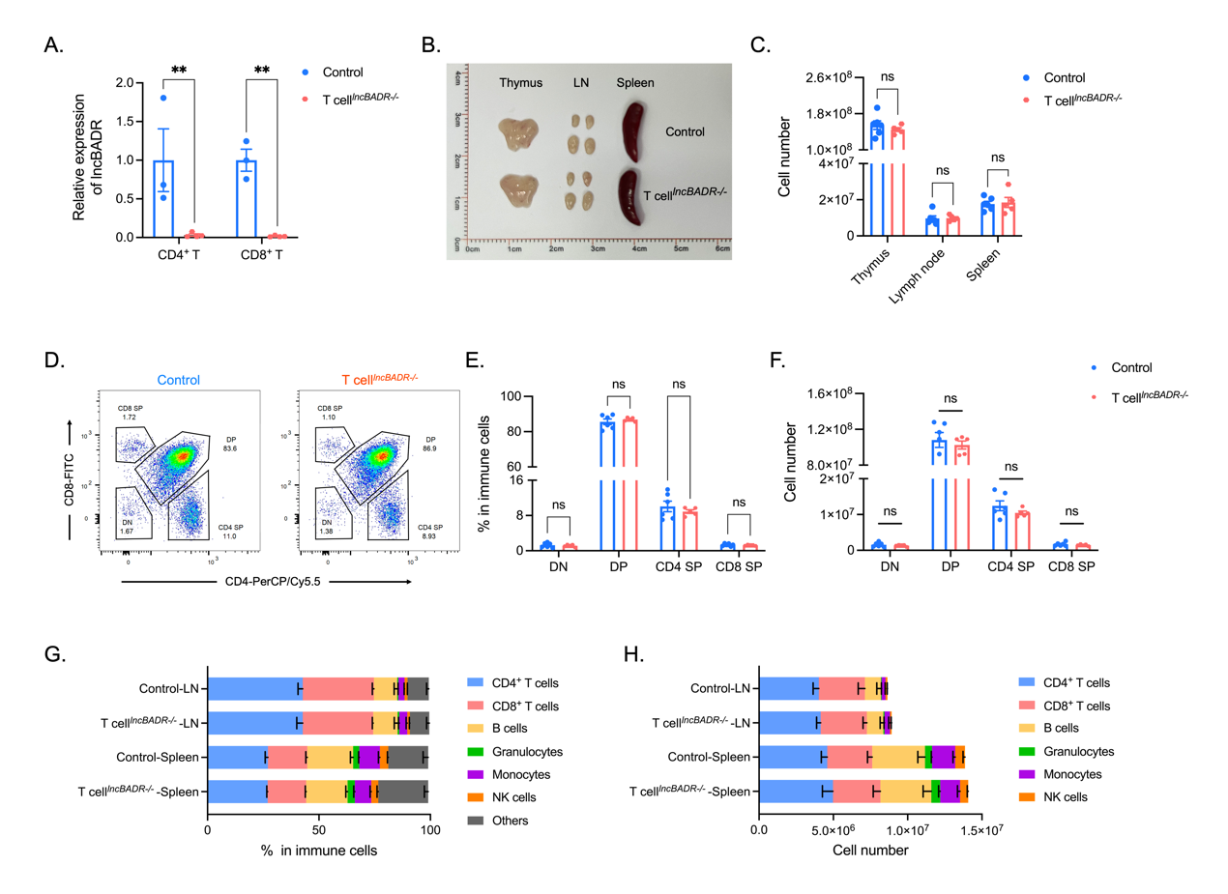Supplementary Fig. 1. The impact of lncBADR in the development of immune organs and immune cells. (A) RT-PCR validation of lncBADR knockout in CD4⁺ T and CD8⁺ T cells (n = 3 or 4). (B) Size and (C) total cell numbers of the thymus, lymph nodes, and spleen in control and T cell^{lncBADR-/-} mice (n = 5 or 6). (D to F) Relative percentages and cell numbers of CD4⁻ CD8⁻ (DN), CD4⁺ CD8⁺ (DP), CD4⁺ (CD4 SP), and CD8⁺ (CD8 SP) cells in the thymus (n = 5 or 6). (G) Relative percentages and (H) cell numbers of CD4⁺ T cells, CD8⁺ T cells, B cells, granulocytes, monocytes and NK cells in the lymph nodes and spleen of control and T cell^{lncBADR-/-} mice (n = 5 or 6). Statistical analysis was performed using two-way ANOVA, ns: not significant.

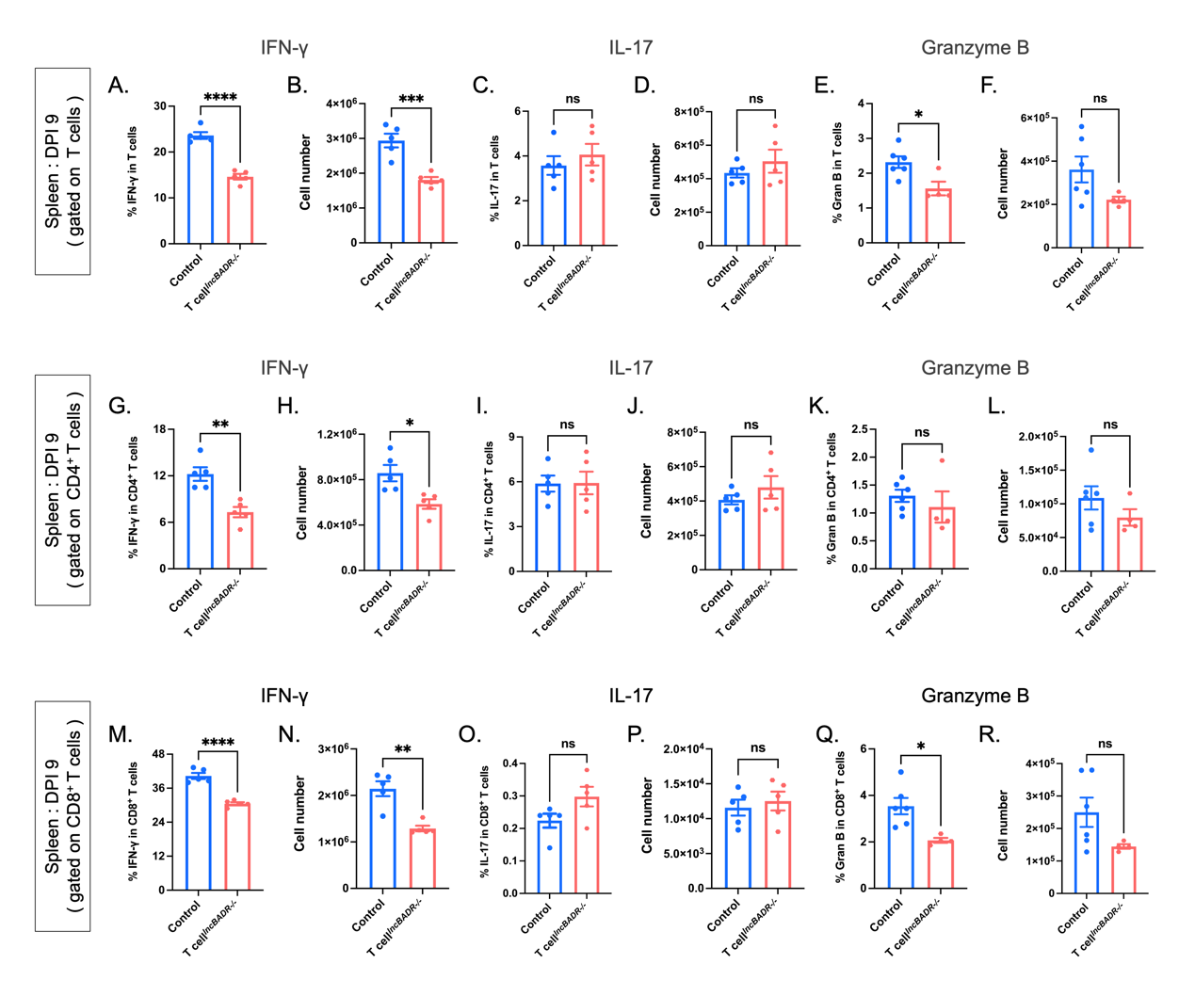
Supplementary Fig. 2. Effect of lncBADR deletion on T cell effector function in vivo during EAE. (A to F) Analysis of IFN-γ⁺, IL-17⁺, and Granzyme B⁺ cells gated on T cells in the spleen 9 days after EAE induction. (A) Relative percentage and (B) cell number of IFN-γ⁺ T cells (n = 5). (C) Relative percentage and (D) cell number of IL-17⁺ T cells (n = 5). (E) Relative percentage and (F) cell number of Granzyme B⁺ T cells (n = 4 or 6). (G to L) Analysis of IFN-γ⁺, IL-17⁺ and Granzyme B⁺ cells gated on CD4⁺ T cells in the spleen 9 days after EAE induction. (G) Relative percentage and (H) cell number of IFN-γ⁺ CD4⁺ T cells (n = 5). (I) Relative percentage and (J) cell number of IL-17⁺ CD4⁺ T cells (n = 5). (K) Relative percentage and (L) cell number of Granzyme B⁺ CD4⁺ T cells (n = 4 or 6). (M to R) Analysis of IFN-γ⁺, IL-17⁺ and Granzyme B⁺ cells gated on CD8⁺ T cells in the spleen 9 days after EAE induction. (M) Relative percentage and (N) cell number of IFN-γ⁺ CD8⁺ T cells (n = 5). (O) Relative percentage and (P) cell number of IL-17⁺ CD8⁺ T cells (n = 5). (Q) Relative percentage and (R) cell number of Granzyme B⁺ CD8⁺ T cells (n = 4 or 6). Statistical analysis was performed using t-test. *P < 0.05, **P < 0.01, ***P < 0.001, ****P < 0.0001, ns: not significant.

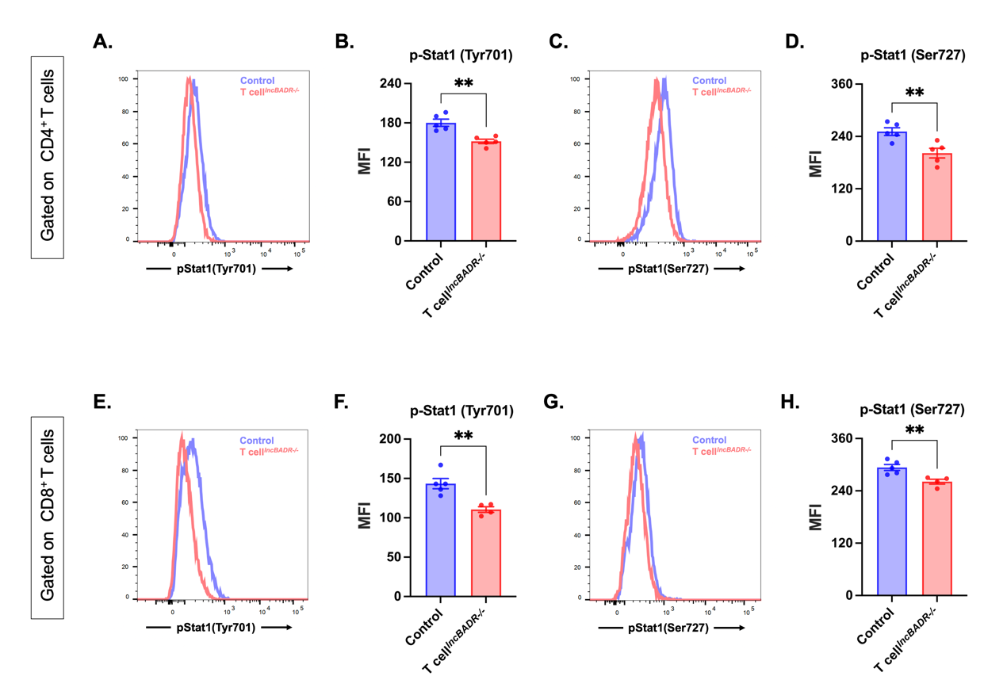
Supplementary Fig. 3. Deletion of lncBADR affects Stat1 phosphorylation in CD4⁺ T and CD8⁺ T cells. (A to G) T cells from mice were stimulated with anti-CD3(2.5 μg/ml) + anti-CD28(2.5 μg/ml) + IL-2(30 U/ml) for 48 hours. (A and B) Mean fluorescence intensity of p-Stat1 (Tyr701) gated on CD4⁺ T cells (n = 5). (C and D) Mean fluorescence intensity of p-Stat1 (Ser727) gated on CD4⁺ T cells (n = 5). (E and F) Mean fluorescence intensity of p-Stat1 (Tyr701) gated on CD8⁺ T cells (n = 4 or 5). (G and H) Mean fluorescence intensity of p-Stat1 (Ser727) gated on CD8⁺ T cells (n = 4 or 5). Statistical analyses were performed using t-tests. **P < 0.01.

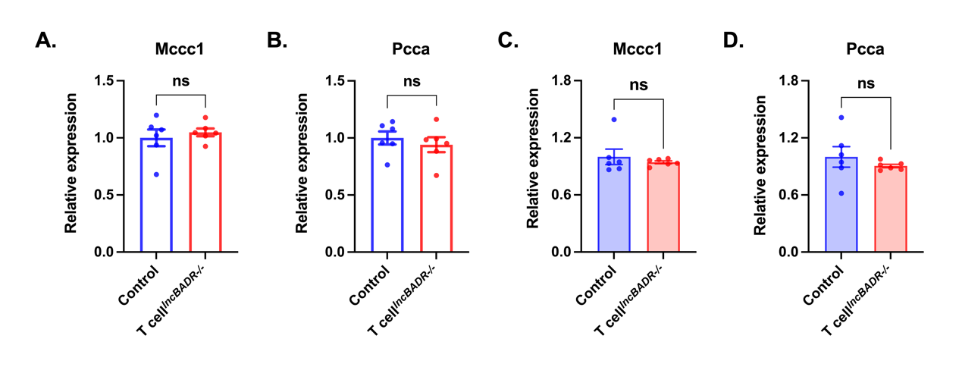
Supplementary Fig. 4. Effect of lncBADR deletion on Mccc1 and Pcca mRNA levels in T cells during EAE and in vitro. (A and B) Relative mRNA levels of Mccc1 and Pcca in T cells isolated from lymph nodes of control and T cell^{lncBADR-/-} mice 10 days post EAE induction (n = 6). (C and D) Relative mRNA levels of Mccc1 and Pcca in T cells stimulated in vitro with anti-CD3 (2.5 μg/ml) + anti-CD28 (2.5 μg/ml) + IL-2 (30 U/ml) for 48 hours (n = 6). Statistical analyses were performed using t-tests. ns: not significant.

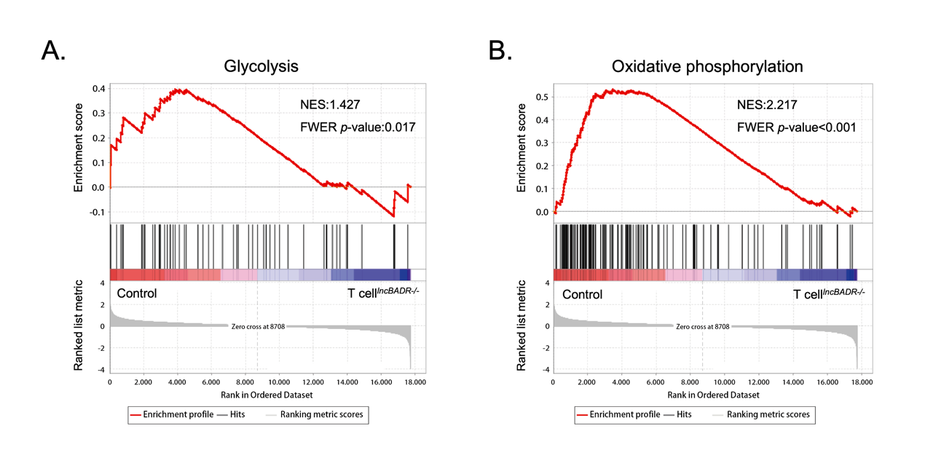
Supplementary Fig. 5. The impact of lncBADR on T cell metabolism. (A and B) Gene set enrichment analysis of T cells isolated from control and T cell^{lncBADR-/-} mice.

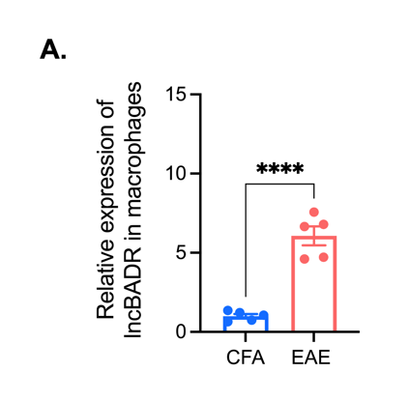
Supplementary Fig. 6. RT-PCR validation of lncBADR relative expression. (A) Relative expression of lncBADR in splenic F4/80⁺ macrophages 10 days post EAE induction (n = 5). Statistical analysis was performed using t-test. ****P < 0.0001.

Supplementary Table 1
﻿Major reagents | ﻿Source | Identifier
Fixable Viability Dye eFluor™ 780 | ﻿Thermo Fisher Scientific | 00-4975-93
APC anti-mouse CD3 Antibody | BioLegend | 100236
FITC anti-mouse CD4 Antibody | BioLegend | 100405
PerCP/Cyanine5.5 anti-mouse CD4 Antibody | BioLegend | 116011
FITC anti-mouse CD8a Antibody | BioLegend | 100706
PerCP/Cyanine5.5 anti-mouse CD8 Antibody | BioLegend | 100733
PE anti-mouse CD8 Antibody | BioLegend | 100708
PerCP/Cyanine5.5 anti-mouse/human CD45R/B220 Antibody | BioLegend | 103236
APC anti-mouse/human CD11b Antibody | BioLegend | 101212
PE anti-mouse Ly-6G Antibody | BioLegend | 127607
BD Pharmingen™ PerCP-Cy™5.5 Rat Anti-Mouse Ly-6G and Ly-6C | BD Biosciences | 552093
PE anti-mouse NK-1.1 Antibody | BioLegend | 108707
FITC anti-mouse CD69 Antibody | BioLegend | 104505
PE anti-mouse CD25 Monoclonal Antibody | eBioscience | 12-0251-83
PE/Cyanine7 anti-mouse/human CD44 Antibody | BioLegend | 103030
APC anti-mouse CD62L Antibody | BioLegend | 104412
PerCP rat anti-mouse CD45 | BD Biosciences | 557235
PE/Cyanine7 anti-mouse Ki-67 Antibody | BioLegend | 652425
APC anti-mouse FOXP3 Monoclonal Antibody | eBioscience | 17-5773-82
PE/Cyanine7 anti-mouse Granzyme B Monoclonal Antibody | eBioscience | 25-8898-82
PE anti-mouse IFN-γ Antibody | BioLegend | 505807
PE/Cyanine7 anti-mouse IFN-γ Antibody | BioLegend | 505826
APC anti-mouse IL-17A Antibody | BioLegend | 506916
Phospho-Stat1 (Tyr701) Recombinant Rabbit Monoclonal Antibody (Stat1Y701-3E6), FITC | Invitrogen | MA5-37306
PE anti-STAT1 Phospho (Ser727) Antibody | BioLegend | 686403
PerCP/Cyanine5.5 anti-mouse CD3 Antibody | BioLegend | 100217
PE/Cyanine7 anti-mouse F4/80 Antibody | BioLegend | 123113
CellTrace™ CFSE Cell Proliferation Kit | Invitrogen | C34554
Annexin V-FITC/PI apoptosis assay kit | absin | abs50001
Phospho-mTOR (Ser2448) (D9C2) XP® Rabbit mAb | CST | 5536T
Phospho-p70 S6 Kinase (Thr389) (108D2) Rabbit mAb | CST | 9234T
Phospho-Stat1 (Tyr701) (58D6) Rabbit mAb | CST | 9167S
Phospho-Stat1 (Ser727) (D3B7) Rabbit mAb | CST | 8826S
β-Actin (8H10D10) Mouse mAb | CST | 3700S
BD Cytofix/Cytoperm™ Fixation/Permeabilization Kit | BD Biosciences | 554714
Foxp3 / Transcription Factor Staining Buffer Set | eBioscience | 00-5523-00
L-Leucine | Sigma-Aldrich | L8912
L-Isoleucine | Sigma-Aldrich | I7403
L-Valine | Sigma-Aldrich | V0513
Branched Chain Amino Acid Assay | abcam | ab83374
Transcriptor First Strand cDNA Synthesis Kit | Roche | 0489686601
MojoSort™ Mouse CD3 T Cell Isolation Kit | BioLegend | 480024
Ultra-LEAF™ Purified anti-mouse CD3ε Antibody | BioLegend | 100340
Ultra-LEAF™ Purified anti-mouse CD28 Antibody | BioLegend | 102116
Mouse IL-2 Recombinant Protein, PeproTech® | Gibco | 212-12-20
EasySep™ Mouse F4/80 Positive Selection Kit | STEMCELL Technologies | 100-0659
NeonTM Transfection System 100 μL Kit | Thermo Fisher Scientific | MPK10025

