Supplemental Material
For

IL-1β⁺ tumor-associated macrophages accelerate glioblastoma progression by amplifying the PGE2-EP4 signaling
Hao Liang, et al.

Corresponding authors:
Yong Zhang, zhangyongsey@163.com
Hui Peng, hpeng392@163.com

The PDF file includes:
Supplementary Figures 1-5
Supplementary Table 1
Fig.S1
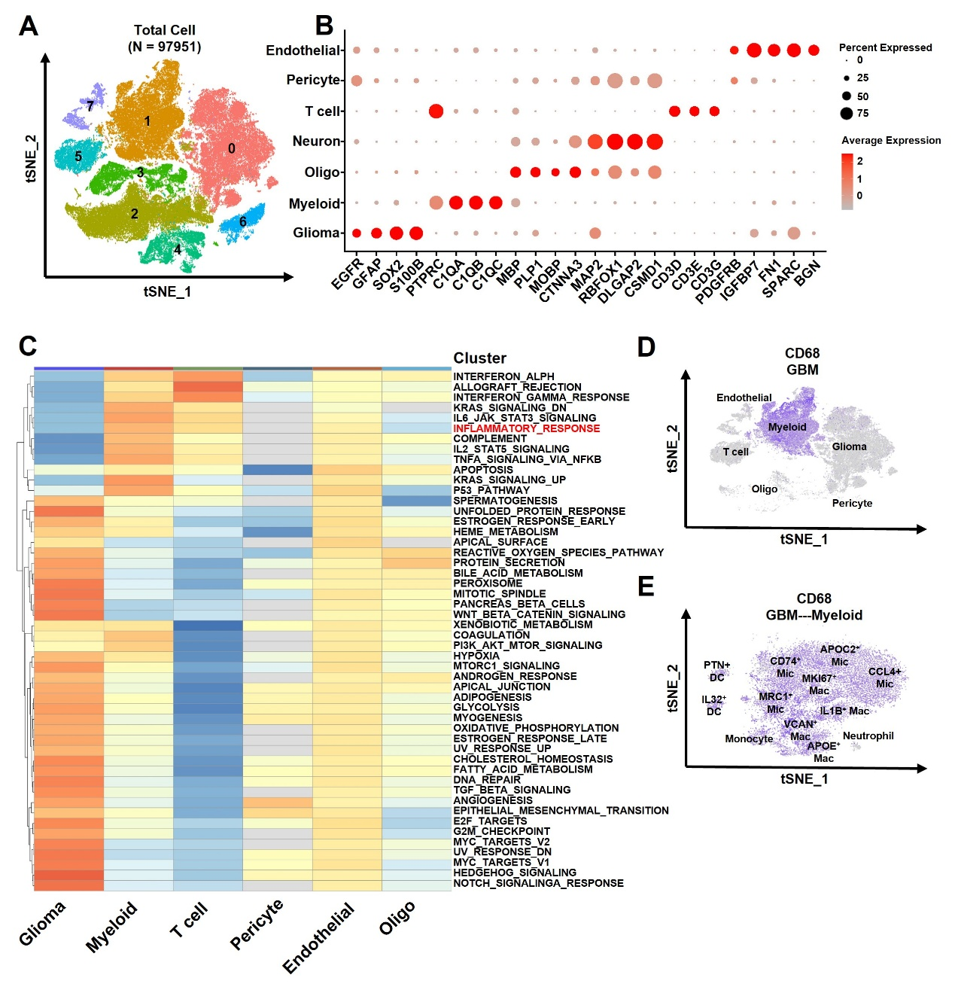
Fig. S1. Single-cell RNA sequencing analysis highlights differences in the microenvironment between normal human brain tissues and GBM patient tissues. (A) t-SNE plots from unsupervised clustering analysis of single-cell RNA sequencing data from normal brain tissues and GBM patient tissues. Colors and numbers represent different cell clusters. (B) Bubble plot showing marker gene expression for seven distinct cell types identified by single-cell sequencing. The size of the circles represents the percentage of cells expressing the gene, and the color intensity indicates the expression level of the gene within the cluster. (C) Heatmap of Gene Set Enrichment Analysis (GSEA) for hallmark pathways in six cell clusters from GBM patients (n=9). Colors represent the enrichment score of each pathway in different cell clusters. (D-E) Expression distribution of CD68 in myeloid cell clusters from single-cell RNA sequencing data of GBM patients.
Fig.S2
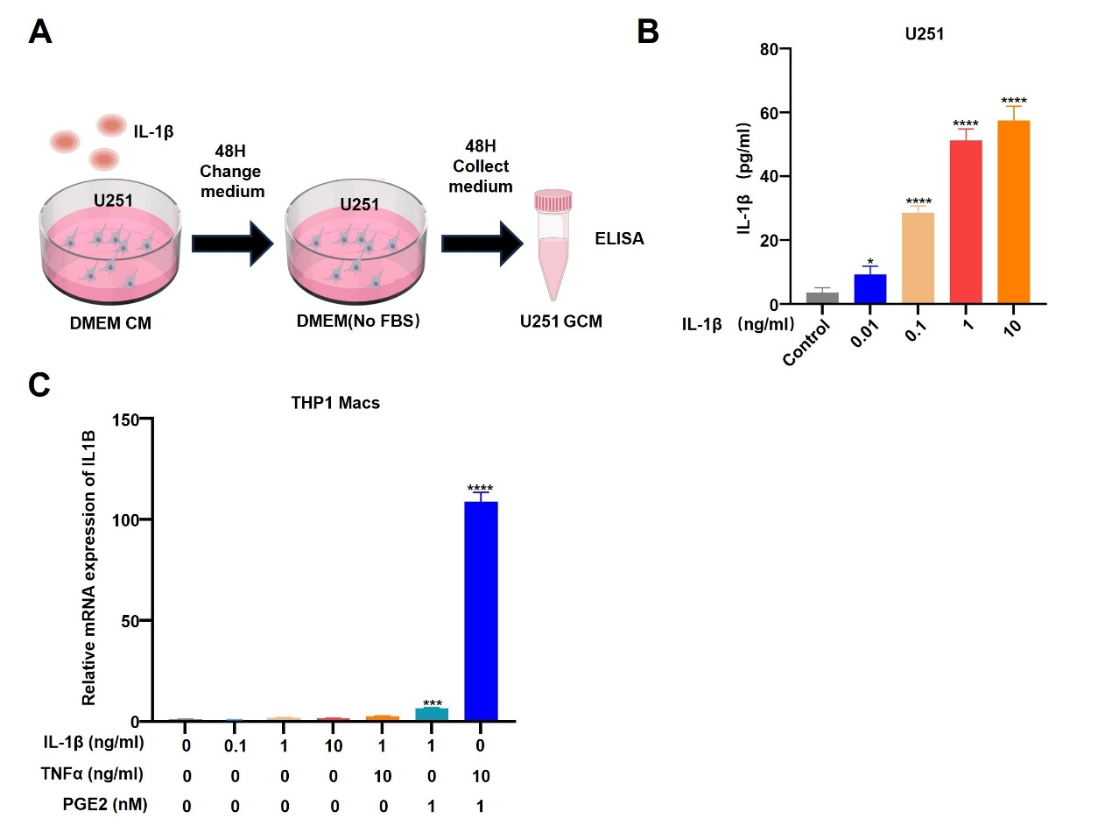
Fig. S2. PGE2 and TNFα, not IL-1β secreted by GBM cells, collaboratively induce the IL-1β⁺ macrophage phenotype. (A) Workflow for collecting GCM from U251 cells treated with or without IL-1β stimulation. (B) ELISA was used to detect the expression level of IL-1β protein in tumor supernatants after U251 cells were stimulated with different concentrations of IL-1β. (C) RT-PCR was performed to detect IL1B expression in THP1 Macs treated with various concentrations of IL1β, and/or PGE2/TNFα for 24 hours (Data are shown as the Mean ± SEM. *p < 0.05,***p < 0.001, ****p < 0.0001).

Fig.S3
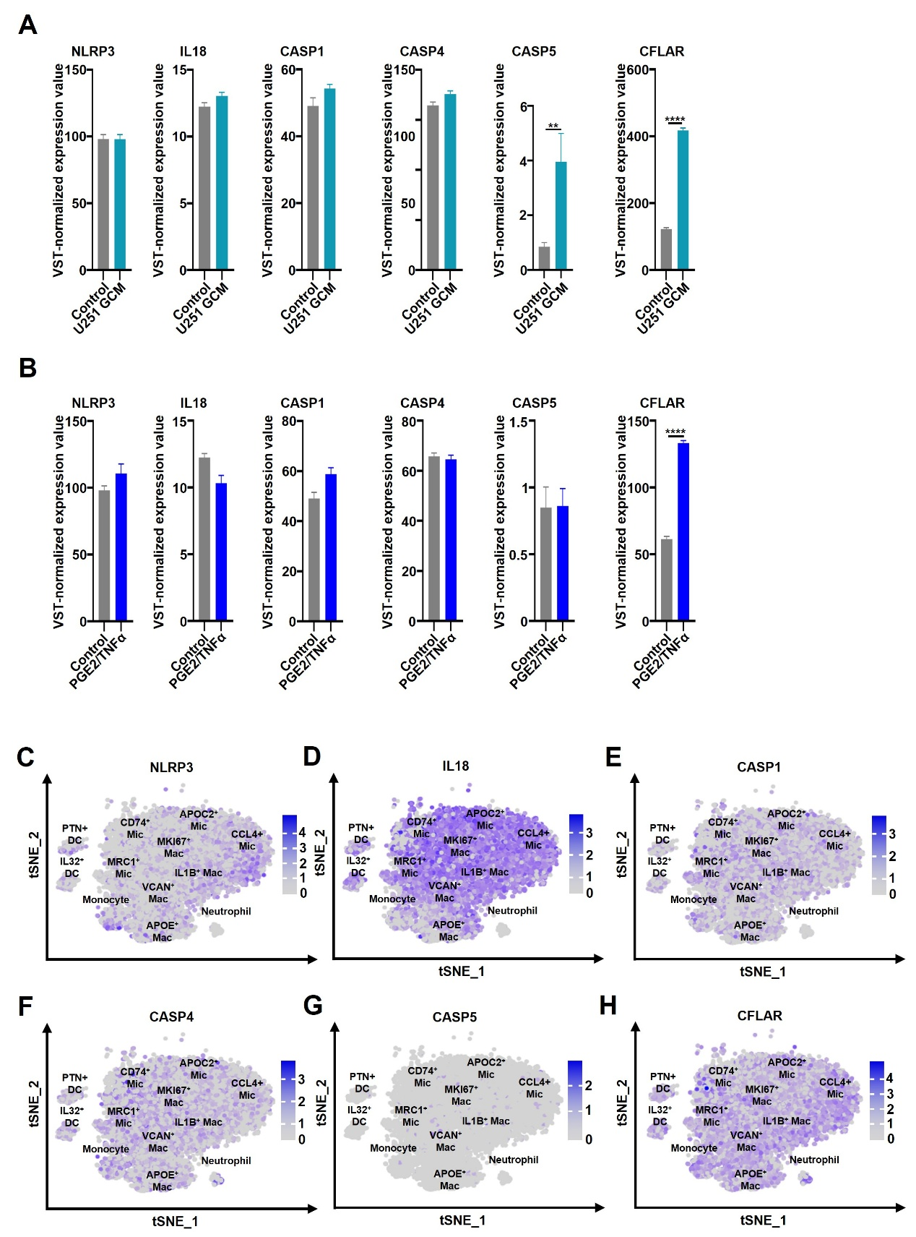
Fig. S3. Analysis of inflammasome-related gene expression in macrophages using transcriptome and single-cell sequencing. (A-B) Bulk RNA-seq analysis of THP1 Macs treated with GCM or PGE2/TNFα showed that CASP5 upregulation by GCM and CFLAR induction by GCM or PGE₂/TNFα. (Data are shown as the Mean ± SEM. **p < 0.01, ****p < 0.0001). (C-H) Expression profiles of key inflammasome-related genes in myeloid cell populations from nine GBM patients.
Fig.S4
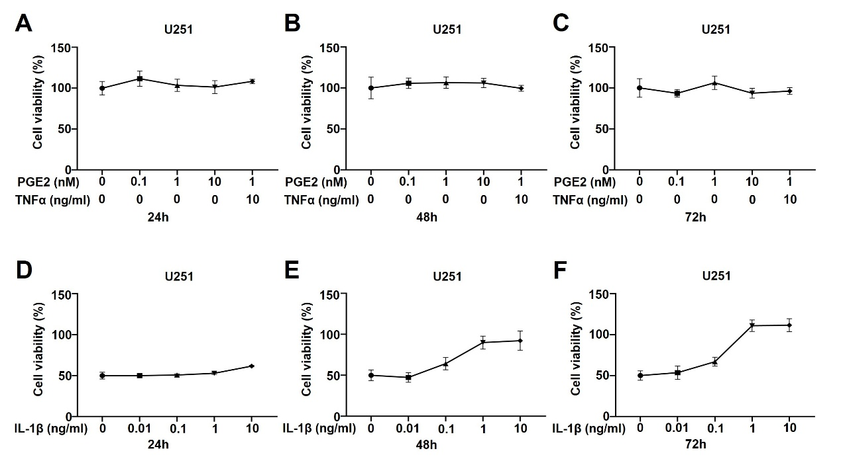
Fig. S4. Proliferation of U251 cells following PGE2/TNFα or IL-1β stimulation at different time points. (A-C) CCK-8 assay measuring U251 cell proliferation after stimulation with varying concentrations of PGE₂/TNFα for 24, 48, and 72 h. (D-F) CCK-8 assay measuring U251 cell proliferation after stimulation with varying concentrations of IL-1β for 24, 48, and 72 h.
Fig.S5
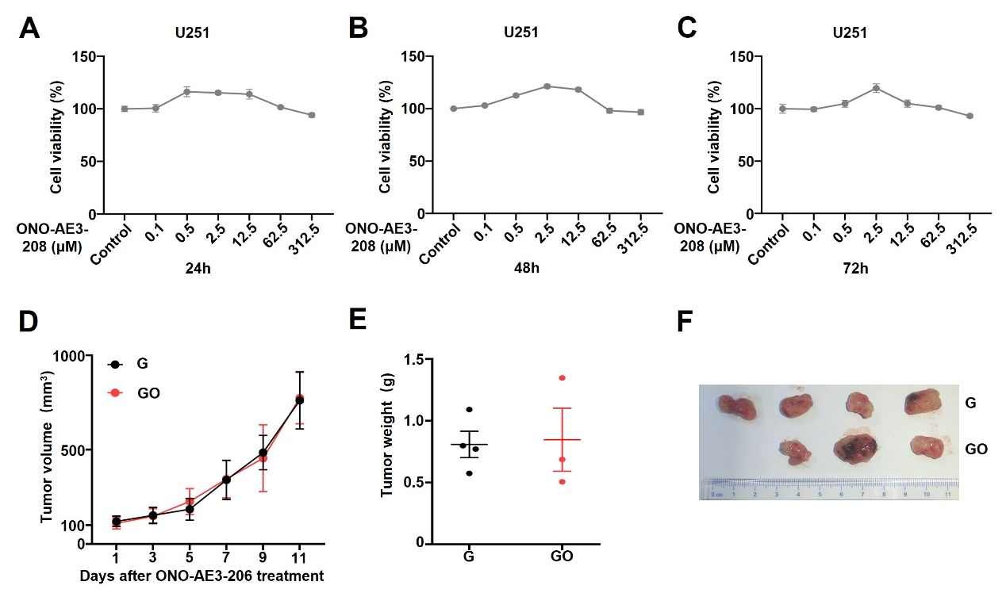
Fig. S5. Effect of EP4 receptor antagonist (ONO-AE3-208) on U251 cell proliferation and tumor progression. (A-C) The impact of various concentrations of ONO-AE3-208 on U251 cell proliferation was evaluated in vitro over multiple time points. (D–F) A subcutaneous xenograft model was created by injecting 5 × 10⁶ U251 cells into BALB/c nude mice. Once tumors reached ~100 mm³, mice were randomly divided into two groups: control (G) and treatment (GO). The treatment group received daily intraperitoneal injections of ONO-AE3-208 (10 mg/kg). Tumor volume was measured every two days using the formula: (length × width²)/2. (D) Tumor growth curves comparing treated mice (Group GO, n = 3) to untreated controls (Group G, n = 4). (E) Final tumor weights in both groups (n = 3–4). (F) Tumor images collected at the experimental endpoint.

Table S1 Primer list
Name | Primer
Human IL1B-F | ATGATGGCTTATTACAGTGGCAA
Human IL1B-R | GTCGGAGATTCGTAGCTGGA
Human PTGS2-F | CTGGCGCTCAGCCATACAG
Human PTGS2-R | CGCACTTATACTGGTCAAATCCC
Human TNFA-F | CTCTTCTGCCTGCTGCACTTTG
Human TNFA-R | ATGGGCTACAGGCTTGTCACTC
Human PTGER1-F | AGCTTGTCGGTATCATGGTGG
Human PTGER1-R | AAGAGGCGAAGCAGTTGGC
Human PTGER2-F | CGATGCTCATGCTCTTCGC
Human PTGER2-R | GGGAGACTGCATAGATGACAGG
Human PTGER3-F | CGCCTCAACCACTCCTACAC
Human PTGER3-R | GACACCGATCCGCAATCCTC
Human PTGER4-F | CCGGCGGTGATGTTCATCTT
Human PTGER4-R | CCCACATACCAGCGTGTAGAA
Human IL6-F | ACTCACCTCTTCAGAACGAATTG
Human IL6-R | CCATCTTTGGAAGGTTCAGGTTG
Human CSF3-F | GCTGCTTGAGCCAACTCCATA
Human CSF3-R | GAACGCGGTACGACACCTC
Human CEBPB-F | AGAAGACCGTGGACAAGCACAG
Human CEBPB-R | CTCCAGGACCTTGTGCTGCGT

