Supplemental Methods and Results
CT scoring of brain injury
Brain CT data of patients were collected within 24 hours after TBI. CT scans were scored using the Rotterdam CT scoring system with the following scoring items: 1) basal cistern status was classified as normal, score 0, compressed score 1, or absent score 2; 2) midline shift was classified as 0–5 mm score 0 or > 5 mm score 1; 3) epidural hematoma was classified as present score 0 or absent score 1; and 4) traumatic subarachnoid hemorrhage or/and intraventricular hemorrhage was classified as absent score 0 or present score 1 ^{[1]}. Scores of each item were summed up to obtain the total CT score for brain injury.
CT scoring of lung injury
The pulmonary CT scans were graded on 1 to 6 scale based on the classification by Ichikado scoring system ^{[2]}. Areas with 1 normal attenuation, 2 ground-glass attenuation, 3 consolidation, 4 ground-glass attenuation with traction bronchiolectasis or bronchiectasis, 5 consolidation with traction bronchiolectasis or bronchiectasis, and 6 honeycombing. The extent of involvement of each abnormality was assessed independently for each of three zones of each lung. The CT score in upper, middle, and lower lung zones of each lung was determined by visually estimating the extent of disease in each zone. The score was based on the percentage of lung parenchyma that showed evidence of abnormality and estimated to be the nearest 10% of parenchymal involvement. Each abnormal score was calculated by multiplying the extent of involvement by each grading score. For each index, we drew up an average score of the six lung zones for each patient, and then the overall CT score was obtained by adding the averages for each index.
Flow cytometry
Flow cytometry (LSR II, Beckon Dickinson, San Jose, CA) was used to detect: (1) mice BM and its differentiated cells. Briefly, Mice samples were stained with the following antibodies for 30 min at 4℃. BM sample of mice were incubated with Brilliant Violet 421™ anti-mouse Lineage Cocktail (Biolegend), Brilliant Violet 650™ anti-mouse CD117 (c-kit) antibody (Biolegend), Brilliant Violet 510™ anti-mouse Ly-6A/E (Sca-1) antibody (Biolegend), APC anti-mouse CD48 antibody (Biolegend) and PE/Cyanine7 anti-mouse CD150 (SLAM) antibody (Biolegend) for detecting HSC; Brilliant Violet 421™ anti-mouse Lineage Cocktail (Biolegend), Brilliant Violet 650™ anti-mouse CD117 (c-kit) antibody (Biolegend), Brilliant Violet 510™ anti-mouse Ly-6A/E (Sca-1) antibody (Biolegend), PerCP/Cyanine5.5 anti-mouse CD34 antibody (Biolegend), FITC anti-mouse CD16/32 antibody (Biolegend) and APC anti-mouse CD115 (CSF-1R) antibody (Biolegend) to detect CMP, GMP and MDP; PE/Cyanine7 anti-mouse CD45 antibody (Biolegend), APC anti-mouse/human CD11b antibody (Biolegend), PerCP/Cyanine5.5 anti-mouse Ly6G antibody (Biolegend) for detecting neutrophil and monocyte/macrophage and Brilliant Violet 421™ anti-mouse Ly6c antibody (Biolegend) for distinguishing different phenotype of monocyte and macrophage. (2) Neutrophil and macrophage infiltration in mice brain. Mouse brain was harvested after perfusion with cold PBS, minced and incubated with collagenase IV at 37°C for 30 minutes. After PBS washing, myelin debris was removed by centrifugation in 30% Percoll (Cytiva), and the cell pellet was washed with PBS and resuspended in 1% BSA and incubated with PE/Cyanine7 anti-mouse CD45 antibody (Biolegend), APC anti-mouse/human CD11b antibody (Biolegend), FITC anti-mouse F4/80 antibody (Biolegend), Brilliant Violet 421™ anti-mouse Ly6C antibody (Biolegend) and PerCP/Cyanine5.5 anti-mouse Ly-6G antibody (Biolegend) for 30 minutes at 4℃ to identify neutrophil and macrophage. (3) Intracellular flow cytometry was performed to detect the expression of IL-1β. Briefly, cells were fixed in fixation buffer for 20 minutes after surface marker staining, washed with permeabilization buffer, stained with PE anti-mouse/human IL-1β antibody (eBioscience) for 45 minutes, washed again and resuspended in flow cytometry buffer. (4) Chimeric mice identification. BM from chimeric mice were incubated with PE anti-mouse CD45.1 Antibody (Biolegend) for 30 minutes at 4℃ to distinguish recipient mouse cells from donor mouse cells. (5) For lung cell isolation, lung vessels were perfused with 15 ml PBS via the right ventricle, followed by injection of 1 ml HBSS containing 0.5 UI/ml dispase II (Sigma-Aldrich), 0.1 mg/ml elastase (MedChemExpress), and 0.075 mg/ml DNAse (Sigma-Aldrich). Lungs were dissected and digested for 30 minutes at 37°C in the same enzyme solution, then minced and filtered through a 70 μm strainer. Red blood cells were lysed using RBC lysis buffer. After centrifugation, cells were resuspended in 1% BSA and incubated with PE/Cyanine7 anti-mouse CD45 antibody (Biolegend), APC anti-mouse/human CD11b antibody (Biolegend), FITC anti-mouse F4/80 antibody (Biolegend), Brilliant Violet 421™ anti-mouse SiglecF antibody (Biolegend) and PerCP/Cyanine5.5 anti-mouse Ly-6G antibody (Biolegend) for 30 minutes at 4℃ to identify neutrophil and macrophage. Flow cytometric data were analyzed with the FlowJo program 10.9.0 (Tree Star, Ashland, Oregon, USA).
Pulmonary function test
The pulmonary function test was conducted 1, 3, and 7 days post-TBI. Briefly, mice were anesthetized with isoflurane and then underwent tracheotomy. First, a tube was attached to the trachea and placed within a pressure sensor to monitor expiratory velocity (BoiLab Co., Ltd., Beijing, China). Second, changes in lung volume were evaluated according to the pressure variations in the plethysmographic chamber. The AniRes2005 animal lung function analytic system (Bestlab version 2.0, AniRes2005, China) was employed to detect lung function. Function parameters such as the total lung resistance (RL), lung outflow resistance (RE), and lung dynamic compliance (Cydn) were automatically measured.
Neurological deficits and Motor function assays
Mice were evaluated for neurological deficits 1, 3, and 7 days post-FPI using the modified neurological severity score (mNSS). We utilized a rodent treadmill (RWD Life Science, Shenzhen, China) to evaluate the motor coordination of the mice. Briefly, each mouse was placed on the Rota-Rod apparatus with the rotation speed accelerated from 4 to 40 revolutions RPM within 5 minutes. The time until each mouse fell off was recorded. All mice were pre-trained 3 days before the FPI. To ensure data reliability, each mouse underwent three trials per day at consistent speeds, with a 30 minutes interval between each trial. The average time for the mice to fall off was used for data analysis. For the corner turn test, mice were pre-trained 30 minutes before TBI. A mouse was placed between two boards at a 30° angle, facing the corner, and was observed the direction (left or right) in which they turn to exit. The preferred turning direction of each mouse at each corner instance was noted. The data were expressed as the average of 10 trials, with a 30 minutes rest between each trial.
Immunostaining
Brain and lung sections were collected 1 day after TBI. The brain and lung sections were rinsed, preincubated with 5% blocking serum in 0.3% Triton X-100 (Sigma) for 1 hour, and then incubated overnight at 4°C with following primary antibodies: Rat Anti-Mouse CD68 (1:200, Abcam), Anti-Mannose Receptor antibody (1:150, Abcam), Anti-CD68 (1:100, Abcam), Recombinant Anti-CD86 antibody (1:100, Abcam), CD68 antibody (1:200, Abcam), Anti-Mannose Receptor antibody (1:200, Abcam). After three rinses in PBS, brain and lung sections were then incubated with Alexa Fluor conjugated secondary antibodies (1:300, Abcam) overnight at 4°C. After three times rinses in PBS, the brain sections were mounted with a drop of 4′,6-diamidino-2-phenylindole (DAPI) Fluoromount-G mounting medium (Invitrogen). For brain immunostaining analyses, three coronal sections were randomly chosen, displaying the lesioned ipsilateral cortex and hippocampus. For lung immunostaining analyses, three regions were randomly chosen from each lung tissue section to count the number of triple-stained cells. The final average value was taken as the final cell count. The results were presented as the mean number of cells per mm2 for staining cells.
Anakinra administration
C57BL/6J mice were randomly assigned to receive intraperitoneal anakinra, 25 mg/kg, or an equal volume of sterile 0.9% saline after FPI. This dose regimen was chosen as previously report^{[3]}. Anakinra (Sobi; 67 mg/100 ml) was diluted in sterile 0.9% saline. First treatment (anakinra or saline) was initiated within 30 min after FPI, and ​administered via intraperitoneal injection every 12 hours​ until ​subsequent experimental procedures were performed.
Blood gas analyses
The blood samples underwent analysis to detect blood oxygen saturation (SpO₂). Specifically, the SpO₂ was measured using a blood-gas analyzer (ABL-800, manufactured by Radiometer in Copenhagen, Denmark) according to their procedures.
ReferenceS
[1] K. Fujimoto, M. Miura, T. Otsuka, J. Kuratsu, Sequential changes in Rotterdam CT scores related to outcomes for patients with traumatic brain injury who undergo decompressive craniectomy, JNS. 124 (2016) 1640–1645.
[2] K. Ichikado, M. Suga, N.L. Müller, H. Taniguchi, Y. Kondoh, M. Akira, T. Johkoh, N. Mihara, H. Nakamura, M. Takahashi, M. Ando, Acute Interstitial Pneumonia: Comparison of High-Resolution Computed Tomography Findings between Survivors and Nonsurvivors, Am J Respir Crit Care Med. 165 (2002) 1551–1556.
[3] E.A. Newell, B.P. Todd, J. Mahoney, A.A. Pieper, P.J. Ferguson, A.G. Bassuk, Combined Blockade of Interleukin-1α and -1β Signaling Protects Mice from Cognitive Dysfunction after Traumatic Brain Injury, eNeuro. 5 (2018) ENEURO.0385-17.2018.

Supplemental Table
Table S1: Basic Information of patients included in scRNA-seq.
 | Gender | Age (years) | GCS* before surgery | GCS before out of hospital | Time from injury to surgery | Mechanism of injury | Medical History | Medication
Control-1 | F | 47 | 15 | 15 | / | / | None | None
Control-2 | M | 34 | 15 | 15 | / | / | None | None
Control-2 | F | 50 | 15 | 15 | / | / | None | None
TBI-01 | M | 69 | 3 | 3+T | 5 hours | Road traffic accident | coronary heart disease | aspirin
TBI-02 | M | 50 | 5 | 9+T | 5 hours | Road traffic accident | hypertension,  stroke | aspirin
TBI-03 | M | 69 | 3 | 8+T | 3 hours | Fall injury | none | none
TBI-04 | M | 69 | 8 | 14 | 21 hours | Road traffic accident | coronary heart disease,  hypertension | aspirin
TBI-05 | M | 56 | 7 | 15 | 19 hours | Fall injury | none | none
TBI-06 | M | 22 | 6 | 15 | 19 hours | Road traffic accident | none | none
TBI-07 | F | 26 | 8 | 15 | 11 hours | Road traffic accident | none | none
TBI-08 | M | 33 | 8 | 15 | 11 hours | Fall injury | none | none
*GCS: Glasgow Coma Score.

Table S2: Basic information of patients of the second cohort.
 |  | Control (n=10) | TBI (n=27) | P value (Con. vs. TBI)
Demographics
Age, years, median (IQR (interquartile range)) |  | 50.5 (41-63) | 48.63 (39-69) | 0.7575
Sex, male, n (%) |  | 5 (50%) | 19 (70.4%) | 0.2613
Clinical features
GCS score before surgery, median (IQR) |  | 15 | 7.8 (5.5-9.5) | <0.0001
GCS score before out of hospital, median (IQR) |  | 15 | 12.3 (9.5-15) | 0.0408
Time from injury to surgery (hours), median (IQR) |  | N/A | 11 (5-21) | N/A
History of medications (aspirin or clopidogrel), n (%) |  | 0 (0%) | 7 (25.9%) | 0.0840
Mechanism of injury
Road traffic accident, n (%) |  | N/A | 14 (51.9%) | N/A
Fall injury, n (%) |  | N/A | 8 (29.6%) | N/A
Assault, n (%) |  | N/A | 5 (18.5%) | N/A
Medical history
Smoking, n (%) |  | 3 (30%) | 11 (40.7%) | 0.5625
Drinking, n (%) |  | 4 (40%) | 11 (40.7%) | 0.9686
Hypertension, n (%) |  | 3 (30%) | 9 (33.3%) | 0.7446
Diabetes, n (%) |  | 2 (20%) | 10 (37.0%) | 0.3724
Coronary heart disease, n (%) |  | 1 (10%) | 8 (29.6%) | 0.1889
stroke, n (%) |  | 1 (10%) | 7 (25.9%) | 0.3311

Table S3: The gene sets for cells for inflammation response.
ABCA1 | C5AR1 | CLEC5A | FFAR2 | IFNAR1 | IRF7 | MEP1A | P2RX7 | RHOG | SLC7A1
ABI1 | CALCRL | CMKLR1 | FPR1 | IFNGR2 | ITGA5 | MET | P2RY2 | RIPK2 | SLC7A2
ACVR1B | CCL17 | CSF1 | FZD5 | IL10 | ITGB3 | MMP14 | PCDH7 | RNF144B | SPHK1
ACVR2A | CCL2 | CSF3 | GABBR1 | IL10RA | ITGB8 | MSR1 | PDE4B | ROS1 | SRI
ADGRE1 | CCL20 | CSF3R | GCH1 | IL12B | KCNA3 | MXD1 | PDPN | RTP4 | STAB1
ADM | CCL22 | CX3CL1 | GNA15 | IL15 | KCNJ2 | MYC | PIK3R5 | SCARF1 | TACR1
ADORA2B | CCL24 | CXCL10 | GNAI3 | IL15RA | KCNMB2 | NAMPT | PLAUR | SCN1B | TACR3
ADRM1 | CCL5 | CXCL11 | GP1BA | IL18 | KIF1B | NDP | PROK2 | SELE | TAPBP
AHR | CCL7 | CXCL6 | GPC3 | IL18R1 | KLF6 | NFKB1 | PSEN1 | SELENOS | TIMP1
APLNR | CCR7 | CXCL8 | GPR132 | IL18RAP | LAMP3 | NFKBIA | PTAFR | SELL | TLR1
AQP9 | CCRL2 | CXCL9 | GPR183 | IL1A | LCK | NLRP3 | PTGER2 | SEMA4D | TLR2
ATP2A2 | CD14 | CXCR6 | HAS2 | IL1B | LCP2 | NMI | PTGER4 | SERPINE1 | TLR3
ATP2B1 | CD40 | CYBB | HBEGF | IL1R1 | LDLR | NMUR1 | PTGIR | SGMS2 | TNFAIP6
ATP2C1 | CD48 | DCBLD2 | HIF1A | IL2RB | LIF | NOD2 | PTPRE | SLAMF1 | TNFRSF1B
AXL | CD55 | EBI3 | HPN | IL4R | LPAR1 | NPFFR2 | PVR | SLC11A2 | TNFRSF9
BDKRB1 | CD69 | EDN1 | HRH1 | IL6 | LTA | OLR1 | RAF1 | SLC1A2 | TNFSF10
BEST1 | CD70 | EIF2AK2 | ICAM1 | IL7R | LY6E | OPRK1 | RASGRP1 | SLC28A2 | TNFSF15
BST2 | CD82 | EMP3 | ICAM4 | INHBA | LYN | OSM | RELA | SLC31A1 | TNFSF9
BTG2 | CDKN1A | EREG | ICOSLG | IRAK2 | MARCO | OSMR | RGS1 | SLC31A2 | TPBG
C3AR1 | CHST2 | F3 | IFITM1 | IRF1 | MEFV | P2RX4 | RGS16 | SLC4A4 | VIP

Supplemental Figures and legends
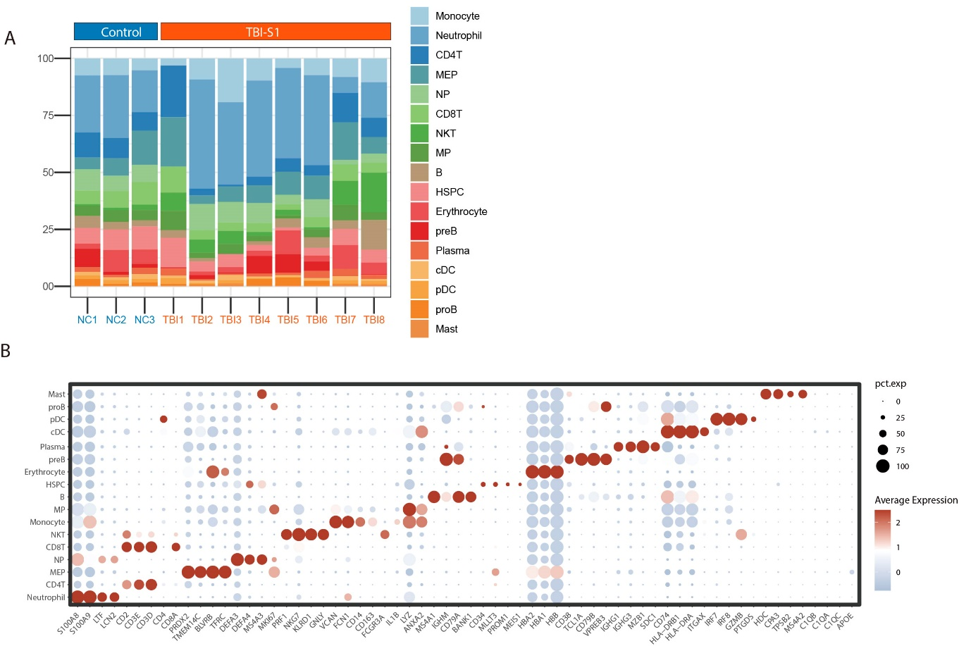Figure S1: ScRNA-seq analysis of bone marrow cellular lineages. (A) Proportions of 19 cell types in BMMCs for control and TBI patients. (B) Summarized graph shows cell-type-specific marker for indicated clusters (Dot color indicates the expression level, dot size represents the proportion of cells expressing indicated markers).

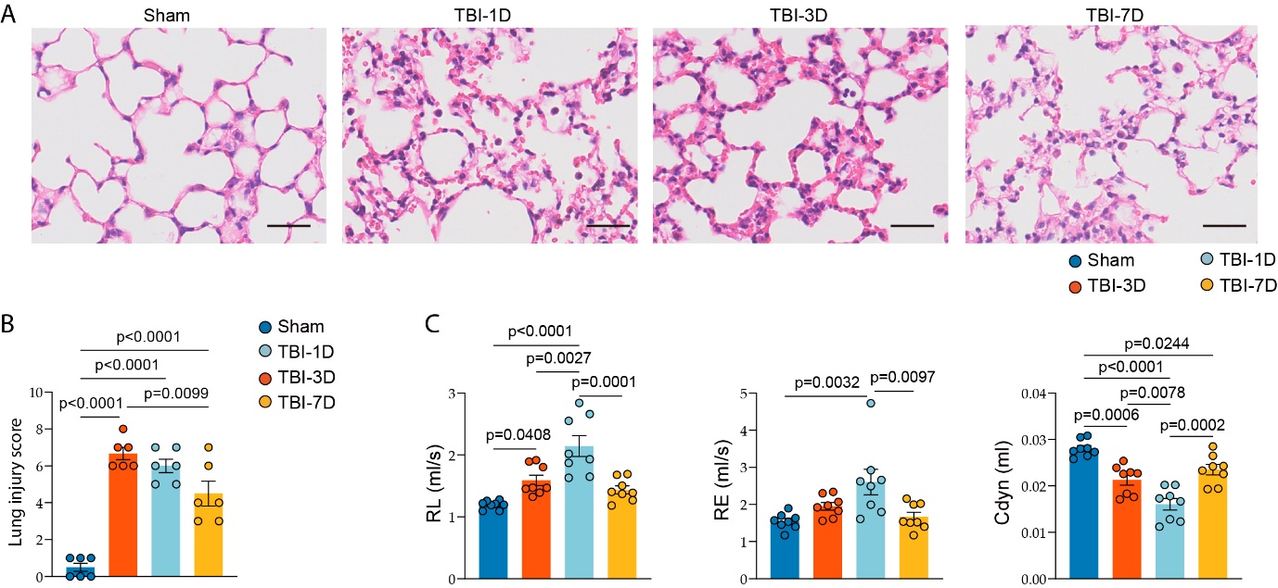Figure S2: TBI induced lung injury in mice.​​ (A-B)​​ Representative H&E images (scale bars=50 μm) for lung injury at 1, 3 and 7 days after FPI compared with sham surgery (A) and ALI score (B, n=6/group, paired t test). (C)​​ The ​pulmonary function (RL, RE, and Cdyn) of mice was measured via the AniRes 2005 system at 1, 3 and 7 days post-TBI (n=8/group, one-way ANOVA). All data are expressed as means ± SEM.

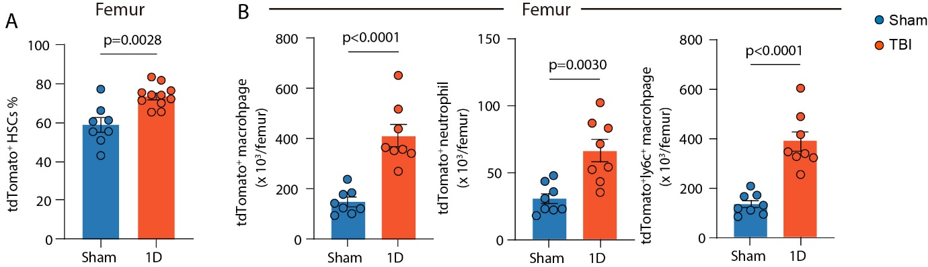Figure S3: Increased myeloid cells in femur BM of Fgd5-CreER; tdTomato mouse. (A) Active expression of tdTomato was profiled in HSCs of femur BM cells in sham or TBI mice (n=8/group, unpaired t test). (B) Active expression of tdTomato was measured in the indicated mature immune cells of femur BM cells (n=8/group, unpaired t test). All data are expressed as means ± SEM.

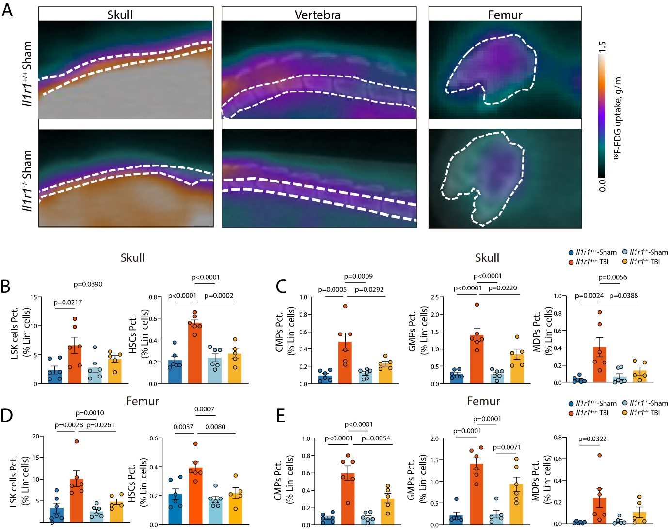Figure S4: Global loss of Il1r1 influenced emergency hematopoiesis. (A) ¹⁸F-FDG uptake-based PET-CT imaging on the BM regions of skull, vertebra and femur of Il1r1^{+/+} and Il1r1^{-/-} sham mice. BM hematopoiesis analysis of LSK cells, HSCs (B), and CMPs, GMPs and MDPs (C) in skull by flow cytometry in 4 indicated groups (n=5-6/group, one-way ANOVA). BM hematopoiesis analysis of LSK cells, HSCs (D), CMPs, GMPs and MDPs (E) in femur by flow cytometry in 4 indicated groups (n=5-6/group, one-way ANOVA). All data are expressed as means ± SEM.

Figure S5: The influence of inhibition emergency myelopoiesis through global loss of Il1r1 on TBI and sham mice. Representative images of CD68⁺CD86⁺ pro-inflammation and CD68⁺CD206⁺ patrolling macrophages in brain (A) and lung (B) sections of sham mice (bar=20 μm). (C) Flow cytometry gating strategy for macrophage, neutrophil, Ly6C⁺ and Ly6C⁻ macrophage in mice brain. (D) Sham mice from Il1r1^{+/+} and Il1r1^{-/-} group received MRI scans (Representative images of T2, CE-T1 and T2* map of 1 day post injury). mNSS test (E) Rotarod (F) and Coner tests (G) were conducted to evaluate the neurological deficits and motor functional recovery of the Il1r1^{+/+} and Il1r1^{-/-} mice with TBI at indicated time points (n=5-8/group, one-way ANOVA). All data are expressed as means ± SEM.
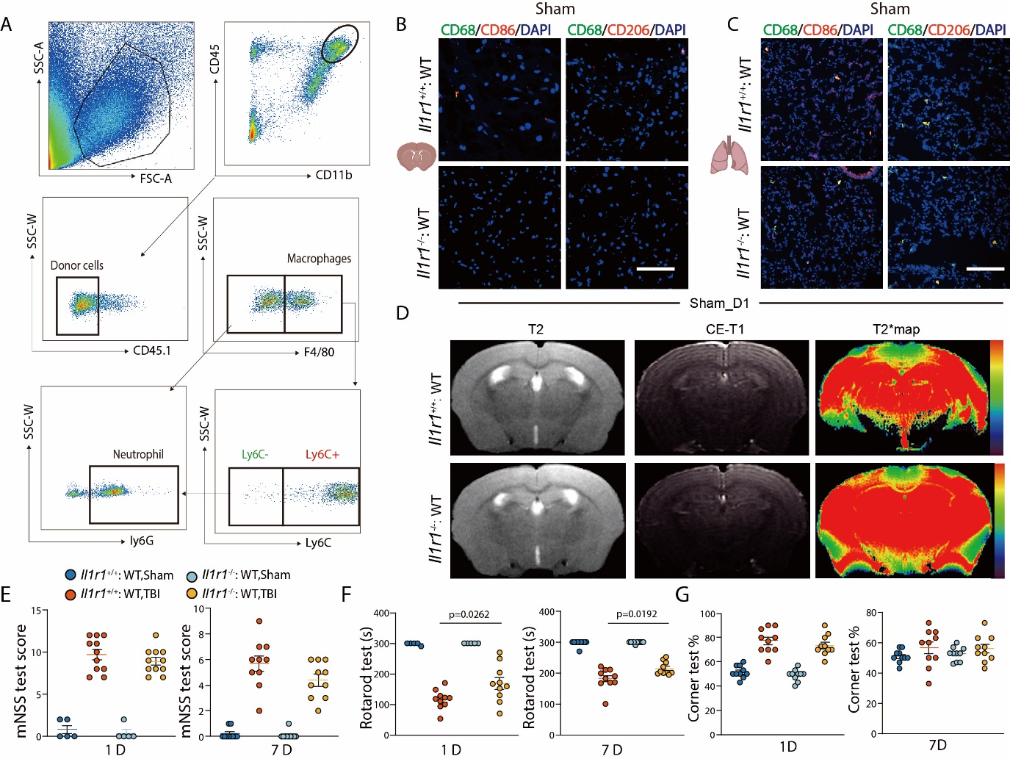Figure S6: The impact of inhibition myelopoiesis through hematopoiesis-specific loss of Il1r1 on TBI and sham mice. (A) Flow cytometry gating strategy for macrophage, neutrophil, Ly6C⁺ and Ly6C⁻ macrophage from donor mice in BM-chimeric mice brain. Representative images of CD68⁺CD86⁺ pro-inflammation and CD68⁺CD206⁺ patrolling macrophages in brain (B) and lung (C) tissues from chimeric sham mice (bar=20 μm). (D) Sham mice from Il1r1^{+/+}: WT and Il1r1^{-/-}: WT BM-chimeric mice group received MRI scans (Representative images of T2, CE-T1 and T2* map of 1 day post injury). mNSS (E), Rotarod test (F), and Coner tests (G) were conducted for evaluating the neurological deficits and motor functional recovery of the Il1r1^{+/+}: WT and Il1r1^{-/-}: WT BM-chimeric mice challenged by sham or TBI at indicated time points (n=5-10/group, one-way ANOVA). All data are expressed as means ± SEM.

