Supplementary Materials for:

Helicobacter pylori infection and α-synuclein pathology drive parallel neurodegenerative pathways in the substantia nigra

Alejandro Soto-Avellaneda¹, Alice Prigent¹, Lindsay Meyerdirk¹, Noah Schautz¹, John Andrew Pospisilik², Lena Brundin¹, Michael X. Henderson¹

¹Department of Neurodegenerative Science, Van Andel Institute, Grand Rapids, MI 49503
²Department of Epigenetics, Van Andel Institute, Grand Rapids, MI 49503

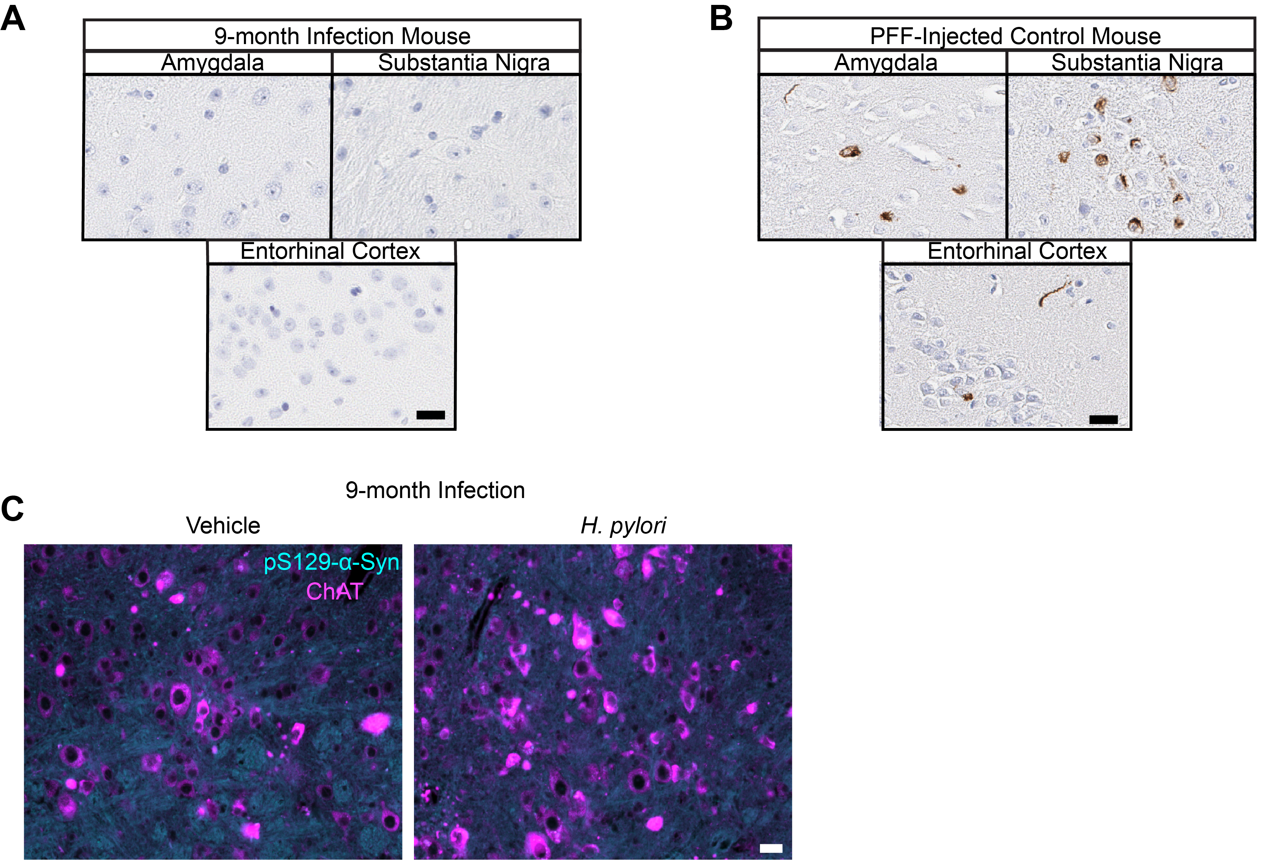
Fig. S1. Aged H. pylori-infected mice do not show signs of α-synucleinopathy in the brain. A. representative images of H. pylori-infected 9-month infection amygdala, substantia nigra, and entorhinal cortex stained for pS129 α-synuclein. B. Representative images of α-synuclein PFF-injected positive control amygdala, substantia nigra, and entorhinal cortex stained for pS129 α-synuclein. C. Representative image of vehicle-treated and H. pylori-infected hindbrains showing the dorsal motor nucleus of the vagus nerve (DMX) stained for choline acetyltransferase (ChAT) and pS129 α-synuclein. The pS129 α-synuclein channel intensity has been increased to demonstrate that the channel was imaged, but only background staining is visible. Scale bars = 20 µm.

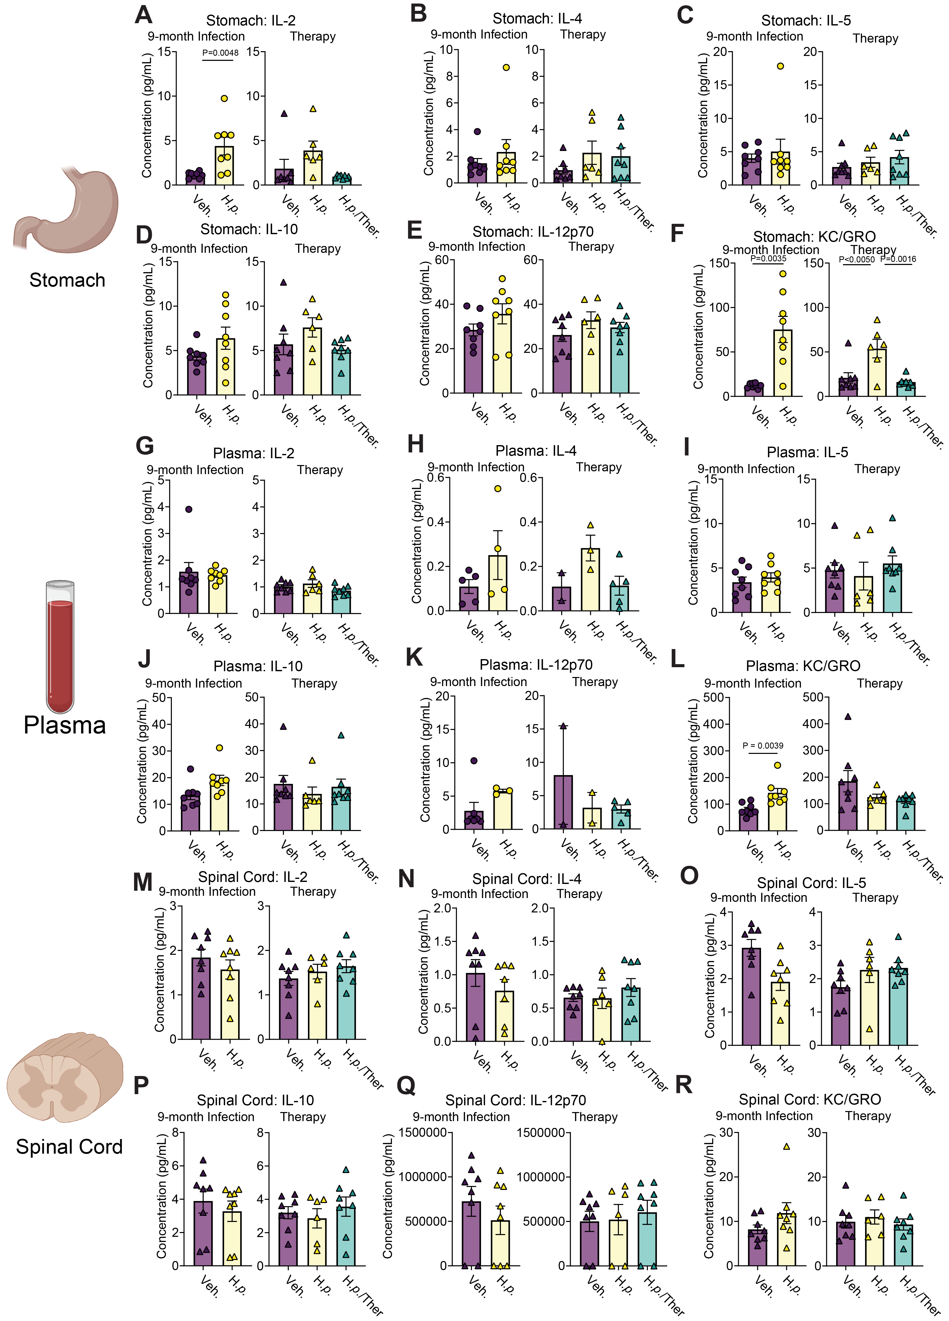
Fig. S2. Further evaluation of cytokines and chemokines across tissues. Multiplexed cytokine assay showing calculated concentration of IL-2, IL-4, IL-5, IL-10, IL-12p70, and KC/GRO levels measured in the A-F. stomach tissue, G-L. blood plasma, and M-R. spinal cord tissue of 9-month infection and Therapy cohort mice. For the 9-month infection cohort, n = 8 (Veh.) or n = 8 (H.p.), Welch’s T-tests were performed for A, C, D, F, G, K, and R. Unpaired T-tests were performed for the remaining panels. For the Therapy cohort, n = 8 (Veh.), 6 (H.p.), or 8 (H.p./Ther.), one-way ANOVA with Tukey’s multiple comparisons test was performed. Individual mice with cytokine levels below assay detection limits were excluded from analysis. Statistical significance (p < 0.05) is indicated above relevant comparisons; all other differences are non-significant.

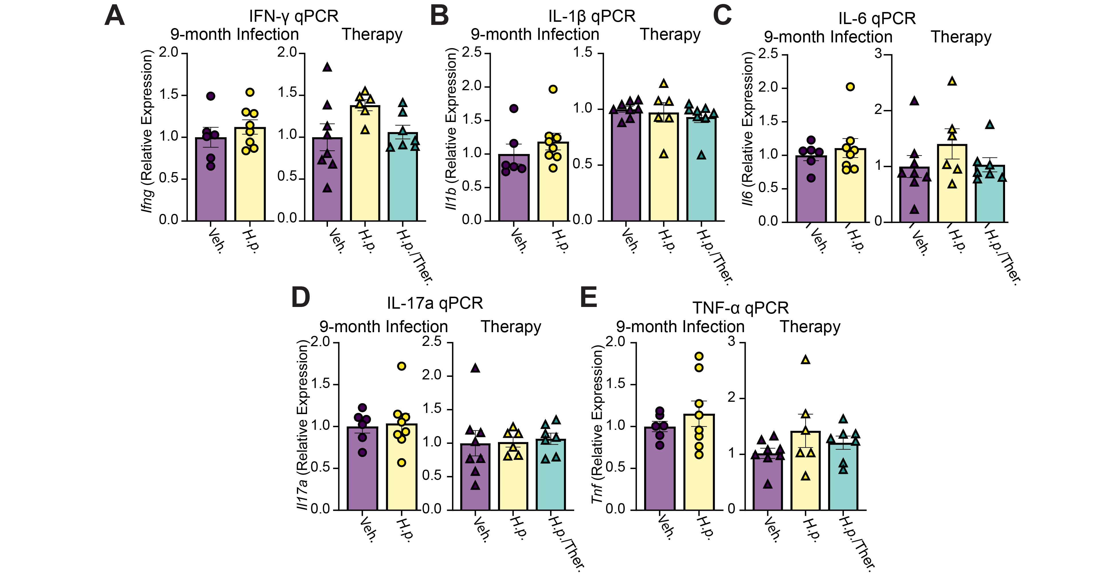
Fig. S3. mRNA expression of proinflammatory cytokines is not significantly elevated in mouse spinal cords. Relative expression of A. Ifng, B. Il1b, C. Il6, D. Il17a, and E. Tnfa mRNA in 9-month Infection and Therapy cohort spinal cords. n=6 (Veh.) or 8 (H.p.). Welch’s T-test was performed for E. Unpaired T-test was performed for A, B, C, and D. For the Therapy mice, n= 8(Veh.), 6 (H.p.), or 7 (H.p./Ther.). One-way ANOVA with Tukey’s multiple comparisons test was performed. Statistical significance (p < 0.05) is indicated above relevant comparisons; all other differences are non-significant.

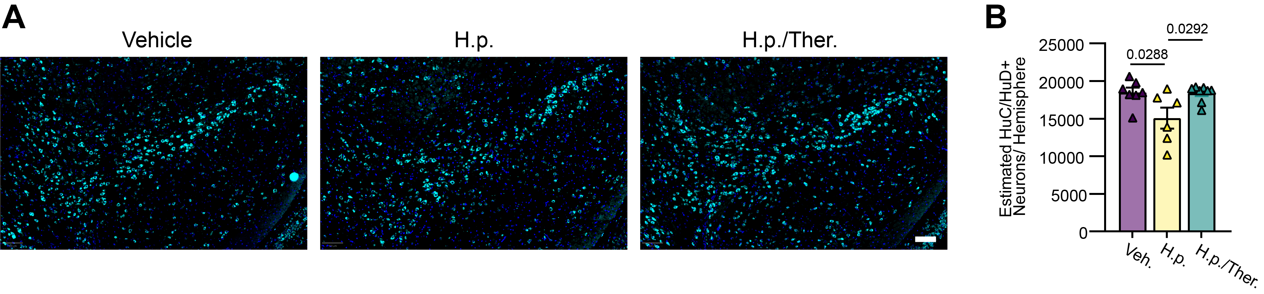

Fig. S4. H. pylori infection leads to mild neurodegeneration in the substantia nigra. A. Representative images of Therapy cohort substantia nigra stained for HuC/HuD. Scale bar = 100 µm. B. Estimated quantification of HuC/HuD+ cells throughout the substantia nigra shows a mild loss of neurons overall in this region. n = 7 (Veh.), 6 (H.p.), or 8 (H.p./Ther.), one-way ANOVA with Tukey’s multiple comparisons tests were performed. Statistical significance (p < 0.05) is indicated above relevant comparisons; all other differences are non-significant.

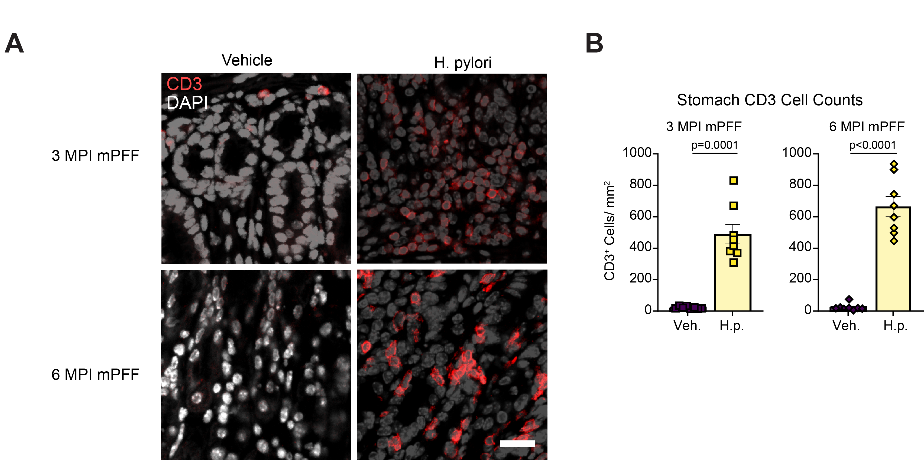

Fig. S5. Dual-hit H. pylori model shows similar prolonged infiltration of the stomach by T-cells. A. Representative image of 3 MPI PFF and 6 MPI PFF cohort mouse stomachs stained for CD3. Scale bar = 20 µm. B. Quantification of CD3⁺ cells. n= 8 (Veh.) or n=8 (H.p.). Welch’s T-test was performed. Statistical significance (p < 0.05) is indicated above relevant comparisons; all other differences are non-significant.

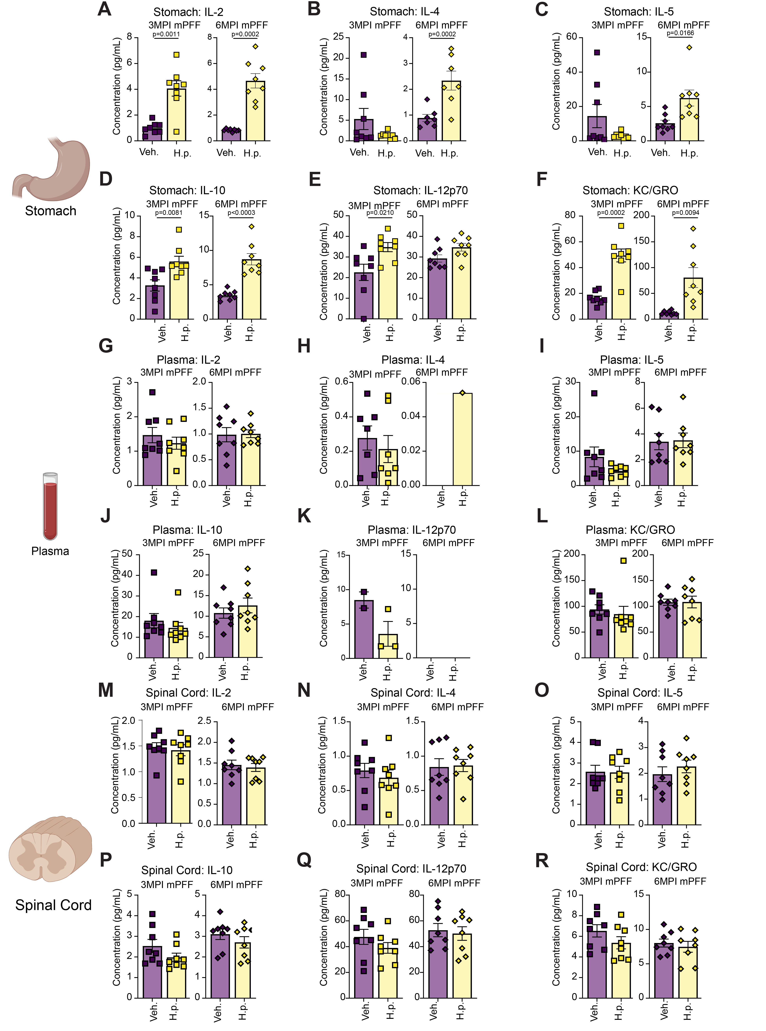
Fig. S6. Further evaluation of cytokines and chemokines in α-synuclein PFF-treated mice. Multiplexed cytokine assay showing calculated concentration of IL-2, IL-4, IL-5, IL-10, IL-12p70, and KC/GRO levels measured in A-F. stomach tissue, G-L. blood plasma, and M-R. spinal cord tissue of 3 MPI PFF and 6 MPI PFF cohort mice. n = 8 (Veh.) or n = 8 (H.p.), Welch’s T-tests were performed for A, B, C, D, and I. Unpaired T-tests were performed for the remaining panels. Statistical significance (p < 0.05) is indicated above relevant comparisons; all other differences are non-significant.

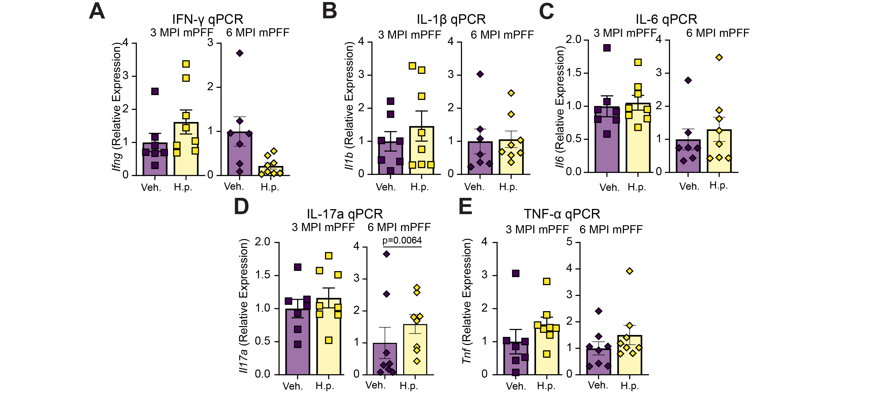
Fig. S7. Addition of mPFF injections to H. pylori infection in mice does not alter expression of proinflammatory cytokines in spinal cords. Relative expression of A. Ifng, B. Il1b, C. Il6, D. Il17a, and E. Tnfa mRNA in3 MPI mPFF and 6 MPI mPFF spinal cords. n=7 (Veh.) or 8 (H.p.). Welch’s T-test was performed for A and D. Unpaired T-test was performed for B, C, and E. Statistical significance (p < 0.05) is indicated above relevant comparisons; all other differences are non-significant.

