Supplementary

Metabolic reprogramming and altered ATP content impair neuroprotective functions of microglia in β-glucocerebrosidase deficiency models

Authors
Electra Brunialti¹, Alessandro Villa¹, Eva M. Szego², Pietro La Vitola², Denise Drago³, Radmila Pavlovic³, Laura Fontana^{4,5}, Doga Tuna¹, Alessia Panzeri¹, Clara Meda¹, Christin Weissleder⁶, Ornella Rondinone⁴, Mattia Pitasi⁷, Monica Miozzo^{4,5}, Michela Deleidi⁶, Annapaola Andolfo³, Donato A. Di Monte² and Paolo Ciana^{1*}

Affiliations
¹ Department of Health Sciences, University of Milan, Via di Rudinì 8, 20142 Milan, Italy.
² German Center for Neurodegenerative Diseases (DZNE), Venusberg-Campus 1, Gebäude 99, 53127 Bonn, Germany.
³ Center for Omics Sciences (COSR), IRCCS San Raffaele Scientific Institute, Via Olgettina 60, 20132 Milan, Italy.
⁴ Medical Genetics, Department of Health Sciences, University of Milan, Via di Rudinì 8, 20142 Milan, Italy.
⁵ Medical Genetic Unit, ASST Santi Paolo e Carlo, Via di Rudinì 8, 20142 Milan, Italy.
⁶ Mechanisms and Therapy of Genetic Brain Diseases, Institut Imagine, INSERM UMR1163, 24 Bd du Montparnasse, 75015 Paris, France.
⁷ Max Perutz Labs, Department of Microbiology, Immunobiology and Genetics, University of Vienna, Dr. Bohr-Gasse 9, A-1030 Vienna, Austria.
*corresponding author paolo.ciana@unimi.it

Figure Supplementary 1. Treatment with 100 mg/kg/day CBE for 3 days does not reduce the number of Th⁺ neurons or induce apoptosis in the SNpc.
(A) Quantification of Th⁺ cells (n = 4 mice per group). Data are presented as mean ± SD of average cell counts per field of view per mouse (unpaired t-test).
(B) Quantification of cleaved caspase-3⁺ cells in the SNpc. Left: representative image. Right: percentage of cleaved caspase-3⁺ cells -positive cells over total cells, showing no evidence of apoptosis induction (n = 4 mice per group). Data are presented as mean ± SD of positive cells averaged per mouse (unpaired t-test).

Figure Supplementary 2. LC–MS/MS analysis and quantification of glucosylsphingosine (GlcSph, d18:1).
A) Extracted ion chromatogram (EIC, m/z 462.34 [M+H]⁺) of GlcSph (d18:1) showing a sharp peak at 18.04 min.
B) The corresponding MS/MS spectrum exhibits the characteristic fragmentation pattern with loss of the hexose moiety (m/z 300.29), subsequent water losses (m/z 282.28, 264.27), and diagnostic sugar oxonium ions (m/z 163.06, 145.05), confirming the molecular identity.
C) Extracted ion chromatogram (EIC, m/z 467.42 [M+H]⁺) of internal standard GlcSph (d18:1, d5) displaying a peak at 18.05 min
D) The corresponding MS/MS spectrum exhibits a characteristic fragmentation pattern equivalent to that of the non-deuterated counterpart.
E) Extracted ion chromatogram (EIC, m/z 462.34 [M+H]⁺) of GlcSph (, d18:1) showing traces of peak at 18.04 min.
F) Extracted ion chromatogram (EIC, m/z 467.42 [M+H]⁺) of internal standard GlcSph (d18:1, d5) displaying a peak at 18.05 min
G) The corresponding MS/MS spectrum exhibits a characteristic fragmentation pattern equivalent to that of the non-deuterated counterpart.
(H) Quantification of GlcSph levels in the brains of mice treated with CBE (100 mg/kg/day) for 3 days, showing a marked accumulation of the substrate.

Figure Supplementary 3: the red color indicates the quantified morphological value reported in Figure 1. Solidity represents the ratio between the object's area and its convex area, while the number of triple points refers to junctions where exactly three branches meet.

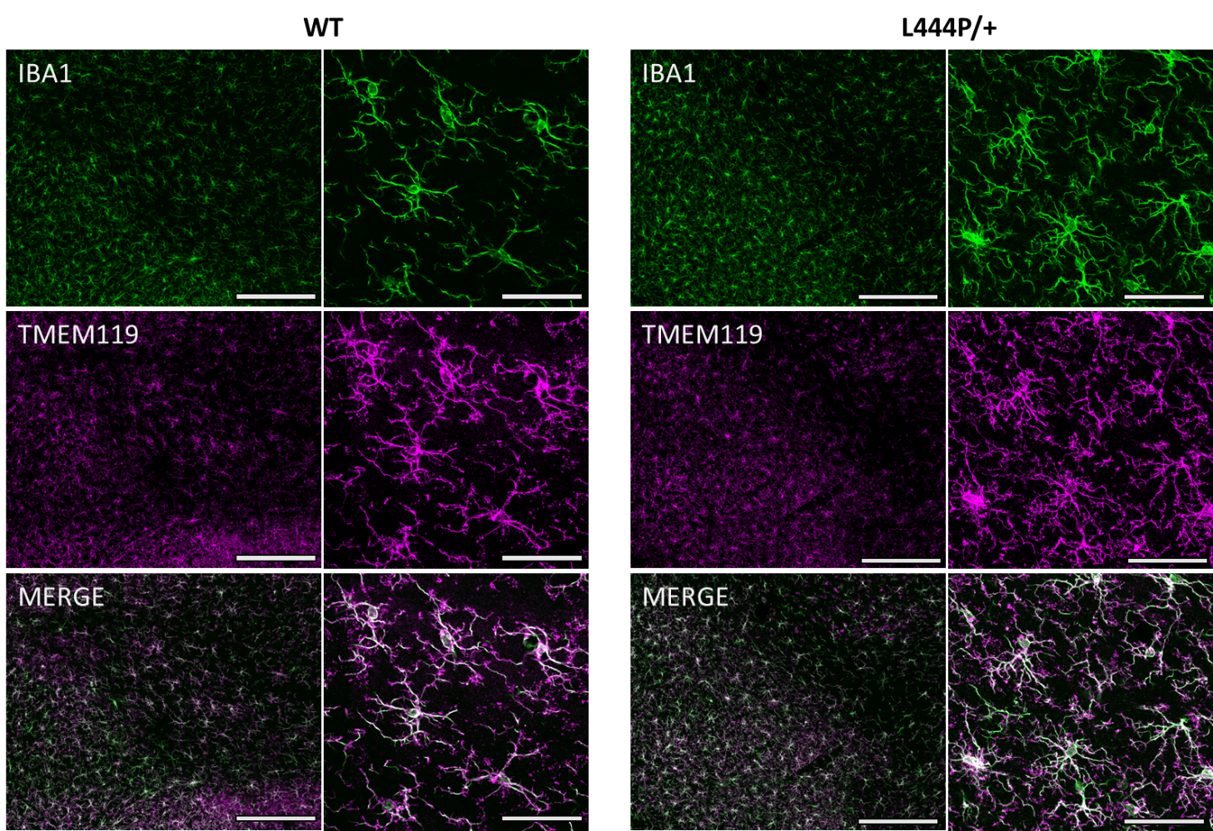

Figure Supplementary 4: Both Tmem119 and Iba1 immunoreactivity characterized immune cells in the ventral midbrain of WT and L444P/+ mice.
Representative immunofluorescence images (low and high magnification) of the ventral midbrain showing co-staining of cells with the specific microglial marker, Tmem119 (magenta), and the pan macrophagic marker, Iba 1 (green). Please note that all of the Iba 1-positive cells also appeared to display immunoreactivity for Tmem119, indicating absence or negligible burden by infiltrated peripheral macrophages. Scale bar: 200 µm for low magnification and 50 µm for high magnification.

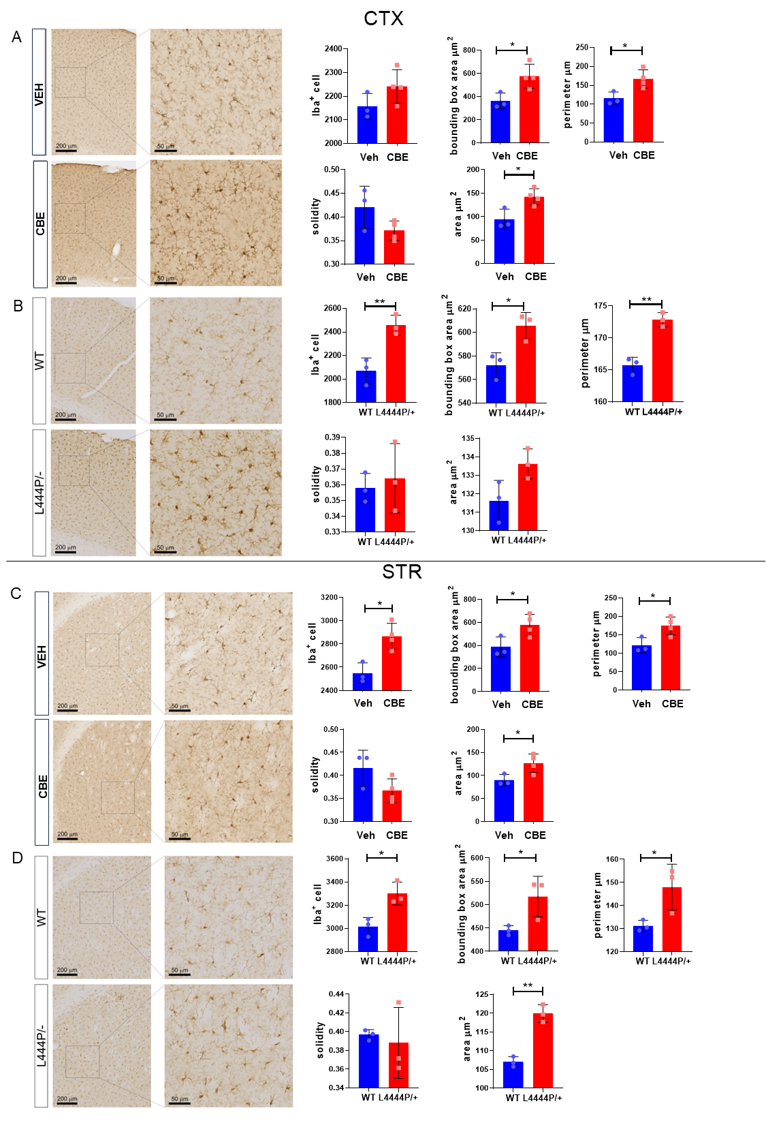
Figure Supplementary 5. Morphological characterization of GCase-impaired microglia. Representative images of the cortex (CTX) and striatum (STR) showing Iba1-positive microglia stained with DAB (left) (scale bars: 200 µm and 50 µm) from vehicle-treated (Veh) and CBE-treated (CBE; 100 µg/kg for 3 days) mice, as well as from L444P/+ and wild-type (WT) littermates. Quantitative analysis of microglial morphology is shown on the right. Data are presented as mean ± SD, averaged per mouse. *p < 0.05, **p < 0.01, unpaired t-test (n=3).
Figure Supplementary 6: Analysis of the TPM values obtained from the transcriptomic assay described in Figure 2 highlights that the samples were highly enriched in microglia, as microglial genes (C1qa, P2ry12, Csf1r, Hexb) are drastically overrepresented compared to genes of other brain cells.

Figure Supplementary 7: qPCR validation(left): A total of 9 genes were selected. Data are expressed using the 2^{-ΔΔCt} method. Columns represent the mean ± SEM of 8 animals per experimental group. *p < 0.05; determined by unpaired t-test comparisons. The expression analyses of the selected genes gave results consistent with those obtained by RNAseq (right).

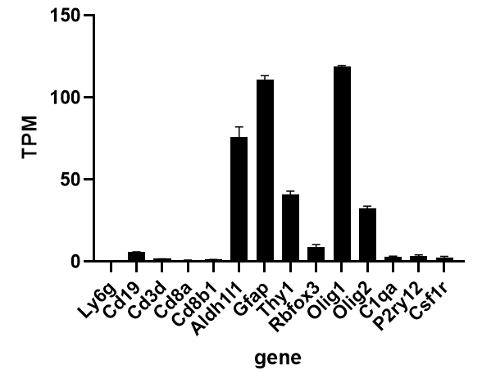
Figure Supplementary 8: Gene expression analysis of the cellular brain population from which the microglia were removed highlights that the sample is enriched in neuron, astrocyte, and oligodendrocyte transcripts.

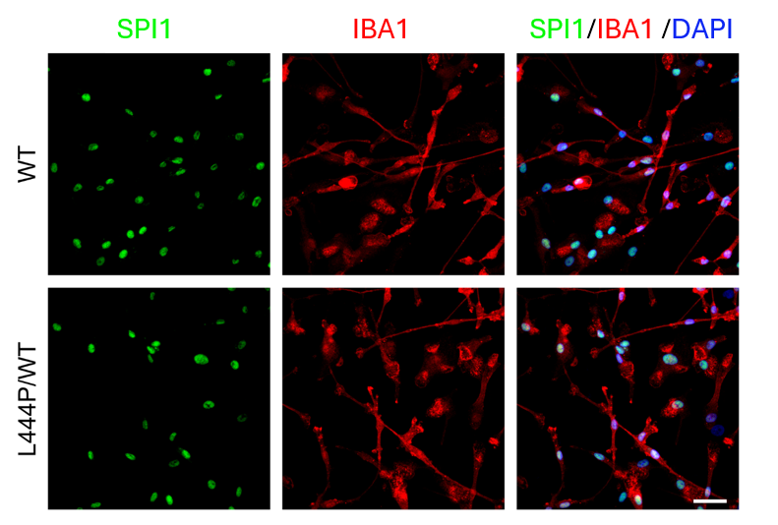
Figure Supplementary 9: Immunocytochemical characterization of GBA (L444P/+) and paired isogenic (wt) iPSC-derived control microglia. Representative confocal images showing the immunocytochemical staining of IBA1 (red) and SPI1 (green- A crucial transcription factor for microglial development) with nuclei (DAPI, blue) in L444P/WT and paired isogenic control iPSC-derived microglia. Scale bar, 50µm.

Figure Supplementary 10: Viability assay using trypan blue in cocultures of SK-N-BE and BV-2 cells treated with vehicle or 200 µM CBE for 48 hours. Data represent percentage viability relative to vehicle-treated cells ± SEM (n=6); no significant difference identified with unpaired t-test.

Figure Supplementary 11. Representative FACS histograms showing mitochondrial staining intensity in CD11b⁺ and CD11b⁻ cell populations after treatment with 200 µM CBE for 48 hours. Fluorescence profiles are shown for MitoTracker Red (A), MitoTracker Green (B), and TMRM (C). The H gate indicates cells with high fluorescence intensity (percentage reported in figure 4), while the L gate indicates cells with low intensity. In first panel, the histogram also includes the profile of unstained cells.

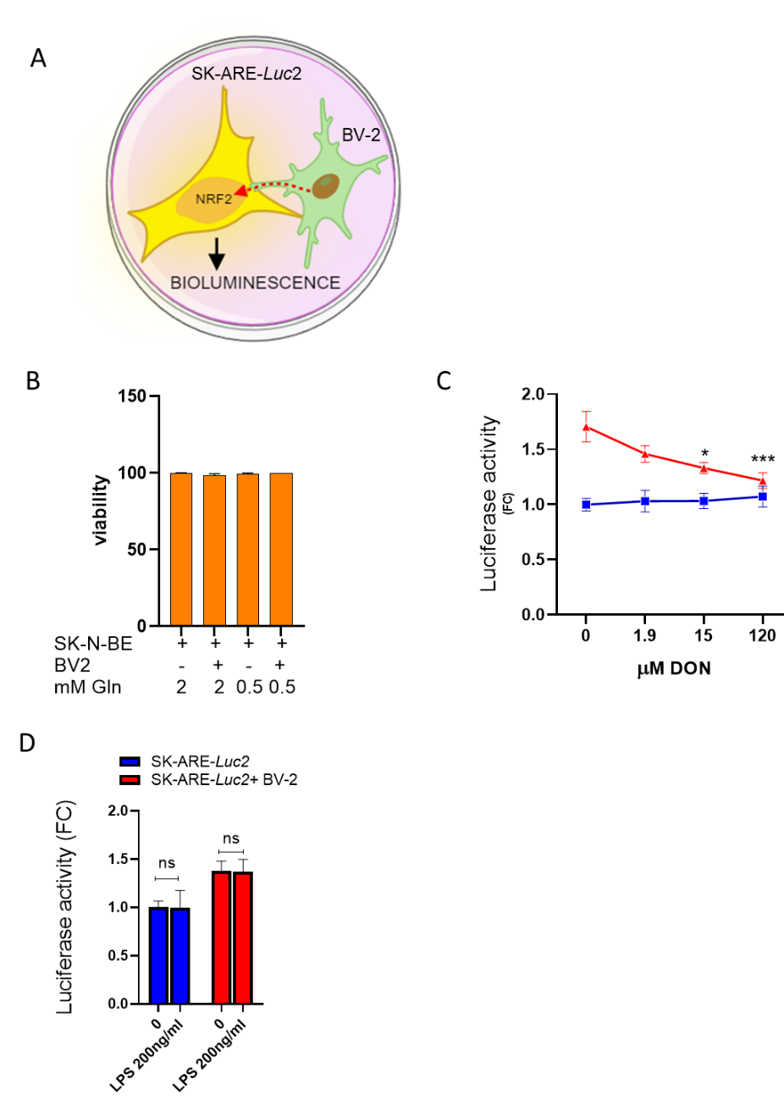
Supplementary 12
(A) Schematic representation of co-culture experiments designed to evaluate the effects of various treatments on microglia-neuron communication. The microglia are capable of activating the NFE2L2 (NRF2) transcription factor in neurons, a mechanism that can be detected using the SK-N-BE bioluminescent cell reporter for NFE2L2 (SK-ARE-luc2).

(B) Viability assay on cells grown with reduced amounts of glutamine highlights that there is no viability deficit. SK-N-BE and BV-2 cells were grown for 6 hours with different concentrations of glutamine.
(C) Inhibition of multiple enzymes that use glutamine through the mimetic 6-diazo-5-oxo-L-norleucine (DON) reduces microglia-to-neuron communication. SK-ARE-luc2 cells or coculture of SK-ARE-luc2 + BV-2 were treated with different doses of DON for 6 hours, and the luciferase activity was measured in cellular extracts. Data represents fold change (FC) of luciferase activity versus SK-ARE-luc2 ± SEM. *p<0.05, **p<0.01, calculated with one-way ANOVA followed by Sidak’s multiple comparisons test versus vehicle-treated cells.

(D) Luciferase activity measured in protein extracts derived from SK-ARE-luc2 cells or coculture of SK-ARE-luc2 and BV-2 cells treated for 4 hours with 200 ng/ml of LPS. Data represent fold change (FC) of luciferase activity versus SK-ARE-luc2 grown in complete media ± SEM (n=7); ns, not significant, calculated with one-way ANOVA followed by Sidak’s multiple comparisons test.

Supplementary material and methods

GlcSph LC-MS/MS analysis
Glucosyl(ß)Sphingosine-d5 (GlcSph-d5) from AVANTI POLAR was used as internal standard to identify and quantify GlucosylSphingosine. A working solution of GlcSph-d5 was prepared in DMSO/methanol (1:1) at the final concentration of 2 ng/µl. Frozen brain tissue samples (one hemisphere) were put into one crio-vial. Ceramic beads (1.4 mm) were added to brain tissues (0.2 g beads/200 mg tissue) in addition to 120 µl H2O to prepare the brain homogenates. The samples were homogenized by using Tissue Lyser (Tissue Lyser Neo Biotech (NB-12-0004) with 6.5 m/s speed for 3 cycles of 30 sec with 30 sec break every each cycle. The samples were then centrifuged at 14,000 g for 10 min at 4°C. The final homogenates were around 1.6 mg/µl. These homogenates were stored at –80 °C until the GlcSph extraction. A 50 µl aliquot of brain homogenate, containing 25 µl of internal standard GlcSph-d5 (working solution 2 ng/µl), was used for the lipids extraction. 400 µl of methanol and 500 µl of methyl-ter-butyl ether (MTBE) were added to the tube prior to shaking on a vortexer for 2 min. After shaking, the samples were incubated on ice for 10 minutes. Consequently, they were added of 350 µl of water and shaked on a wheel for 5 minutes at room temperature. Upon a centrifugation step of 10 minutes at 10,000 g at 4°C, polar and apolar fractions were separated. The polar fraction was further resuspended and extracted by adding 500 µl of MTBE, vortexed and centrifuged as above. The upper apolar phase was added to the previous one, dried under N2 flow and then resuspended in 200 µl of a mixture of methanol/acetonitrile/isopropanol 2:3:5 containing 5 mM NH4HCOO and 0.05% NH4OH. The reconstituted apolar fraction was centrifuged again at 14,000 g for 5 min at 4°C just before the LC-MS/MS analysis.
The isolated apolar fractions were ready to be separated by hydrophilic interaction liquid chromatography (Phenomenex, Luna Omega 3µm SUGAR, 150 x 2.1 mm) coupled with high-resolution mass spectrometry (HR-MS) on a TRIPLE TOF 5600+ mass spectrometer (SCIEX) equipped with UPLC 1290 (Agilent Technologies). The chromatographic separation was performed by injecting 5 μl of each apolar extract. GlcSph was detected in positive modality by using a flow rate set at 0.7 ml/min with a separation gradient of 45 min using solvent A (acetonitrile, 0.1% formic acid) and solvent B (40 mM NH4HCOO in water, 0.1% formic acid). The chromatographic gradient started from 1% B, increased up to 20% B in 24 min, increased again up to 40% B in 2 min, maintained constant at 40% B for 4 min and decreased to 1% B in 1 min. The column was set at 25°C while the samples were kept at 4°C. The ion source-dependent parameters were optimized for positive mode, as follows: Ion Spray Voltage Floating (ISVF) 5500 V; Declustering Potential (DP): 80 V; Temperature 500°C; Curtain Gas, 35 (CUR, arbitrary units) and Ion Source Gas (GS1 and GS2) at 33 psi and 58 psi; for SWATH fragmentation CE ± CES were (35 ± 15) V. For GlcSph (m/z 462.3) quantification, the analysis was performed by using Analytics within SCIEX OS software (SCIEX) which allows to measure the peak areas and to correct them by using the internal standards in a targeted processing workflow (GlcSph-d5 (m/z 467.4)). The concentration of GlcSph was quantified relative to the internal standard GluSph-d5, which was added at a final concentration of 0.6 µg/mL.

Characterisation of human microglia by immunocytochemistry
For immunocytochemisty, cells seeded on coverslips were fixed in 4% paraformaldehyde (Sigma-Aldrich) for 15 minutes, rinsed with phosphate-buffered saline (PBS), and blocked with 10% normal goat serum (NGS) in 0.1% Triton X-100 in PBS (PBST) at room temperature for 1 hour. Cells were then incubated with rabbit anti-IBA1 (1:500, WAKO, 016-2001) and mouse anti-SPI1 (PU.1) (1:500, BioLegend 658002) diluted in 5% NGS in PBST overnight at 4°C. The following day, cells were incubated for 2 hours at room temperature with Alexa 488/568-coupled secondary antibodies (1:1000, Invitrogen). Nuclei were stained for 10 minutes with 1 µM 4’,6-diamidino-2-phenylindole dihydrochloride (DAPI, Invitrogen). Coverslips were mounted on glass slides with mounting medium (DAKO) and images were captured using a Leica TCS SP8 confocal microscope with a 40×/1.4 numerical aperture oil-immersion objective (Leica, Germany).

Fluorescence immunohistochemistry of Tmem119
Double immunofluorescence staining was performed to verify that Iba 1-positive cells were also immunoreactive for a more specific microglial marker, namely Tmem119. Analyses were carried out in 3 mice/experimental group. Equally spaced ventral midbrain free-floating coronal sections containing the SN (3 sections/mouse) were co-stained with anti-Iba 1 and anti-Tmem119. Briefly, sections were first incubated for 10 min at 95°C in 10 mM Citrate buffer (pH 6.0). To avoid non specific binding samples were then blocked in 5% normal donkey serum, 2% BSA and 0.5% Triton-X100 for 1 hour at room temperature. Next, sections were probed overnight at room temperature with the two primary antibodies rabbit anti-Tmem119 (1:500, ab209064, Abcam) and goat anti-Iba 1 (1:1000, ab5096, Abcam). Immunofluorescence signals were generated incubating samples for 1 hour at room temperature with donkey anti-rabbit and donkey anti-goat antibodies conjugated with Dylight 488 and Alexa Fluor 555 (1:200; ab96919, Abcam and A32794, Invitrogen), respectively.

