Online supplement for Wang B, et al. miR-106a-5p in extracellular vesicles derived from alveolar epithelial cells mediates cognitive dysfunction induced by chronic intermittent hypoxia in mice through MAPK signaling pathway

Supplementary Table S1. Antibodies used in this study
Antibody name | Company | Catalog number | Reactive | Dilution
iNOS | Proteintech | 18985-1-AP | M, H, R | WB 1:1000  IF 1:500
Arg-1 | Proteintech | 16001-1-AP | M, H, R | WB 1:5000  IF 1:500
APC anti-mouse CD86 Antibody | Biolegend | 105011 | M | FC
PE anti-mouse CD206 (MMR) Antibody | Biolegend | 141705 | M | FC
Alix | Santa Cruz | sc-53540 | M, H, R | WB 1:200
Calnexin | Santa Cruz | sc-23954 | M, H, R | WB 1:200
TSG101 | Bioss Antibodies | bsm-52746R | M, H, R | WB 1:1000
dicer | HUABIO | HA500522 | M, H | WB 1:1000
Dusp2 | Proteintech | 27327-1-AP | M, H | WB 1:1000
ERK | HUABIO | ET1601-29 | M, H, R | WB 1:5000
p-ERK | HUABIO | ET1610-13 | M, H | WB 1:5000
synaptophysin | CST | #36406 | M, H, R | WB 1:1000
synaptophysin | Finetest | FNab08421 | M, H | WB 1:1000
CD11b | HUABIO | HA722075 | M, H | WB 1:1000
sp-C | Santa Cruz | sc-7706 | M | WB 1:200
IBA-1 | Santa Cruz | sc-32725 | M | IF 1:50
IBA-1 | HUABIO | ET1705-78 | M, H, R | IF 1:500
FITC anti-mouse F4/80 Antibody | Biolegend | 123107 | M | FC
β-Actin | Proteintech | 66009-1-IG | M, H, R | WB 1:50000
Supplemental Figures
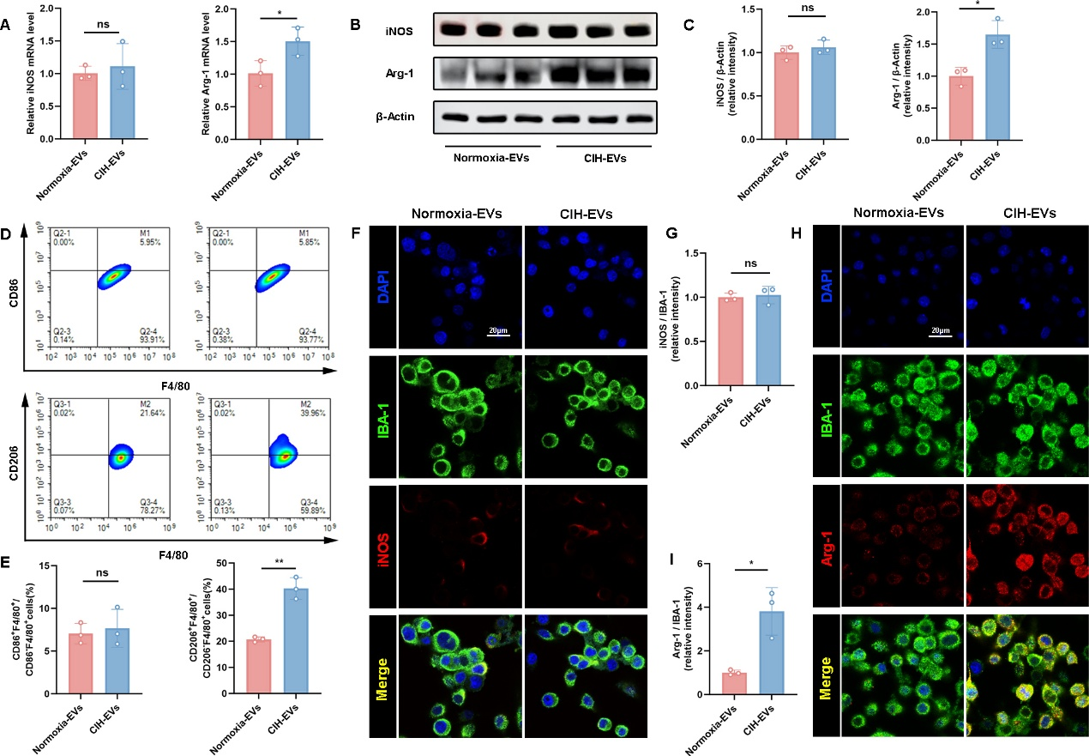
Figure S1 Exosomes produced by BV2 cells under CIH conditions can increase polarization of M2 cells.
A RT-qPCR analysis of iNOS and Arg-1 mRNA levels (n=3).
B and C Western blotting was used to detect the expression levels of iNOS and Arg-1 (n=3).
D and E Flow cytometry analysis of the proportion of M1 macrophages (CD86⁺ F4/80⁺) and M2 macrophages (CD206⁺ F4/80⁺) in BV2 cells (n=3).
F-I Immunofluorescence detection of iNOS or Arg-1 expression in BV2 cells from different groups (n=3). Blue: DAPI; red: iNOS or Arg-1; green: IBA-1, Scale bar: 20 μm.
The data are presented as the mean (SD), *p < 0.05 and **p < 0.01. Statistical significance was determined by two-sided Student’s t-test as appropriate.

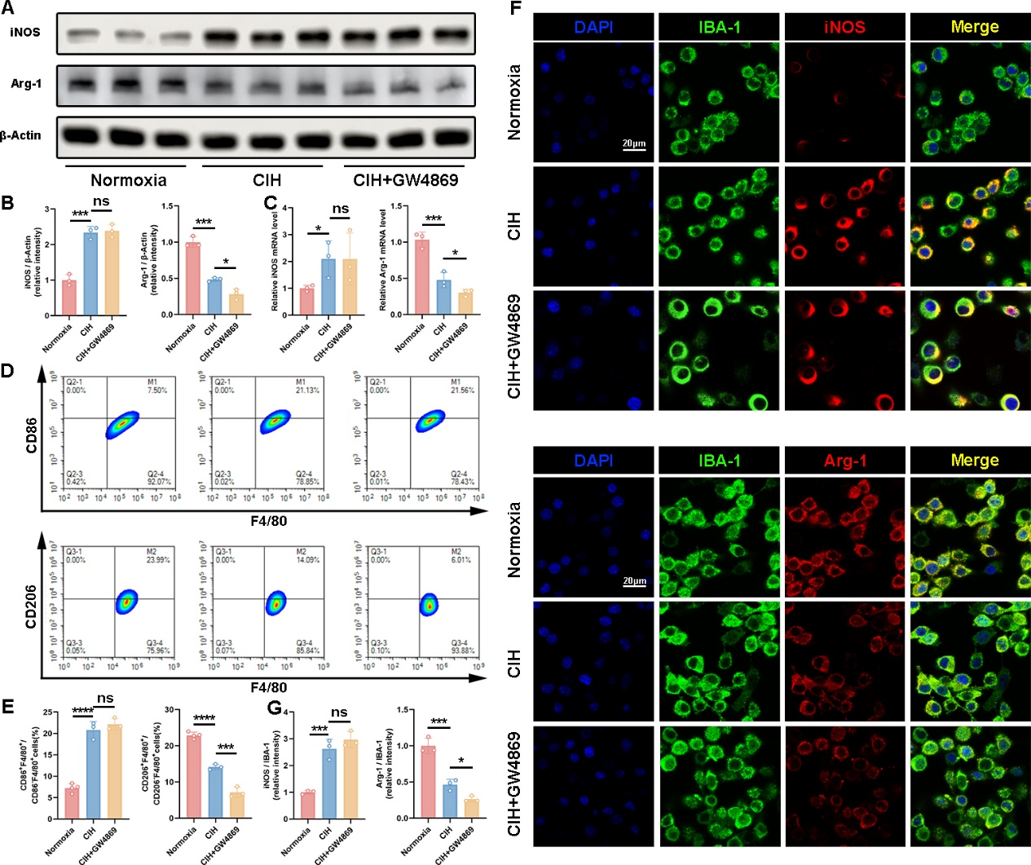
Figure S2 Inhibition of extracellular vesicle production in BV2 cells amplified CIH induced decrease in M2 polarization in BV2 cells.
A and B Western blotting was used to detect the expression levels of iNOS and Arg-1 in BV2 cells (n=3).
C RT-qPCR analysis of iNOS and Arg-1 mRNA levels in BV2 cells (n=3).
D and E Flow cytometry analysis of the proportion of M1 macrophages (CD86⁺ F4/80⁺) and M2 macrophages (CD206⁺ F4/80⁺) in BV2 cells (n=3).
F and G Immunofluorescence detection of iNOS or Arg-1 expression in BV2 cells from different groups (n=3). Blue: DAPI; red: iNOS or Arg-1; green: IBA-1, Scale bar: 20 μm.
The data are presented as the mean (SD), *p < 0.05, ***p < 0.005 and ****p < 0.001. Statistical significance was determined by one-way ANOVA as appropriate.

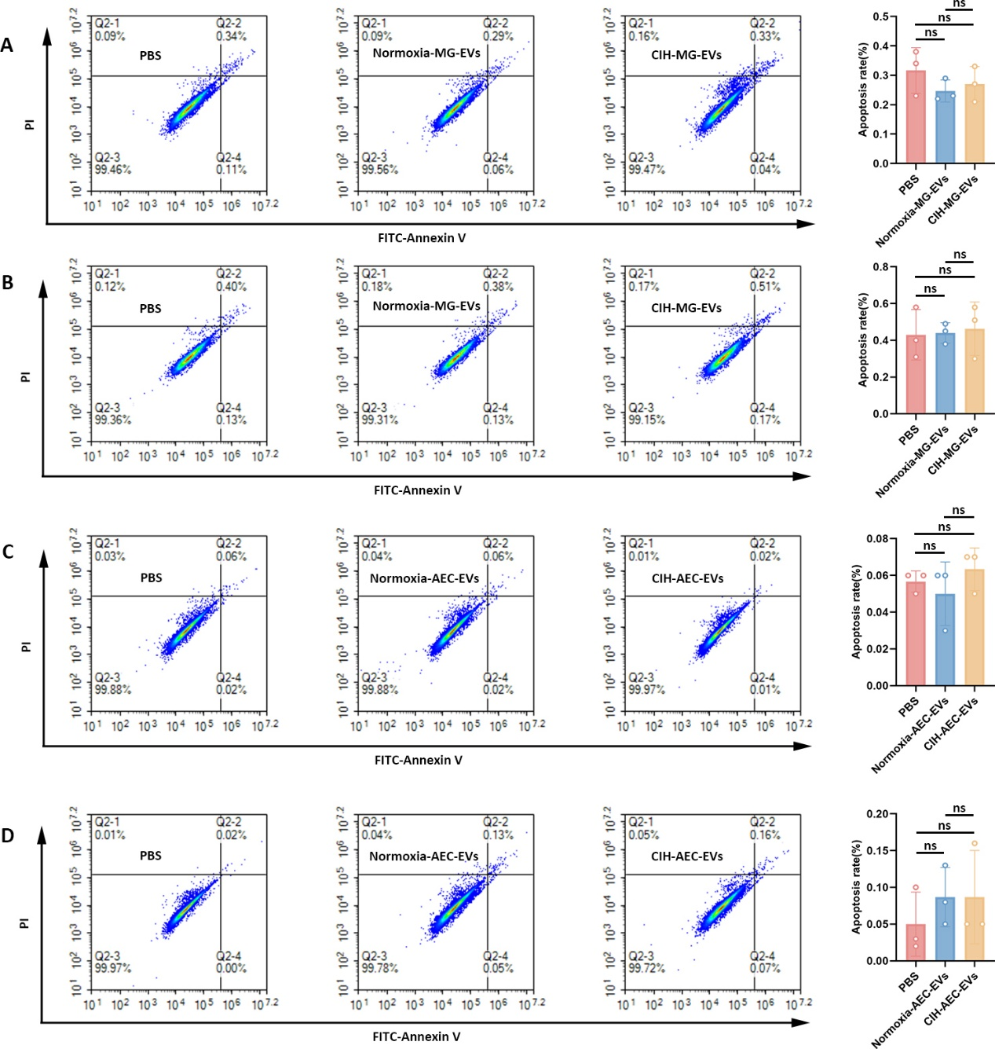
Figure S3 AEC-EVs and MG-EVs did not directly damage neuronal cells and astrocytes.
A Flow cytometry was used to detect apoptosis in neuronal cells treated with PBS, Normoxia-MG-EVs, and CIH-MG-EVs.
B Flow cytometry was used to detect apoptosis in astrocytes treated with PBS, Normoxia-MG-EVs, and CIH-MG-EVs.
C Flow cytometry was used to detect apoptosis in neuronal cells treated with PBS, Normoxia-AEC-EVs, and CIH-AEC-EVs.
D Flow cytometry was used to detect apoptosis in astrocytes treated with PBS, Normoxia-AEC-EVs, and CIH-AEC-EVs.
The data are presented as the mean (SD), ^{ns}p > 0.05. Statistical significance was determined by one-way ANOVA as appropriate.
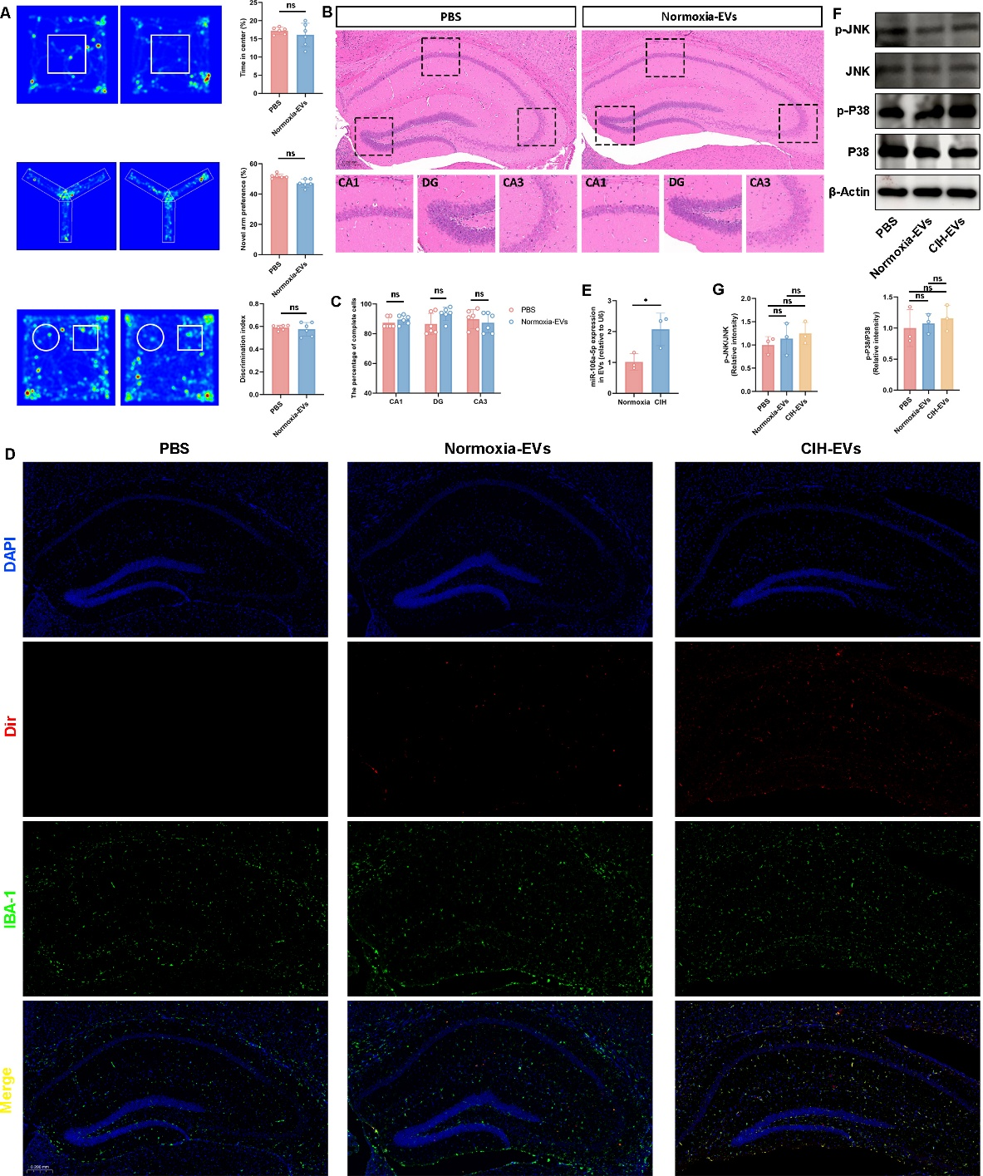
Figure S4 AEC-EVs act on mouse microglia through the blood-brain barrier.
A Results of cognitive tests. OFT, Y-maze and NOR (n=6).
B and C HE staining of mouse brain tissues. Scale bar: 0.2 mm.
D Confocal detection of the distribution of EVs in mouse hippocampal tissue and their co localization with microglia. Blue: DAPI; red: Dir; green: IBA-1, Scale bar: 0.2 mm.
E RT-qPCR analysis of miR-106a-5p levels in mouse plasma EVs.
F and G Western blotting was used to detect the expression levels of JKN, p-JNK, P38 and p-P38 in BV2 cells (n=3).
The data are presented as the mean (SD), ^{ns}p > 0.05, *p < 0.05. Statistical significance was determined by one-way ANOVA or two-sided Student’s t-test as appropriate.

