Supplementary Figures

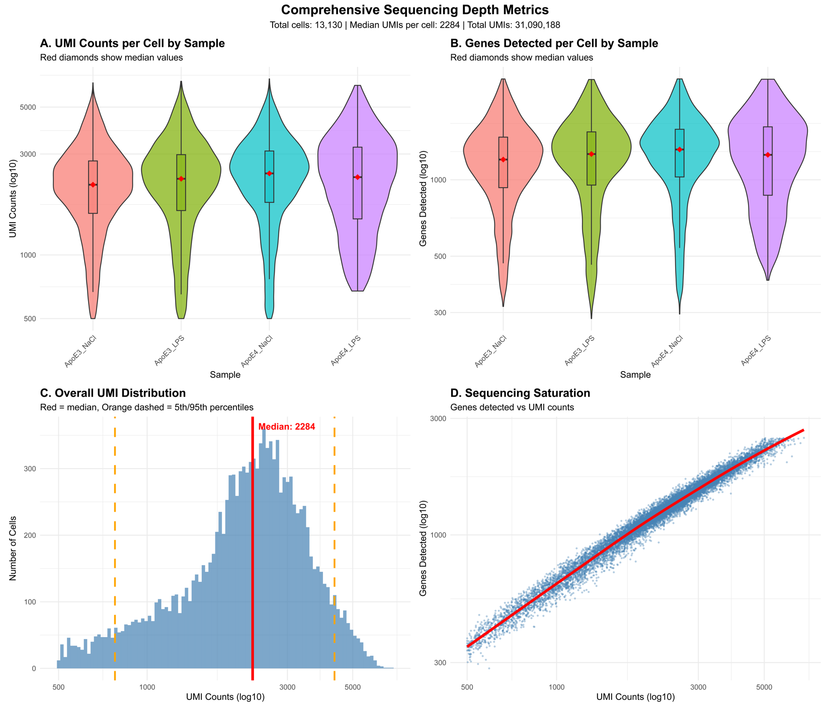

Supplemental Figure 1. Comprehensive sequencing depth and quality control metrics for single-cell RNA sequencing of astrocyte subset. Quality control metrics demonstrating high-quality single-cell RNA sequencing data across all experimental conditions (Total cells: 13,130; Median UMIs per cell: 2,284; Total UMIs: 31,090,188). (A) Violin plots showing UMI counts per cell distribution across the four pooled samples (ApoE3_NaCl, ApoE3_LPS, ApoE4_NaCl, ApoE4_LPS). Red diamonds indicate median values, demonstrating consistent sequencing depth across conditions. (B) Violin plots displaying genes detected per cell by sample. Red diamonds show median values, indicating robust gene detection across all experimental groups. (C) Overall UMI distribution histogram across all cells. Red solid line marks the median (2,284 UMIs), while orange dashed lines indicate the 5th and 95th percentiles, demonstrating appropriate sequencing saturation and minimal low-quality cells. (D) Sequencing saturation curve showing the relationship between UMI counts and genes detected. The strong linear relationship (red trend line) indicates adequate sequencing depth, with most cells approaching saturation in gene detection. These metrics confirm high-quality data suitable for downstream single-cell transcriptomic analyses, with minimal technical artifacts or low-quality cells.

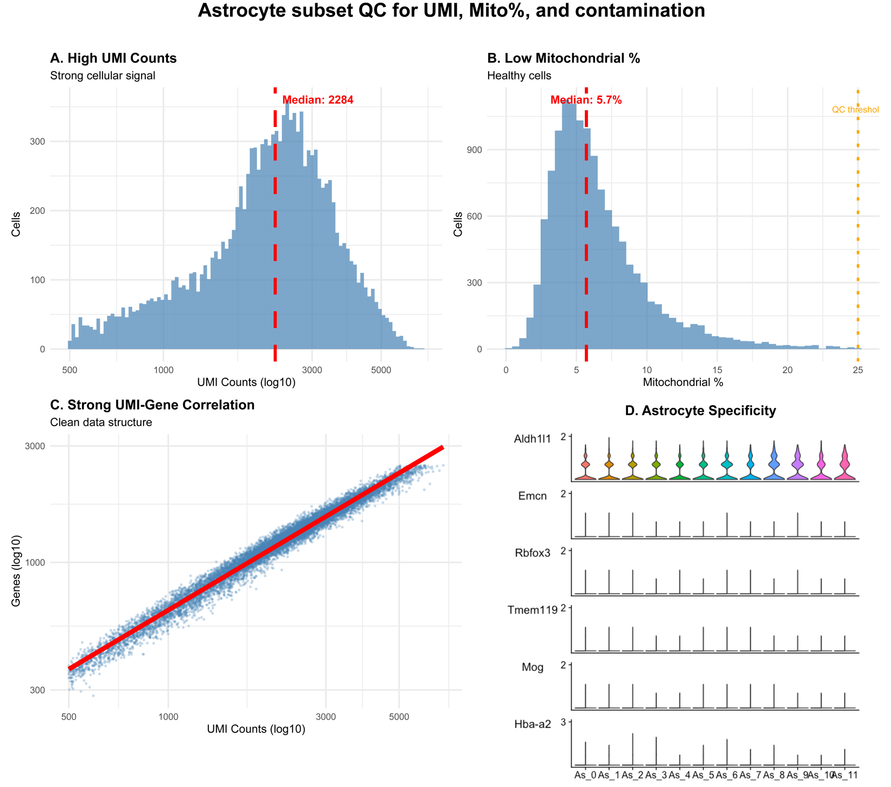

Supplemental Figure 2. Quality control metrics demonstrate high astrocyte purity and cellular integrity. Quality control analysis of the computationally isolated astrocyte population (13,130 cells) confirms robust data quality with minimal contamination. (A) Histogram of UMI counts across all astrocyte cells shows strong cellular signal with a median of 2,284 UMIs per cell (red dashed line), indicating robust transcript capture and adequate sequencing depth. (B) Distribution of mitochondrial gene percentage demonstrates healthy, viable cells with a median of 5.7% mitochondrial content (red dashed line), well below the 25% quality control threshold (orange dashed line). The low mitochondrial percentage excludes apoptotic or dying cells from the analysis. (C) Strong linear correlation between UMI counts and genes detected (red trend line) confirms clean data structure without evidence of technical artifacts such as doublets, validating adequate sequencing saturation across the full range of cellular complexity. (D) Violin plots of cell-type-specific marker expression across all 12 astrocyte clusters (As_0 through As_11). The canonical astrocyte marker Aldh1l1 shows robust and uniform expression across all clusters. In contrast, markers for contaminating cell types including vascular cells (Emcn), neurons (Rbfox3), microglia (Tmem119), oligodendrocytes (Mog), and erythrocytes (Hba-a2) are absent or expressed at negligible levels. These metrics collectively validate the high quality and astrocyte-specificity of the single-cell dataset, demonstrating successful computational isolation with minimal ambient RNA contamination or cellular cross-contamination.

