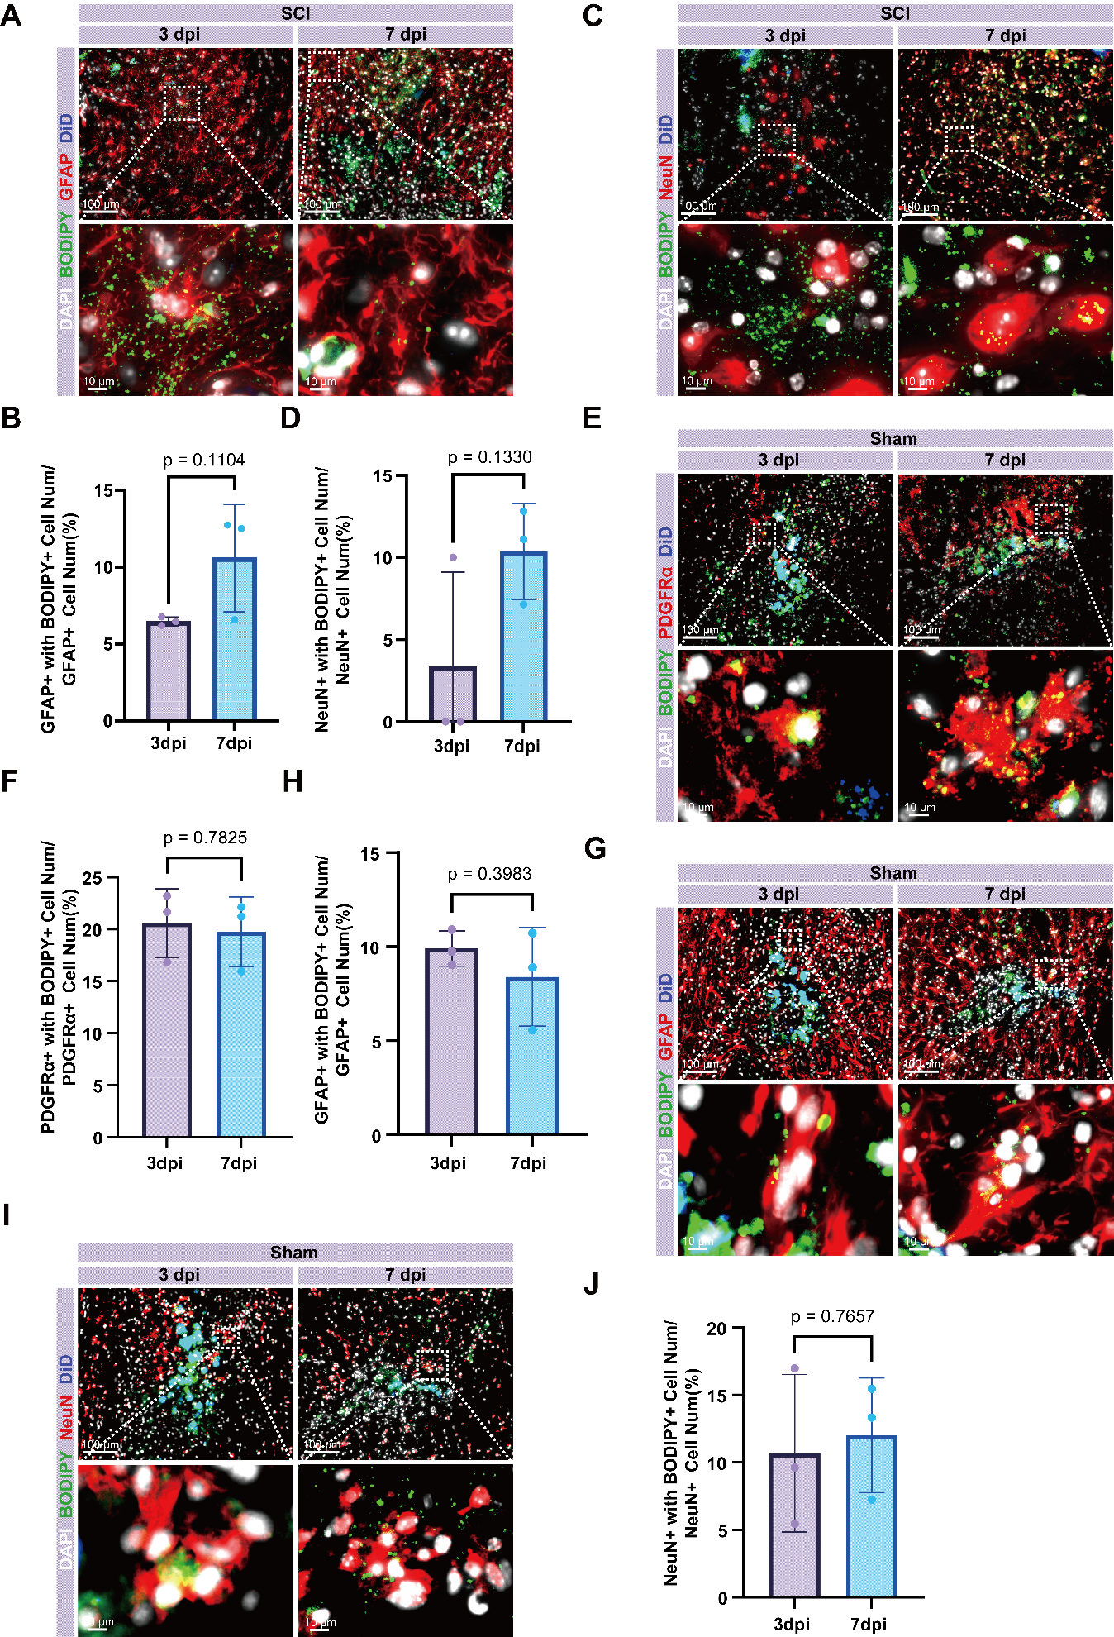
Supplementary Figure 1. Macrophage transfer lipids to fibroblasts, astrocytes, and neurons under both sham and SCI conditions. (A) Representative immunofluorescence images of the spinal cord in SCI mice following intraspinal microinjection of BMDMs loaded with BODIPY-labeled lipid droplets (BMDM@LDs@BODIPY). Images show the colocalization of macrophage-derived BODIPY+ LDs (BODIPY, green) with astrocytes (GFAP, red). (B) Quantification of the percentage of GFAP+ astrocytes containing BODIPY+ LDs in SCI conditions. (C) Images show the colocalization of macrophage-derived BODIPY+ LDs (BODIPY, green) with neurons (NeuN, red). (D) Quantification of the percentage of NeuN+ neurons containing BODIPY+ LDs in SCI conditions. (E) Representative immunofluorescence images of the spinal cord in sham mice following intraspinal microinjection of BMDMs loaded with BODIPY-labeled lipid droplets (BMDM@LDs@BODIPY). Images show the colocalization of macrophage-derived BODIPY+ LDs (BODIPY, green) with fibroblast (PDGFRα, red). (F) Quantification of the percentage of PDGFRα+ fibroblast containing BODIPY+ LDs in sham conditions. (G) Images show the colocalization of macrophage-derived BODIPY+ LDs (BODIPY, green) with astrocytes (GFAP, red). (H) Quantification of the percentage of GFAP+ astrocytes containing BODIPY+ LDs in sham conditions. (I) Images show the colocalization of macrophage-derived BODIPY+ LDs (BODIPY, green) with neurons (NeuN, red). (J) Quantification of the percentage of NeuN+ neurons containing BODIPY+ LDs in sham conditions. For all the data are presented as mean ± SD, n = 3, two-tailed Student's t-test. Scale bars, 100 μm (upper), 10 μm (lower).

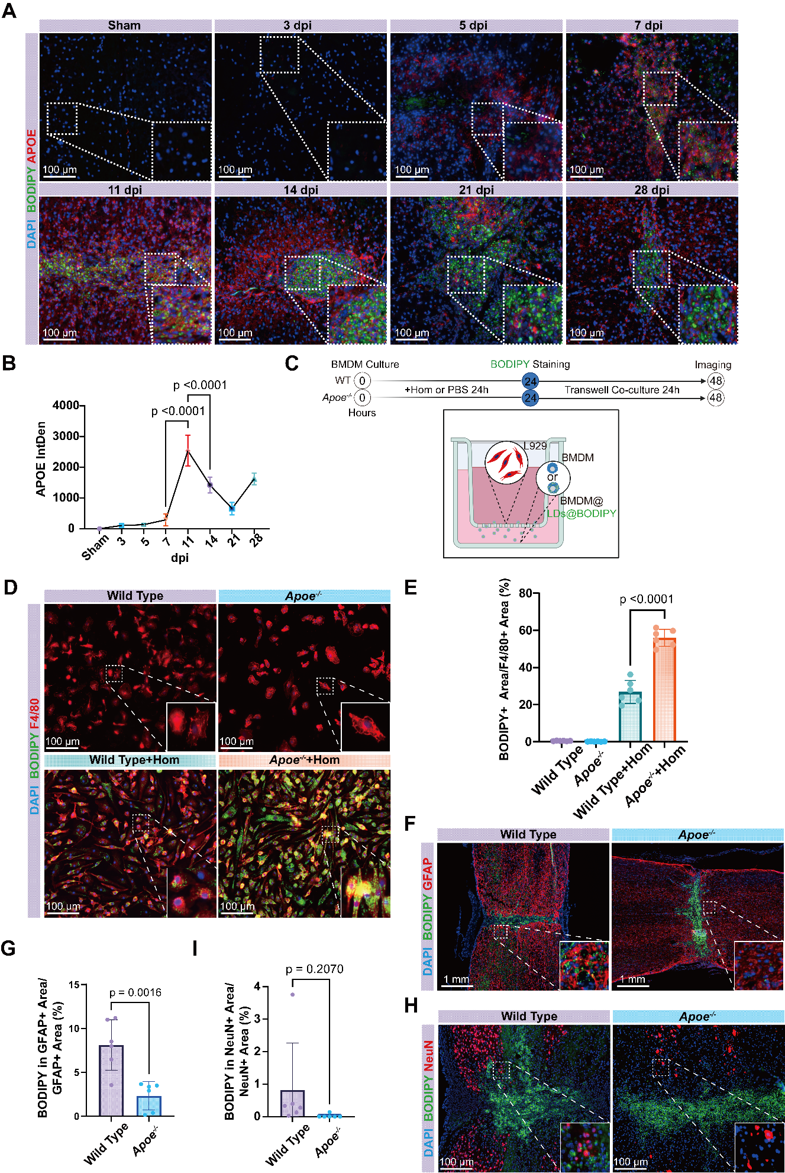
Supplementary Figure 2. Spatiotemporal expression of APOE after SCI and schematic of the in vitro co-culture system. (A) Time-course analysis of APOE protein expression (red) by immunofluorescence staining from sham to 28 dpi. BODIPY (green) labels lipid droplets. (B) Quantification of APOE IntDen over time, showing a peak at 11 dpi. Data are presented as mean ± SD, n = 3, one-way ANOVA with Tukey’s post-hoc test. (C) Schematic diagram of the in vitro Transwell co-culture system used to compare LDs transfer from WT and Apoe^{-/-} BMDMs to L929 fibroblasts. (D) In vitro evidence showing greater retention of BODIPY+ LDs (green) in Apoe^{-/-} BMDMs (F4/80, red) compared to WT BMDMs after co-culture with L929 fibroblasts. (E) Quantification of the intracellular BODIPY+ area in BMDMs from (D). Data are presented as mean ± SD, n = 6, one-way ANOVA with Tukey’s post-hoc test. (F) Representative sections at 11 dpi reveal fewer BODIPY+ LDs (green) in GFAP+ astrocytes (red) surrounding the epicenter in Apoe^{-/-} mice compared with WT littermates. (G) Quantitative analysis of the data shown in (F). Data are presented as mean ± SD, n = 6, two-tailed Student's t-test. (H) Adjacent sections demonstrate a concomitant reduction in NeuN+ neuronal (red) BODIPY+ LDs (green) in the perilesional area of Apoe^{-/-} mice relative to WT controls at 11 dpi. (I) Quantitative summary of the findings presented in (H). Data are presented as mean ± SD, n = 6, two-tailed Student's t-test.
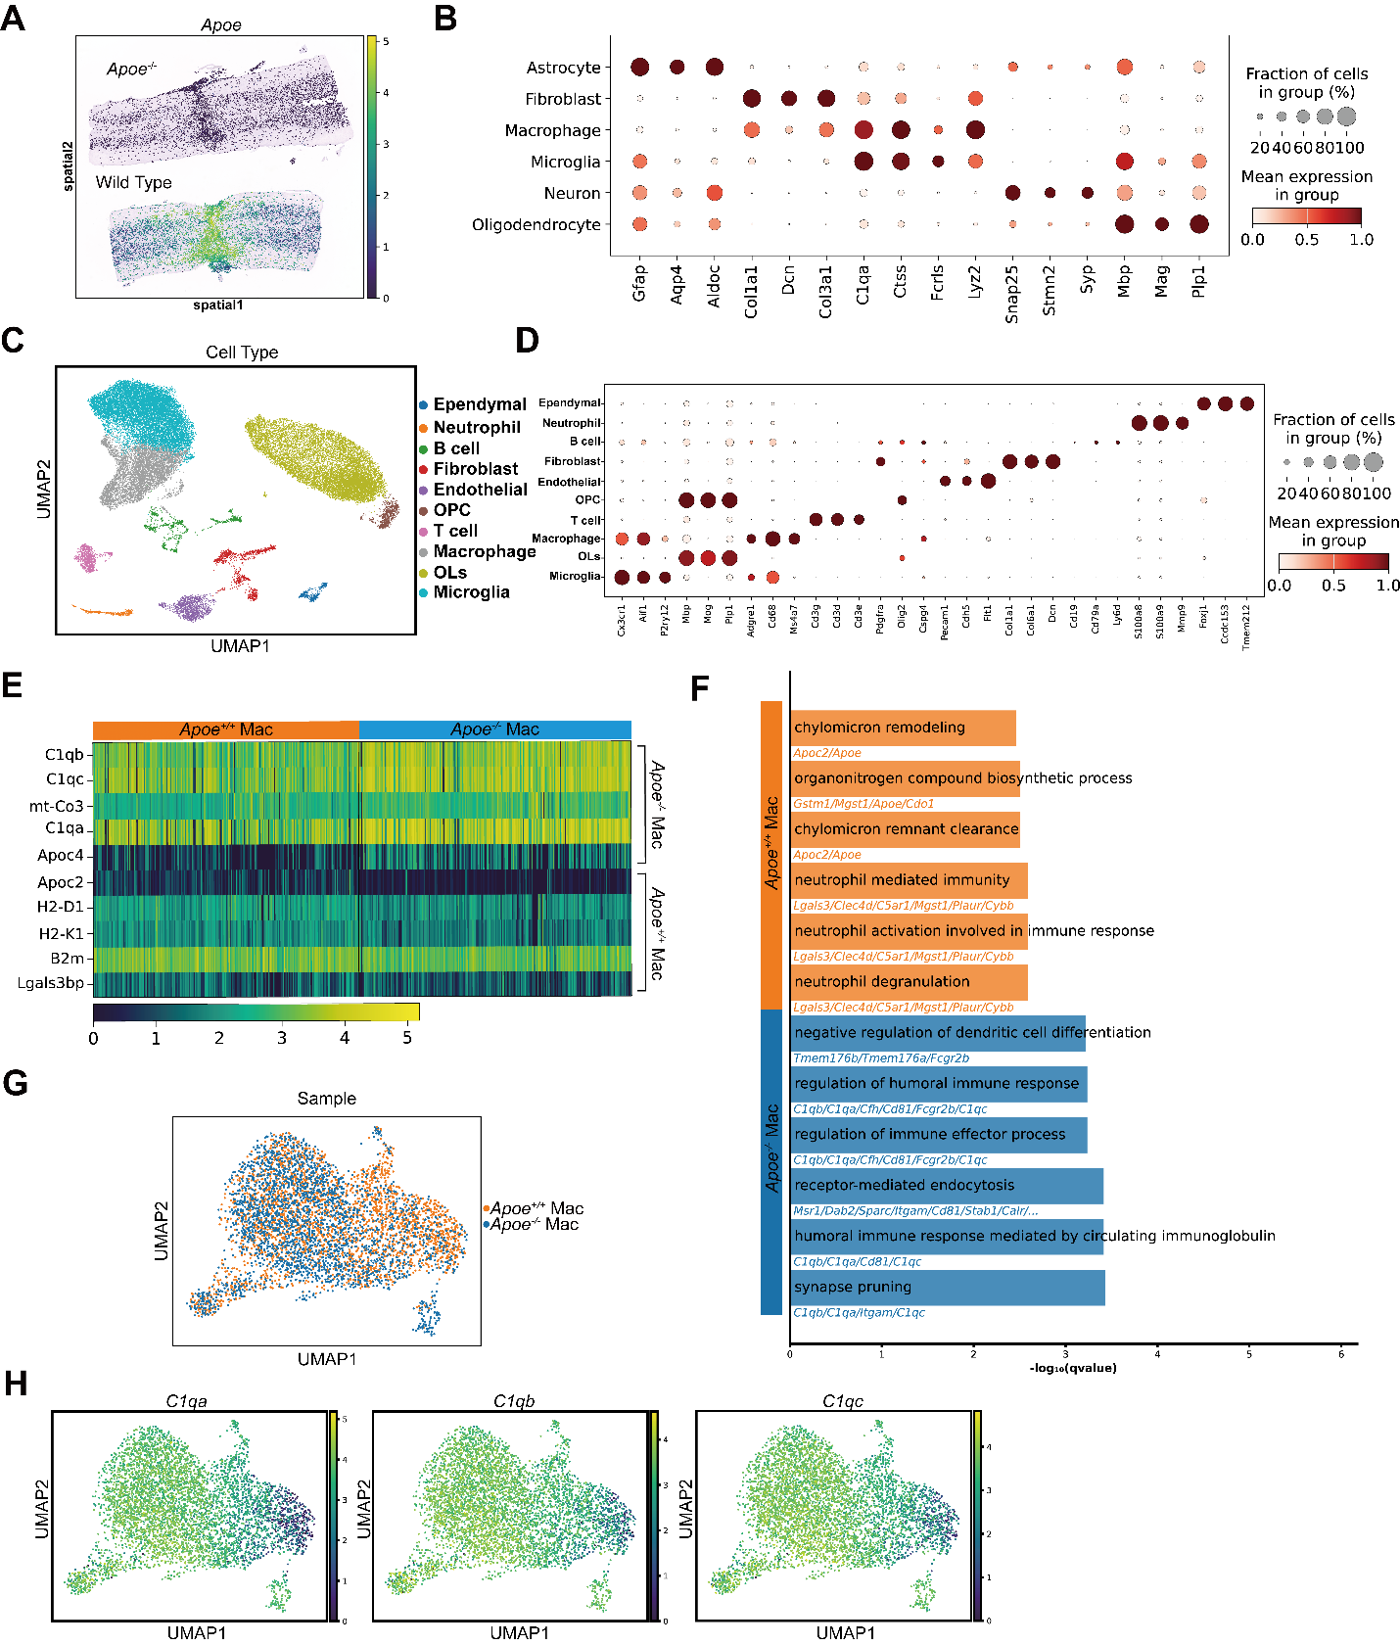
Supplementary Figure 3. Supporting data for spatial and single-cell RNA sequencing analyses. (A) Spatial transcriptomics plot showing the expression of Apoe, confirming its absence in Apoe^{-/-} spinal cord and its localized expression in the lesion epicenter of WT spinal cord. (B) Dot plot of canonical marker genes used for cell type annotation in the spatial transcriptomics data. (C) UMAP plot of integrated single-cell RNA sequencing (scRNA-seq) data, showing distinct cell clusters. (D) Dot plot of marker genes used for cell type annotation in the scRNA-seq data. (E) Heatmap of top differentially expressed genes in macrophages from scRNA-seq, confirming the upregulation of complement genes in Apoe^{-/-} Mac. (F) GO analysis of upregulated genes in Apoe^{-/-} Mac from scRNA-seq data. (G) UMAP plot showing macrophage populations separated by sample origin (Apoe^{+/+} vs. Apoe^{-/-}). (H) Feature plots showing the expression of C1qa, C1qb, and C1qc overlaid on the UMAP, demonstrating higher expression in the Apoe^{-/-} macrophage population.

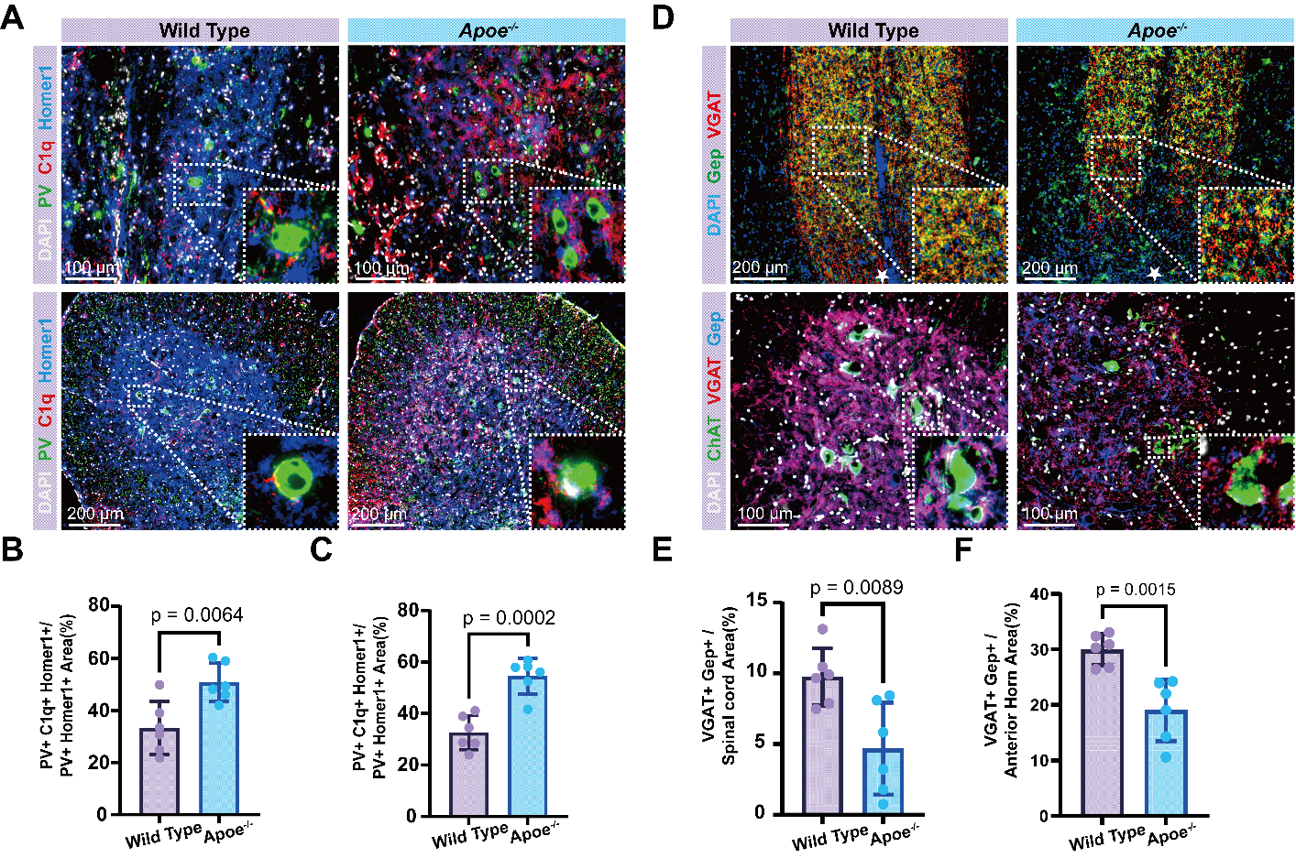
Supplementary Figure 4. Increased PV+ synapse tagging and reduced inhibitory synaptic density in Apoe^{-/-} mice. (A) Representative immunofluorescence images showing the colocalization of PV (green), C1q (red), and Homer1 (blue) in the perilesional area and the lumbar walking executive center’s anterior horn. (B, C) Quantification of the frequency of C1q-tagged excitatory synapses on PV+ neurons (PV+C1q+Homer1+/PV+Homer1+) in the perilesional area (B) and the lumbar walking executive center’s anterior horn (C). (D) Representative immunofluorescence images showing the density of inhibitory synapses. Sections were stained for Gephyrin and VGAT in the perilesional area and the lumbar walking executive center’s anterior horn. Note the reduction in VGAT+/Gephyrin+ puncta in Apoe^{-/-} mice. (E, F) Quantification of inhibitory synaptic density (VGAT+/Gephyrin+) in the perilesional area (E) and the lumbar walking executive center’s anterior horn (F). For all the data are presented as mean ± SD, n = 6 biologically independent animals for histological analyses, two-tailed Student's t-test. Scale bars are indicated in the images.
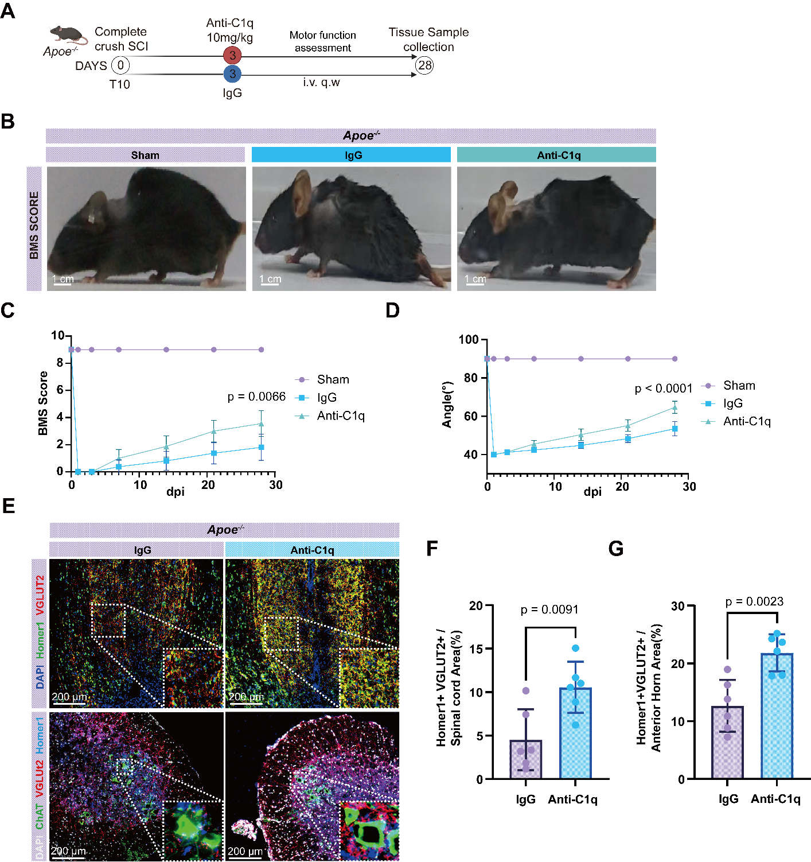
Supplementary Figure 5. Anti-C1q antibody treatment rescues synaptic density and promotes functional recovery in Apoe^{-/-} mice. (A) Schematic diagram illustrating the experimental protocol for Anti-C1q neutralizing antibody treatment in Apoe^{-/-} mice following SCI. I.v., intravenous. Q.w, once a week. (B) Representative BMS test performance images from Sham, IgG-treated, and Anti-C1q-treated Apoe^{-/-} mice. (C) BMS scores. Anti-C1q treatment significantly improved locomotor function compared to the IgG control group. (D) Assessment of angle using the Inclined Plane test. Data are presented as mean ± SD, n = 6 biologically independent animals for behavioral assessments, two-way ANOVA with Tukey’s post-hoc test. (E) Representative triple immunofluorescence images of excitatory synapses in the perilesional area and the anterior horn of the lumbar enlargement. Sections were stained for ChAT, VGLUT2, and Homer1. Note the preservation of VGLUT2+Homer1+ excitatory synaptic density in Anti-C1q-treated mice compared to IgG-treated controls. (F, G) Quantification of excitatory synaptic density (VGLUT2+Homer1+) in the perilesional area (F) and in the lumbar walking executive center’s anterior horn (G). Data are presented as mean ± SD, n = 6 biologically independent animals for histological analyses, two-tailed Student's t-test. Scale bars are indicated in the images.
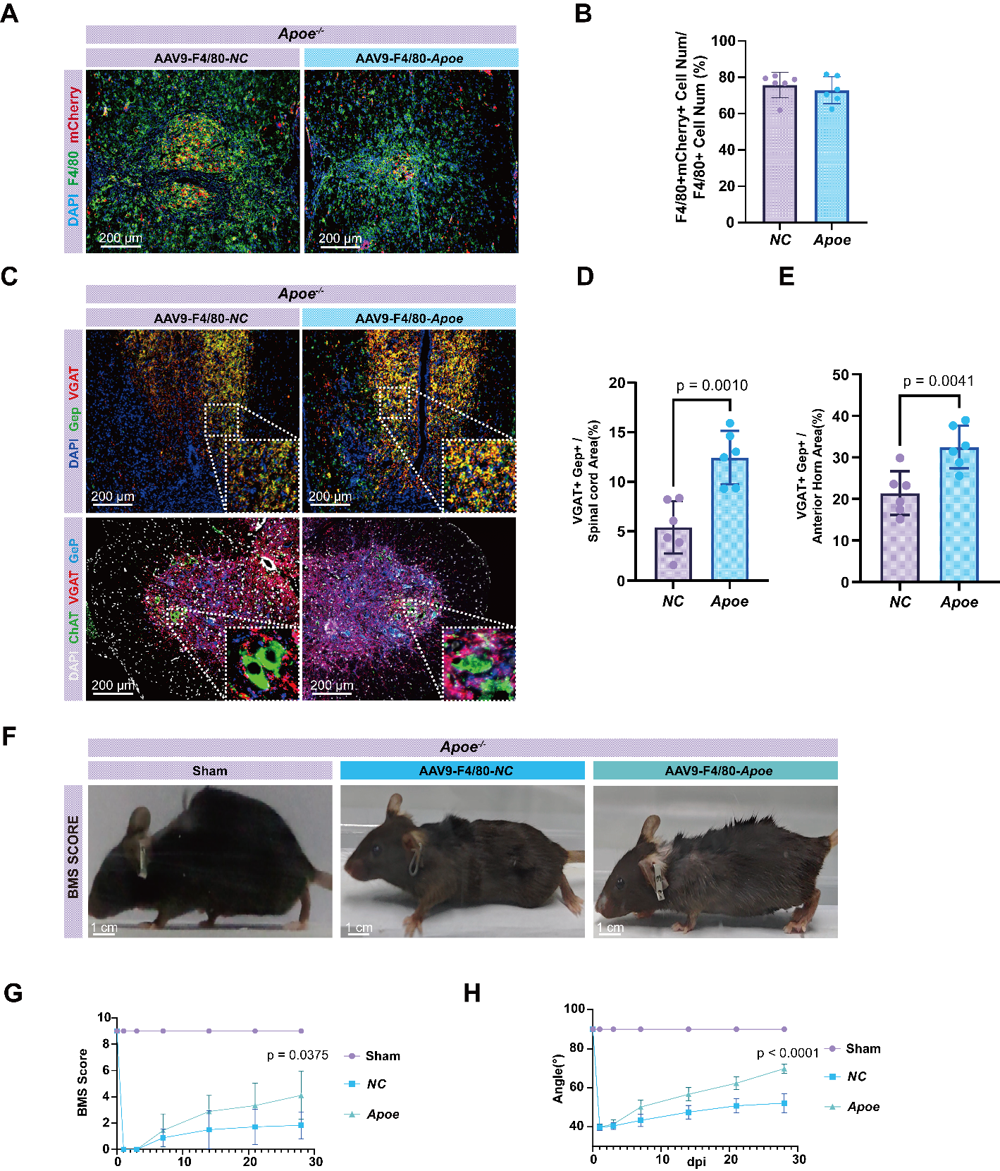
Supplementary Figure 6. Infection efficiency, synaptic density rescue and functional recovery following macrophage-specific APOE re-expression in Apoe^{-/-} mice. (A) Representative images showing mCherry expression (red) in F4/80+ macrophages (green) in the lesion core, demonstrating successful AAV transduction. (B) Quantification of the percentage of F4/80+ macrophages expressing mCherry, showing high transduction efficiency for both control (NC) and Apoe-expressing AAVs. Data are presented as mean ± SD. n = 6, two-tailed Student's t-test. (C-E) APOE re-expression significantly rescued inhibitory synaptic density in the perilesional area (D) and in the lumbar walking executive center’s anterior horn (E). Data are presented as mean ± SD. n = 6, two-tailed Student's t-test. (F-H) Functional analysis showing improved locomotor recovery in Apoe^{-/-} mice treated with AAV9-F4/80-Apoe-mCherry compared to the NC group. (F) Representative images. (G) BMS scores, (H) Inclined plane test results. Data are presented as mean ± SD, n = 9, two-way ANOVA with Tukey’s post-hoc test. Normality and homogeneity of variances were verified by Shapiro–Wilk and Levene’s tests, respectively, before two-way ANOVA. Scale bars are indicated in the images.

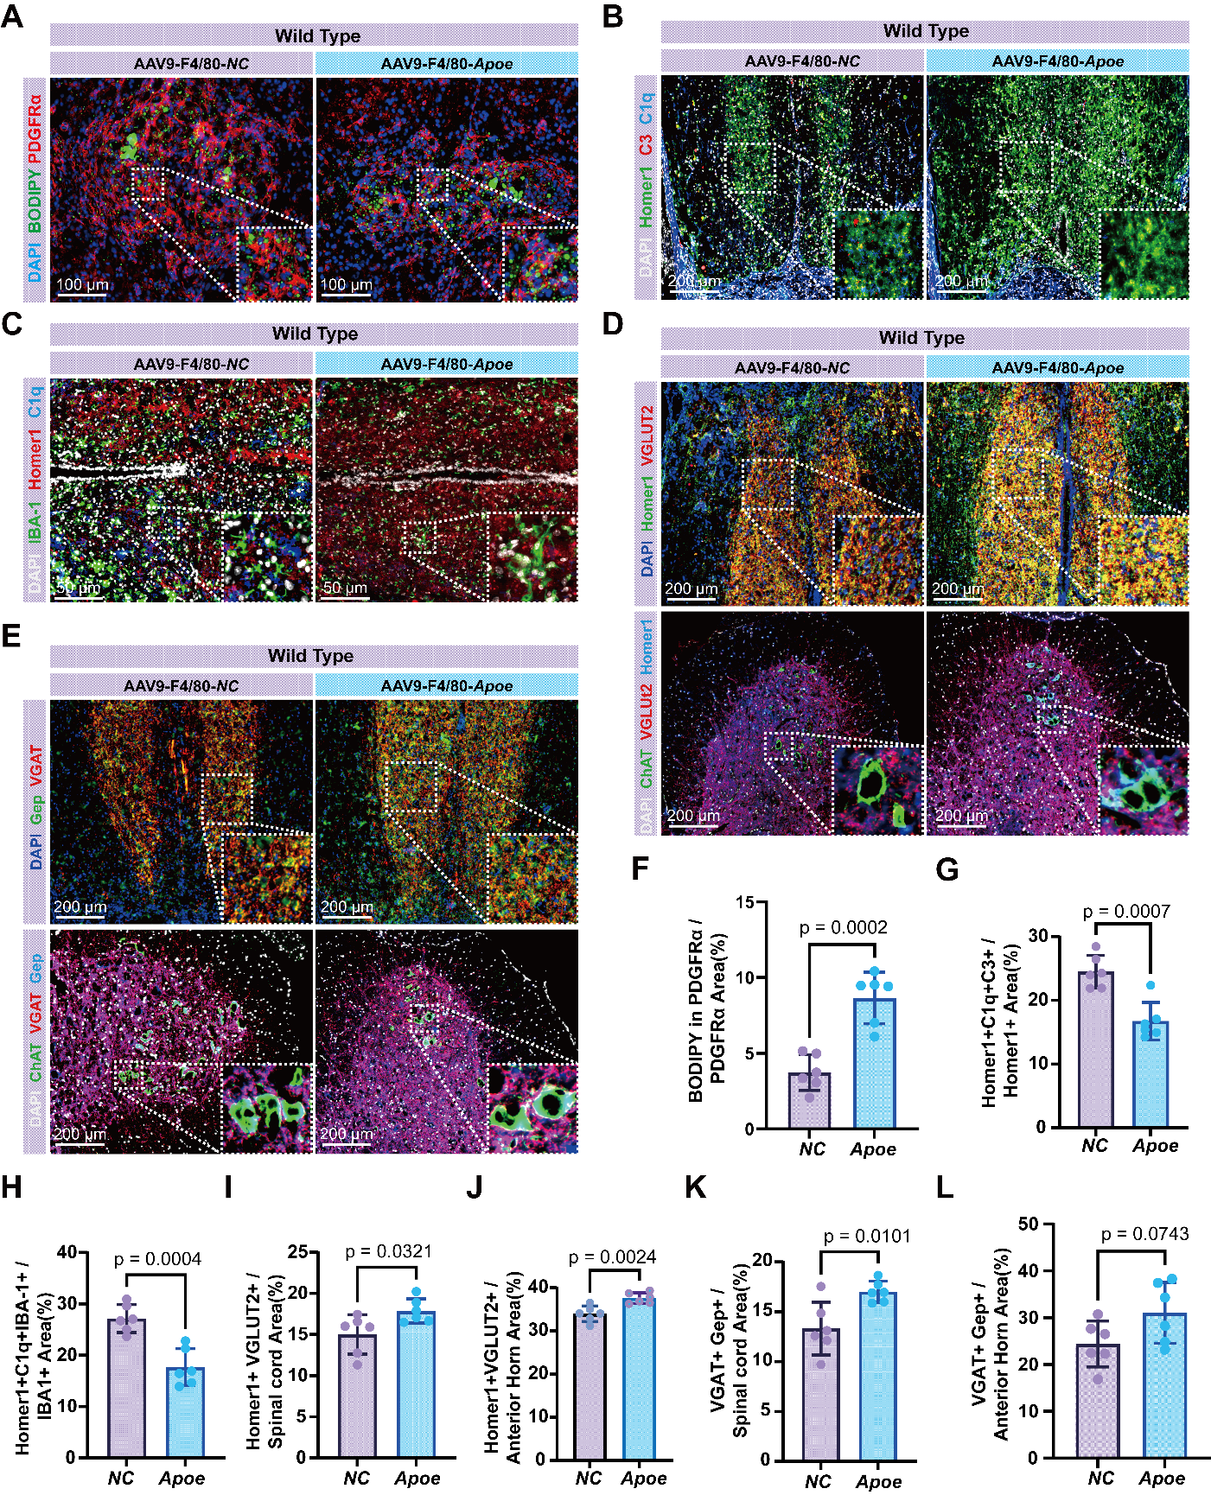
Supplementary Figure 7. APOE overexpression in wild-type mice reduces synaptic pruning and preserves synaptic density. (A) APOE overexpression in WT mice led to increased LDs transfer from macrophages to fibroblasts, shown by increased BODIPY+ area in PDGFRα+ cells. (B) Overexpression reduced complement C1q(blue)/C3(red) tagging on synapses (Homer1, green). (C) Engulfment of synapses by microglia (IBA-1, green) was decreased. (D) Excitatory synaptic density (VGLUT2, Homer1) was significantly preserved in both the spinal cord peri-lesion area and the lumbar walking executive center’s anterior horn. (E) APOE overexpression increased the density of inhibitory synapses (VGAT, Gephyrin) in the perilesional area and the lumbar walking executive center’s anterior horn. (F) Quantification of the data shown in (A). (G) Quantification of the data shown in (B). (H) Quantification of the data shown in (C). (I, J) Quantification of the data shown in (D). (K, L) Quantification of the data shown in (E). (F-L) Data are presented as mean ± SD, n = 6, two-tailed Student's t-test. Scale bars are indicated in the images.

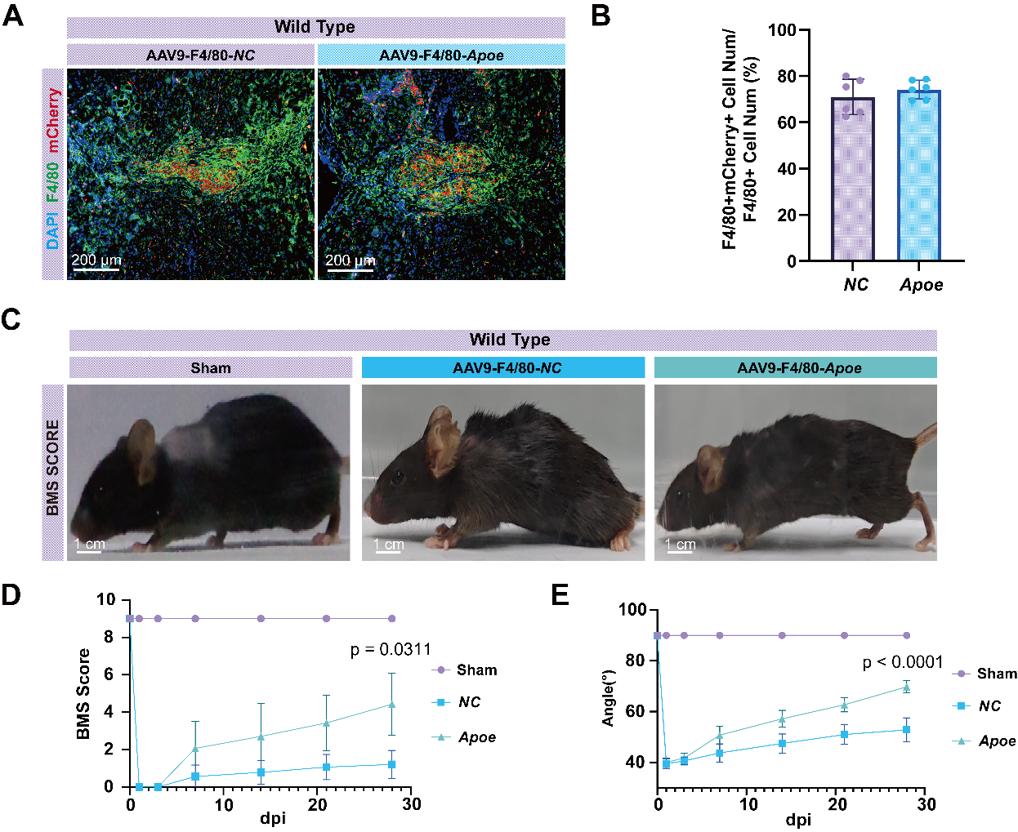
Supplementary Figure 8. Infection efficiency and functional recovery following macrophage-specific APOE overexpression in WT mice. (A) Representative images showing successful AAV transduction (mCherry, red) in F4/80+ macrophages (green) of WT mice. (B) Quantification of transduction efficiency. Data are presented as mean ± SD, n = 6, two-tailed Student's t-test. (C-E) Functional tests demonstrating that APOE overexpression in WT mice also significantly improved locomotor recovery compared to the control AAV group. (C) Representative images. (D) BMS scores, (E) Inclined plane test results. Data are presented as mean ± SD, n = 7, two-way ANOVA with Tukey’s post-hoc test. Normality and homogeneity of variances were verified by Shapiro–Wilk and Levene’s tests, respectively, before two-way ANOVA. Scale bars are indicated in the images.

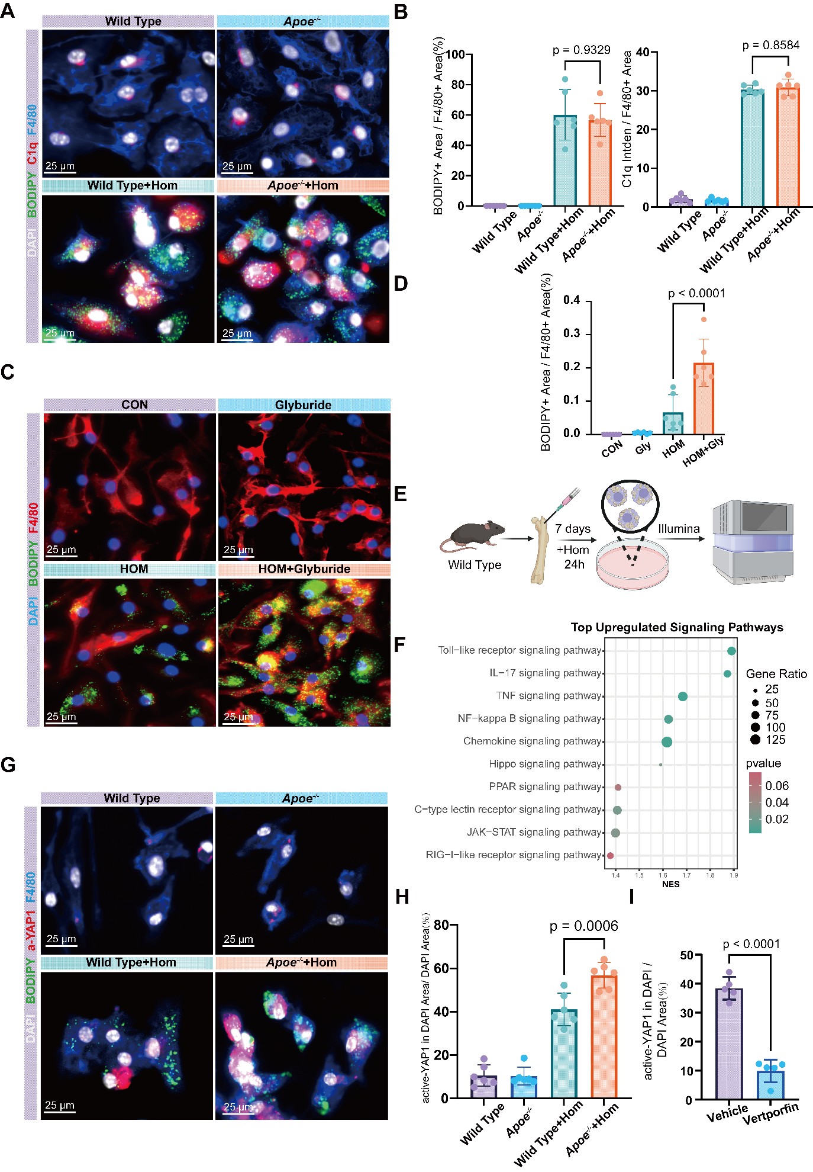
Supplementary Figure 9. Bulk RNA-seq analysis identifies the Hippo pathway as a candidate linking lipid stress to C1q expression. (A, B) Representative immunofluorescence images and quantification showing that in a single-culture system (without L929 fibroblasts), HOM stimulation induced comparable levels of intracellular lipid droplets (BODIPY, green) and C1q expression (red) in both WT and Apoe^{-/-} macrophages. (C, D) Assessment of intracellular lipid retention following pharmacological inhibition of lipid efflux. Treatment with Glyburide (100uM) significantly increased the accumulation of intracellular lipid droplets in HOM-stimulated BMDMs compared to the vehicle-treated HOM group. (E) Schematic diagram of the experimental design for bulk RNA sequencing of BMDMs stimulated with HOM for 24 hours. (F) KEGG enrichment analysis of upregulated genes in HOM-stimulated BMDMs. The dot plot highlights the top enriched signaling pathways, including the Hippo signaling pathway. Gene Ratio indicates the percentage of upregulated genes falling into a pathway, and NES represents the normalized enrichment score. (G, H) Representative immunofluorescence images (G) and quantification (H) of active-YAP1 (red) nuclear translocation in F4/80+ macrophages (green) in an in vitro co-culture system. Apoe^{-/-} macrophages exhibited significantly increased nuclear active-YAP1 compared to WT controls. (I) Verteporfin treatment significantly reduced the nuclear accumulation (colocalization with DAPI) of active-YAP1. For (B), (D), (H), data are presented as mean ± SD, n = 6. Statistical significance was determined by one-way ANOVA with Tukey’s post-hoc test. For (I), Data are presented as mean ± SD, n = 5. Statistical significance was determined by two-tailed Student's t-test. Normality and homogeneity of variances were verified by Shapiro–Wilk and Levene’s tests, respectively, before one-way ANOVA. Scale bars are indicated in the images.

