Fig. S1 Flow cytometric analysis and gating strategy of retinal leukocytes and T cells. (A) Representative images of flow cytometric analysis of CD45⁺ leukocytes in the retina among the control, VD–deficiency, EAU, and VD-deficient EAU group. (B) The gating strategy for retinal T cells in EAU mice, and VD-deficient EAU mice.
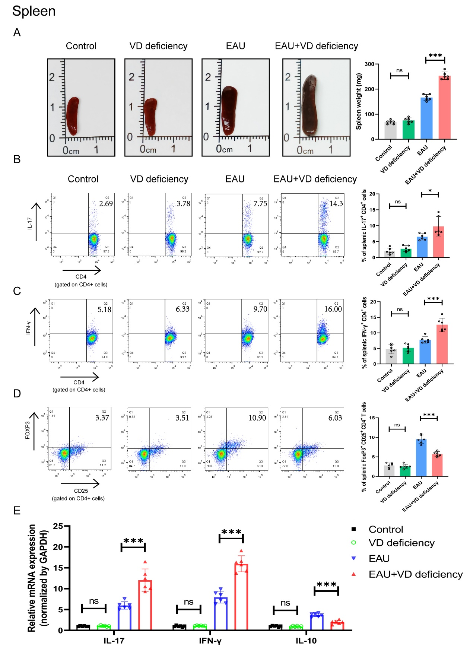
Fig. S2 Vitamin D deficiency altered the effector and regulatory T-cell balance in the spleen. (A) Representative images and quantitative results of the spleens for each group on day 14 post-immunization. (B) Flow cytometry analysis performed on day 14 post-immunization showing the frequency of Th17 cells. (C) Flow cytometry analysis performed on day 14 post-immunization showing the frequency of Th1 cells. (D) Flow cytometry analysis performed on day 14 post-immunization showing the frequency of Tregs. (E) RT-qPCR analysis of the IL-17, IFN-γ, and IL-10 mRNA expression in mononuclear cells isolated from spleens on day 14 post-immunization. *P < 0.05, ***P < 0.001, ns, not statistically significant, one-way ANOVA.

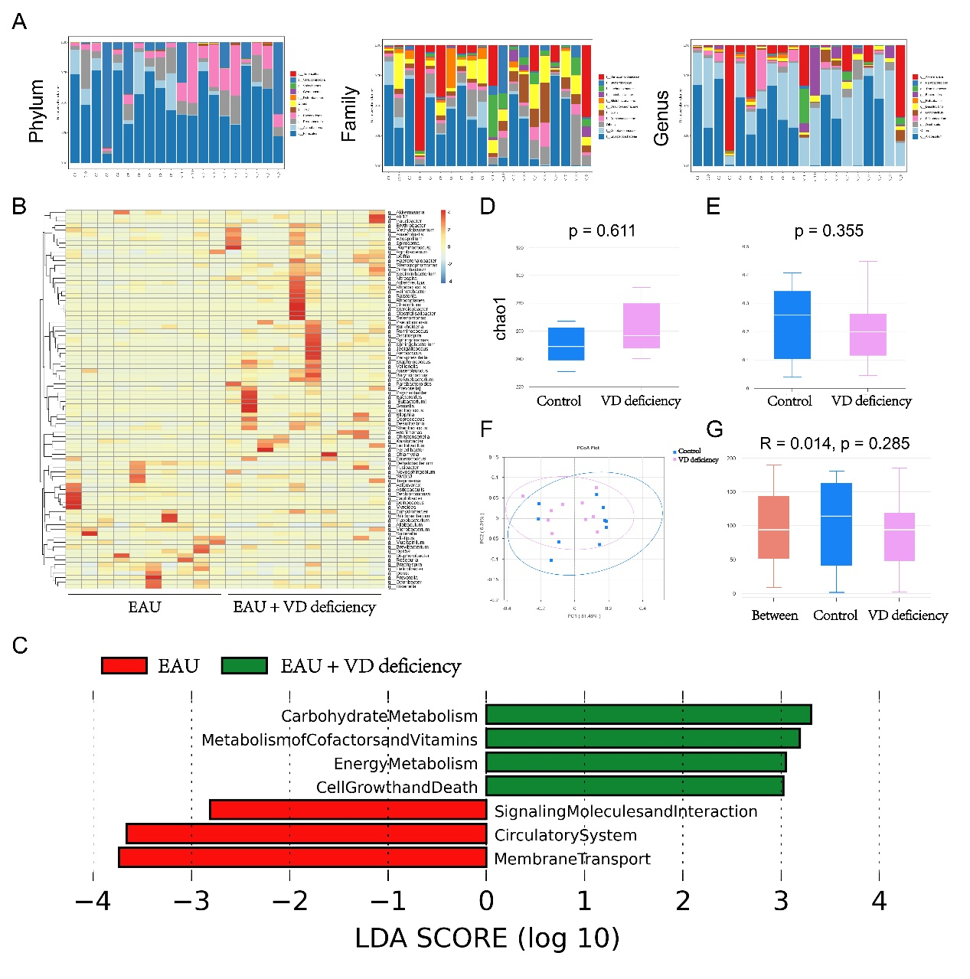
Fig. S3 Vitamin D deficiency altered gut microbiota composition in the feces of EAU. (A) The taxonomic distribution at the phylum, family, and genus levels in the EAU and VD deficient EAU group. (B) The taxa heatmap of clustering distribution in the two groups at the genus level. (C) The KEGG function prediction result based on LEfSe analysis. The green nodes indicate the functional items that play an important role in the VD-deficient EAU group, and the red nodes in the tree branches indicate the functional items that play an important role in the EAU group. (D) The α-diversity analysis of the control and VD-deficiency groups. (E) The β-diversity analysis of the control and VD-deficiency groups. (F) The principal-coordinate analysis (PCoA) of the control and VD-deficiency groups. (G) The ANOSIM analysis between the control and VD-deficiency groups (n = 10/group).

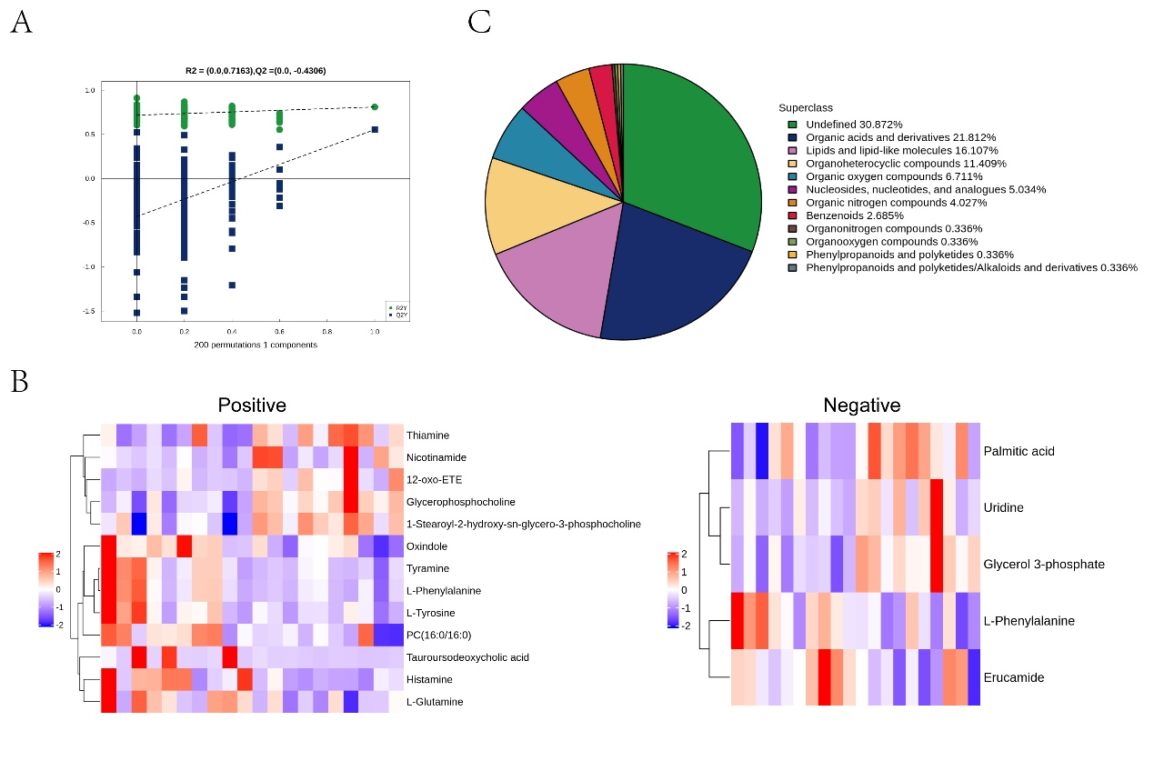
Fig. S4 Vitamin D deficiency altered plasma metabolites in EAU. (A) The analysis of permutation tests with 200 iterations. (B) Hierarchical heatmap analysis showed the clustering distribution of differential metabolites in positive and negative ion modes. (C) The superclass pie chart displayed the proportion of identified metabolites in each chemical classification.

Table S1
The sequences.
Name | Sequence | species
GAPDH forward | GGTTGTCTCCTGCGACTTCA | mouse
GAPDH reverse | TGGTCCAGGGTTTCTTACTCC | mouse
IFN-γ forward | CTGCTGATGGGAGGAGATGT | mouse
IFN-γ reverse | TTTGTCATTCGGGTGTAGTCA | mouse
IL-17A forward | GGACTCTCCACCGCAATGA | mouse
IL-17A reverse | TCAGGCTCCCTCTTCAGGAC | mouse
IL-10 forward | TGCACTACCAAAGCCACAAG | mouse
IL-10 reverse | TGATCCTCATGCCAGTCAGT | mouse
Occludin forward | CTTTGGCTACGGAGGTGGCTAT | mouse
Occludin reverse | CTTTGGCTGCTCTTGGGTCTG | mouse
Claudin-1 forward | GCTGGGTTTCATCCTGGCTTCT | mouse
Claudin-1 reverse | CCTGAGCGGTCACGATGTTGTC | mouse
Claudin-3 forward | ACCAACTGCGTACAAGACGAG | mouse
Claudin-3 reverse | CAGAGCCGCCAACAGGAAA | mouse
LRAT forward | CCGTCCCTATGAAATCAGCTC | mouse
LRAT reverse  IL-6 forward  IL-6 reverse  CXCL1 forward  CXCL1 reverse  CXCL2 forward  CXCL2 reverse  APOA forward  APOA reverse  APOB forward  APOB reverse  RBP2 forward  RBP2 reverse  ARAT forward  ARAT reverse | ATGGGCGACACGGTTTTCC  CGGCCTTCCCTACTTCACAA  GCAAGTGCATCATCGTTGTTC  CCCAAACCGAAGTCATAGCC  CAGGTGCCATCAGAGCAGTC  CCCAGACAGAAGTCATAGCCA  AGTTAGCCTTGCCTTTGTTCA  AAGACACTTGGCGAGAAAGC  ATCACACTCTGGACTTGGGT  AAGTCTACAGGTCAATGCTGAAC  CACGGGCTACTCTCTGGAAA  ATCGCAGTGCGTCTGACTC  GGTGAAATCCAGGTCGTAGTTG  TTGACTGGAAGACCCCTGAG  TCACCATCTTGAGTGGGAAGTA | mouse
GAPDH forward | ACTCCTCCACCTTTGACGCT | human
GAPDH reverse | TCCACCACCCTGTTGCTGTA | human
LRAT forward | CGAGCACTTCGTGACCTACT | human
LRAT reverse | AGACGCCAATCCCAAGACTG | human
IL-6 forward | CCTGAACCTTCCAAAGATGGC | human
IL-6 reverse | TTCACCAGGCAAGTCTCCTCA | human
CXCL8 forward | TTTTGCCAAGGAGTGCTAAAGA | human
CXCL8 reverse | AACCCTCTGCACCCAGTTTTC | human

TABLE S2
Identified differential metabolites between the EAU and EAU with VD-deficiency group.
Metabolites | VIP | FC | p-value | ESI ± | Class
Glycerophosphocholine | 14.96 | 0.47 | 0.00085 | + | Glycerophospholipids
Glycerol 3-phosphate | 1.24 | 0.45 | 0.00141 | − | Glycerophospholipids
1-Stearoyl-2-hydroxy-sn-glycero-3-phosphocholine | 25.89 | 0.75 | 0.00202 | + | Glycerophospholipids
Histamine | 1.95 | 1.93 | 0.00321 | + | Organonitrogen compounds
Palmitic acid | 21.06 | 0.79 | 0.00411 | − | Fatty Acyls
Thiamine | 1.18 | 0.73 | 0.00755 | + | Diazines
Oxindole | 1.75 | 1.45 | 0.01075 | + | Notmatcheda
L-Glutamine | 1.3 | 1.22 | 0.01271 | + | Carboxylic acids and derivatives
L-Phenylalanine | 4.23 | 1.5 | 0.01785 | ± | Carboxylic acids and derivatives
Tyramine | 5.3 | 1.46 | 0.01791 | + | Benzene and substituted derivatives
12-oxo-ETE | 1.75 | 0.32 | 0.0251 | + | Notmatcheda
PC(16:0/16:0) | 4.37 | 1.47 | 0.02686 | + | Glycerophospholipids
Nicotinamide | 7.89 | 0.64 | 0.04052 | + | Pyridines and derivatives
Erucamide | 1.67 | 1.44 | 0.04534 | − | Notmatcheda
Tauroursodeoxycholic acid | 1.17 | 9.8 | 0.04918 | + | Steroids and steroid derivatives
Uridine | 3.67 | 0.39 | 0.04927 | − | Pyrimidine nucleosides
L-Tyrosine | 1.54 | 1.57 | 0.04999 | + | Notmatcheda
VIP, variable importance in the projection; FC, fold change; ESI, electrospray ionization.
ªThe detected metabolite could not match a known metabolite in the Human Metabolome Database. P value was calculated by Student’s t-test.

