Supplemental Figures
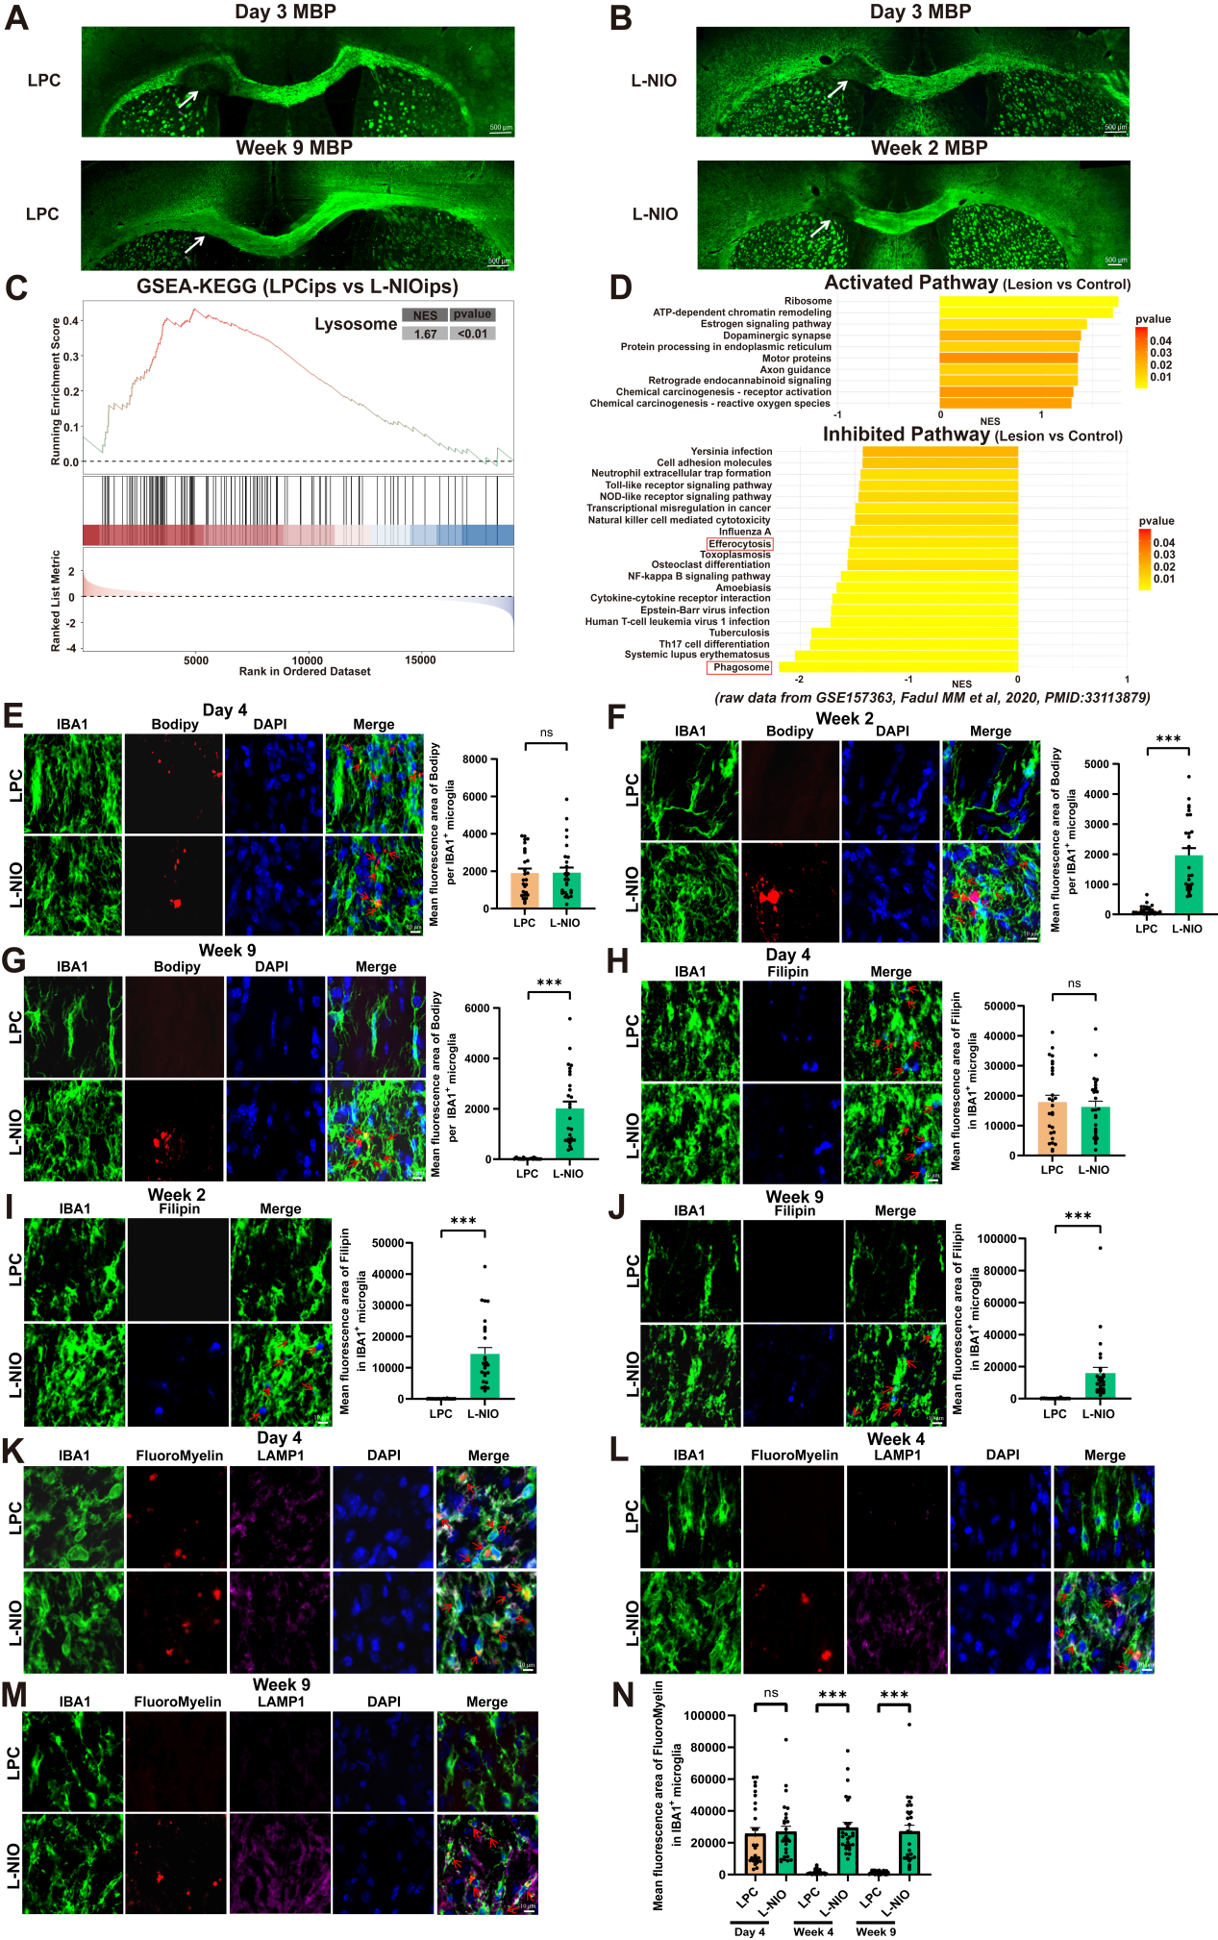
Supplemental Figure 1. Reduced lipid metabolism and myelin debris clearance in WMS-induced irreparable white matter lesions versus LPC-induced reparable lesions.
A & B) Representative images of demyelinated lesions (indicated by MBP staining) at 3 days and 2 or 9 weeks after LPC-induced repair injury or L-NIO-induced WMS (3 biological replicates per group). Scale bars, 500μm. C) GSEA revealed the upregulation of the lysosome pathway in LPC-induced lesions (LPCips) vs. L-NIO-induced ischemic lesions (L-NIOips), NES > 0, p < 0.01. D) GSEA revealed the activated and inhibited pathways in periventricular white matter lesions derived from patients vs. control tissues (raw data from GSE157363), NES > 0 or NES < 0, p < 0.05. E-G) Representative Bodipy staining images and quantitative analyses of neutral lipid (lipid droplet) deposition in white matter lesions at 4 days, 2 weeks, and 9 weeks post-injury induction by LPC or L-NIO (n=27 from 3 biological replicates). Scale bars, 10 μm. Data are presented as mean ± SEM. "ns" = no significance, *** (P < 0.001) by Mann-Whitney test. H-J) Representative Filipin staining images and quantitative analyses of free cholesterol deposition in white matter lesions at 4 days, 2 weeks, and 9 weeks post-injury induction by LPC or L-NIO (n=27 from 3 biological replicates). Scale bars, 10μm. Data are presented as mean ± SEM. "ns" = no significance, *** (P < 0.001) by Mann-Whitney test. K-N) Representative images showing myelin debris (labeled by FluoroMyelin) within microglia in white matter lesions at 4 days, 4 weeks, and 9 weeks after injury induction by LPC or L-NIO (n=27 from 3 biological replicates; LAMP1: lysosomal marker). Scale bars, 10μm. Data represent mean ± SEM. "ns" indicates no significance, *** (P < 0.001) by Mann-Whitney test.

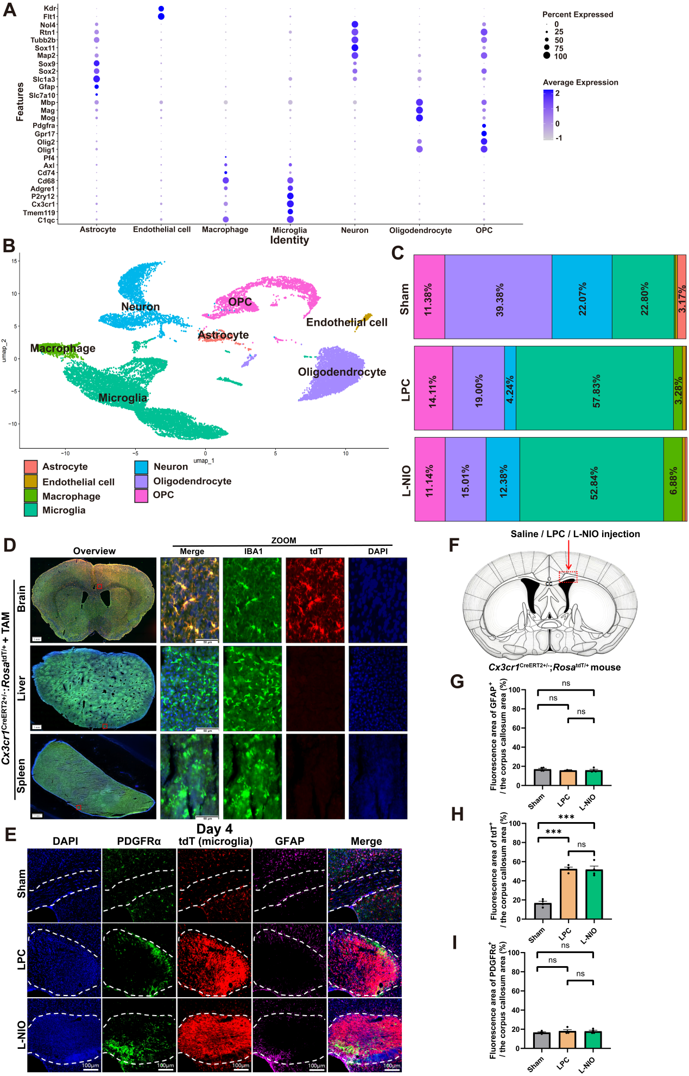

Supplemental Figure 2. Microglial accumulation within white matter lesions after white matter injury
A) Dot plot of the signature marker genes for identifying seven annotated cell types. B) UMAP plots of seven annotated cell types. C) Bar charts of the relative percentages of seven annotated cells across the LPC, L-NIO and Sham groups. D) Representative images showing specific labeling of brain-resident microglia (IBA1⁺), but not peripheral monocytes (IBA1⁺), with tdTomato (tdT) in microglia lineage-tracing mice (Cx3cr1^{CreERT2+/-}: Rosa^{flox/+}) at two weeks post tamoxifen injection. Scale bars, 1mm for overview images, 50μm for zoom images. E - I) Representative images demonstrating a dramatic increase in the density of brain-resident microglia (tdT⁺) at 4 days post-LPC-induced reparable white matter injury and post-L-NIO-induced WMS (n = 4 biological replicates). OPCs (PDGFRα⁺) exhibited moderate accumulation, while astrocytes (GFAP⁺) showed no accumulation within white matter lesions. Scale bars, 100 μm. Data are presented as mean ± SEM. "ns" indicates no significance, *** (P < 0.001) by one-way ANOVA with multiple comparisons.

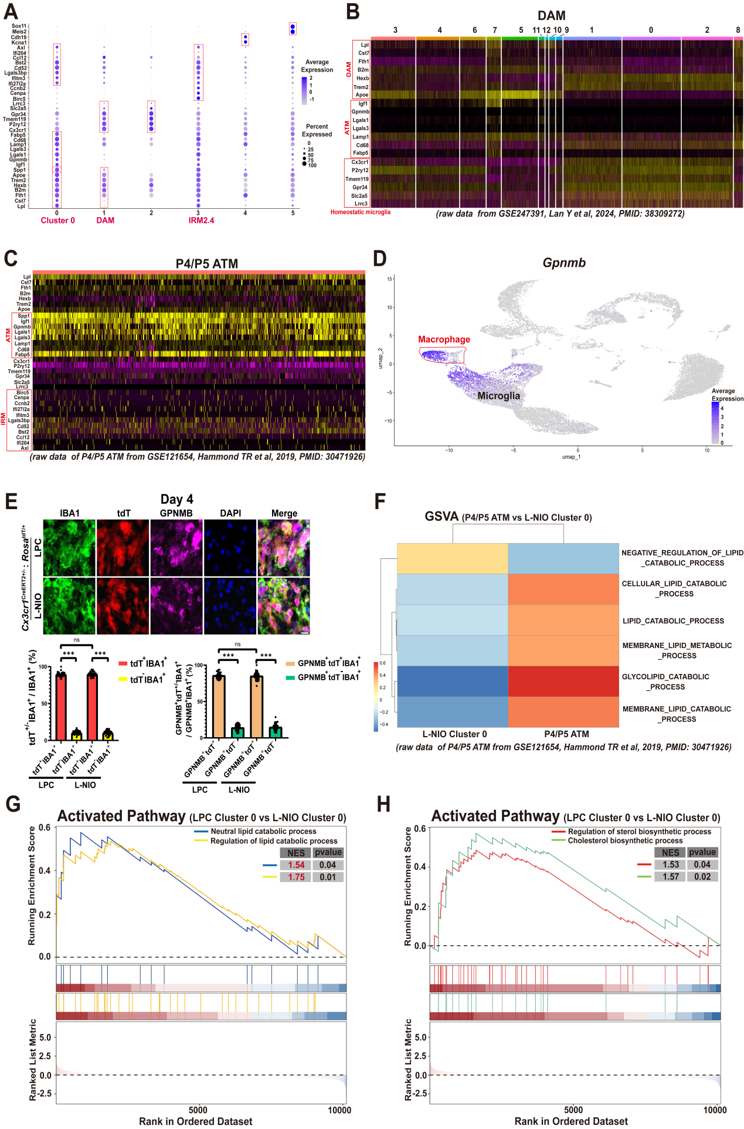

Supplemental Figure 3. GPNMB⁺ microglia displayed context-dependent activities in lipid metabolism following white matter injury
A) Dot plot of signature marker genes used for clustering microglial subtypes. B) Reanalysis of DAMs in the ischemic gray matter (raw sc-RNA data from GSE247391) with the signature marker genes of microglial clusters used in this study. The results show that DAMs do not express the signature genes that cluster 0 microglia share with ATMs. C) Reanalysis of P4/P5 ATMs (raw data from GSE121654) with the signature marker genes of microglial clusters used in this study. These results indicate that ATMs do not express injury-associated signature genes. D) UMAP visualization revealed that Gpnmb was exclusively expressed in cluster 0 microglia and in macrophages among seven annotated cell types across the LPC, L-NIO, and Sham groups, but the proportion of macrophages was markedly lower than that of microglia in white matter lesions. E) Representative images and quantitative analyses reveal a markedly lower density of peripherally infiltrating macrophages (IBA1⁺tdT⁻) compared with brain-resident microglia (IBA1⁺tdT⁺; LPC: 89.72% vs. 10.28%, L-NIO: 89.74% vs. 10.26%). A large proportion of GPNMB⁺IBA1⁺ cells (cluster 0 microglia) were restricted to microglia (tdT⁺IBA1⁺) rather than macrophages (IBA1⁺tdT⁻) in white matter lesions at 4 days post LPC- or L-NIO-induced injury. Scale bars, 10 μm. Data are presented as mean ± SEM; "ns" indicates no significance, *** (P < 0.001) by two-way ANOVA with multiple comparisons. F) Gene set variation analysis (GSVA) revealed the upregulation of lipid metabolism-associated pathways in P4/P5 ATMs (raw sc-RNA data from GSE121654) compared with cluster 0 microglia in L-NIO-induced lesions. G & H) GSEA revealed greater activation of neutral lipid catabolism/lipid catabolism regulatory pathways and cholesterol biosynthesis/regulation of sterol biosynthesis pathways in cluster 0 microglia in LPC-induced lesions than that in cluster 0 microglia in L-NIO-induced irreparable lesions.

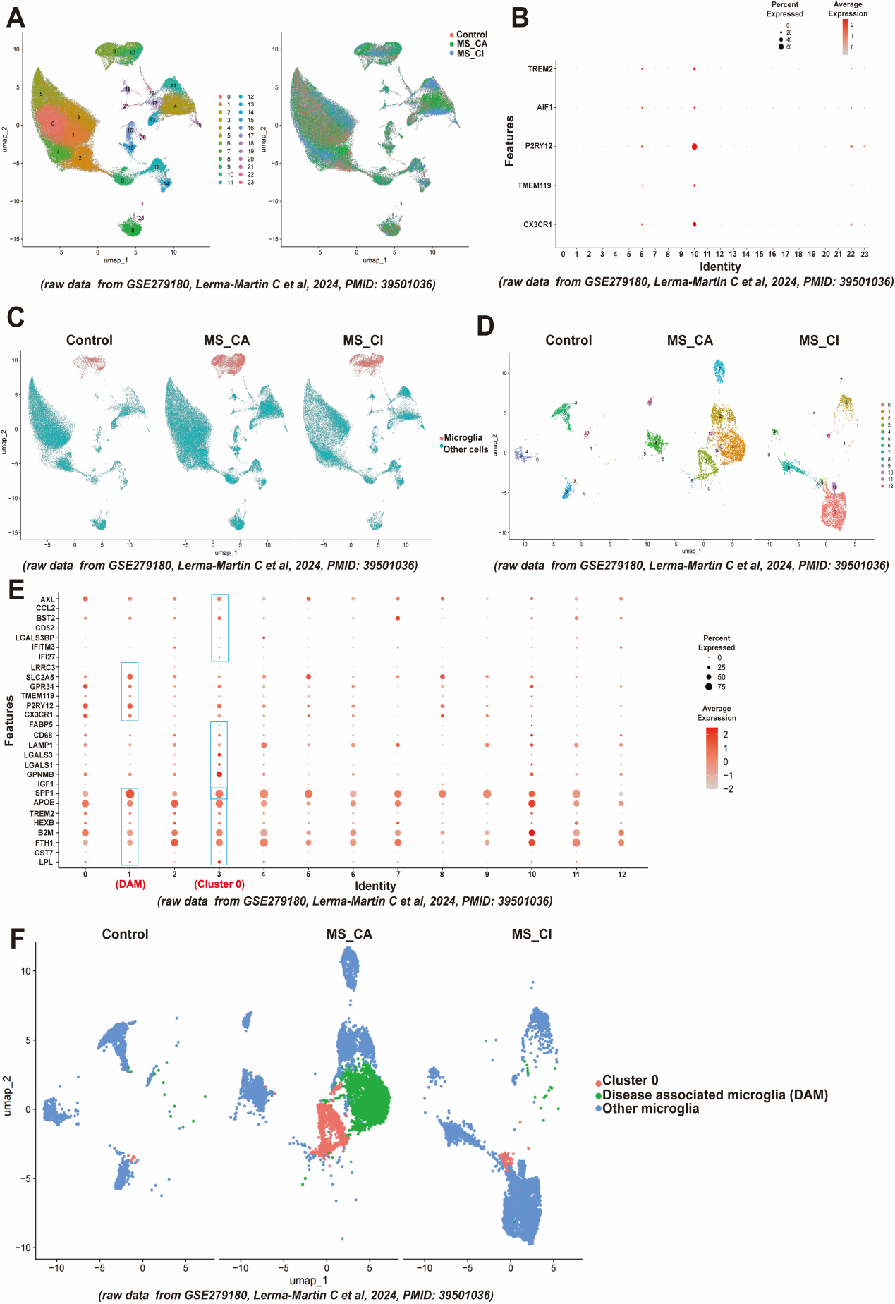

Supplemental Figure 4. A microglial subset with a gene signature analogous to cluster 0 microglia is present in active white matter lesions from MS patients.
A) UMAP visualization of cellular clusters in control tissues, chronic active white matter lesions (MS_CA) and chronic inactive white matter lesions (MS_CI). Raw snRNA-seq data from GSE279180. B) Dot plot of the signature marker genes used for identifying microglia. C) UMAP plot of microglia and other cell types across the control tissue, MS_CA and MS_CI. D) UMAP plot of microglial subclusters across the control, MS_CA and MS_CI tissues. E) Dot plot of the signature genes used for subclustering microglia. F) UMAP visualization of microglial subclusters across the control, MS_CA and MS_CI tissues.

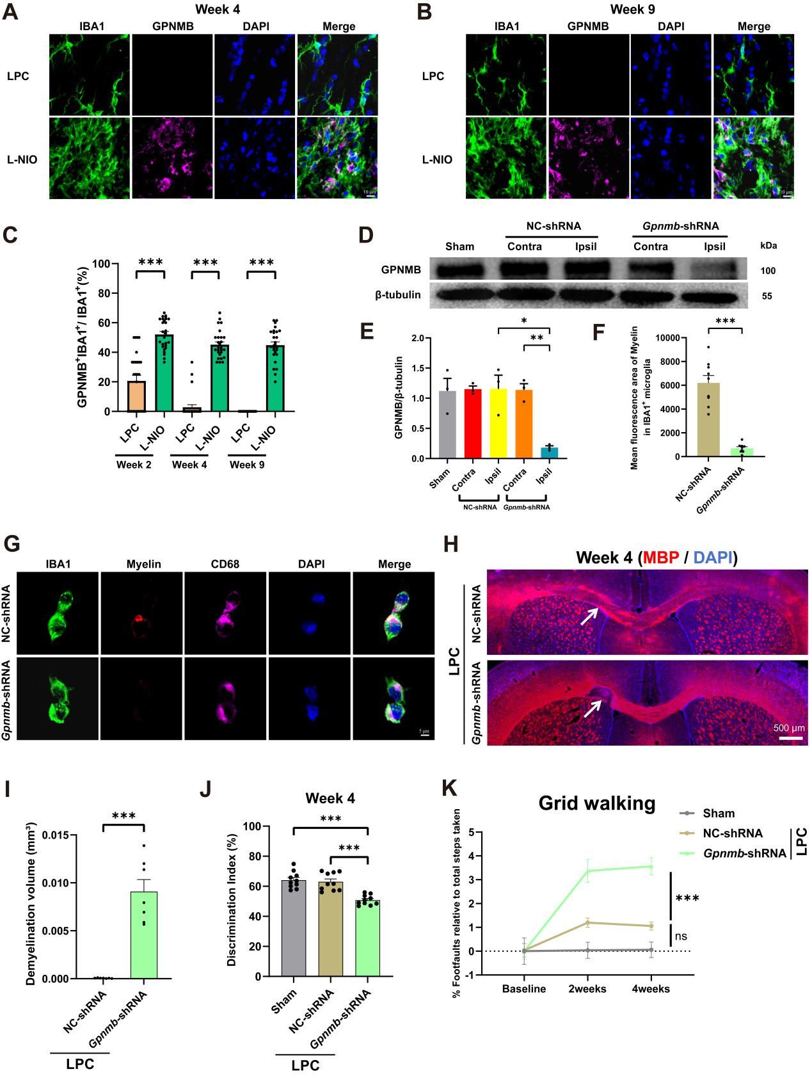

Supplemental Figure 5. Temporal dynamics of GPNMB⁺ microglia and impairment of spontaneous repair following functional depletion of GPNMB⁺ microglia after white matter injury
A-C) Representative images and quantitative analyses show the temporal dynamics of GPNMB⁺ microglia (GPNMB⁺IBA1⁺) in white matter lesions at 4 and 9 weeks after LPC- and L-NIO-induced injury (n=27 from 3 biological replicates). GPNMB⁺ microglia were comparably induced at 4 days after LPC-induced reparable and L-NIO-induced irreparable injury (see Fig. 2I–J), but exhibited distinct dynamics: they resolved by 2 weeks post-injury in the reparable LPC model (undetectable thereafter), yet remained persistently elevated at all time points in irreparable L-NIO-induced lesions (Fig. 2I–J and panels A-C). Scale bars, 10μm. Data represent mean ± SEM. *** (P < 0.001) by Mann-Whitney test. D & E) GPNMB protein levels in the contralateral (Contra) and virus-injected ipsilateral (Ipsil) corpus callosum at 14 days post-injection of Gpnmb-shRNA-expressing lentivirus or control lentivirus (NC-shRNA); n=3. Data represent mean ± SEM. * (P < 0.05), ** (P < 0.01) by two-way ANOVA with multiple comparisons. F & G) Representative images and quantitative analyses of internalized myelin debris in BV2 microglia transfected with Gpnmb-shRNA relative to control BV2 microglia transfected with control shRNA (n = 9 from 3 biological replicates). Scale bars, 5μm. Data represent mean ± SEM. *** (P < 0.001) by Welch’s t test. H & I) Representative images of demyelinated lesions (assessed by MBP staining with DAPI nuclear counterstain) at 4 weeks post LPC-induced white matter injury (n=7). Lentiviral vectors expressing Gpnmb-shRNA or NC-shRNA were stereotactically injected into the corpus callosum 2 weeks prior to injury induction. Scale bars, 500μm. Data represent mean ± SEM. *** (P < 0.001) by Welch’s t test. J & K) GPNMB knockdown in white matter lesions exacerbated functional deficits in the novel object recognition (NOR) and foot fault tests at 4 weeks post-LPC-induced white matter injury (n = 10). Data represent mean ± SEM. J: *** (P < 0.001) by one-way ANOVA with multiple comparisons. K: "ns" indicates no significance, *** (P < 0.001) by two-way ANOVA with multiple comparisons.

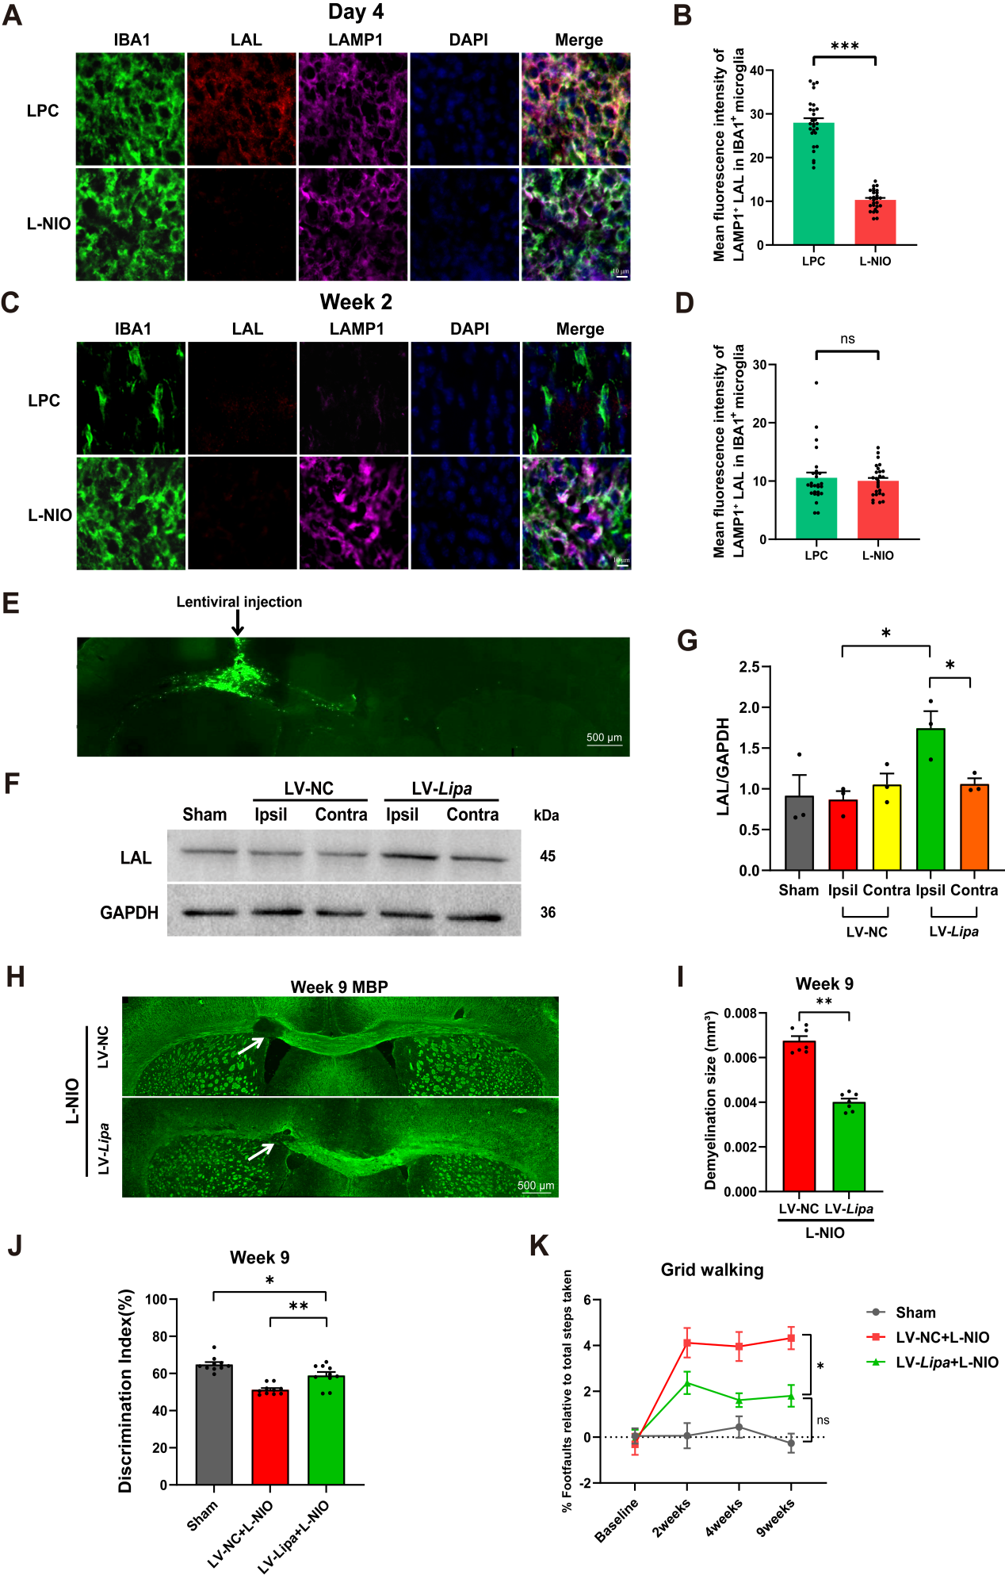

Supplemental Figure 6. Nonspecific overexpression of LAL in white matter lesions promotes repair following WMS
A-D) Representative images and quantitative analyses of LAL expression in microglia lysosomes (IBA1⁺LAMP1⁺) in white matter lesions at 4 days and 2 weeks post LPC- and L-NIO-induced injury (n=27 samples from 3 biological replicates; LAMP1: lysosomal marker). Scale bars: 10 μm. Data are presented as mean ± standard error of the mean (SEM). *** P < 0.001 (Welch’s t-test) for panel B; ns, not significant (Mann-Whitney test) for panel D. E) Representative images of lentiviral infection, as indicated by eGFP expression by lentivirus. Scale bars, 500μm. F & G) Protein levels of LAL in the contralateral (Contra) and ipsilateral (Ipsil) corpus callosum of mice receiving lentivirus expressing LAL and eGFP (LV-Lipa) or control lentivirus (LV-NC). Lentiviruses were injected into the corpus callosum, and tissues were collected at 14 days after injection (n=3). Data represent mean ± SEM. * (P < 0.05) by two-way ANOVA with multiple comparisons. H & I) Representative images of demyelinated lesions (indicated by MBP staining) at 9 weeks following L-NIO-induced WMS (n=7). LV-Lipa and LV-NC were injected into the corpus callosum 2 weeks before WMS induction. Scale bars, 500μm. Data represent mean ± SEM. ** (P < 0.01) by Unpaired t-test. J & K) Improvement in mouse functions in the NOR test and foot fault test by LAL overexpression in the corpus callosum at 9 weeks following L-NIO-induced WMS (n=10). Data represent mean ± SEM. J: * (P < 0.05), ** (P < 0.01) by one-way ANOVA with multiple comparisons. K: "ns" indicates no significance, * (P < 0.05) by two-way ANOVA with multiple comparisons.

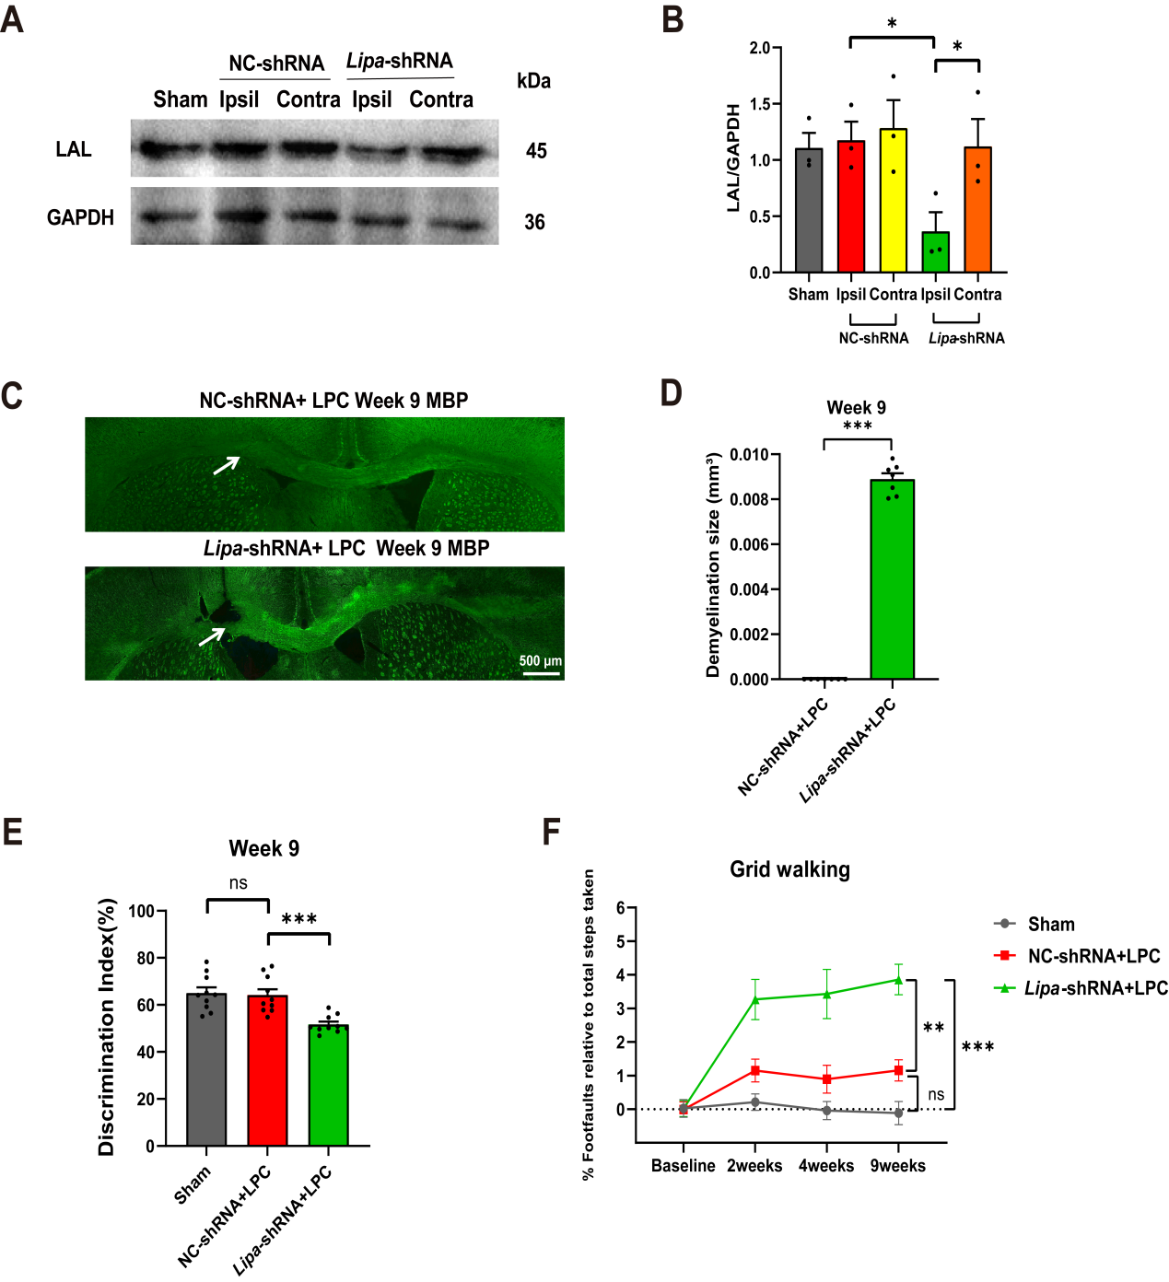

Supplemental Figure 7. LAL knockdown abrogates spontaneous repair following LPC-induced white matter injury
A & B) Protein levels of LAL in the contralateral (Contra) and ipsilateral (Ipsil) corpus callosum in mice receiving lentivirus expressing Lipa-shRNA or control lentivirus (NC-shRNA). Lentiviruses were injected into the corpus callosum, and tissues were collected at 2 weeks after lentiviral injection (n=3). Data represent mean ± SEM. * (P < 0.05) by two-way ANOVA with multiple comparisons. C & D) Representative images of demyelinated lesions (indicated by MBP staining) at 9 weeks following LPC-induced injury (n=7). NC-shRNA or Lipa-shRNA was injected into the corpus callosum 2 weeks before LPC injection. Scale bars, 500μm. Data represent mean ± SEM. *** (P < 0.001) by Unpaired t-test. E & F) The exacerbation of mouse neurologic functions in the NOR test and foot fault test by LAL knockdown in the corpus callosum at 9 weeks following LPC injection (n=10). Data represent mean ± SEM. E: "ns" indicates no significance, *** (P < 0.001) by one-way ANOVA with multiple comparisons. F: "ns" indicates no significance, ** (P < 0.01), *** (P < 0.001) by two-way ANOVA with multiple comparisons.

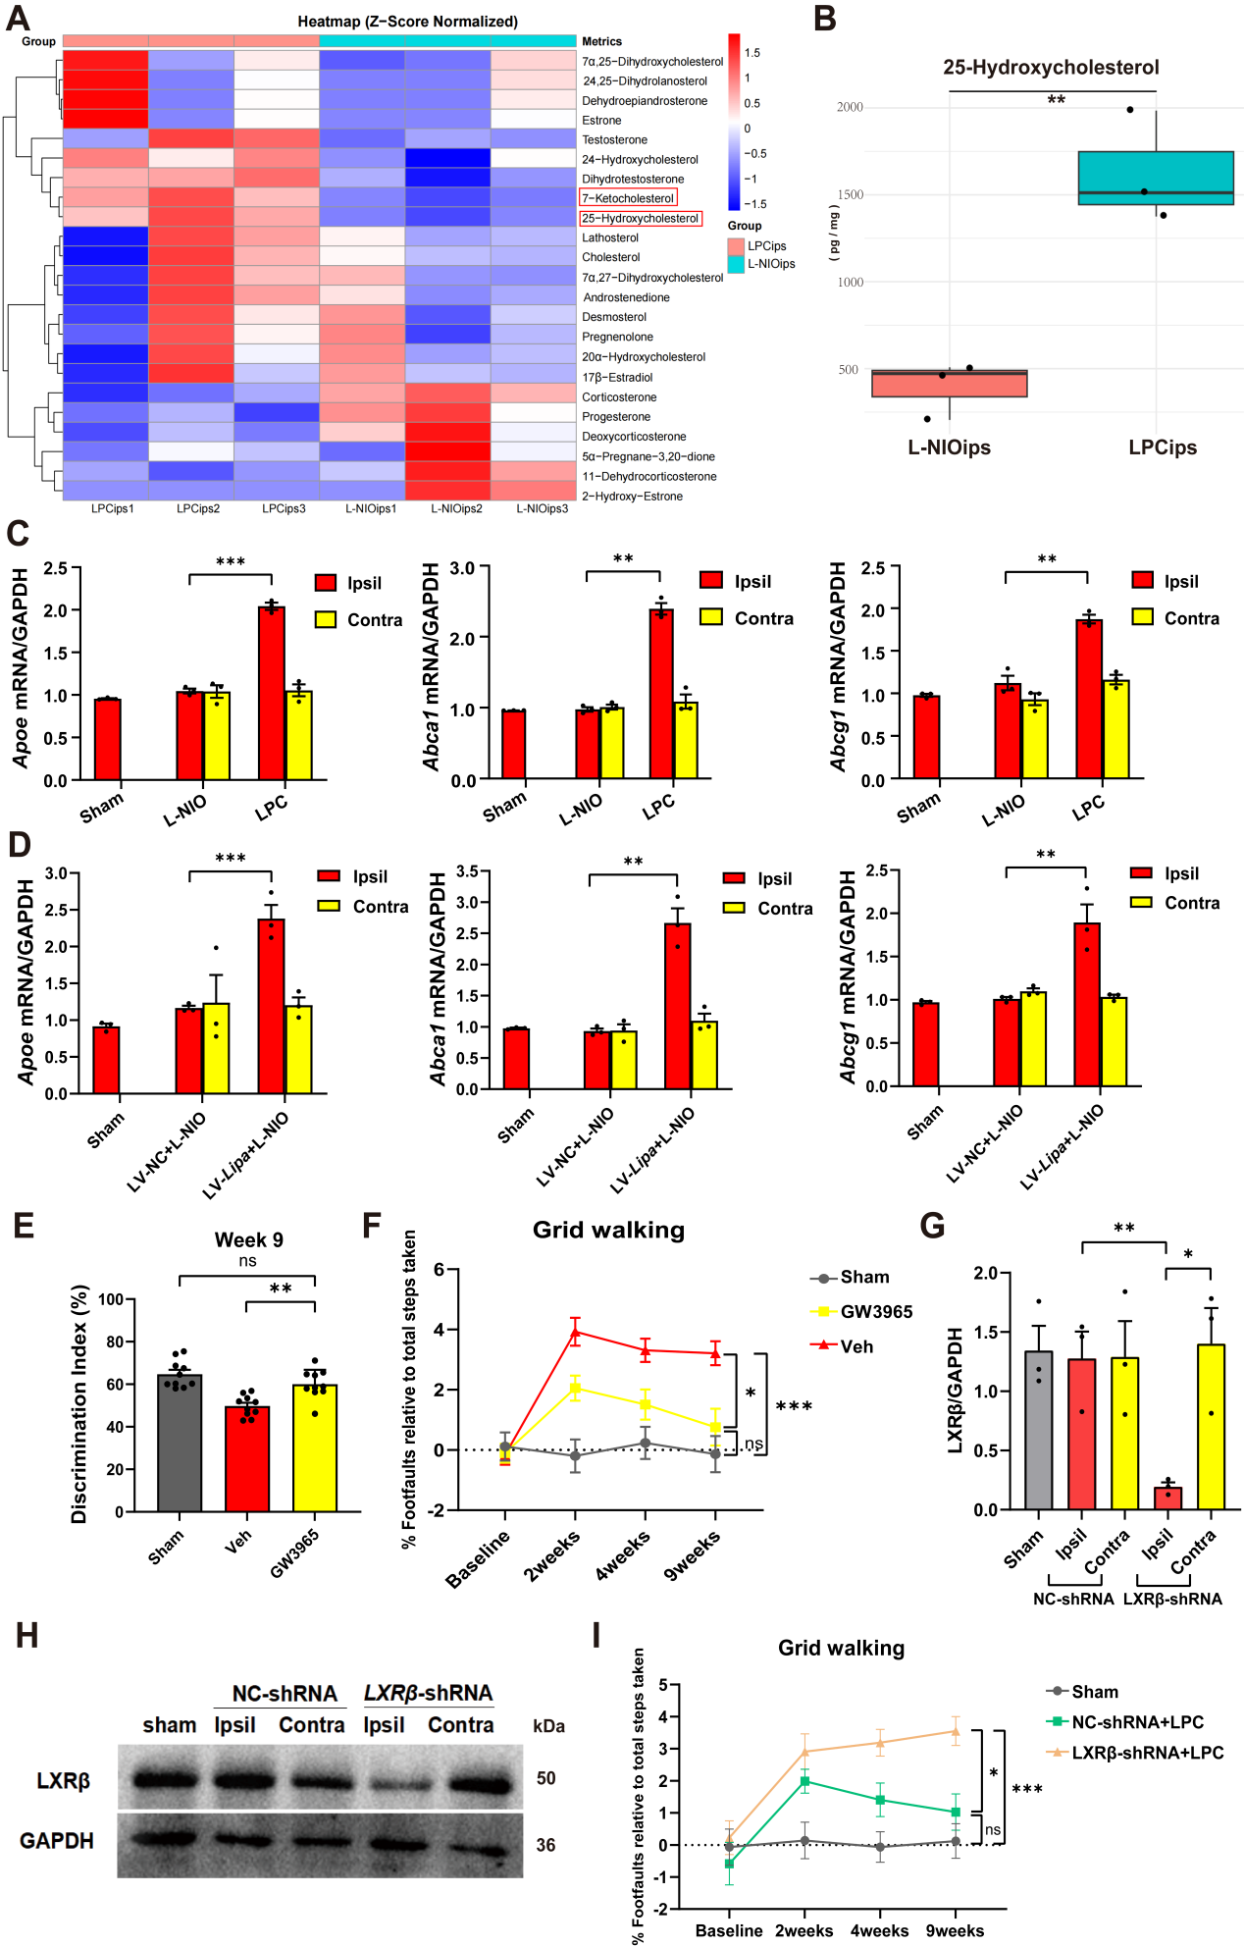

Supplemental Figure 8. LAL-mediated LXR activation is required for functional recovery following white matter injury
A) Heatmap of cholesterol metabolites in LPC-induced (LPCips) and L-NIO-induced white matter lesions (L-NIOips) at 4 days after injury (n=3). B) 25-OHC levels in LPCips and L-NIOips (n=3). C) mRNA levels of LXR target genes (Apoe, Abca1 and Abcg1) in the contralateral (Contra) and ipsilateral (Ipsil) corpus callosum at 4 days after L-NIO-induced or LPC-induced injury (n=3). Sham: sham-operated corpus callosum. D) The mRNA levels of Apoe, Abca1 and Abcg1 in the contralateral (Contra) and ipsilateral (Ipsil) corpus callosum at 4 days after L-NIO-induced WMS (n=3). Lentiviruses that nonspecifically expressed LAL (LV-Lipa) or control virus (LV-NC) were injected into the corpus callosum 2 weeks before WMS. E & F) Improvement in neurologic function in the NOR test and foot fault test by the LXR activator GW3965 at 9 weeks following L-NIO-induced WMS (n=10). G & H) The protein levels of LXRβ in the contralateral (Contra) and ipsilateral (Ipsil) corpus callosum in the mice receiving lentivirus expressing LXRβ-shRNA or control lentivirus (NC-shRNA, n=3). I) Exacerbation of neurologic function in the foot fault test by knockdown of LXRβ in the corpus callosum at 9 weeks following LPC injection (n=10). Data represent mean ± SEM. "ns" indicates no significance, * (P < 0.05), ** (P < 0.01), *** (P < 0.001); two-way ANOVA with multiple comparisons for C-D, F-G and I; one-way ANOVA with multiple comparisons for E.

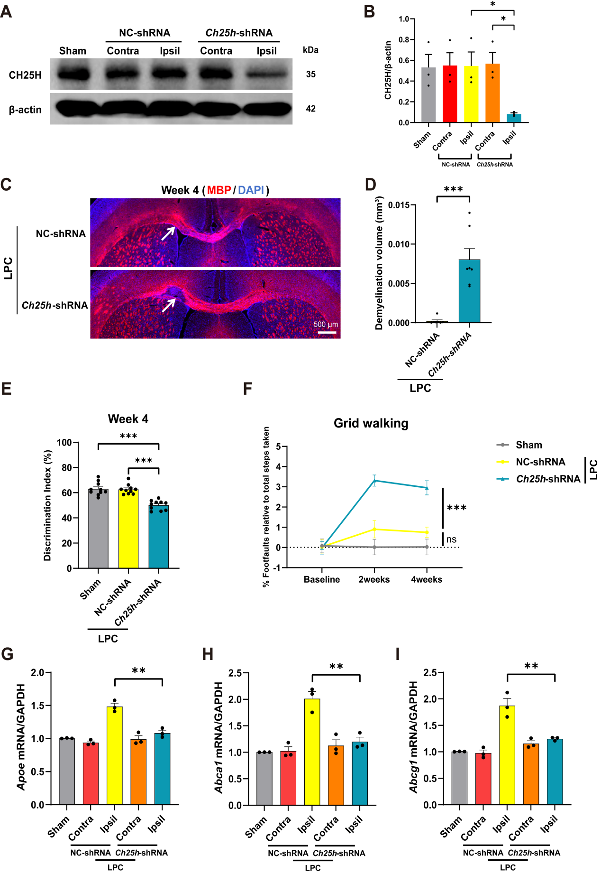

Supplemental Figure 9. CH25H knockdown abrogates spontaneous repair following LPC-induced white matter injury
A & B) CH25H protein levels in the contralateral (Contra) and virus-injected ipsilateral (Ipsil) corpus callosum at 14 days post-injection of CH25H-shRNA-expressing lentivirus or control lentivirus (NC-shRNA); n=3. Data represent mean ± SEM. * (P < 0.05) by two-way ANOVA with multiple comparisons. C & D) Representative images of demyelinated lesions (assessed by MBP staining with DAPI nuclear counterstain) at 4 weeks post LPC-induced white matter injury (n=7). Lentiviral vectors expressing NC-shRNA or Ch25h-shRNA were injected into the corpus callosum 2 weeks before LPC injection. Scale bars, 500μm. Data represent mean ± SEM. *** (P < 0.001) by Mann-Whitney test. E & F) CH25H knockdown in white matter lesions exacerbated functional deficits in the novel object recognition (NOR) and foot fault tests at 4 weeks post-LPC-induced white matter injury (n = 10). Data represent mean ± SEM. E: *** (P < 0.001) by one-way ANOVA with multiple comparisons. F: "ns" indicates no significance, *** (P < 0.001) by two-way ANOVA with multiple comparisons. G-I) The mRNA levels of Apoe, Abca1 and Abcg1 in the contralateral (Contra) and ipsilateral (Ipsil) corpus callosum at 4 days after LPC-induced injury (n=3). Lentiviruses expressing Ch25h-shRNA or NC-shRNA were injected into the corpus callosum 2 weeks before injury induction. Data represent mean ± SEM. ** (P < 0.01) by two-way ANOVA with multiple comparisons.

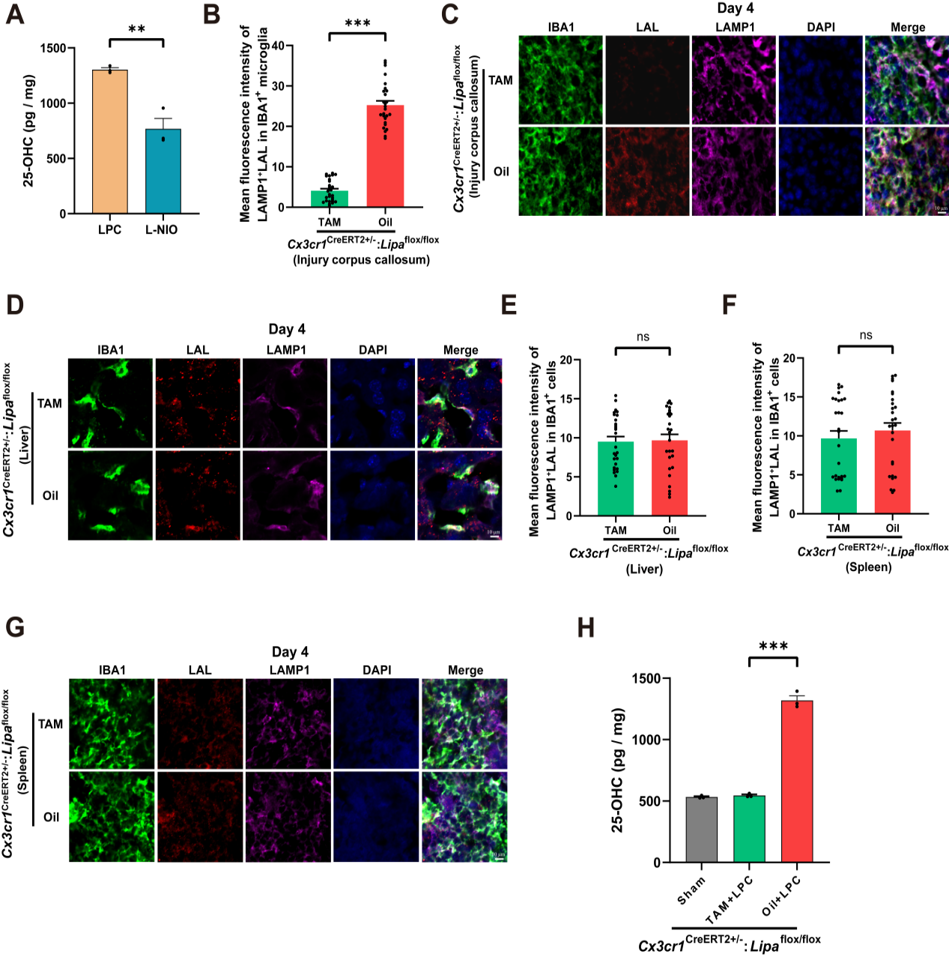

Supplemental Figure 10. Microglia-specific LAL deletion abrogates injury-induced 25-OHC elevation in the LPC model
A) 25-OHC levels in LPC- and L-NIO-induced white matter lesions at 4 days after injury induction (n=3). B & C) Representative images and quantitative analyses of LAL expression in IBA1⁺ microglia within white matter lesions of microglia-specific LAL knockout mice (Cx3cr1^{CreERT2+/-}:Lipa^{flox/flox} mice treated with TAM), at 4 days post LPC-induced injury (n=27 from 3 biological replicates). Conditional KO mice treated with oil served as controls. Scale bars, 10μm. D-G) Representative images and quantitative analyses of LAL expression in peripheral macrophages (IBA1⁺) in the liver and spleen of microglia-specific LAL knockout mice at 4 days post LPC-induced injury (n=27 from 3 biological replicates). Scale bars, 10μm. H) Lesional 25-OHC levels in LAL knockout, control, and sham-operated mice at 4 days post LPC-induced injury (n=3). Data represent mean ± SEM. ** (P < 0.01) by Unpaired t test for A. *** (P < 0.001), "ns" indicates no significance by Mann-Whitney test for B, E and F. *** (P < 0.001) by one-way ANOVA with multiple comparisons for H.

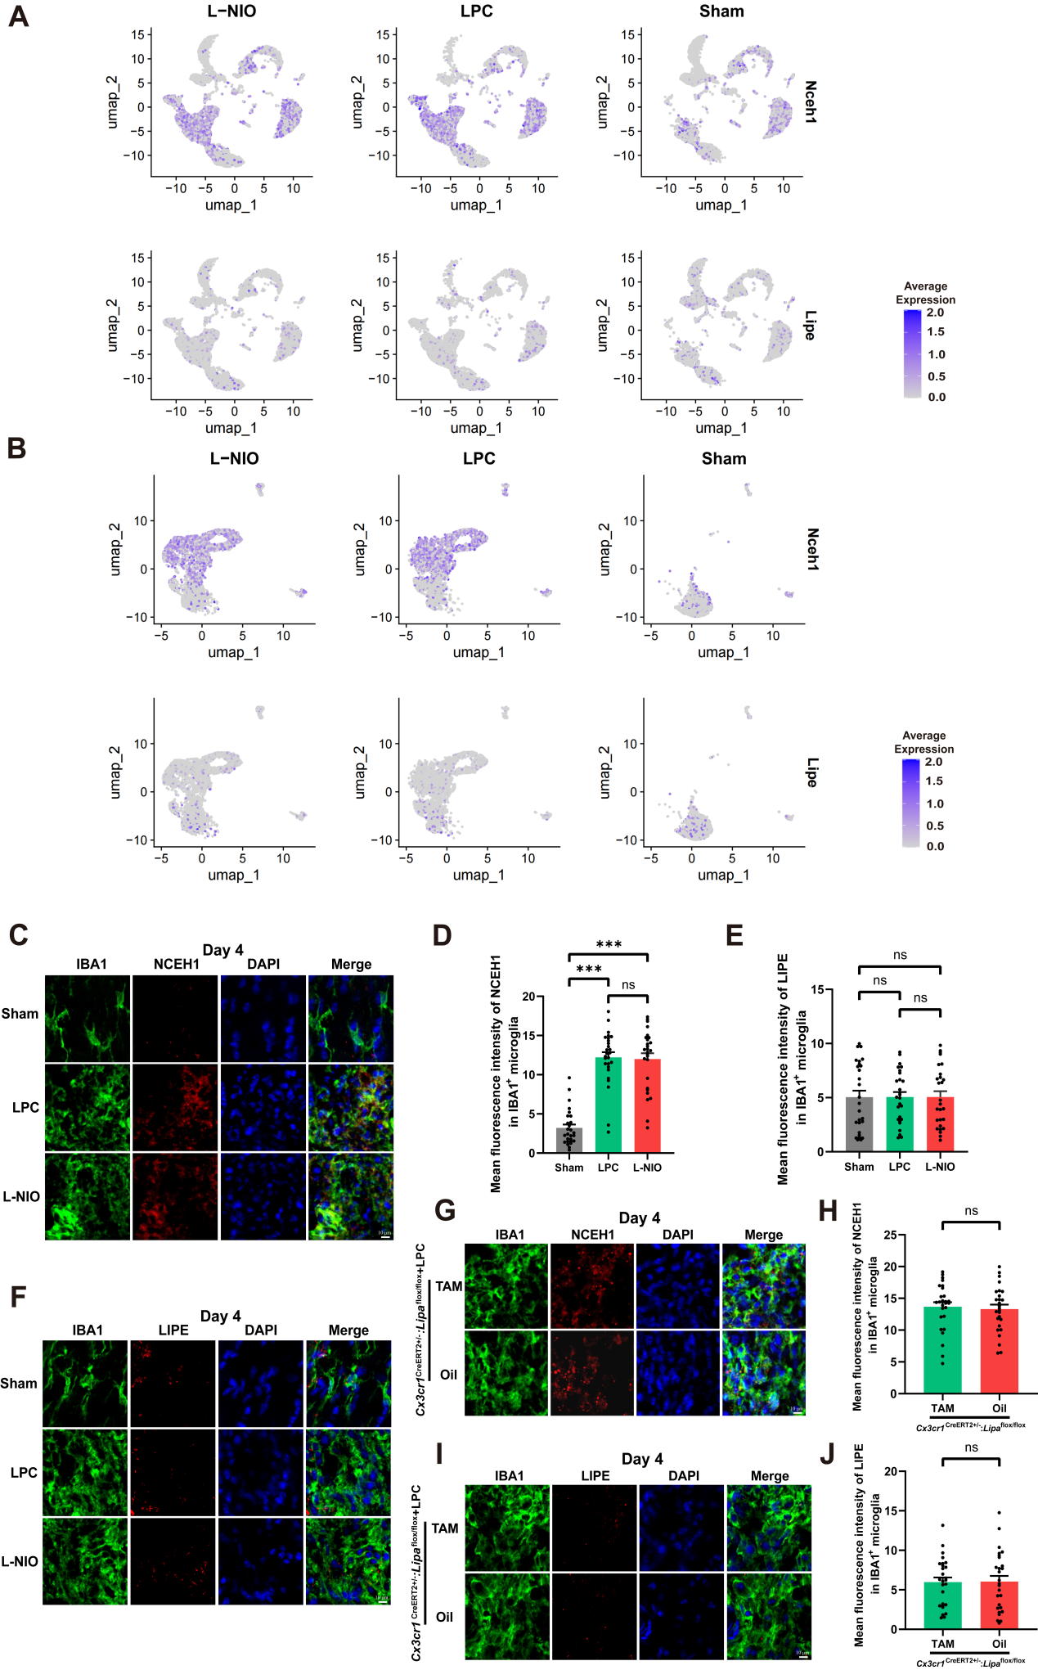

Supplemental Figure 11. Nceh1 and Lipe expression in white matter lesions
A) The expression patterns of the cytosolic hydrolyases Nceh1 and Lipe in different cell types at 4 days following LPC- or L-NIO-induced injury, as indicated by the sc-RNA-seq data. B) The expression patterns of the cytosolic hydrolyases Nceh1 and Lipe in several microglial subsets at 4 days following LPC- or L-NIO-induced injury, as indicated by the sc-RNA-seq data. C & D) Representative images and quantitative analyses of NCEH1 expression in IBA1⁺ microglia within white matter lesions at 4 days following LPC-induced and L-NIO-induced injury (n=27 from 3 biological replicates). Scale bars, 10μm. Data represent mean ± SEM. *** (P < 0.001), "ns" indicates no significance by one-way ANOVA with multiple comparisons. E & F) Representative images and quantitative analysis of LIPE expression in IBA1⁺ microglia within white matter lesions at 4 days following LPC-induced and L-NIO-induced injury (n=27 from 3 biological replicates). Scale bars, 10μm. Data represent mean ± SEM. "ns" indicates no significance by one-way ANOVA with multiple comparisons. G-J) Representative images and quantitative analyses of NCEH1 and LIPE expression in IBA1⁺ microglia within white matter lesions of microglia-specific LAL knockout mice (Cx3cr1^{CreERT2+/-}:Lipa^{flox/flox} mice treated with TAM), at 4 days post LPC-induced injury (n=27 from 3 biological replicates). Conditional KO mice treated with oil served as controls. Scale bars, 10μm. Data represent mean ± SEM. "ns" indicates no significance by Mann-Whitney test.

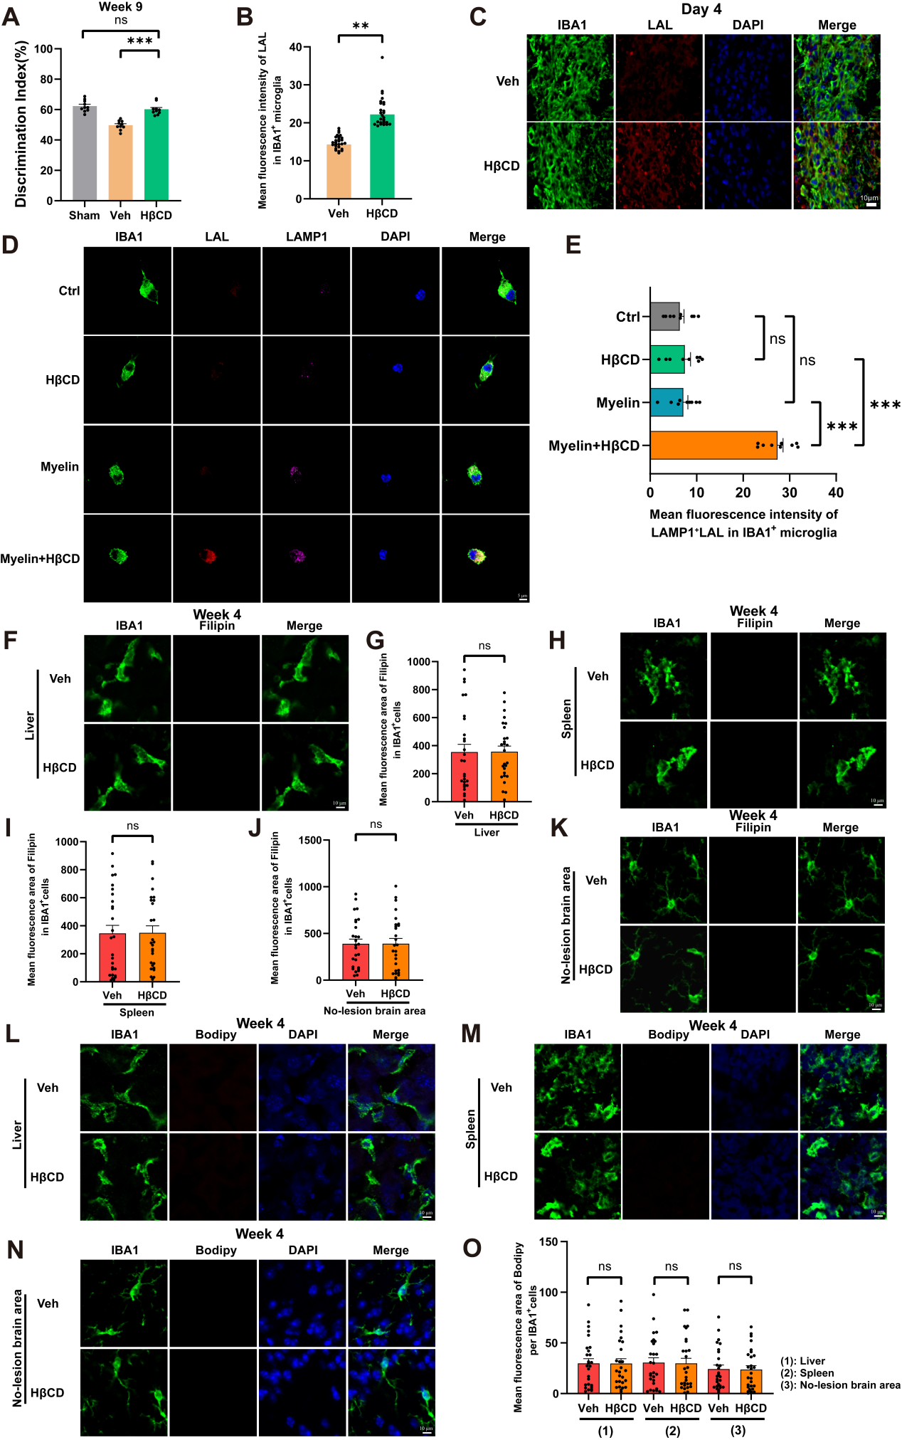

Supplemental Figure 12. HβCD increases microglial LAL expression and lipid clearance specifically within white matter lesions
A) Improvement of neurologic function in the NOR test by injection of HβCD at 9 weeks following L-NIO-induced WMS (n=10). Data represent mean ± SEM. "ns" indicates no significance, *** (P < 0.001) by one-way ANOVA with multiple comparisons. B & C) Representative images and quantitative analyses of LAL expression in IBA1⁺ microglia within the injured corpus callosum at 4 days after daily HβCD injection following L-NIO-induced WMS (n=27 from 3 biological replicates). Scale bars, 10μm. Data represent mean ± SEM. ** (P < 0.01) by Mann-Whitney test. D & E) Representative images and quantitative analyses of LAL expression in primary microglia from the control (Ctrl), HβCD-treated, myelin-treated, and myelin+HβCD-treated groups (n=9 from 3 biological replicates). Notably, enhanced LAL expression was co-localized with lysosomes (LAMP1⁺). Scale bars, 5μm. Data represent mean ± SEM. "ns" indicates no significance, *** (P < 0.001) by one-way ANOVA with multiple comparisons. F-K) Representative images and quantification of free cholesterol deposition (Filipin staining) in IBA1⁺ cells of the liver, spleen, and uninjured contralateral corpus callosum at 4 weeks after daily HβCD injection following L-NIO-induced WMS (n=27 from 3 biological replicates). Scale bars, 10μm. Data represent mean ± SEM. "ns" indicates no significance by Mann-Whitney test. L-O) Representative images and quantification of neutral lipids (Bodipy staining) in IBA1⁺ cells of liver, spleen and uninjured contralateral corpus callosum at 4 weeks following daily HβCD administration post L-NIO-induced WMS (n=27 from 3 biological replicates). Scale bars, 10μm. Data represent mean ± SEM. "ns" indicates no significance by Mann-Whitney test.

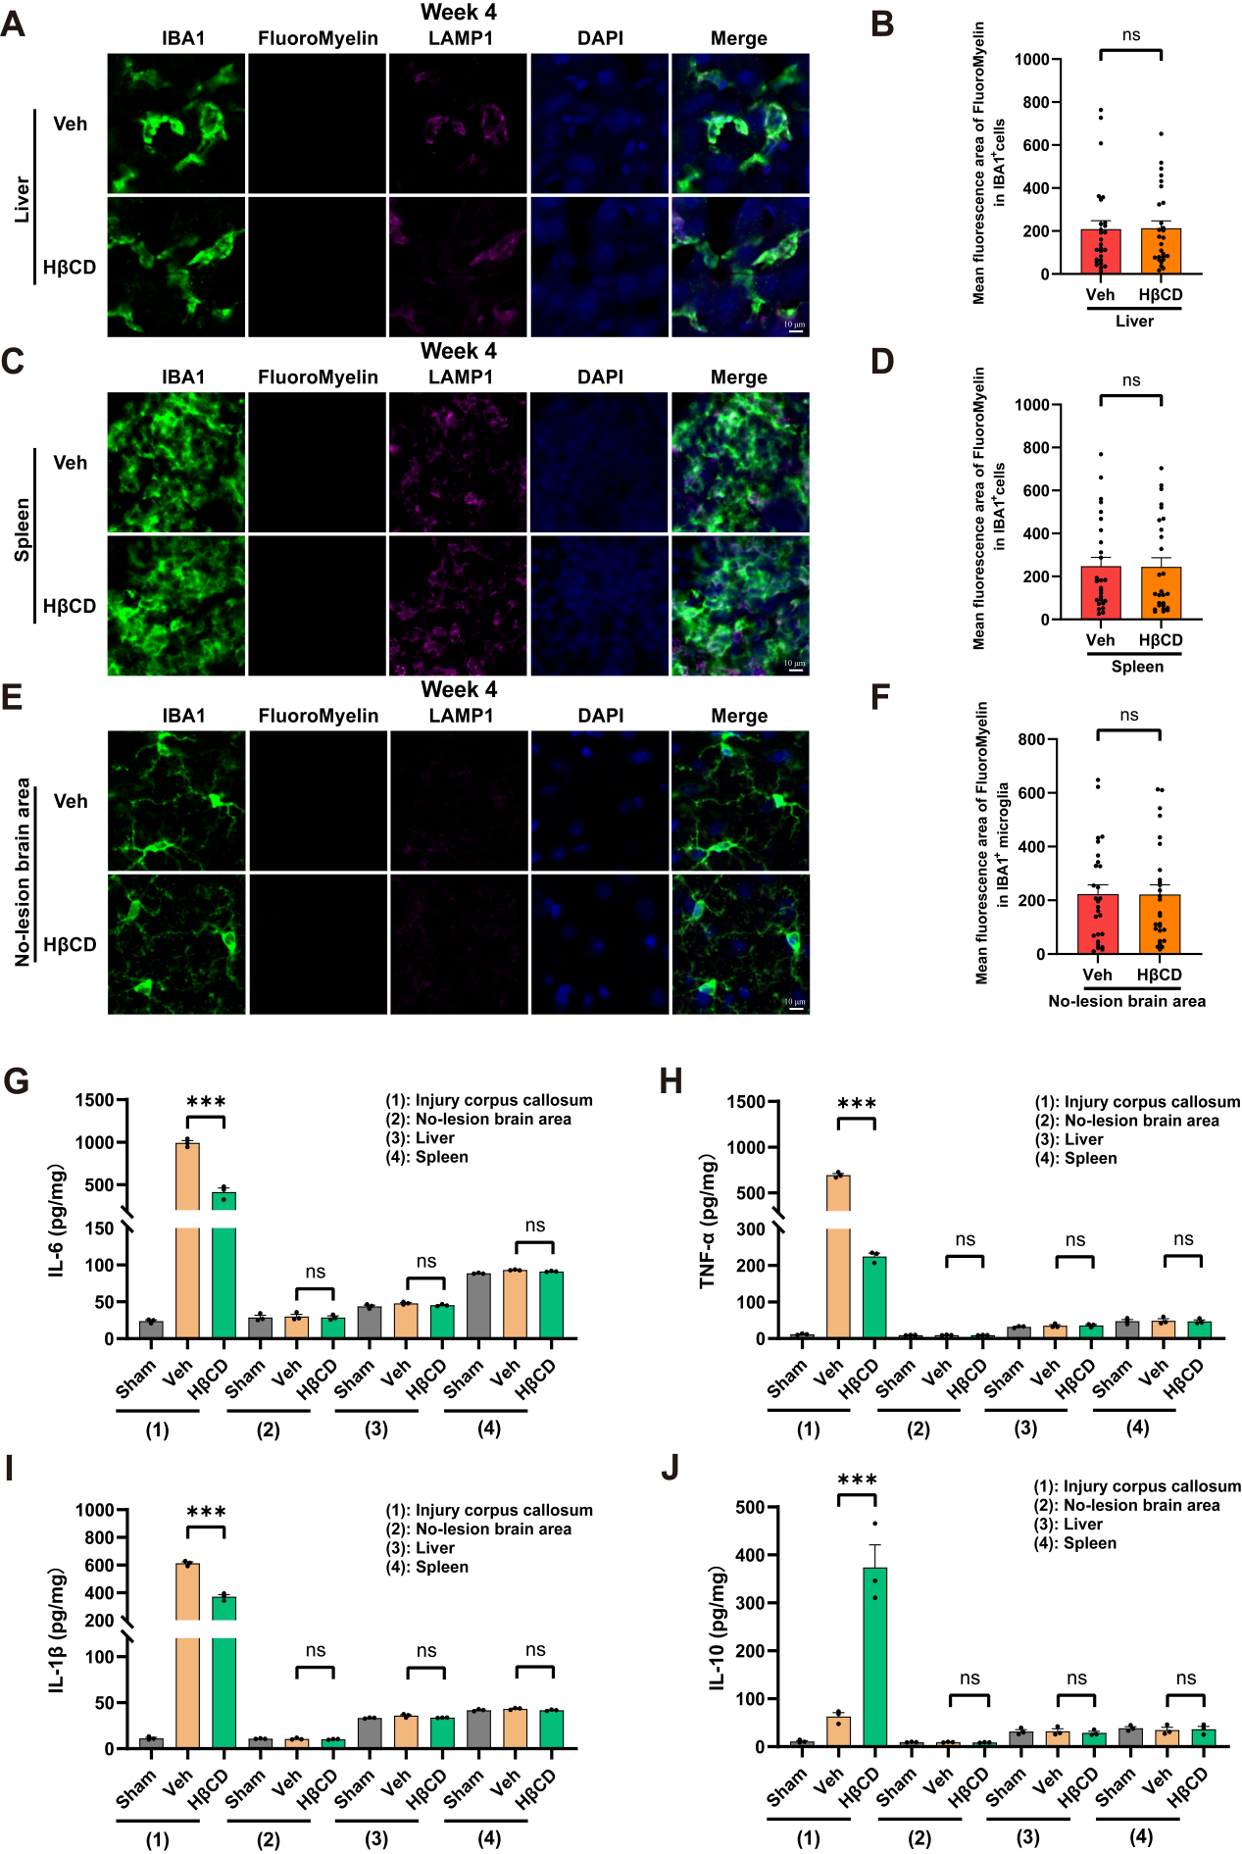

Supplemental Figure 13. HβCD reduces neuroinflammation in white matter lesions without affecting myelin debris deposition outside lesions.
A-F) Representative images and quantification of myelin debris (labelled by FluoroMyelin) in IBA1⁺ cells of liver, spleen and uninjured contralateral corpus callosum at 4 weeks following daily HβCD administration post L-NIO-induced WMS (n=27 from 3 biological replicates). Scale bars, 10μm. Data represent mean ± SEM. "ns" indicates no significance by Mann-Whitney test. G-J) ELISA results of pro-inflammatory factors (IL-6, TNF-α and IL-1β) and the anti-inflammatory factor (IL-10) in liver, spleen and injured or uninjured contralateral corpus callosum at 1 week following daily HβCD administration post L-NIO-induced WMS (n=3). Data represent mean ± SEM. "ns" indicates no significance, *** (P < 0.001) by one-way ANOVA with multiple comparisons.

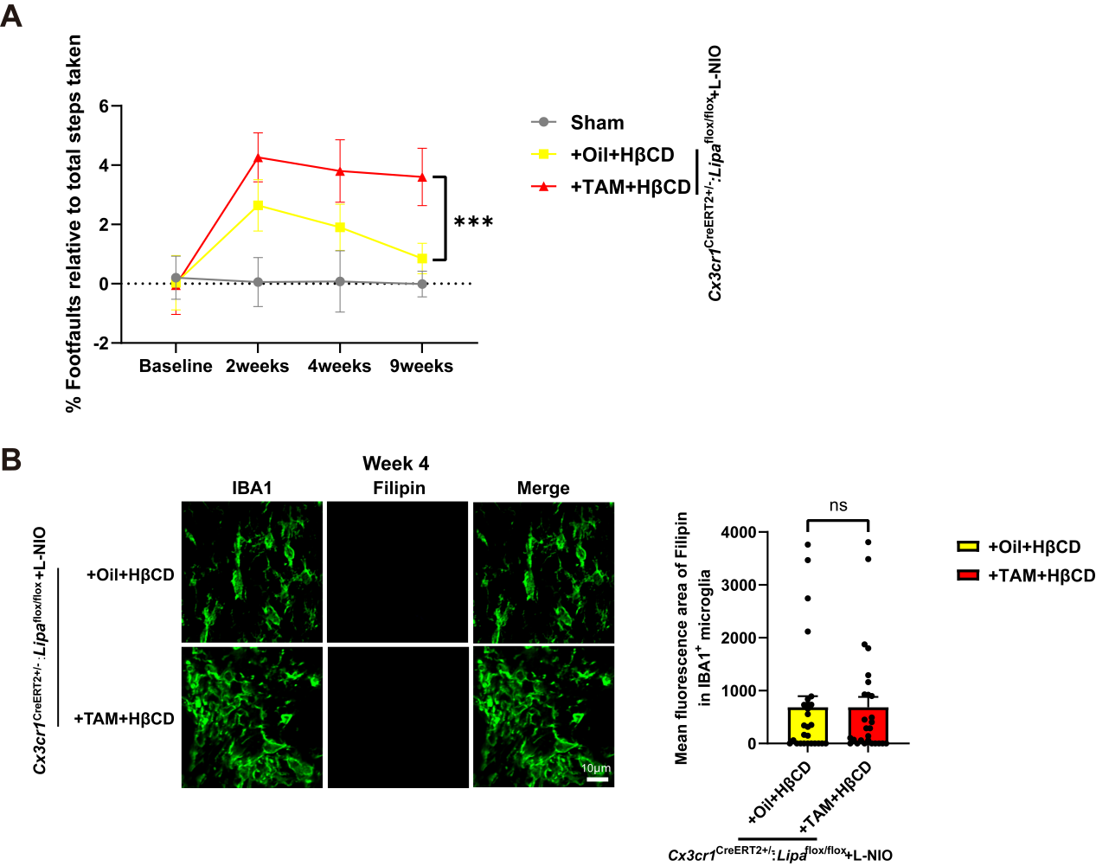
Supplemental Figure 14. HβCD targets microglial LAL to promote functional recovery following L-NIO-induced WMS
A) HβCD failed to promote functional recovery in microglia-specific LAL knockout mice (Cx3cr1^{CreERT2+/-}: Lipa^{flox/flox} mice treated with TAM) at 9 weeks following L-NIO-induced WMS, compared to control mice (Cx3cr1^{CreERT2+/-}: Lipa^{flox/flox} mice treated with Oil). Sham: Sham-operated microglia-specific LAL non-knockout mice (Cx3cr1^{CreERT2+/-}: Lipa^{flox/flox}+Oil, n=10). Data represent mean ± SEM. *** (P < 0.001) by two-way ANOVA with multiple comparisons. B) Microglial LAL deficiency blocked free cholesterol production (regardless of HβCD treatment) at 4 weeks after L-NIO-induced WMS, as evidenced by Filipin staining and quantitative analyses (n = 27 from 3 biological replicates per group). Scale bars, 10μm. Data represent mean ± SEM. "ns" indicates no significance by Mann-Whitney test.

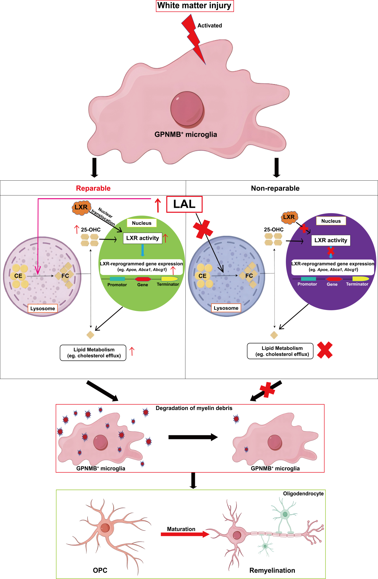

Supplemental Figure 15. Working model of the study
LAL reprograms GPNMB⁺ microglia into a reparative state to drive white matter repair, achieved by hydrolyzing cholesteryl esters (CE). Following white matter injury, a large proportion of microglia are reprogrammed into GPNMB⁺ microglia, which dominate myelin debris engulfment but exhibit context-dependent capacity for lipid metabolic and myelin debris clearance; critically, their capacity to digest engulfed myelin debris is LAL-dependent. Notably, microglial LAL expression was higher in LPC-induced reparable white matter lesions than in L-NIO-induced irreparable lesions. Mechanistically, microglial LAL drives myelin debris clearance and remyelination through two essential pathways: 1) LAL-mediated cholesteryl ester hydrolysis enhances the production of 25-hydroxycholesterol (25-OHC), which in turn activates LXRs. This is supported by increased transcription of genes governing cholesterol efflux—Apoe, Abca1, and Abcg1. 2) LAL-mediated hydrolysis of cholesteryl esters into free cholesterol (FC) is a prerequisite for cholesterol efflux. Consistent with these mechanisms, LXR activation alone is insufficient to rescue the impairment of white matter repair induced by LAL deficiency.

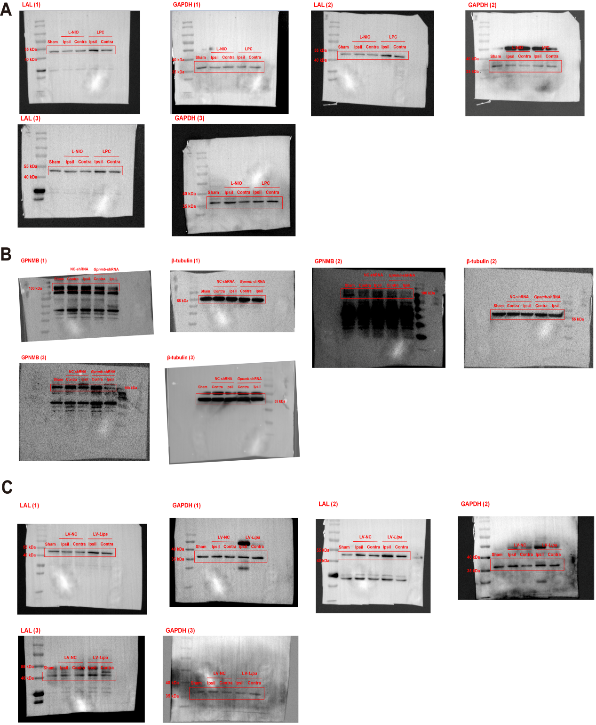
Supplemental Figure 16. Western Blot images
A) Western Blot images of Figure 3. B) Western Blot images of Supplemental Figure 5. C) Western Blot images of Supplemental Figure 6.
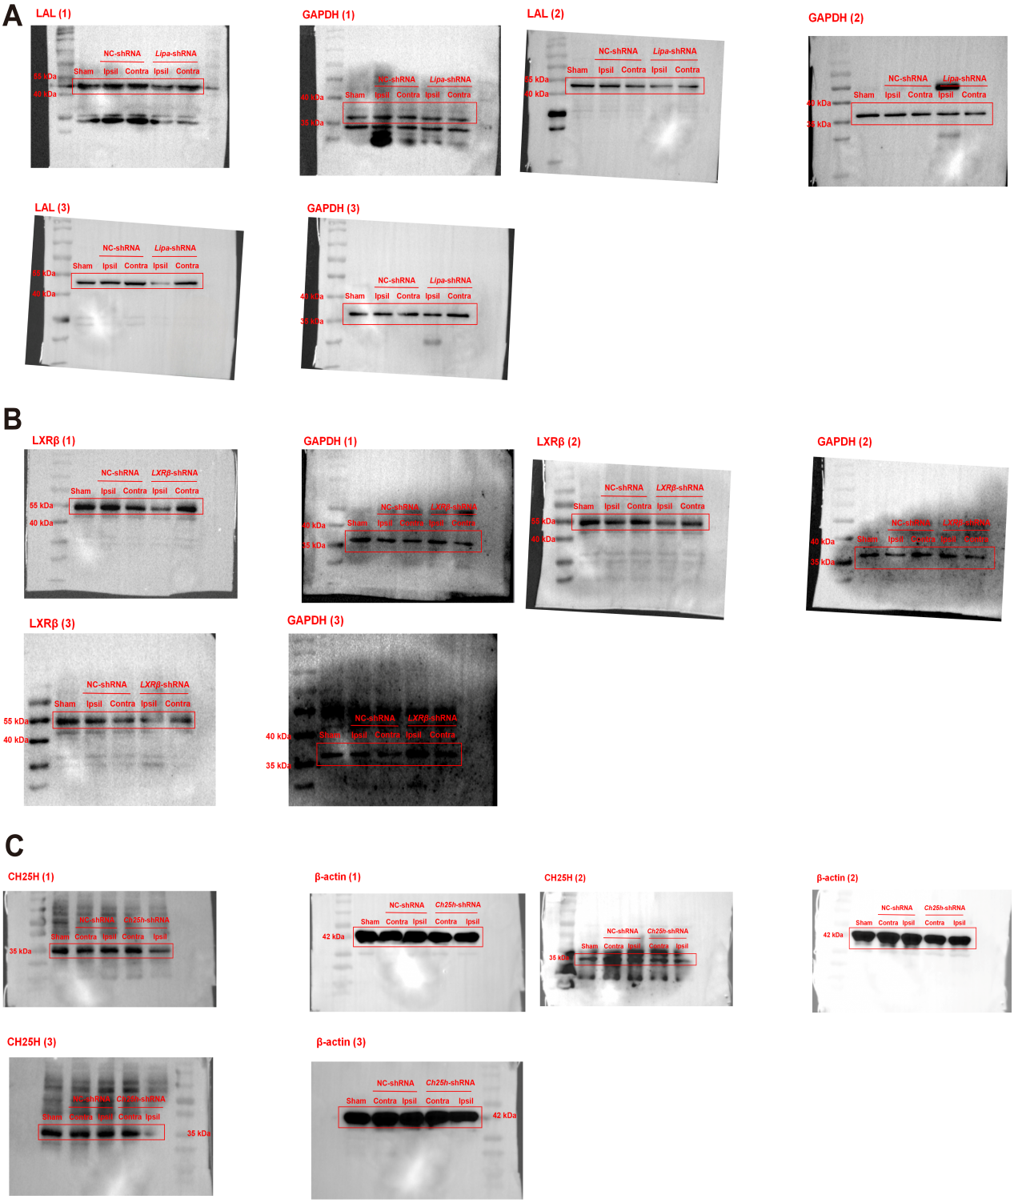
Supplemental Figure 17. Western Blot images
A) Western Blot images of Supplemental Figure 7. B) Western Blot images of Supplemental Figure 8. C) Western Blot images of Supplemental Figure 9.

