Supporting Information

Therapeutic targeting of blood-derived protein infiltration to modulate neuroinflammation in cerebellar ataxia

Park et al.

Supporting Figures and Figure legends 1–10.
Table 1.
Uncropped western blot images

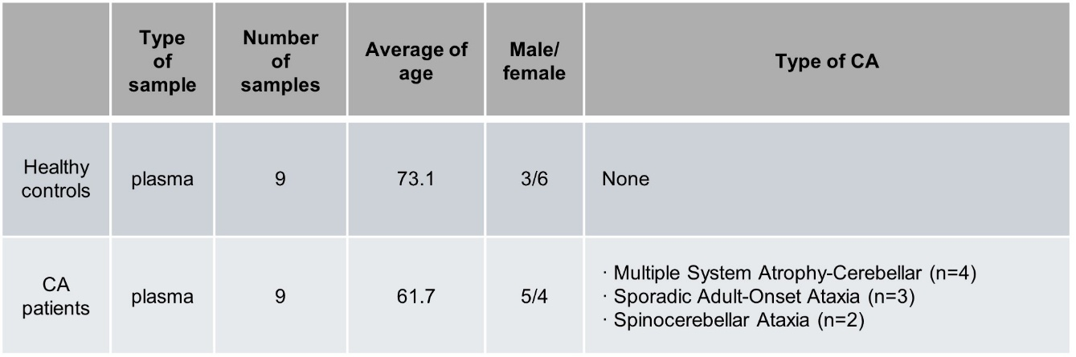
Fig. S1. Detailed information on human plasma samples.

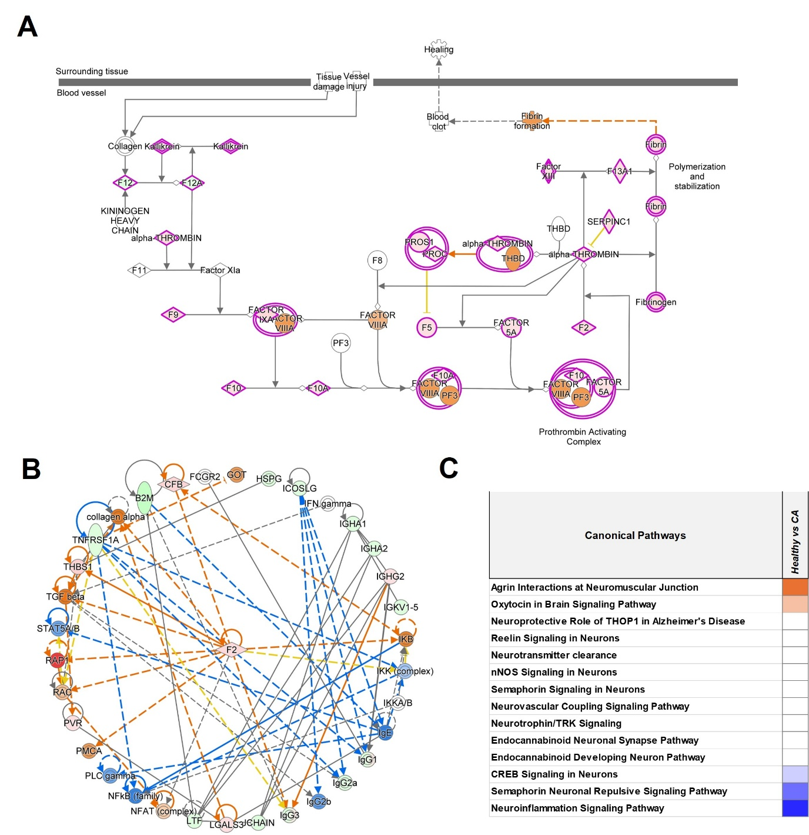
Fig. S2. Thrombin pathway alterations, factor II-centered PPIs, and canonical pathway analyses in CA proteomes. A Thrombin pathway alterations in proteomes. Red and green indicate upregulation and downregulation in the CA proteome compared to healthy proteome, respectively. B Factor II-centered PPIs in the comparative proteomic result. Red and green indicate the increased and decreased protein levels in the CA proteome compared to healthy proteome, respectively. C Comparative canonical pathway analyses for neuroscience using IPA. Orange and blue color indicate canonical pathways with positive and negative z-scores in pathway activation, respectively. PPIs, protein–protein interactions
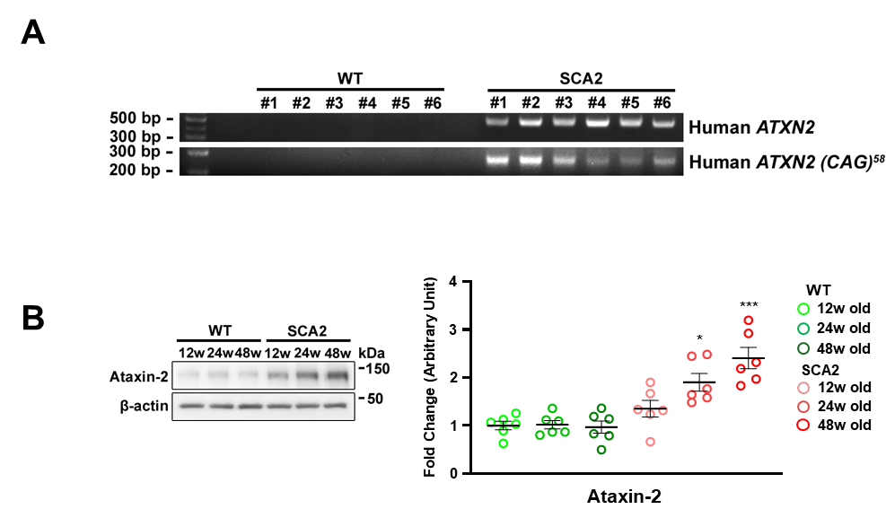
Fig. S3. SCA2 mouse model. A Genetic analysis confirmed the presence of human ATXN2 with 58 CAG repeats in SCA2 mice. B Western blot analysis of ataxin-2 protein levels in cerebellar tissues obtained from 12-, 24-, and 48-week-old WT and SCA2 mice. *p < 0.05 and ***p < 0.001 vs. age-matched WT mice (two-way ANOVA with Tukey’s post hoc analysis; n = 6 per group).

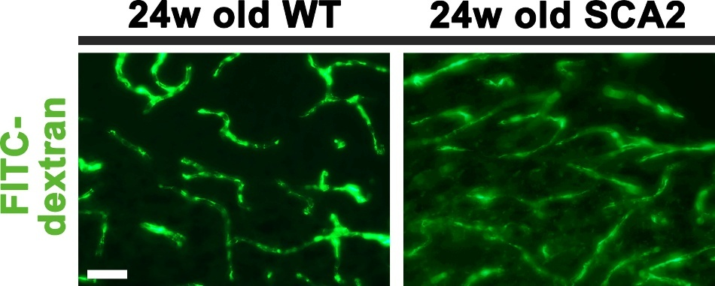
Fig. S4. Increased BBB permeability in the cerebellum of 24-week-old SCA2 mice. Representative images of fluorescent (10 kDa) dextran staining in the cerebellum of 24-week-old WT and SCA2 mice. SCA2 mice exhibit increased dextran extravasation compared with WT controls. Scale bar: 20 μm.

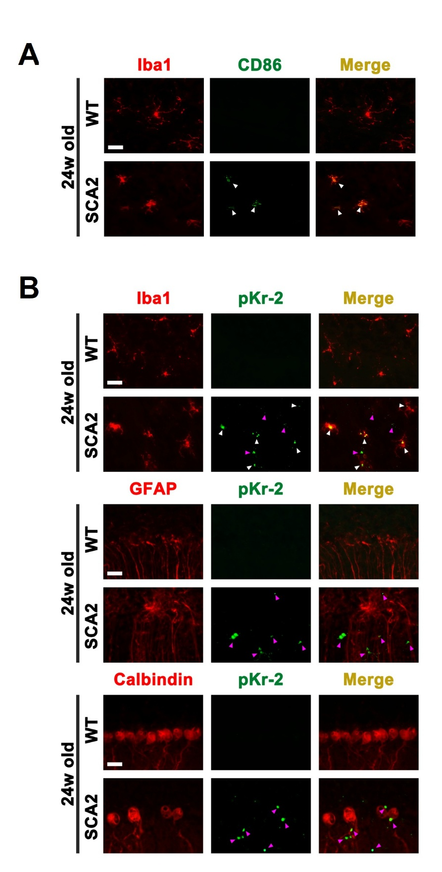
Fig. S5. Predominant co-localization of pKr-2 with microglia in the cerebellum of 24-week-old SCA2 mice. Representative immunofluorescence images of cerebellar sections from 24-week-old WT and SCA2 mice. A Immunofluorescence images of Iba1 (red) and CD86 (green) in the cerebellum of 24-week-old WT and SCA2 mice. Scale bar: 20 μm. B Co-immunofluorescence analyses of pKr-2 (green) with cell-type-specific markers, including Iba1 (red; microglia), GFAP (red; astrocytes), and calbindin (red; Purkinje cells), demonstrating predominant co-localization of pKr-2 with microglial populations in the SCA2 cerebellum. White arrows indicate co-localization, whereas purple arrows indicate a lack of co-localization. Scale bar: 20 μm.

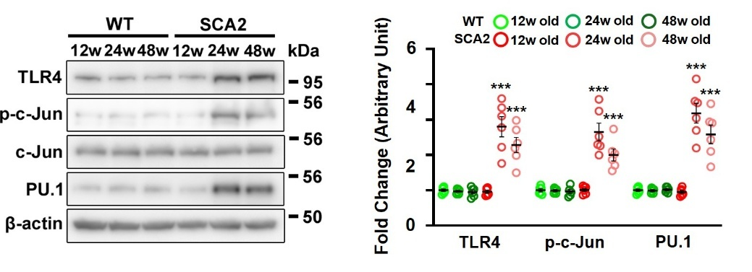
Fig. S6. Upregulation of TLR4 and its associated transcription factors in the cerebellum of SCA2 mice. Western blotting for TLR4, p-c-Jun, and PU.1 in the cerebellum of 24-week-old WT and SCA2 mice. ***p < 0.001 vs. age-matched WT mice (two-way ANOVA with Tukey’s post hoc analysis; n = 6 per group).

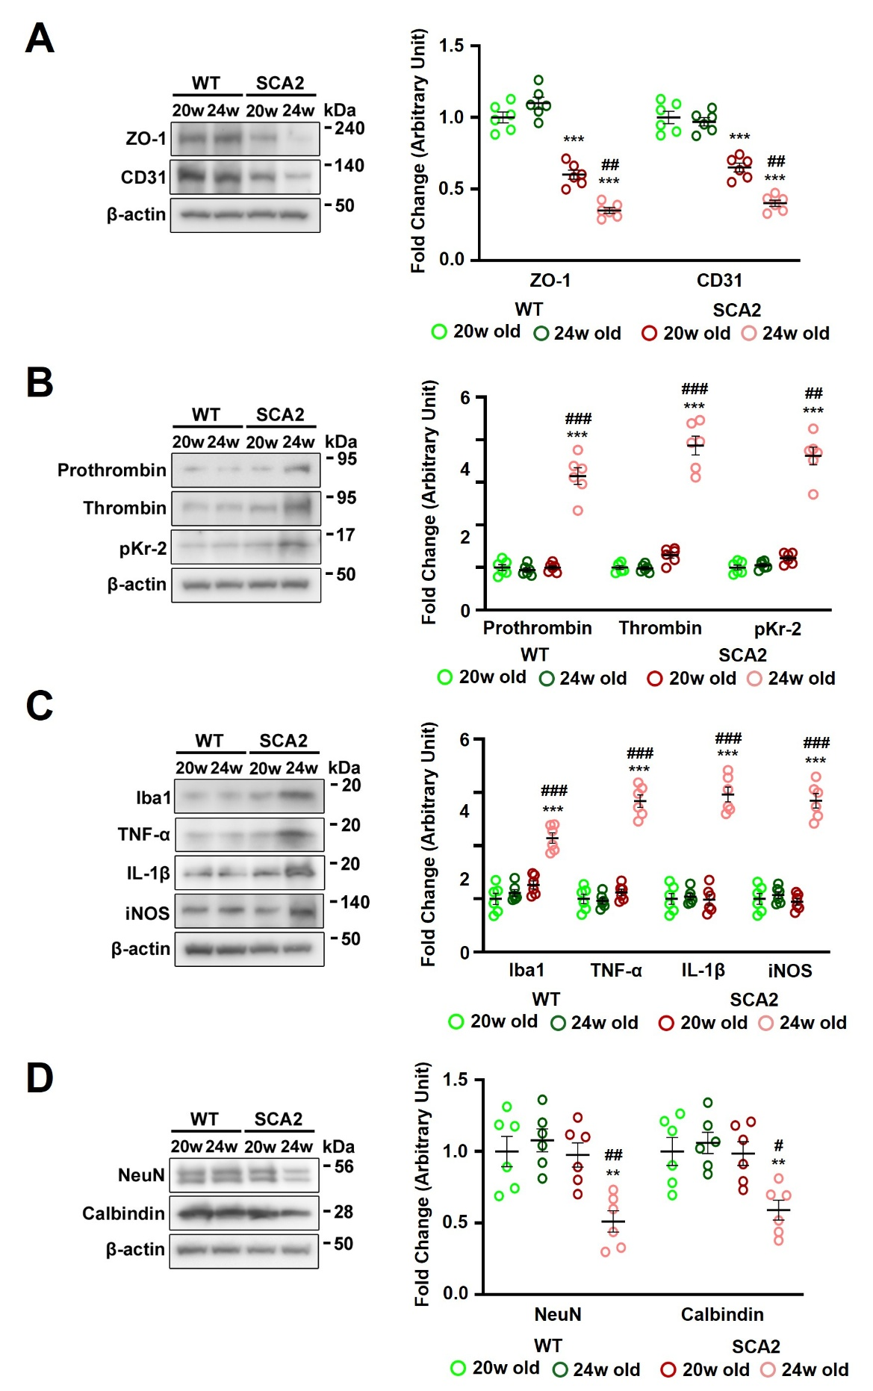
Fig. S7. Early BBB disruption without accumulation of blood-derived proteins in the cerebellum of SCA2 mice. A Western blotting for ZO-1 and CD31 in the cerebellum of 20- and 24-week-old WT and SCA2 mice. ***p < 0.001 vs. age-matched WT mice; ##p < 0.01 vs. 20-week-old SCA2 mice (two-way ANOVA with Tukey’s post hoc analysis; n = 6 per group). B Western blotting for prothrombin, thrombin, and pKr-2 in the cerebellum of 20- and 24-week-old WT and SCA2 mice. ***p < 0.001 vs. age-matched WT mice; ##p < 0.01 and ###p < 0.001 vs. 20-week-old SCA2 mice (two-way ANOVA with Tukey’s post hoc analysis; n = 6 per group). C Western blotting for Iba1, TNF-α, IL-1β, and iNOS in the cerebellum of 20- and 24-week-old WT and SCA2 mice. ***p < 0.001 vs. age-matched WT mice; ###p < 0.001 vs. 20-week-old SCA2 mice (two-way ANOVA with Tukey’s post hoc analysis; n = 6 per group). D Western blotting for NeuN and calbindin in the cerebellum of 20- and 24-week-old WT and SCA2 mice **p < 0.01 vs. age-matched WT mice; #p < 0.05 and ##p < 0.01 vs. 20-week-old SCA2 mice (two-way ANOVA with Tukey’s post hoc analysis; n = 6 per group).

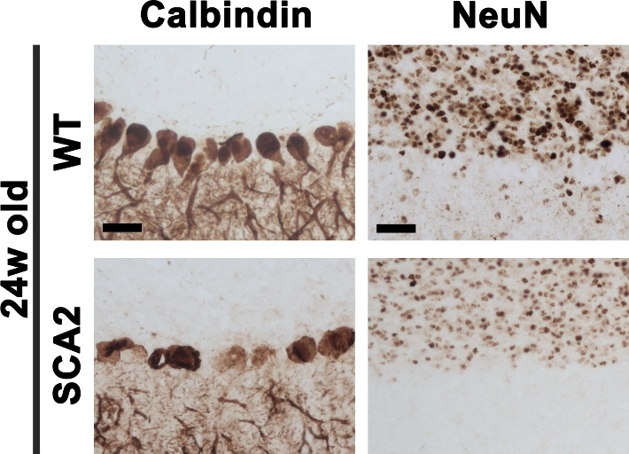

Fig. S8. Neuronal loss in the cerebellum of 24-week-old SCA2 mice. Immunohistochemical images of calbindin (brown) and NeuN (brown) staining in the cerebellum of 24-week-old WT and SCA2 mice. Scale bars: 20 μm.

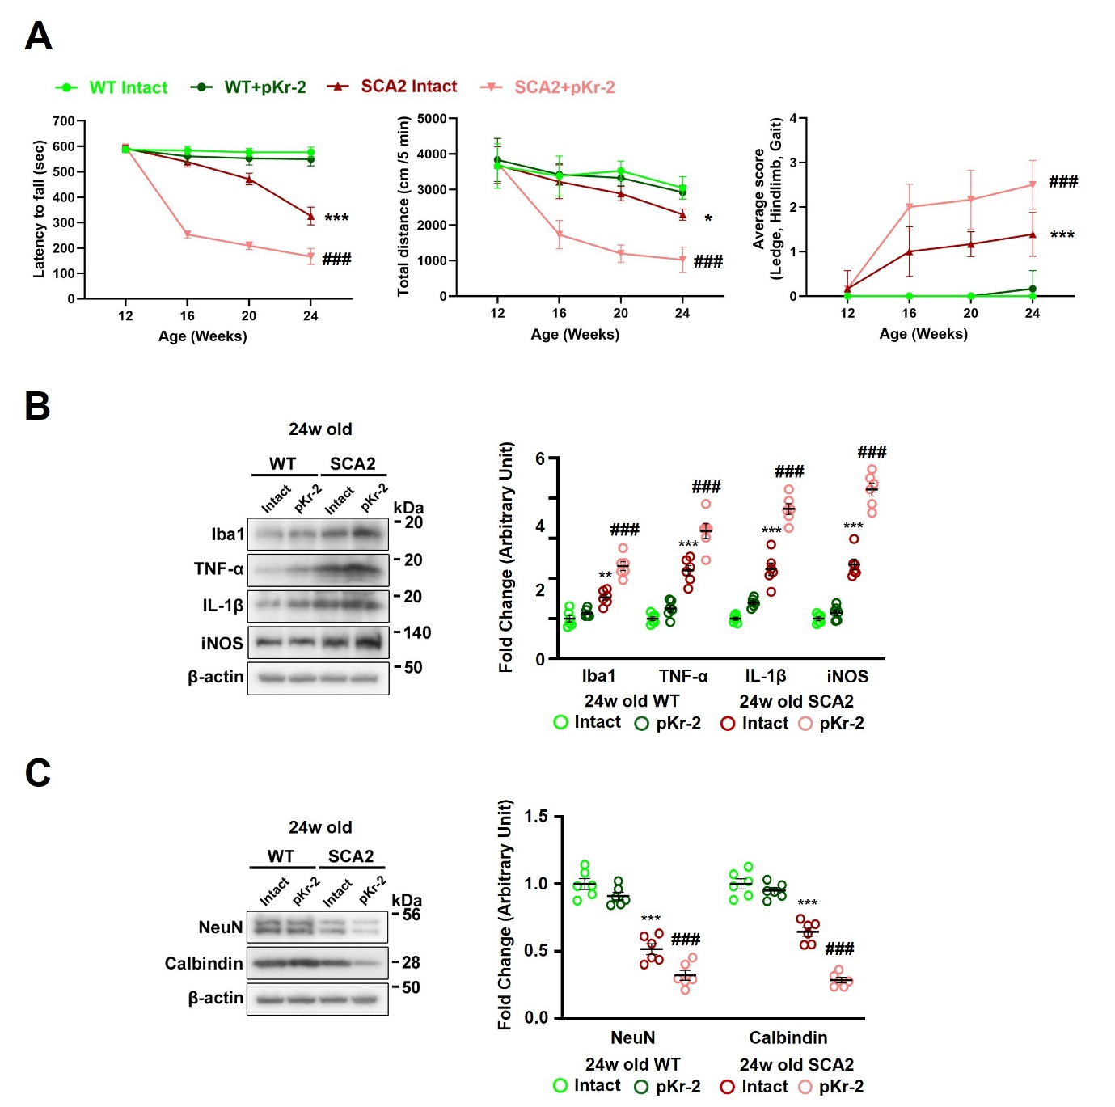
Fig. S9. No evident neurotoxic effects following pKr-2 administration in the cerebellum of WT mice. A Rota-rod, open-field, and simple composite phenotype scoring tests were performed every 4 weeks until 24 weeks of age to assess locomotor activity in WT and SCA2 mice after intracerebellar pKr-2 injection at 12 weeks of age. *p < 0.05 and ***p < 0.001 vs. untreated age-matched WT mice; ###p < 0.001 vs. untreated age-matched SCA2 mice (two-way ANOVA with Tukey’s post hoc analysis; n = 6 per group). B Western blotting for Iba1, TNF-α, IL-1β, and iNOS in the cerebellum of mice at 24 weeks of age. **p < 0.01 and ***p < 0.001 vs. untreated WT mice; ###p < 0.001 vs. untreated age-matched SCA2 mice (two-way ANOVA with Tukey’s post hoc analysis; n = 6 per group). C Western blotting for NeuN and calbindin in the cerebellum of mice at 24 weeks of age. ***p < 0.001 vs. untreated WT mice; ###p < 0.001 vs. untreated age-matched SCA2 mice (two-way ANOVA with Tukey’s post hoc analysis; n = 6 per group).

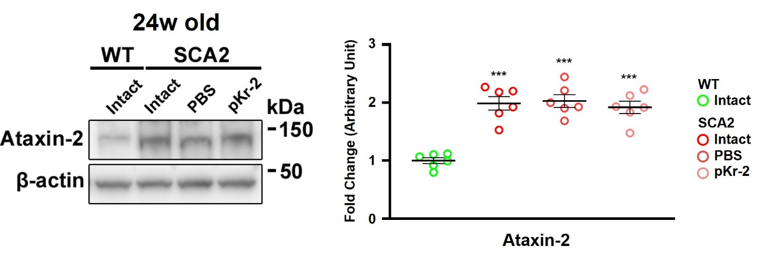
Fig. S10. No effect of pKr-2 upregulation on ataxin-2 expression in the cerebellum of SCA2 mice. Western blotting for ataxin-2 levels in the cerebellar tissues of mice at 24 weeks of age. Cerebellar tissues from SCA2 mice were collected 12 weeks after an intracerebellar pKr-2 injection at 12 weeks of age. ***p < 0.001 vs. untreated WT mice (one-way ANOVA with Tukey’s post hoc analysis; n = 6 per group).

Table 1. Summary of statistical analysis
Figure |  | Mean±SEM  (Normalized to control group = 1) | Type of test | p value
Main figures
1E | CD31 | 43.7 ± 2.894 | Student’s t test | ***p < 0.0001
1F | ZO-1 | 0.354 ± 0.043  0.369 ± 0.069 | Two-way ANOVA with Tukey’s post hoc | ***p < 0.0001  ***p < 0.0001
1F | CD31 | 0.526 ± 0.055  0.489 ± 0.101 | Two-way ANOVA with Tukey’s post hoc | ***p = 0.0009  **p = 0.0016
1G | Prothrombin | 2.494 ± 0.254  2.662 ± 0.204 | Two-way ANOVA with Tukey’s post hoc | ***p < 0.0001  ***p < 0.0001
1G | Thrombin | 4.042 ± 0.150  4.223 ± 0.214 | Two-way ANOVA with Tukey’s post hoc | ***p < 0.0001  ***p < 0.0001
1G | pKr-2 | 3.473 ± 0.351  3.908 ± 0.191 | Two-way ANOVA with Tukey’s post hoc | ***p < 0.0001  ***p < 0.0001
1H | Iba1 | 1.710 ± 0.138  2.116 ± 0.141 | Two-way ANOVA with Tukey’s post hoc | **p = 0.0013  ***p < 0.0001
1H | TNF-α | 2.782 ± 0.314  3.276 ± 0.407 | Two-way ANOVA with Tukey’s post hoc | **p = 0.0022  ***p < 0.0001
1H | IL-1β | 2.130 ± 0.104  2.343 ± 0.115 | Two-way ANOVA with Tukey’s post hoc | ***p < 0.0001  ***p < 0.0001
1H | iNOS | 2.163 ± 0.129  2.061 ± 0.207 | Two-way ANOVA with Tukey’s post hoc | ***p < 0.0001  **p = 0.0026
1I | NeuN | 0.516 ± 0.024  0.307 ± 0.054 | Two-way ANOVA with Tukey’s post hoc | **p = 0.0061  ***p < 0.0001
1I | Calbindin | 0.466 ± 0.051  0.349 ± 0.051 | Two-way ANOVA with Tukey’s post hoc | **p = 0.0031  ***p < 0.0001
2B | Rota-rod test | 194.333 ± 4.639  383.000 ± 11.177 | Two-way ANOVA with Tukey’s post hoc | ***p < 0.0001  ###p < 0.0001
2B | Open field test | 1623.833 ± 129.790  2103.333 ± 47.477 | Two-way ANOVA with Tukey’s post hoc | ***p < 0.0001  ##p = 0.0069
2B | Scoring test | 1.833 ± 0.114  2.500 ± 0.224 | Two-way ANOVA with Tukey’s post hoc | ***p < 0.0001  #p = 0.0376
2C | ZO-1 | 0.253 ± 0.051  0.826 ± 0.027 | Two-way ANOVA with Tukey’s post hoc | ***p < 0.0001  ###p = 0.0007
2C | CD31 | 0.568 ± 0.105  0.997 ± 0.010 | Two-way ANOVA with Tukey’s post hoc | *p = 0.0375  #p = 0.0392
2D | Prothrombin | 4.276 ± 0.417  1.701 ± 0.096 | Two-way ANOVA with Tukey’s post hoc | ***p < 0.0001  ###p < 0.0001
2D | Thrombin | 2.625 ± 0.274  1.466 ± 0.058 | Two-way ANOVA with Tukey’s post hoc | ***p < 0.0001  ###p = 0.0002
2D | pKr-2 | 2.540 ± 0.223  1.162 ± 0.239 | Two-way ANOVA with Tukey’s post hoc | ***p = 0.0001  ###p = 0.0004
2E | Iba1 | 2.112 ± 0.165  1.203 ± 0.123 | Two-way ANOVA with Tukey’s post hoc | ***p < 0.0001  ###p < 0.0001
2E | TNF-α | 2.758 ± 0.215  1.261 ± 0.075 | Two-way ANOVA with Tukey’s post hoc | ***p < 0.0001  ###p < 0.0001
2E | IL-1β | 2.324 ± 0.135  1.092 ± 0.125 | Two-way ANOVA with Tukey’s post hoc | ***p < 0.0001  ###p < 0.0001
2E | iNOS | 2.761 ± 0.174  1.191 ± 0.120 | Two-way ANOVA with Tukey’s post hoc | ***p < 0.0001  ###p < 0.0001
2F | NeuN | 0.225 ± 0.008  0.850 ± 0.110 | Two-way ANOVA with Tukey’s post hoc | ***p = 0.0003  ##p = 0.003
2F | Calbindin | 0.543 ± 0.032  0.940 ± 0.045 | Two-way ANOVA with Tukey’s post hoc | ***p < 0.0001  ###p < 0.0001
3B | Rota-rod test | 359.166 ± 13.363  193.333 ± 9.739  281.000 ± 7.321 | Two-way ANOVA with Tukey’s post hoc | ***p < 0.0001  ***p < 0.0001  ###p < 0.0001
3B | Open field test | 2297.965 ± 65.125  1365.667 ± 83.428  1956.333 ± 127.598 | Two-way ANOVA with Tukey’s post hoc | ***p < 0.0001  ***p < 0.0001  ##p = 0.0017
3B | Scoring test | 1.167 ± 0.167  2.444 ± 0.141  1.833 ± 0.075 | Two-way ANOVA with Tukey’s post hoc | ***p < 0.0001  ***p < 0.0001  ##p = 0.0016
3C | Prothrombin | 2.842 ± 0.043 | Two-way ANOVA with Tukey’s post hoc | ***p < 0.0001
3C | Thrombin | 0.671 ± 0.050  2.787 ± 0.274  1.520 ± 0.130 | Two-way ANOVA with Tukey’s post hoc | *p = 0.0117  ***p < 0.0001  ###p < 0.0001
3C | pKr-2 | 0.672 ± 0.094  3.132 ± 0.307  1.316 ± 0.170 | Two-way ANOVA with Tukey’s post hoc | *p = 0.0382  ***p < 0.0001  ###p < 0.0001
3D | Iba1 | 2.314 ± 0.160  1.080 ± 0.082 | Two-way ANOVA with Tukey’s post hoc | ***p < 0.0001  ###p < 0.0001
3D | TNF-α | 2.650 ± 0.149  1.073 ± 0.134 | Two-way ANOVA with Tukey’s post hoc | ***p < 0.0001  ###p < 0.0001
3D | IL-1β | 3.110 ± 0.269  1.107 ± 0.051 | Two-way ANOVA with Tukey’s post hoc | ***p < 0.0001  ###p < 0.0001
3D | iNOS | 3.776 ± 0.094  1.629 ± 0.163 | Two-way ANOVA with Tukey’s post hoc | ***p < 0.0001  ###p < 0.0001
3E | NeuN | 0.331 ± 0.040  0.724 ± 0.048 | Two-way ANOVA with Tukey’s post hoc | ***p < 0.0001  ##p = 0.009
3E | Calbindin | 0.440 ± 0.027  0.660 ± 0.045 | Two-way ANOVA with Tukey’s post hoc | ***p < 0.0001  #p = 0.0378
4B | Rota-rod test | 325.833 ± 14.326  166.250 ± 12.841 | One-way ANOVA with Tukey’s post hoc | ***p < 0.0001  ###p < 0.0001
4B | Open field test | 2297.965 ± 65.125  1024.823 ± 145.345 | One-way ANOVA with Tukey’s post hoc | *p = 0.015  ###p < 0.0001
4B | Scoring test | 1.389 ± 0.200  2.500 ± 0.224 | One-way ANOVA with Tukey’s post hoc | ***p < 0.0001  ###p < 0.0001
4C | Iba1 | 148.740 ± 3.894  235.116 ± 17.204 | One-way ANOVA with Tukey’s post hoc | *p = 0.0117  ###p = 0.0004
4D | Iba1 | 1.335 ± 0.060  2.172 ± 0.097 | One-way ANOVA with Tukey’s post hoc | **p = 0.0088  ###p < 0.0001
4D | TNF-α | 2.012 ± 0.071  3.344 ± 0.075 | One-way ANOVA with Tukey’s post hoc | ***p < 0.0001  ###p < 0.0001
4D | IL-1β | 2.269 ± 0.072  4.007 ± 0.168 | One-way ANOVA with Tukey’s post hoc | ***p < 0.0001  ###p < 0.0001
4D | iNOS | 2.811 ± 0.084  4.796 ± 0.120 | One-way ANOVA with Tukey’s post hoc | ***p < 0.0001  ###p < 0.0001
4E | NeuN | 0.617 ± 0.051  0.216 ± 0.021 | One-way ANOVA with Tukey’s post hoc | ***p < 0.0001  ###p < 0.0001
4E | Calbindin | 0.630 ± 0.007  0.248 ± 0.012 | One-way ANOVA with Tukey’s post hoc | ***p < 0.0001  ###p < 0.0001
Supporting figures
S3B | Ataxin-2 | 1.901 ± 0.183  2.406 ± 0.221 | Two-way ANOVA with Tukey’s post hoc | *p = 0.0143  ###p < 0.0001
S6 | TLR4 | 2.800 ± 0.284  2.283 ± 0.215 | Two-way ANOVA with Tukey’s post hoc | ***p < 0.0001  ***p < 0.0001
S6 | p-c-Jun | 2.650 ± 0.254  2.000 ± 0.169 | Two-way ANOVA with Tukey’s post hoc | ***p < 0.0001  ***p < 0.0001
S6 | PU.1 | 3.183 ± 0.281  2.583 ± 0.264 | Two-way ANOVA with Tukey’s post hoc | ***p < 0.0001  ***p < 0.0001
S7A | ZO-1 | 0.601 ± 0.032  0.351 ± 0.021 | Two-way ANOVA with Tukey’s post hoc | ***p < 0.0001  ***p < 0.0001  ##p = 0.002
S7A | CD31 | 0.651 ± 0.031  0.402 ± 0.022 | Two-way ANOVA with Tukey’s post hoc | ***p < 0.0001  ***p < 0.0001  ##p = 0.001
S7B | Prothrombin | 0.999 ± 0.041  3.147 ± 0.196 | Two-way ANOVA with Tukey’s post hoc | ***p < 0.0001  ###p < 0.0001
S7B | Thrombin | 1.288 ± 0.071  3.865 ± 0.221 | Two-way ANOVA with Tukey’s post hoc | ***p < 0.0001  ###p < 0.0001
S7B | pKr-2 | 1.217 ± 0.052  3.621 ± 0.027 | Two-way ANOVA with Tukey’s post hoc | ***p < 0.0001  ###p < 0.0001
S7C | Iba1 | 1.263 ± 0.075  2.143 ± 0.098 | Two-way ANOVA with Tukey’s post hoc | 0.0027  P<0.0001  0.0004
S7C | TNF-α | 1.121 ± 0.060  2.837 ± 0.118 | Two-way ANOVA with Tukey’s post hoc | ***p < 0.0001  ###p < 0.0001
S7C | IL-1β | 0.985 ± 0.099  2.962 ± 0.139 | Two-way ANOVA with Tukey’s post hoc | ***p < 0.0001  ###p < 0.0001
S7C | iNOS | 0.945 ± 0.062  2.844 ± 0.135 | Two-way ANOVA with Tukey’s post hoc | ***p < 0.0001  ###p < 0.0001
S7D | NeuN | 0.976 ± 0.085  0.511 ± 0.074 | Two-way ANOVA with Tukey’s post hoc | **p = 0.009  ##p = 0.0062
S7D | Calbindin | 0.985 ± 0.083  0.590 ± 0.069 | Two-way ANOVA with Tukey’s post hoc | **p = 0.0031  #p = 0.0134
S9A | Rota-rod test | 325.833 ± 14.326  166.250 ± 12.841 | Two-way ANOVA with Tukey’s post hoc | ***p < 0.0001  ###p < 0.0001
S9A | Open field test | 2297.965 ± 65.125  1024.823 ± 145.345 | Two-way ANOVA with Tukey’s post hoc | *p = 0.022  ###p < 0.0001
S9A | Scoring test | 1.389 ± 0.200  2.500 ± 0.224 | Two-way ANOVA with Tukey’s post hoc | ***p < 0.0001  ###p < 0.0001
S9B | Iba1 | 1.531 ± 0.073  2.311 ± 0.110 | Two-way ANOVA with Tukey’s post hoc | **p = 0.007  ###p < 0.0001
S9B | TNF-α | 2.100 ± 0.052  3.100 ± 0.073 | Two-way ANOVA with Tukey’s post hoc | ***p < 0.0001  ###p < 0.0001
S9B | IL-1β | 2.233 ± 0.158  3.733 ± 0.134 | Two-way ANOVA with Tukey’s post hoc | ***p < 0.0001  ###p < 0.0001
S9B | iNOS | 2.350 ± 0.136  4.217 ± 0.165 | Two-way ANOVA with Tukey’s post hoc | ***p < 0.0001  ###p < 0.0001
S9C | NeuN | 0.517 ± 0.040  0.323 ± 0.036 | Two-way ANOVA with Tukey’s post hoc | ***p < 0.0001  ###p < 0.0001
S9C | Calbindin | 0.645 ± 0.033  0.287 ± 0.020 | Two-way ANOVA with Tukey’s post hoc | ***p < 0.0001  ###p < 0.0001
S10 | Ataxin-2 | 1.987 ± 0.116  2.028 ± 0.108  1.918 ± 0.106 | One-way ANOVA with Tukey’s post hoc | ***p < 0.0001  ***p < 0.0001  ***p < 0.0001

