Fig S1: Flow cytometry gating strategy of lung tissue from HDM+ IgG (mild) and HDM+ αC5aR1 (severe) AI mice (A) Gating strategy to examine IL-17A and IL-13 production by CD4+ T cells or IL-17A production by ILCs. IL-17A (IL-13) expressing CD4+ T cells were identified as CD90.2+,𝛾𝛿TCR-,CD3+TCR𝛽+, CD4+, CD44+IL17A+(IL-13+) live lymphocytes. IL-17A expressing ILCs were identified CD90.2+,𝛾𝛿TCR-,CD3-TCR𝛽-, CD44+IL17A+ live lymphocytes. A representative plot from each treatment group and FMO is shown in panel (B)
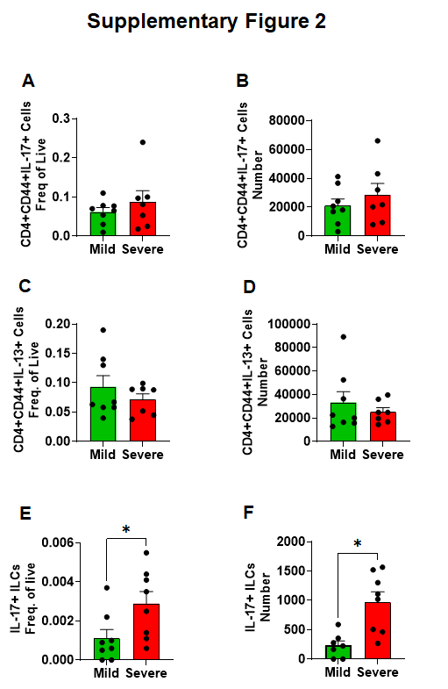

Fig S2: Flow cytometry analysis of lung tissue from HDM+IgG (mild) and HDM+ αC5aR1 (severe) AI mice The frequency and number of IL-17A (A-B) and IL-13 (C-D) producing CD4+ T cells and IL-17A producing ILCs (E-F) in the lungs of HDM-treated mice that received either IgG antibody (mild) or anti-CD5aR1 antibody (severe). IL-17A (IL-13) expressing CD4+ T cells were identified as CD90.2+,𝛾𝛿TCR ,CD3+TCR𝛽+,CD4+,CD44+IL17A+(IL-13+) live lymphocytes. IL-17A expressing ILCs were identified CD90.2+,𝛾𝛿TCR-,CD3-TCR𝛽-,CD44+IL17A+ live lymphocytes. Data are shown as a frequency of total live cells in each sample as well as the number of cells per lung sample. Significantly higher frequency of total live IL-17A producing lung ILCs (panel E) (unpaired t test t=2.319, df=14, p=0.036) and total number of IL-17A producing lung ILCs (panel F) (unpaired t test t=3.627, df=13, p=0.003) was observed. Mean ±SEM. * p= , students t-test, N=8 mice per group.
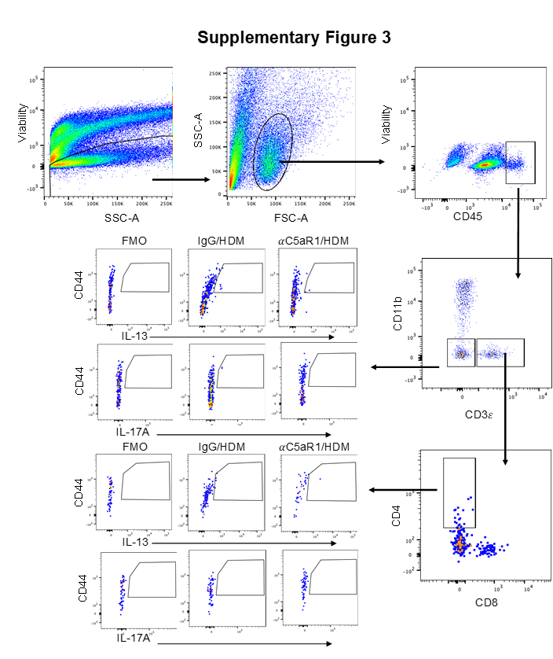

Fig S3: Flow cytometry gating strategy of brain tissue from HDM+ IgG (mild) and HDM+ αC5aR1 (severe) AI mice Gating strategy to examine cytokine production by infiltrating immune cells in the brain.
Infiltrating immune cells were identified as CD45Hi. IL-13- or IL-17A-producing CD4+ T cells were defined as CD3+CD11b-CD44+ while other infiltrating immune cells were identified at CD3-CD11b-CD44+. A representative plot from each treatment group and FMO is shown.

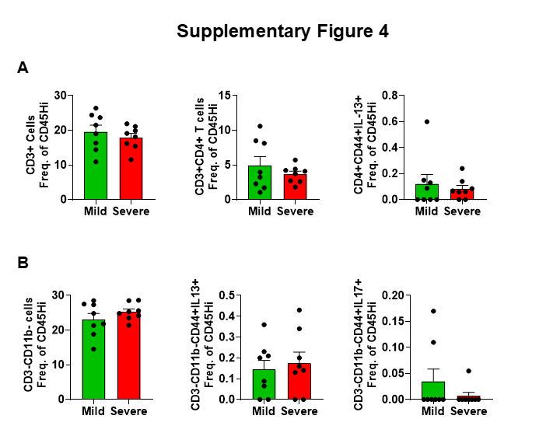

Fig S4: Flow cytometry analysis of brain tissue from HDM+ IgG (mild) and HDM+ αC5aR1 (severe) AI mice The frequency of infiltrating CD3+CD11b-(A.) and CD3-CD11b-(B.) cells in the brains of HDM-treated mice that received either IgG control antibody or anti-C5aR1 antibody.
IL-13-producing CD4+ T cells were defined as CD45HiCD3+CD11b-CD4+CD44+ and IL-13- and IL-17A-producing immune cells were defined at CD45HiCD3-CD11b-CD44+. No differences were observed between treatment groups (p>0.05). Data are shown as a frequency of CD45Hi cells in each sample, ean ± sem. N= 8 mice per group

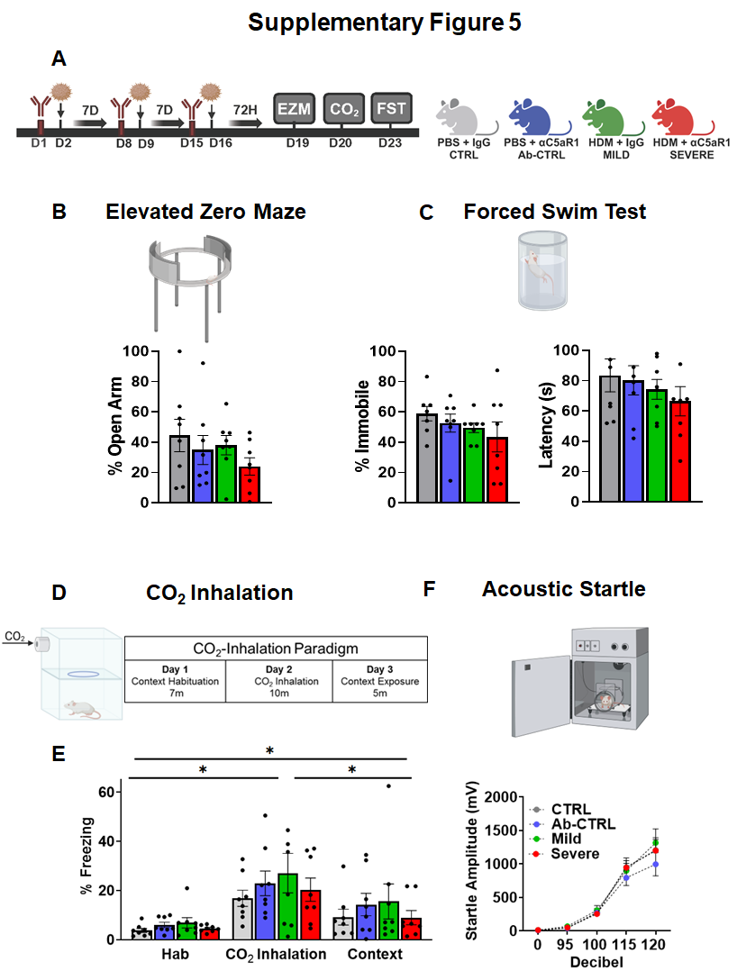

Figure S5: Defensive behaviors to exteroceptive (elevated zero maze, forced swim test, acoustic startle) or interoceptive (CO₂ inhalation) threat exposures are not altered in severe AI mice
(A) Schematic showing experimental layout and timeline. Mice treatment groups that underwent behavioral testing are shown. Acoustic startle was performed in a separate cohort of mice at 72h after the last treatment
(B) Exposure to the EZM showed no significant group differences (open arm time, F_{3,28} = 0.9966; p= 0.4089)
(C) No significant group differences were observed in the FST (% immobility, F_{3,28} = 0.9988; p= 0.4079; latency to immobility, F_{3,28} = 0.6089; p = 0.6417)
(D) Dual chamber CO₂-inhalation setup and schematic of the 3-day CO₂ inhalation- contextual fear paradigm
(E) Fear response (% freezing) to interoceptive threat, CO₂ inhalation and CO₂-context conditioned fear (CF) revealed increased freezing to CO₂ inhalation and 24h post CO₂ context exposure. A 2-way ANOVA revealed a significant effect of exposure day (F _{1.719, 48.13} =30.13, p<0.0001), post hoc analysis revealed significantly higher freezing on CO₂ and context exposure days relative to habituation [Hab v CO₂ (p < 0.0001), Hab v CF (p = 0.0044) and CO₂ vs CF (p < 0.001)]. However, no significant effect of treatment group was observed (F _{3,28} = 0.725, p=0.545).
(F) Exposure to a variable range of acoustic stimuli revealed a significant overall effect of decibel on startle amplitude (F _{1.682, 43.72} = 136.9, p<0.0001). However, no significant effects of treatment (F _{(3, 26)} = 0.5178, p= 0.673) or decibel × treatment interaction (F _{5.045, 43.72} = 0.4665, p= 0.800) were observed
Data are mean ± sem, N=8 /group (EZM, FST, CO₂ inhalation), N=7-8 /group (acoustic startle)

Figure S6: Post behavior ΔFosB (FosB) analysis within fear regulatory brain regions
(A) Brain atlas representation of brain areas for ΔFosB quantification: prelimbic cortex (PL), basolateral amygdala (BLA), central nucleus of amygdala (CeA), hippocampal dentate gyrus (DG), and bed nucleus of stria terminalis (BNST). Scale Bar= 100µm. (B) No significant differences were observed in the PL (t₁₁ = 0.33; p = 0.330), BLA (t₁₁ = 1.85; p = 0.091), CeA (t₁₁ = 1.74; p = 0.110), DG (t₁₁ = 0.543; p = 0.597) or BNST (t₁₁ = 0.435; p = 0.671). All data are Mean ± sem, N= 7 (mild), 6 (severe)
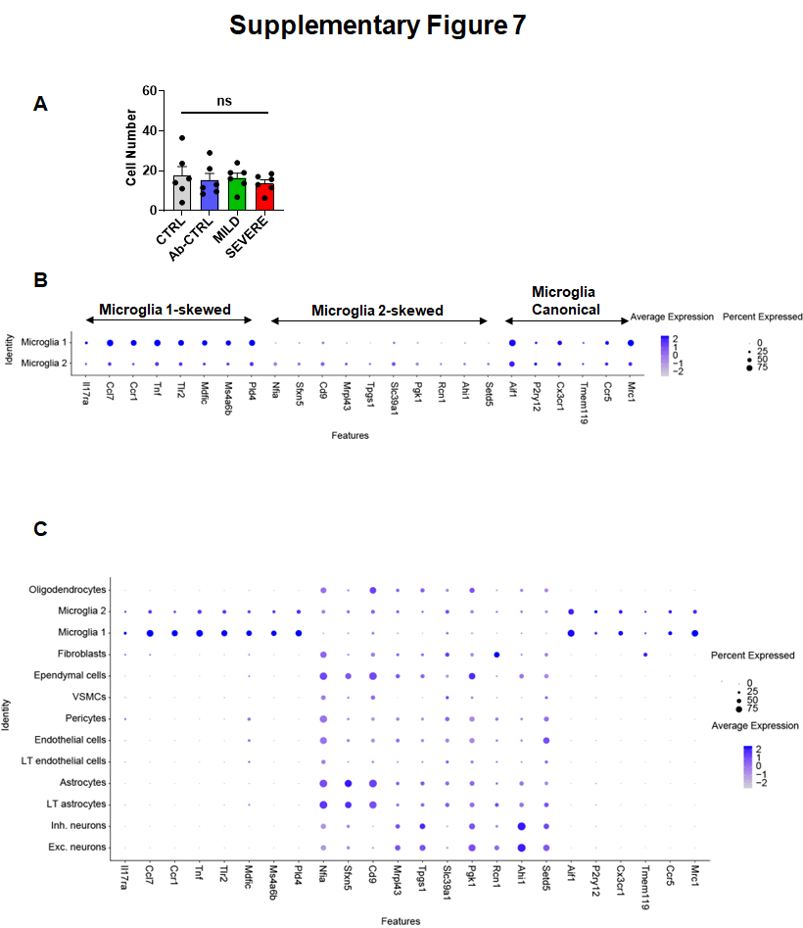
Figure S7: SFO microglia cell counts and molecular profile of two transcriptomically distinct microglial populations in the SFO.
A. No significant group differences in microglial cell counts were observed within the SFO (F_{3,20} = 0.262, p=0.85) Data are represented as mean ± sem. N= 6 mice per group
B. Dotplot of cell-type-specific and canonical microglial markers in the two SFO microglial populations. Dot size is proportional to % of cells with transcript count >0, color scale represents z-scored average gene expression (n =m7,950 SFO cells).
C. Dotplot of cell-type-specific and canonical microglial markers in SFO cell classes. Data in A and B reanalyzed and plotted from a previous study (Pool et al, 2020) [56].

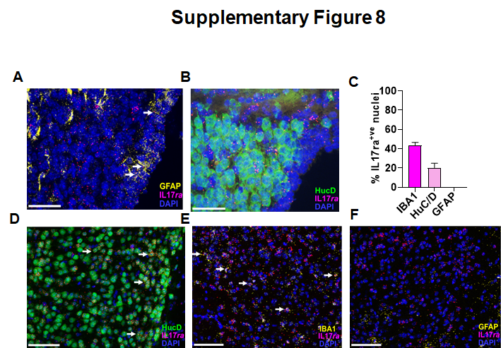

Figure S8: RNAscope in-situ hybridization for cellular expression of Il17ra in the SFO and PFC
Representative 20x images from RNAscope in-situ hybridization on SFO slices using probes for Il17ra and GFAP (A) and immunohistochemistry with neuronal marker HuC/D (B). Arrows in (A) show scattered co-localization of Il17ra^{+ve} puncta (magenta) with GFAP^{+ve} puncta (yellow), DAPI stained cells shown in blue. No co-localization of Il17ra^{+ve} puncta (magenta) was evident with HuC/D^{+ve} neurons (green) (B).
Graph (C) and Images (D-F) are from Il17ra in situ-hybridization performed in PFC slices.
Representative 20x images using Il17ra probe with neuronal marker HuC/D (D) and IBA1 (E) co-localized with Il17ra puncta. Arrows in (D, E) show scattered co-localization of Il17ra^{+ve} puncta (magenta) with HuC/D^{+ve} cells (green) and IBA1^{+ve} puncta (yellow) (E). No co-localization was observed with GFAP^{+ve} puncta (yellow) (F). Graph (C) shows percent expression of Il17ra with IBA1 (43.8%), HuC/D (20.3%) and GFAP (not detected) within the prefrontal cortex. Scale Bar= 20µm

Figure S9: AAV-Gi-DREADD expression and CNO supplemental data
(A) The ratio of co-labeled Gi-DREADD-mCherry expressing (RFP^{+ve}) + IL-projecting (eFP^{+ve} ) / total eGFP^{+ve} cells in the SFO was not different between vehicle and CNO treated severe-AI mice. Data are mean ± sem. N= 14 (Veh), 13 (CNO)
(B) Representative images showing absence of Gi-DREADD-mCherry expressing (RFP^{+ve}) soma in fear-regulatory sites such as the basolateral amygdala (BLA), prelimbic cortex (PL) and hippocampus (HIP). Note IL-projecting eGFP positive cells (green) within the BLA and PL. No RFP^{+ve} soma or co-localized RFP^{+ve}/eGFP^{+ve} cells were evident in any area. Scale bar =100µm
(C) Schematic for experimental setup. Control naïve mice received either vehicle (Veh) or CNO, i.p, at indicated timepoints followed by FC-EXT testing (temporal layout for Veh/CNO same as Fig 6H)
(D) For fear acquisition (Acq), no significant group difference was observed in freezing between vehicle and CNO-treated mice [RM-ANOVA: effect of time (F_{1.528, 13.75} = 9.159; p=0.0048) but no treatment (F _{1, 9} = 0.5859; p=0.585) or treatment x time interaction (F_{1.528, 13.75} = 0.8242; p =0.425)]. Conditioned freezing (CF) 24 h later was not significantly different (t _{3.5} = 0.6326,; p = 0.568). Freezing during extinction revealed a significant effect of time
(F_{2.643, 18.50} = 7.363; p=0.0025) but no treatment (F_{1, 9} = 1.095 p=0.330) or treatment x time interaction (F _{2.643, 18.50} = 0.9448; p=0.429). Data are Mean± sem, N=3-6 mice/group

