Hyperactive basolateral amygdala mediates comorbid anxiety in chronic rhinosinusitis
Xiaojun Zhang^{a b,#}, Wensi Wu^{c,#}, Haomiao Zhaoª, Yimeng Changª, Xinyi Maª, Xueyun Shiª, Binxiang Tangª, Pin Wangª, Chen Duan ª, Min Jin^{b,} , Xin Feng^{a,*}

Supplementary Table 1. Information of the participants recruited in the clinical studies
Characteristic | Overall  (n=201) | Anxiety  (n=91) | Non-Anxiety  (n=110) | P value
Age, mean (SD) (years) |  | 43.5  (16.3) | 41.0  (15.2) | 0.371
Gender (%) |  |  |  | 0.541
Male | 124 (61.7) | 56 (61.5) | 68 (61.8)
Female | 77 (38.3) | 35 (38.5) | 42 (38.2)
Height, mean (SD) (cm) |  | 167.6  (9.1) | 167.4  (10.3) | 0.521
Body weight, mean (SD) (kg) |  | 70.6  (16.2) | 72.4  (19.3) | 0.839
BMI, mean (SD) |  | 24.9  (4.5) | 25.6  (5.4) | 0.709
Hypertension | 29 | 16 | 13 | 0.500
Diabetes | 5 | 2 | 3 | 0.169
Coronary heart disease | 4 | 1 | 3 | 0.385
CRSwNP | 127 | 57 | 70 | 0.500
CRSsNP | 74 | 34 | 40 | 0.500
Eosinophilic type | 101 | 49 | 52 | 0.216
non-Eosinophilic type | 100 | 42 | 58 | 0.216
Asthma | 20 | 9 | 11 | 0.246

Supplementary Table 2. The 20 brain regions for c-FOS analysis
number | brain region | abbreviation
1 | anterior cingulate cortex | ACC
2 | prelimbic cortex | PL
3 | infralimbic cortex | IL
4 | accumbens nucleus, core | AcbC
5 | accumbens nucleus, shell | AcbSh
6 | caudate putamen | CP
7 | lateral septal nucleus | LS
8 | nucleus of the vertical limb of the diagonal band | nVDB
9 | bed nucleus of stria terminalis | BNST
10 | retrosplenial granular cortex | RSGc
11 | lateral habenular nucleus | LHb
12 | paraventricular thalamic nucleus | PVT
13 | paraventricular nucleus | PVN
14 | reuniens thalamic nucleus | RE
15 | basolateral amygdaloid | BLA
16 | hippocampus | HPC
17 | ventral tegmental area | VTA
18 | medial periaqueductal gray | MPAG
19 | lateral periaqueductal gray | LPAG
20 | dorsal raphe | DR

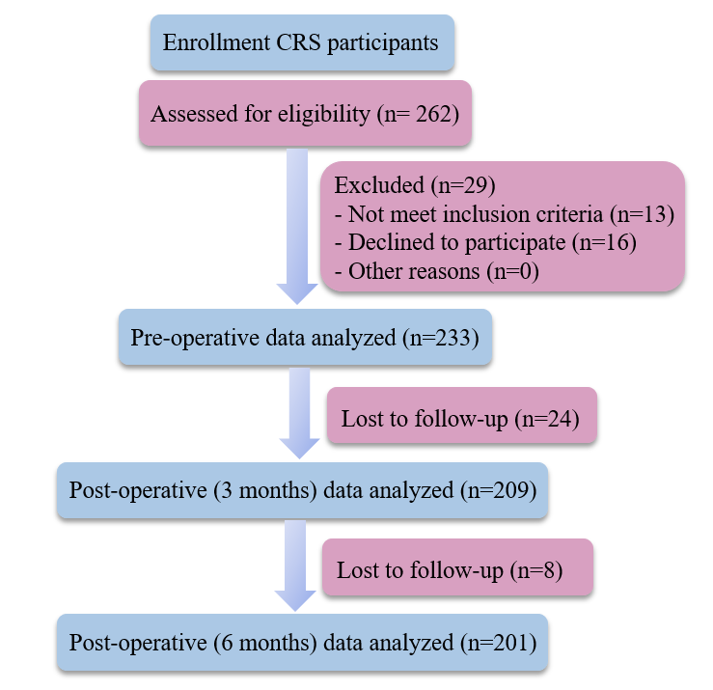
Supplementary Figure 1. Participant flow diagram for this study

Supplementary Figure 2. Body weight of mice during papain administration
Body weight was continuously monitored during papain administration. Data were presented as mean ± SEM. Statistical analyses were performed using two-Way ANOVA.

Supplementary Figure 3. Behavioral paradigms and quantitative assessments of affective, fear-related, and social behaviors in mice
A. Schematic representations of the behavioral paradigms employed, including the SPT, TST and FST. B. Behavioral outcomes derived from the SPT, expressed as sucrose preference, together with immobility durations measured during the TST and FST. C. Diagrammatic overview of the fear conditioning response test. D. Freezing behavior quantified as the proportion of total recording time during the contextual and cue-associated phases of the FCR test. E. Representative locomotor trajectories illustrating exploratory behavior during the sociability phase of the three-chamber social interaction assay. F. Quantification of time spent in each chamber during the sociability phase. G. Representative locomotor trajectories depicting behavior during the social novelty phase. H. Time spent in each chamber during the social novelty phase of the three-chamber assay. n=10 mice per group. Data were presented as mean ± SEM. Statistical analyses were performed using unpaired t-test (B, D) and one-way ANOVA (F, H). *** P < 0.001, n.s. represents no significance.

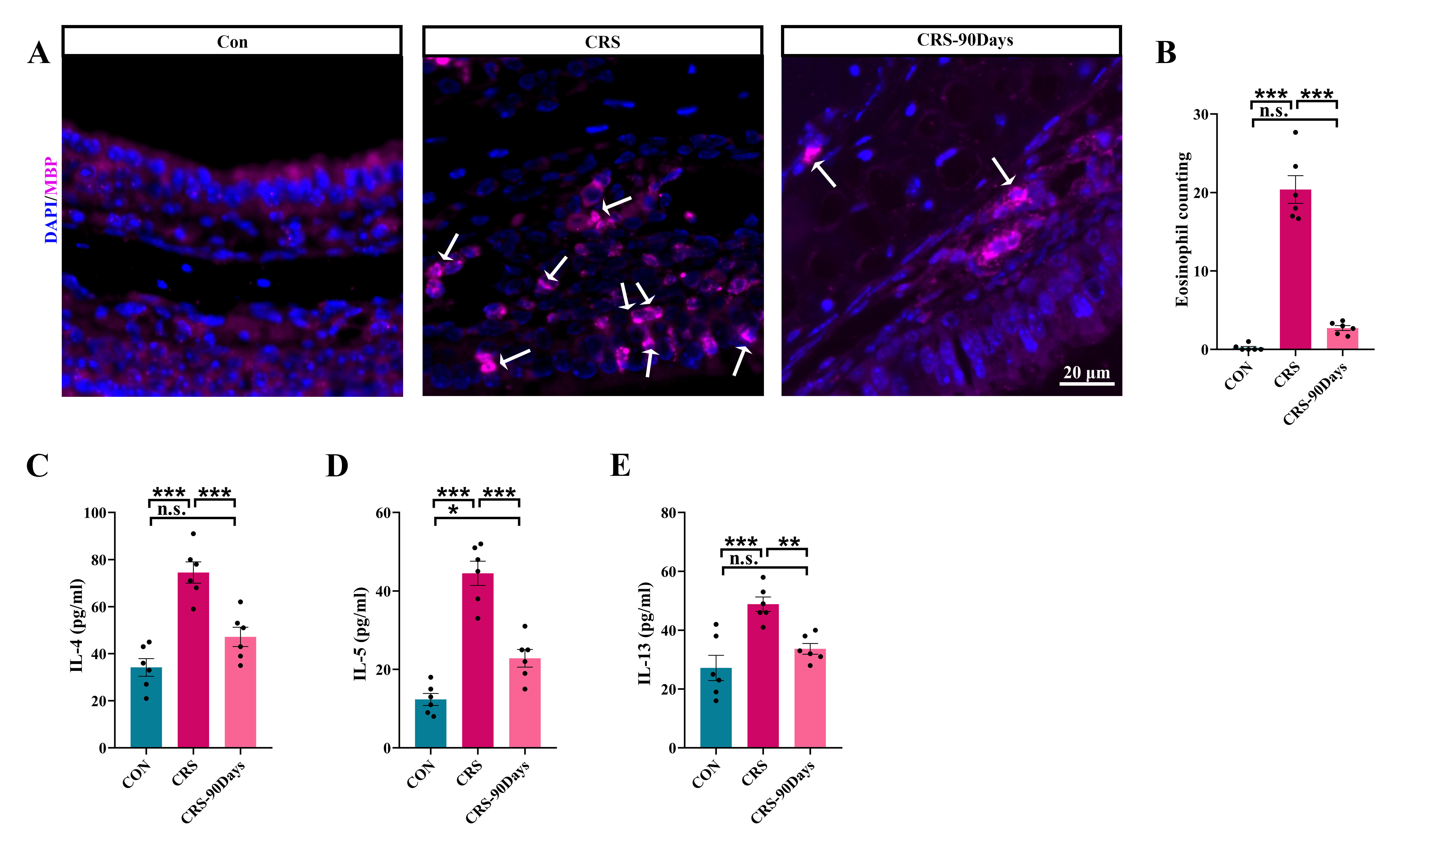
Supplementary Figure 4. Pathology determination of mice following three months of drug administration
A. Representative nasal tissue eosinophil staining images (indicated by the white arrow); scale bar, 20 μm. B. Quantification of eosinophils in IF staining. C-E. Cytokines levels of IL-4, IL-5, and IL-13 in NALF. Data were presented as mean ± SEM. Statistical analyses were performed using One-Way ANOVA. * P < 0.05, ** P < 0.01, *** P < 0.001, n.s. represents no significance.
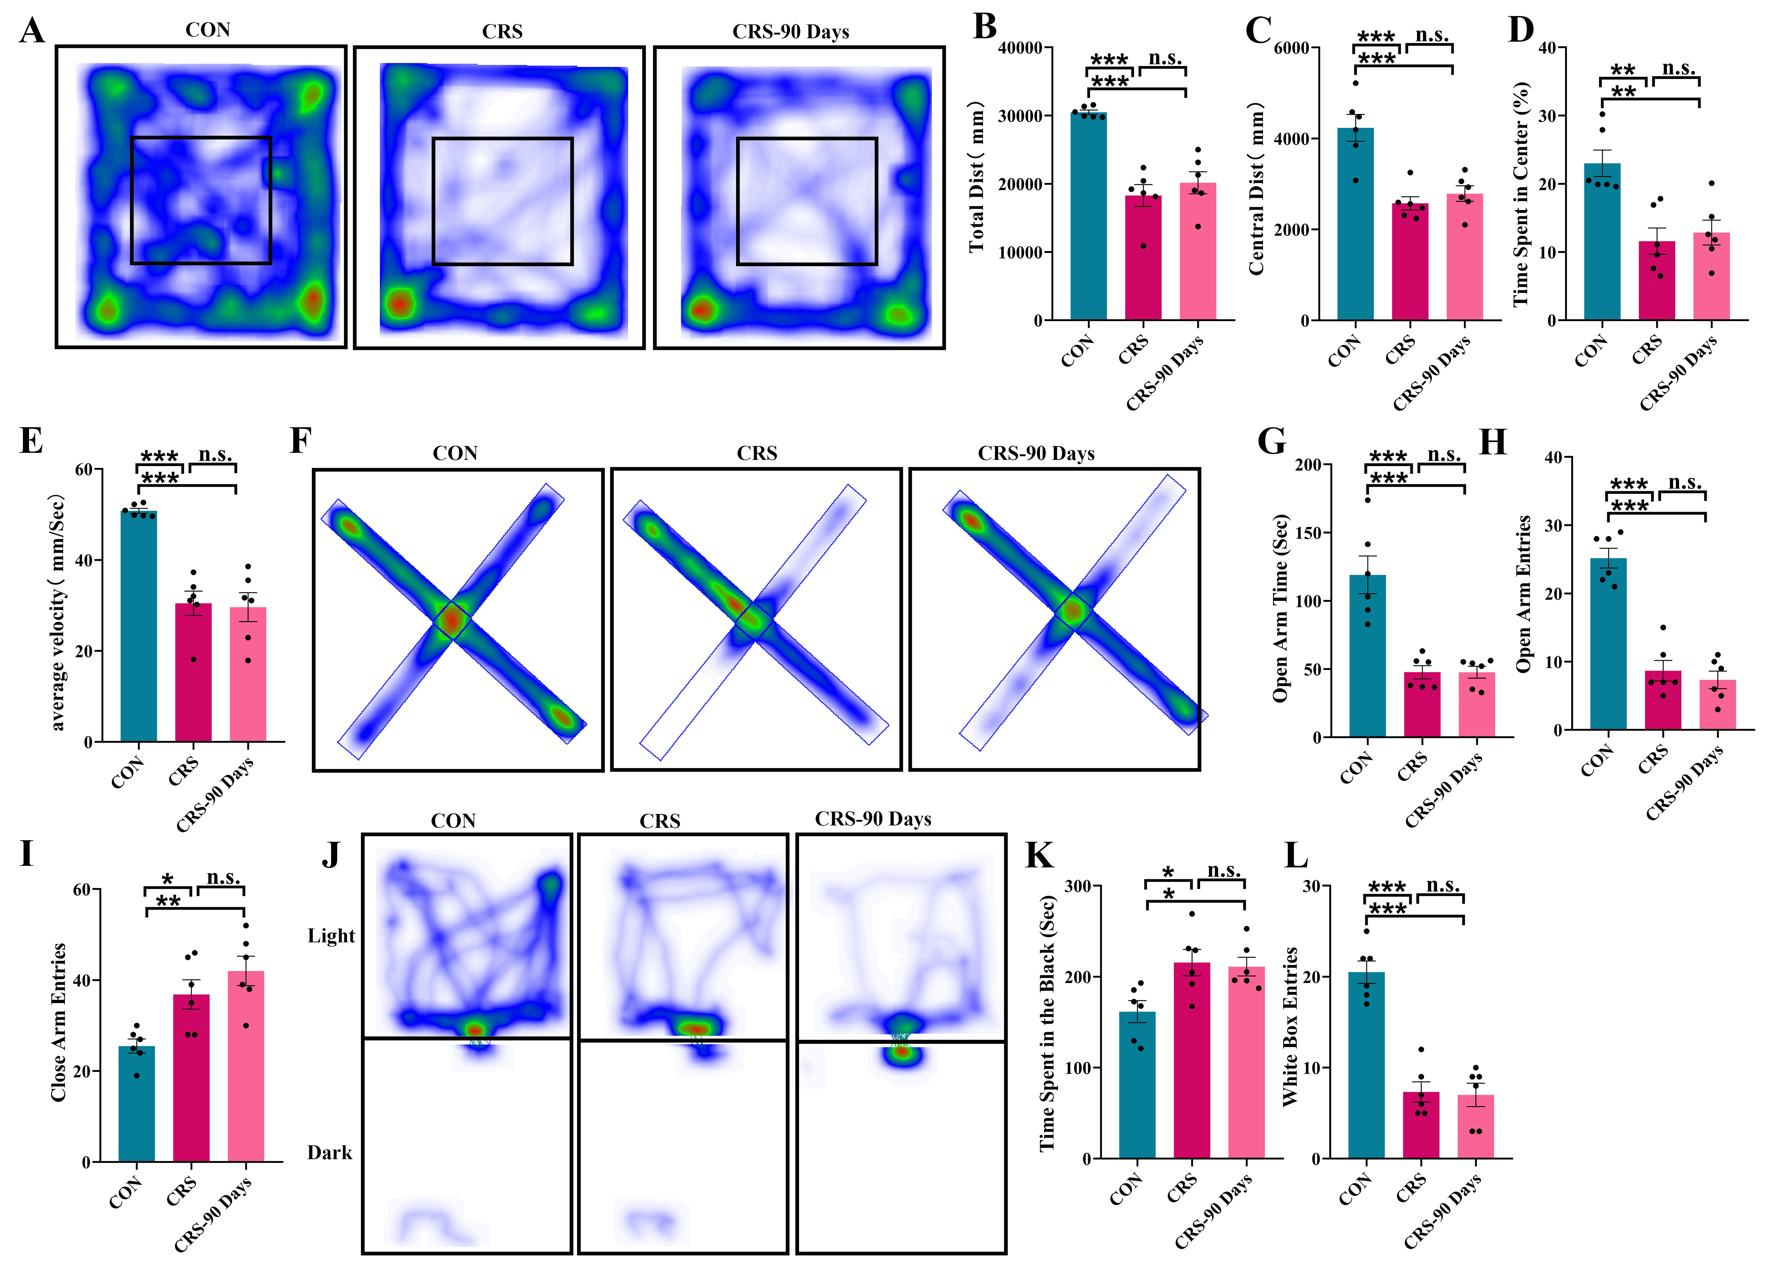
Supplementary Figure 5. Behavioral assessment of mice anxiety following three months of papain administration
A. Representative activity traces in the OFT. B-E. Total distance traveled (B), activity within the central area (C-D) and average velocity (E) in the OFT. F. Representative activity trace in the EPM. G. Time spent in the open arms of the EPM. H. Number of entries into the open arms. I. Closed arm entries during the EPM. J. Representative activity trace in the LDB test. K. Time spent in the dark box during the LDB test. L. Number of entries into the light box during the LDB test. Data were presented as mean ± SEM. Statistical analyses were performed using One-Way ANOVA. * P < 0.05, ** P < 0.01, *** P < 0.001, n.s. represents no significance.
Supplementary Figure 6. Activation of BLA neurons induces behavioral and peripheral alterations with greater effects under CRS conditions
A. Schematic overview of the experimental design, including AAV injection into the BLA, CNO administration, behavioral assessments, and tissue collection. B. Representative images and quantification of c-FOS immunostaining in the BLA, Scale bar = 200 μm. C-F. Total distance traveled (C), distance traveled in the center zone (D), percentage of time spent in the center area (E), and mean locomotor velocity (F) in the OFT. G-I. Time spent in open arms (G), number of entries into open arms (H), and number of entries into closed arms (I) in EPM. J-K. Duration spent in the dark compartment (J) and number of transitions into the light compartment (K) in LDB test. L-M. Representative images and quantification of TH-positive sympathetic nerve fibers in the nasal mucosa. Scale bars = 100 μm. N–O. Representative images of MBP-labeled eosinophils in the nasal mucosa and the quantification. Scale bars = 100 μm. P-Q. Levels of NE and IL-33 in NALF. Data were presented as mean ± SEM. Statistical analyses were performed using One-Way ANOVA. * P < 0.05, **P < 0.01, *** P < 0.001.

Supplementary Figure 7. Action potential firing and firing frequency of VGAT-labeled inhibitory neuron in BLA
Representative action potential traces recorded from VGAT-positive inhibitory neurons are shown, together with quantification of firing frequency. Data were presented as mean ± SEM. Statistical analyses were performed using two-way ANOVA.

Supplementary Figure 8. VGLUT2 immunostaining in the BLA.
A-B. Representative images and quantification of VGLUT2 (magenta) staining in the BLA. Blue, DAPI. Scale bar, 100 µm.

