Supplemental Materials
ABCA1-mediated Lipid Efflux Restrains Oxidative Stress and Neuroinflammation after Spinal Cord Injury

Yuqi Shao^{1,2}†, Jiayun Liu^{1,2}†, Jiangyu Zhao^{1,2}†, Kaixiao xue^{1,2}, Xincan Wu^{1,2}, Heng Cao^{1,2}, Rui Bao^{1,2}, Qiancheng Sun^{1,2}, Yuanzhen Zhang^{1,2}, Peng Gao^{1,2}, Mingran Luo³, Jian Chen^{1,2}*, and Guoyong Yin^{1,2}*

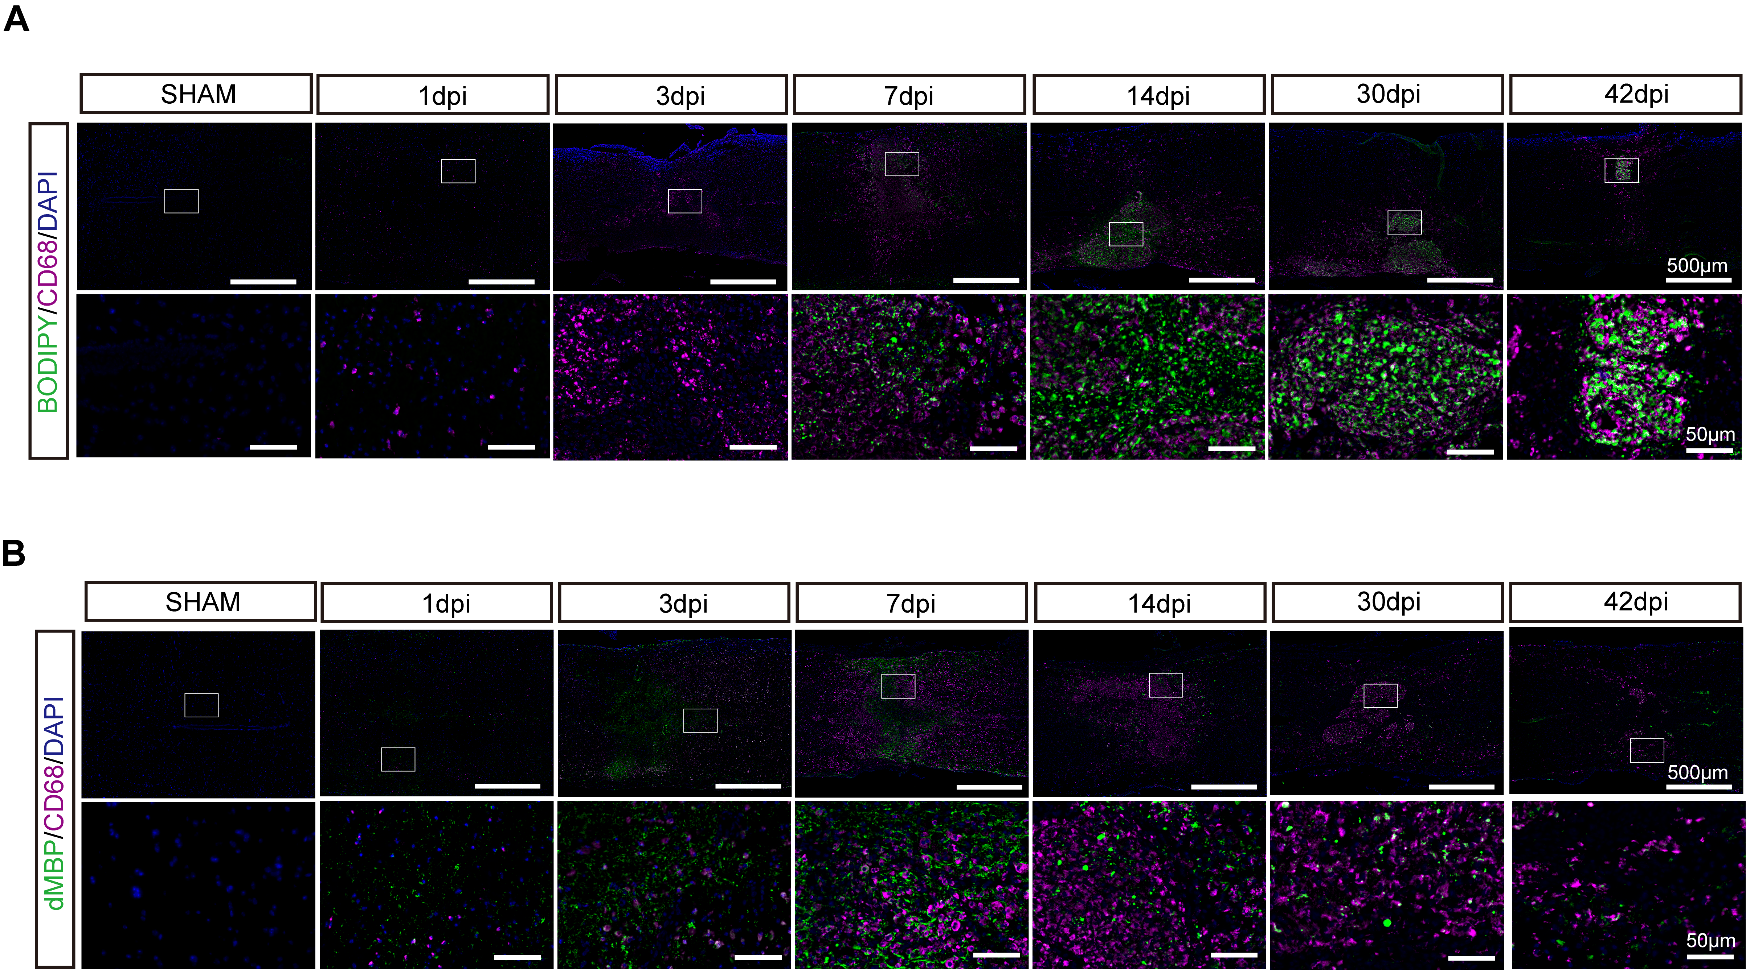
Fig. 1 Persistent activation of phagocytes coincides with sustained lipid burden after spinal cord injury.
(A) Representative immunofluorescence images showing activated microglia/macrophages (CD68, magenta) co-stained with lipid droplets (BODIPY, green) and DAPI (blue) at indicated time points after SCI, Scale bars=500 μm (overview) and 50 μm (magnified images).
(B) Representative immunofluorescence images showing activated microglia/macrophages (CD68, magenta) co-stained with degraded myelin basic protein (dMBP, green) and DAPI (blue) at indicated time points after SCI, Scale bars= 500 μm (overview) and 50 μm (magnified images).

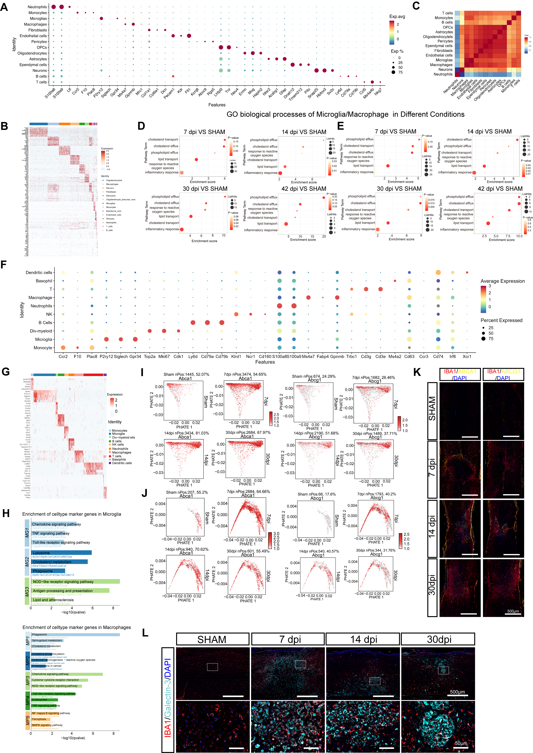
Fig. 2 Cell-type annotation and immune-state refinement validate clustering and highlight ABCA1-enriched efflux subpopulations.
(A) Dot plot of canonical marker genes supporting annotation of the 14 major cell classes in the snRNA-seq dataset.
(B) Heatmap of top marker genes across the 14 major cell classes, showing distinct transcriptional identities.
(C) Pairwise correlation (coefficient) heatmap among major cell classes, indicating robust inter-cluster separation.
(D) GO biological process enrichment analyses of microglial DEGs for each post-injury comparison versus SHAM.
(E) GO biological process enrichment analyses of macrophage DEGs for each post-injury comparison versus SHAM.
(F) Dot plot of canonical markers supporting annotation of immune cell classes in the CD45⁺ scRNA-seq dataset.
(G) Heatmap of top marker genes across CD45⁺ immune cell classes, demonstrating clear transcriptional separation.
(H) KEGG pathway enrichment summary across microglial (MG1–MG3) and macrophage (MP1–MP5) subclusters, supporting functional heterogeneity among subclusters.
(I,J) feature plots showing expression of ABCA1 and ABCG1 within microglial (g) and macrophage (h) subclusters across conditions.
(K) Representative immunofluorescence images showing ABCA1 and ABCG1 signals in IBA1+ phagocytes across indicated stages after SCI. Scale bars=500μm.
(L) Representative immunofluorescence images showing Lgals3 expression in spinal cord sections from SHAM and SCI mice at 7, 14, and 30 days post-injury. Scale bars=500μm (overview) and 50μm (magnified images).

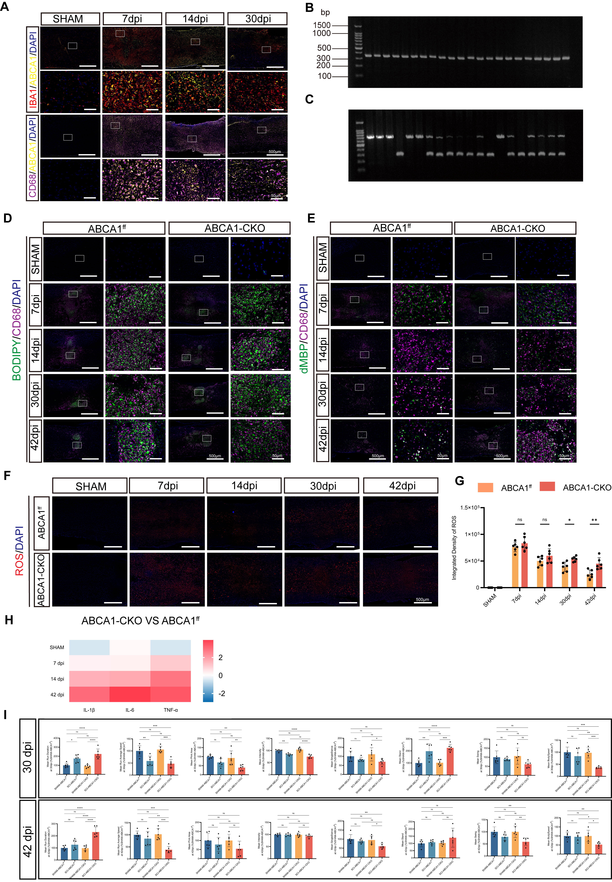
Fig. 3 Genotyping validation and ABCA1 deletion enhances oxidative stress, inflammatory signaling, and gait abnormalities after SCI.
(A) Representative immunofluorescence images showing ABCA1 expression in spinal cord sections from SHAM and SCI mice at 7, 14, and 30 days post-injury. ABCA1 (yellow) is co-stained with IBA1 (red) or CD68 (magenta), with DAPI (blue) labeling nuclei, Scale bars=500μm (overview) and 50μm (magnified images).
(B) Representative PCR genotyping gel electrophoresis for Abca1^{flox/flox} alleles. Homozygous floxed mice display a single band at 334 bp.
(C) Representative PCR genotyping gel electrophoresis for Cx3cr1^{CreER} alleles. Heterozygous mice exhibit two bands at 695 bp and 300 bp, whereas homozygous mice show a single band at 300 bp.
(D) Representative immunofluorescence images showing activated microglia/macrophages (CD68, magenta) co-stained with lipid droplets (BODIPY, green) and DAPI (blue) in ABCA1^{f/f} and ABCA1-CKO mice at indicated time points after SCI, Scale bars=500μm (overview) and 50μm (magnified images).
(E) Representative immunofluorescence images showing activated microglia/macrophages (CD68, magenta) co-stained with degraded myelin (dMBP, green) and DAPI (blue) in ABCA1^{f/f} and ABCA1-CKO mice, Scale bars=500μm (overview) and 50μm (magnified images).
(F) Representative ROS staining images from isolated spinal cord tissues at indicated time points, Scale bars=500μm.
(G) Quantification of ROS integrated fluorescence intensity (n=6).
(H) Heatmap showing relative expression of IL-1β, IL-6, and TNF-α in ABCA1-CKO versus ABCA1^{f/f} mice across time points.
(I) Quantification of additional CatWalk gait parameters (n=6).
Data are presented as mean ± SEM. ns indicates no significance, *, P < 0.05; **, P < 0.01; ***, P < 0.001; ****, P < 0.0001 by two-way ANOVA with Tukey’s test for multiple comparisons (F), one-way ANOVA with Tukey’s test (H).

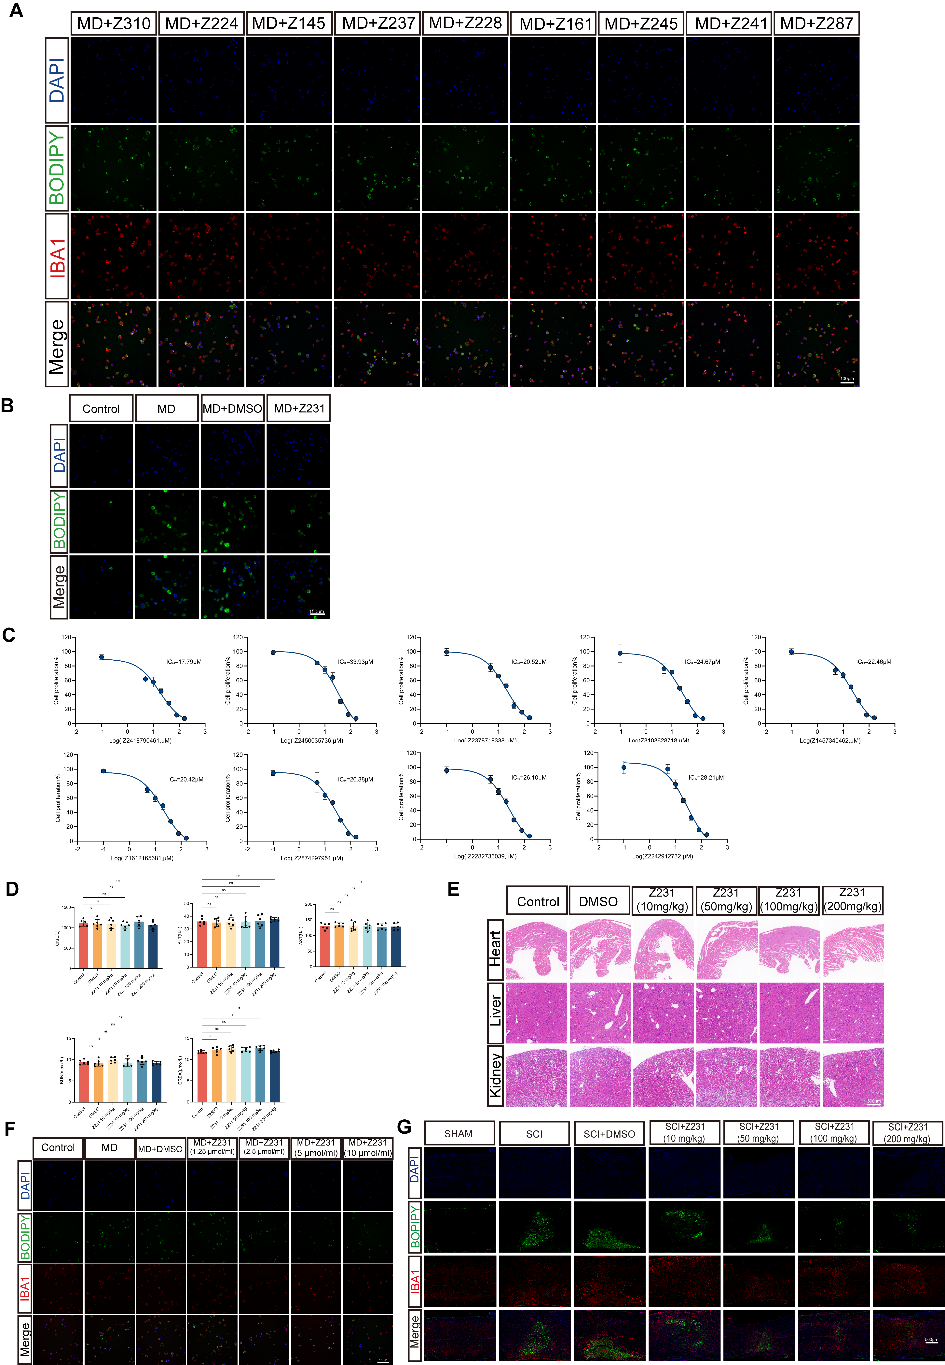
Fig. 4 Candidate compound triage, safety evaluation, and dose selection for Z231 in vitro and in vivo.
(A) Representative immunofluorescence images (DAPI/BODIPY/IBA1) showing lipid droplet responses in primary microglia after MD stimulation and treatment with the top docking-ranked candidate compounds. Scale bars=100μm.
(B) Representative immunofluorescence images showing lipid droplet accumulation in the human microglial cell line HMC3 following MD challenge and Z231 treatment. Scale bars=150μm.
(C) CCK-8 viability curves for candidate compounds used for cellular triage (IC50 values indicated in plots).
(D) Serum biochemistry indices (CK, ALT, AST, BUN, CREA) after systemic administration of Z231 at indicated doses, assessing potential cardiac, hepatic, and renal toxicity (n=6).
(E) H&E staining of heart, liver, and kidney following Z231 treatment at indicated doses, Scale bars=500μm.
(F) In vitro dose-response evaluation of Z231 in primary microglia after MD stimulation, supporting selection of 5μM for subsequent cell-based experiments, Scale bars=150μm.
(G) In vivo dose exploration of Z231 following SCI, showing reduced lipid droplet accumulation at ≥100 mg/kg at 14 dpi and supporting selection of 100 mg/kg for subsequent animal studies, Scale bars=500μm.
Data are presented as mean ± SEM. ns indicates no significance by one-way ANOVA with Tukey’s test for multiple comparisons (C).

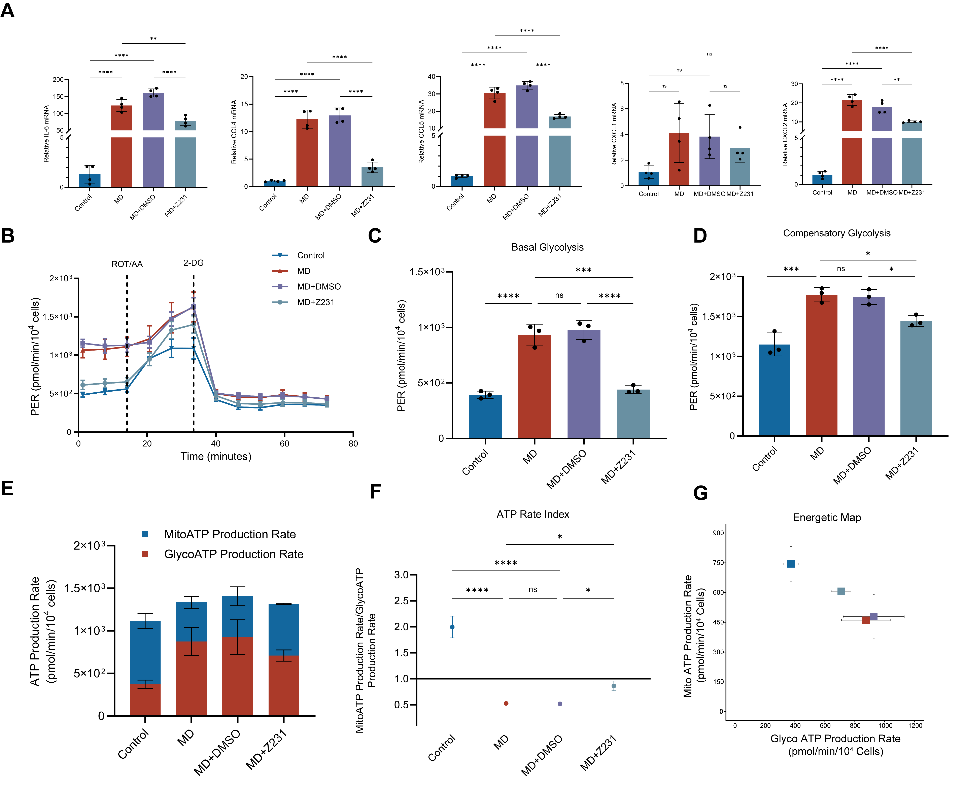
Fig. 5 Z231 partially restores mitochondrial respiration and limits glycolytic dependence in myelin debris–stimulated primary microglia.
(A) qPCR quantification of chemokine transcripts induced by MD stimulation and modulated by Z231, Values are shown relative to Control (n=4).
(B) Seahorse glycolytic rate assay showing proton efflux rate (PER) traces over time across the four conditions. Rotenone/antimycin A (Rot/AA) and 2-deoxy-D-glucose (2-DG) were injected sequentially at the indicated time points to resolve mitochondrial contribution and glycolytic dependence.
(C,D) Quantification of basal glycolysis or compensatory glycolysis (n=3).
(E) Seahorse ATP rate assay showing mitochondrial ATP production rate (MitoATP) and glycolytic ATP production rate (GlycoATP) across the four conditions (stacked representation).
(F) ATP Rate Index calculated as the ratio of mitochondrial ATP production rate to glycolytic ATP production rate (n=3).
(G) Energetic map depicting the balance between mitochondrial and glycolytic ATP production across conditions, plotted as Mito ATP production rate versus Glyco ATP production rate.
Data are presented as mean ± SEM. ns indicates no significance, *, P < 0.05; **, P < 0.01; ***, P < 0.001; ****, P < 0.0001 by one-way ANOVA with Tukey’s test (A, C, D and F).

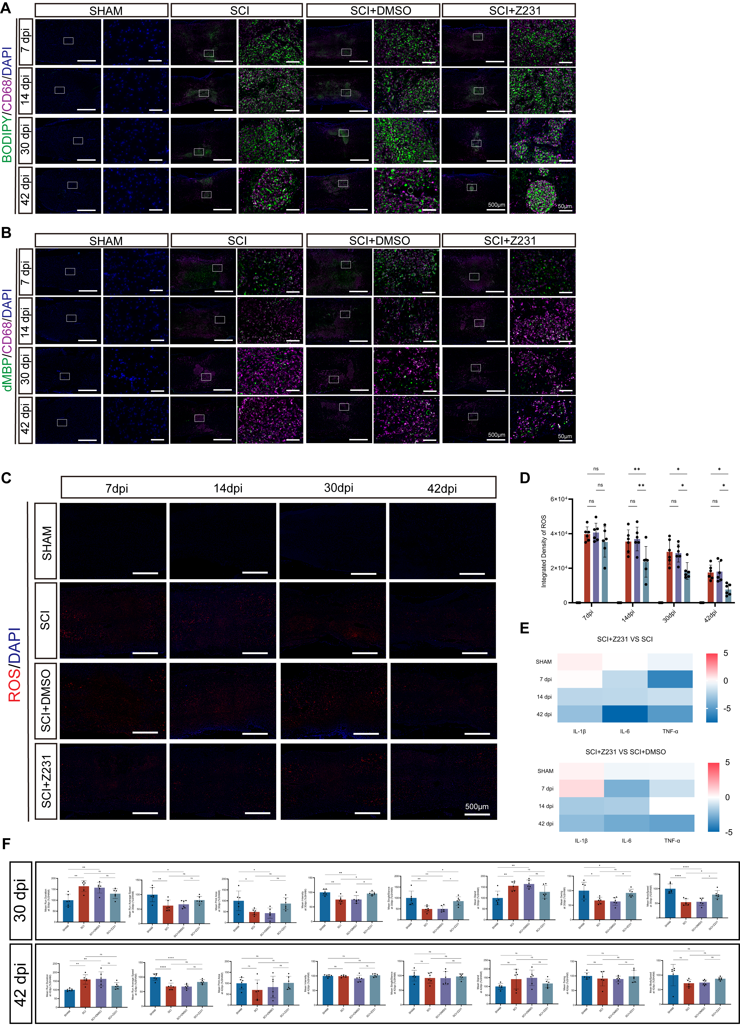
Fig. 6 Z231 reduces chronic phagocyte activation, oxidative stress, and inflammatory cytokine signatures after SCI.
(A) Representative immunofluorescence images showing activated microglia/macrophages (CD68, magenta) co-stained with lipid droplets (BODIPY, green) and DAPI (blue) at 7, 14, 30, and 42 dpi, Scale bars=500μm (overview) and 50μm (magnified images).
(B) Representative immunofluorescence images showing activated microglia/macrophages (CD68, magenta) co-stained with degraded myelin (dMBP, green) and DAPI (blue) at indicated time points across groups, Scale bars=500μm (overview) and 50μm (magnified images).
(C) Representative ROS staining images from prepared spinal cord tissues in each group at 7, 14, 30, and 42 dpi, Scale bars=500μm.
(D) Quantification of ROS integrated fluorescence intensity (n=6).
(E) Heatmaps showing relative expression changes of IL-1β, IL-6, and TNF-α comparing SCI + Z231 versus SCI (top) and SCI + Z231 versus SCI + DMSO (bottom) across time points.
(F) Quantification of additional CatWalk gait parameters at 30 and 42 dpi (n=6).
Data are presented as mean ± SEM. ns indicates no significance, *, P < 0.05; **, P < 0.01; ****, P < 0.0001 by two-way ANOVA with Tukey’s test for multiple comparisons (d), one-way ANOVA with Tukey’s test(F).

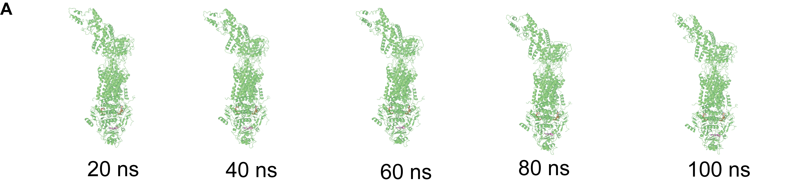
Fig. 7 Representative snapshots of the ABCA1–Z231 complex during MD simulation.
(A) Representative structural snapshots of the ABCA1–Z231 complex at 20 ns, 40 ns, 60 ns, 80 ns, and 100 ns show persistent retention of Z231 within the binding pocket and an overall stable complex architecture throughout the trajectory.

Table 1. Top 10 candidate compounds identified from virtual screening against human ABCA1.

Catalog ID | Docking score | MW | SMILES
Z3103628718 | -7.379 | 309.35 | C1C[C@@H]([NH3+])C[C@@H]1C(=O)N2CCN(CC2)c3c(F)ccc(F)c3
Z2242912732 | -7.053 | 301.21 | C1[NH2+]CC[C@H]1N(C)C(=O)CCc2c(Cl)c(Cl)ccc2
Z1457340462 | -7.020 | 278.78 | [NH3+]C[C@@H](C)N(C)C(=O)c(c1)ccc(c12)cccc2
Z2378718338 | -6.990 | 281.33 | CN(C)c(cc1)cc(F)c1C(=O)NC[C@H]2C[NH2+]CCO2
Z2282736039 | -6.916 | 291.30 | FC(F)c1ccc(cc1)CC(=O)N[C@@H]2CCn(c23)cc[nH+]3
Z1612165681 | -6.887 | 322.83 | c1cccc(Cl)c1C(=O)N(CC2)CCC2[NH2+]C3(CO)CCC3
Z2312316994 | -6.883 | 307.43 | c1ccccc1[C@H]2C[C@@H](C2)[NH2+]C3CCN(CC3)c4cc[nH+]cc4
Z2450035736 | -6.876 | 292.35 | C1[NH2+]CC[C@H]1CCC(=O)N[C@@H]2CCOc(c23)c(F)ccc3
Z2418790461 | -6.870 | 272.35 | C[NH2+][C@@H]1CCCN(C1)C(=O)Cc(n2)cn(c23)cccc3
Z2874297951 | -6.804 | 328.45 | C1C[NH2+]CCC12CCN(C2)C(=O)NC[C@@H](C3)[NH2+]Cc(c34)cccc4

Table 2. Primer sequences used for quantitative PCR and mouse genotyping.
Gene | Forward primer | Reverse primer
lL1β | TGCCACCTTTTGACAGTGATG | TGATGTGCTGCTGCGAGATT
lL6 | GGGACTGATGCTGGTGACAA | ACAGGTCTGTTGGGAGTGGT
TNF-α | TAGCCCACGTCGTAGCAAAC | TGTCTTTGAGATCCATGCCGT
GAPDH | GGGGTCGTTGATGGCAACA | AGGTCGGTGTGAACGGATTTG
lL4 | CATGGGAAAACTCCATGCTT | TGGACTCATTCATGGTGCAG
lL10 | GCTCTTACTGACTGGCATGAG | CGCAGCTCTAGGAGCATGTG
CCL3 | TGAAACCAGCAGCCTTTGCTC | AGGCATTCAGTTCCAGGTCAGTG
CCL4 | TCCCACTTCCTGCTGTTTCT | GAGGAGGCCTCTCCTGAAGT
CCL5 | AAGATCTCTGCAGCTGCCCT | GAGCCATATGGTGAGGCAGG
CXCL10 | AGTGCTGCCGTCATTTTCTG | TCAACACGTGGGCAGGATA
CXCL1 | AACCGAAGTCATAGCCACAC | CAGACGGTGCCATCAGAG
CXCL2 | CATCCAGAGCTTGAGTGTGACG | GGCTTCAGGGTCAAGGCAAACT
ABCA1^{flox/flox} | TTACGTGGTACTGCATGGTCT | ACACCGGCTTCTATTCAGAGG
CX2CR1^{CreER}-P1 | AGGATGTTGACTTCCGAGTTG^{a)}
CX2CR1^{CreER}-P2 | AAGACTCACGTGGACCTGCT^{b)}
CX2CR1^{CreER}-P3 | CGGTTATTCAACTTGCACCA^{c)}
^{a)} Primer Type: Wild type; ^{b)} Primer Type: Common; ^{c)} Primer Type: Mutant;

Data availability statement：The data that support the findings of this study are available from the corresponding author upon reasonable request.

