Supplementary materials for
Lung Microbiota-Derived Deoxyinosine Alleviates TBI-Aggravated Sepsis-Induced Lung Injury via the S100A9/RAGE Pathway
Bailun Wang^{1, #}, Angran Gu^{1, #}, Yizheng Yang^{1, #}, Xuan Liu², Runmeng Liu², Yuelan Wang^{1, *}
1 Department of Anesthesiology, Shandong Provincial Hospital Affiliated to Shandong First Medical University, Jinan, Shandong, 250021, China
2 School of Clinical and Basic Medical Sciences, Shandong First Medical University& Shandong Academy of Medical Sciences, Jinan, Shandong, 250117, China.
#These authors contributed equally to this work.

Corresponding author: Yuelan Wang
Department of Anesthesiology, Shandong Provincial Hospital Affiliated to Shandong First Medical University, Jinan, Shandong, 250021, China

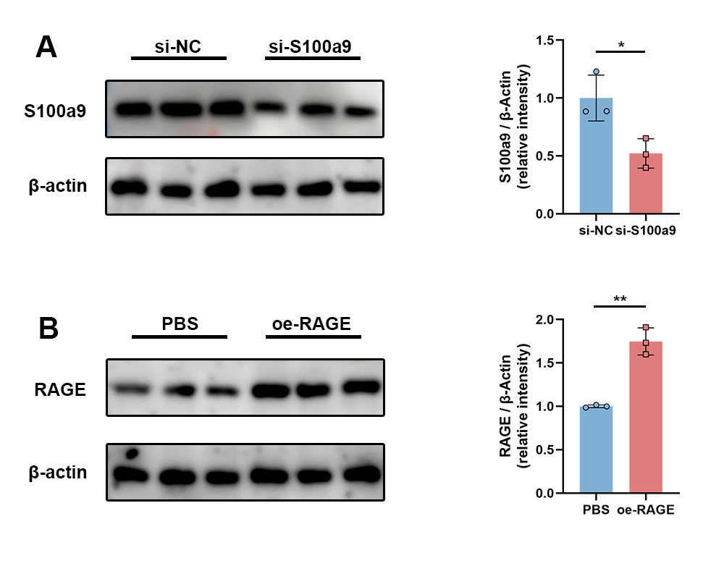
Fig. S1. Validation of S100a9 knockdown and RAGE overexpression efficiency. (A) Representative Western blot (left) and quantitative analysis (right) showing S100a9 protein levels in MH-S transfected with si-NC or si-S100a9 (n = 3). (B) Efficiency of RAGE overexpression. Representative Western blot (left) and quantitative analysis (right) of RAGE protein expression in MH-S treated with PBS or transfected with the RAGE overexpression vector (oe-RAGE) (n = 3). Data are presented as mean ± SD. *P < 0.05, **P < 0.01.

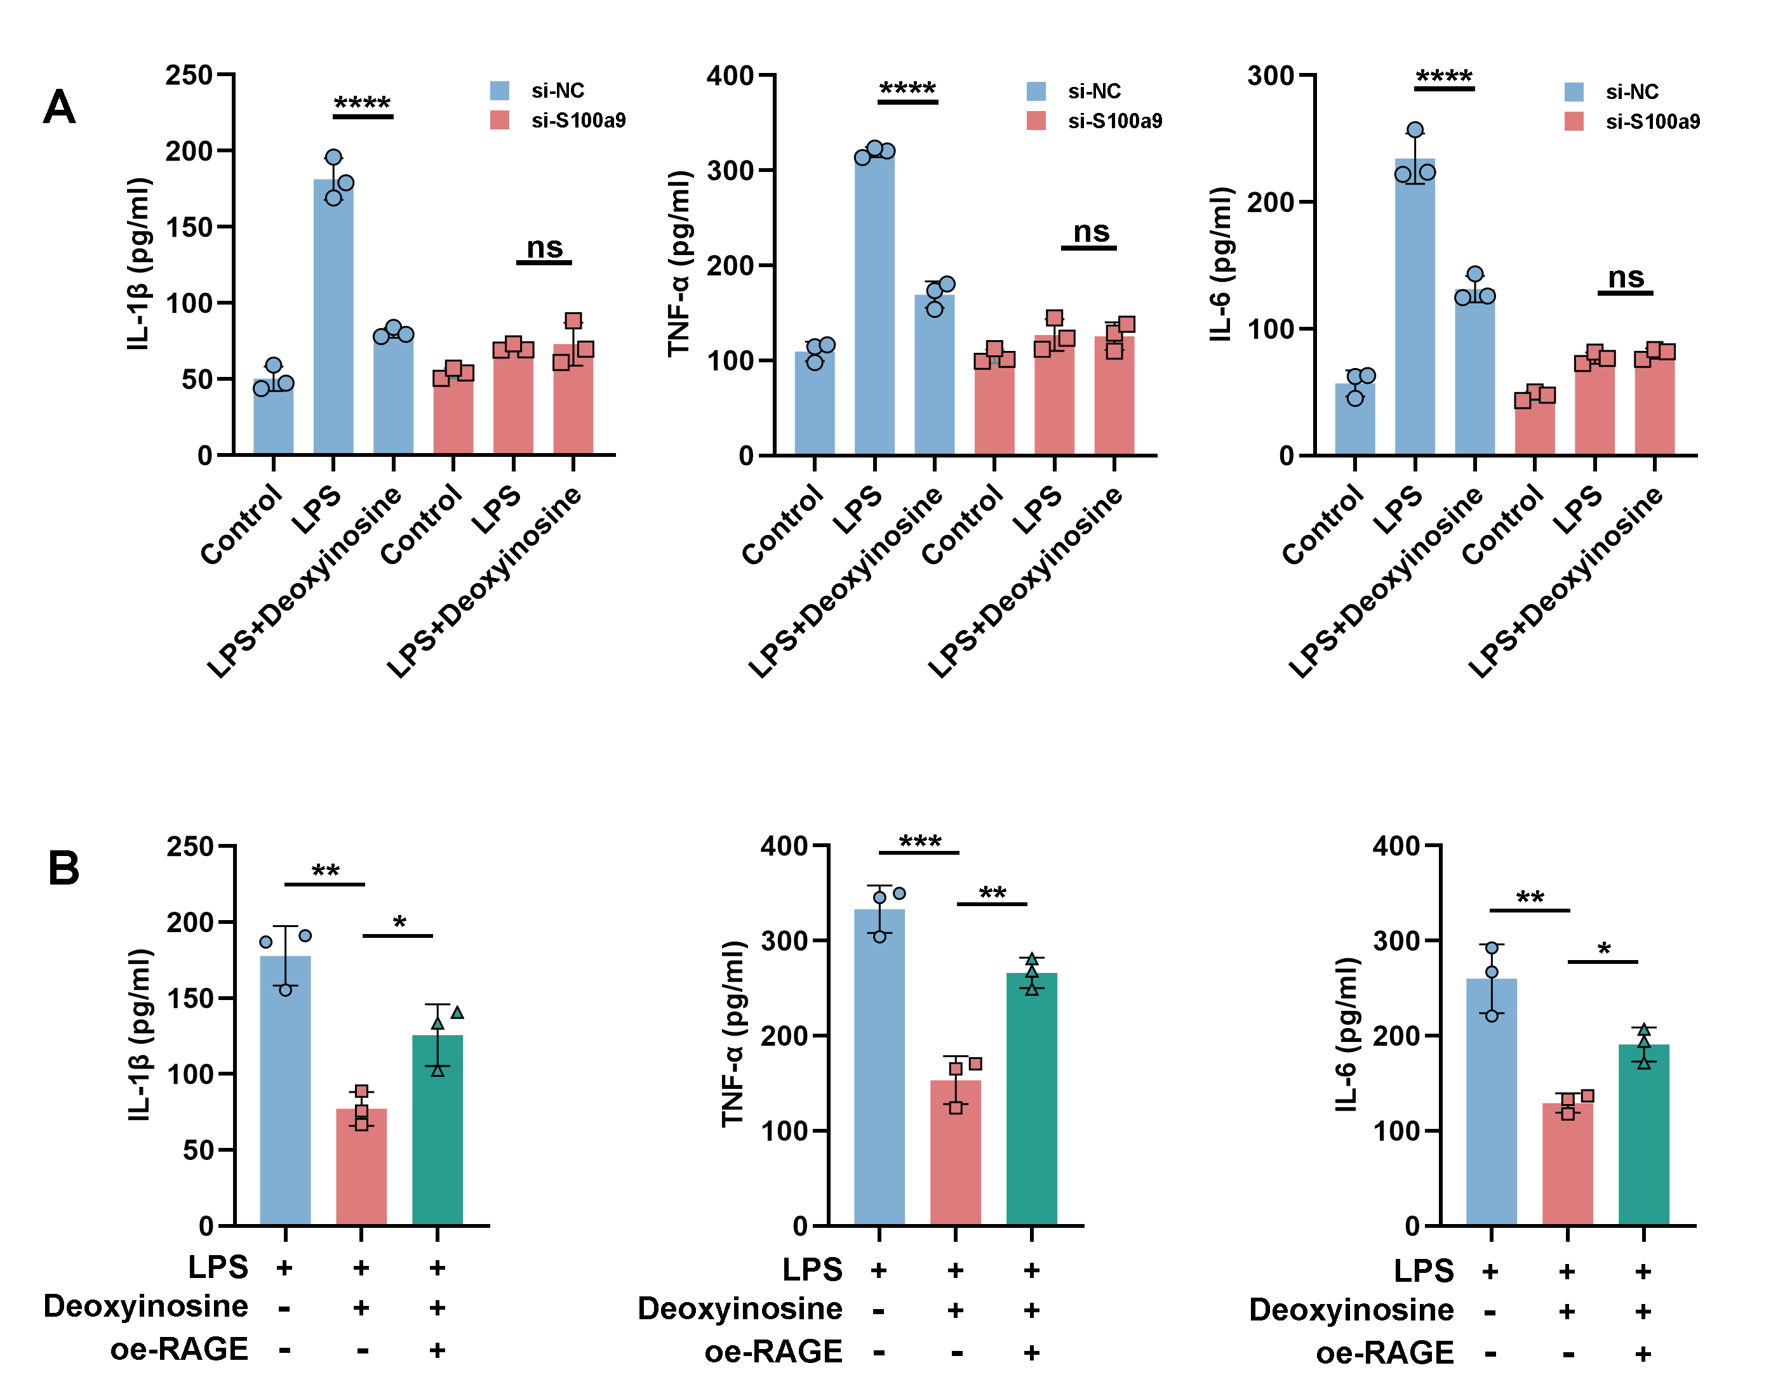
Fig. S2. Deoxyinosine suppresses pro-inflammatory cytokine production in MH-S cells through the S100a9/RAGE axis. (A) ELISA analysis of IL-6, IL-1β, and TNF-α levels in the supernatants of MH-S cells under the indicated conditions related to the S100a9 knockdown experiment. Deoxyinosine significantly reduced the secretion of these pro-inflammatory cytokines in LPS-stimulated MH-S cells, whereas this inhibitory effect was abolished after si-S100a9 treatment (n = 3). (B) ELISA analysis of IL-6, IL-1β, and TNF-α levels in the supernatants of MH-S cells under the indicated conditions related to the RAGE overexpression experiment. Deoxyinosine significantly decreased cytokine production in LPS-treated MH-S cells, while RAGE overexpression partially reversed this effect (n = 3). Data are presented as mean ± SD. *P < 0.05, **P < 0.01, ***P < 0.001, ****P < 0.0001, ns: not significant.

