Supplemental Figures
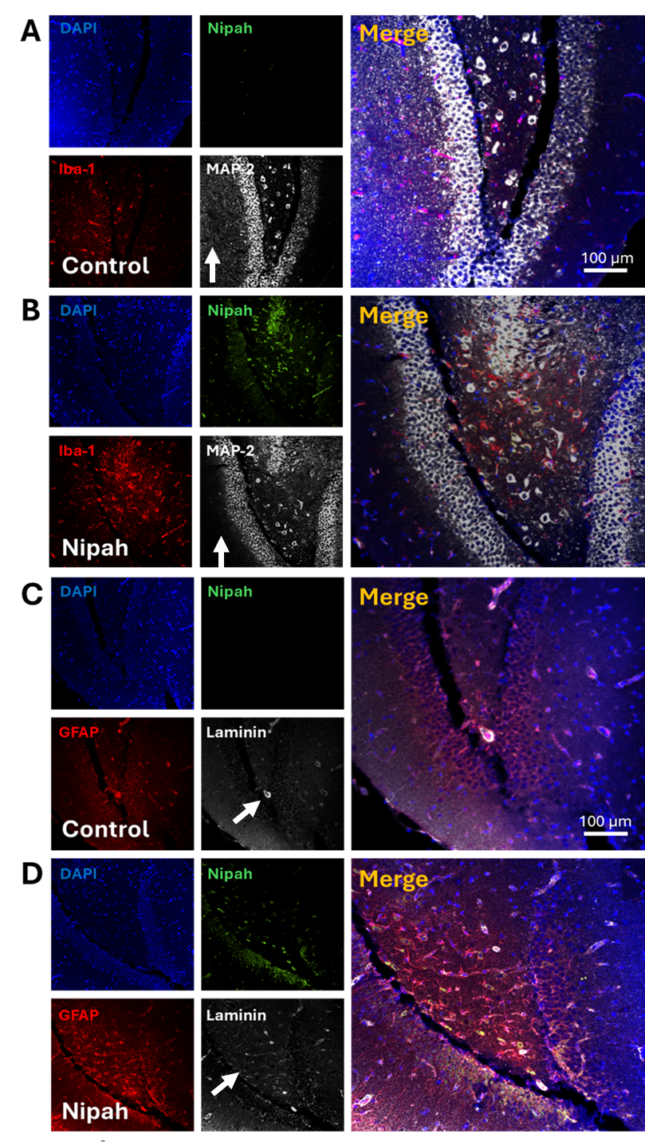

Supplemental Figure 1. NiV infection compromises neuronal, microglia/macrophage, glial, and BBB integrity. (A) Representative confocal images of brains obtained from uninfected and NiV-infected animals. Focus on the D.G. Tissue sections were stained for nuclei (DAPI, blue staining), Nipah N protein (green staining), Iba-1 (a marker of microglia/macrophage, red staining), and MAP-2 (a neuronal marker, white staining) or GFAP and Laminin (red and white for C and D panels). (A) Representative staining and 3D reconstruction of uninfected brains in the D.G., denoting the lack of N protein, low numbers of microglia/macrophages, and abundant expression of MAP-2 on neuronal bodies and processes. (B) Representative staining and 3D reconstruction of NiV-infected brains in the D.G.. Nipah expression was concentrated in neurons and microglia/macrophages. But also is evident the reduction in MAP-2 staining in the cell bodies and in the neuronal tracks. (C) Representative staining and 3D reconstruction of uninfected brains in the D.G., denoting the lack of N protein, low numbers of astrocytes, and organized laminin expression along the BBB. (D) Representative staining and 3D reconstruction of NiV-infected brains in the D.G.. Nipah expression was concentrated in GFAP and laminin-positive cells. Bar: 100 µm. Arrows denote neuronal processes or axons.

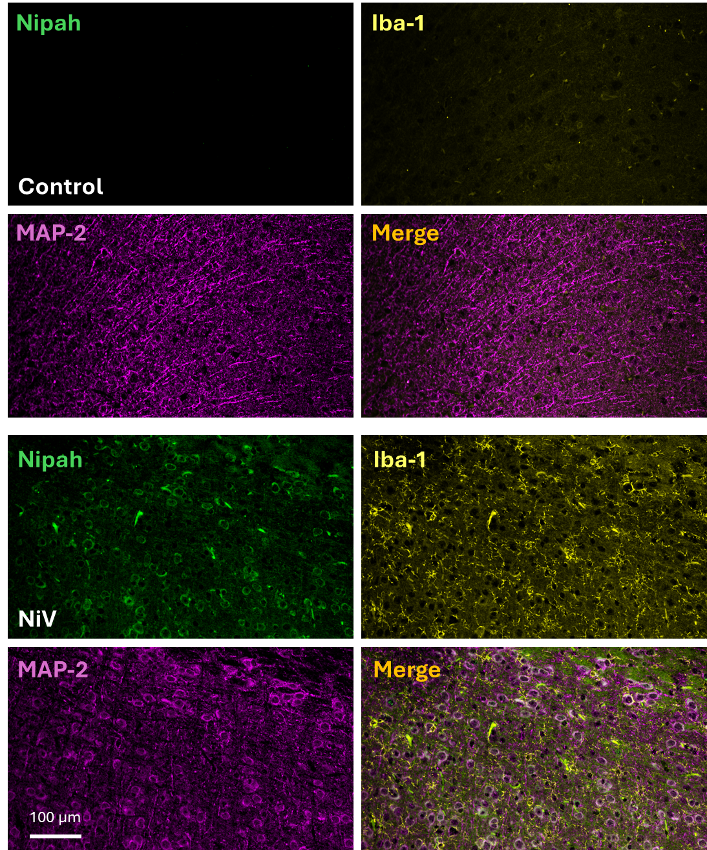

Supplemental Figure 2. NSPARC microscopy identified that NiV infectivity of neurons and microglia is selective, resulting in a reduction in neuronal processes and microglia activation. Representative images of the tissues described in Figs. 2, 3, and 4, but reanalyzed by NSPARC microscopy. Denoting in control uninfected conditions, the lack of N protein staining (Nipah) with minimal microglia activation (Iba-1 staining) and long MAP-2 processes. The lower panel denotes the presence of Nipah staining (N protein) in microglia (Iba-1) and neuronal (MAP-2) cells. Also, it is possible to observe the microglia activation and the decrease in neuronal processes. Bar: 100 µm.

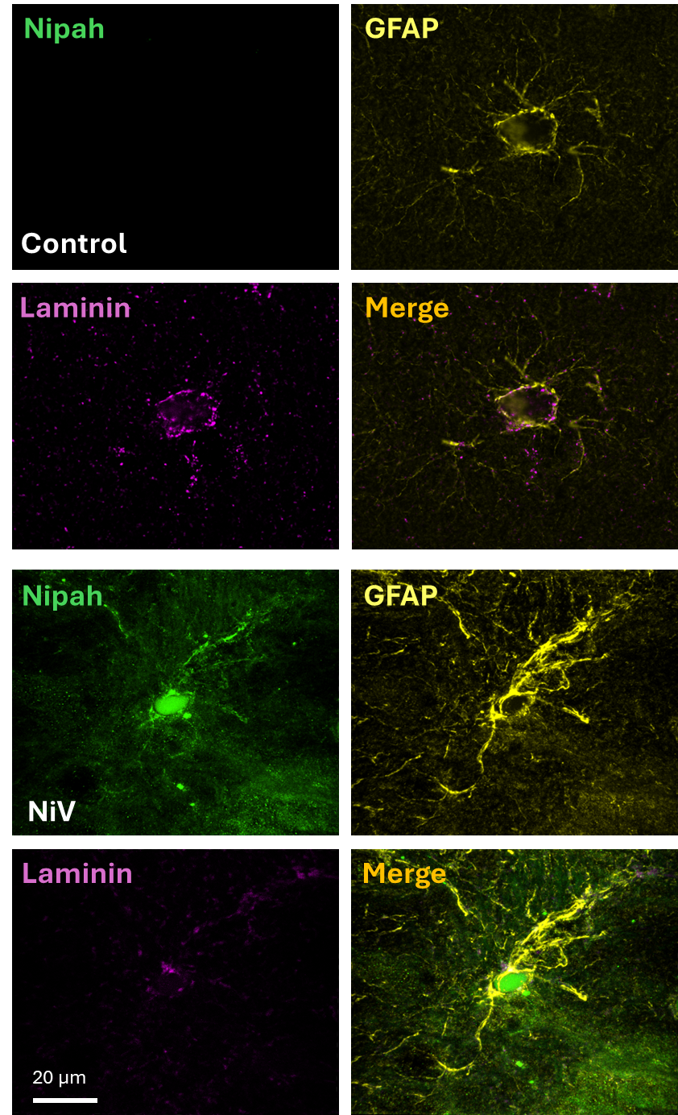
Supplemental Figure 3. NSPARC microscopy identified that NiV infectivity of astrocytes and BBB cells, resulting in gliosis and BBB compromise. Representative images of the tissues described in Figs. 2, 3, and 4, but reanalyzed by NSPARC microscopy. Denoting in control uninfected conditions, the lack of N protein staining (Nipah), and how GFAP-positive cells and laminin distribution surround the blood vessels. The lower panel denotes the presence of Nipah staining (N protein) in astrocytes (GFAP) and BBB cells (laminin) in a high magnification blood vessel. It is possible to observe the wide distribution of NiV protein N within and around the BBB, suggesting BBB dysruption and the lack of laminin continuity, as well as gliosis. Bar: 20 µm.

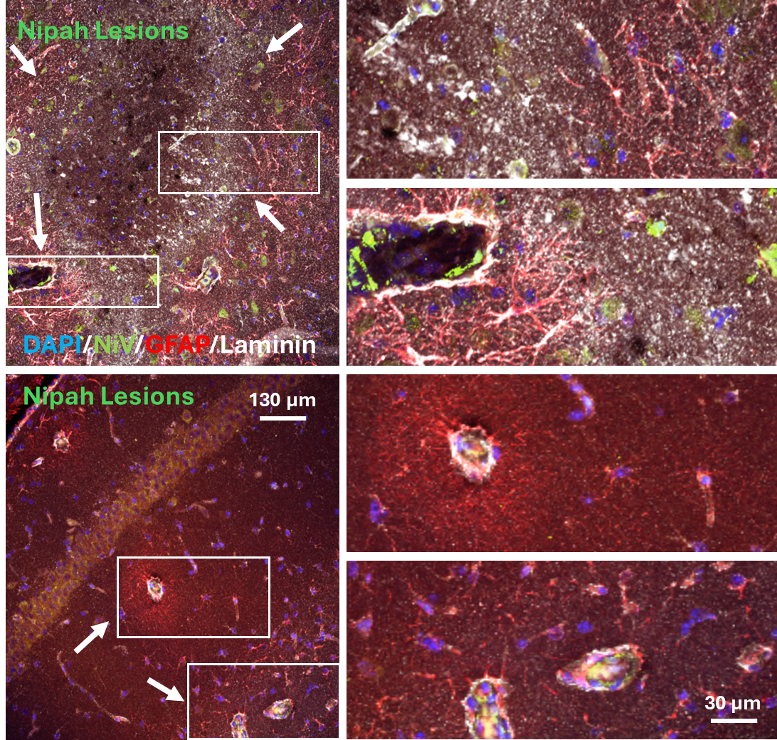

Supplemental Figure 4: Amplification of NiV-induced lesions. Representative 3D reconstructions of NiV-induced brain lesions. Staining for Nuclei (DAPI), NiV (Green), GFAP (red), and laminin (white) denoting two different kinds of lesions in the brain. Large sections with significant astrocyte proliferation around the lesion and endothelial compromise. The panel below corresponds to the BBB and the astrocyte gliosis around it. Arrows denote the lesions and rectangles the area amplified in the left size—bars: 130 or 30 µm. Lesions were observed in all 10 infected animals, and no detction of lesions were detected in uninfected animals.

