Supplementary Information
Figure S1 Brainwide mapping of LPS-induced c-Fos expression
Figure S2 Enrichment analysis of the differentially expressed genes
Figure S3 PRV retrograde tracing of lung-associated neural pathways
Figure S4 Defining the optimal time points for assessing inflammation, cytokine dynamics, and neuronal modulation
Figure S5 ADRB2 antagonism suppresses neutrophil chemotaxis and NETosis to mitigate lung injury
Figure S6 Bilateral subdiaphragmatic vagotomy aggravates LPS-induced lung injury
Table S1 The demographic data of the septic ARDS patients included
Table S2 Primer pairs for RT-qPCR

Figure S1. Brainwide mapping of LPS-Induced c-Fos expression
(A, B) LPS-induced lung injury. Scale bar, 100 μm. n=3.
(C)Immunofluorescence marked LPS-activated neurons in nucleus of the stria terminalis (BNST), the lateral preoptic area (LPO), mediodorsal thalamic nucleus (MD), central amygdala (CeA), nucleus of the solitary tract (NTS). Scale bar, 2000 μm. n = 3.
Data are presented as mean ± SEM. ***P < 0.0001, lung injury scores between two groups were analyzed using the Mann-Whitney U test.
Figure S2. Enrichment analysis of the differentially expressed genes
- A comparison of the distribution of differentially expressed genes and all genes at GO Level2. Blue indicates all the gene enriched GO Level2 entries, orange indicates the differentially enriched GO Level2 entries, horizontal axis indicates the entry name, vertical axis indicates the number and percentage of genes in the corresponding entry.
- A comparison of the distribution of differentially expressed genes and all genes at KEGG Level2. The horizontal axis is the ratio (%) of the total number of genes annotated to each Level2 Pathway (differentially expressed genes) and all the genes annotated to KEGG pathway (differentially expressed genes). The vertical axis represents the name of Level2 pathway. The numbers on the right of the column represent the number of differentially expressed genes annotated under the Level2 Pathway.
Figure S3. PRV retrograde tracing of lung-associated neural pathways
- PRV-labeled lung-associated regions, including the spinal IML/lateral horn, rostral ventrolateral medulla (RVLM), locus coeruleus (LC), periaqueductal gray (PAG), paraventricular nucleus of the hypothalamus (PVN), central amygdala (CeA), the detailed enlarged view is below. Scale bar, 50 μm. n=3.
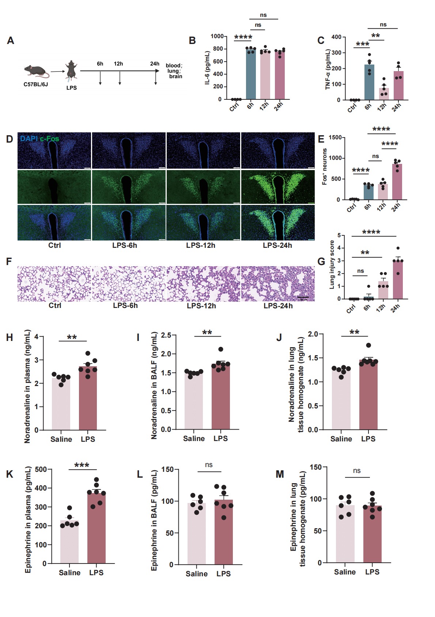
Figure S4. Defining the optimal time points for assessing inflammation, cytokine dynamics, and neuronal modulation
(A) Schematic diagram of sample collection at different time points.
(B, C) Plasma proinflammatory cytokine levels. n=5.
(D, E) Immunofluorescence marked LPS-activated neurons in PVN at different time points. Scale bar, 100 μm. n=5.
(F, G) Histological examination of lung tissues. Scale bar, 100 μm. n=5.
(H-J) NE levels in plasma, BALF, and lung homogenates after saline or LPS challenge. n≥6.
(K-M) EPI levels in plasma, BALF, and lung homogenates after saline or LPS challenge. n≥6.
*Data are presented as mean ± SEM. **P < 0.01, ***P < 0.001, ****P < 0.0001 and ns, not significant (P > 0.05). Statistical comparisons via one-way ANOVA with Tukey’s test.
Figure S5. ADRB2 antagonism suppresses neutrophil chemotaxis and NETosis to mitigate lung injury
(A, B, C) ICI 118,551 (5 mg/kg, i.p.) was administered 1 h before LPS. After ICI intervention, the chemotactic ability NETosis of neutrophils weakened. Scale bar, 50 μm. n=5.
(D, E) Histological examination of lung tissues. Scale bar, 100 μm. n=5.
(F, G) Plasma proinflammatory cytokine levels. n=5.
Data are presented as mean ± SEM. *P < 0.05, ***P < 0.001, ****P < 0.0001. Statistical comparisons were performed using one-way ANOVA with Tukey’s post-hoc test.
Figure S6. Bilateral subdiaphragmatic vagotomy aggravates LPS-induced lung injury
(A, C) Histological examination of lung tissues. Scale bar, 100 μm. n=6.
(B, D) MPO expression in lung tissues of each group. Scale bar, 100 μm. n=6.
(E, F) Plasma proinflammatory cytokine levels.
Data are presented as mean ± SEM. *P < 0.05, **P < 0.01, ***P < 0.001, ****P < 0.0001; ns, not significant. Statistical comparisons were performed using one-way ANOVA with Tukey’s post-hoc test.
Table S1. The demographic data of the septic ARDS patients included
Table S1 summarizes the full enrolled cohort. Figure 7 experiments were performed using fresh neutrophils from representative subsets of this cohort, as indicated for each assay.
ARDS, acute respiratory distress syndrome; BMI, body mass index; COPD, chronic obstructive pulmonary disease; ICU, intensive care unit.
 | Control (n=20) | ARDS (n=20)
Sex | M:10 F:10 | M:10 F:10
Age (years) | 56 (45-67) | 58 (47-70)
BMI (kg/m²) | 23.1 (22.1-25.1) | 23.6 (21.9-25.7)
PaO₂/FiO₂ ratio | 365 (332-389) | 195 (132-228)
Underlying disease
Hypertension | - | 12
Diabetes | - | 9
COPD | - | 6
Tumor | - | 7
Lactic acid (mmol/L) | 0.5-1.5 | 2-4
Mechanical ventilation | - | 12
Reason for ICU admission
Severe infection  Trauma  Shock | - | pulmonary infection (n=6), abdominal infection (n=2), urinary tract infection (n=1), and other sources (n=1),
Severe infection  Trauma  Shock | - | 4
Severe infection  Trauma  Shock | - | 6

Table S2. Primers pairs for Real-time PCR
Primers | Sequence
Crh-F | 5’-CAG CAA GCT CAC AGC AAC AG-3’
Crh-R | 5’-CGG AGC TGC GAT ATG GTA CA-3’
Actin-F (mice) | 5’-GTG CTA TGT TGC TCT AGA CTT CG-3’
Actin-R (mice) | 5’-ATG CCA CAG GAT TCC ATA CC-3’
ADRB1-F | 5’-GAC GCT CAC CAA CCT CTT CA-3’
ADRB1-R | 5’-CAC AGC TCG CAG AAG AAG GA-3’
ADRB2-F | 5’-TTG CCT CTT CCA TCG TGT CC-3’
ADRB2-R | 5’-CCA CCT GGC TAA GGT TCT GG-3’
Actin-F (human) | 5’-GCA CAG AGC CTC GCC TT-3’
Actin-R (human) | 5’-GTT GTC GAC GAC GAG CG-3’

