Supplementary Figures:
Figure S1. Neuroinflammation was upregulated during the symptomatic stage of SOD1^{G93A} mice. (a-d) Relative mRNA levels of Cox2 (a), Il1β (b), Tnfα (c), and iNOS (d) measured by qRT-PCR in SOD1^{G93A} mice at different ages. n = 4 mice per condition. Each data point represents one individual mouse. Data are presented as mean ± SEM. *P < 0.05, **P < 0.01, ***P < 0.001, ns: not significant.

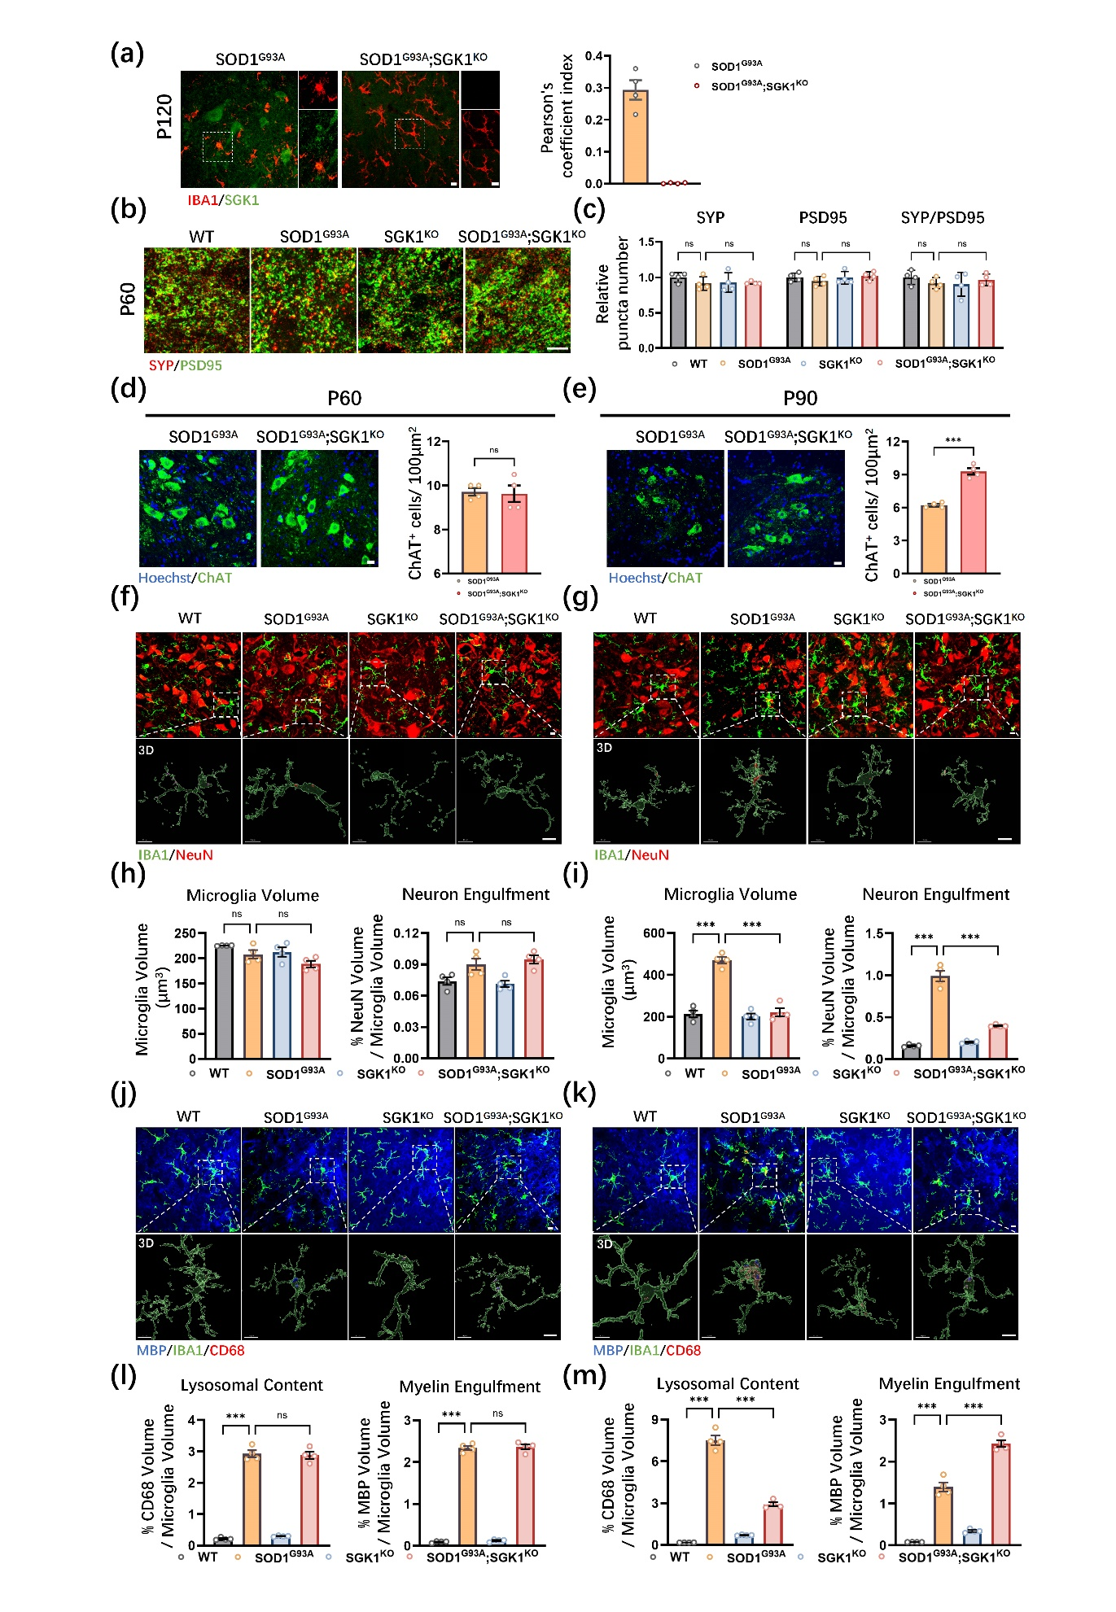
Figure S2. Sgk1 knockout revealed a stage-dependent pathological transition in microglial phagocytic function. (a) Representative immunofluorescent micrographs of spinal cord sections from SOD1^{G93A} and SOD1^{G93A}; SGK1^{KO} mice at P120, stained for IBA1 (microglia, red) and SGK1 (green). (b) Representative images of pre-synaptic marker SYP and the postsynaptic marker PSD95 in WT, SOD1^{G93A}, SGK1^{KO}, SOD1^{G93A}; SGK1^{KO} mice at P60. (c) Quantification of SYP puncta number, PSD95 puncta number, and SYP/PSD95-colocalized puncta number. n = 4 mice per group. (d,e) Representative micrographs and quantification of ChAT-positive motor neurons of SOD1^{G93A} and SOD1^{G93A}; SGK1^{KO} mice at P60 (d) and P90 (e). n = 4 mice per condition. (f-g) Representative micrographs and 3D reconstructions showing microglial engulfment of neuronal material, assessed by IBA1 and NeuN staining of WT, SOD1^{G93A}, SGK1^{KO}, SOD1^{G93A}; SGK1^{KO} mice at P60 (f) and P90 (g). (h-i) Quantification of microglial volume and neuronal material within microglia at P60 (h) and P90 (i). n = 4 mice per condition. (j-k) Representative micrographs and 3D reconstructions showing microglial phagocytic processing of myelin debris, assessed by IBA1, CD68, and MBP staining in WT, SOD1^{G93A}, SGK1^{KO}, SOD1^{G93A}; SGK1^{KO} mice at P60 (j) and P90 (k). (l-m) Quantification of lysosomal content and MBP volume within microglia at P60 (l) and P90 (m). n = 4 mice per condition. Scale bar = 10 μm. Data are presented as mean ± SEM. *P < 0.05, **P < 0.01, ***P < 0.001, ns: not significant.

Figure S3. Microglial phagocytic capacity was impaired during the symptomatic stages of SOD1^{G93A} mice. (a) Representative micrographs and 3D reconstructions of IBA1, CD68, and GAL-3 staining in WT and SOD1^{G93A} mice at different ages. (b) Quantification of GAL-3 volume within CD68-positive compartments of IBA1-positive microglia. n = 4 mice per condition. Scale bar = 10 μm. Data are presented as mean ± SEM. ***P < 0.001, ns: not significant.

Figure S4. Phagocytic deficits in SOD1^{G93A} microglia. (a) Experimental schematic showing assessment of BV2 microglial phagocytosis following 3 h exposure to myelin debris and/or apoptotic neurons. Created with BioRender.com. (b) Representative micrographs showing the phagocytic activity of BV2 cells following 3 h incubation with Red CMTPX-labeled myelin debris alone, CFSE-labeled apoptotic N2a cells alone, or both. (c–d) Quantification of BV2 microglial phagocytosis following 3 h treatment. (c) Myelin debris uptake. (d) Apoptotic N2a cell uptake. n = 3 independent experiments. (e) Experimental schematic showing assessment of BV2 microglial phagocytosis following 1 h exposure to myelin debris and/or apoptotic neurons. Created with BioRender.com. (f) Representative micrographs showing the phagocytic activity of BV2 cells following 1 h incubation with CFSE-labeled myelin debris alone, Red CMTPX-labeled apoptotic N2a cells alone, or both. (g-h) Quantification of BV2 microglial phagocytosis following 1 h incubation. (g) Myelin debris uptake. (h) Apoptotic N2a cell uptake. n = 3 independent experiments. (i, k) pHrodo-based assessment of myelin debris phagocytosis in WT- and G93A-BV2 cells at 1 h and 3 h. Cells were treated with pHrodo-labeled myelin debris alone or in combination with apoptotic N2a cells. Phagolysosomal acidification was quantified as pHrodo-positive puncta area per cell. (j, l) pHrodo-based assessment of apoptotic neuron phagocytosis in WT- and G93A-BV2 cells at 1 h and 3 h. Cells were treated with pHrodo-labeled apoptotic N2a cells alone or in combination with myelin debris. Phagolysosomal acidification was quantified as pHrodo fluorescence intensity normalized to IBA1 fluorescence intensity within each field of view. For each independent experiment, 3–4 fields of view were analyzed per condition and averaged to generate one biological replicate. n = 4 independent experiments. Scale bar = 40 μm. Data are presented as mean ± SEM. *P < 0.05, **P < 0.01, ***P < 0.001, ns: not significant.

Figure S5. Impaired phagocytic function of primary microglia derived from SOD1^{G93A} mice. (a) Representative micrographs of phagocytic activity in primary microglia derived from WT and SOD1^{G93A} mice treated with myelin debris-CFSE alone, apoptotic N2a-Red CMTPX alone, or a combination of both. (b) Quantitative data of myelin debris and apoptotic N2a cells phagocytosis by primary microglia. n = 4 independent experiments. For each experiment, 3–5 FOVs were analyzed per condition and averaged before statistical analysis. Scale bar = 40 μm. Data are presented as mean ± SEM. *P < 0.05, **P < 0.01, ***P < 0.001, ns: not significant.

Figure S6. Impaired phagocytosis was associated with enhanced inflammatory responses in BV2 microglia, which were attenuated by GSK650394. (a) Representative micrographs of ROS levels in BV2 cells treated with myelin debris alone, apoptotic N2a alone, or a combination of both. (b) Quantification of relative ROS fluorescence intensity in BV2 cells. n = 4 independent experiments. (c-e) Relative mRNA expression levels of Tnfα (c), Ifnγ (d), and Cox2 (e) measured by qRT-PCR in BV2 cells. n = 3 independent experiments per group. (f) Representative micrographs of ROS levels in BV2 cells after co-stimulation with myelin debris and apoptotic N2a cells, with or without GSK650394 treatment. (g) Quantification of relative ROS fluorescence intensity in BV2 cells after GSK650394 treatment. n = 4 independent experiments. (h) Relative mRNA expression levels of Tnfα, Ifnγ, and Cox2 measured by qRT-PCR in BV2 cells after co-stimulation with myelin debris and apoptotic N2a cells, with or without GSK650394 treatment. n = 3 independent experiments per group. Scale bar = 40 μm. Data are presented as mean ± SEM. *P < 0.05, **P < 0.01, ***P < 0.001, ns: not significant.

Figure S7. Restoration of autophagy suppressed aberrant SGK1 upregulation in SOD1^{G93A} microglia. (a, b) Representative immunoblots (a) and quantification (b) of SGK1 protein levels in BV2 cells. Cells were treated with myelin debris and apoptotic N2a cells in the presence or absence of EBSS-induced starvation. β-ACTIN was used as the loading control. n = 4 independent experiments per condition. Data are presented as mean ± SEM. **P < 0.01, ***P < 0.001.

Figure S8. GSK650394 attenuated neuroinflammation in the spinal cord of SOD1^{G93A} mice. (a-d) Relative mRNA levels of Cox2 (a), Il1β (b), Tnfα (c), and iNOS (d) measured by qRT-PCR in WT and SOD1^{G93A} mice treated with or without GSK650394 at P120. n = 4 mice per group. Data are presented as mean ± SEM. *P < 0.05, ***P < 0.001.

