Supplementary file of figures and tables

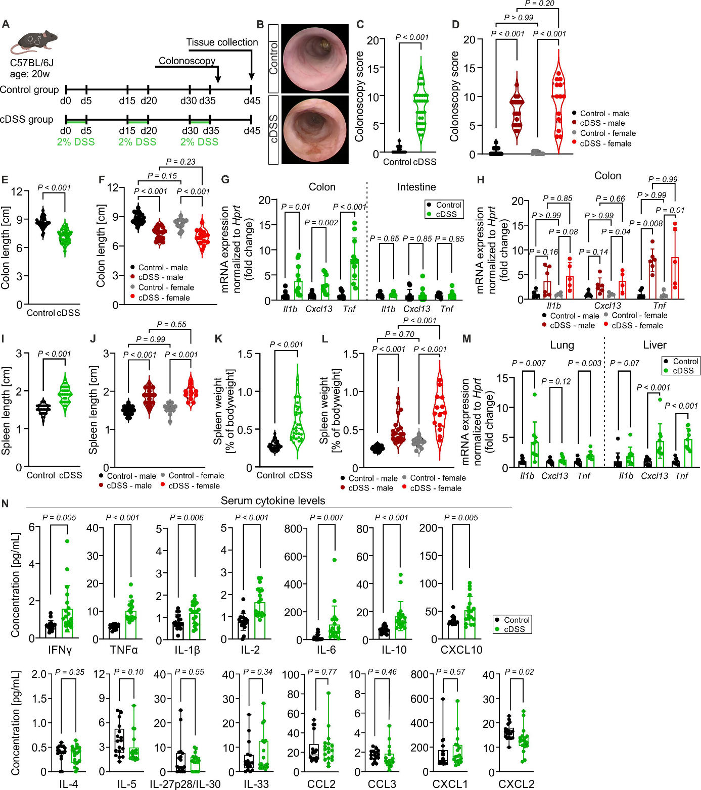
Figure S1. Cyclic DSS treatment induces chronic colitis and systemic inflammation in C57BL/6J mice. A Timeline of colitis induction in male and female C57BL/6J mice aged 20 weeks at the start of the experiment. B Representative colonoscopy images. C Colonoscopy scores, mixed sex (n = 32-33 mice per group; pooled of four independent experiments). D Colonoscopy scores, split by sex (n = 12-20 mice per group; Control: 20 male, 12 female, cDSS: 19 male, 14 female; pooled of four independent experiments; Two-way ANOVA with Tukey’s multiple comparisons test). E Colon length post dissection, mixed sex (n = 32-34 mice per group; pooled of four independent experiments). F Colon length post dissection, split by sex (n = 12-20 mice per group; Control: 20 male, 12 female, cDSS: 20 male, 14 female; pooled of four independent experiments; Two-way ANOVA with Tukey’s multiple comparisons test). G Expression of the inflammation-associated genes Il1b, Cxcl13, and Tnf in the colon and small intestine, mixed sex (n = 10-11 mice per group; multiple unpaired t-tests). H Expression of the inflammation-associated genes Il1b, Cxcl13, and Tnf in the colon and small intestine, split by sex (n = 4-6 mice per group; Control: 6 male, 4 female, cDSS: 6 male, 5 female; Two-way ANOVA with Tukey’s multiple comparisons test). I Spleen length, mixed sex (n = 29-31 mice per group; pooled of four independent experiments). J Spleen length, split by sex (n = 12-20 mice per group; Control: 18 male, 11 female, cDSS: 19 male, 12 female; pooled of four independent experiments; Two-way ANOVA with Tukey’s multiple comparisons test). K Spleen weight in percentage of bodyweight, mixed sex (n = 32-34 mice per group; pooled of four independent experiments). L Spleen weight in percentage of bodyweight, split by sex (n = 12-20 mice per group; Control: 20 male, 12 female, cDSS: 20 male, 14 female; pooled of four independent experiments; Two-way ANOVA with Tukey’s multiple comparisons test). M Expression of the inflammation-associated genes Il1b, Cxcl13, and Tnf in the lung and liver, mixed sex (n = 9-10 mice per group; Control: 6 male, 4 female, cDSS: 5 male, 4 female; multiple unpaired t-tests). N Serum concentrations of the inflammation-associated cytokines IFNγ, TNFα, IL-1β, IL-2, IL-6, IL-10, CXCL10, IL-4, IL-5, IL-27p28/IL-30, IL-33, CCL2, CCL3, CXCL1 and CXCL2 (n = 18 mice per group; Control: 14 male, 4 female, cDSS: 14 male, 4 female;). Two-tailed, unpaired t-test, if not otherwise indicated. Each point represents the value of one mouse. Data are presented as mean ± s.d. Icons in A were created with BioRender.com.
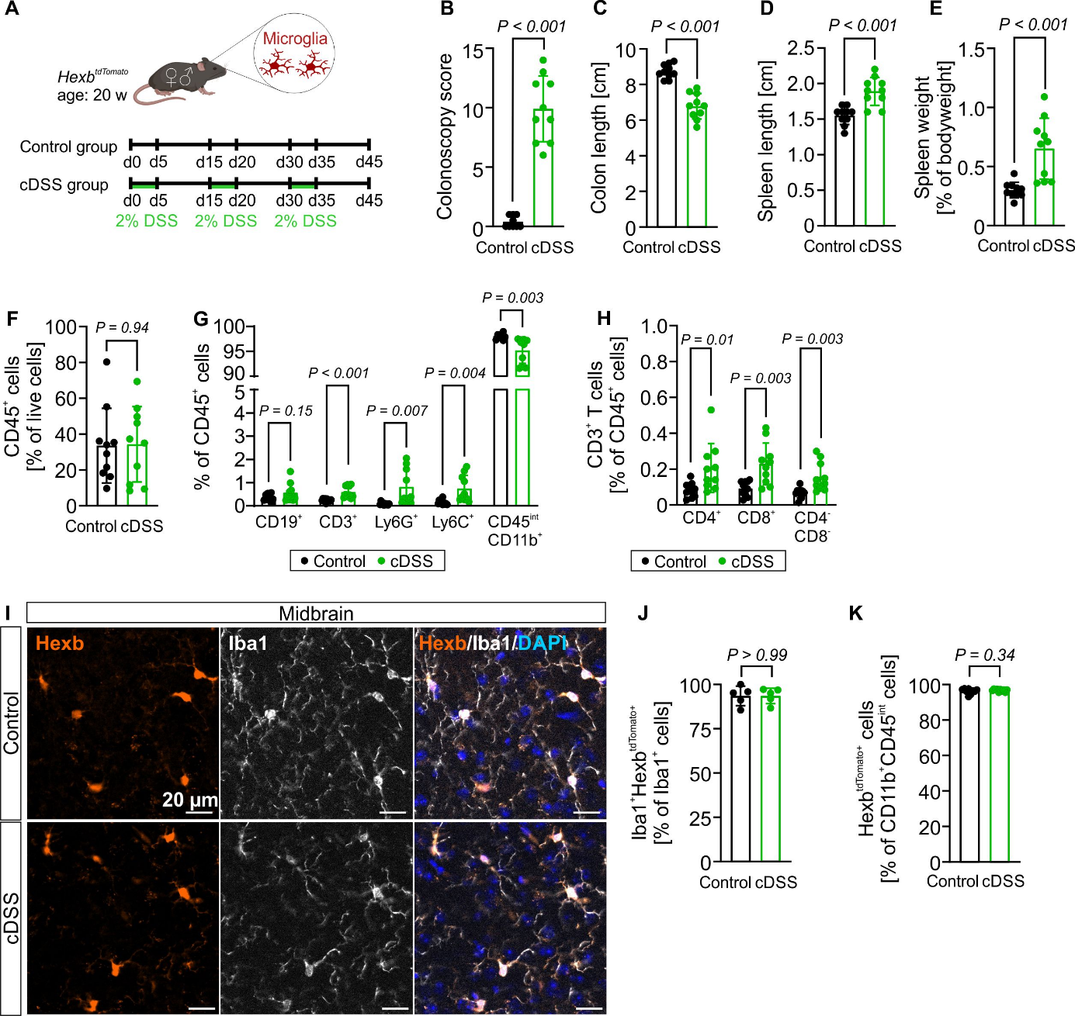
Figure S2. Cyclic DSS treatment induces chronic colitis and immune cell response in the whole brain of Hexb^{tdTomato} mice while microglial Hexb^{tdTomato} expression is maintained. A Timeline of colitis induction in male and female Hexb^{tdTomato} mice aged 20 weeks at the start of the experiment. B Colonoscopy score on day 36. C Colon length post dissection. D Spleen length post dissection. E Spleen weight in percentage of bodyweight. F, G, H Flow cytometry analysis of CD45⁺ immune cells (F), CD19⁺ B cells, CD3⁺ T cells, Ly6G⁺ neutrophils, Ly6C⁺ monocytes, and CD45^{int}CD11b⁺ microglia as percentage of CD45⁺ cells (G), and CD3⁺CD4⁺, CD3⁺CD8⁺, and CD3⁺CD4⁻CD8⁻ T cells as percentage of CD45⁺ cells (H) in whole brain tissue. I, Immunostaining for Iba1 (white) and Hexb (tdTomato) in brain tissue of Hexb^{tdTomato} mice. Scale bar, 20 µm. J, Quantification of Iba1⁺Hexb^{tdTomato+} cells in percentage of Iba1⁺ cells in the midbrain. K, Flow cytometry analysis of Hexb^{tdTomato+} cells in percentage of CD11b⁺CD45^{int} cells. The results are from n = 10 (Control: 5 male, 5 female, cDSS: 4 male, 6 female; B - H, K) and n = 5 (Control: 2 male, 3 female, cDSS: 1 male, 4 female; J) mice per group. Two-tailed, unpaired t-test, if not otherwise indicated. Each point represents the value of one mouse. Data are presented as mean ± s.d. Icons in A were created with BioRender.com.
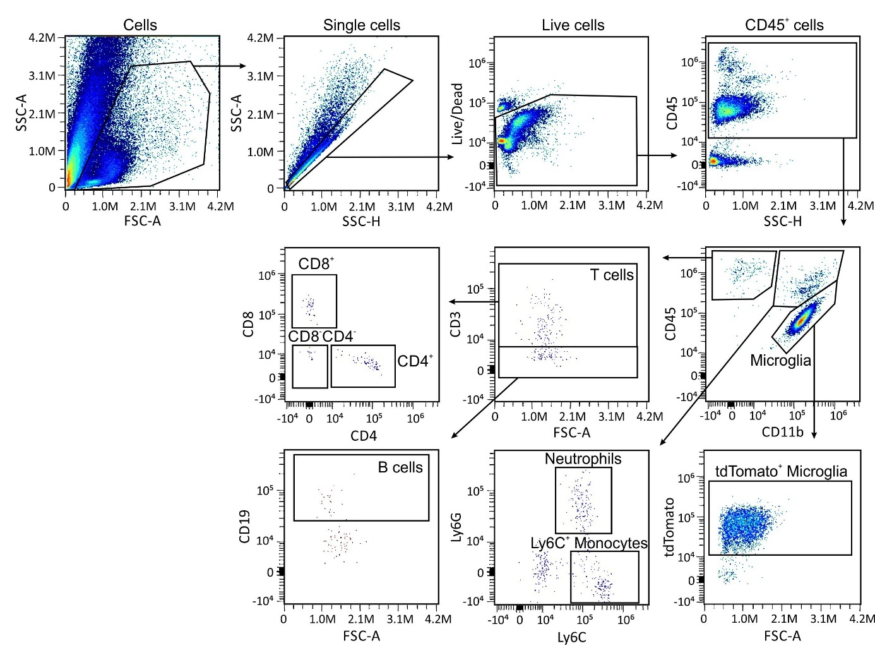
Figure S3. Flow cytometry gating strategy of brain immune cells isolated from cDSS-treated and control Hexb^{tdTomato} mice. Cells were gated on SSC-A and SSC-H to remove doublets. Singlets negative for the Live/Dead fixable Aqua stain were considered as live cells. CD45⁺ live cells were gated on CD11b to identify CD11b⁺CD45^{int} microglia that were further gated on tdTomato to determine tdTomato⁺ microglia. CD11b⁺CD45⁺ cells were gated on Ly6G and Ly6C to distinguish Ly6G⁺ neutrophils from Ly6C⁺ monocytes. CD11b⁻CD45⁺ cells were gated on CD3 (T cells) and CD19 (B cells), and CD3⁺ cells were further gated on CD8 and CD4 to identify T cell subpopulations.
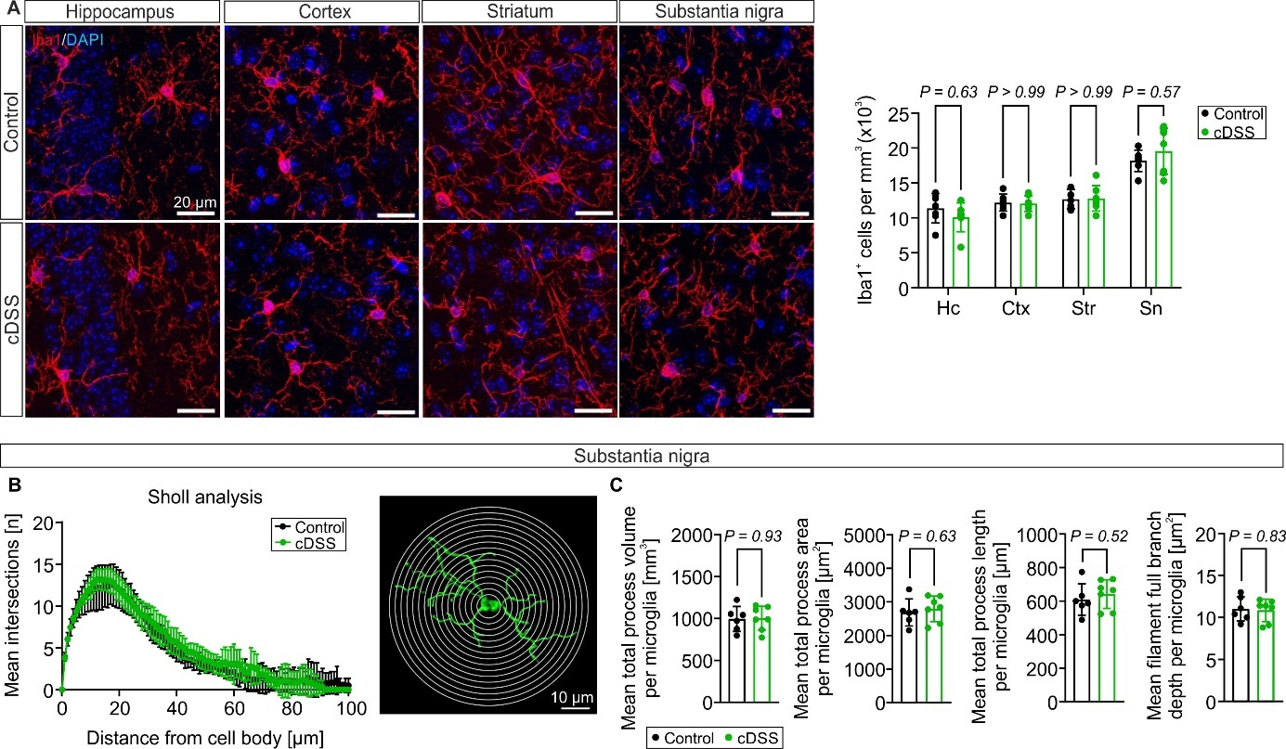
Figure S4. Regional microglia density and morphology remain unaltered in chronic DSS colitis mice.
A Immunostaining for Iba1 in brain tissue of C57BL/6J mice (left) and quantification of Iba1⁺ cells normalized to mm³ in the hippocampus (Hc), cortex (Ctx), striatum (str), and substantia nigra (Sn, n = 7 mice per group; Control/DSS: 4 male, 3 female; two-way ANOVA with Šídák's multiple comparisons test). Scale bars, 20 µm. B Sholl analysis of microglia in the substantia nigra. C Microglial process parameters in the substantia nigra (n = 6-7 mice per group; Control: 4 male, 2 female, DSS: 4 male, 3 female; two-tailed, unpaired t-test). Each point represents the mean value of one mouse. Data are presented as mean ± s.d.
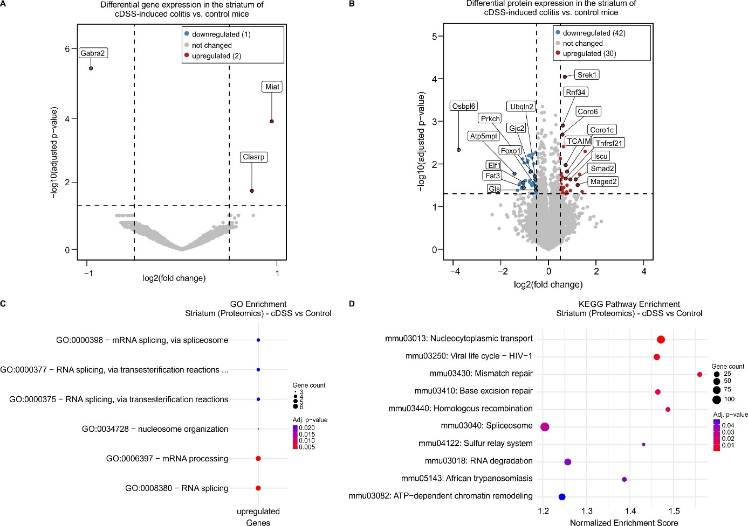
Figure S5. Transcriptome and proteome analyses reveal subtle alterations in the striatum during chronic DSS colitis. A Volcano plot of genes differentially expressed in the striatum of chronic DSS colitis mice vs. control mice. B Volcano plot of proteins differentially expressed in the striatum of chronic DSS colitis mice vs. control mice. C Gene Ontology Biological Process analysis of the 30 proteins significantly higher expressed in the striatum of chronic DSS colitis mice compared to control mice. D KEGG (GSEA) pathway enrichment of proteins differentially expressed in the striatum of chronic DSS colitis mice compared to control mice.
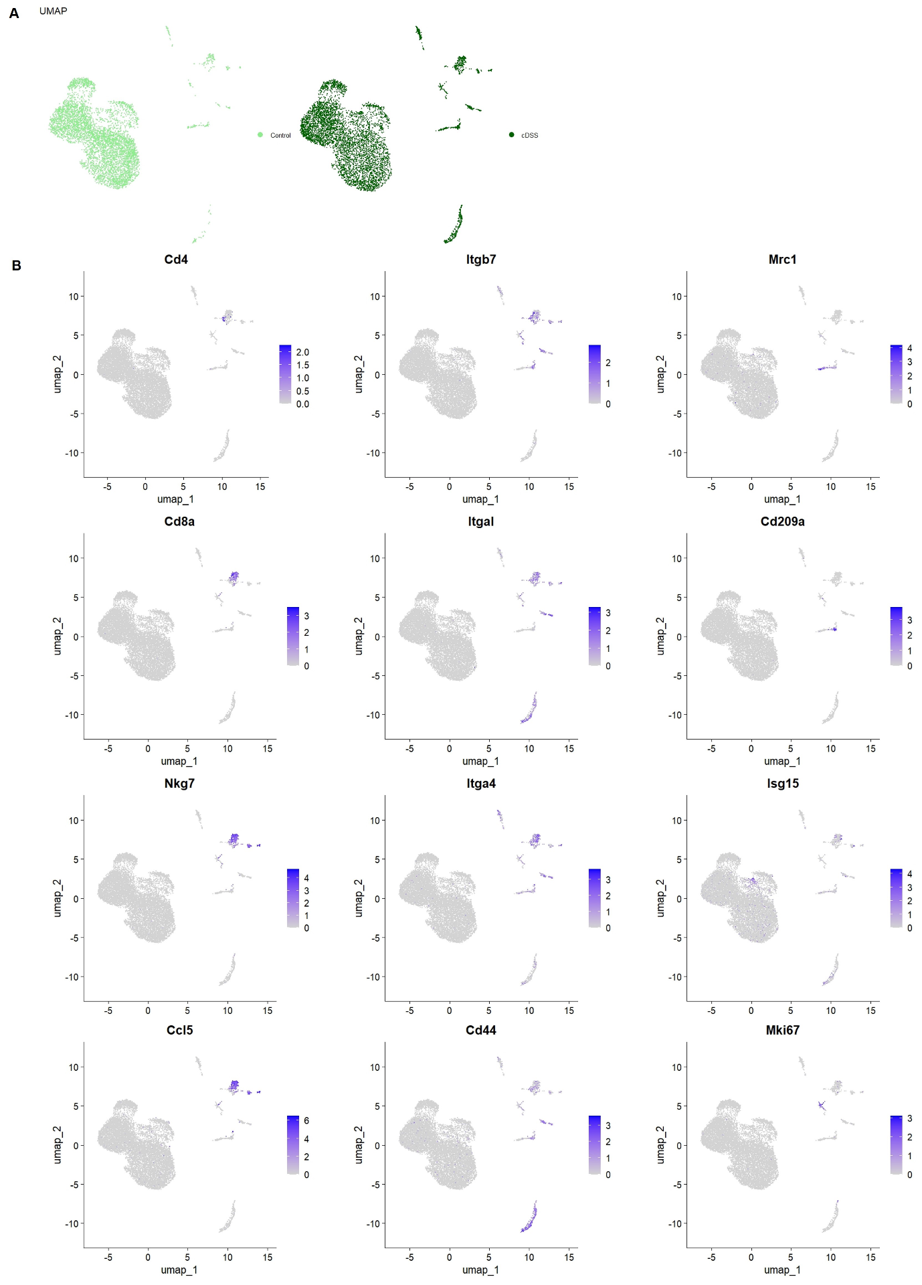
Figure S6. UMAPs and feature plots of immune cell type defining genes in the midbrain. A Individual UMAPs of immune cells in the midbrain per group. B Feature plots of cluster defining markers.
Table S1. Antibodies used for immunofluorescence and flow cytometry.
Antibody | Source | Identifier
Iba1 polyclonal antibody | Abcam | Cat# ab5076
Iba1 polyclonal antibody | FUJIFILM Wako Pure Chemical Corporation | Cat# 019-19741
C1q monoclonal antibody [4.8] | Abcam | Cat# ab182451
CD4 monoclonal antibody [EPR19514] | Abcam | Cat# ab183685
CD8 monoclonal antibody [EPR21769] | Abcam | Cat# ab217344
CD68 monoclonal antibody [Fa-11] | Bio-Rad Laboratories | Cat# MCA1957
Collagen IV polyclonal antibody | Sigma-Aldrich | Cat# AB769
Ly6G monoclonal antibody [1A8] | BioLegend | Cat# 127602
Phospho-alpha-Synuclein (Ser129) monoclonal antibody [D1R1R] | Cell Signaling Technology | Cat# 23706
TH polyclonal antibody | Sigma-Aldrich | Cat# AB152
TH polyclonal antibody | Thermo Fisher Scientific | Cat# MA1-24654
Donkey anti-Mouse IgG (H+L) High Cross-Adsorbed Secondary Antibody, Alexa Fluor™ 568 | Thermo Fisher Scientific | Cat# A10037
Donkey anti-Goat IgG (H+L) High Cross-Adsorbed Secondary Antibody, Alexa Fluor™ 488 | Thermo Fisher Scientific | Cat# A11055
Donkey anti-Goat IgG (H+L) High Cross-Adsorbed Secondary Antibody, Alexa Fluor™ 568 | Thermo Fisher Scientific | Cat# A11057
Donkey anti-Rabbit IgG (H+L) High Cross-Adsorbed Secondary Antibody, Alexa Fluor™ 568 | Thermo Fisher Scientific | Cat# A10042
Donkey anti-Rabbit IgG (H+L), Alexa Fluor™ 647 | Dianova | Cat# 711-605-152
Donkey anti-Rat IgG (H+L) High Cross-Adsorbed Secondary Antibody, Alexa Fluor™ 488 | Thermo Fisher Scientific | Cat# A21208
Donkey anti-Rat IgG (H+L), Alexa Fluor™ 647 | Dianova | Cat# 712-605-153
eFluor™ 450 anti-mouse CD3e monoclonal antibody [145-2C11] | Thermo Fisher Scientific | Cat# 48-0031-82
APC/Fire™ 810 anti-mouse CD4 monoclonal antibody [GK1.5] | BioLegend | Cat# 100480
Brilliant Violet 650™ anti-mouse CD8 monoclonal antibody [53-6.7] | BioLegend | Cat# 128049
PE/Cyanine7 anti-mouse/human CD11b monoclonal antibody [M1/70] | BioLegend | Cat# 101216
Alexa Fluor™ 660 anti-mouse monoclonal antibody CD19 [1D3] | Thermo Fisher Scientific | Cat# 606-0193-82
PE-Cyanine5.5 anti-mouse CD45 monoclonal antibody [30-F11] | Thermo Fisher Scientific | Cat# 35-0451-82
APC anti-mouse CD45 monoclonal antibody [30-F11] | BioLegend | Cat# 103112
Brilliant Violet 570™ anti-mouse Ly-6C monoclonal antibody [HK1.4] | BioLegend | Cat# 128030
APC/Cyanine7 anti-mouse Ly-6G monoclonal antibody [1A8] | BioLegend | Cat# 127624

Table S2. Primer sequences for reverse transcription-quantitative PCR.
Gene | Primer forward (5’ - 3’) | Primer reverse (5’ - 3’)
Cxcl13 | CTCCAGGCCACGGTATTCTG | CCAGGGGGCGTAACTTGAAT
Hprt | GTCATGTCGACCCTCAGTCC | GCAAGTCTTTCAGTCCTGTCC
Il1b | GCAACTGTTCCTGAACTCAACT | ATCTTTTGGGGTCCGTCAACT
Pgk1 | GTCGTGATGAGGGTGGACTT | AACGGACTTGGCTCCATTGT
Tnf | TAGCCCACGTCGTAGCAAAC | GCAGCCTTGTCCCTTGAAGA

