Supplementary Materials for

Neuroinflammation from ultrasound-driven blood-brain barrier modulation features early NFκB innate and late interferon immune stages

Song et al.

*Corresponding author. Email: mark.borden@colorado.edu

This PDF file includes:

Figs. S1 to S16
Tables S1 to S2

Fig. S1.

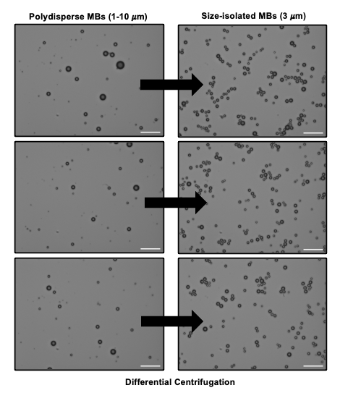

S1. Pre- and post-size isolated microbubbles. Bright-field images of MBs before and after differential centrifugation. The left-most panel shows a representative image of the polydisperse bubbles, while the right panel shows the MBs after size isolation to a mean diameter of 3 μm. Images were captured at 20x. Scale bar = 10 $μ$m

Fig. S2.
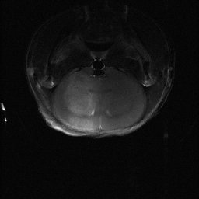
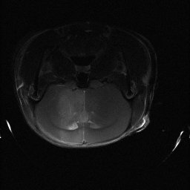
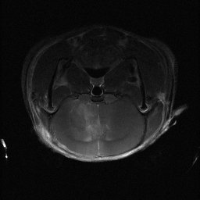
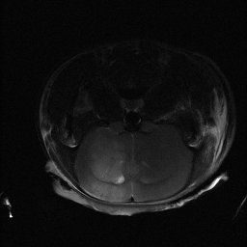
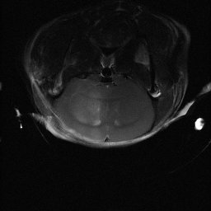
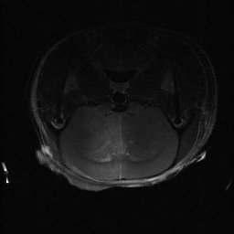
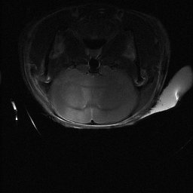
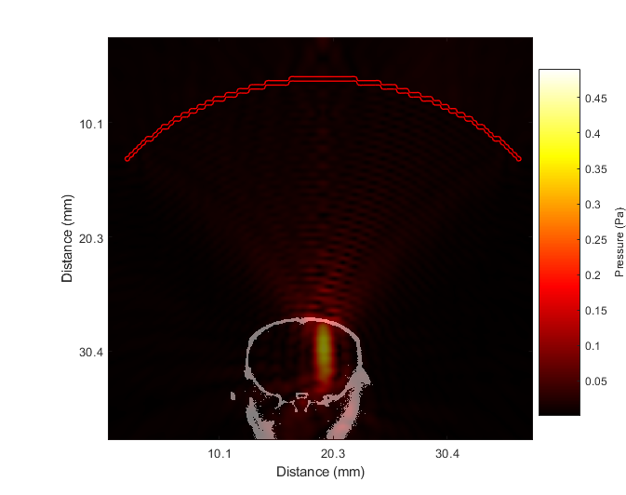
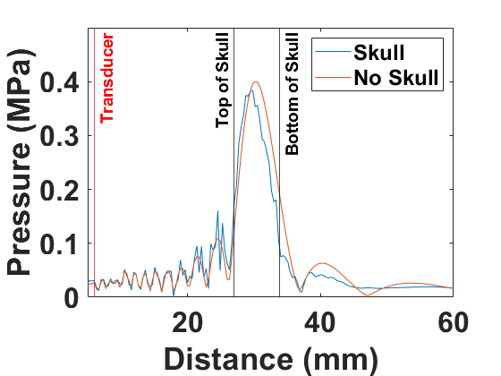
0.5hr
3hr
6hr
12hr
24hr
48hr
72hr
168hr
Initial Post- T1w MRI, 30 minutes post FUS
10 MVD + 0.4 MI
C
B
A

S2. Acoustic wave simulation of the mouse striatum. (A) Simulated peak negative pressure at 1 MHz inside the mouse skull, showing the focal region after skull attenuation. Axes show distance (mm) while the color bar shows pressure (MPa). (B) Pressure profile from transducer through the skull and brain, with and without the skull, illustrating attenuation and focal shift. (C) T1-weighted coronal images at the first 30 minutes after BBBO, across all time points, with gadolinium contrast enhancement delivered at 10 ul/kg of MBs and 0.4 MI. Enhancement shows consistent localization of contrast in the right striatum.

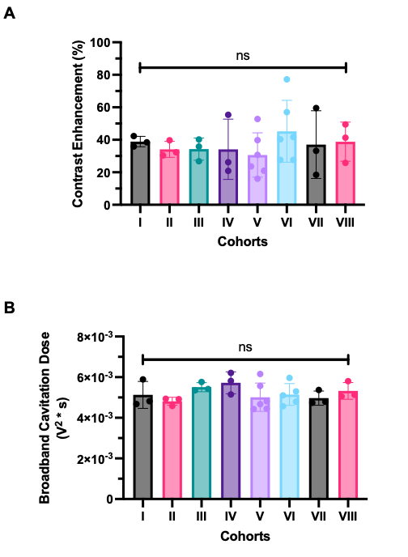
Fig. S3.

S3. MRI contrast enhancement and cavitation dose after BBBO. (A) Percent contrast enhancement (% CE) in the sonicated region across eight time points showed no significance (ns) between averages across all 8 time points (mean: 36.9 ± 13.8%). (B) Broadband cavitation dose (BCD, V² ∗ s) likewise showed no significant differences of averages between groups (mean: 5.18 x 10³ ± 5.28 x 10⁴). ns for all groups via ordinary one-way ANOVA with Tukey’s multiple comparisons test for all pairwise comparisons. Error bars represent mean ± SD.

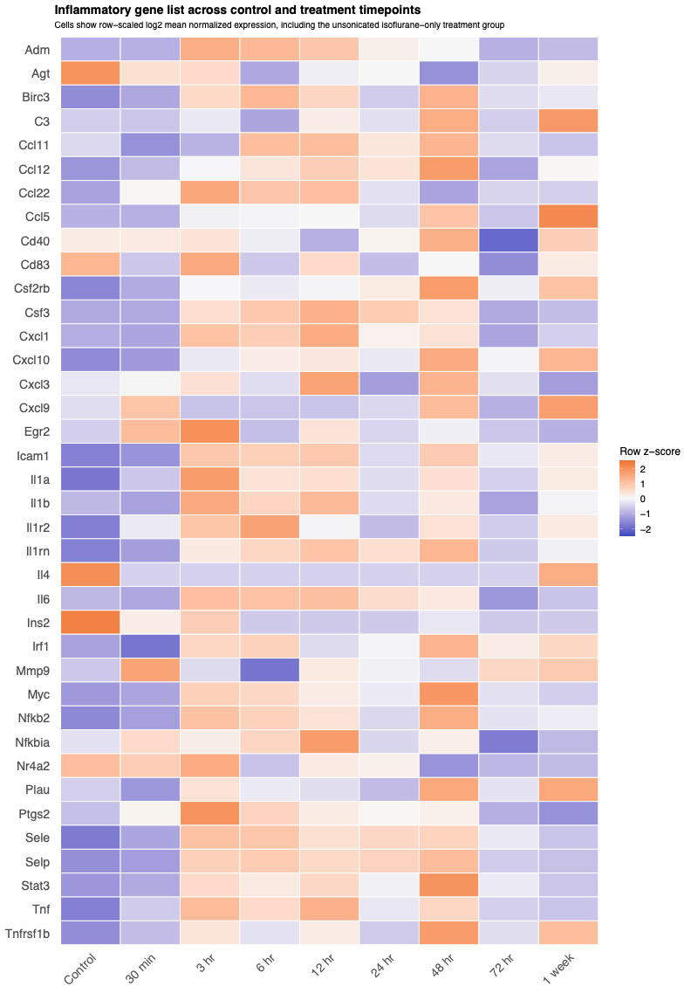
Fig. S4.

S4. Inflammatory gene list across control and treatment timepoints. Heatmap showing row-scaled, log2-mean-normalized RNA-seq expression for a literature-informed inflammatory gene set adapted from Kovacs et al. (2017) in the unsonicated isoflurane-only control group and in sonicated brains collected at the indicated time points.

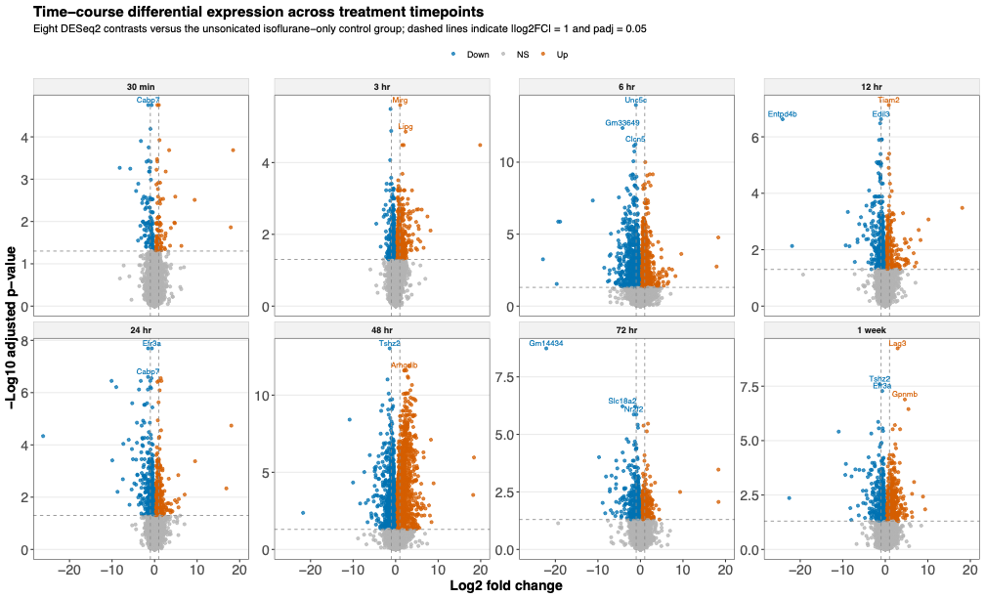
Fig. S5.

S5. Time-course differential gene expression relative to unsonicated controls. Faceted volcano plots showing DESeq2 differential expression results for each sonicated time point compared with the unsonicated isoflurane-only control group. Each point represents one transcript. The x-axis shows log2 fold change, and the y-axis shows -log10 adjusted p-value. Red points indicate significantly upregulated genes, blue points indicate significantly downregulated genes, and gray points indicate non-significant genes. Dashed lines denote |L₂FC| ≥ 1.1 and adjusted p-value < 0.05. Selected highly significant genes are labeled in each panel.

Fig. S6.
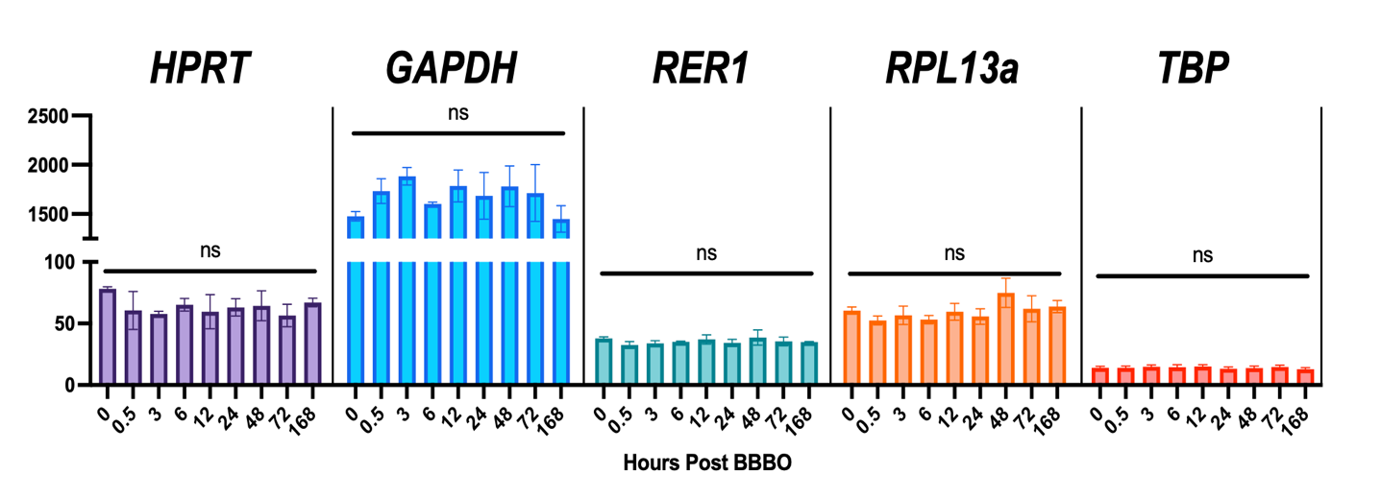
S6. Brain housekeeping gene expression remains stable over time. Expression of Hprt, Gapdh, Rer1, Rpl13a and Tbp from 0.5–168 h shows no significant differences (one-way ANOVA, all p > 0.05). Bars represent mean ± SD, brackets mark groupwise comparisons within each gene.

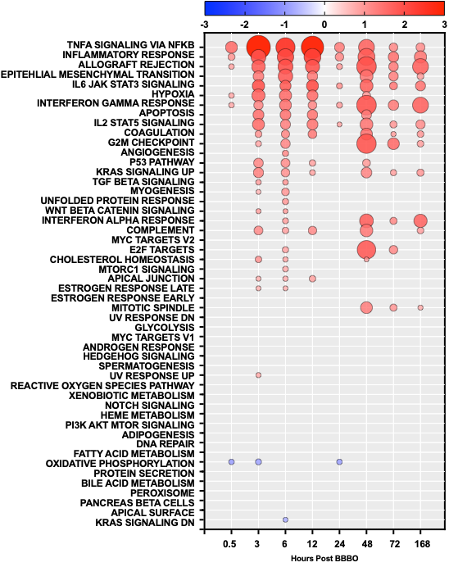
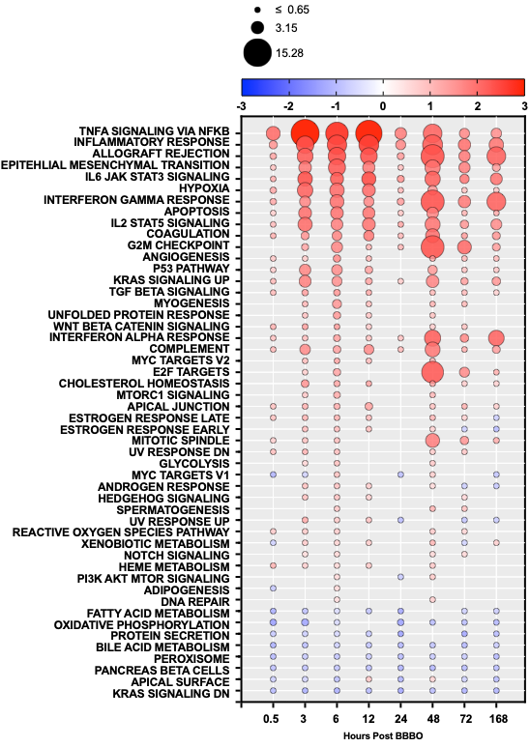
Fig. S7.
NES
-log₁₀₀ (adjusted p-value)

S7. Extended 50 Hallmarks GSEA. GSEA bubble plot of enriched DEGs (|NES| > 1.65, FDR < 0.05). Circle color denotes NES enrichment (red = upregulated, blue = downregulated), while size indicates significance log-compressed (–log₁₀₀) FDR values (larger = greater significance, smaller = less significance). The size of the smallest indicates the log-compressed value of p = 0.05.

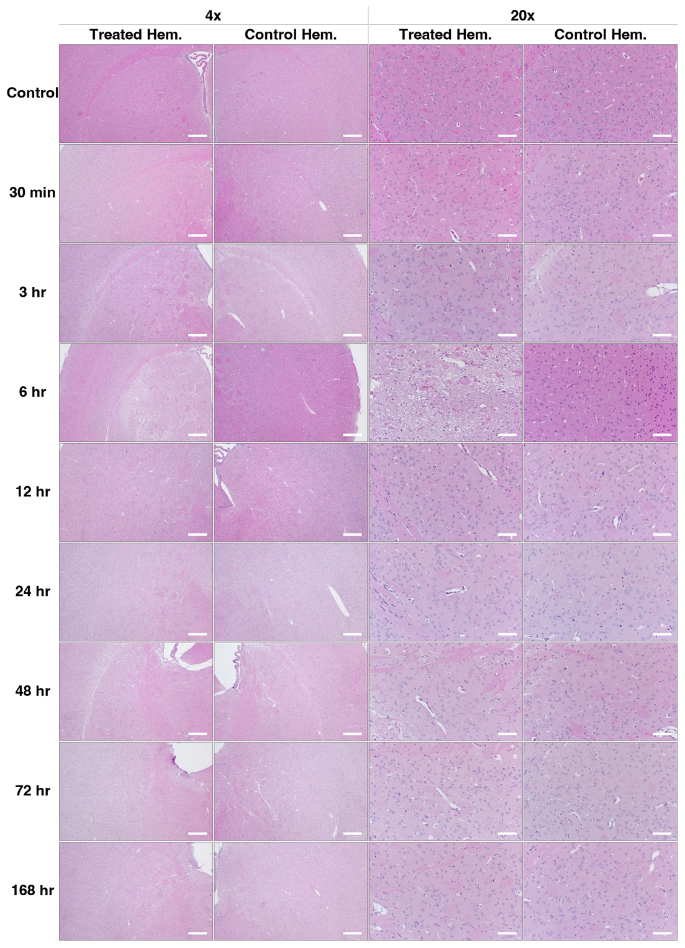
Fig. S8

S8. Representative hematoxylin and eosin-stained mouse brains. Representative H&E images of the treated and control hemispheres across all time points following BBBO. Coronal brain sections from the sonicated (treated) and contralateral (control) hemispheres were stained with hematoxylin and eosin (H&E) at 4× and 20× magnification. Prior to tissue harvest, all animals were transcardially perfused with PBS. Time points spanning from non-sonicated control to 168 h post-BBBO are shown in rows, as labeled. Columns indicate hemisphere and magnification. Scale bars: 500 µm (4×), 100 µm (20×).
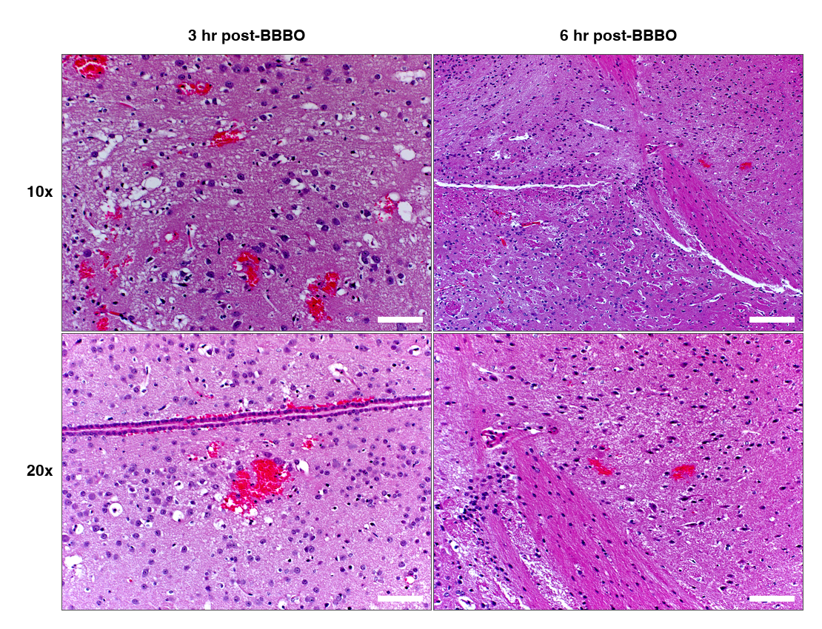
Fig. S9

S9. Representative H&E images of red blood cell extravasation in the sonicated hemisphere following BBBO. Brain sections from the treated (sonicated) hemisphere were stained with hematoxylin and eosin (H&E) at 3 and 6 h post-BBBO (columns). Prior to tissue harvest, all animals were transcardially perfused with PBS. Rows indicate magnification (left). Black arrows denote sites of RBC extravasation. Scale bars: 200 µm (10×), 100 µm (20×).
Fig. S10.
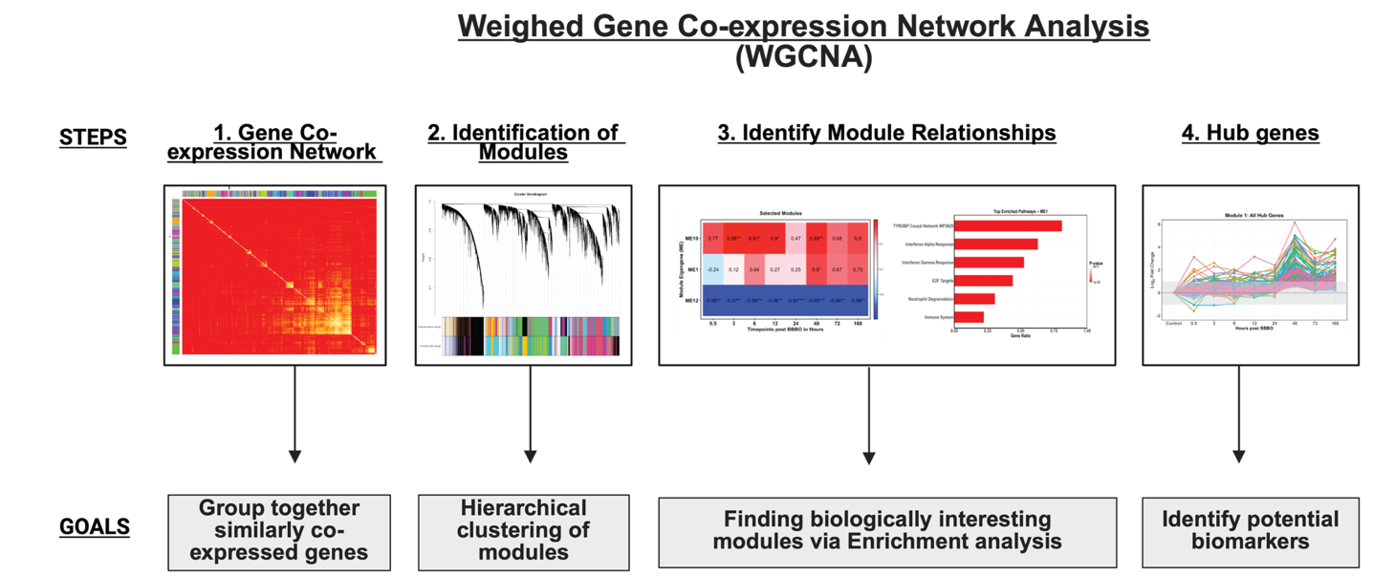

S10. WGCNA workflow. WGCNA workflow: network construction, module detection, module–trait analysis, and hub-gene identification

Fig. S11.

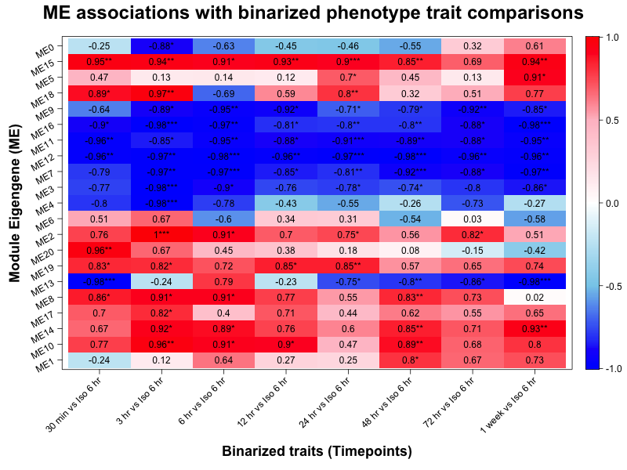
S11. WGCNA Whole Module Trait Association. Twenty co-expression modules were identified (WGCNA, deepSplit = 1) and summarized by their module eigengenes (rows). Columns are binarized contrasts for each time point versus the reference group (Iso 6 h). Cell values are Pearson correlation coefficients between each module eigengene and the corresponding contrast. The diverging color scale (–1 to +1) encodes direction and magnitude (red, positive/upregulated pattern; blue, negative/downregulated pattern). Asterisks denote significance of the correlation: p < 0.05 (*), p < 0.01 (**), p < 0.001 (***).

Fig. S12.

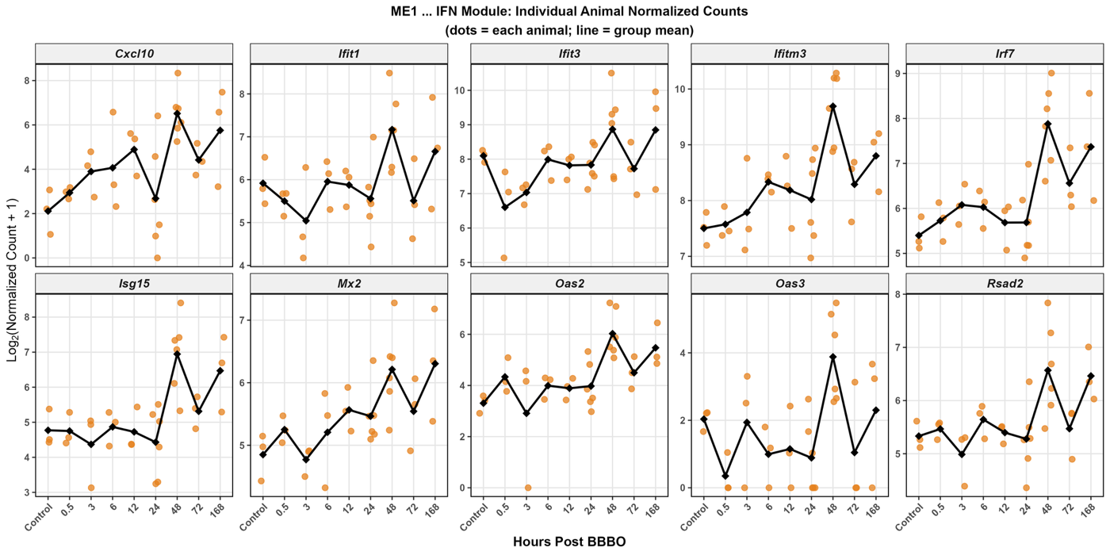
A.
B.
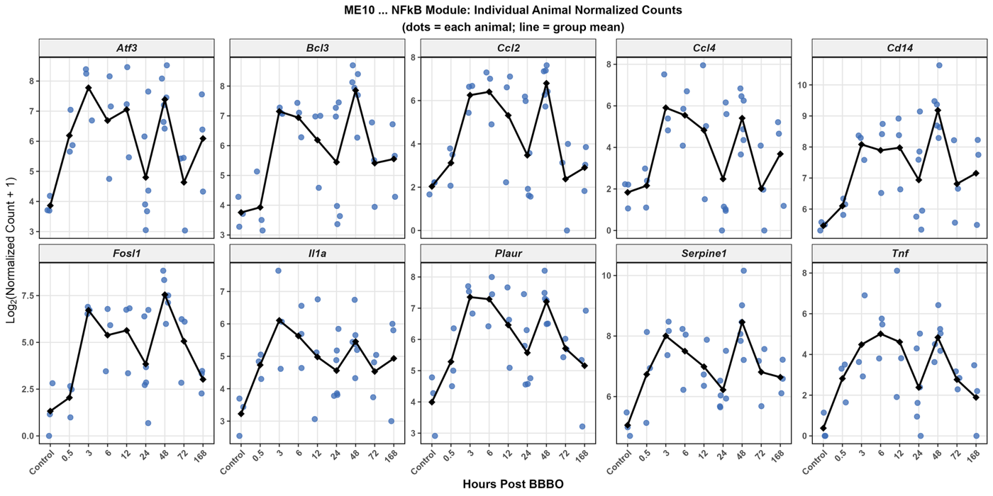

S12. Per-animal expression trajectories of representative module genes. Normalized expression of ten representative genes from (A) the late interferon module ME1 and (B) the early NFκB module ME10, shown across time following MB+FUS BBBO. The y-axis is log₂(DESeq2-normalized counts + 1); the x-axis is time post-BBBO (isoflurane-only control, then 0.5, 3, 6, 12, 24, 48, 72, and 168 h). Each dot is an individual animal (orange, ME1; blue, ME10), and the black line connects the group means at each timepoint (n = 3 per timepoint; n = 6 at 24 and 48 h). Plotting individual animals alongside the mean conveys the replicate-level variability underlying each trajectory.

Fig. S13

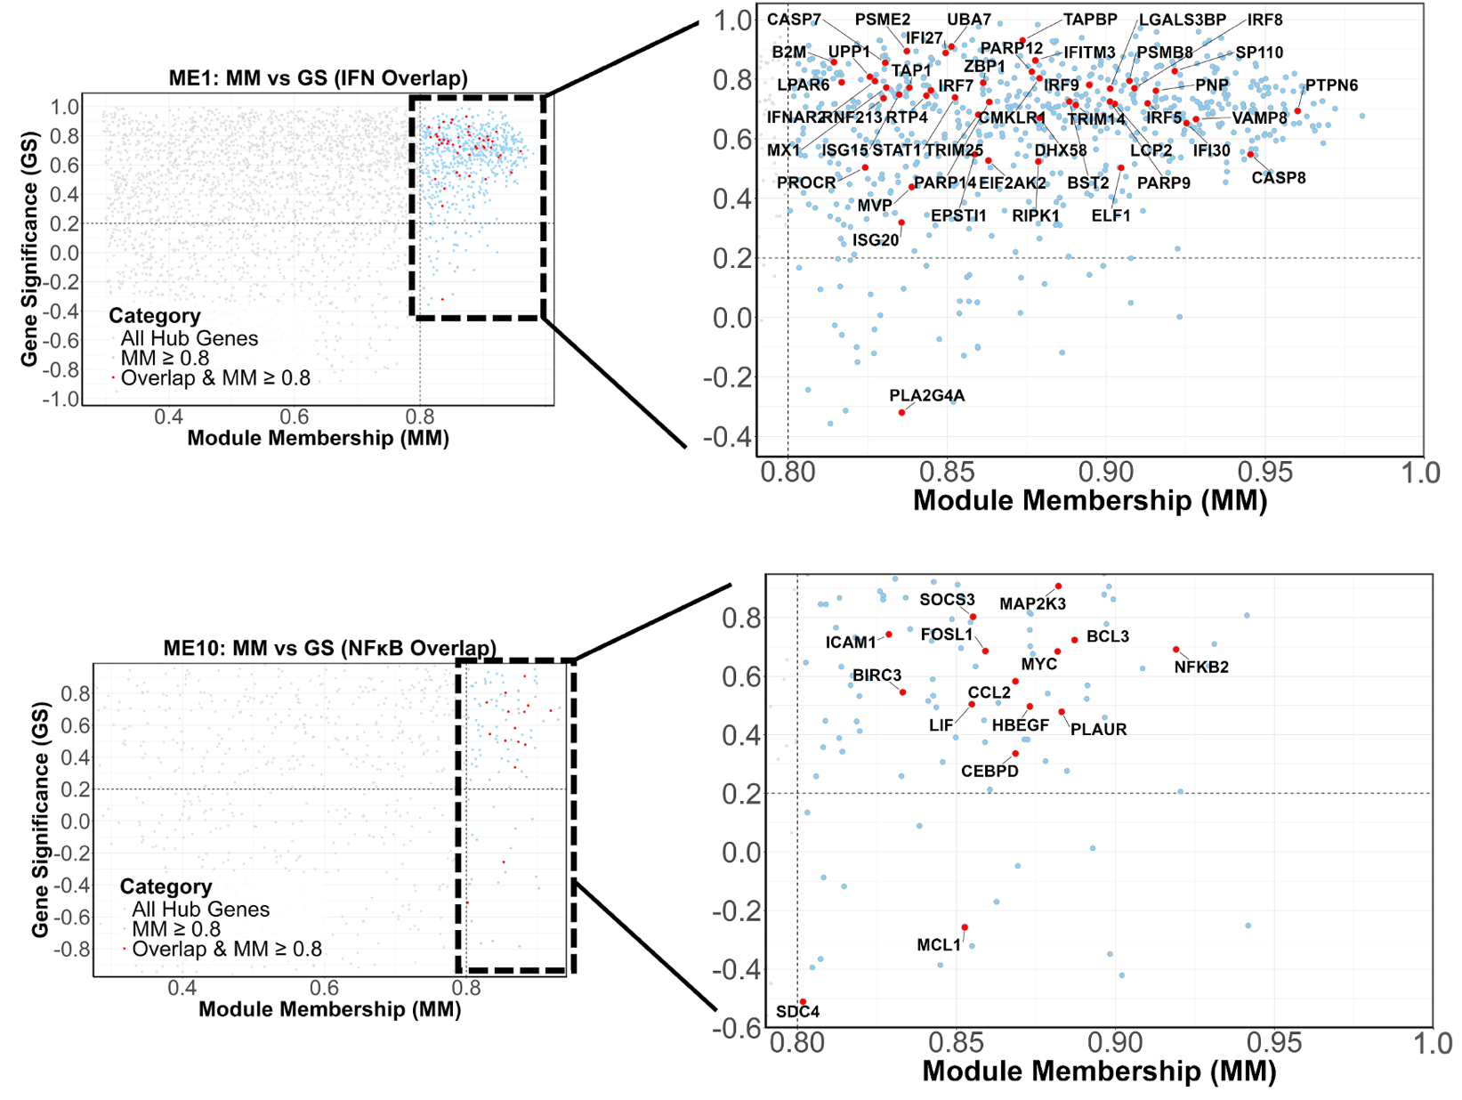
B

A

S13. ME1 and ME10 hub overlap and MM-GS plots. A scatter plot shows all genes in modules and their gene module membership and gene significance (GS) score (grey points). The inlet provides a zoomed-in view of significant hub genes in blue (MM $≥$0.8, p < 0.05) with overlapping genes from the Venn diagram analysis in red, which are annotated. Dashed lines from the x-axis indicate the significance of the MM score (0.8), while the y-axis indicates the significance of the GS score (0.2).

Fig. S14.
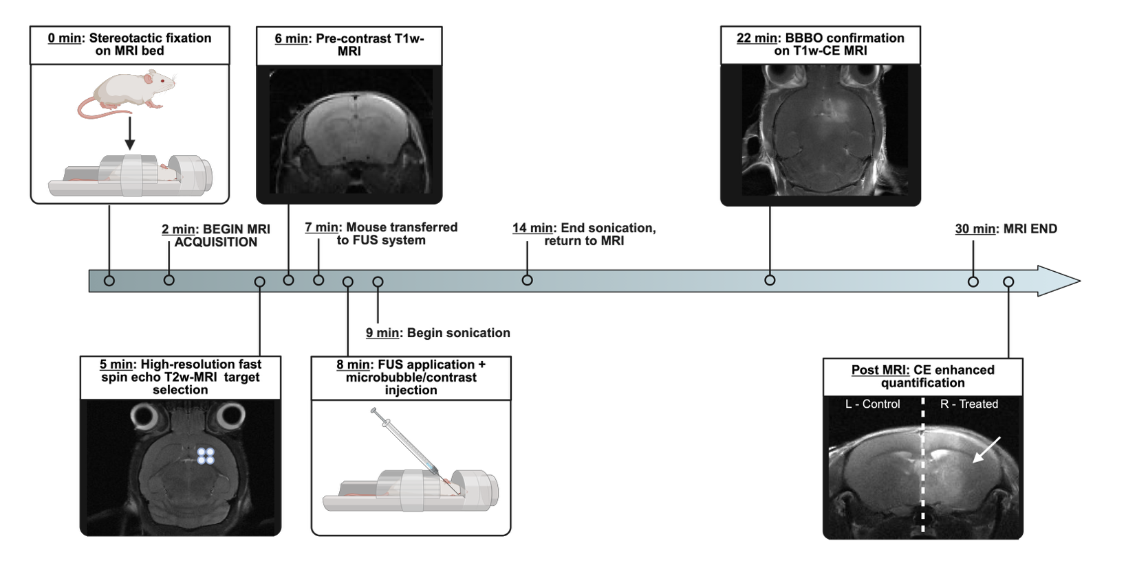

S14. Murine MRI-guided Focused Ultrasound BBBO protocol. Mice undergo stereotactic fixation (0 min) followed by T2-weighted imaging for targeting (5 min) and pre-contrast T1-weighted CE imaging (6 min). Animals are transferred to the FUS system (7 min), where microbubbles and contrast are injected, and sonication begins (9 min). Treatment is for 180 pulses or 3 minutes and mice are returned to the MRI machine (14 min) to obtain post-FUS T1-weighted CE MRI for BBBO confirmation (~20 minutes). Total MRI time is approximately 30 minutes. MRI DICOM images are subsequently analyzed for BBBO volume (mm³) and gadolinium CE quantification.

Fig. S15.
S15. Network Analysis and module clustering. (A) Scale-free topology model fit (signed R²) versus soft-threshold power (β). We chose β = 10 to meet the R² ≥ 0.80 criterion while retaining sufficient connectivity. (B) Mean connectivity versus β, showing the expected decline with increasing power. (C) Gene dendrogram from hierarchical clustering of the TOM dissimilarity. Color bars show module assignments before merging (top) and after merging highly similar modules by eigengene correlation (bottom).
Fig. S16.

S16. Eigengene Relationship Analysis. (A) Dendrogram of module eigengenes clustered by dissimilarity with average linkage. The y-axis shows the dissimilarity at which clusters merge: 0 = identical magnitude of correlation (|cor| = 1), 0.5 ≈ moderate similarity (|cor| = 0.5), 1 = no linear relation (|cor| = 0). Branches that join low indicate similar temporal profiles. ME1 groups most closely with ME10, then ME14. (B) Heatmap of eigengene dissimilarity. Red blocks mark high similarity, blue blocks low similarity, corroborating the tree structure and highlighting coordinated module behavior over time.

Table S1.

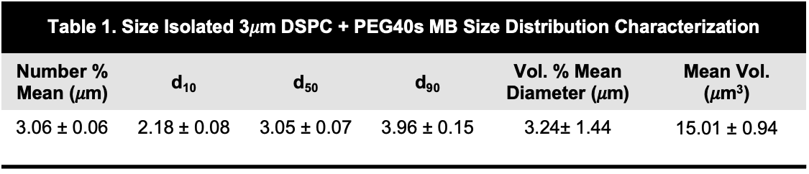

Table S1. Size Isolated 3𝜇m DSPC + PEG40s MB Size Distribution Characterization. The table reports the average diameter (μm) from the number- and volume-weighted distribution and mean volume (um³). The d₁₀-d₉₀ range represents where 10-90% of all MBs fall below these reported diameters in the number-weighted distribution. Data represent the mean ± standard deviation from 9 different batches of isolated MBs.

Table S2.
MRI Sequence | TR (ms) | TE (ms) | # aver | Flip Angle | FOV (mm) | Matrix | Resolution  (μm) | Acquisit  Time
turboRARE T2weighted | 2511 | 33 | 4 | 90°/180° | 20×20 | 256×256 | 78x78x700 (cor) | 5m21s
MSME T1-weighted | 700 | 15/30 | 4 | 90°/180° | 20×20 | 128×128 | 156x156x1200 (cor/axial) | 5m58s

Table S2. MRI sequences for BBBO. MRI Acquisition parameters for high-resolution fast spin echo T2-weighted MRI and gadolinium-enhanced T1-weighted MRI for BBBO. * cor, coronal plane; axial plane. The number of slices varied between 12 and 19 slices. All images were acquired on Bruker BioSpec 9.4T/20cm MRI scanner, equipped with a receiver mouse head 4-element array coil. Bruker ParaVision neo360 (v3.3) software was used for image acquisition and reconstruction.

