CXCL10 contributes to female-specific pathological progression in tauopathy model mice
Ryohei Uenishi¹, Rinna Kawata^{1,2}, Tatsuya Manabe^{1,2}, Yukio Matsuba^{3,4}, Naomi Mihira³, Toru Takeo⁵, Takaomi C. Saido³, Masanori Hijioka^{1,2}, Takashi Saito^{1,2}
1. Department of Neurocognitive Science, Institute of Brain Science, Nagoya City University Graduate School of Medical Sciences, Nagoya, 467-8601, Japan
2. Department of Neuropathology, Graduate School of Medicine, The University of Tokyo,
Tokyo, 113-0033, Japan
3. Laboratory for Proteolytic Neuroscience, RIKEN Center for Brain Science, Wako, 351-0198, Japan
4. Pioneering Research Division, Medical Innovation Research Center, Shiga University of Medical Science, Otsu, 520-2192, Japan
5. Division of Reproductive Engineering, Center for Animal Resources and Development, Kumamoto University, Kumamoto, 860-0811, Japan
Correspondence to: Drs. Masanori Hijioka and Takashi Saito
E-mail: mhijioka@m.u-tokyo.ac.jp and tsaito@m.u-tokyo.ac.jp

Contents:

Raw western blot images 1–11
Raw western blot images
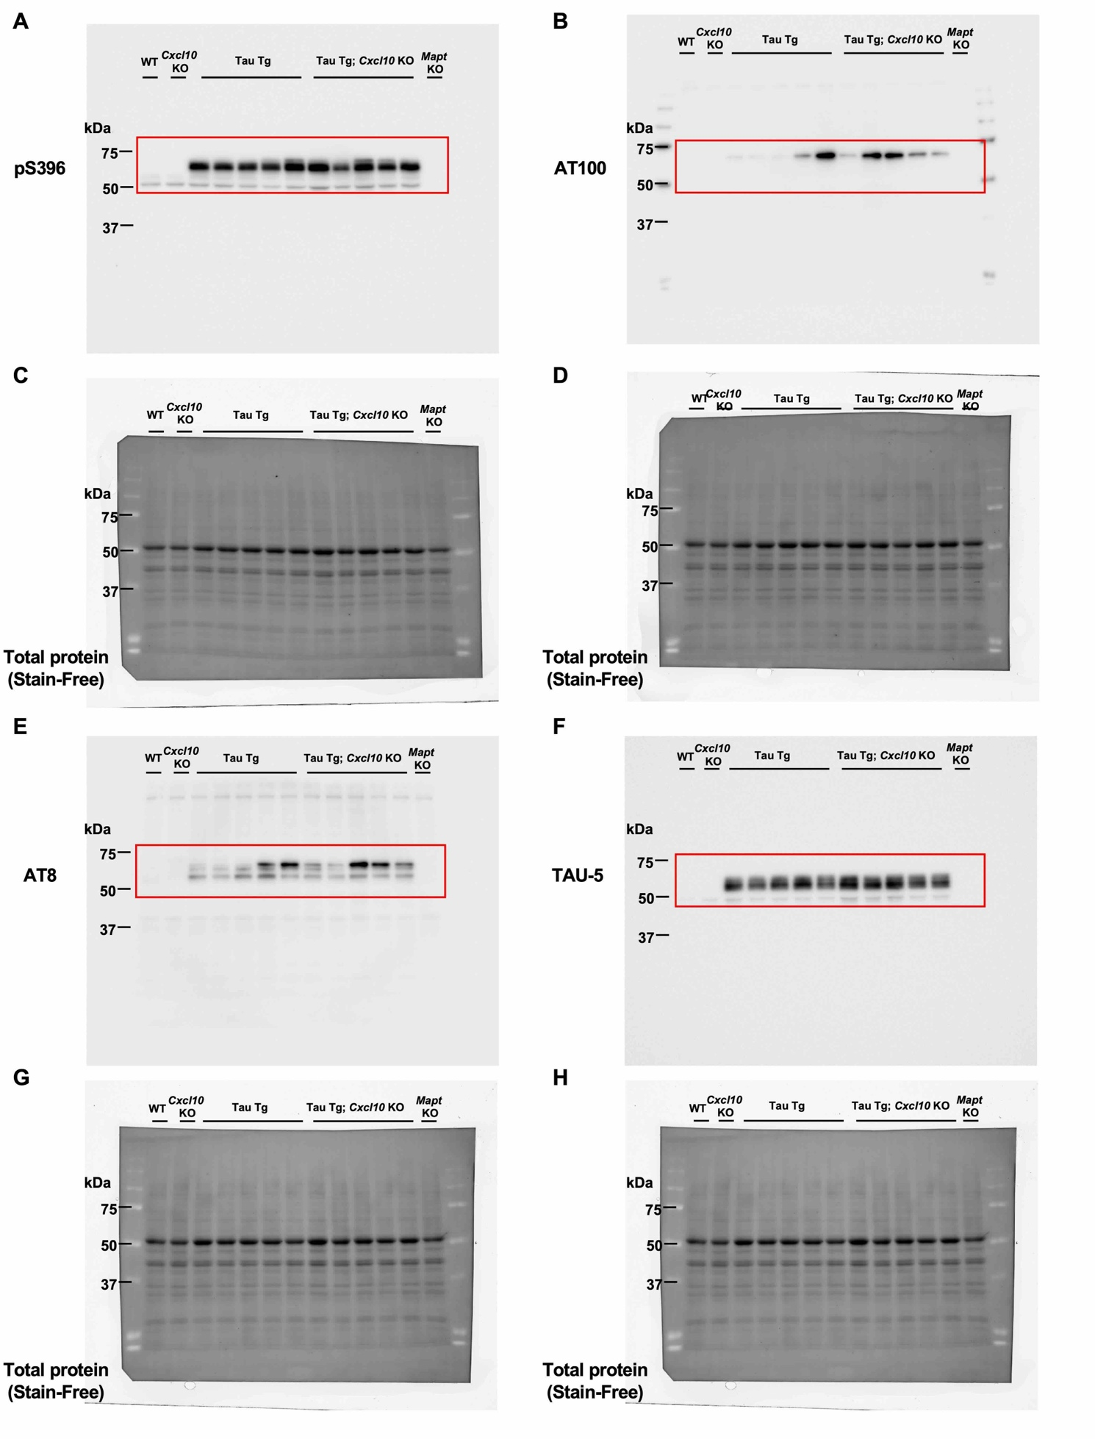
Raw western blot image 1 Full uncropped blot images for Figure 2A. (A, B, E, F) Protein bands were detected using specific primary antibodies against pS396 (A), AT100 (B), AT8 (E), and TAU-5 (F) in 9-month-old male mice of each genotype. (C, D, G, H) In these panels, total protein is visualized using the Stain-Free method on the membranes corresponding to A, B, E, and F, respectively.

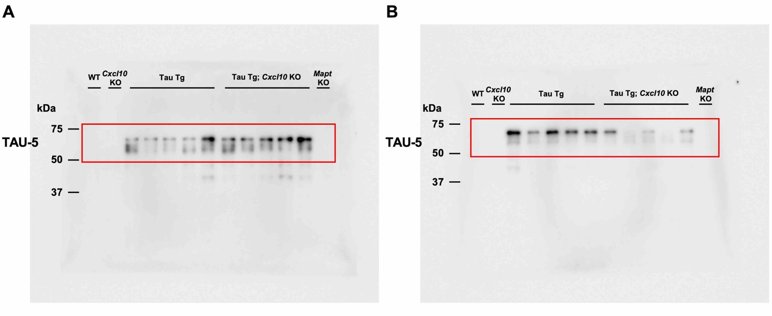
Raw western blot image 2 Full uncropped blot images for Figure 2F, L. (A, B) Protein bands were detected using specific primary antibodies against TAU-5 in 9-month-old male (A) and female (B) mice of each genotype.

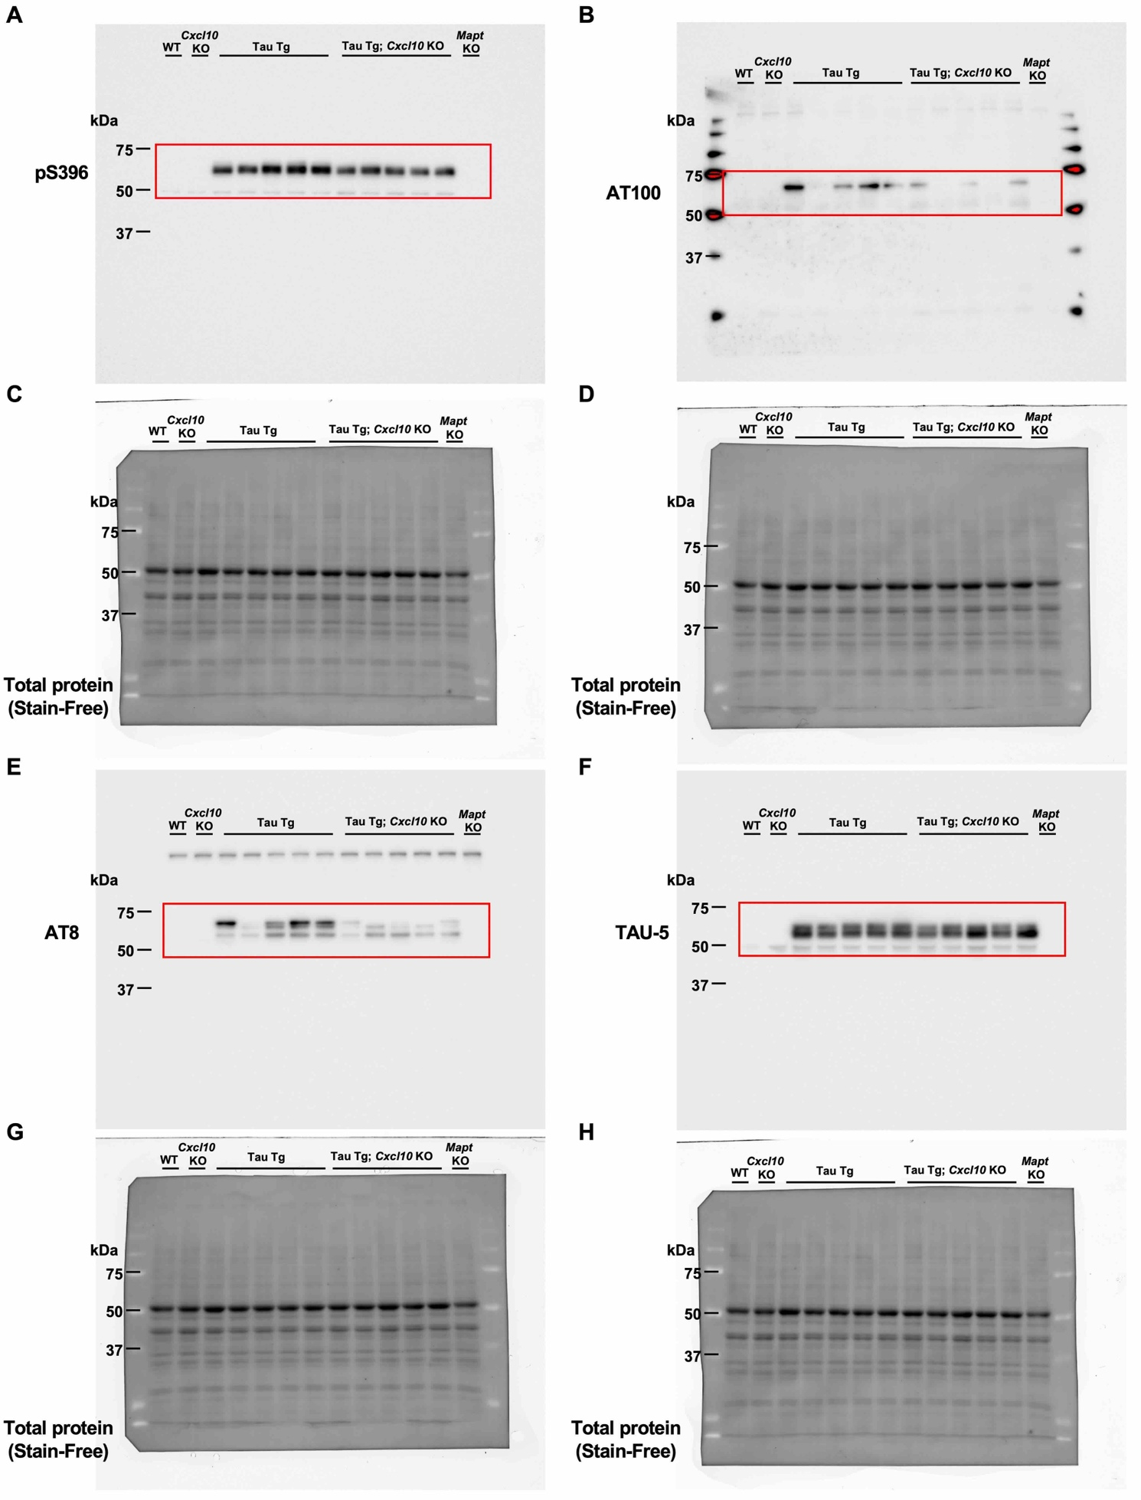

Raw western blot image 3 Full uncropped blot images for Figure 2G. (A, B, E, F) Protein bands were detected using specific primary antibodies against pS396 (A), AT100 (B), AT8 (E), and TAU-5 (F) in 9-month-old female mice of each genotype. (C, D, G, H) In these panels, total protein is visualized using the Stain-Free method on the membranes corresponding to A, B, E, and F, respectively.

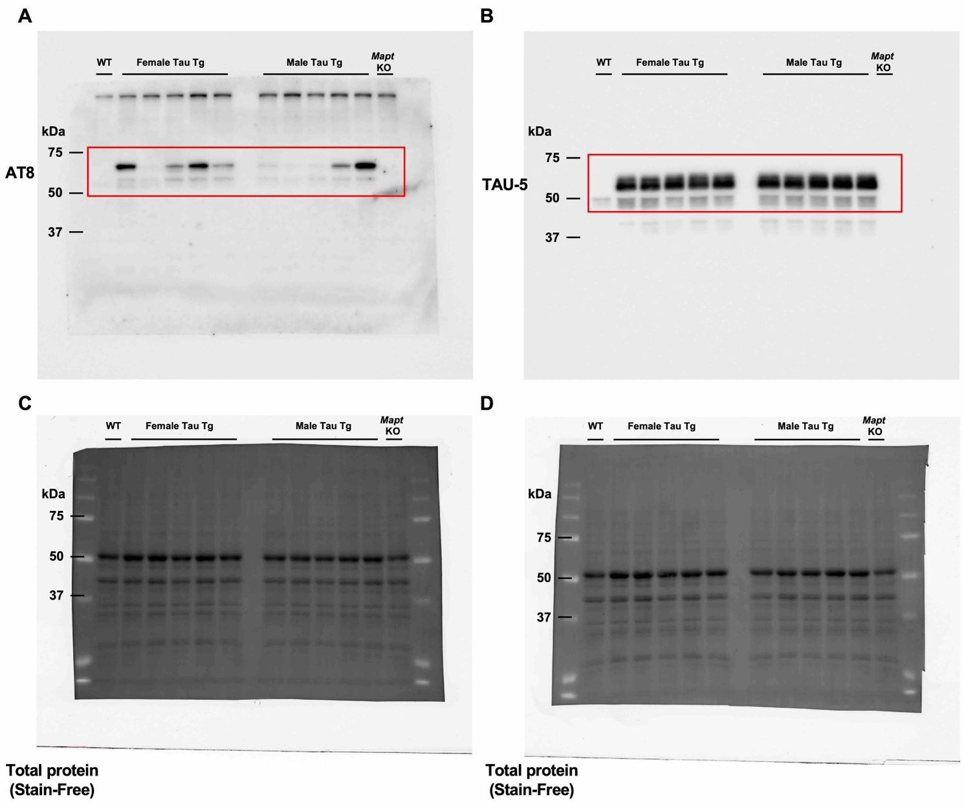
Raw western blot image 4 Full uncropped blot images for Supplementary Figure 2A. Protein bands were detected using specific primary antibodies against AT8 (A) and TAU-5 (B) in 9-month-old female and male mice of each genotype. (C, D) In these panels, total protein is visualized using the Stain-Free method on the membranes corresponding to A, B.

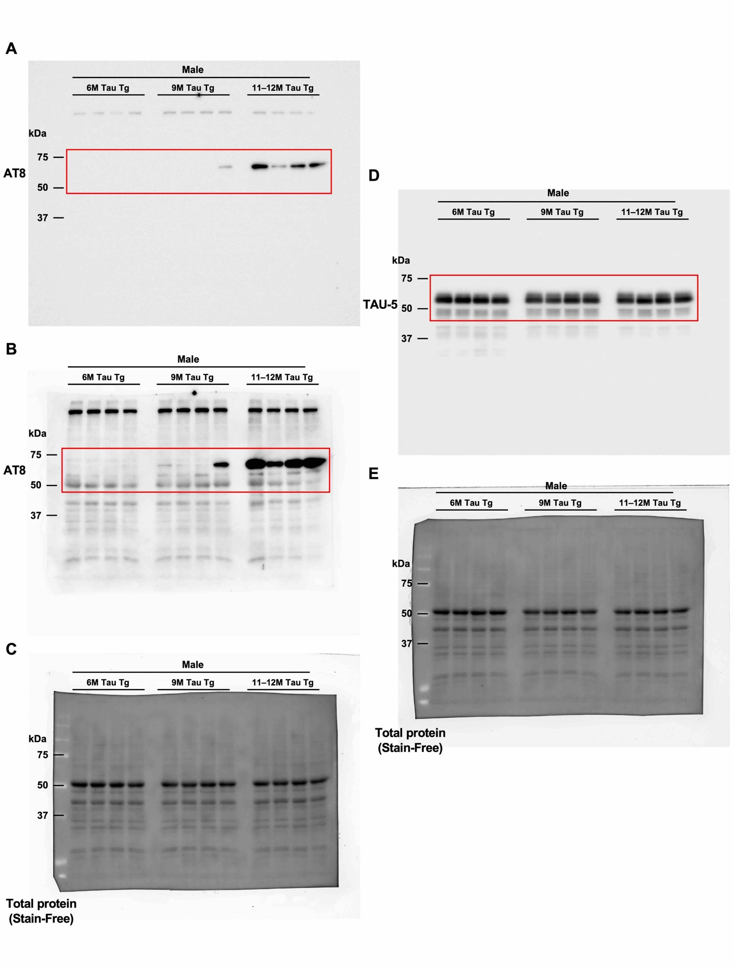

Raw western blot image 5 Full uncropped blot images for Supplementary Figure 3A. Protein bands were detected using specific primary antibodies against AT8 (A, B) and TAU-5 (B) in male Tau Tg mice at 6, 9, and 11–12 months of age. (B) A long-exposure image of the membrane from panel A. (C, E) In these panels, total protein is visualized using the Stain-Free method on the membranes corresponding to A, D.

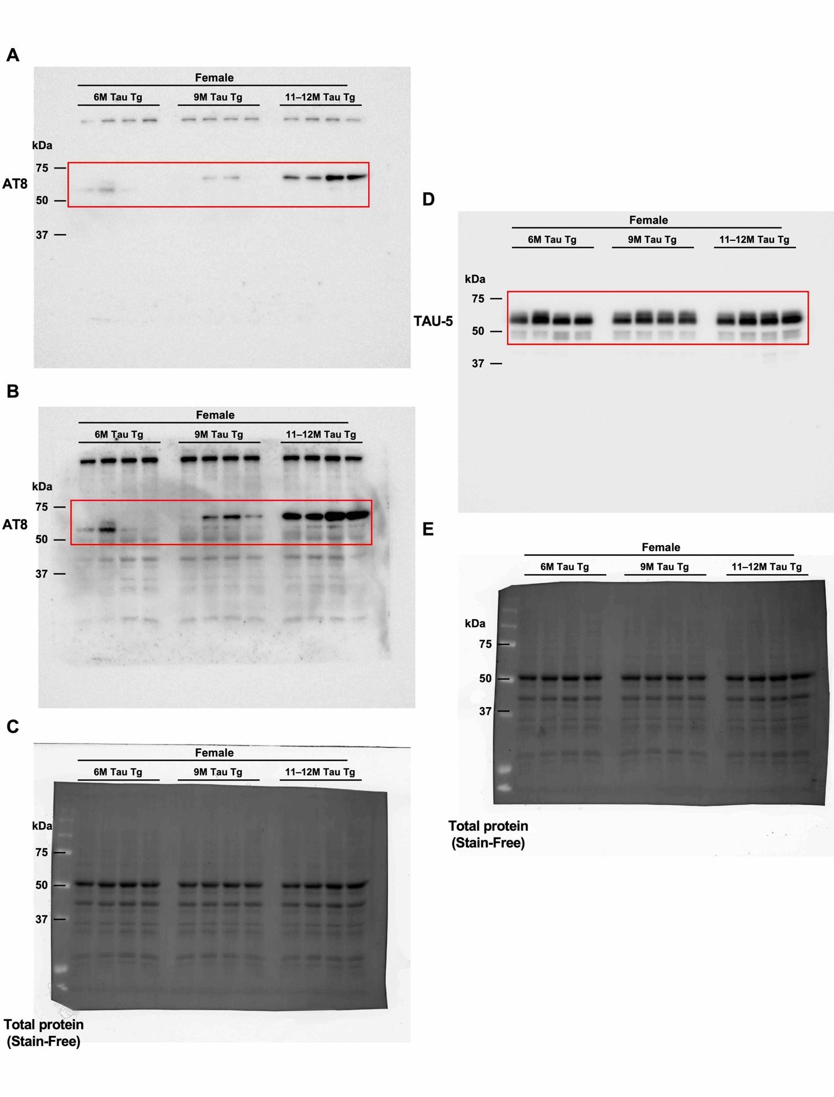

Raw western blot image 6 Full uncropped blot images for Supplementary Figure 3B. Protein bands were detected using specific primary antibodies against AT8 (A, B) and TAU-5 (B) in fenale Tau Tg mice at 6, 9, and 11–12 months of age. (B) A long-exposure image of the membrane from panel A. (C, E) In these panels, total protein is visualized using the Stain-Free method on the membranes corresponding to A, D.

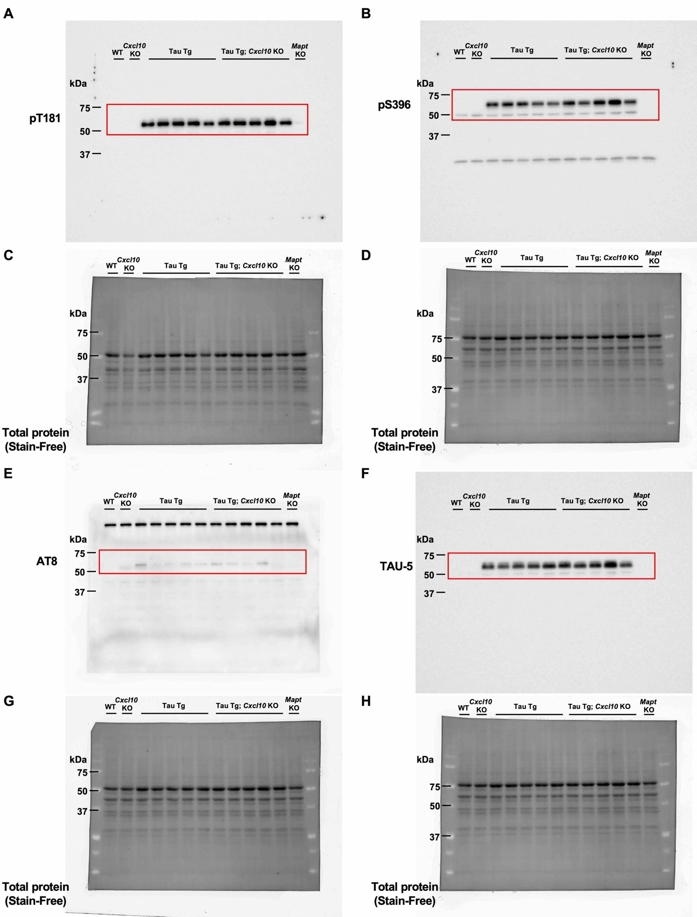
Raw western blot image 7 Full uncropped blot images for Supplementary Figure 4A. Protein bands were detected using specific primary antibodies against pT181 (A), pS396 (B), AT8 (E), and TAU-5 (F) in 6-month-old male mice of each genotype. (C, D, G, H) In these panels, total protein is visualized using the Stain-Free method on the membranes corresponding to A, B, E, and F, respectively.

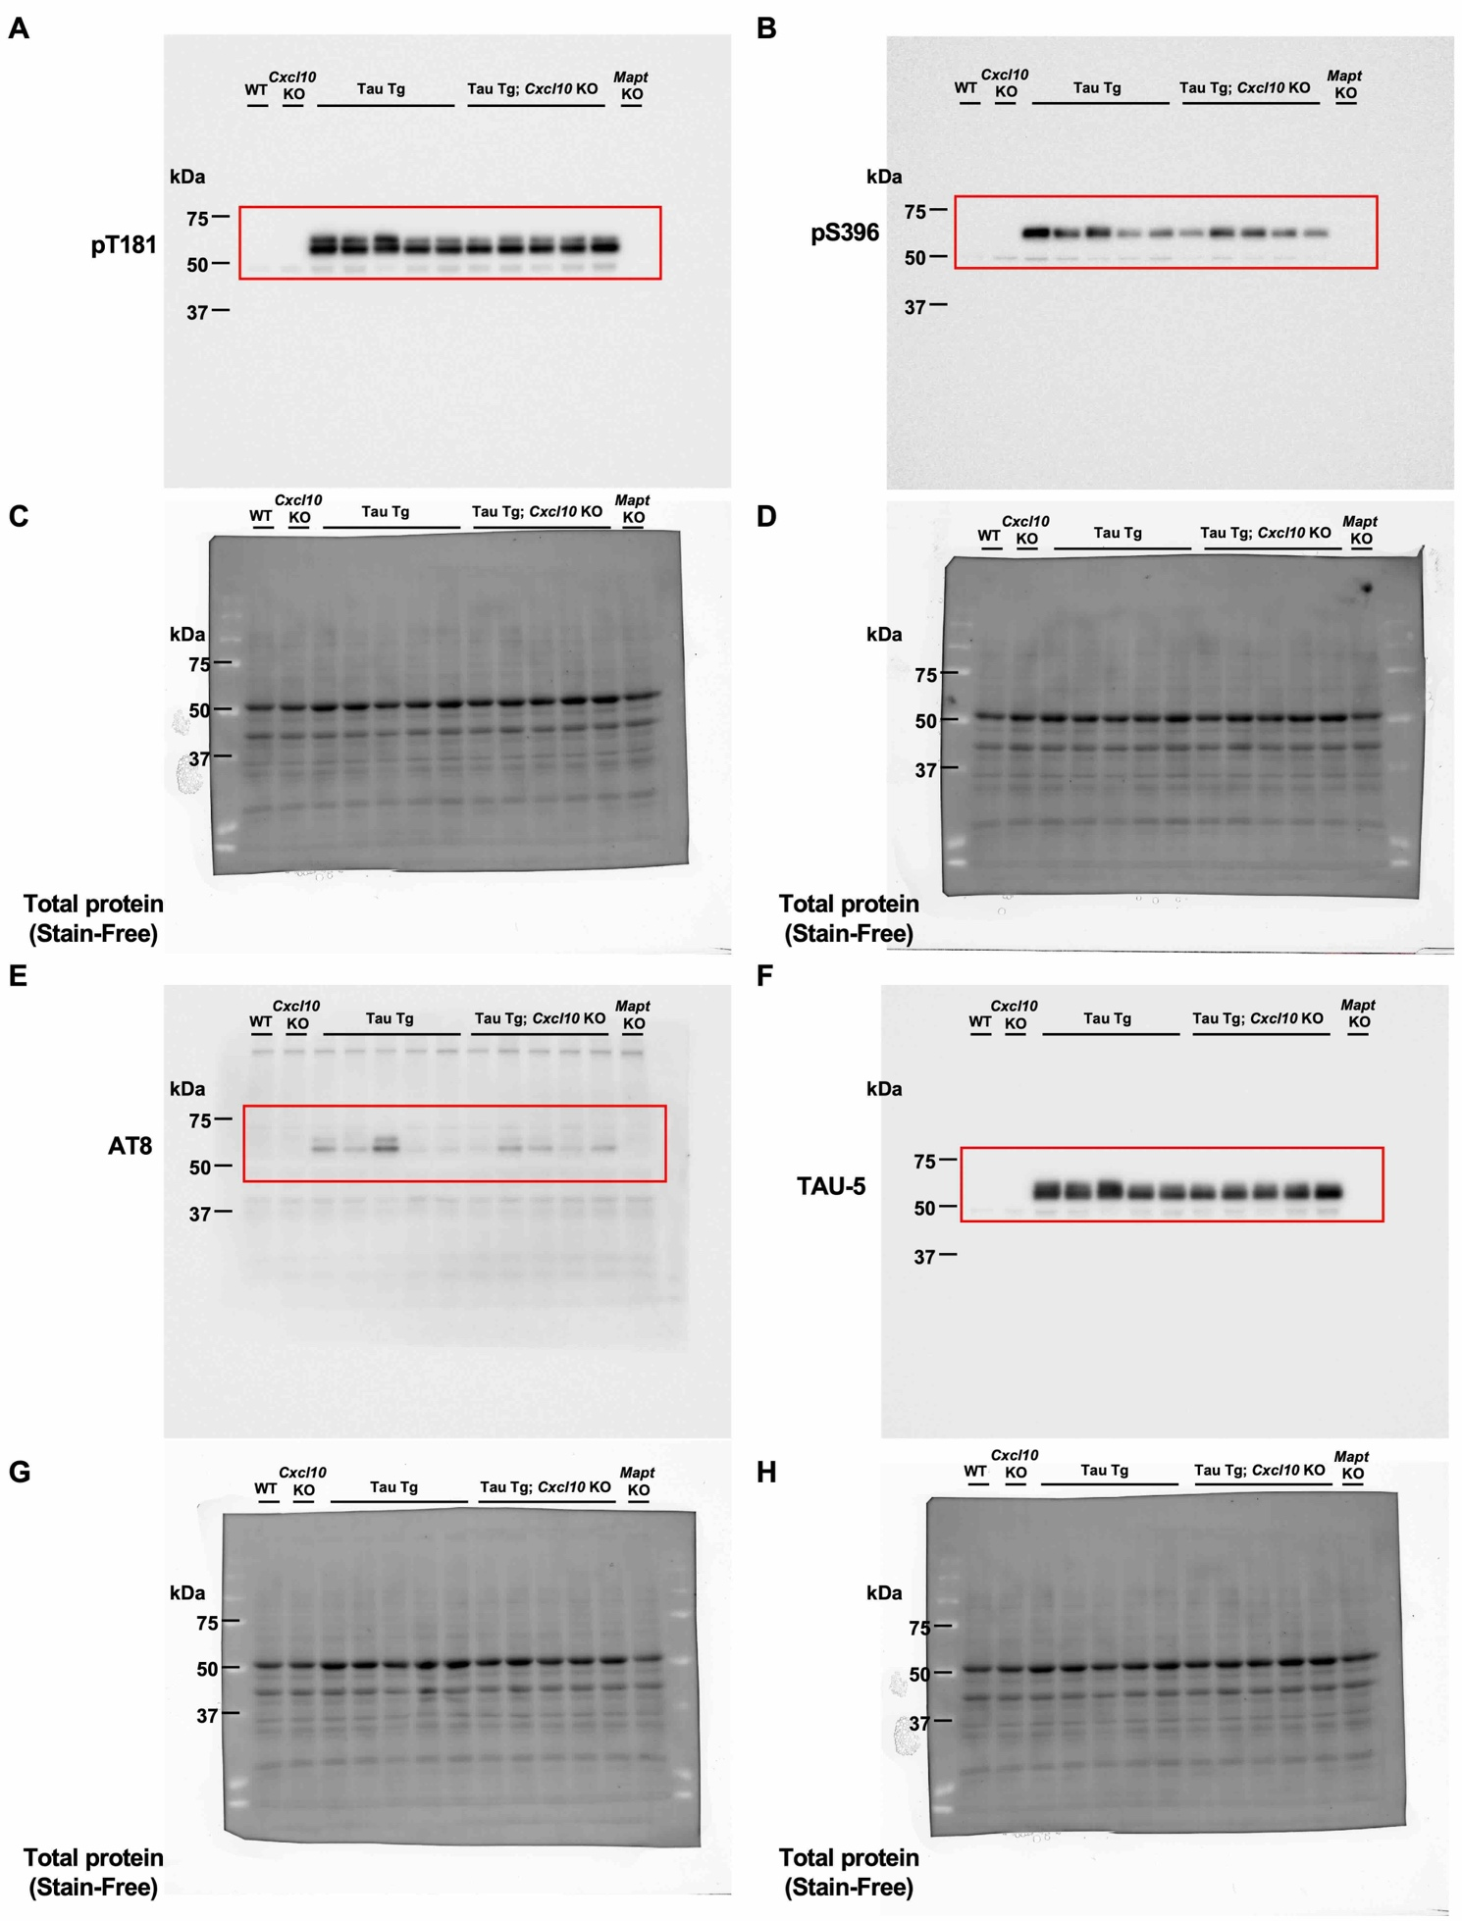

Raw western blot image 8 Full uncropped blot images for Supplementary Figure 4F. Protein bands were detected using specific primary antibodies against pT181 (A), pS396 (B), AT8 (E), and TAU-5 (F) in 6-month-old female mice of each genotype. (C, D, G, H) In these panels, total protein is visualized using the Stain-Free method on the membranes corresponding to A, B, E, and F, respectively.

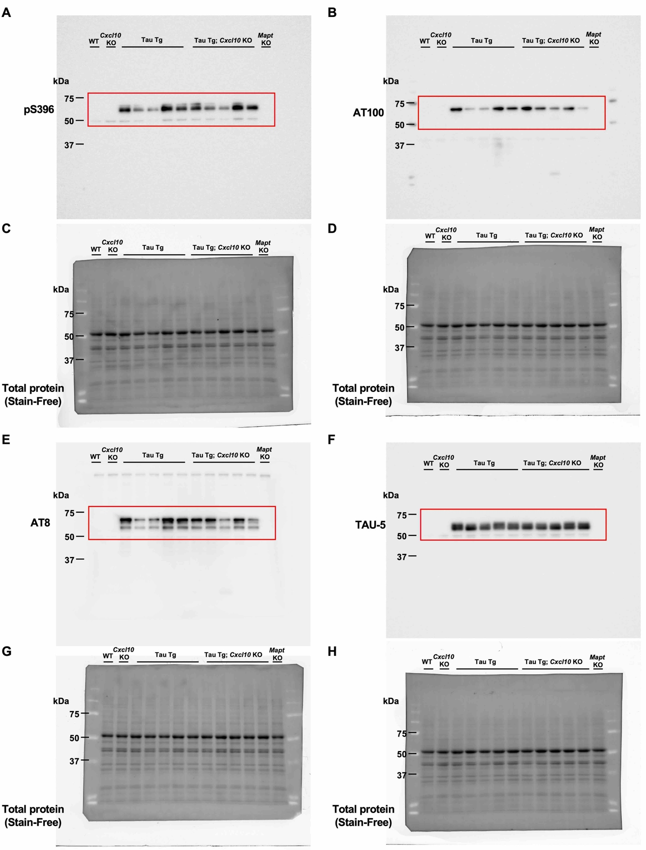
Raw western blot image 9 Full uncropped blot images for Supplementary Figure 5A. Protein bands were detected using specific primary antibodies against pS396 (A), AT100 (B), AT8 (E), and TAU-5 (F) in 11–12-month-old male mice of each genotype. (C, D, G, H) In these panels, total protein is visualized using the Stain-Free method on the membranes corresponding to A, B, E, and F, respectively.

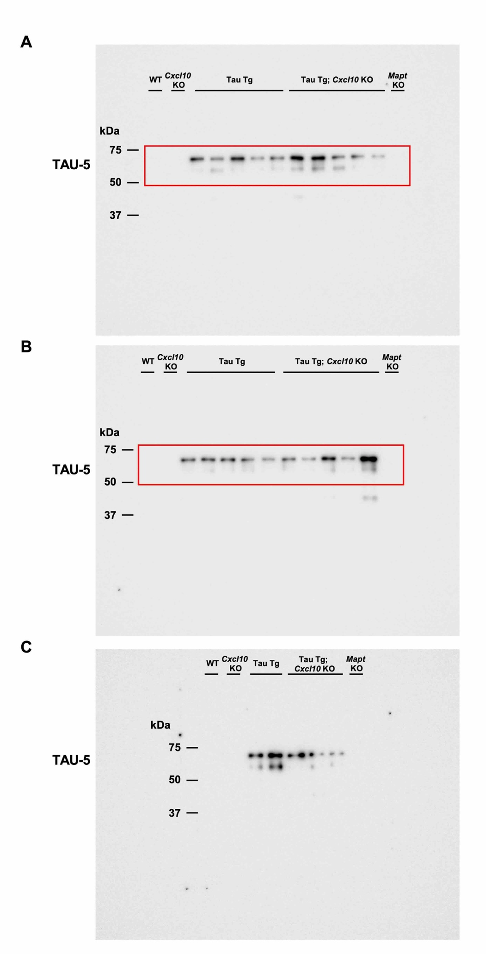
Raw western blot image 10 Full uncropped blot images for Supplementary Figure 5F, L. (A, B, C) Protein bands were detected using specific primary antibodies against TAU-5 in 11–12-month-old male (A) and female (B, C) mice of each genotype. Panel B is presented as a representative figure. Panel C shows additional samples that could not be included in panel B because of limited well capacity.

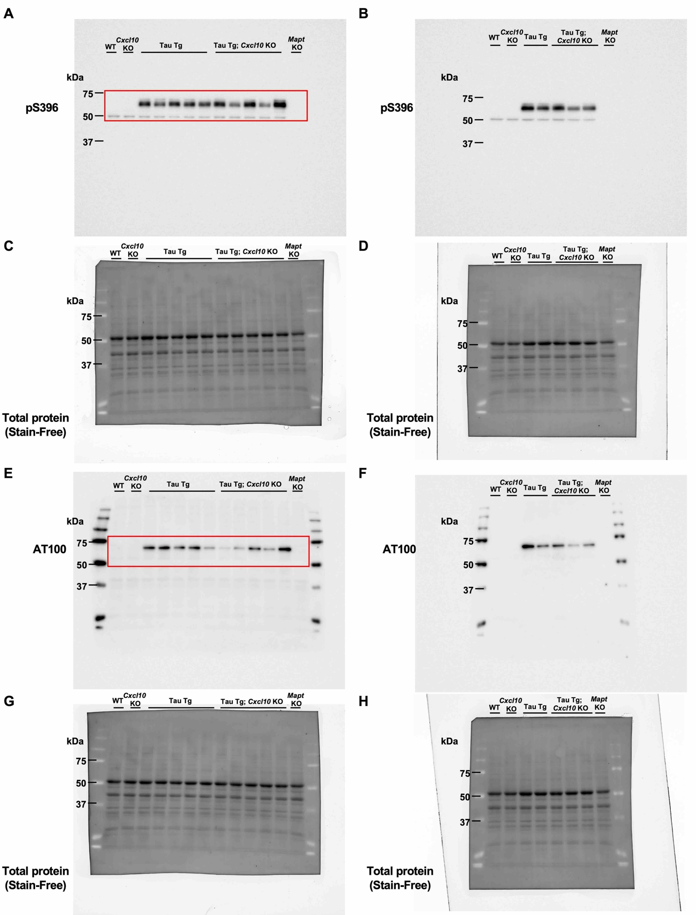
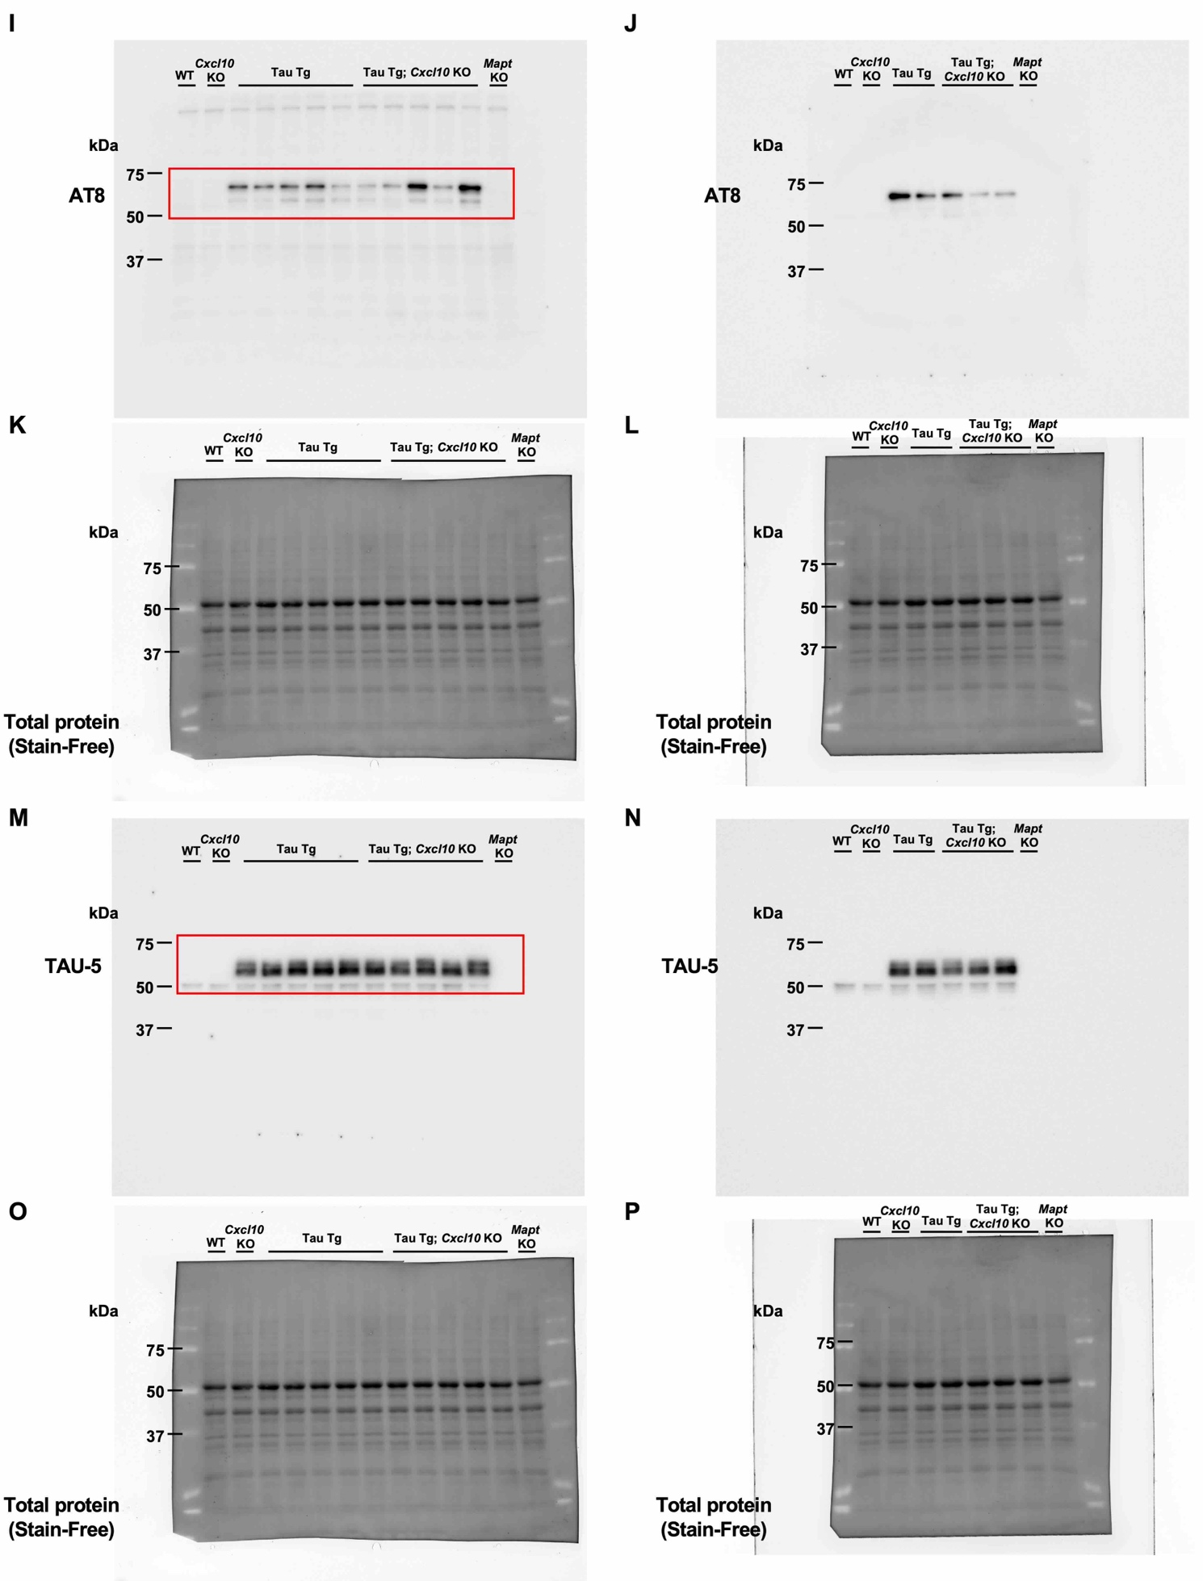

Raw western blot image 11 Full uncropped blot images for Supplementary Figure 5G. (A, B, E, F, I, J, M, N) Protein bands were detected using specific primary antibodies against pS396 (A, B), AT100 (E, F), AT8 (I, J), and TAU-5 (M, N) in 11–12-month-old female mice of each genotype. Panel A, E, I, M is presented as a representative figure. Panel B, F, J, and N show additional samples that could not be included in panels A, E, I, and M because of limited well capacity. (C, D, G, H, K, L, O, P) In these panels, total protein is visualized using the Stain-Free method on the membranes corresponding to A, B, E, F, I, J, M, and F, respectively.

