CXCL10 contributes to female-specific pathological progression in tauopathy model mice
Ryohei Uenishi¹, Rinna Kawata^{1,2}, Tatsuya Manabe^{1,2}, Yukio Matsuba^{3,4}, Naomi Mihira³, Toru Takeo⁵, Takaomi C. Saido³, Masanori Hijioka^{1,2}, Takashi Saito^{1,2}
1. Department of Neurocognitive Science, Institute of Brain Science, Nagoya City University Graduate School of Medical Sciences, Nagoya, 467-8601, Japan
2. Department of Neuropathology, Graduate School of Medicine, The University of Tokyo,
Tokyo, 113-0033, Japan
3. Laboratory for Proteolytic Neuroscience, RIKEN Center for Brain Science, Wako, 351-0198, Japan
4. Pioneering Research Division, Medical Innovation Research Center, Shiga University of Medical Science, Otsu, 520-2192, Japan
5. Division of Reproductive Engineering, Center for Animal Resources and Development, Kumamoto University, Kumamoto, 860-0811, Japan
Correspondence to: Drs. Masanori Hijioka and Takashi Saito
E-mail: mhijioka@m.u-tokyo.ac.jp and tsaito@m.u-tokyo.ac.jp

Contents:

Supplementary Figures 1–19
Supplementary Figures
Supplementary Fig. 1 Inflammatory response pathway was activated in the hippocampus of Tau Tg mice. (A, B) Gene Ontology (GO) pathway analysis focusing on biological processes (BP) and molecular functions (MF) was performed to compare P301S tau transgenic (Tau Tg) mice with wild-type (WT) mice. The top 10 significantly upregulated pathways in Tau Tg mice are shown in each panel. Number of mice used: WT (n = 3), Tau Tg (n = 3). Differentially expressed genes (DEGs) were identified using the Wald test. GO enrichment analysis was performed by over-representation analysis based on the hypergeometric test using DEGs with |log₂ fold change| > 1 and padj < 0.1.
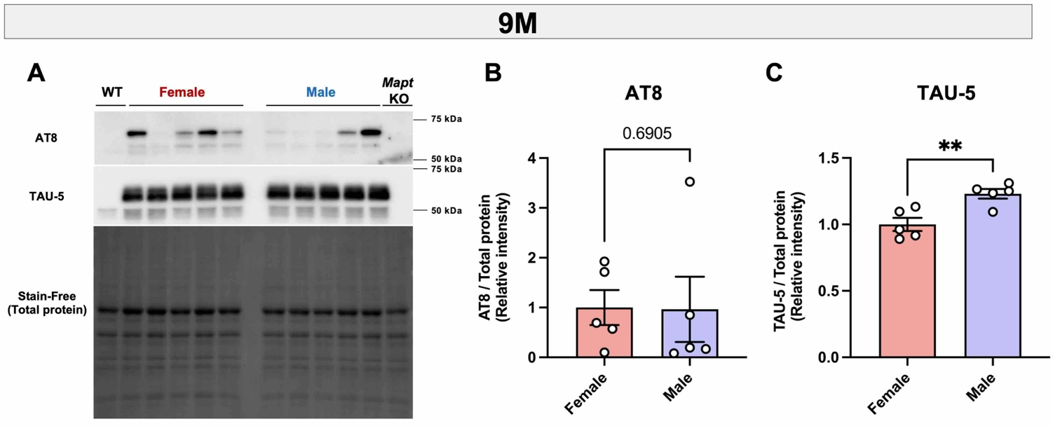
Supplementary Fig. 2 Sex-dependent changes relative to AT8-positive tau accumulation in 9-month-old Tau Tg mice. (A–C) Immunoblot analysis of tau protein in the cerebral cortices of 9-month-old Tau Tg mice of both sexes. Immunoblot images of phosphorylated tau (p-tau) detected with anti-pSer202/pThr205 [AT8] antibodies and total tau detected with TAU-5 antibody (A). (B, C) Protein expression levels were normalized to total protein using the Stain-Free method. Data are presented as mean ± S.E.M. Five female and five male Tau Tg mice were used Number of mice used: Female Tau Tg (n = 5), and Male Tau Tg (n = 5). Statistical analysis was performed using an unpaired two-tailed t-test (C) or a Mann-Whitney U test (B). Uncropped full-size membrane images in Raw western blot image 4.
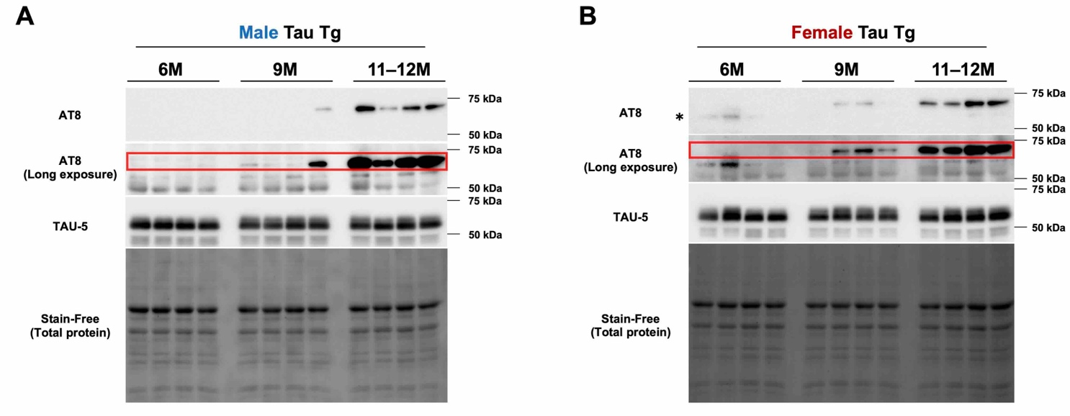Supplementary Fig. 3 Age-dependent changes in AT8-positive tau accumulation. (A, B) Immunoblot analysis of tau protein in the cerebral cortices of Tau Tg mice aged 6 to 11–12 months from both sexes. Immunoblot images of p-tau detected with anti-pSer202/pThr205 [AT8] antibodies and total tau detected with TAU-5 antibody (A: male, B: female). Red rectangle indicates AT8-positive tau band; asterisk denotes a non-specific band. Uncropped full-size membrane images in Raw western blot images 5, 6.
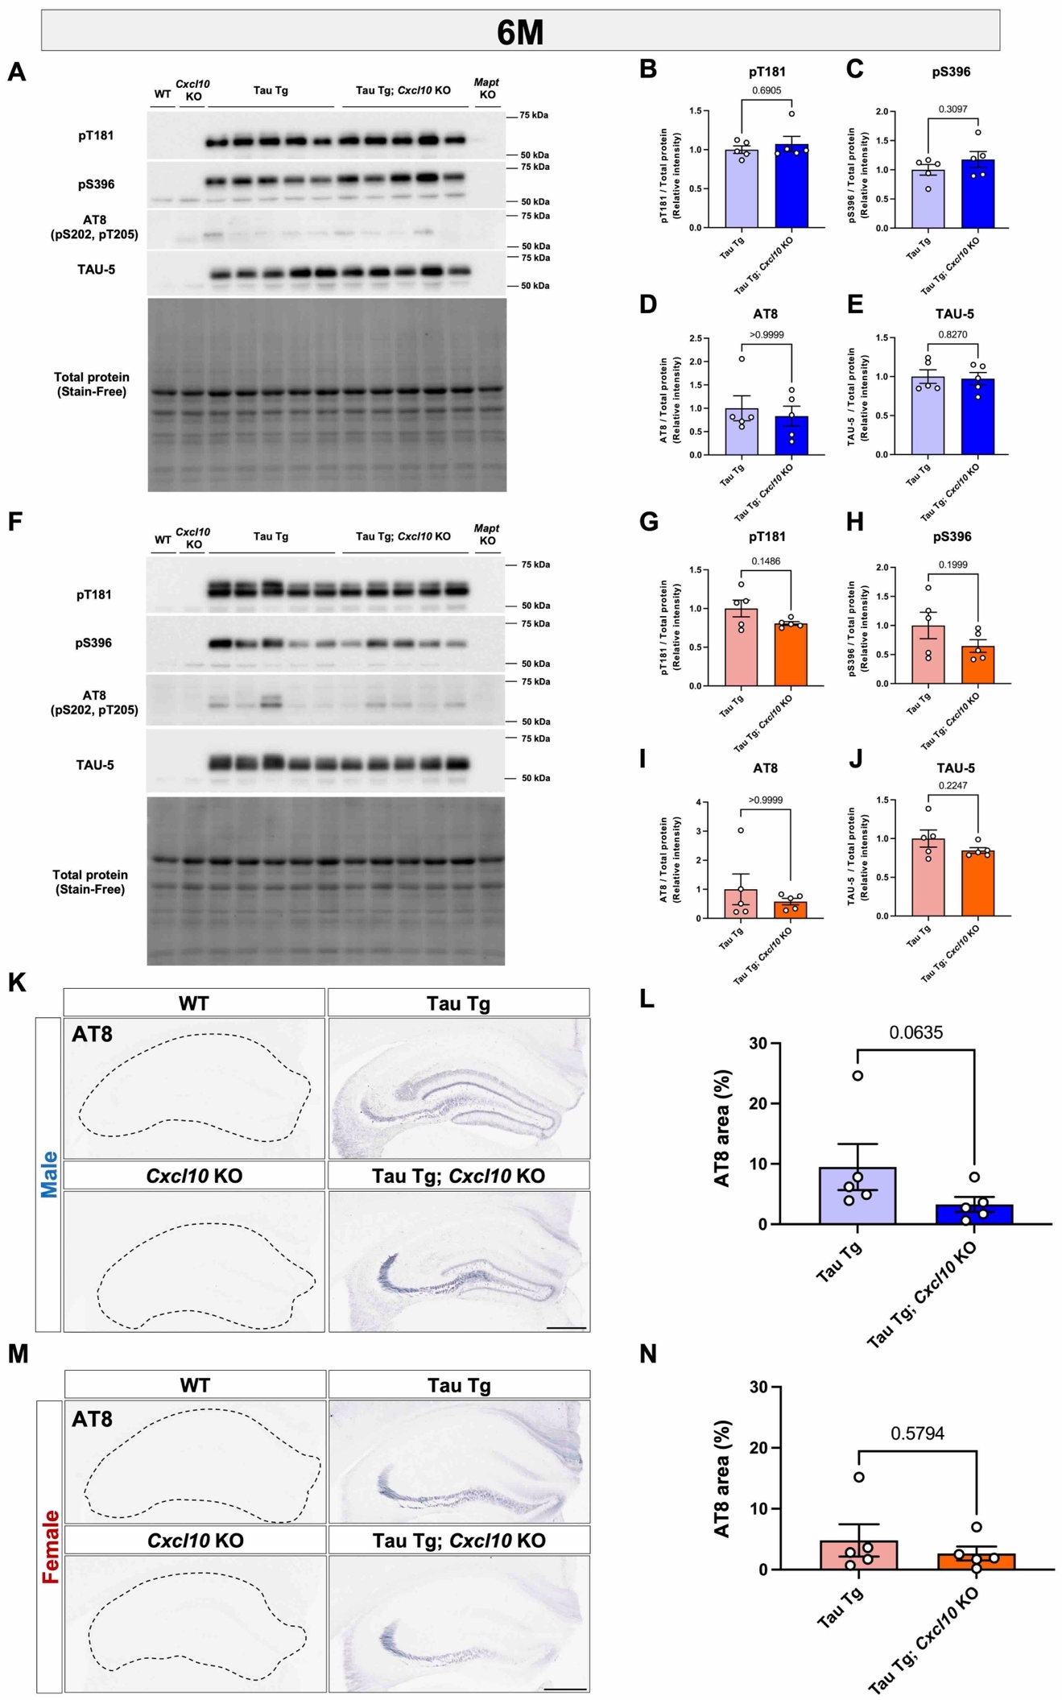
Supplementary Fig. 4 Effect of Cxcl10 deficiency on tauopathy model mice at 6 months of age. Immunoblot analysis of tau protein in the cerebral cortices of 6-month-old Tau Tg mice with or without C-X-C motif chemokine ligand 10 (Cxcl10) deficiency. Males (A–E), females (F–J). (A, F) Immunoblot images of p-tau detected with anti-pThr181, pSer396, and pSer202/pThr205 [AT8] antibodies, and total tau detected with TAU-5 antibody. (B–E, G–J) Protein expression levels were normalized to total protein using the Stain-Free method. (K, M) Immunohistochemical analysis of p-tau in the hippocampus using AT8 antibody. (L, N) Quantification of the AT8-positive area in males (L) and females (N). Scale bar = 500 µm. Data are presented as mean ± S.E.M. Number of mice used: Tau Tg (n = 5), and Tau Tg; Cxcl10 KO (n = 5) for both sexes. Statistical analysis was performed using an unpaired two-tailed t-test (C, E, H, J), an unpaired t-test with Welch's correction (G), and a Mann-Whitney U test (B, D, I, L, N). Uncropped full-size membrane images in Raw western blot images 7, 8.
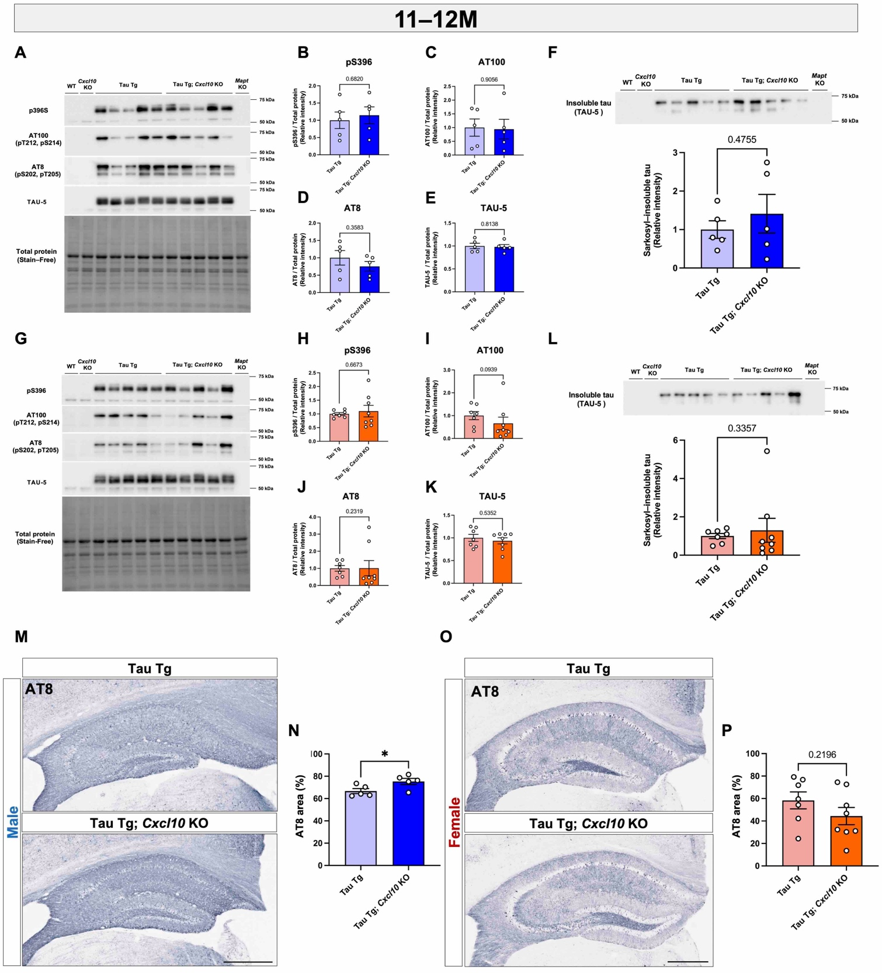

Supplementary Fig. 5 Biochemical and histological assessment of tau pathology in 11–12-month-old Tau Tg mice with or without Cxcl10 deficiency. Immunoblot analysis of tau protein in the cerebral cortices of 11–12-month-old Tau Tg mice with or without Cxcl10 deficiency. Males (A–F, M), females (G–L, O). (A, G) Immunoblot images of p-tau detected with anti-pSer396, pThr212/pSer214 [AT100], and pSer202/pThr205 [AT8] antibodies, and total tau detected with TAU-5 antibody. (B–E, H–K) Protein expression levels were normalized to total protein using the Stain-Free method. (F, L) Immunoblot images of sarkosyl-insoluble tau from the cerebral cortex, including the piriform and entorhinal cortices. Bar graphs represent relative expression level of tau protein in Tau Tg; Cxcl10 KO mice compared to Tau Tg mice. Uncropped full-size membrane images in Supplementary material. (M, O) Immunohistochemical analysis of p-tau in the hippocampus using AT8 antibody. Bar graphs indicate the AT8-positive area in males (N) and females (P). Scale bar = 500 µm. Data are presented as mean ± S.E.M. Number of mice used: male Tau Tg (n = 5), male Tau Tg; Cxcl10 KO (n = 5), female Tau Tg (n = 7), and female Tau Tg; Cxcl10 KO (n = 8). Statistical analysis was performed using an unpaired two-tailed t-test (B–F, H, K, N, P) or a Mann-Whitney U test (I, J, L). Uncropped full-size membrane images in Raw western blot images 9–11.

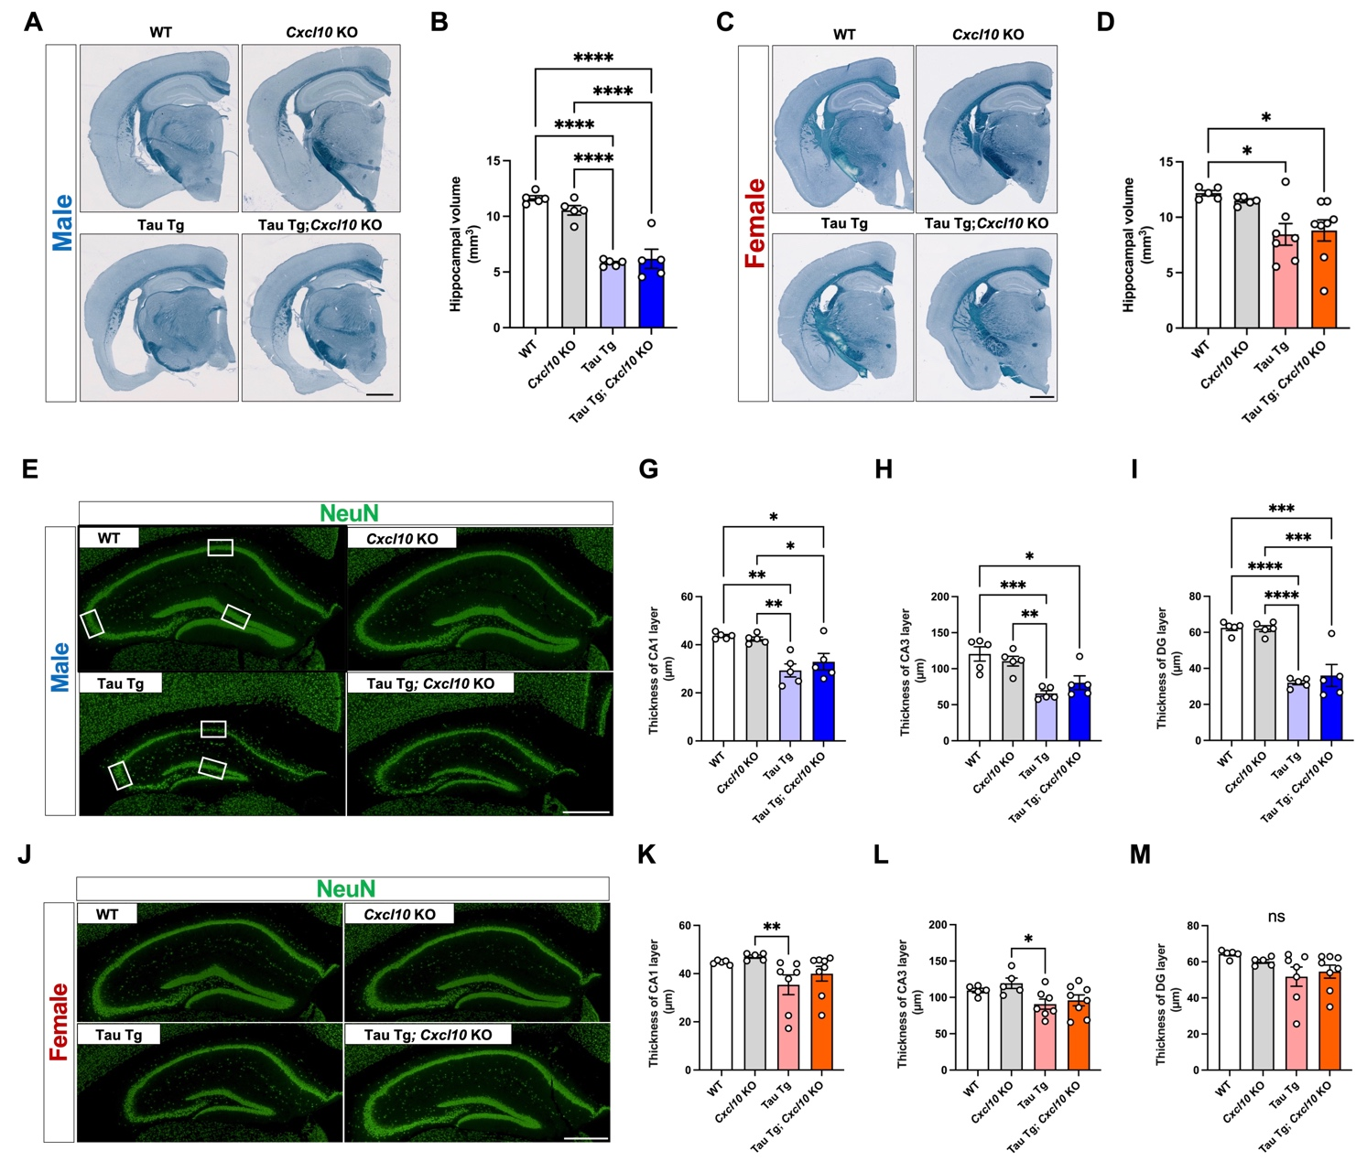

Supplementary Fig. 6 Effect of Cxcl10 deficiency on the brain atrophy, neurodegeneration, and behavior. (A, C) Representative images of brain atrophy in age-matched male (A) and female (C) mice of each genotype are shown. Scale bar = 1 mm. Bar graphs indicate the hippocampal volume in males (B) and females (D). Data are presented as mean ± S.E.M. (E, I) Representative images of NeuN-stained hippocampal sections from age-matched male (E) and female (I) mice of each genotype are shown. (E, J) The areas outlined by the white squares were defined as CA1, CA3, and DG in a blinded manner, and the thickness of neuronal layers within these regions was measured. Scale bar = 500 µm. Bar graphs show the thickness of the CA1 (male: F, female: J), CA3 (male: G, female: K), and dentate gyrus (DG) (male: H, female: L) layers in 11–12-month-old mice. Data are presented as mean ± S.E.M. Number of mice used: male WT (n = 5), male Cxcl10 KO (n = 5), male Tau Tg (n = 5), and male Tau Tg; Cxcl10 KO (n = 5). Female WT (n = 5), female Cxcl10 KO (n = 5), female Tau Tg (n = 7), and female Tau Tg; Cxcl10 KO (n = 8). Statistical analysis was performed using a one-way ANOVA followed by a Tukey’s multiple comparisons test (B, D, F, G, H, K and L) and a Kruskal-Wallis test followed by the Dunn’s multiple comparisons test (J).
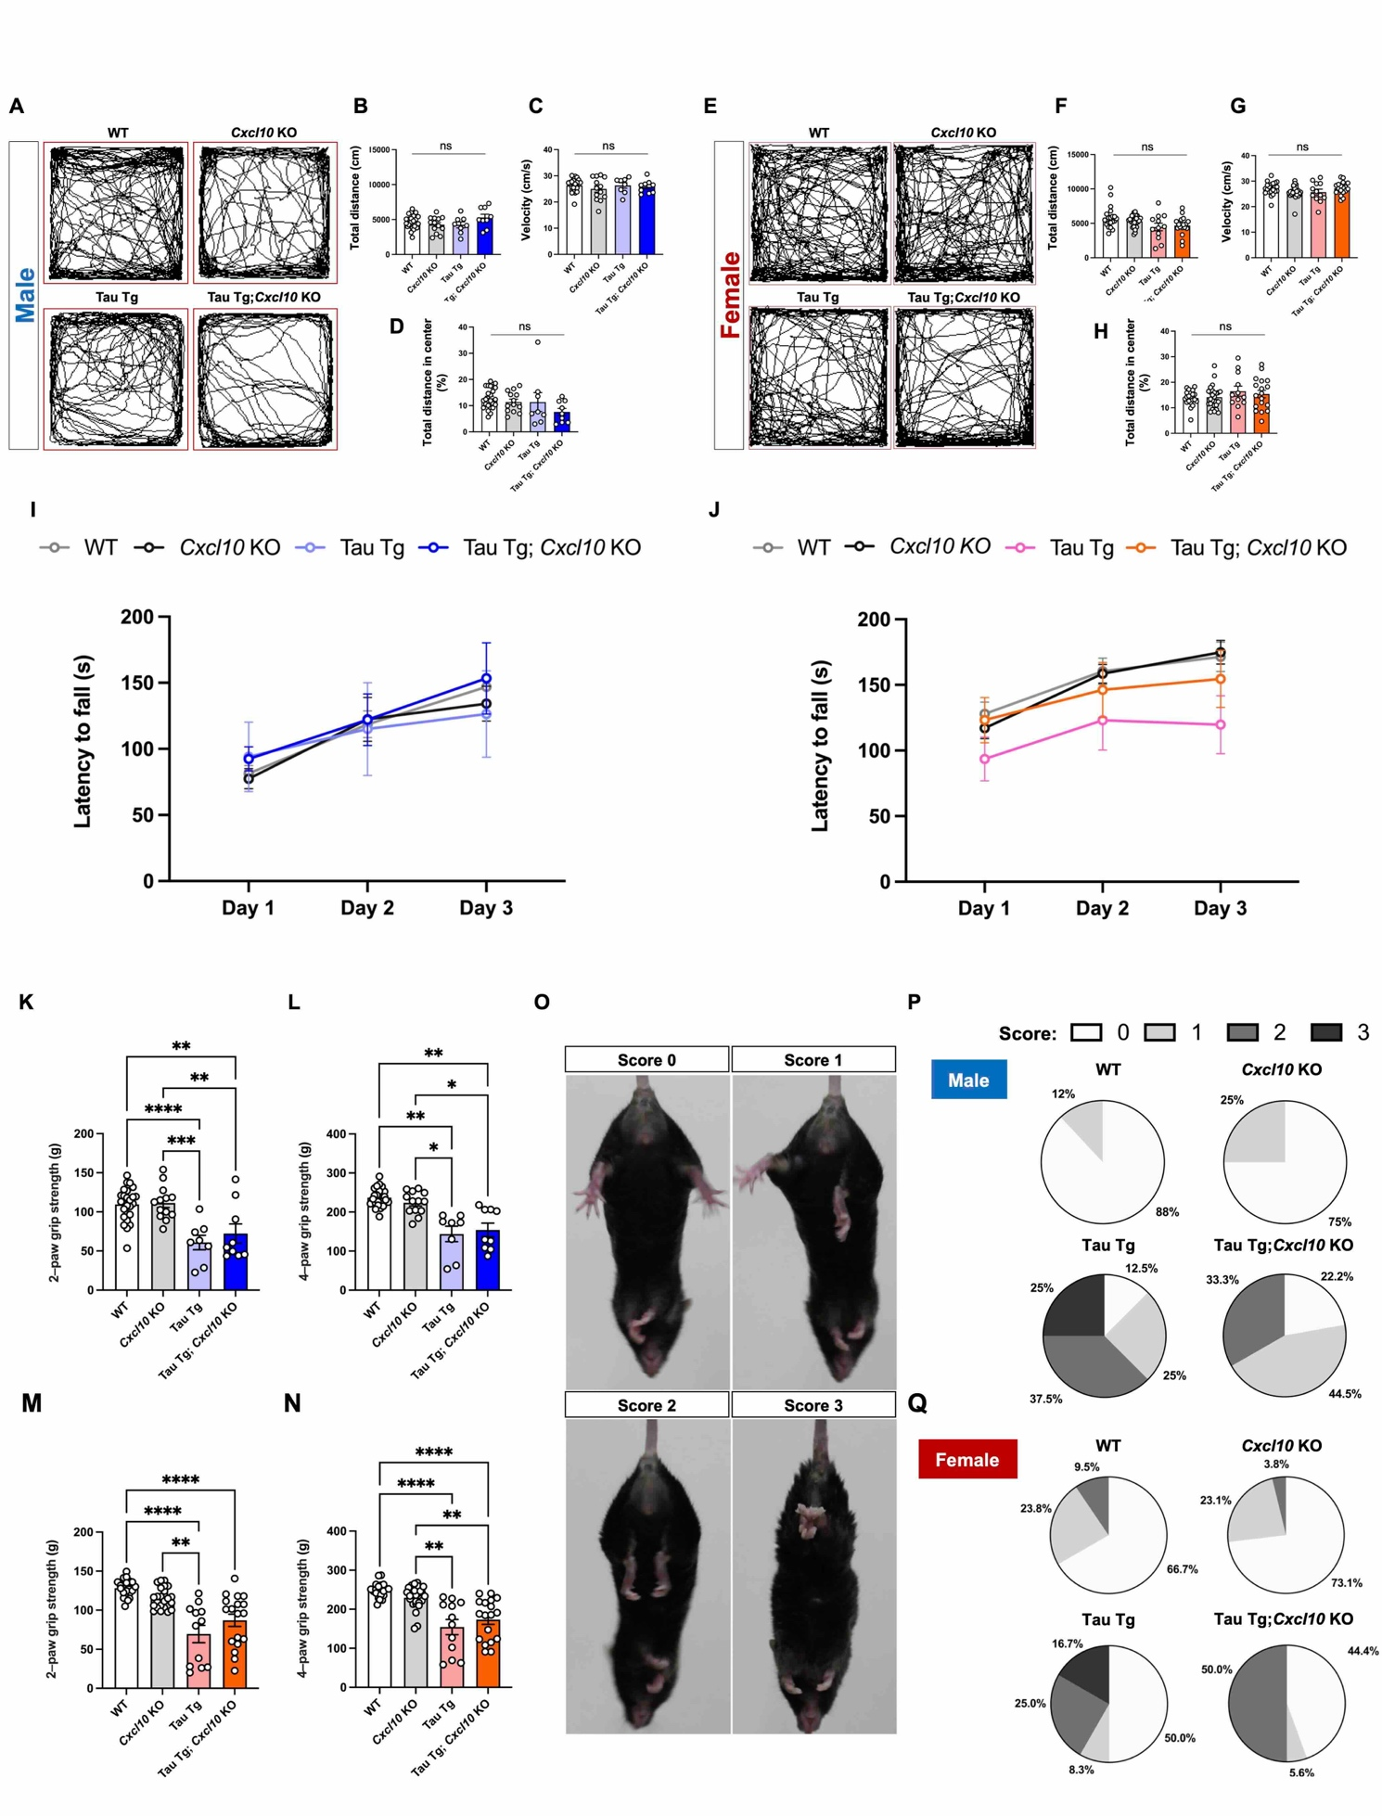

Supplementary Fig. 7 Behavioral assessment of tau pathology-associated 11–12-month-old Tau Tg mice with or without Cxcl10 deficiency. Representative trajectories from the open field test are shown for age-matched male (A) and female (E) mice of each genotype. (B–D, F–H) Bar graphs show total distance and velocity to assess motor function, while the total distance in the center area is used to evaluate anxiety-like behavior. (I, J) Graphs showing latency to fall for each genotype in mice of both sexes (I: male, J: female) as measured by the rotarod test. Data are presented as mean ± S.E.M. (K–N) Grip strength tests were conducted for male (K, L) and female (M, N) mice aged 11–12 months. Results for the two-paw test are shown in (K, M), and the four-paw test are shown in (L, N). Data are presented as mean ± S.E.M. Number of mice used: male WT (n = 25), male Cxcl10 KO (n = 13), male Tau Tg (n = 8), and male Tau Tg; Cxcl10 KO (n = 9). Female WT (n = 21), female Cxcl10 KO (n = 26), female Tau Tg (n = 12), and female Tau Tg; Cxcl10 KO (n = 18). Statistical analyses were performed using a one-way ANOVA followed by a Tukey’s multiple comparisons test (B–D, K), a Brown-Forsythe ANOVA test followed a Dunnett's T3 multiple comparisons test (L), a Kruskal-Wallis test followed by a Dunn’s multiple comparisons test (F–H, M, N), a mixed-effects analysis followed by a Šídák’s multiple comparisons test (I), and a mixed-effects analysis followed by a Tukey’s multiple comparisons test (J). (O) Representative images highlighting abnormalities observed in the hind limbs of age-matched mice. The pie charts show the proportion of each score for each genotype. Male (P); female (Q).

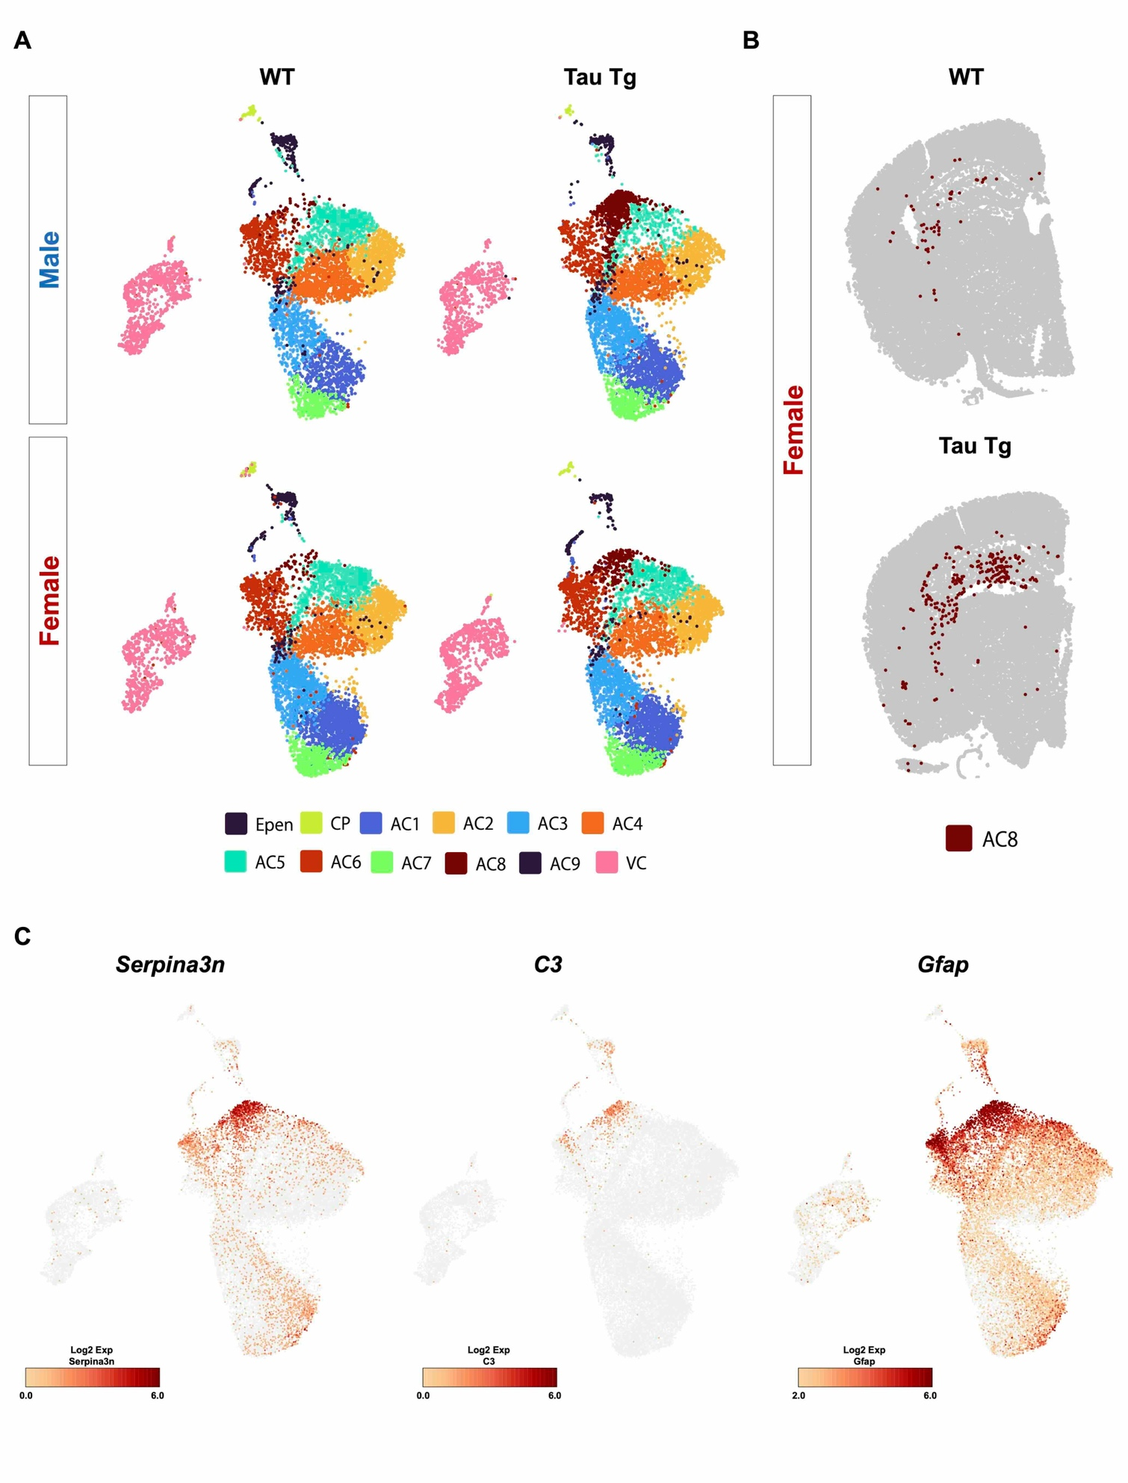

Supplementary Fig. 8 Characterization of AC8 clusters in the brains of Tau Tg mice. (A) Images classified by genotype and sex for re-clustering of astrocyte-ependymal cells (AC-Epen) cluster from Xenium data. The AC8 cluster was significantly present in the brains of Tau Tg mice regardless of the sex of the animals. (B) Cell localization of AC8 in WT and Tau Tg mouse brains. (C) Projection of selected marker genes for disease-associated astrocyte (Serpina3n, C3, Gfap) in uniform manifold approximation projection (UMAP) by Xenium data. Number of mice used: male WT (n = 1), male Tau Tg (n = 1), female WT (n = 1), and female Tau Tg (n = 1).
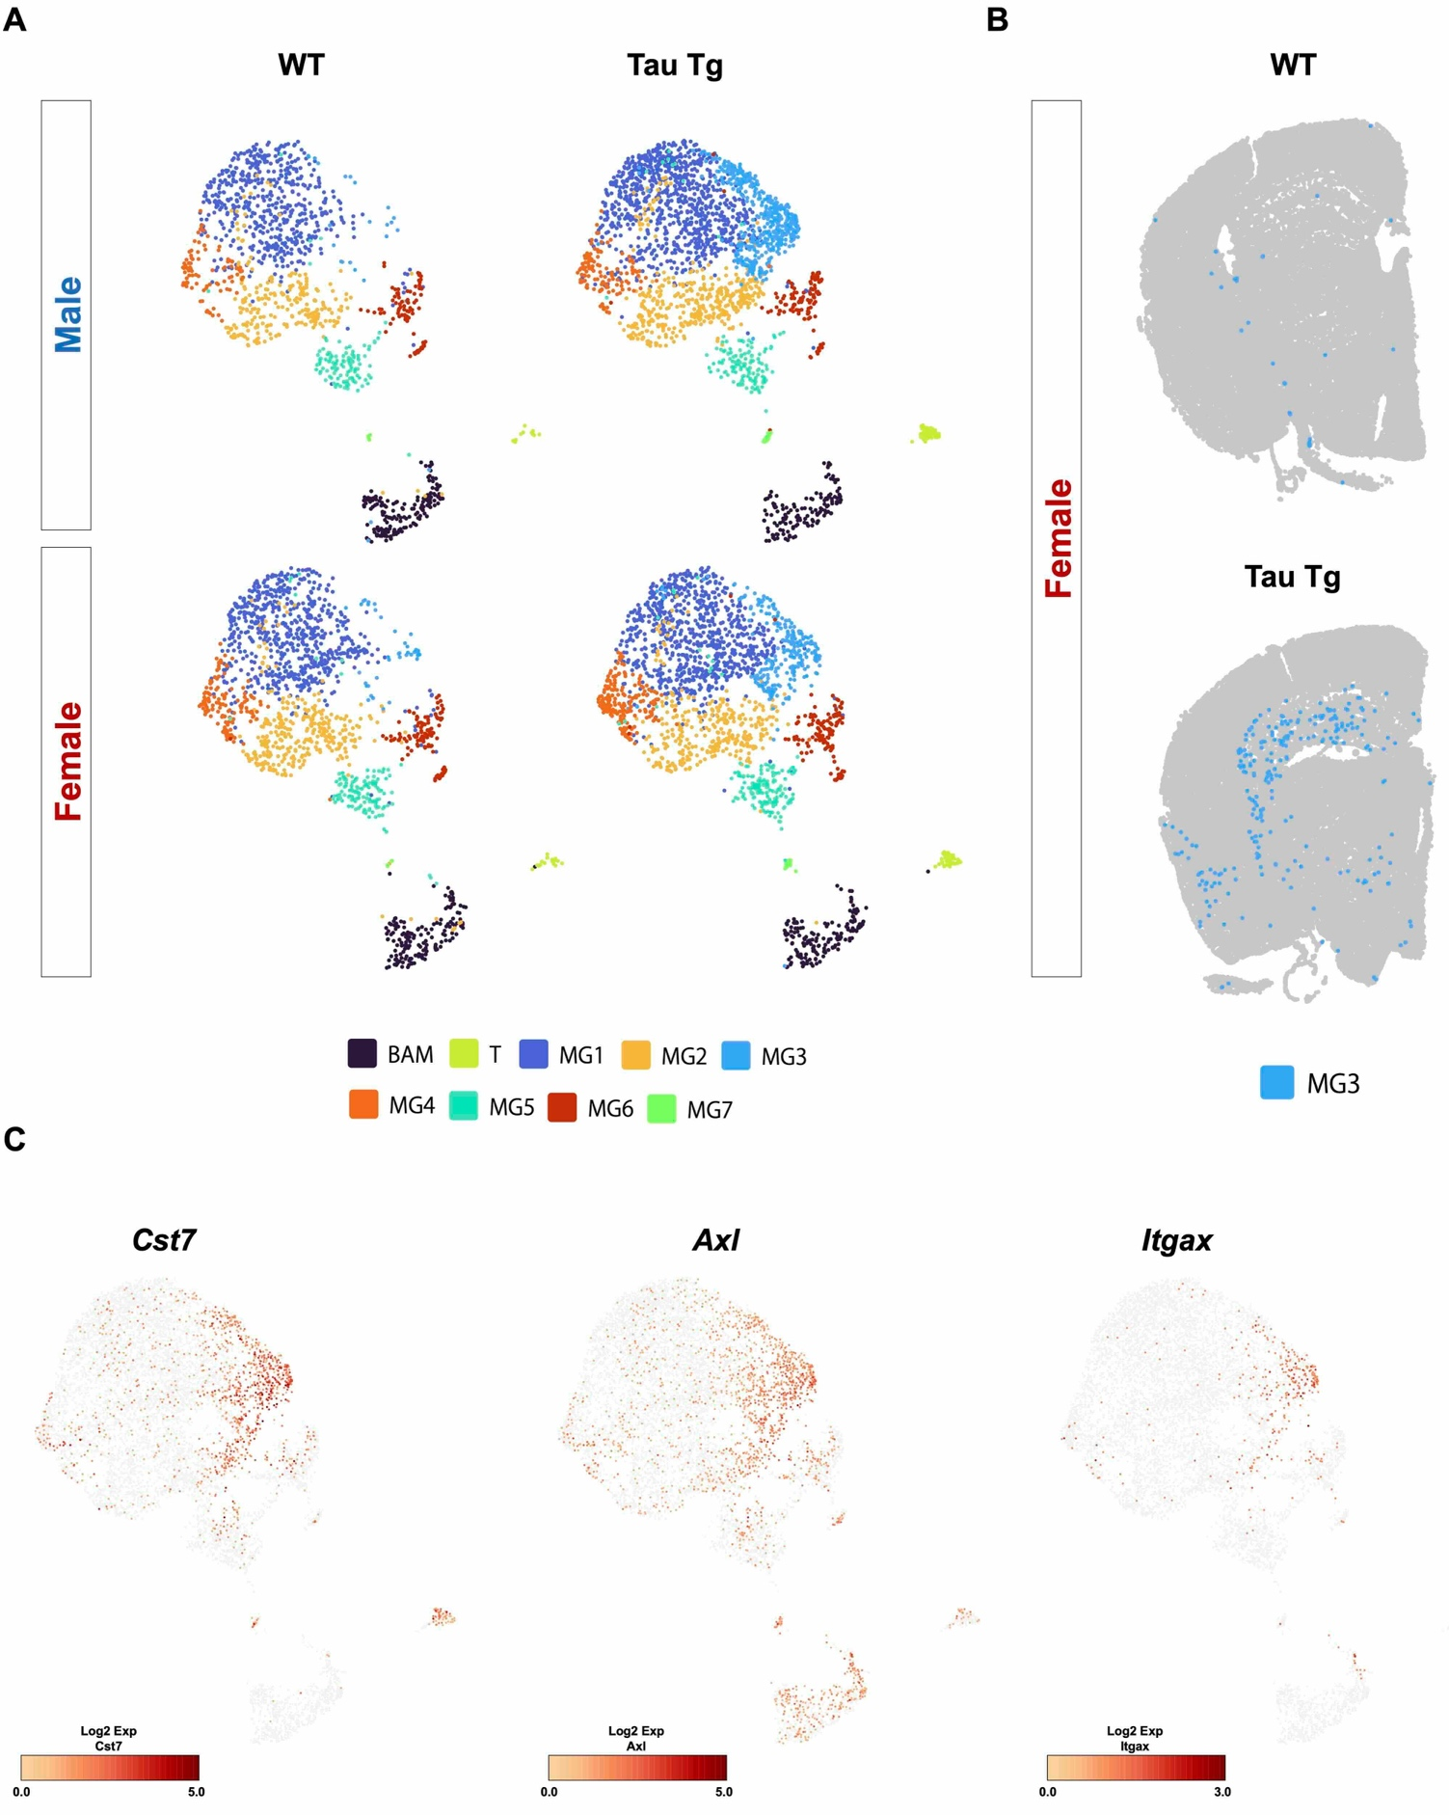

Supplementary Fig. 9 Characterization of MG3 clusters in the brains of Tau Tg mice. (A) Images classified by genotype and sex for re-clustering of microglia-immune (MG-immune) cluster from Xenium data. The Microglia 3 (MG3) cluster was significantly present in the brain of Tau Tg mice regardless of the sex of the animals. (B) Cell localization of MG3 in WT and Tau Tg mice brain. (C) Projection of selected marker genes for disease-associated microglia (Cst7, Axl, Itgax) in UMAP from Xenium data. Number of mice used: male WT (n = 1), male Tau Tg (n = 1), female WT (n = 1), and female Tau Tg (n = 1).

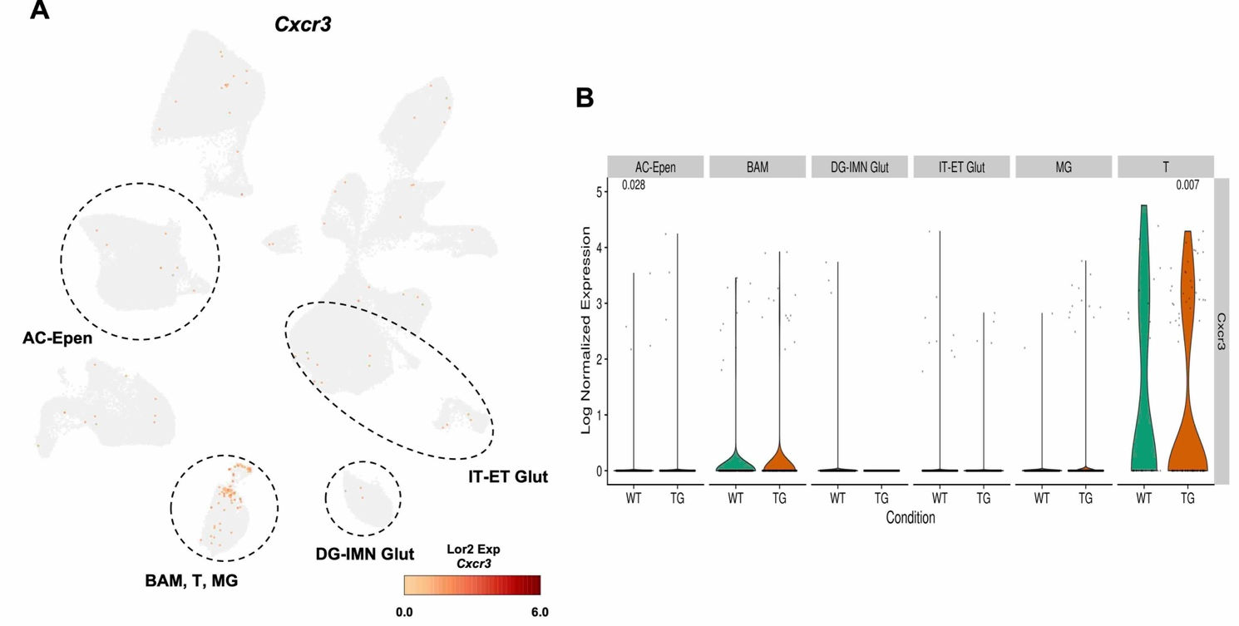
Supplementary Fig. 10 Identification of Cxcr3-expressing cells in the brains of WT and Tau Tg mice. (A) Representative C-X-C motif chemokine receptor 3 (Cxcr3) expressing cells in WT and Tau Tg mice. (B) Quantitative Cxcr3 gene expression shown by violin plots in AC-Epen, border-associated macrophages (BAM), DG-immature neurons (IMN) glutamatergic (Glut), intratelencephalic (IT)-extratelencephalic (ET) Glut, MG, and T cell (T) types. Statistical analysis was performed using the Wilcoxon test. Number of mice used: WT: male WT (n = 1), female WT (n = 1), TG: male Tau Tg (n = 1), female Tau Tg (n = 1).
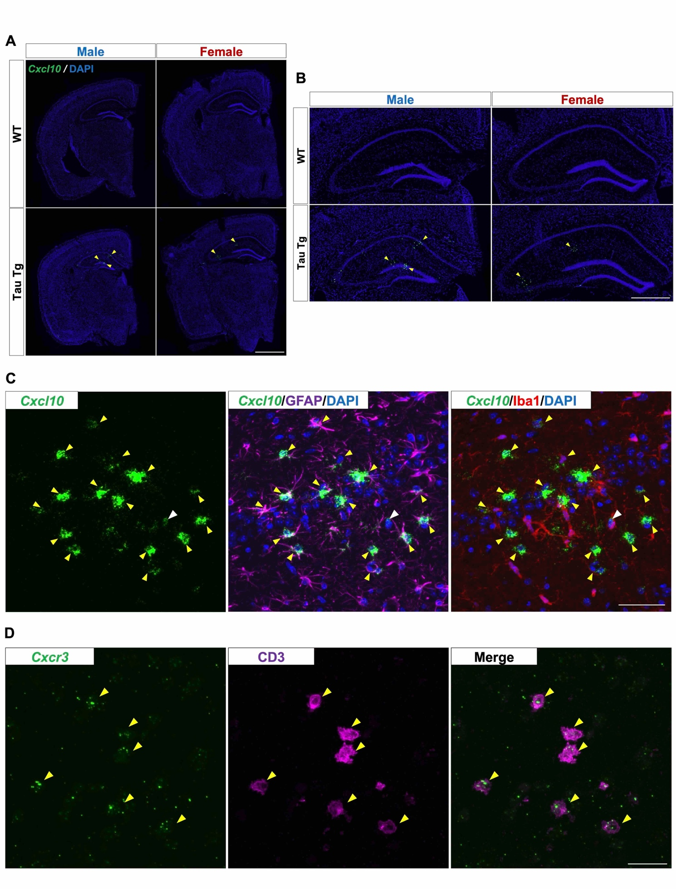

Supplementary Fig. 11 Validation of Cxcl10 and Cxcr3-expressing cells. (A) Image showing brain sections stained with RNAscope and DAPI from age-matched WT and Tau Tg mice of both sexes. Yellow arrowheads indicate Cxcl10⁺ cells. Scale bar = 1 mm. (B) Images showing enlarged views of the hippocampal sections from (A). Scale bar = 500 µm. Number of mice used: male WT (n = 1), male Tau Tg (n = 1), female WT (n = 1), and female Tau Tg (n = 1). (C, D) Images showing Cxcl10 mRNA- and Cxcr3 mRNA-positive cells in the hippocampus. Cxcl10 and Cxcr3 mRNA were detected using RNAscope probes, while GFAP (an astrocyte marker), Iba1 (a microglial marker), and CD3 (a T cell marker) were identified using Anti-GFAP, Anti-Iba1, and Anti-CD3 antibodies, respectively. The yellow and white arrowheads highlight double-immunopositive cells for Cxcl10 mRNA and GFAP or Iba1, respectively in (C), and Cxcr3 mRNA and CD3 in (D). Scale bar = 50 (C) and 20 µm (D). Number of mice used: male Tau Tg (n = 1).

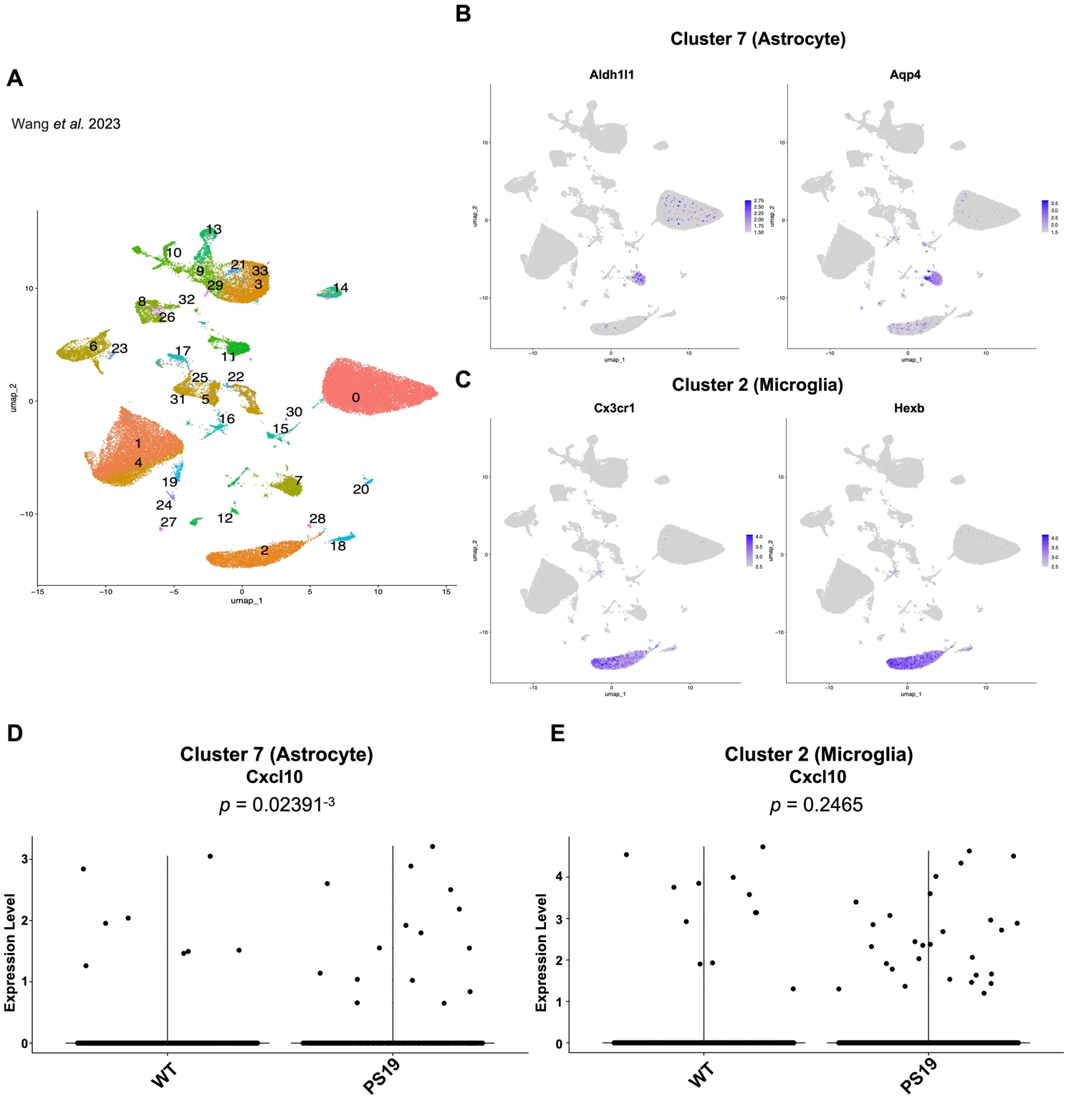

Supplementary Fig. 12 Re-analysis of snRNA-seq datasets to identify Cxcl10-expressing cell types in tauopathy mouse model. (A–E) Re-analysis of the single-nucleus RNA sequencing (snRNA-seq) dataset (GSE218728), including samples from three PS19 and three WT mice. (A) UMAP plot showing individual clusters of single nuclei from hippocampus. (B, C) Astrocytic (B) and microglial (C) clusters were identified using canonical markers. (D, E) Quantitative Cxcl10 gene expression shown by violin plots in cluster 7 (Astrocyte) and cluster 2 (Microglia). Statistical analysis was performed using the Wilcoxon test. Number of mice used: male WT (n = 2), male PS19 (n = 2), female WT (n = 1), and female PS19 (n = 1).
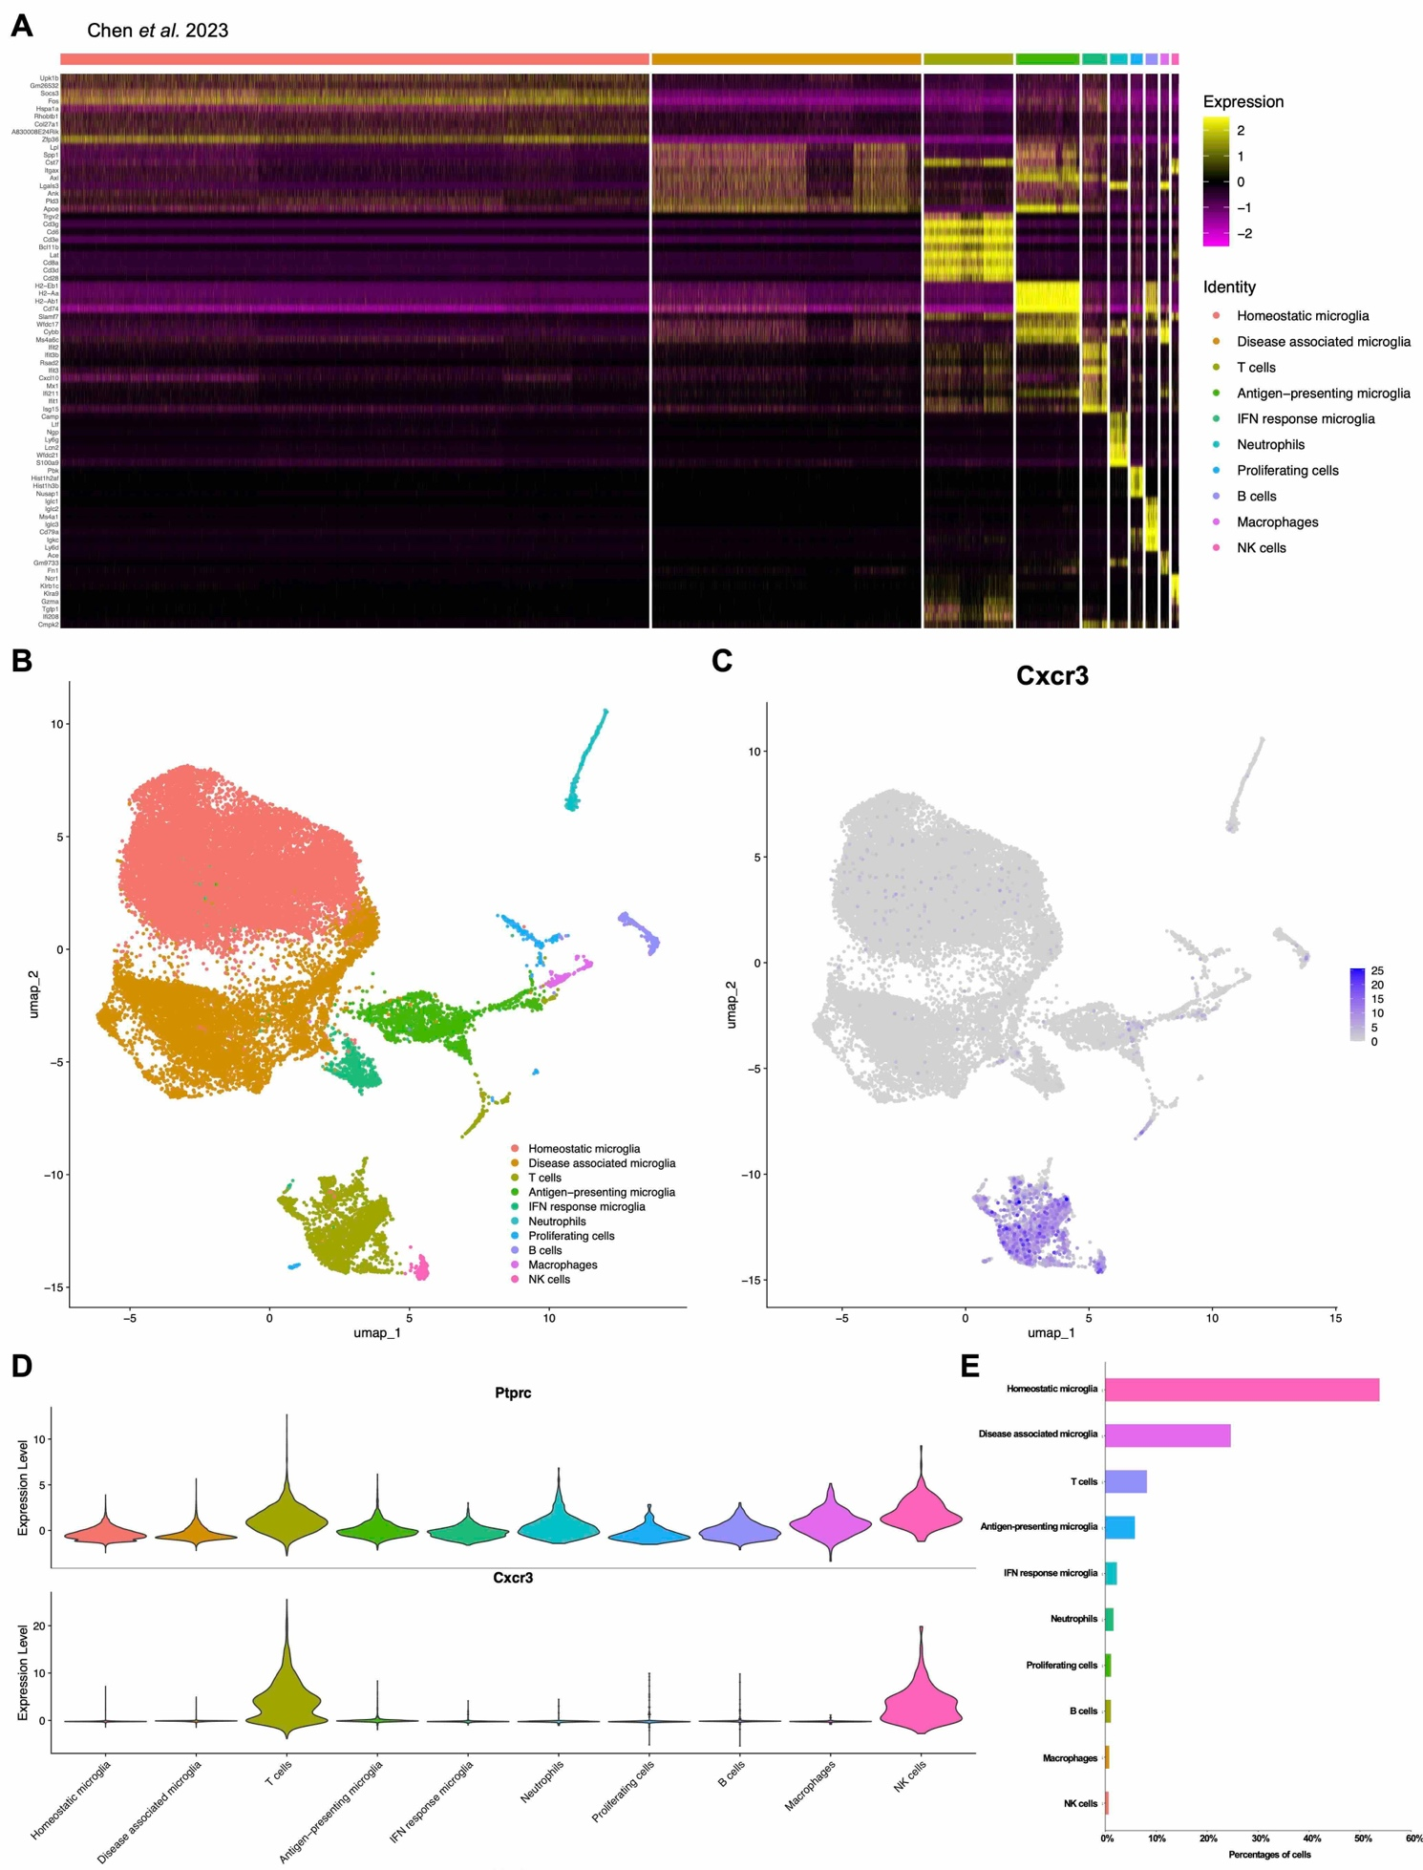

Supplementary Fig. 13 Re-analysis of scRNA-seq datasets to identify Cxcr3-expressing cell types in tauopathy mouse model. (A–D) Re-analysis of the single-cell RNA-seq (scRNA-seq) dataset (GSE221856) from CD45⁺-sorted cells in TE4 and E4 mice. (A) The top 10 genes upregulated in each cluster are shown in heatmap. (B) Immune cells categorized as CD45⁺ from TE4 and E4 mice were classified into eight distinct cell types, as illustrated by UMAP plots. These eight cell types were identified based on unique gene expression patterns. (C) Representative mRNA expression patterns of Cxcr3 in TE4 and E4 mice by Feature plot. (D) Violin plot illustrating cell clusters expressing Ptprc and Cxcr3. (E) Bar graph showing the percentage of each cell type in TE4 and E4 mice. Number of mice used: male E4 (n = 2), male TE4 (n = 2).

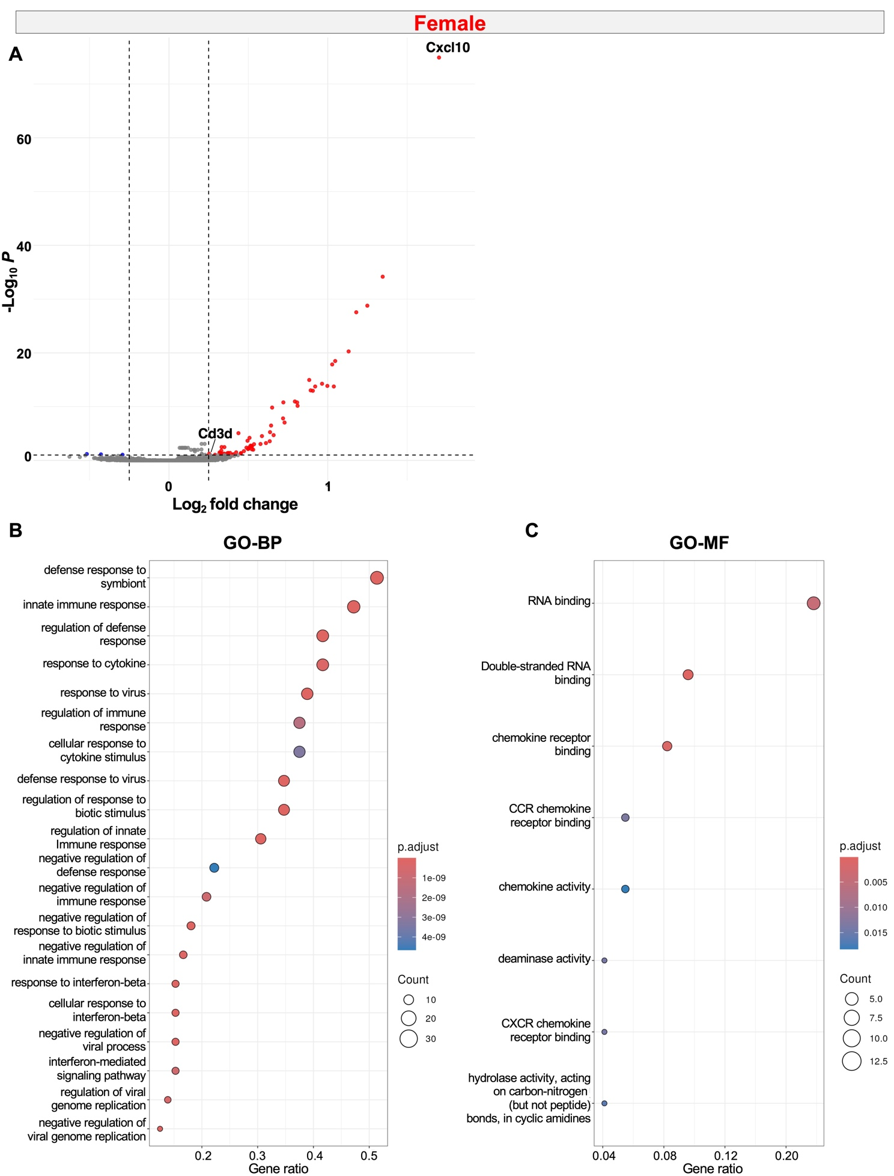
Supplementary Fig. 14 Characterization of cells neighboring Cxcl10⁺ astrocytes in female Tau Tg mice. (A) Volcano plot illustrates |log₂ fold change| > 0.25 and padj < 0.1 highlighted in red, |log₂ fold change| < 0.25 and padj < 0.1 shown in blue. All other transcripts are indicated in gray. The analysis included 303 Cxcl10＋ astrocytes and 5,208 Cxcl10⁻ astrocytes. (B, C) GO pathway analysis focusing on BP and MF was performed to compare cells neighboring Cxcl10⁺ astrocytes with those neighboring Cxcl10⁻ astrocytes in female Tau Tg mice. The top 20 significantly upregulated pathways in cells neighboring Cxcl10⁺ astrocytes are shown in each panel. Number of mice used: female Tau Tg (n = 1). (A–C) DEGs were identified using the Wilcoxon test, and GO analysis was evaluated via over-representation analysis employing the hypergeometric test. GO term enrichment analysis was performed using up to the top 500 upregulated or downregulated genes (padj ≤ 0.05).
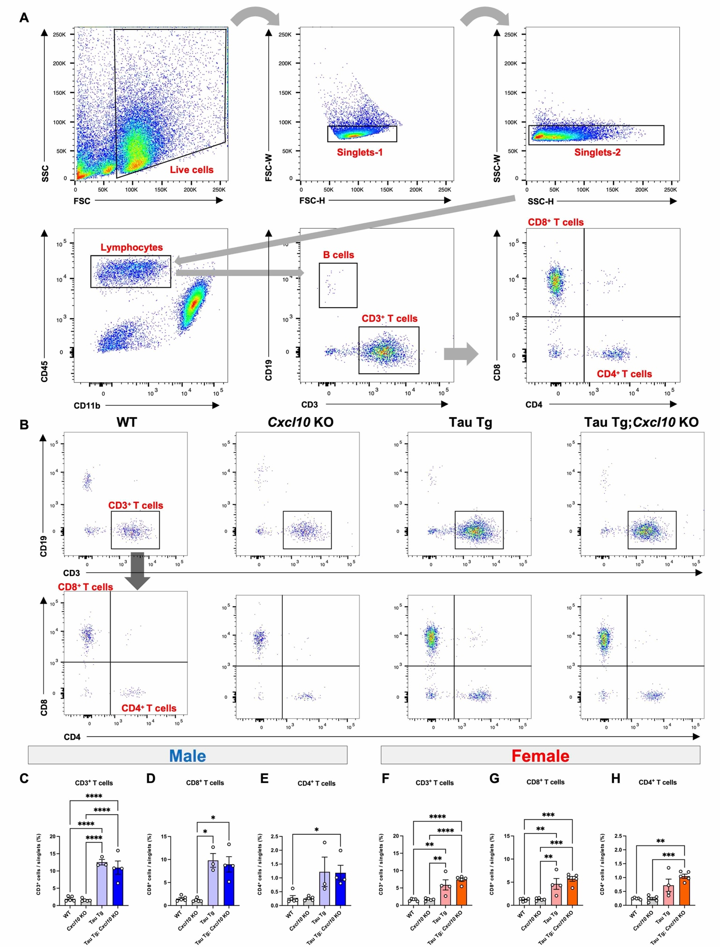
Supplementary Fig. 15 Flow cytometric analysis of T cells in the brain. (A) Sequential gating was performed to identify live cells and singlets, followed by gating for CD45⁺ CD11b⁻ cells. CD19⁺ B cells and CD3⁺ T cells were further classified. Within the CD3⁺ cell population, CD4⁺ and CD8⁺ T cells were identified. (B) Representative gating plots of CD3⁺, CD4⁺, and CD8⁺ T cells in the brains of mice by from each genotype. (C–H) Quantification of single-cell populations: CD3⁺ T cells (C: male, F: female), CD8⁺ T cells (D: male, G: female), and CD4⁺ T cells (E: male, H: female). Data are presented as mean ± S.E.M. Number of mice used: male WT (n = 5), male Cxcl10 KO (n = 5), male Tau Tg (n = 3), and male Tau Tg; Cxcl10 KO (n = 4). Female WT (n = 5), female Cxcl10 KO (n = 5), female Tau Tg (n = 4), and female Tau Tg; Cxcl10 KO (n = 5). Statistical analyses were performed using a one-way ANOVA followed by Tukey’s multiple comparisons test (C, F, G) a Brown-Forsythe ANOVA test followed by Dunnett's T3 multiple comparisons test (H), and a Kruskal-Wallis test followed by Dunn’s multiple comparisons test (D, E).

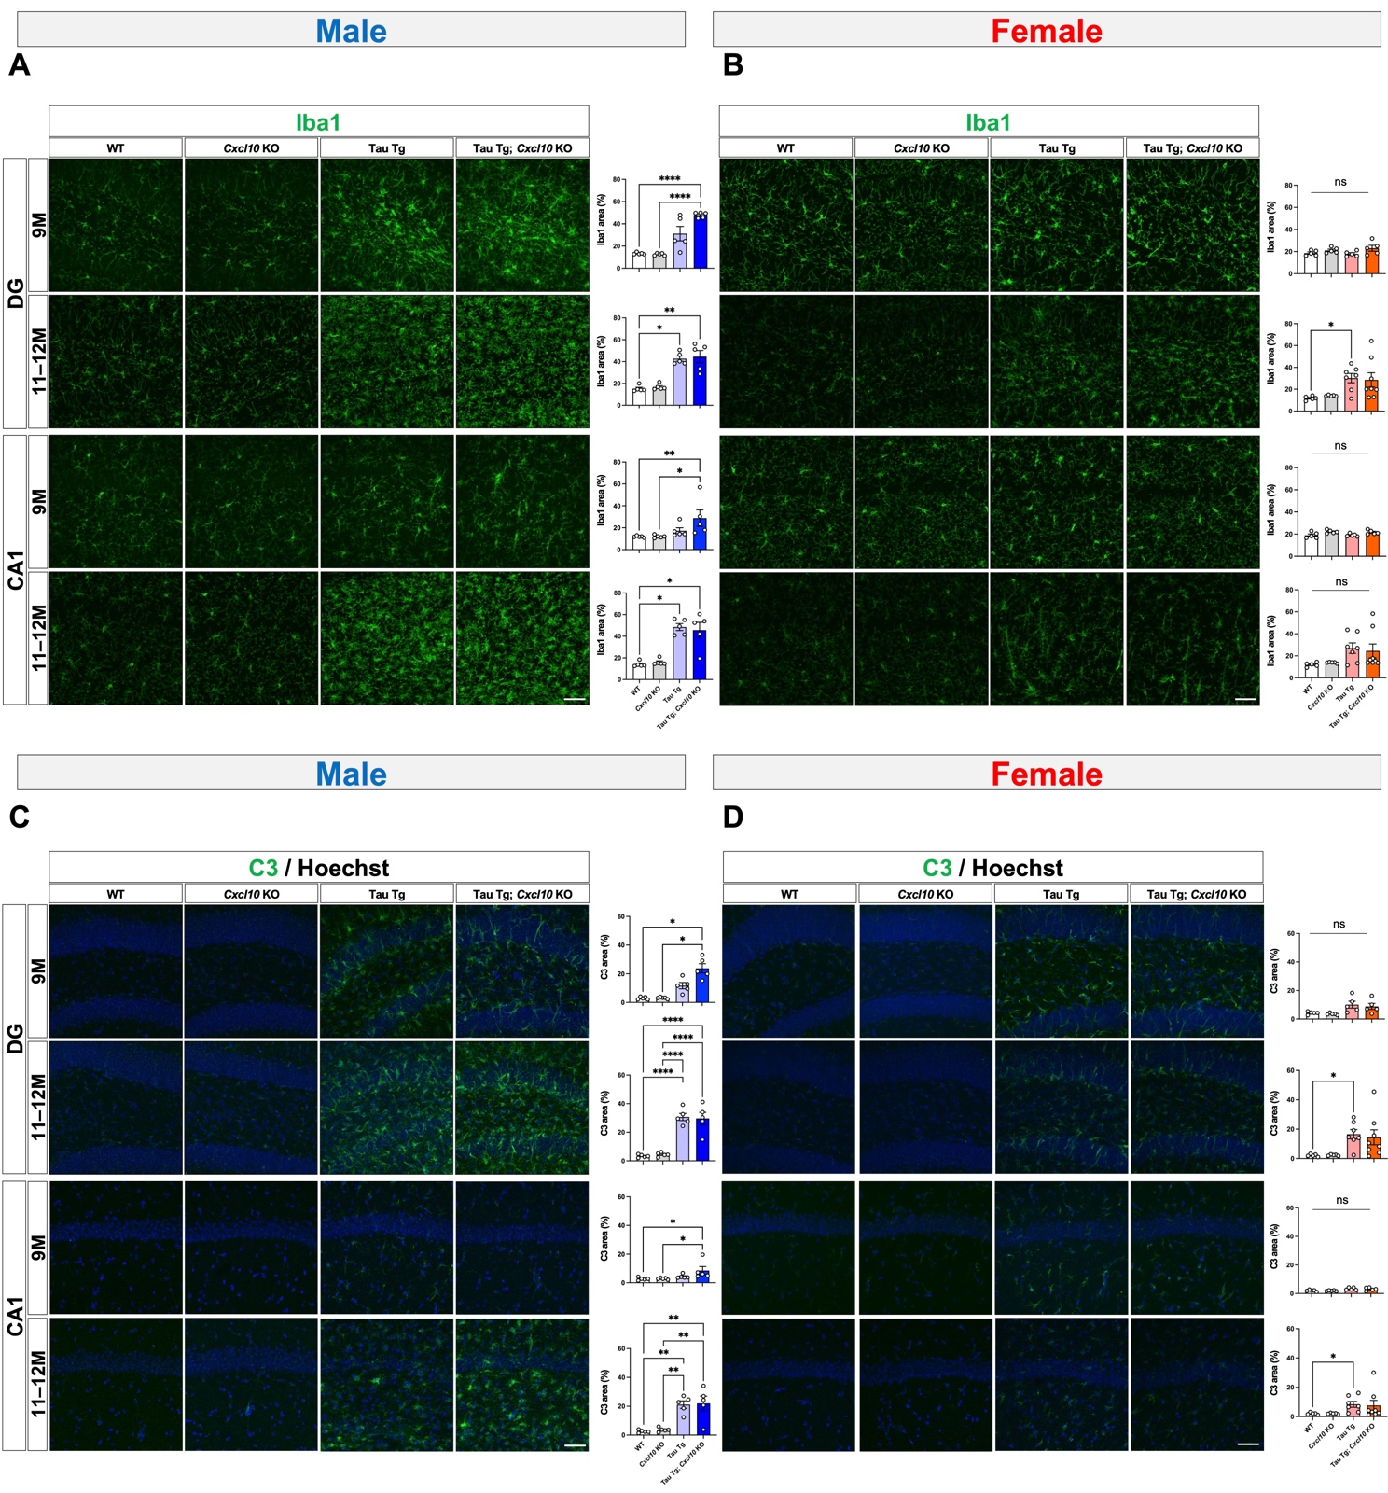

Supplementary Fig. 16 Immunohistochemical analysis of microglia and astrocytes in 9- and 11–12-month-old mice. (A–D) Representative images of brain sections stained with anti-Iba1 (A, B) and anti-C3 (C, D) in the DG and CA1 regions of 9- or 11–12-month-old mice (A, C male; B, D female). Scale bar = 500 μm. Bar graphs represent the quantified percentage of the image area that is positive for Iba1 or C3. Male and female samples were processed in separate batches. Data are presented as mean ± S.E.M. Number of mice used: male WT (n = 5), male Cxcl10 KO (n = 5), male Tau Tg (n = 5), and male Tau Tg; Cxcl10 KO (n = 5). Female WT (n = 5), female Cxcl10 KO (n = 5), female Tau Tg (n = 7), and female Tau Tg; Cxcl10 KO (n = 8). Statistical analyses were performed using a one-way ANOVA followed by Tukey’s multiple comparisons test (B-9M-DG, B-9M-CA1, C-11–12M-DG, C-11–12M-CA1, D-9M-DG, D-9M-CA1), a Brown-Forsythe ANOVA test followed by Dunnett's T3 multiple comparisons test (A-9M-DG, C-9M-DG), and a Kruskal-Wallis test followed by Dunn’s multiple comparisons test (A-9M-CA1, A-11–12M-DG, A-11–12M-CA1, B-11–12M-DG, B-11–12M-CA1, C-9M-CA1, D-11–12M-DG, D-11–12M-CA1).


Supplementary Fig. 17 Investigating the localization of BAMs in mouse brain tissue. Images illustrating the localization of BAMs in brain sections used for the Xenium analysis. Number of mice used: male WT (n = 1), male Tau Tg (n = 1), female WT (n = 1), female Tau Tg (n = 1).

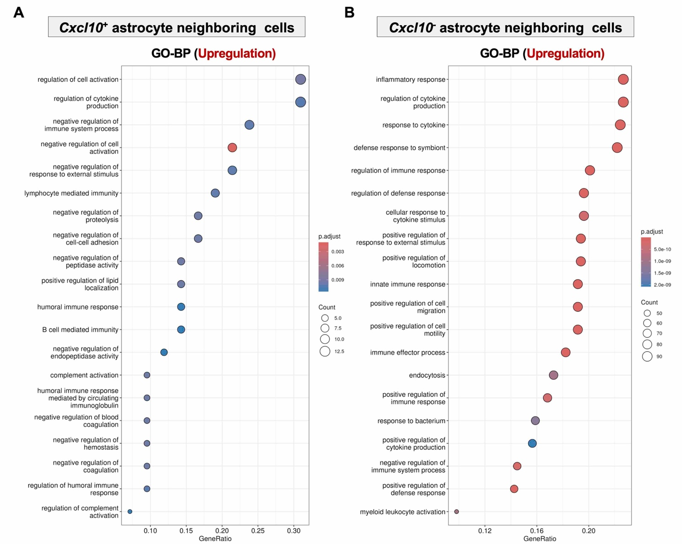
Supplementary Fig. 18 Pathway analysis of sex-dependent differences in gene expression in cells neighboring Cxcl10⁺ or Cxcl10⁻ astrocytes in Tau Tg mice. (A, B) Genes expressed in cells neighboring Cxcl10⁺ astrocytes in females were used as the baseline to identify differential expression in the corresponding male condition, followed by BP pathway of GO analysis (A). The same analytical framework was applied to Cxcl10⁻ astrocytes (B). The top 20 significantly upregulated pathways in cells neighboring Cxcl10⁺ astrocytes (A) and Cxcl10⁻ astrocytes (B) in males are shown in each panel. Number of mice used: male Tau Tg (n = 1), female Tau Tg (n = 1). (A, B) DEGs were identified using the Wilcoxon test, and GO analysis was evaluated via over-representation analysis employing the hypergeometric test. GO term enrichment analysis was performed using up to the top 500 upregulated or downregulated genes (padj ≤ 0.05).
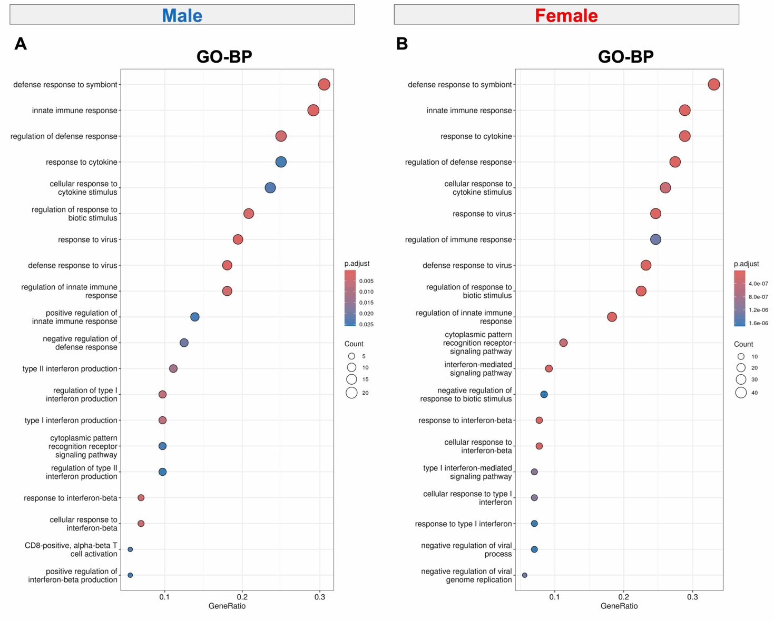
Supplementary Fig. 19 Pathway analysis to investigate characterization of Cxcl10⁺ astrocytes in the brains of Tau Tg mice. (A) GO pathway analysis focusing on BP was performed to compare Cxcl10⁺ astrocytes with Cxcl10⁻ astrocytes in Tau Tg mice. The top 20 significantly upregulated pathways in male (A) and female (B) mice are shown in each panel. Number of mice used: male Tau Tg (n = 1), female Tau Tg (n = 1). (A, B) DEGs were identified using the Wilcoxon test, and GO analysis was evaluated via over-representation analysis employing the hypergeometric test. GO term enrichment analysis was performed using up to the top 500 upregulated or downregulated genes (padj ≤ 0.05).

