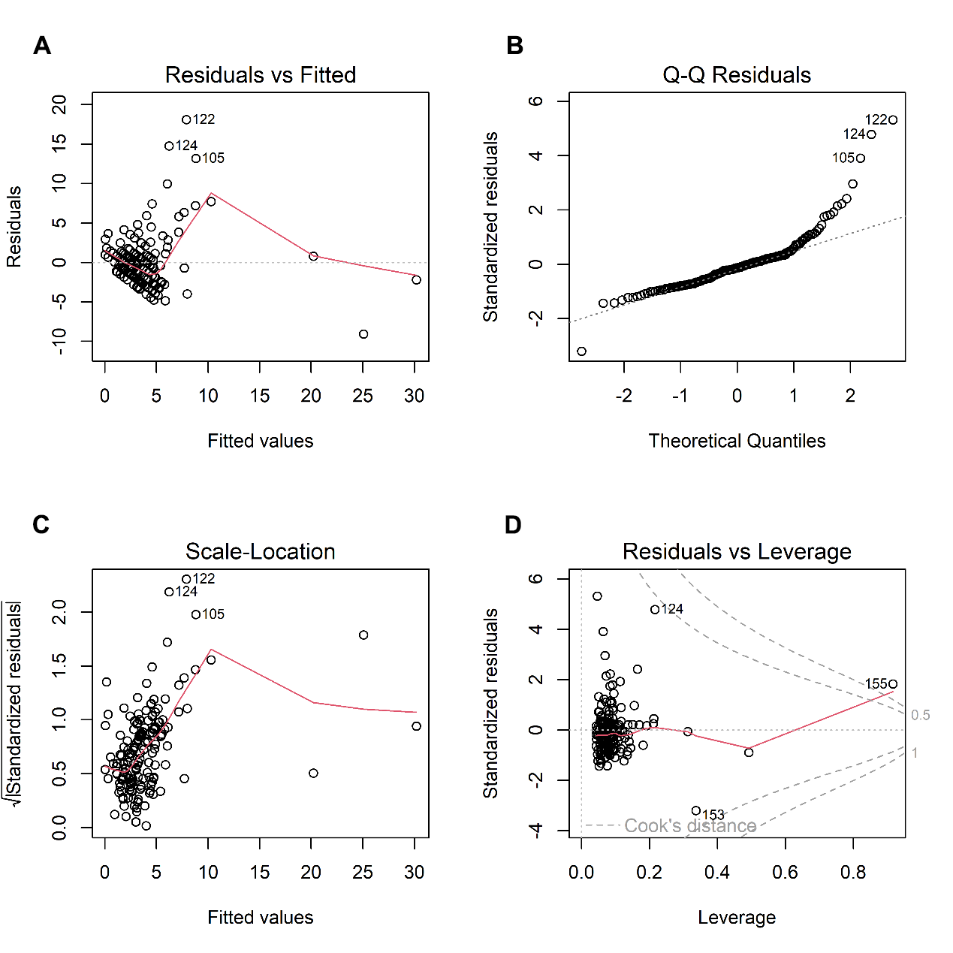
Figure S1 Diagnostic plots for the multiple linear regression model. (A) Residuals vs. fitted values. The random scatter of residuals around zero confirms a linear relationship between NIHSS scores and the predictors. (B) Normal Q-Q plot. The close alignment of points with the theoretical line indicates normally. (C) Scale-Location plot. The constant spread of residuals across fitted values supports the homoscedasticity assumption. (D) Residuals vs. leverage plot. Most data points are in the low-leverage region, with all Cook’s distance values below 0.5, confirming the absence of unduly influential observations.

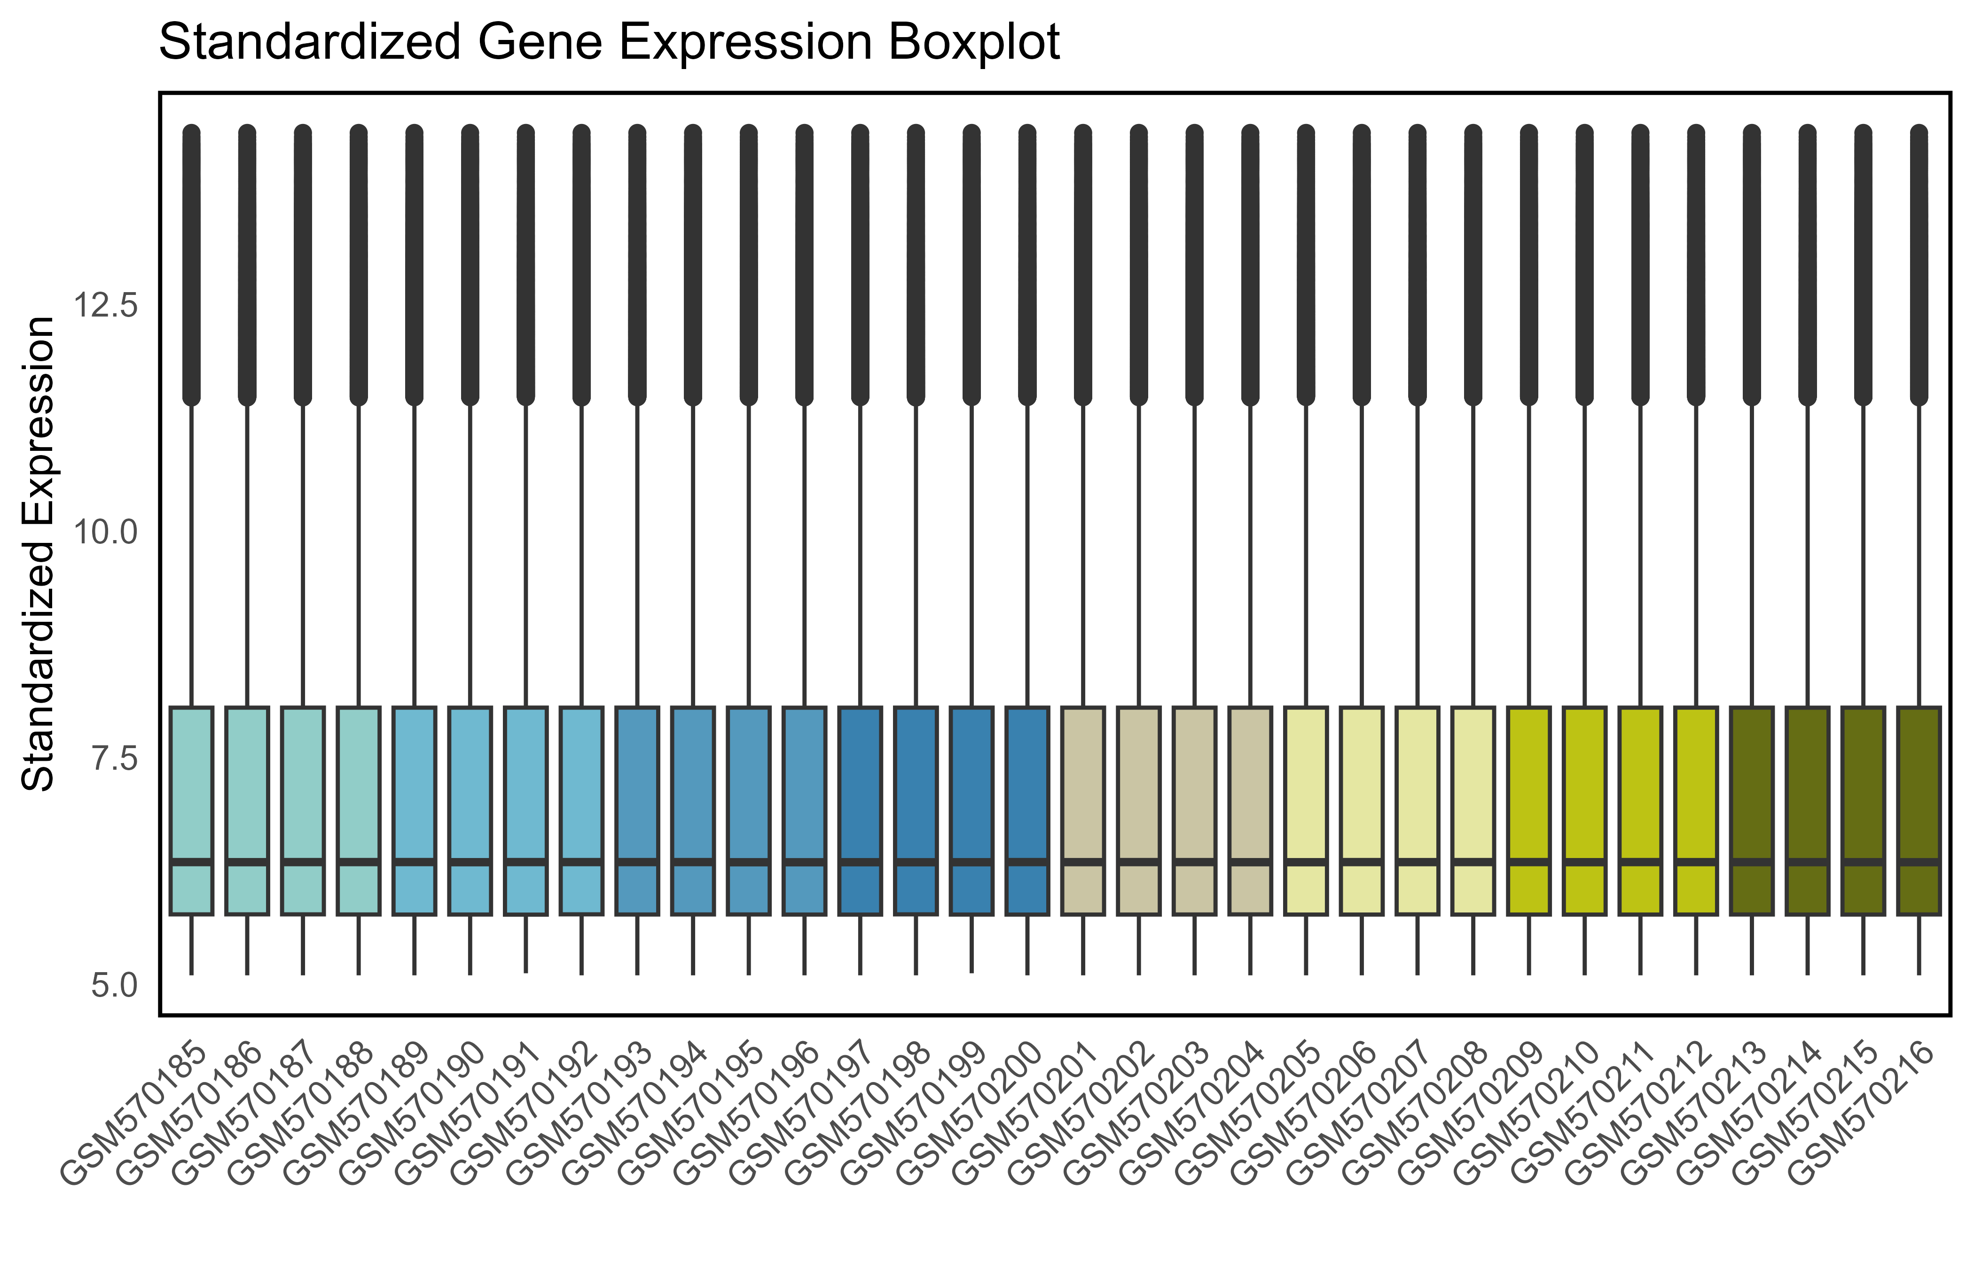Figure S2 Expression distribution of the normalized GSE23160 dataset.

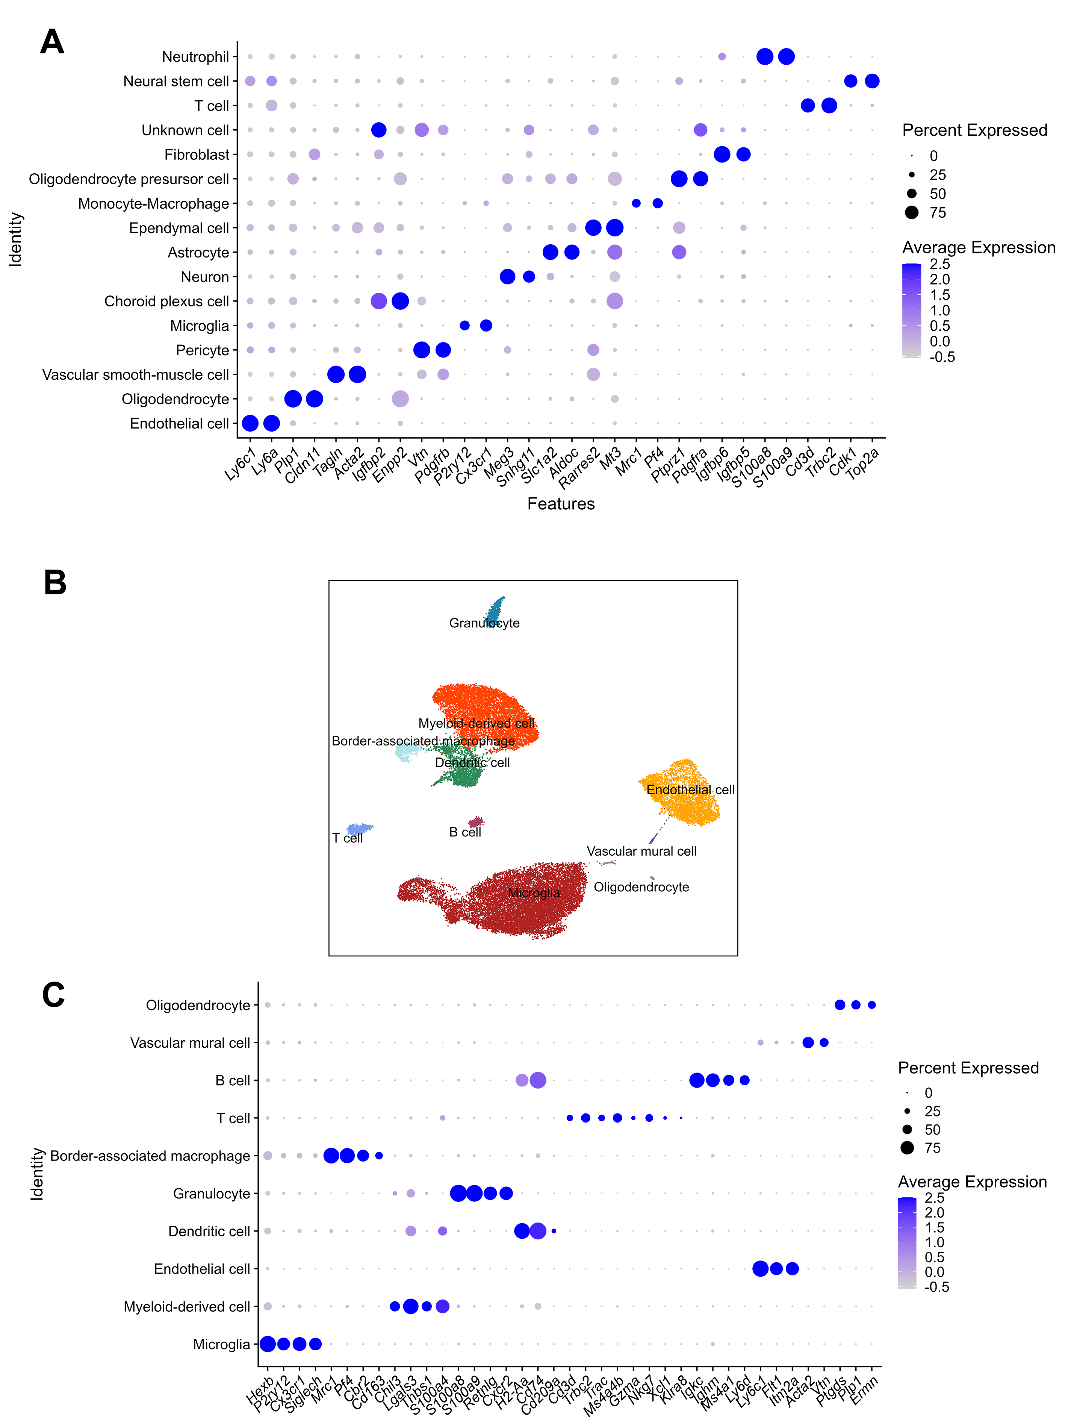
Figure S3 Cell type annotation markers for single-cell RNA sequencing datasets. (A) Dot plot displaying canonical marker genes used for cell type identification in dataset GSE227651. (B) UMAP visualization of the cellular landscape in mouse brain from dataset GSE225948. (C) Dot plot displaying canonical marker genes used for cell type identification in dataset GSE225948.
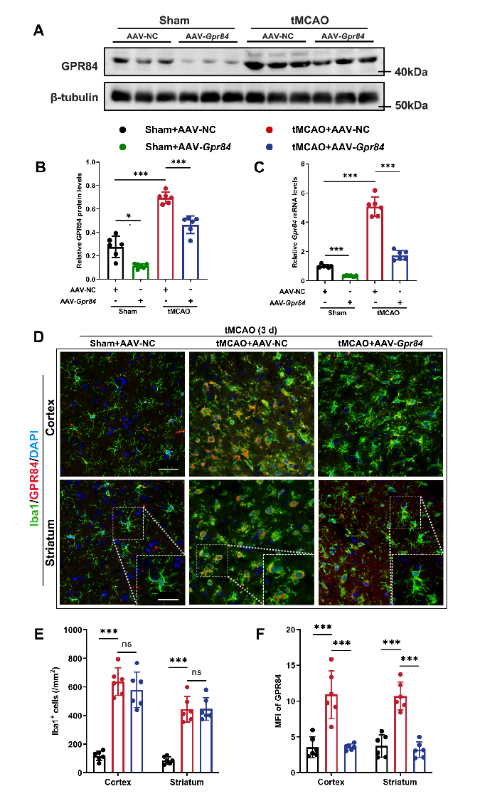
Figure S4 Intracerebroventricular AAV delivery effectively knocks down GPR84 in brain tissue. (A) Immunoblotting analysis of GPR84 protein expression in the peri-infarct region. (B) Quantification of GPR84 protein levels from (A). Data are mean ± SEM (n = 6). **P < 0.01, ***P < 0.001, two-way ANOVA. (C) RT-qPCR analysis of Gpr84 mRNA levels in the peri-infarct area. Data are mean ± SEM (n = 6). *P < 0.05, ***P < 0.001, two-way ANOVA. (D) Representative immunofluorescence images showing GPR84 (red) co-localized with Iba1⁺ microglia (green) in the peri-infarct region at 3 days post-tMCAO. Bar = 50 μm, Bar = 10 μm (higher-magnification images). (E) Quantification of Iba1⁺ microglia density in the ischemic areas from (D). Data are mean ± SEM (n = 6). ***P < 0.001, one-way ANOVA. (F) Quantification of GPR84 mean fluorescence intensity (MFI) in Iba1⁺ microglia from (D). Data are mean ± SEM (n = 6). ***P < 0.001, one-way ANOVA.

Figure S5 Representative triple-staining image from contralateral brain tissue as negative control. NeuN served as a neuronal marker, Iba1 to identify microglia, and TUNEL staining to detect damaged apoptotic cells. Bar = 50 μm. Rare TUNEL⁺ neurons were found in contralateral brain regions.

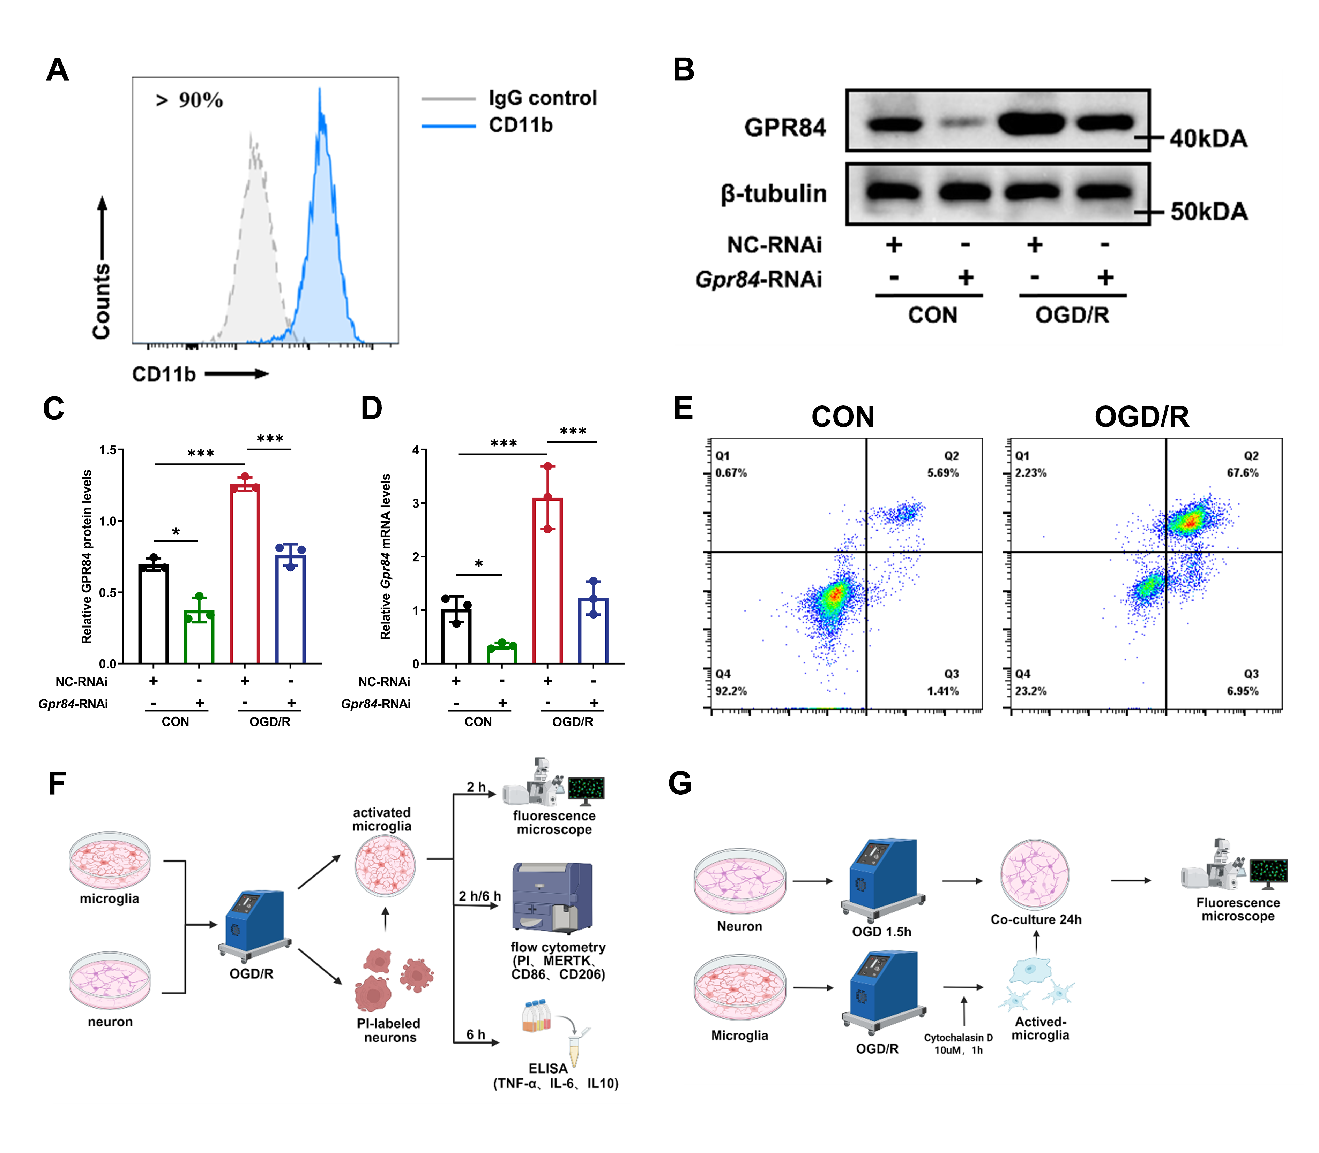
Figure S6 GPR84 Knockdown Validation and In Vitro Efferocytosis Assay. (A) Flow cytometry analysis confirming > 90% purity of cultured microglia (CD11b⁺ cells). (B) Immunoblotting of GPR84 protein expression under various treatments. (C) Quantification of GPR84 protein levels from (B). Data are mean ± SEM (n = 3). **P < 0.01, ***P < 0.001, two-way ANOVA. (D) RT-qPCR analysis of Gpr84 mRNA levels under various treatments. Data are mean ± SEM (n = 3). *P < 0.05, ***P < 0.001, two-way ANOVA. (E) Annexin V/PI staining showing ~70% neuronal apoptosis after OGD/R. (F) Schematic of the efferocytosis assay workflow. (G) Design of the microglia-neuron co-culture system.

