Clostridioides difficile colitis promotes neuroinflammatory responses in the prefrontal cortex: a preclinical study in mice

Deiziane V.S. Costa^{1*†}, Suemin E. Yang^{1†}, G. Brett Moreau¹, Nick R. Natale^{1,2}, Jae Hyun Shin³, Cirle A. Warren^{1*}

† Equal contribution

¹Division of Infectious Diseases and International Health, University of Virginia, Charlottesville, Virginia, USA.

²Center for Brain Immunology and Glia (BIG), Department of Neuroscience, University of Virginia, Charlottesville, USA.

³Infectious Disease, Hoag Memorial Hospital Presbyterian, Newport Beach, California, USA.

*Correspondence and requests for materials should be addressed to Deiziane V. S. Costa (dv2t@virginia.edu) or Cirle A. Warren (ca6t@virginia.edu).

Fig. S1
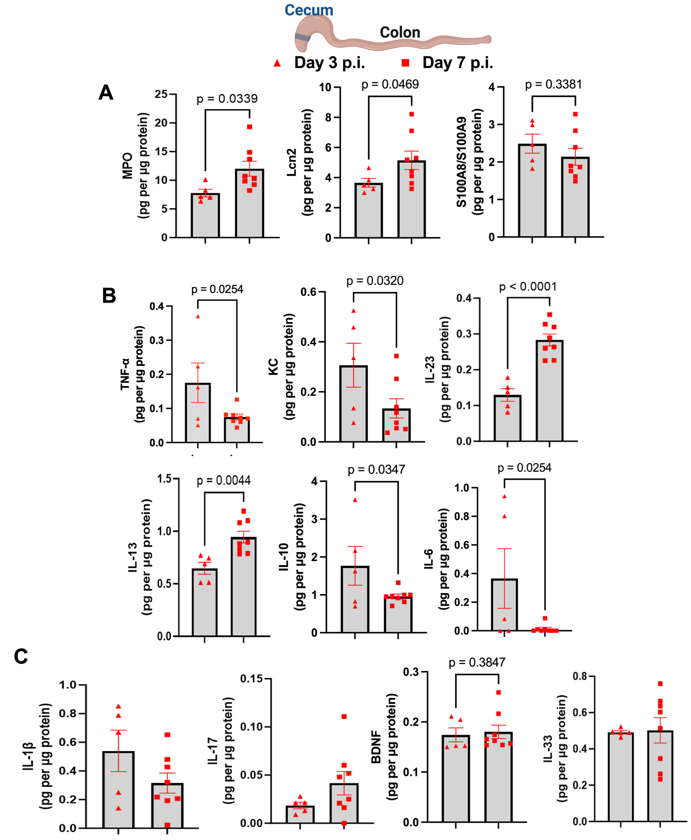
C. difficile-infected mice exhibit increased proinflammatory mediators at the peak of clinical symptoms. (A) Levels of MPO, Lcn2, and S100A8/A9 in cecum tissues measured by ELISA in C. difficile-infected mice on day 3 (n = 5) and on day 7 (n = 8) post-infection. (B) Levels of TNF-α, KC (also known as CXCL1), IL-23, IL-13, IL-10, and IL-6 measured by ELISA in C. difficile-infected mice on day 3 (n = 5) and on day 7 (n = 8) post-infection. (C) Levels of IL-1β, IL-17, BDNF, and IL-33 measured by ELISA in C. difficile-infected mice on day 3 (n = 5) and on day 7 (n = 8) post-infection. (A-C) Unpaired t-test.
Fig. S2

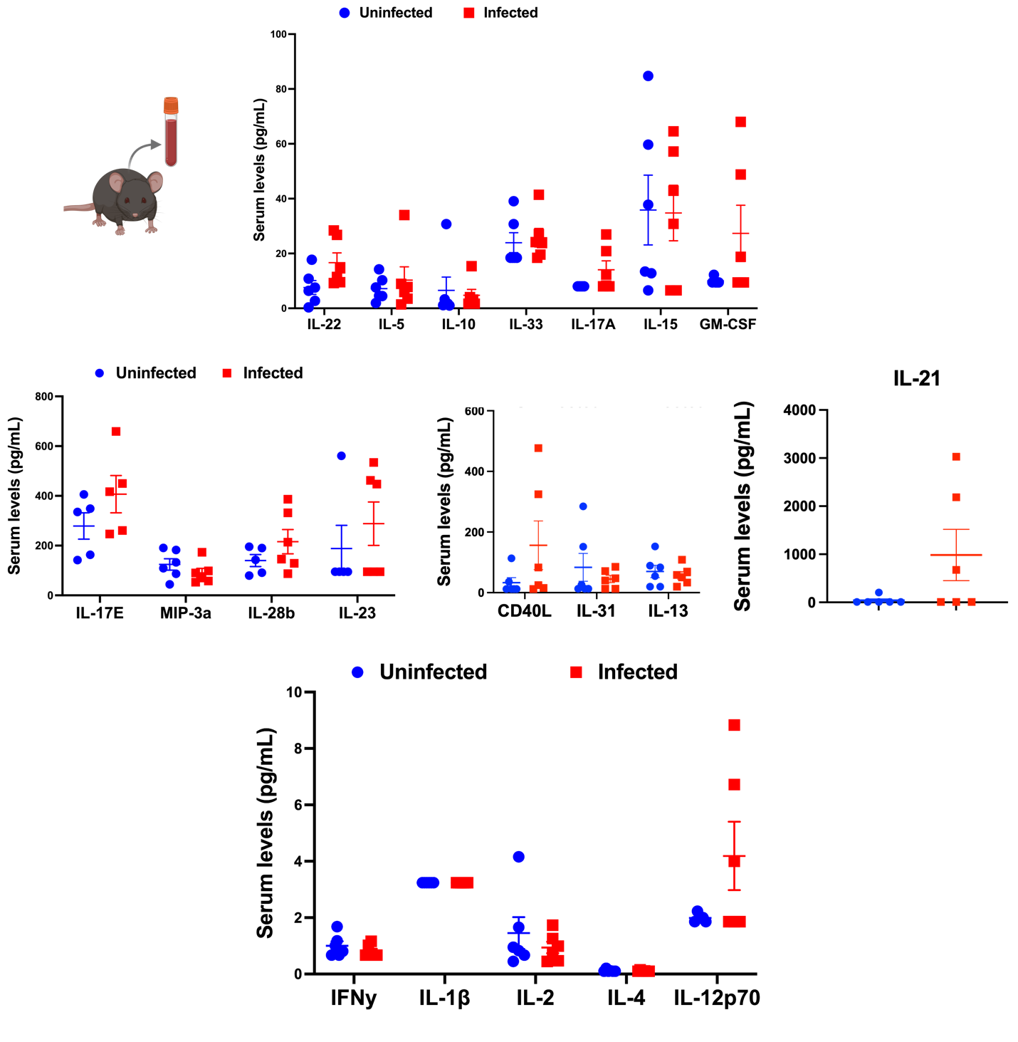

Measurement of proinflammatory and anti-inflammatory mediators in serum samples from C. difficile-infected and uninfected mice on day 7 post-infection. Levels of IL-22, IL-5, IL-10, IL-33, IL-17A, IL-15, GM-CSF, IL-17E, MIP-3α, IL-28b, IL-23, CD40L, IL-31, IL-13, IL-21, INF-γ, IL-1β, IL-2, IL-4, and IL-12p70 measured by multiplex bead assay in serum samples of uninfected (n=5-6) and C. difficile infected mice (n = 8) on day 7 post-infection. Unpaired t test.

Fig. S3
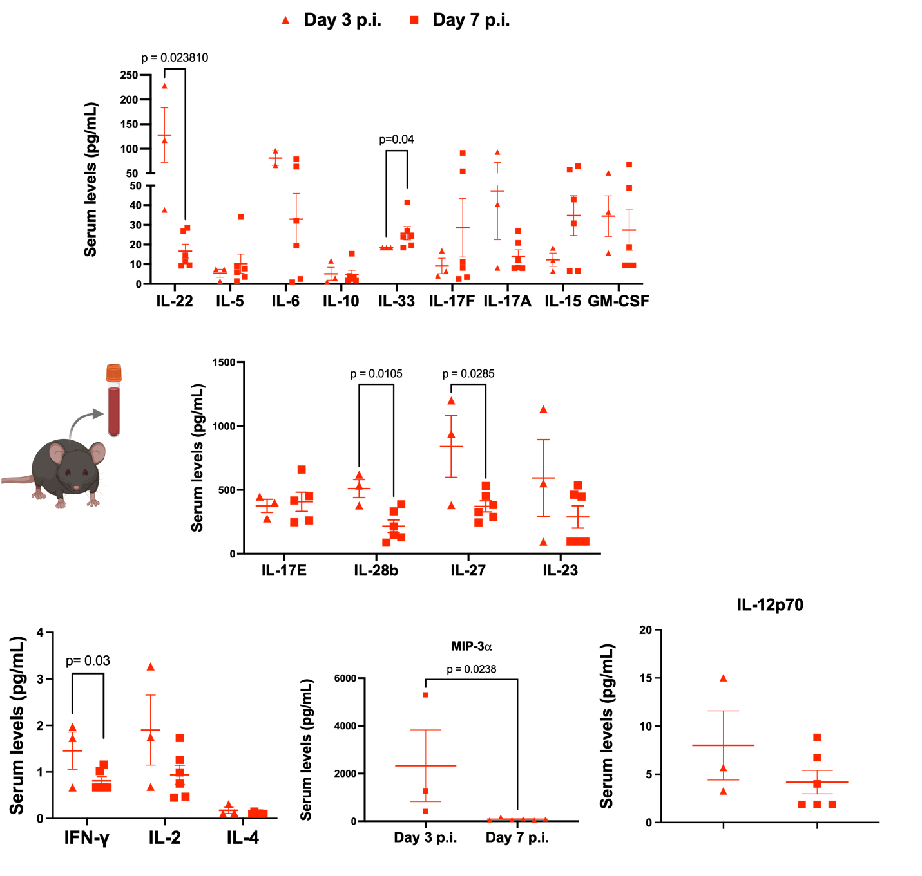
Measurement of proinflammatory and anti-inflammatory mediators in serum samples from C. difficile-infected mice on day 3 and on day 7 post-infection. Levels of IL-22, IL-5, IL-6, IL-10, IL-33, IL-17F, IL-17A, IL-15, GM-CSF, IL-17E, IL-28b, IL-27, INF-γ, IL-2, IL-4, MIP-3α, and IL-12p70 measured by multiplex bead assay in serum samples of C. difficile-infected mice on day 3 (n = 5) and on day 7 (n = 8) post-infection. Unpaired t-test.

Fig. S4

MPO and S100B were detected but unchanged in the mouse prefrontal cortex of both uninfected and infected mice on day 3 post-infection. Levels of MPO and S100B were measured by ELISA in prefrontal cortex samples from uninfected (n=4) and C. difficile-infected mice (n=6) on day 3 post-infection. An unpaired t-test was used. Observation: IL-6 and IL-1β were also measured but not detected in the prefrontal cortex tissues of either uninfected or infected mice on day 3 post-infection.

Fig. S5
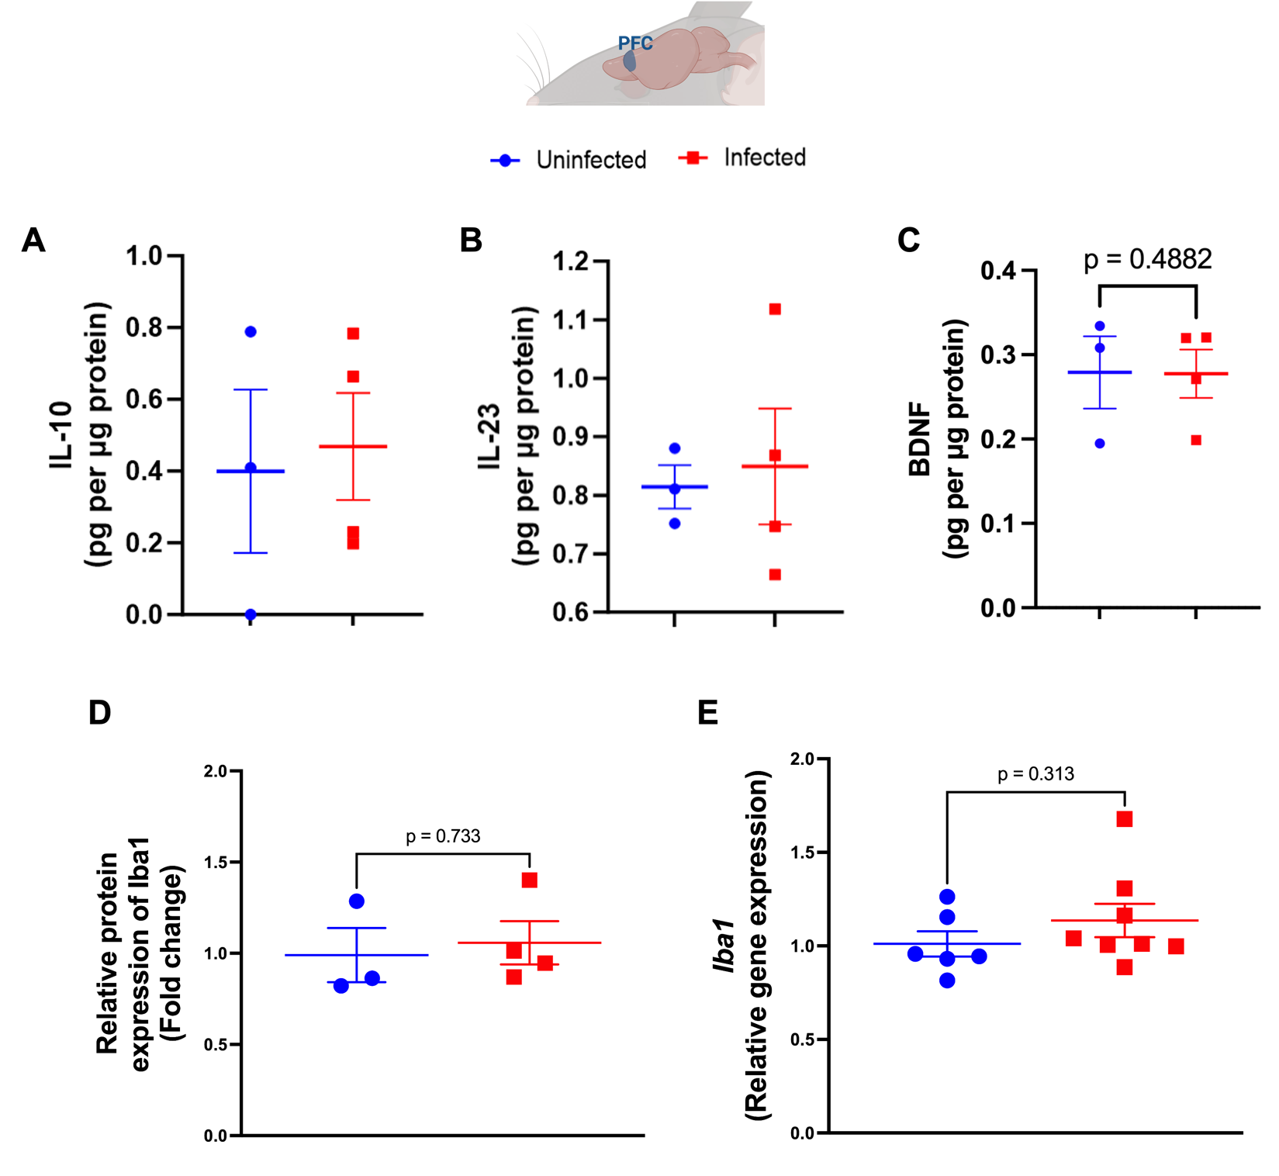

IL-10, IL-23, and BDNF were detected but not changed in the mouse prefrontal cortex in uninfected and infected mice on day 7 post-infection. Levels of (A) IL-10, (B) IL-23, and (C) BDNF measured by ELISA in prefrontal cortex samples of uninfected (n=3) and C. difficile infected mice (n = 4) on day 7 post-infection. Unpaired t-test. (D) Iba1 protein expression determined by Western blot in PFC samples of uninfected (n= 3) and C. difficile infected mice (n= 4) on day 7 p.i. α-tubulin was used as a control protein. Unpaired t test. (E) Iba1 gene expression determined by qPCR in PFC samples of uninfected (n= 6) and C. difficile infected mice (n= 7) on day 7 p.i. GAPDH was used as a housekeeping gene. Unpaired t test.

Fig. S6
Extension of Fig. 4B: Western blot images showing GFAP and α-tubulin (loading control) protein expression in PFC samples on day 7 post-infection in uninfected (U, n=11) and C. difficile-infected (I, n=12) mice. The highlighted black rectangle indicated the representative images shown in Fig. 4B. I and U in red indicated repeated samples.

Fig. S7
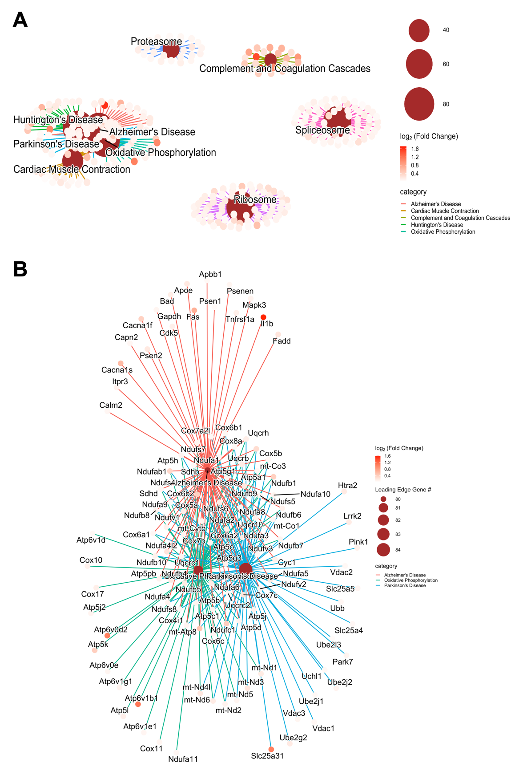
Extension of Fig. 5C: (A) A network constructed of gene sets that were significantly upregulated within the prefrontal cortex during infection. Central nodes represent significant gene sets, with individual points representing leading edge genes that drove enrichment. (B) Leading edge genes associated with oxidative phosphorylation, Parkinson’s disease, and Alzheimer’s disease. Connected points represent genes that were shared between gene sets.

