Sleep disruption exacerbates allergic airway inflammation through sympathetic-mediated activation of the mtDNA-cGAS-STING pathway in pulmonary macrophages
Haotian Chen^{1 †}, Haoyue Zhang^{1 †}, Yanbo Liu¹, Xuanyuan Pan¹, Ying Zhou¹, Juan Zhi¹, Jin Xu¹, Quanle Liu¹, Qianyu Wang¹, Weipeng Xia¹, Dong Yang^{1*}

Supplementary material 1

Figure S1. Effects of sleep disruption on methacholine-induced respiratory mechanics in OVA-challenged mice. (A) Methacholine dose-response curves for Newtonian resistance (Rn) and (B) tissue elastance (H), measured by FlexiVent (n = 6). Data are presented as mean ± SEM. Statistical significance was assessed using two-way ANOVA. *P<0.05, **P<0.01, and ***P<0.001.

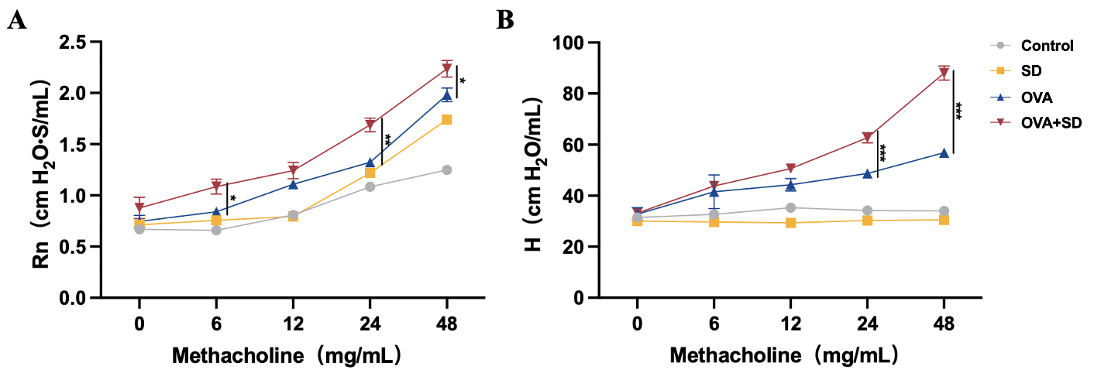

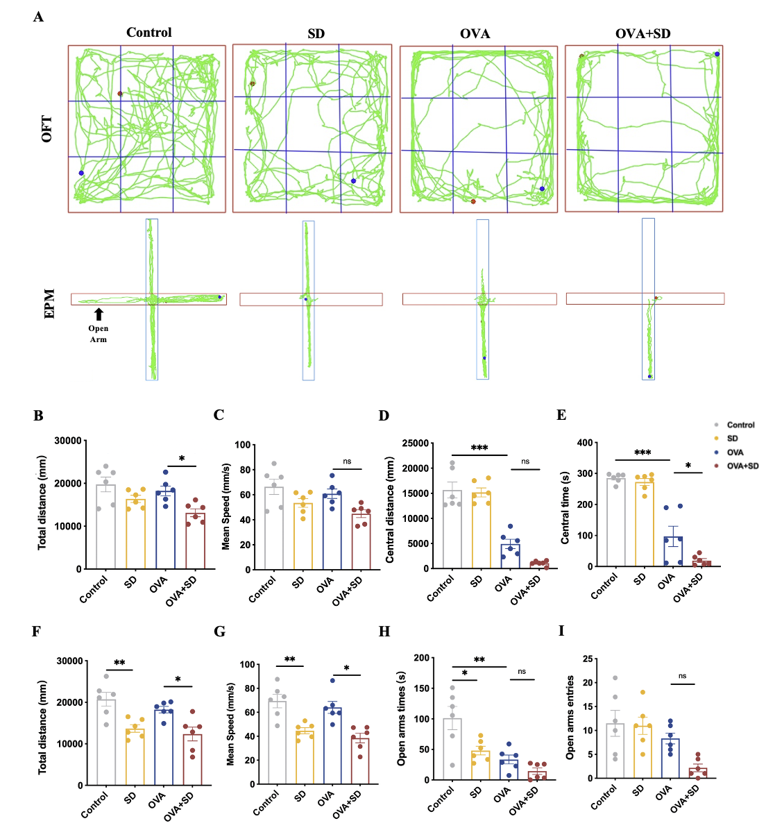
Figure S2. Sleep disruption exacerbates anxiety-like behavior in OVA-challenged mice in the OFT and EPM. (A) Representative trajectory traces of mice in the open field test (OFT) and elevated plus maze (EPM) (n=6). (B–E) Quantification of OFT parameters, including total distance traveled, mean speed, center distance, and center time. (F–I) Quantification of EPM parameters, including total distance traveled, mean speed, time spent in the open arms, and number of open-arm entries. Data are presented as mean ± SEM. Statistical significance was assessed by one-way ANOVA. *P < 0.05, **P < 0.01, ***P < 0.001.

Figure S3. Sleep disruption activates the T4 dorsal root ganglion and enhances catecholaminergic signaling. (A-B) Representative immunofluorescence images of c-Fos and tyrosine hydroxylase (TH) in the T4 dorsal root ganglion (T4DRG) from Control and SD mice. (C-D) Quantification of c-Fos-positive cells and TH fluorescence intensity in the T4DRG (n=6, scale bar, 100 μm). Data are presented as mean ± SEM. Statistical significance was assessed by unpaired two-tailed Student’s t-test. *P < 0.05, **P < 0.01, ***P < 0.001.

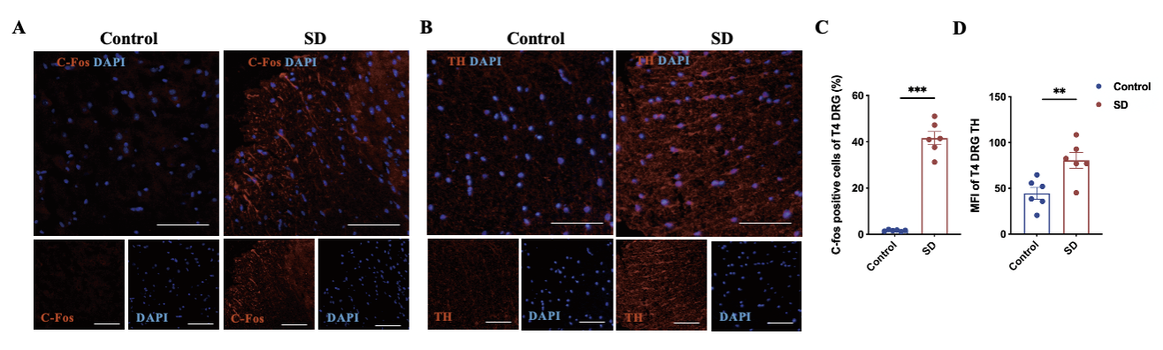

Figure S4. Histopathological changes in the hippocampus and major peripheral organs following SD and OVA exposure. (A) Representative H&E staining of the hippocampal CA1 region across the Control, SD, OVA, and OVA+SD groups (n=6, scale bar, 500 μm and 200 μm). Higher-magnification images are shown below. (B) Quantification of the percentage of damaged pyramidal neurons in the CA1 region. (C) Representative H&E staining of the heart, liver, spleen, and kidney across the Control, SD, OVA, and OVA+SD groups. Scale bars as indicated. (n=6, scale bar, 100 µm).

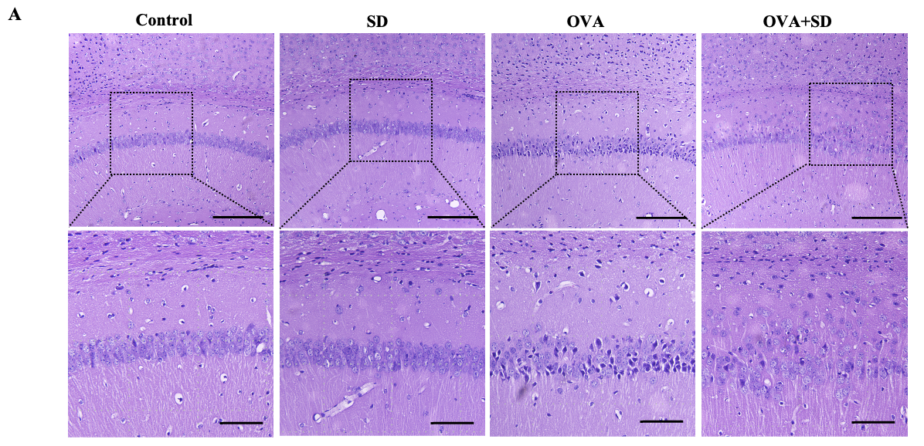

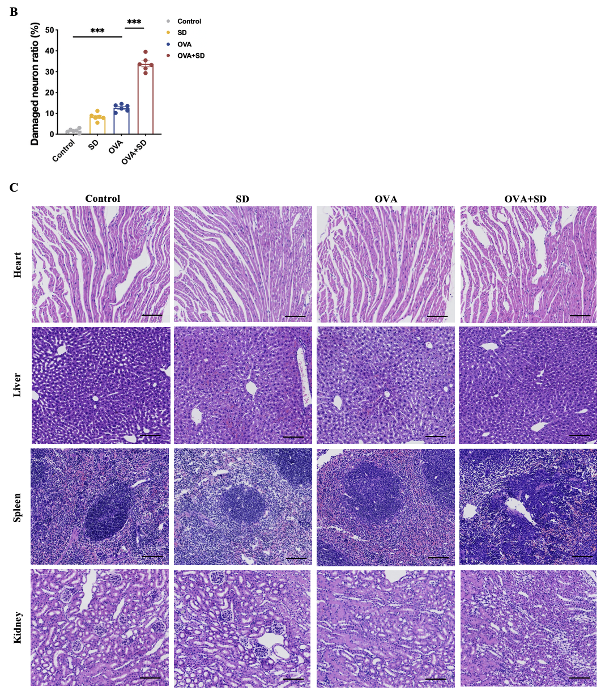

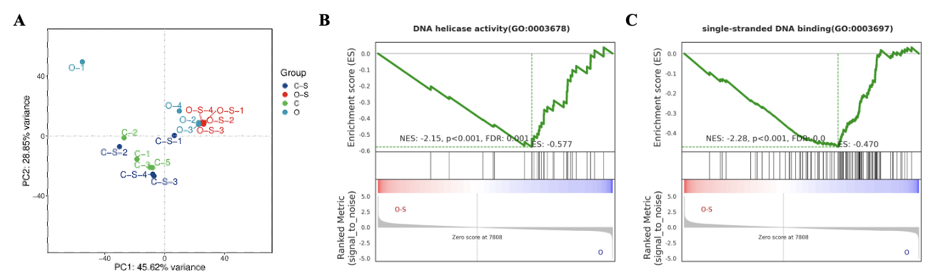
Figure S5. Principal component analysis of lung bulk RNA-seq profiles across Control, SD, OVA, and OVA+SD groups (n=4). (A) Principal component analysis (PCA) of lung bulk RNA-seq profiles from Control, SD, OVA, and OVA+SD groups. Each dot represents one biological replicate. (B,C) Gene set enrichment analysis (GSEA) showing suppression of DNA helicase activity and single-stranded DNA binding in OVA+SD lungs relative to OVA lungs. These data further support altered DNA-related programs in the setting of sleep disruption-superimposed allergic airway inflammation.

Principal component analysis (PCA) was performed on lung bulk RNA-seq data from the four experimental groups. Each dot represents one biological replicate. PC1 and PC2 explain the indicated proportions of total variance.

Figure S6. Representative immunofluorescence staining of p-STING in Ly6G⁺ cells and airway epithelial cells in allergic lungs. (A) Representative immunofluorescence images of lung sections stained for p-STING (Cy3; red), Ly6G (Alexa Fluor® 488; green), and nuclei (DAPI, blue), with higher-magnification views and single-channel images (n=4, scale bar, 200 μm and 100 μm). (B) Quantification of p-STING⁺Ly6G⁺/Ly6G⁺ cells. (C) Representative immunofluorescence images of lung sections stained for p-STING (Cy3; red), E-cadherin (Alexa Fluor® 488; green), and nuclei (DAPI, blue), with higher-magnification views and single-channel images (n=4, scale bar, 200 μm and 100 μm). (D) Quantification of p-STING⁺ E-cadherin⁺/ E-cadherin⁺ cells. Data are presented as the mean ± SEM. Statistical significance was assessed by one-way ANOVA. ∗P < 0.05, ∗∗P < 0.01, and ∗∗∗P < 0.001.

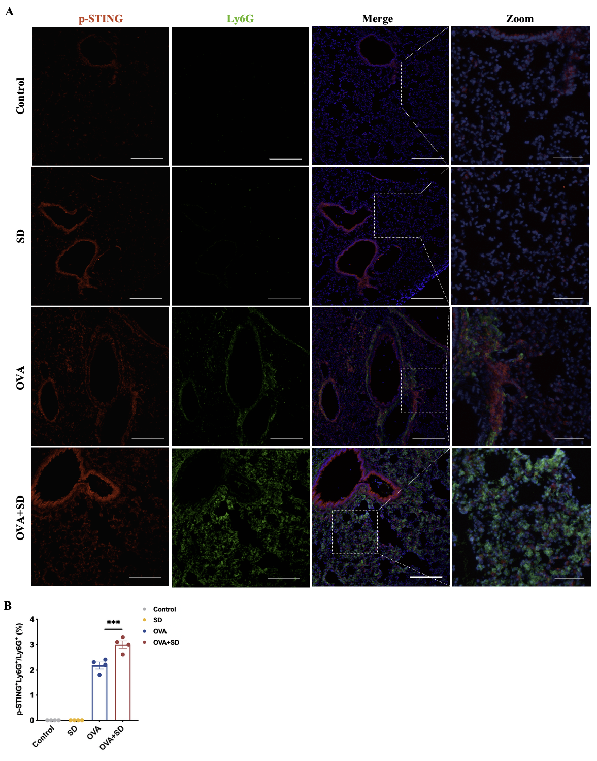

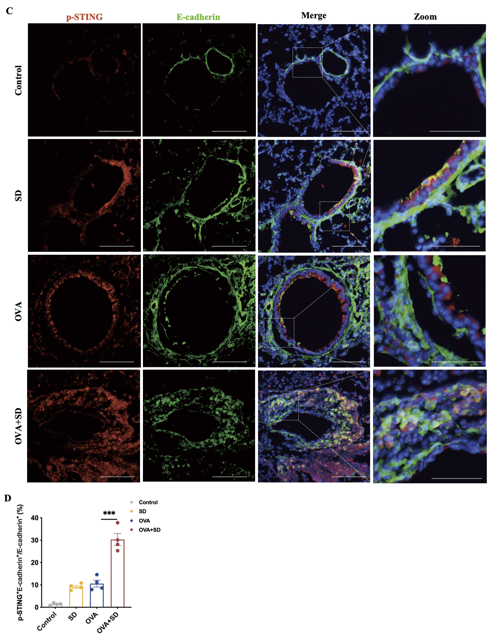

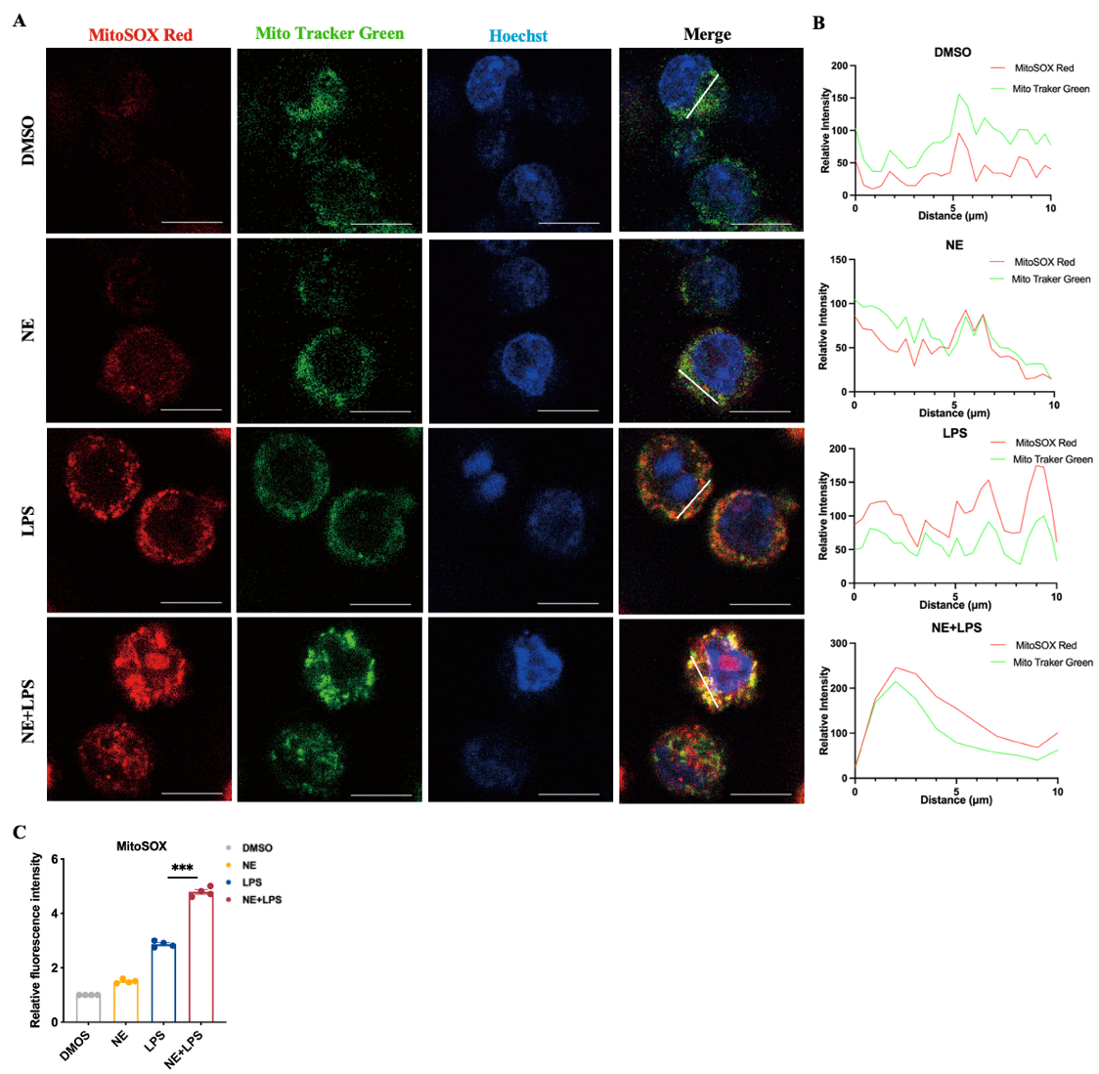
Figure S7. Norepinephrine enhances mitochondrial reactive oxygen species production in macrophages. (A) Representative confocal images showing mitochondrial ROS levels in RAW264.7 cells under the indicated treatments (DMSO, NE, LPS, and NE+LPS). Mitochondrial superoxide was detected using MitoSOX Red (red), mitochondria were labeled with MitoTracker Green (green), and nuclei were stained with DAPI (blue). Merged images demonstrate increased mitochondrial ROS accumulation, particularly in the NE+LPS group (n=4, Scale bars, 10 μm). (B) Line-scan analysis of fluorescence intensity along the indicated regions in merged images, showing the spatial distribution and overlap of MitoSOX Red and MitoTracker Green signals. (C) Quantification of MitoSOX fluorescence intensity in RAW264.7 cells under different treatments. Data are presented as mean ± SEM (n = 4). Data are presented as the mean ± SEM. Statistical significance was assessed by one-way ANOVA. ∗P < 0.05, ∗∗P < 0.01, and ∗∗∗P < 0.001.

Figure S8. Sympathetic denervation attenuates SD-aggravated AHR and airway inflammation in OVA-challenged mice. (A) Methacholine dose-response curves for Newtonian resistance (Rn) and (B) tissue elastance (H), measured by FlexiVent (n = 6). (C-D) Quantification of lung TH immunoreactivity. (E) dsDNA levels in BALF. (F-H) Differential BALF inflammatory cell counts, including neutrophils, eosinophils, and macrophages (n = 6). Data are presented as mean ± SEM. For methacholine dose-response curves in (A-B), statistical significance was assessed using two-way ANOVA. For quantification of lung TH immunoreactivity, statistical significance was assessed using unpaired two-tailed Student’s t-test. For BALF dsDNA levels and cell counts in (E-H), statistical significance was assessed by one-way ANOVA. *P<0.05, **P<0.01, and ***P<0.001.
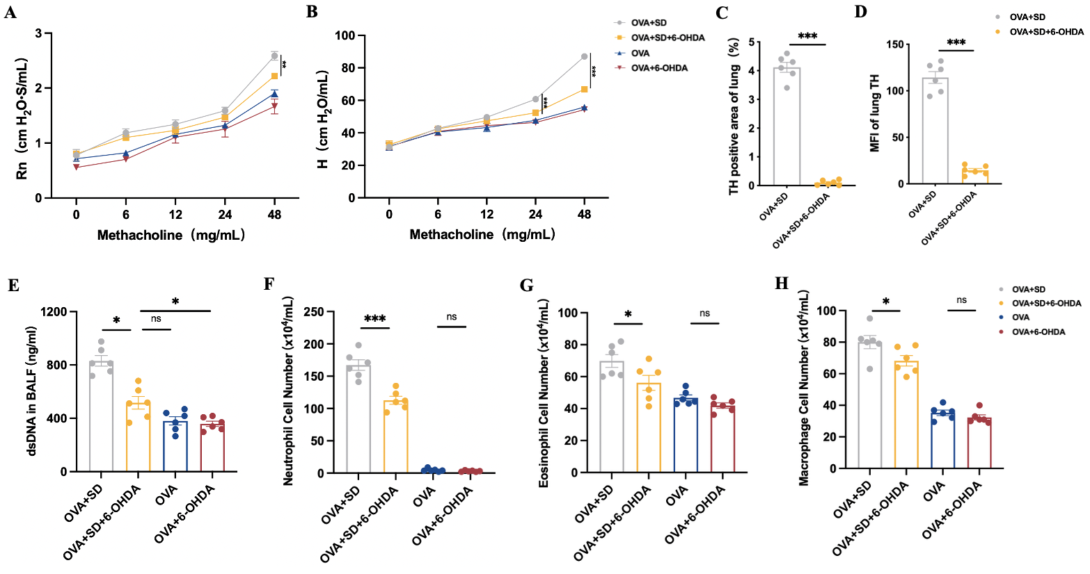
Figure S9. Flow cytometric isolation of pulmonary macrophage-enriched cells and validation of STING activation in OVA+SD mice. (A, B) Representative sequential gating strategies for the isolation of pulmonary macrophage-enriched cells from the lungs of OVA and OVA+SD mice, respectively. Cellular events were first selected based on forward- and side-scatter characteristics, followed by exclusion of doublets and nonviable cells. Viable CD45⁺ leukocytes were subsequently gated, Ly6G⁺ neutrophils were excluded, and CD11b⁺F4/80⁺CD64⁺ cells were sorted. Percentages shown within each gate represent the proportion of the corresponding immediate parent population. Each mouse was processed and sorted independently without sample pooling. (C) Representative immunoblots of p-STING and total STING in flow-sorted viable CD45⁺Ly6G⁻CD11b⁺F4/80⁺CD64⁺ pulmonary macrophage-enriched cells from OVA and OVA+SD mice. (D) Quantification of p-STING/STING (n=3). Data are presented as the mean ± SEM. Statistical significance was assessed by unpaired two-tailed Student’s t-test. ∗P < 0.05, ∗∗P < 0.01, and ∗∗∗P < 0.001.
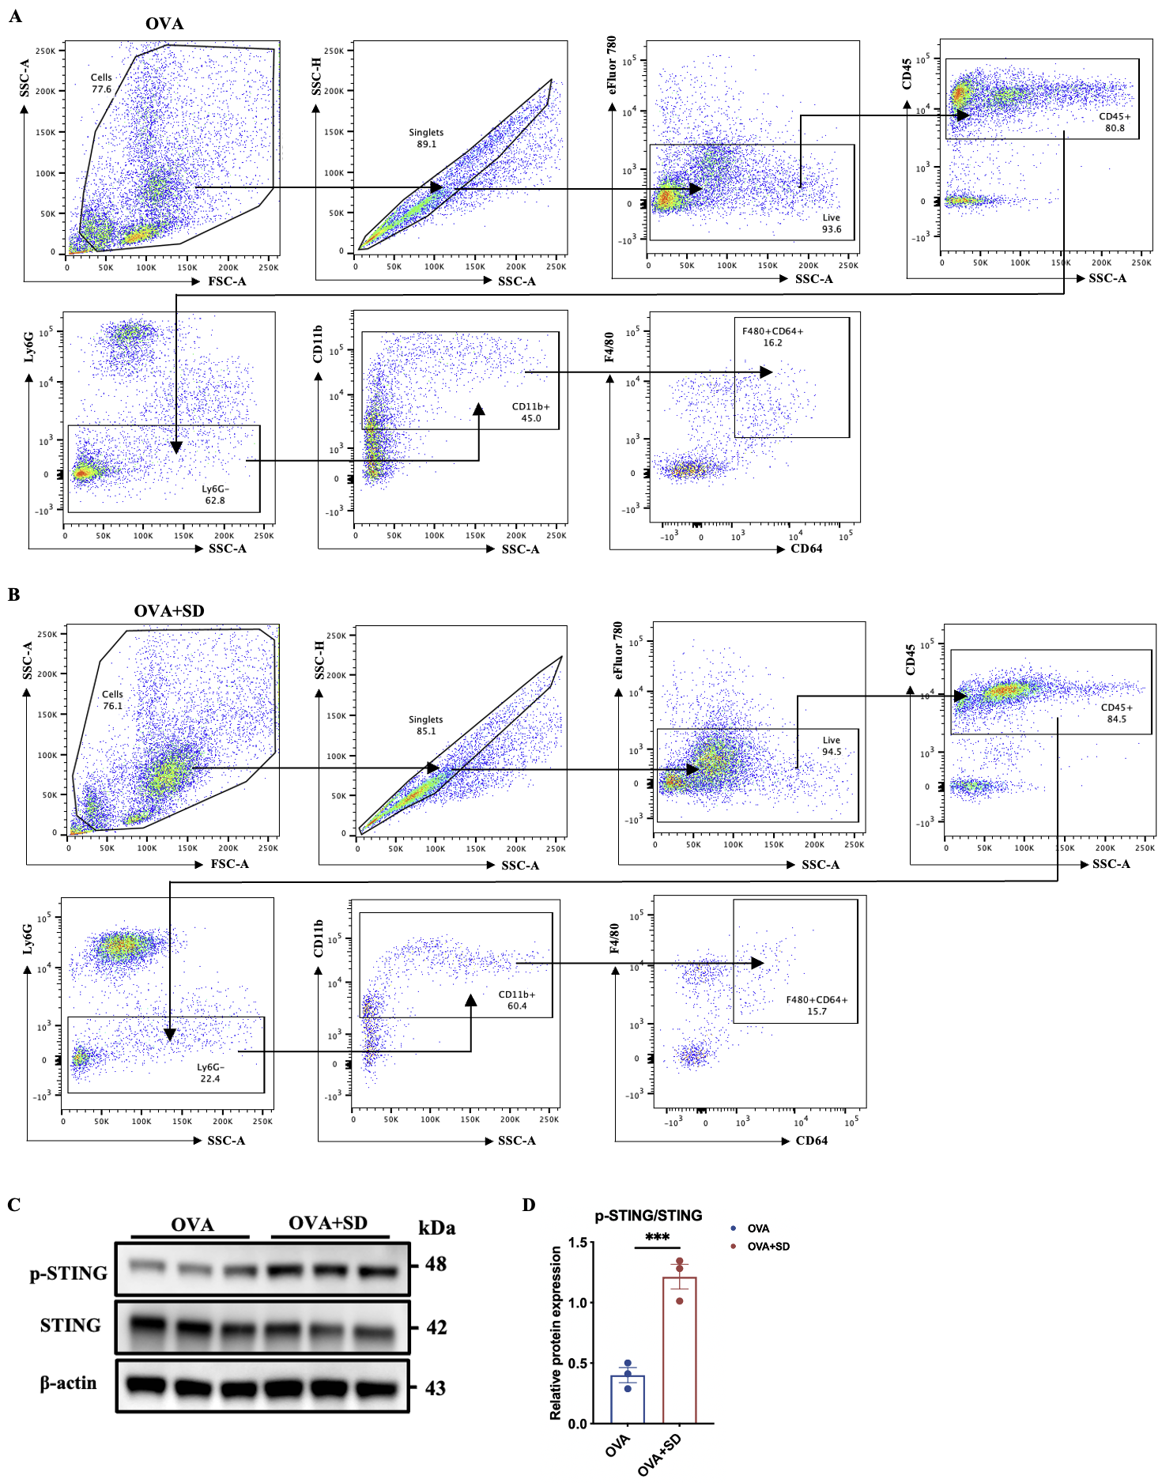

Table S1 Patient Demographic and Baseline Characteristics
Characteristic | Healthy controls  (n = 5) | Asthma without SD (n = 5) | Asthma with SD  (n = 5) | P value
Age, years | 29 (28, 30) | 28 (28, 29) | 29 (27, 29) | 0.749
Gender |  |  |  | 1.000
Male, n (%) | 3 (60.0) | 3 (60.0) | 2 (40.0)
Female, n (%) | 2 (40.0) | 2 (40.0) | 3 (60.0)
BMI, kg/m² | 24.2 (20.8, 25.5) | 20.2 (20.2, 23.1) | 22.4 (21.1, 23.4) | 0.236
Asthma duration, years | / | 10 (10, 11) | 9 (8, 11) | 0.673
Data are presented as median (p25, p75) for continuous variables and n (%) for categorical variables. Continuous variables were compared using the Kruskal-Wallis test or Mann-Whitney U-test, as appropriate. Categorical variables were compared using Fisher’s exact test. Statistical significance was set at P < 0.05.

Table S2 Primers for qPCR analysis

Gene | Direction | Primer (5’-3’)
mActB | F (forward) | CCGTTCCGAAAGTTGCCTTT
mActB | R (reverse) | CTGCAAAGAAGCTGTGCTCG
mt-CytB | F | TGCATACGCCATTCTACGCT
mt-CytB | R | AGGCTTCGTTGCTTTGAGGT
mt-Co1 | F | ACACATGAGCAAAAGCCCAC
mt-Co1 | R | AGTCTGAGTAGCGTCGTGGT
mt-Nd1 | F | CCACGCTTCCGTTACGATCA
mt-Nd1 | R | TATGGTGGTACTCCCGCTGT

