SUPPLEMENTARY INFORMATION
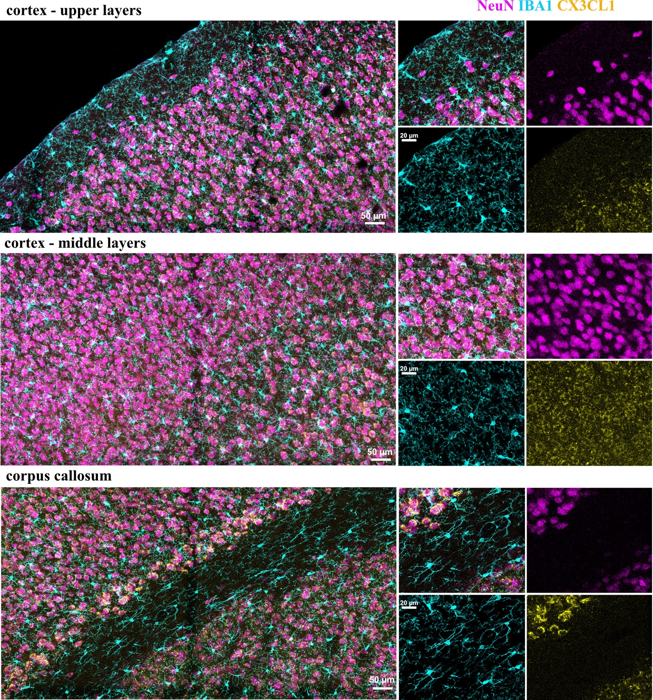Supplementary Figure 1: CX3CL1 localization in the mouse neocortex and corpus callosum.
CX3CL1 immunoreactivity (yellow) in the different layers of the mouse cortex and corpus callosum. CX3CL1 immunoreactivity is present in cortical layers II-VI colocalizing with NeuN⁺ cells (magenta) and mostly absent in cortical layer I and the corpus callosum where there is little to no NeuN immunoreactivity.

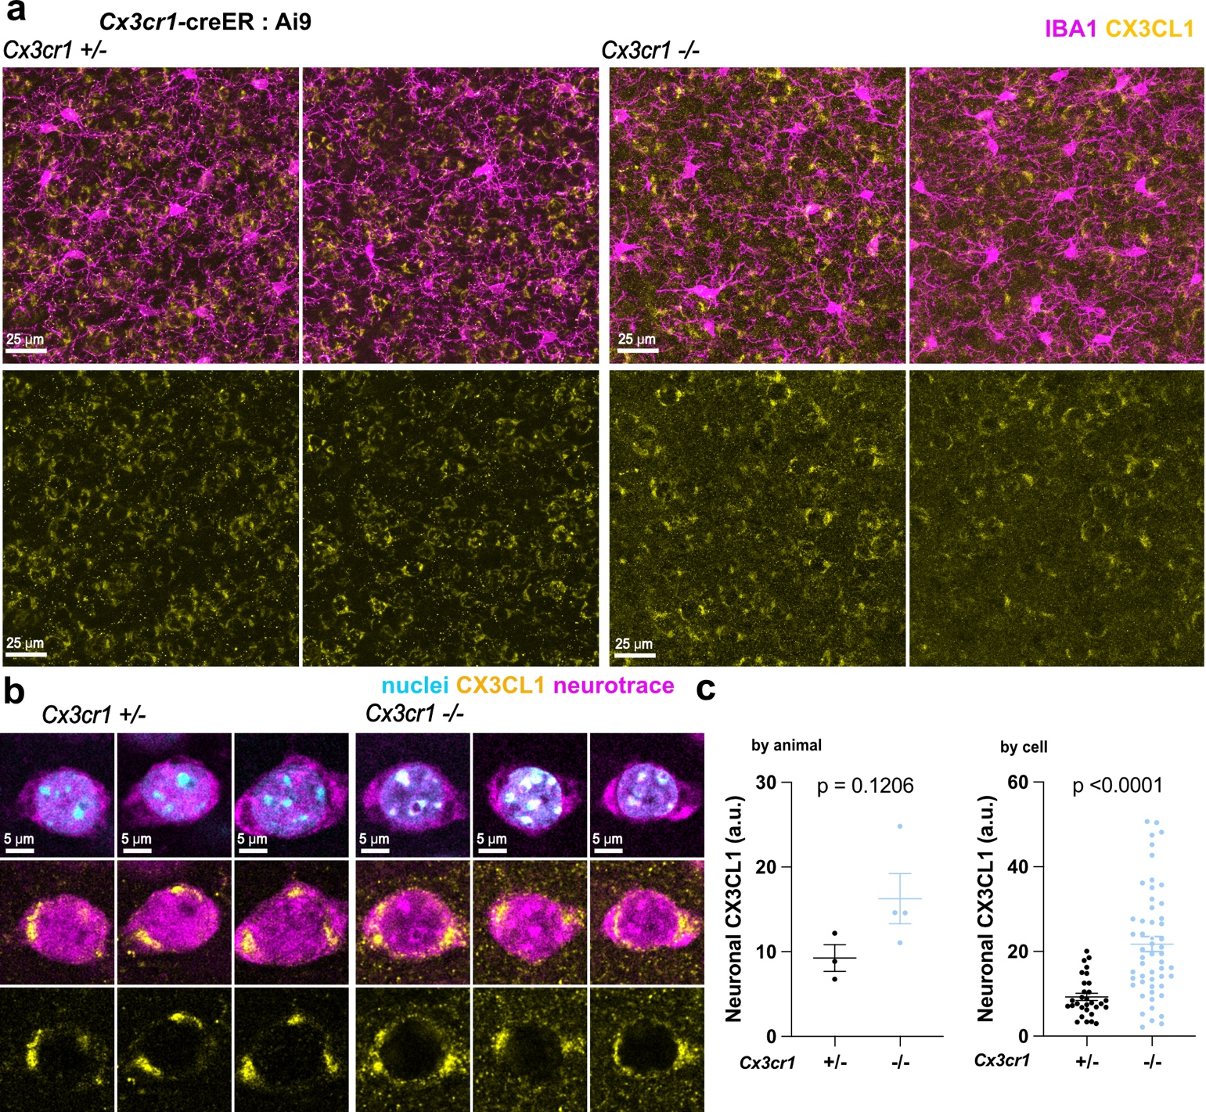
Supplementary Figure 2: CX3CL1 levels in neurons are variable and slightly elevated in Cx3cr1^{-/-} mice
a. Representative images of CX3CL1 immunoreactivity in the cerebral cortex of Cx3cr1^{+/-} and Cx3cr1^{-/-} mice. b. High resolution single confocal z slices of neurotrace-labeled neurons in Cx3cr1^{+/-} and Cx3cr1^{-/-} mice and corresponding immunolabeling of CX3CL1 in the neuronal cytoplasm. c. Fluorescence intensity measurements of CX3CL1 within neurons shown averaged by animal (left), n = 3 (1 female, 2 male) Cx3cr1^{+/-} and 4 (2 male, 2 female) Cx3cr1^{-/-} mice) and by cell (right, n = 30 cells from 3 Cx3cr1^{+/-} mice and 41 cells from 4 Cx3cr1^{-/-} mice); unpaired two-tailed t-test; error bars represent SEM.
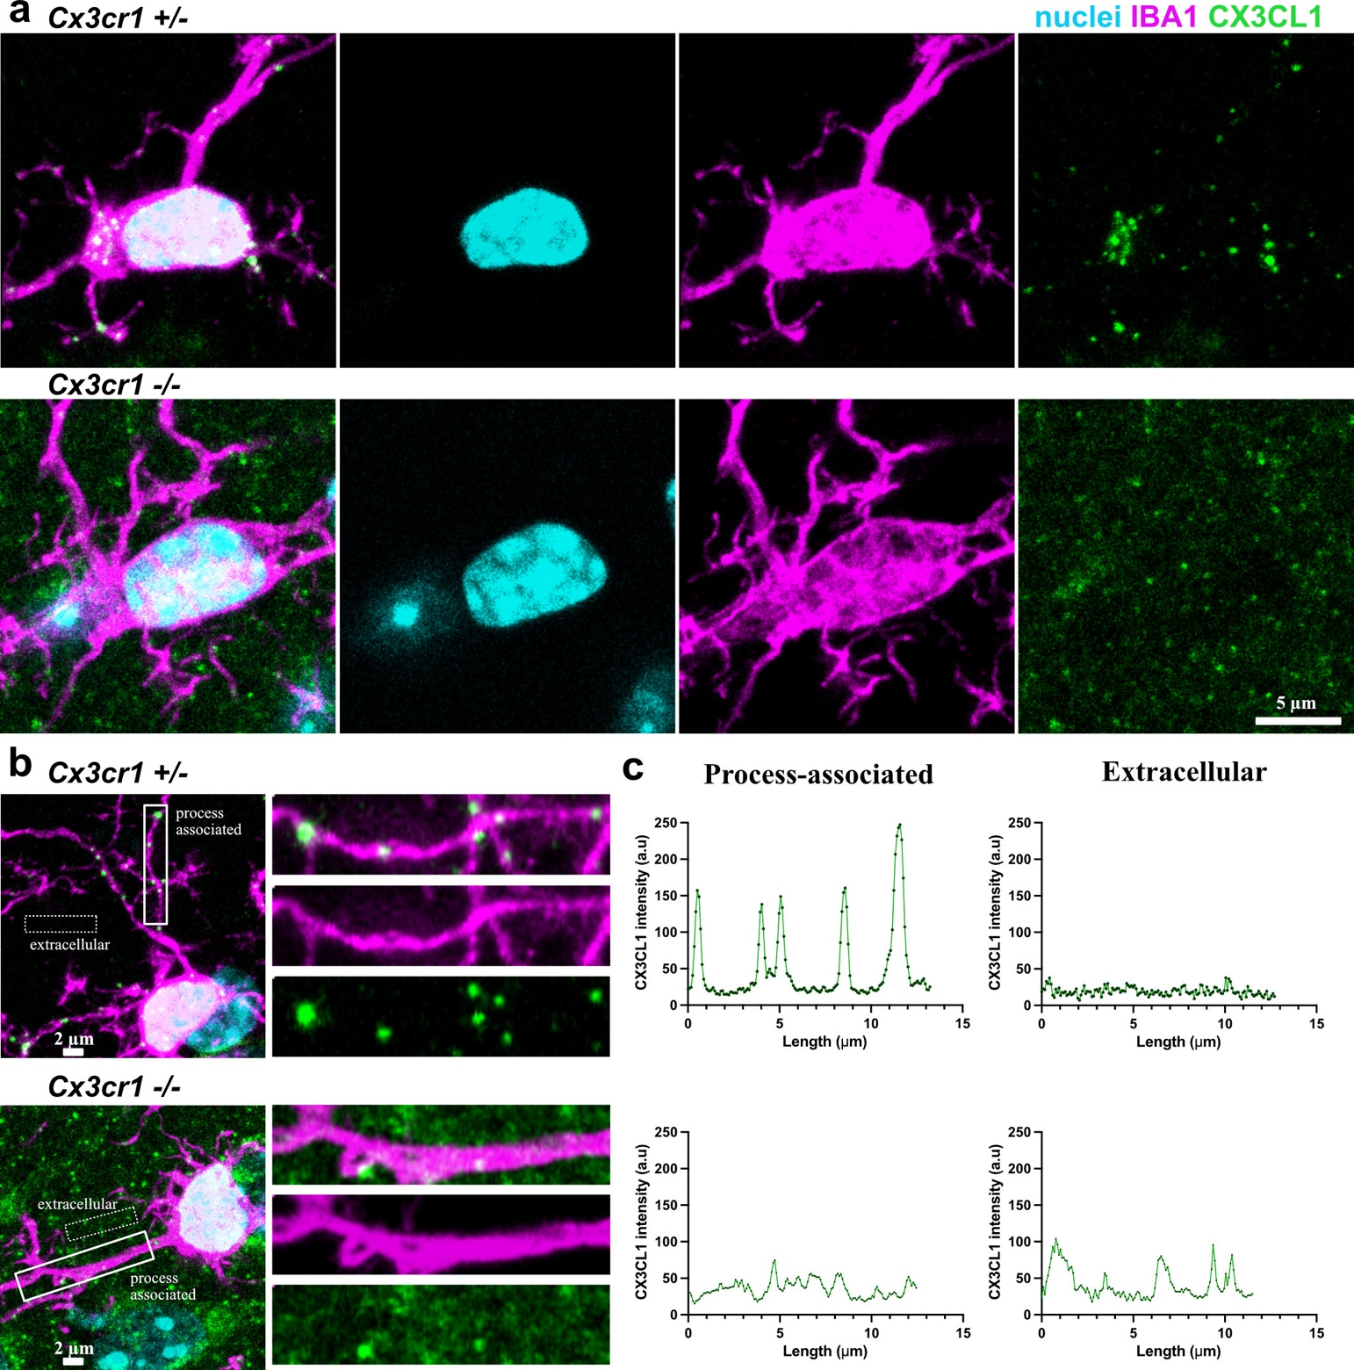
Supplementary Figure 3: CX3CL1 puncta aggregation on microglia is dependent on CX3CR1.
a. CX3CL1 immunoreactivity colocalizes with IBA1 staining on microglia as bright distinct puncta (top panel) which are lost when the CX3CR1 receptor is deleted (bottom panel). b. Example images of CX3CL1 fluorescent signal on microglial processes and in the extracellular matrix in the presence (top panels) and absence (bottom panels) of the CX3CR1 receptor. c. Graphical representation of the CX3CL1 fluorescent intensity in the boxed regions of the Cx3cr1^{+/-} and Cx3cr1^{-/-} microglia shown in (b).

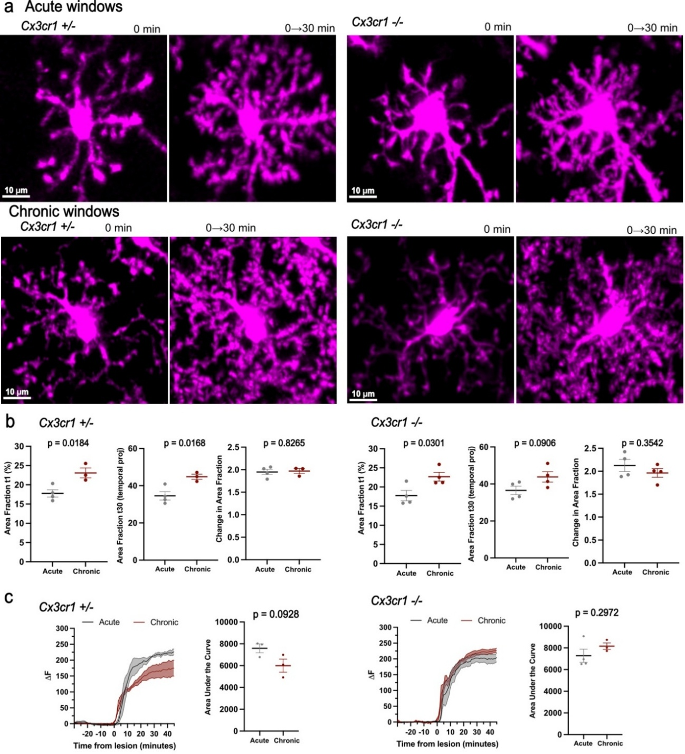
Supplementary Figure 4. Cranial window preparation impacts microglial morphology and laser lesion responses.
a. In vivo images of Cx3cr1^{+/-} and Cx3cr1^{-/-} microglia were acquired every 1 minute for 30 minutes in either acute (top panels) or chronic (bottom panels) window preparations. Area fractions at the first timepoint were measured to assay for microglia morphology. The change in area fraction across thirty minutes relative to the first time point was measured to assay for microglial surveillance. b. Microglia morphology and microglial surveillance in Cx3cr1^{+/-} mice (left) and Cx3cr1^{-/-} mice (right) in acute vs chronic window preparations (unpaired two-tailed t-test; error bars represent SEM). c. Microglia process response to a focal laser injury across acute and chronic window preparations in Cx3cr1^{+/-} mice (two-way ANOVA; interaction p < 0.0001, F(74,296) = 3.209; genotype p = 0.0930, F(1,4) = 4.827; time p < 0.0001, F (2.251, 9.002) = 113.2; error bars represent SEM) and Cx3cr1^{-/-} mice (two-way ANOVA; interaction p = 0.9504, F(74,370) = 0.7294; genotype p = 0.2985, F(1,5) = 1.345; time p < 0.0001, F (2.131, 10.65) = 162.4; error bars represent SEM). For (b) and (c), the Cx3cr1^{+/-} mice have n = 4 mice (1 female, 3 male) with acute windows and n = 3 mice (all male) with chronic windows; the Cx3cr1^{-/-} mice have n = 4 mice (1 female, 3 male) in both acute and chronic window groups.
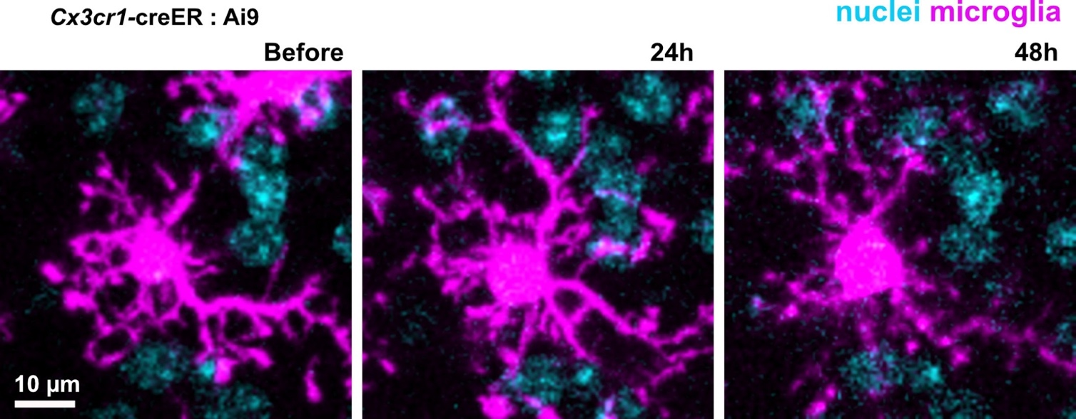
Supplementary Figure 5. Surveillant microglia maintain a stationary soma while their processes remain highly dynamic in the absence of neurodegeneration. Representative image showing a microglial cell imaged over a period of 48 hours away from any targeted cells labeled with TdTomato in the Ai9 reporter mice. The cell soma maintains its specific position in the parenchyma while its processes are seen to change at each timepoint, a characteristic of a surveillant phenotype.

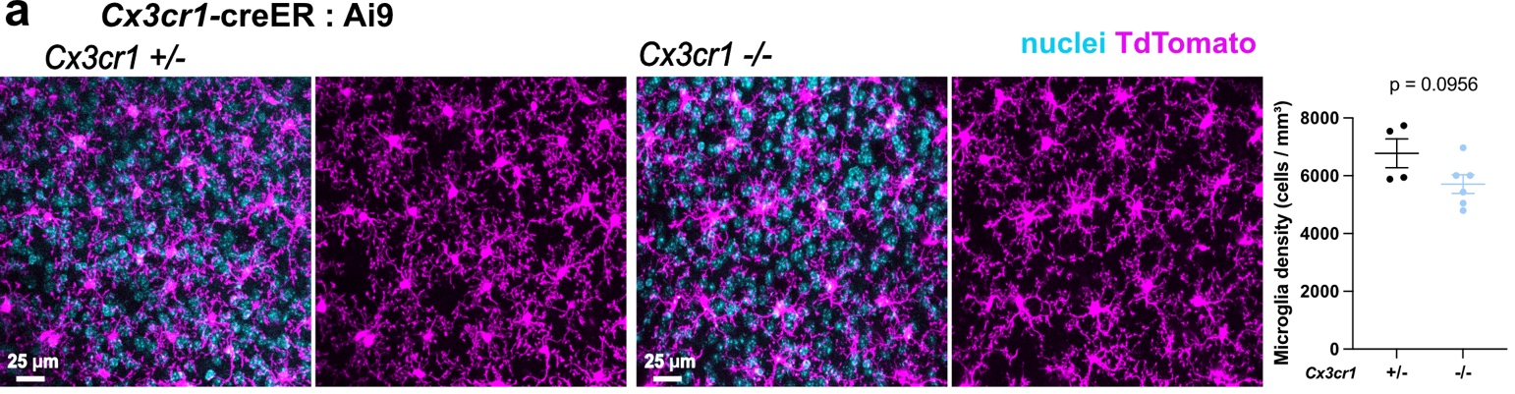
Supplementary Figure 6. Similar microglial densities in Cx3cr1^{+/-} and Cx3cr1^{-/-} mice
a. In vivo images showing tdTomato-labeled microglia in Cx3cr1^{+/-} and Cx3cr1^{-/-} mice and microglia density in both genotypes (n = 4 Cx3cr1^{+/-} mice (2 female, 2 male) and 6 Cx3cr1^{-/-} mice (2 female, 4 male); unpaired two-tailed t-test; error bars represent SEM).

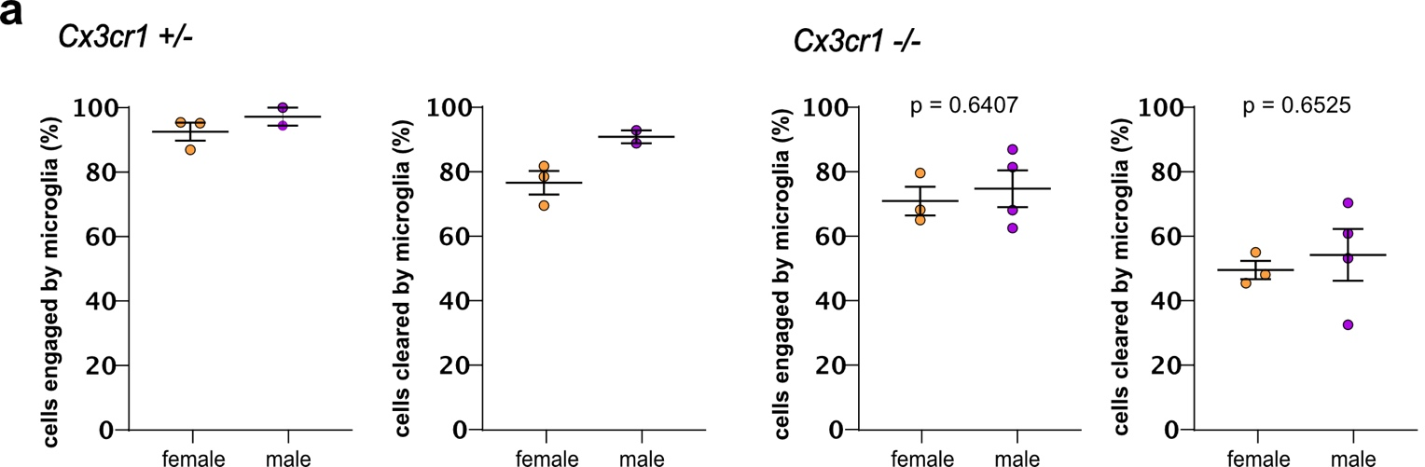
Supplementary Figure 7. Sex does not drive differences in microglial engagement or clearance in Cx3cr1^{-/-} mice.
a. Graphical representation of sex comparison of the total cells engaged and cleared by microglia expressed as a percentage in Cx3cr1^{+/-} (left two panels) and Cx3cr1^{-/-} (right two panels) mice at the 24-hour time point (n = 5 Cx3cr1^{+/-} mice (3 female, 2 male) and 7 Cx3cr1^{-/-} mice (3 female, 4 male); unpaired two-tailed t-test; error bars represent SEM).
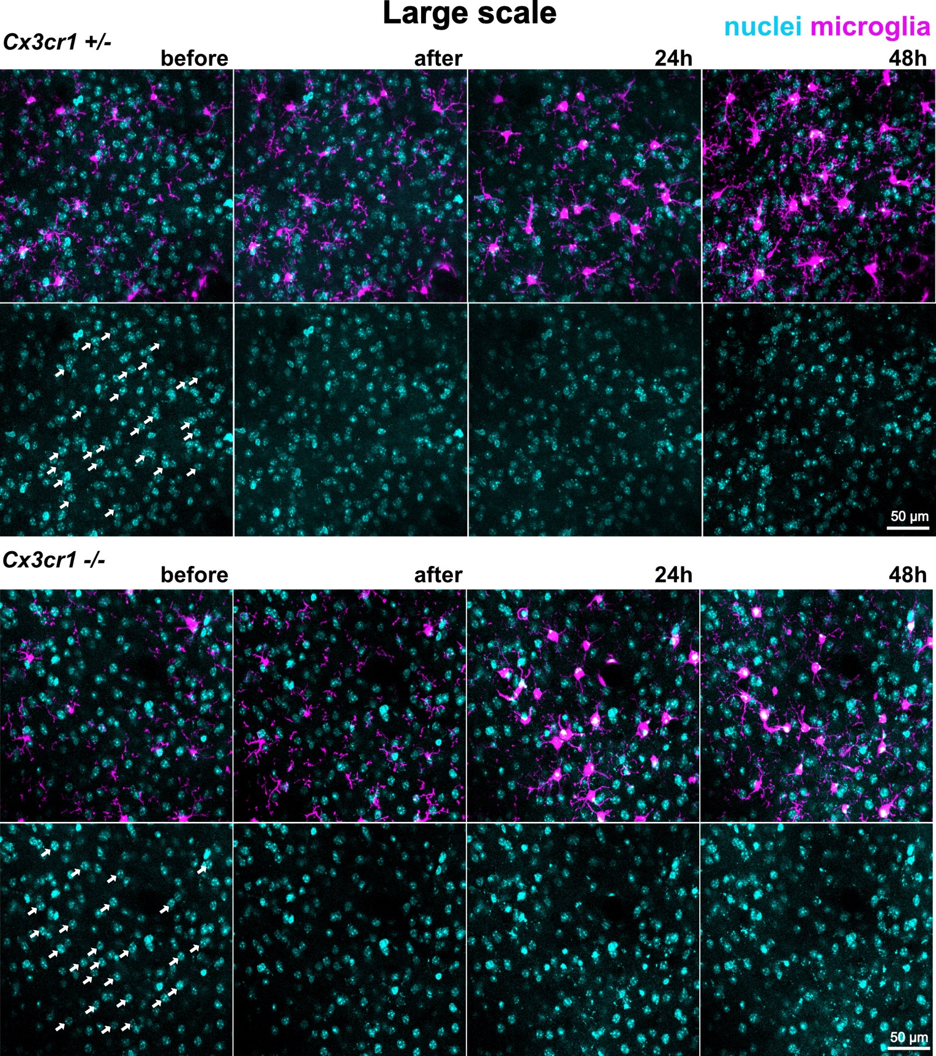
Supplementary Figure 8. Representative image of longitudinal imaging of the large-scale cell death model. Representative images showing twenty-five cells targeted per position in Cx3cr1^{+/-} mice (top panels) and Cx3cr1^{-/-} mice (bottom panels) across different time points. White arrows show targeted cells.
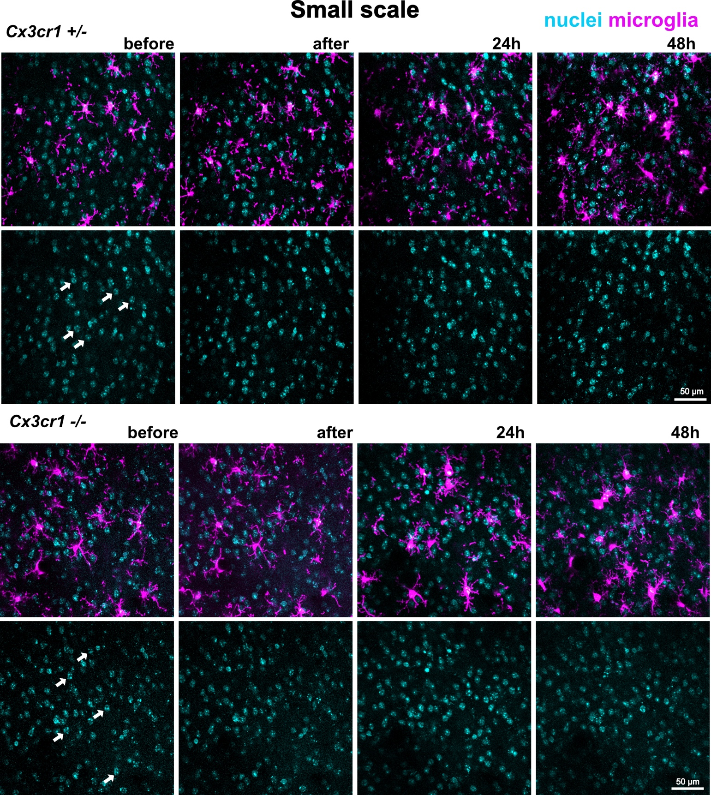
Supplementary Figure 9. Representative image of longitudinal imaging of the small-scale cell death model. Representative images showing five cells targeted per position in Cx3cr1^{+/-} mice (top panels) and Cx3cr1^{-/-} mice (bottom panels) across different time points. White arrows show targeted cells.

