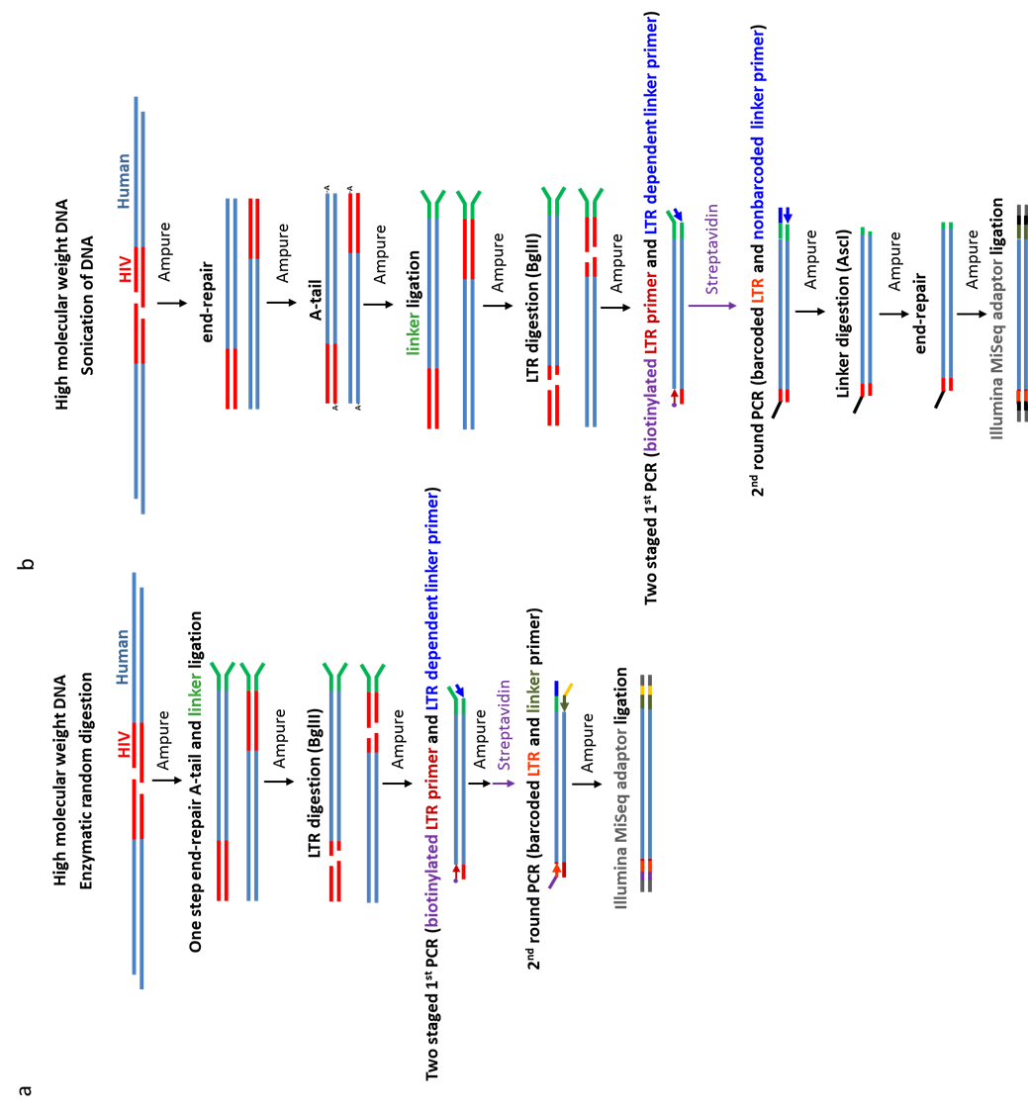
Figure S1. Analysis of HIV integration sites. Comparison of A. a new high throughput method suitable for robotic processing and B a published method [12] to analyse HIV integration sites.
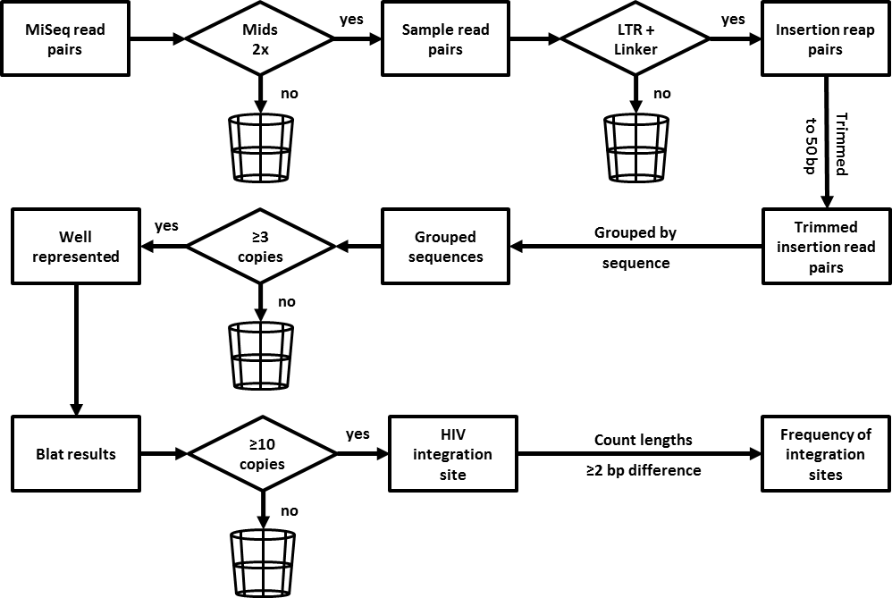
Figure S2. Schematic overview of analysis strategy used to define an integration site.

Table S1. Linker sequence and primer sequence.
* indicates phosphorothioated nucleotide. MID is multiplex identifier sequence.

