Supplementary material
Suppl Fig 1: Schematic of wild-type and Gag-fusion viruses
Schematic representation of the plasmids transfected into HEK293T cells to produce WT and Gag-fusion viruses. The genome plasmid of each virus is based on the HIV-1 LAI strain[32] with a deletion in envelope (Δenv) and expressing GFP in the place of Nef (pLAIΔEnvGFP), except Gag-GFP. Each virus was pseudotyped with VSV-G, and for 8.91 LAI, Gag-LUC and Gag-GFP viruses, were co-transfected with p8.91 packaging construct encoding Gag-Pol, Tat and Rev[60]. LTR: long terminal repeat, MA: matrix, CA: capsid, SP: spacer peptide, NC: nucleocapsid, env: envelope, Luc: firefly luciferase, GFP: green fluorescent protein.

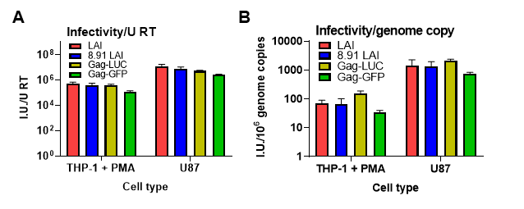
Suppl Fig 2: Particle infectivity of wild-type and Gag-fusion viruses
A: Virus infectivity (infectious units, I.U.) on THP-1 cells differentiated with PMA or U87 cells (measured by flow cytometry at 48 h post-transduction) normalised to units of RT (measured by SG-PERT).
B: Virus infectivity (infectious units, I.U.) on THP-1 cells differentiated with PMA or U87 cells (measured by flow cytometry at 48 h post-transduction) normalised to genome copy number (measured by qPCR).
Data are mean ± SD from biological triplicates of a single experiment, representative of at least 2 repeats.

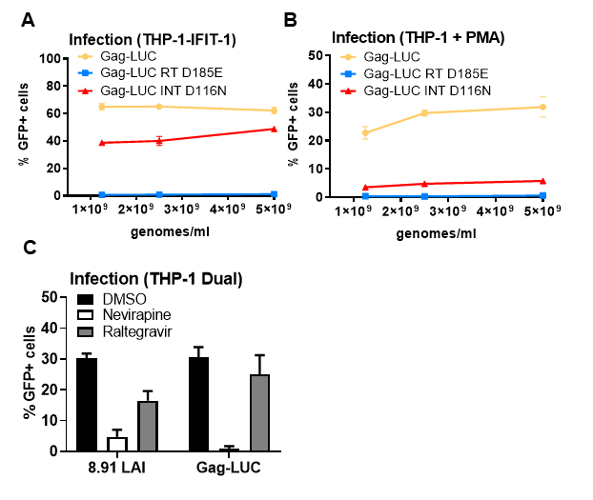
Suppl. Fig 3: ISG induction by HIV-1 Gag-fusion virus is RT-dependent
A: Infection data from Fig 3A. THP-1-IFIT-1 cells transduced for 48 h with Gag-LUC, RT-defective Gag-LUC (Gag-LUC RT D185E) or integrase-defective Gag-LUC (Gag-LUC INT D116N) at 1.25×10⁹, 2.5×10⁹ and 5×10⁹ genomes/ml.
B: Infection data from Fig 3B-D. PMA-treated THP-1 shSAMHD1 cells transduced for 48 h with Gag-LUC, Gag-LUC RT D185E or Gag-LUC INT D116N at 1.25×10⁹, 2.5×10⁹ and 5×10⁹ genomes/ml.
C: Infection data from Fig 3E-G. THP-1 Dual cells transduced for 48 h with 8.91 LAI or Gag-Luc (1.5 U RT/ml) in the presence of DMSO vehicle, 5 μM neviripine or 10 μM raltegravir.
Data are mean ± SD from biological triplicates of a single experiment, representative of at least 3 repeats.

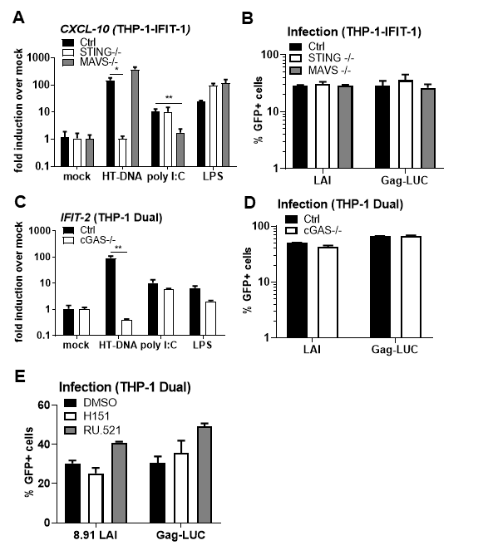
Suppl. Fig 4: ISG induction by HIV-1 Gag-fusion virus is dependent on cGAS and STING
A: CXCL-10 ISG qPCR from monocytic THP-1-IFIT-1 cells lacking STING or MAVS, or a gRNA control (Ctrl) cell line stimulated for 24 h with 0.1 μg/ml HT-DNA, 0.5 μg/ml poly I:C or 50 ng/ml LPS.
B: Infection data from Fig 4A-C. THP-1-IFIT-1 cells lacking STING or MAVS, or a gRNA control (Ctrl) cell line transduced for 48 h with WT LAI or Gag-LUC (1.5 U RT/ml).
C: IFIT-2 ISG qPCR from monocytic THP-1 Dual cells lacking cGAS, or a gRNA control (Ctrl) cell line stimulated for 24 h with 0.1 μg/ml HT-DNA, 0.5 μg/ml poly I:C or 50 ng/ml LPS.
D: Infection data from Fig 4D-F. THP-1 Dual cells lacking cGAS, or a gRNA control (Ctrl) cell line transduced for 48 h with WT LAI or Gag-LUC (1.5 U RT/ml).
E: Infection data from Fig 4G. THP-1 Dual cells lacking cGAS, or a gRNA control (Ctrl) cell line transduced for 48 h with WT LAI or Gag-LUC (1.5 U RT/ml) in the presence of DMSO vehicle, 0.5 μg/ml STING inhibitor H151 or 10 μg/ml cGAS inhibitor RU.521
Data are mean ± SD from biological triplicates of a single experiment, representative of at least 3 repeats. Statistical analyses were performed using Student's t‐test, with Welch's correction where appropriate, comparing to Ctrl cells as indicated. *P < 0.05, **P < 0.01.

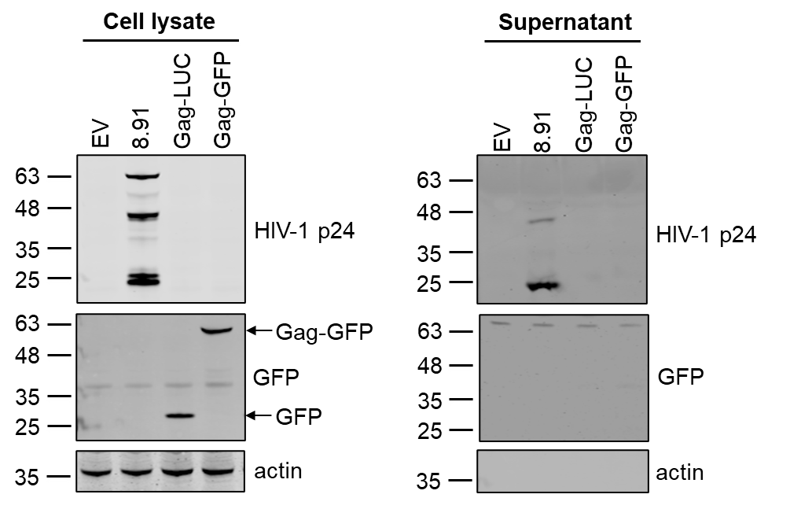
Suppl. Fig 5: Gag-fusion viruses display defects in Gag processing
Immunoblot of whole cell lysates or the supernatant from HEK293T cells transfected for 48 h with 8.91, Gag-LUC or Gag-GFP plasmids alone, or an empty vector (EV) as a control, detecting HIV-1 p24, GFP or actin. The Gag-GFP fusion (expressed from the Gag-GFP plasmid) and free GFP (expressed from the Gag-LUC plasmid) are indicated with arrows.
Suppl. Fig 6: Gag-fusion viruses have reduced capacity to saturate TRIM5α
Third replicate assay of data presented in Fig. 5B. FRhK4 cells were co-transduced with a fixed dose of WT LAI.GFP (5×10⁷ genomes/ml) and increasing doses of the WT/Gag-LUC chimeric viruses carrying a luciferase-expressing genome (0.0005 – 1 U RT/ml). Rescue of GFP infectivity was assessed by flow cytometry at 48 h. Data are singlet % GFP values.

