ERC Approval/Exemption Letter
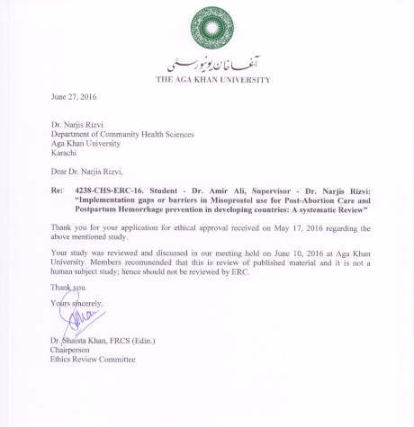

Waiver Letter

