Additional file 1

Annex I Search Strategy

Larson et al. 2015- January 2019
(maternal health[tiab] OR maternal service*[tiab] OR maternity care[tiab] OR maternal care[tiab] OR maternity service*[tiab] OR "Maternal Health"[mesh] OR "Maternal Health Services"[mesh]) AND (experience[tiab] OR experiences[tiab] OR patient-centered[tiab] OR woman centered[tiab] OR women centered[tiab] OR client centered[tiab] OR satisfaction[tiab] OR social support*[tiab] OR emotional support*[tiab] OR provider choice[tiab] OR choice of provider[tiab] OR wait time*[tiab] OR affordability[tiab] OR dignity[tiab] OR respect[tiab] OR privacy[tiab] OR confidentiality[tiab] OR discrimination[tiab] OR communication[tiab] OR disrespect[tiab] OR abuse[tiab] OR mistreatment[tiab] OR perception*[tiab])

Search Update February 2019- May 2023
(antenatal or prenatal or antepartum [Ti or Ab]) ; AND (experience[tiab] OR experiences[tiab] OR patient-centered[tiab] OR woman centered[tiab] OR women centered[tiab] OR client centered[tiab] OR satisfaction[tiab] OR social support*[tiab] OR emotional support*[tiab] OR provider choice[tiab] OR choice of provider[tiab] OR wait time*[tiab] OR affordability[tiab] OR dignity[tiab] OR respect[tiab] OR privacy[tiab] OR confidentiality[tiab] OR discrimination[tiab] OR communication[tiab] OR disrespect[tiab] OR abuse[tiab] OR mistreatment[tiab] OR perception*[tiab])

Annex II – Table 1. Typology of the mistreatment of women during childbirth.

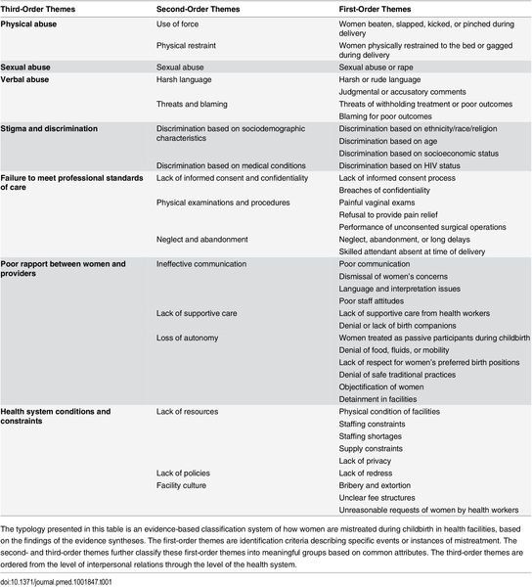
Bohren MA, Vogel JP, Hunter EC, Lutsiv O, Makh SK, et al. (2015) The Mistreatment of Women during Childbirth in Health Facilities Globally: A Mixed-Methods Systematic Review. PLOS Medicine 12(6): e1001847. https://doi.org/10.1371/journal.pmed.1001847
https://journals.plos.org/plosmedicine/article?id=10.1371/journal.pmed.1001847

Annex III – List of tools and measures available

Please visit for a complete list of tools and measures: https://docs.google.com/spreadsheets/d/1CuWdOinK7Fhf8dLCMyGeQiRdA0K9vldRUrCVKEBZ6Kg/edit?usp=sharing

