SUPPLEMENTARY MATERIALS
Table A1 Key indicators for SRHR and gender equality in Ethiopia, Kenya, Zimbabwe, and the World as a comparison
Indicator | World | Ethiopia | Kenya | Zimbabwe
Population, million (UNFPA, 2022) | 7 954 | 120.8 | 56.2 | 15.3
Life expectancy at birth female/male (UNFPA, 2022) | 76 / 71 | 70 / 66 | 70 / 65 | 64 / 60
Total Fertility Rate (UNFPA, 2022) | 2.4 | 3.9 | 3.3 | 3.3
Population with at least some secondary education, % of ages 25 and older, female/male (UNDP, 2021) (SDG4.4) | 64.2 / 70.3 | 9.1 / 20.1 | 31.1 / 37.7 | 61.8 / 72.4
Share of seats in parliament, % held by women (UNDP, 2021) (SDG5.5) | 25.9 | 39.5 | 23.2 | 34.6
Gender inequality index (GII) rank out of 170 countries (UNDP, 2021) | - | 129 | 128 | 134
Poverty headcount ratio at $2.15 a day (2017 PPP) (% of population)  (World Bank) | 8.4  (2017) | 27  (2015) | 29.4  (2015) | 39.8  (2019)
Maternal Mortality Ratio per 100.000 live births (UNFPA, 2017) (SDG3.1) | 211 | 401 | 342 | 458
Contraceptive prevalence rate modern methods, all women & married/in union aged 15–49 (UNFPA, 2022) | 44% all  57% married | 30% all  42% married | 43% all  59% married | 49% all  69% married
Adolescent birth rate, births per 1,000 girls/women aged 15-19 (UNDP, 2021) (SDG3.7) | 42.5 | 69.2 | 64.2 | 94.3
Child marriage <18 years old (UNFPA, 2005–2020) | 26% | 40% | 23% | 34%
FGM girls aged 15–19 (UNFPA, 2004–2020) | - | 65% | 21% | -
Intimate partner violence, past 12 months (UNFPA 2018) | 13% | 27% | 23% | 18%
Decision making on sexual and reproductive health and reproductive rights (UNFPA, 2007–2020) | 57% | 45% | 56% | 60%
Grounds for right to abortion  (Center for Reproductive Rights, 2020) | - | Broad social or economic grounds | Preserve Health | Preserve Health
Criminalization of consensual same-sex sexual acts between adults (ILGA, 2020) | - | YES Up to 8 years prison | YES 10 years to life in prison | YES Up to 8 years prison

Sources: https://www.unfpa.org/data/world-population/ET
https://www.unfpa.org/data/world-population/KE
https://www.unfpa.org/data/world-population/NG
https://www.unfpa.org/data/world-population/ZW
World Bank data: https://data.worldbank.org/
UNFPA: https://www.unfpa.org/data/world-population-dashboard
UNDP: https://hdr.undp.org/data-center/documentation-and-downloads
Center for Reproductive Rights: https://reproductiverights.org/worldabortionlaws
ILGA: https://ilga.org/maps-sexual-orientation-laws

Table A1 Overview of WVS survey items included in the analysis along with response options
Item | Response options
Justifiable: To use contraceptives | 10-graded scale always-never justified
Justifiable: Female genital circumcision | 10-graded scale always-never justified
Justifiable: Prostitution | 10-graded scale always-never justified
Justifiable: For a man to beat his wife | 10-graded scale always-never justified
Justifiable: Parents beating children | 10-graded scale always-never justified
Justifiable: Sex before marriage | 10-graded scale always-never justified
Justifiable: Having casual sex | 10-graded scale always-never justified
Justifiable: Divorce | 10-graded scale always-never justified
Justifiable: Homosexuality | 10-graded scale always-never justified
Justifiable: Abortion | 10-graded scale always-never justified
Honor-related oppression deals with the fact that the family or relatives decide primarily on young women’s life choices. What is your opinion? | 10-graded scale can never be accepted–should always be accepted
Only when a woman has a child is she a real woman | Strongly agree, agree, disagree, or strongly disagree
Having a son is always better than having a daughter | Strongly agree, agree, disagree, or strongly disagree
It’s a woman’s responsibility to avoid getting pregnant | Strongly agree, agree, disagree, or strongly disagree
A man should use violence, if necessary, to get respect | Strongly agree, agree, disagree, or strongly disagree
A man shouldn't have to do household chores | Strongly agree, agree, disagree, or strongly disagree
It is acceptable to have sex with someone in exchange for gifts and favors | Strongly agree, agree, disagree, or strongly disagree
People who dress, act or identify as the opposite sex should be treated just as anyone else | Strongly agree, agree, disagree, or strongly disagree
A "real man" should have as many sexual partners as he can | Strongly agree, agree, disagree, or strongly disagree
A man who talks a lot about his worries, fears, and problems doesn’t deserve respect | Strongly agree, agree, disagree, or strongly disagree
A homosexual guy is not a "real man" | Strongly agree, agree, disagree, or strongly disagree
A man who cannot father children is not a real man | Strongly agree, agree, disagree, or strongly disagree
Sexuality education helps people make informed decisions | Strongly agree, agree, disagree, or strongly disagree
Women should have access to safe abortion services (to terminate an unwanted pregnancy) | Strongly agree, agree, disagree, or strongly disagree
A couple who wants to have children but cannot conceive should have access to infertility services | Strongly agree, agree, disagree, or strongly disagree
Even if a girl does not want to be married, she should honor the decisions/wishes of her family | Strongly agree, agree, disagree, or strongly disagree
Even if a boy does not want to be married, he should honor the decisions/wishes of his family | Strongly agree, agree, disagree, or strongly disagree
A girl should wait to have children until she is at least 18 years old, even if she is married | Strongly agree, agree, disagree, or strongly disagree
It is safer for a woman to give birth at a clinic than at home | Strongly agree, agree, disagree, or strongly disagree
A girl is ready for marriage once she starts menstruating | Strongly agree, agree, disagree, or strongly disagree
Contraceptives should be available for everyone, whether or not one is married | Strongly agree, agree, disagree, or strongly disagree
If a man has a girlfriend or wife, he should know where she is all the time | Strongly agree, agree, disagree, or strongly disagree
No-one else should interfere when it comes to violence within a family | Strongly agree, agree, disagree, or strongly disagree
There is no doubt that gainful employment is good but that what most women really want is a home and children | Strongly agree, agree, disagree, or strongly disagree
A woman should tolerate violence to keep the family together | Strongly agree, agree, disagree, or strongly disagree
A man should always have the final say about decisions in his relationship or marriage | Strongly agree, agree, disagree, or strongly disagree
On the whole, family life suffers when women work full time | Strongly agree, agree, disagree, or strongly disagree
It is a man’s job to earn money and a women’s job to take care of home and family | Strongly agree, agree, disagree, or strongly disagree
Sexuality education promotes sexual activity among young people | Strongly agree, agree, disagree, or strongly disagree
A woman who shows that she is interested in sex is considered indecent/rude/illmannered/vulgar | Strongly agree, agree, disagree, or strongly disagree
A husband shouldn’t have to do household chores | Strongly agree, agree, disagree, or strongly disagree
A man who discusses important decisions with his wife is considered weak | Strongly agree, agree, disagree, or strongly disagree
A man should pay more attention to his mother's opinion than his wife's | Strongly agree, agree, disagree, or strongly disagree
Men may use violence to keep their wives in line | Strongly agree, agree, disagree, or strongly disagree
Parents may use violence or threats when bringing up their children | Strongly agree, agree, disagree, or strongly disagree
It is a man’s duty to exercise guardianship over his female relatives | Strongly agree, agree, disagree, or strongly disagree
It is not good for a boy to be taught how to cook, sew, clean the house, and take care of younger children | Strongly agree, agree, disagree, or strongly disagree
Men should really be the ones to bring money home to provide for their families, not women | Strongly agree, agree, disagree, or strongly disagree
When a mother works for pay, the children suffer | Strongly agree, agree, disagree, or strongly disagree
On the whole, men make better political leaders than women | Strongly agree, agree, disagree, or strongly disagree
A university education is more important for a boy than a girl | Strongly agree, agree, disagree, or strongly disagree
On the whole, men make better business leaders than women do | Strongly agree, agree, disagree, or strongly disagree
Being a housewife is just as fulfilling as working for pay | Strongly agree, agree, disagree, or strongly disagree
Homosexual couples are as good parents as other couples | Strongly agree, agree, neither agree nor disagree, disagree, or strongly disagree
How frequently do the following occur in your neighborhood: Sexual assault/rape | Very frequently, quite frequently, not frequently, or not at all
How frequently do the following occur in your neighborhood: Men and boys hurting women and girl | Very frequently, quite frequently, not frequently, or not at all
How frequently do the following occur in your neighborhood: Men and boys making unwanted sexual comments or gestures toward girls or women | Very frequently, quite frequently, not frequently, or not at all
How frequently do the following occur in your neighborhood: Women and girls trading sex for money | Very frequently, quite frequently, not frequently, or not at all

Table A3 Final five-factor solution with loadings for each of the 23 variables in the SRHR Support Index
Variable | Factor 1 | Factor 2 | Factor 3 | Factor 4 | Factor 5 | Unique-ness | Variable names | Comment
FACTOR 1: “Sexual and Reproductive Rights”
Q182 | 0.8557 | 0.0359 | -0.0332 | 0.0007 | -0.0779 | 0.2676 | Justifiable: Homosexuality | *
Q183 | 0.8838 | 0.0096 | -0.0263 | 0.0472 | -0.0453 | 0.2275 | Justifiable: Prostitution
Q184 | 0.8413 | 0.0283 | 0.0346 | 0.0112 | 0.0532 | 0.2834 | Justifiable: Abortion | *
Q185 | 0.6642 | 0.0011 | 0.0390 | 0.0687 | 0.1005 | 0.5383 | Justifiable: Divorce | *
Q186 | 0.7625 | -0.0215 | 0.0271 | -0.0249 | 0.0806 | 0.4012 | Justifiable: Sex before marriage
Q189 | -0.7236 | 0.0298 | 0.0782 | 0.0361 | 0.0796 | 0.4614 | Justifiable: For a man to beat his wife
Q193 | 0.8295 | -0.0069 | 0.0096 | -0.0301 | 0.0041 | 0.3055 | Justifiable: Having casual sex
FACTOR 2: “Neighborhood Sexual Safety”
H311 | 0.0114 | 0.7112 | -0.0481 | 0.0839 | 0.0234 | 0.4848 | How often in neighborhood: Sexual assault/rape
H312 | 0.0190 | 0.8347 | 0.0597 | -0.0249 | -0.0017 | 0.2949 | How often in neighborhood: Women and girls trading sex for money
H313 | -0.0045 | 0.9159 | -0.0082 | 0.0417 | 0.0300 | 0.1554 | How often in neighborhood: Men and boys hurting women and girls
H314 | 0.0175 | 0.8731 | -0.0151 | -0.0784 | -0.0767 | 0.2304 | How often in neighborhood: Men and boys making unwanted sexual comments or gestures toward girls or women
FACTOR 3: “Gender-Equitable Relationships”
H325 | -0.0449 | -0.0553 | 0.5623 | 0.0946 | 0.0048 | 0.6480 | A man should always have the final say about decisions in his relationship or marriage
H326 | 0.0472 | -0.0743 | 0.5950 | -0.0091 | -0.0434 | 0.6473 | If a man has a girlfriend or wife, he should know where she is all the time | (Z)
H328 | -0.0061 | 0.0091 | 0.7346 | -0.0559 | -0.0344 | 0.4808 | Gainful employment is good but home and children is what most women really want
H329 | 0.1208 | -0.0245 | 0.5770 | 0.0320 | -0.0421 | 0.6402 | On the whole, family life suffers when women works full time | (K)
H330 | -0.1046 | 0.0875 | 0.6746 | 0.0213 | 0.0259 | 0.5113 | It is a man's job to earn money and a woman's job to take care of home and family
FACTOR 4: “Masculinity norms”
H348 | -0.0297 | 0.0507 | 0.1255 | 0.5366 | 0.0443 | 0.6372 | A man who talks a lot about his worries, fears, and problems doesn't reserve respect | **
H350 | -0.0050 | -0.0147 | -0.0704 | 0.7941 | 0.0075 | 0.3921 | A real man should have as many sexual partners as he can | **
H351 | 0.0419 | -0.0093 | 0.0415 | 0.8186 | 0.0044 | 0.3132 | A man should use violence, to get respect, if necessary | **
FACTOR 5: “Sexual and Reproductive Health and Rights Interventions”
H337 | 0.0072 | 0.1008 | 0.1836 | -0.2230 | 0.5261 | 0.6871 | Women should have access to safe abortion services (to terminate an unwanted pregnancy)
H341 | 0.0224 | -0.0719 | -0.0483 | -0.0650 | 0.5808 | 0.6658 | Contraceptives should be available for everyone, whether or not one is married | (E)
H343 | 0.0589 | -0.0643 | -0.0689 | 0.1067 | 0.6184 | 0.5741 | Sexual education helps people make informed decisions
H344 | -0.1116 | 0.0282 | -0.0645 | 0.1355 | 0.6021 | 0.5793 | A couple who cannot conceive should have access to infertility services
Notes: Variables with low loading (<0.50) and high uniqueness (>0.70) are marked (E) for Ethiopia, (K) for Kenya, and (Z) for Zimbabwe.
*=variable included in WVS Choice Index; **=variable included in Man Box Scale

Table A4 Correlation matrix of scores derived from the final five-factor model
 | Factor 1 | Factor 2 | Factor 3 | Factor 4 | Factor 5
Factor 1 | 1
Factor 2 | -0.03 | 1
Factor 3 | 0.11 | 0.11 | 1
Factor 4 | -0.13 | 0.05 | 0.30 | 1
Factor 5 | 0.15 | -0.03 | 0.18 | 0.20 | 1

Table A5 Sociodemographic characteristics of the full sample (n=3,711)
Variable | n | %
Age
18–24 | 1,029 | 27.73
25–29 | 729 | 19.64
30–39 | 922 | 24.85
40–49 | 511 | 13.77
50–99 | 509 | 13.72
Missing | 11 | 0.30
Sex
Man | 1,859 | 50.09
Woman | 1,845 | 49.72
Missing | 7 | 0.19
Place of residence
Urban | 1,410 | 38.00
Rural | 2,301 | 62.00
Relationship status
Married or cohabiting | 2,189 | 58.99
Divorced, separated, or widowed | 377 | 10.16
Single | 1,138 | 30.67
Missing | 7 | 0.19
Education
Primary or lower | 1,878 | 50.61
Secondary | 1,238 | 33.36
Tertiary | 581 | 15.66
Missing | 14 | 0.38
Country
Ethiopia | 1,230 | 33.14
Kenya | 1,266 | 34.11
Zimbabwe | 1,215 | 32.74
TOTAL | 3,711 | 100.0

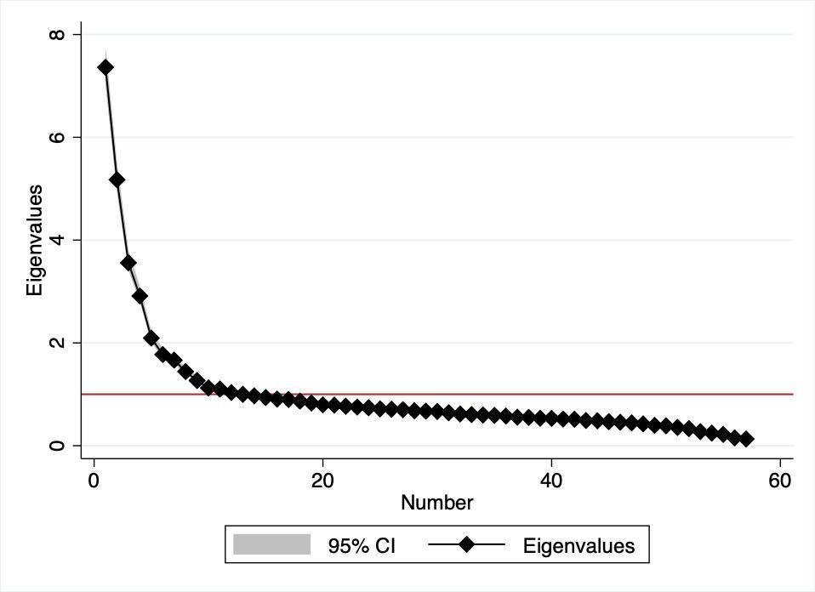
Figure A1 Scree plot of pooled Exploratory Factor Analysis (EFA) with the initial 58 items (N=2,722)

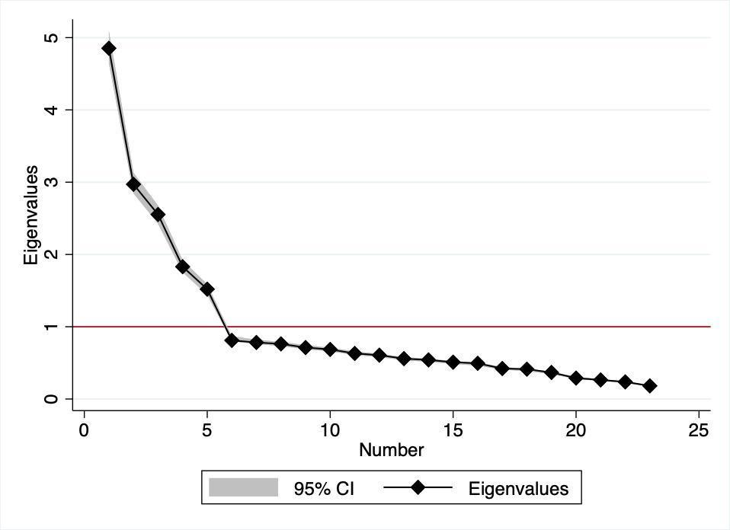
Figure A2 Scree plot of pooled Exploratory Factor Analysis (EFA) with the retained 23 items for the SRHR Support Index (n=3,135)

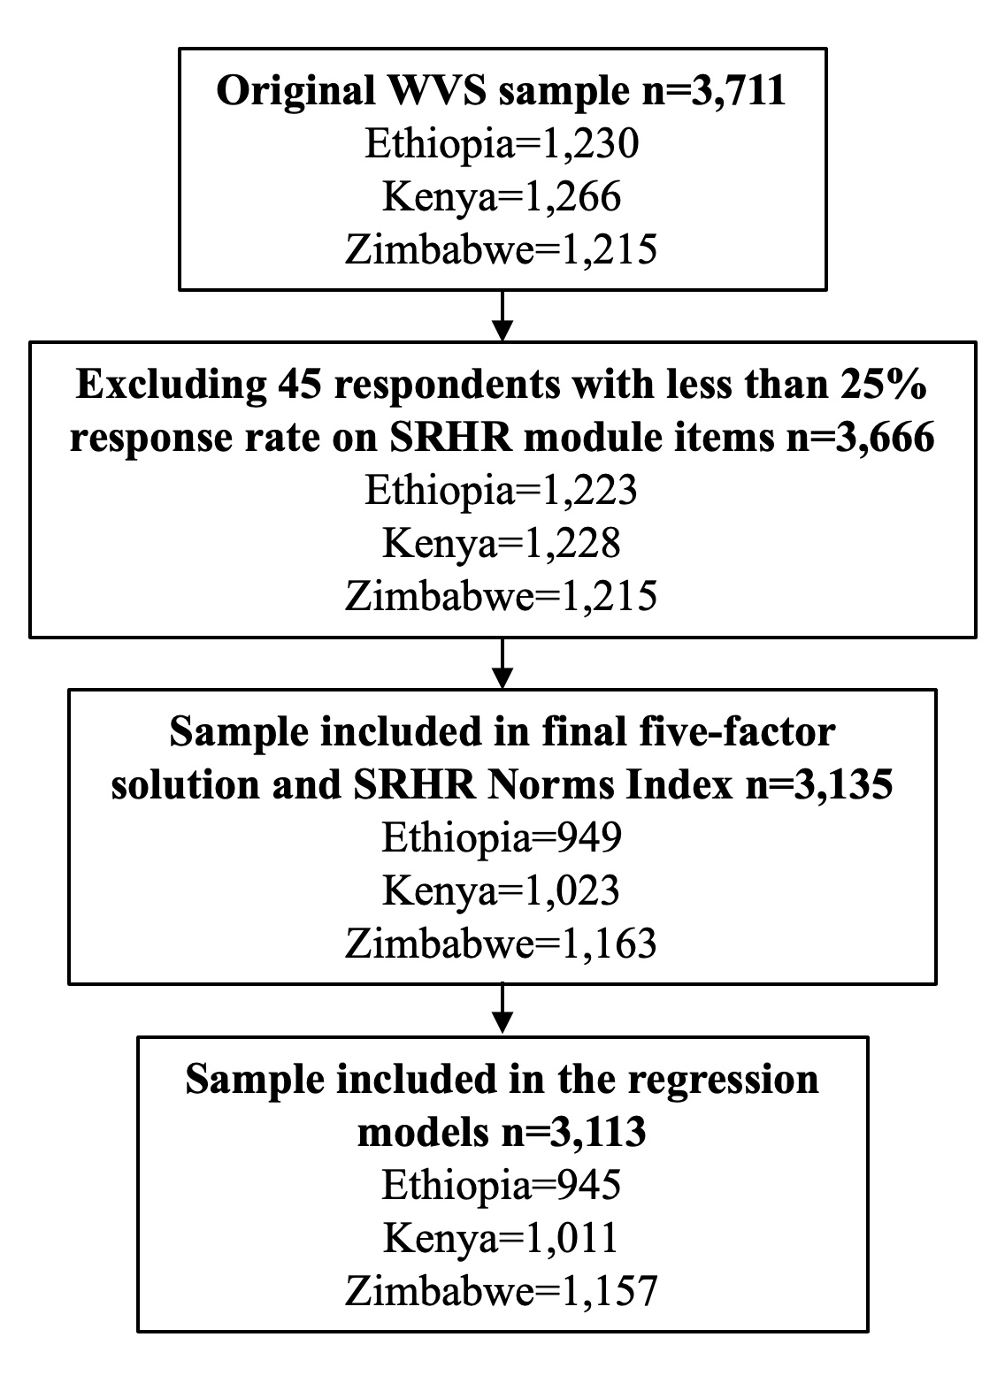
Figure A3 Sample selection flowchart

