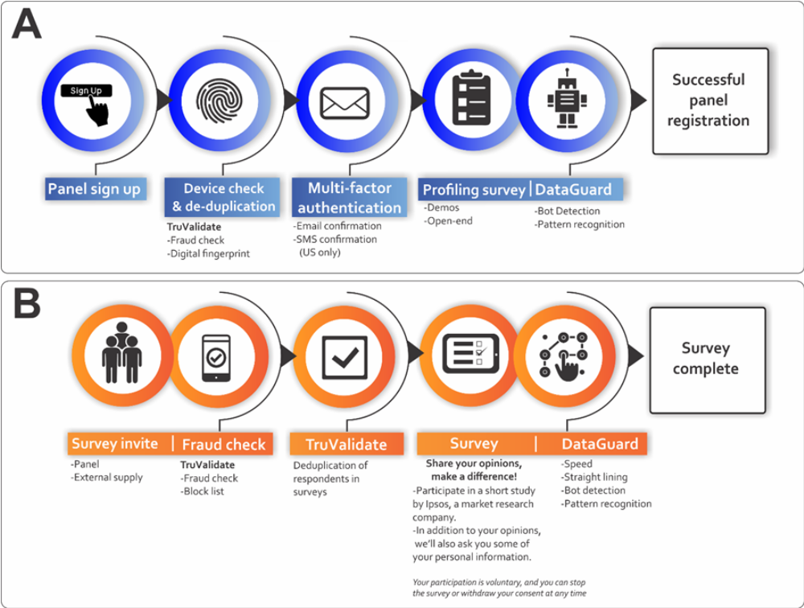Supplementary Figure S1. Ipsos i-Say respondent registration process and survey completion A) panel registration and B) in-survey completion. The survey questionnaire was distributed electronically through Ipsos proprietary i-Say panel as outlined (Supplementary Figure S1), namely in the form of 2 processes A) panel registration and B) in-survey completion. The Ipsos protocol has been published elsewhere [22-24]. In brief, prospective Ipsos panellists interested in partaking in the survey were recruited via a multi-source recruitment process referred by various partner panels known to meet the quality of Ipsos and Global Research Standards. Ipsos additionally partners with TransUnion – an American consumer credit reporting agency – for the use of digital fingerprinting technology known as TruValidate. TruValidate passively collects respondent information associated with the device entering the panel registration and survey link. A unique identifier was issued to the respondents’ device based on its distinctive characteristics. The device was then reviewed against a set of business rules and regulations created by Ipsos to score the likelihood of fraud (fraud check). The device identification is checked to prevent the creation of multiple panel accounts and to ensure that multiple entries into the same survey are ultimately avoided (deduplication). The TruValidate process is deployed at the panel registration and then again in-survey. It is still, however, possible for fraudulent respondents to create multiple digital fingerprints by using different device and account combinations to bypass systems. Digital fingerprinting is one element within a multi-layered suite of tools and systems to mitigate this limitation. Others include the use of Multi-Factor authentication during recruitment (respondent email account and/or cellphone number confirmation), the checking of respondents’ contact details against existing i-Say accounts and checking blocked accounts. Lastly, Ipsos incorporates a newly rebuilt and rebranded tool known as Dataguard, which is a cyber robot designed to detect open ends (copied and pasted text, programmatic text insertion, look-up versus known bad, or suspect responses; exaggerated, and/or unrealistic typing speed; exaggerated, or unrealistic reaction time after question loads), data pattern recognition (algorithms to review new panellists and flag those that match the profile of known fraudsters); speeding (measures the pace of survey completion in answers per minute) and straight lining (identifies respondents who gave the same answer to all statements in a grid question). In the event a respondent is caught by Dataguard, respondents are automatically removed from the survey in real-time.

Supplementary Figure S2. Radar chart showing the relative importance of seven factors before pregnancy in a pooled sample of respondents (n=5000). Higher scores positioned at the outer edge represent lower importance despite their higher values.

Supplementary Figure S3. Radar chart showing the relative importance of health education/information before pregnancy in a pooled sample of respondents (n=5000). Higher scores positioned at the outer edge represent lower importance despite their higher values.

Men
Women
Supplementary Figure S4. Radar chart showing the relative importance of seven factors before pregnancy across the 5 distinct countries between the sexes (n=5000). Higher scores positioned at the outer edge represent lower importance despite their higher values.
Men
Women
Supplementary Figure S5. Radar chart showing the relative importance of health education/information before pregnancy across the 5 distinct countries between the sexes (n=5000). Higher scores positioned at the outer edge represent lower importance despite their higher values.

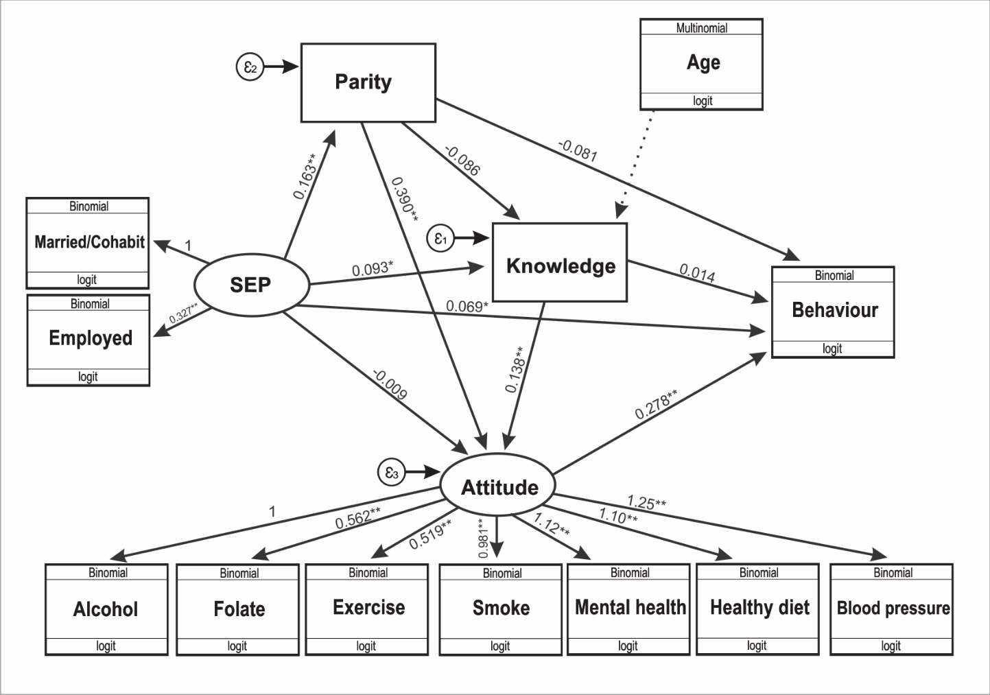

Supplementary Table S1. Preconception health knowledge, attitudes, behavioural intent and preferences prior to conception data survey.
Preconception health knowledge
For the next set of questions, we are going to ask about your health knowledge. Please read the question and then select the correct answer from the listed answers
Question | Answer
What percentage of pregnancies are unplanned in your country? | Country specific
If you are thinking about getting pregnant, when is the right time for you and your partner to visit a family doctor, nurse, or other health care provider (which of the answers below is the correct answer)? | [1] Right now, before you are pregnant  [2] As soon as you discover you are pregnant  [3] After you have been pregnant for 3 months  [4] The timing of the first visit is not important  [5] Don’t know
Success of getting pregnant (either on your own or with medical help like in vitro fertilisation) is lower for women who are (which of the answers below is the correct answer)? | [1] In their late 20s or older  [2] In their early 30s or older  [3] In their late 30s or older  [4] Don’t know
The quality of a man’s sperm decreases: (which of the answers below is the correct answer)? | [1] In his mid-30s and older  [2] In his mid-40s and older  [3] In his mid-50s and older  [4] Don’t know
Sexually transmitted infections (STIs): (which of the answers below is the correct answer)? | [1] Cannot affect fertility  [2] Cannot be passed on to the infant during pregnancy and/or birth  [3] May not have symptoms that you can detect  [4] Don’t know
If you have a chronic medical condition (for example hypertension, diabetes, depression), it is important to speak with your health care provider before getting pregnant to: (which of the answers below is the correct answer)? | [1] Ensure your condition is under control  [2] Review your medications  [3] Discuss potential risks to fertility and pregnancy  [4] All of the above  [5] Don’t know
If you are taking medications, it is important to: (which of the answers below is the correct answer)? | [1] Stop taking them before getting pregnant  [2] Talk with your health care provider to review them and discuss impacts on pregnancy  [3] Always change the type and amount before getting pregnant  [4] Don’t know
Which of the following could impact the health of your pregnancy (which of the answers below is the correct answer)? | [1] Prescription medications  [2] Over-the-counter medications  [3] Herbal products  [4] All of the above  [5] Don’t know
A history of depression or anxiety before pregnancy in women: (which of the answers below is the correct answer)? | [1] May increase risk of depression and anxiety after the baby is born  [2] Should be discussed with a health care provider before getting pregnant  [3] Is a risk factor for complications in pregnancy, like preterm delivery  [4] All of the above  [5] Don’t know
A history of depression or anxiety before pregnancy in men: (which of the answers below is the correct answer)? | [1] May increase risk of depression and anxiety after the baby is born  [2] Should be discussed with a health care provider before getting pregnant  [3] Is a risk factor for complications in pregnancy, like preterm delivery  [4] All of the above  [5] Don’t know
Some things you can do to improve mental health include: (which of the answers below is the correct answer)? | [1] Getting 7 to 8 hours of sleep every night  [2] Eating a balanced diet  [3] Exercising regularly  [4] Talking to your health care provider if you experience any symptoms  [5] All of the above  [6] Don’t know
Which of the following can be negatively impact fertility and pregnancy (which of the answers below is the correct answer)? | [1] Smoking tobacco products  [2] Smoking e-cigarettes  [3] Being exposed to second-hand smoke  [4] All of the above  [5] Don’t know
How many alcoholic drinks should women who are pregnant or planning a pregnancy have (which of the answers below is the correct answer)? | [1] A few sips  [2] One drink per month  [3] Three drinks per month  [4] No amount of alcohol is known to be safe during pregnancy  [5] Don’t know
Being overweight, obese or underweight can affect: (which of the answers below is the correct answer)? | [1] Your health  [2] Your fertility  [3] Having a healthy pregnancy  [4] All of the above  [5] Don’t know
A healthy weight gain in pregnancy is: (which of the answers below is the correct answer)? | [1] 4.5-9kg  [2] 9-13.5kg  [3] It depends on weight before pregnancy and your height  [4] Don’t know
Folic acid should be taken by: (which of the answers below is the correct answer)? | [1] Women during pregnancy  [2] Women planning a pregnancy  [3] Women with a baby who had a neural tube defect  [4] All women of reproductive age who could become pregnant, whether or not they are planning a pregnancy  [5] All of the above  [6] Don’t know
Healthy nutrition, which can improve your fertility and chances of a healthy pregnancy, should include: (which of the answers below is the correct answer)? | [1] A diet high in folic acid  [2] Reduced caffeine intake  [3] A balanced diet  [4] All of the above  [5] Don’t know
How much moderate/vigorous physical activity (exercise sufficient to cause sweating) should adults get per week (which of the answers below is the correct answer)? | [1] 30 minutes or more  [2] 60 minutes or more  [3] 120 minutes or more  [4] 150 minutes or more  [5] Don’t know
Feeling very stressed or not having enough money to make ends meet may: (which of the answers below is the correct answer)? | [1] Impact fertility  [2] Cause complications in pregnancy and birth  [3] can impact the baby after birth  [4] All of the above  [5] Don’t know
Intimate partner violence tends to: (which of the answers below is the correct answer)? | [1] Stay the same in pregnancy  [2] Increase in pregnancy  [3] Decrease in pregnancy  [4] Don’t know
Some types of fish should be avoided when planning a pregnancy or in pregnancy because: (which of the answers below is the correct answer)? | [1] They may contain mercury  [2] They may contain radiation  [3] They may contain solvents  [4] All of the above  [5] Don’t know
Which of the following describes a partner’s role in preparing for pregnancy: (which of the answers below is the correct answer)? | [1] Partners should be screened for sexually transmitted infections  [2] Partners should make healthy food and lifestyle choices  [3] Partners should talk to their physicians about their health  [4] All of the above  [5] Don’t know
Attitudes
For each of these lifestyle or health changes before pregnancy, how important would you rate them.
Factor | Response
Take folate | [1] Not at all important  [2] Slightly important  [3] Fairly important  [4] Very important
Avoid alcohol | [1] Not at all important  [2] Slightly important  [3] Fairly important  [4] Very important
Eat healthy | [1] Not at all important  [2] Slightly important  [3] Fairly important  [4] Very important
Avoid smoking | [1] Not at all important  [2] Slightly important  [3] Fairly important  [4] Very important
Exercise daily | [1] Not at all important  [2] Slightly important  [3] Fairly important  [4] Very important
Maintain good mental health | [1] Not at all important  [2] Slightly important  [3] Fairly important  [4] Very important
Check blood pressure regularly | [1] Not at all important  [2] Slightly important  [3] Fairly important  [4] Very important
Behavioural intent
Question | Response
If you and your partner were planning a pregnancy how likely would you access preconception services if they were available at your clinic? | [1] Highly unlikely  [2] Unlikely  [3] Likely  [4] Highly likely
Relative importance of factors before pregnancy
How important are the following factors before pregnancy? Please rank these factors from most important to least important
Factor | Response
Relationships and family | [1 = most preferred; 7 = least preferred]
Physical health | [1 = most preferred; 7 = least preferred]
Money | [1 = most preferred; 7 = least preferred]
Mental health | [1 = most preferred; 7 = least preferred]
Climate | [1 = most preferred; 7 = least preferred]
Work or education | [1 = most preferred; 7 = least preferred]
Living conditions | [1 = most preferred; 7 = least preferred]
Preferred sources of health education/information
Please rank the following sources of health education/information you would prefer the most to least before you or your partner became pregnant
Factor | Response
Nurses | [1 = most preferred; 7 = least preferred]
Family + friends | [1 = most preferred; 7 = least preferred]
Clinic doctor | [1 = most preferred; 7 = least preferred]
Magazines/newspapers | [1 = most preferred; 7 = least preferred]
Media/social media | [1 = most preferred; 7 = least preferred]
Pharmacist | [1 = most preferred; 7 = least preferred]
Obstetrician/gynaecologist | [1 = most preferred; 7 = least preferred]

