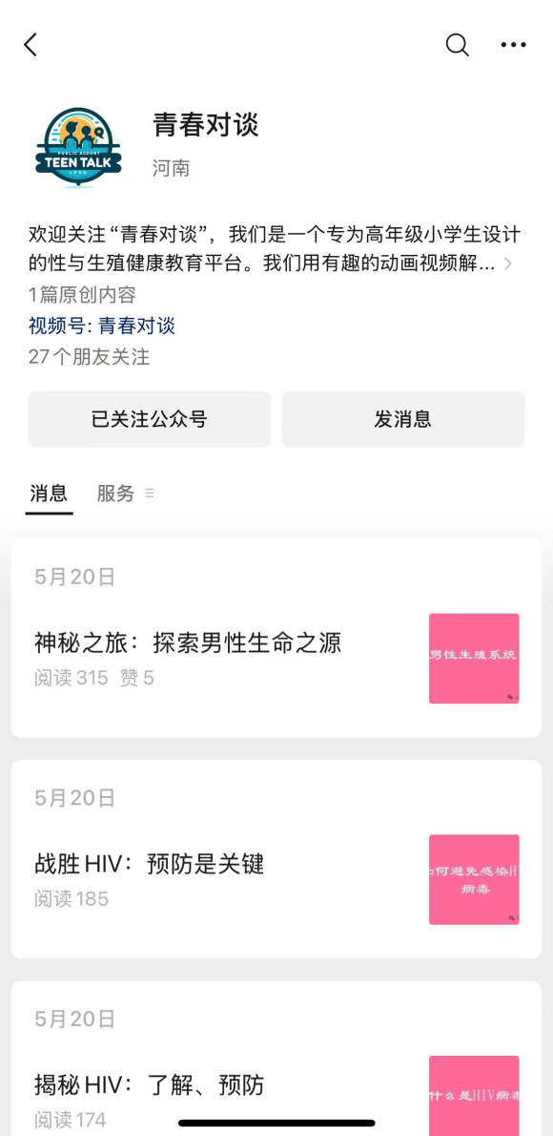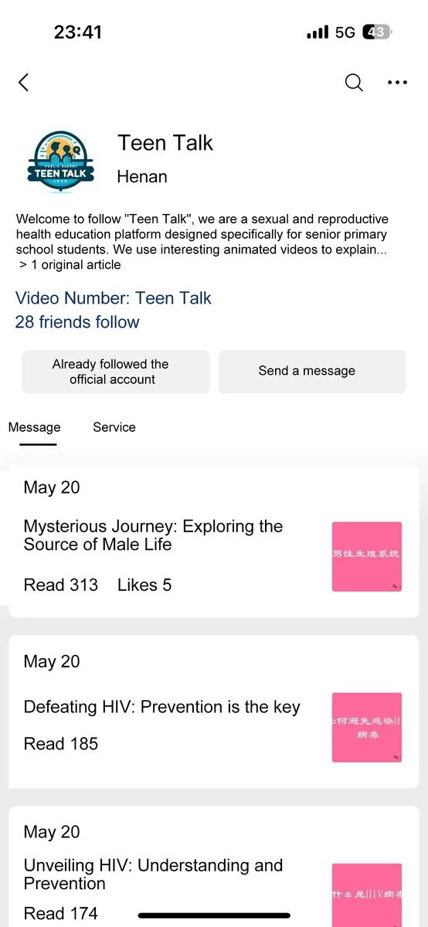
(a)Original Image (b) Translated Version
Additional file 1. Teen Talk: the online SRH educational resource.

