Supplementary Tables
Tables
Table S1 summarizes the predictive performance of the ML-based models on the training set. Overall, the stacking ensemble achieved the accuracy of 67.8% (95% CI: 61.5–70.1) and F1-score of 54.3% (95% CI: 51.7–55.6), and the lowest Brier score of 19.1% (95% CI: 18.3-20.3) with an AUC of 0.677 (95% CI: 0.665–0.689). The artificial neural network also demonstrated relatively high accuracy (66.4%) and sensitivity (70.8%), although with lower precision.
Among the tree-based models including CatBoost and XGBoost showed comparable performance, with AUC values of 0.677 (95% CI: 0.664-0.690) and 0.676 (95% CI: 0.665-0.689), respectively, and balanced trade-offs between sensitivity and precision. RF-based model achieved moderate discrimination (AUC: 0.669) with higher sensitivity than LR model. LR-based model exhibited the lowest sensitivity of 48.3% (95% CI: 46.6-76.7) and F1-score of 46.9% (95% CI: 46.1-53.2) among all evaluated models.
Table S1: Performance comparison of machine-learning models on the training set
Models | ACC (%) | PRE (%) | SEN (%) | F1-score (%) | Brier score (%) | AUC (%)
LR | 64.7 (55.0-65.9) | 46.8 (40.1-48.6) | 48.3 (46.6-76.7) | 46.9 (46.1-53.2) | 22.4 (21.9-23.6) | 0.654 (0.632-0.667)
RF | 64.1 (62.1-65.6) | 46.7 (44.4-48.5) | 62.4 (59.0-67.6) | 52.3 (50.8-54.2) | 22.1 (21.5-23.2) | 0.669 (0.656-0.681)
XGBoost | 64.7 (61.2-66.2) | 47.4 (44.3-49.6) | 62.0 (58.5-71.9) | 52.9 (51.6-55.0) | 21.9 (20.8-23.3) | 0.676 (0.665-0.689)
CatBoost | 63.8 (60.9-66.7) | 46.5 (43.9-50.0) | 65.2 (57.8-72.9) | 53.5 (51.6-55.8) | 20.2 (19.1-21.4) | 0.677 (0.664-0.690)
ANN | 66.4 (61.3-68.6) | 43.4 (42.5-47.4) | 70.8 (58.0-72.3) | 53.3 (50.6-54.6) | 19.4 (18.5-20.5) | 0.664 (0.652-0.677)
Stacking | 67.8 (61.5-70.1) | 44.9 (43.8-49.5) | 70.6 (56.1-72.2) | 54.3 (51.7-55.6) | 19.1 (18.3-20.3) | 0.677 (0.665-0.689)
LR: Logistics regression; RF: Random Forest; XGBoost: Extreme gradient bosting; CatBoost: Categorical gradient boosting; ANN: Artificial neural network; ACC: Accuracy; PRE: Precision; SEN: Sensitivity; AUC: Area under the curve
The predictive performance of the ML-based models using the union of features selected by Boruta and LASSO on the test set is presented in Table S2. The stacking ensemble model achieved the overall accuracy of 66.9% (95% CI: 49.2–70.4), and the AUC of 0.675 (95% CI: 0.637–0.701), indicating the best overall discriminative performance among the evaluated models. LR-based model showed the moderate accuracy of 64.3% (95% CI: 44.7-71.5) but lower F1-score 36.1% (95% CI: 33.8-39.5), reflecting limited balance between sensitivity and precision.
CatBoost and XGBoost demonstrated comparable performance, with AUC values of 0.668 (95% CI: 0.641-0.695) and 0.665 (95% CI: 0.636-0.691), respectively. RF-based models and ANN achieved a higher sensitivity (69.4% (95% CI: 58.2-77.2) and 81.1% (95% CI: 46.2-84.5), respectively) at the expense of lower specificity, whereas the stacking model maintained a more balanced trade-off between sensitivity of 59.6% (95% CI: 50.7-83.5) and specificity of 65.7% (95% CI: 41.2-74.2), along with the lowest Brier score of 14.1% (95% CI: 13.1-15.0). Overall, the F1-score were modest across all models, consistent with the presence of class imbalance.
Table S2. Performance comparison of ML-based model performances using union of features selected by Boruta and LASSO on test set
Models | ACC (%) | SEN (%) | SPE (%) | F1-score (%) | Brier score (%) | AUC
LR | 64.3 (44.7-71.5) | 55.8 (44.9-85.9) | 66.2 (36.1-77.4) | 36.1 (33.8-39.5) | 23.6 (23.2-24.1) | 0.647 (0.619-0.673)
RF | 58.4 (54.0-66.0) | 69.4 (58.2-77.2) | 55.9 (49.9-67.1) | 37.5 (35.1-41.2) | 23.0 (22.7-23.4) | 0.658 (0.632-0.684)
XGBoost | 59.0 (47.3-70.3) | 67.3 (49.9-84.7) | 57.2 (39.6-74.5) | 37.2 (34.7-40.7) | 22.7 (22.2-23.3) | 0.665 (0.636-0.691)
CatBoost | 60.7 (48.9-70.7) | 65.9 (50.7-82.9) | 59.6 (41.5-74.9) | 37.7 (35.1-41.4) | 22.7 (22.3-23.2) | 0.668 (0.641-0.695)
ANN | 58.3 (47.8-69.4) | 81.1 (46.2-84.5) | 40.8 (39.3-75.8) | 36.0 (33.4-39.2) | 14.5 (13.5-15.5) | 0.635 (0.608-0.661)
Stacking | 66.9 (49.2-70.4) | 59.6 (50.7-83.5) | 65.7 (41.2-74.2) | 37.8 (34.9-41.1) | 14.1 (13.1-15.0) | 0.675 (0.637-0.701)
LR: Logistics regression; RF: Random Forest; XGBoost: Extreme gradient bosting; CatBoost: Categorical gradient boosting; ANN: Artificial neural network; ACC: Accuracy; PRE: Precision; SEN: Sensitivity; SPE: Specificity; AUC: Area under the curve

Figures
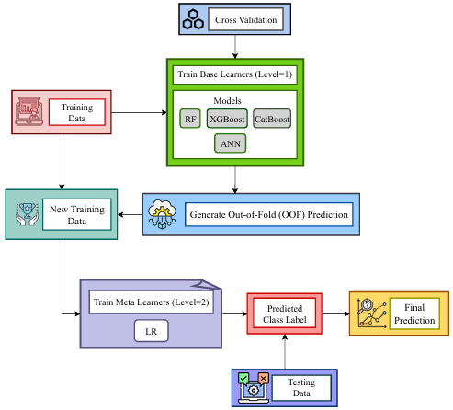
Figure S1. Pipeline building for stacking ensemble model

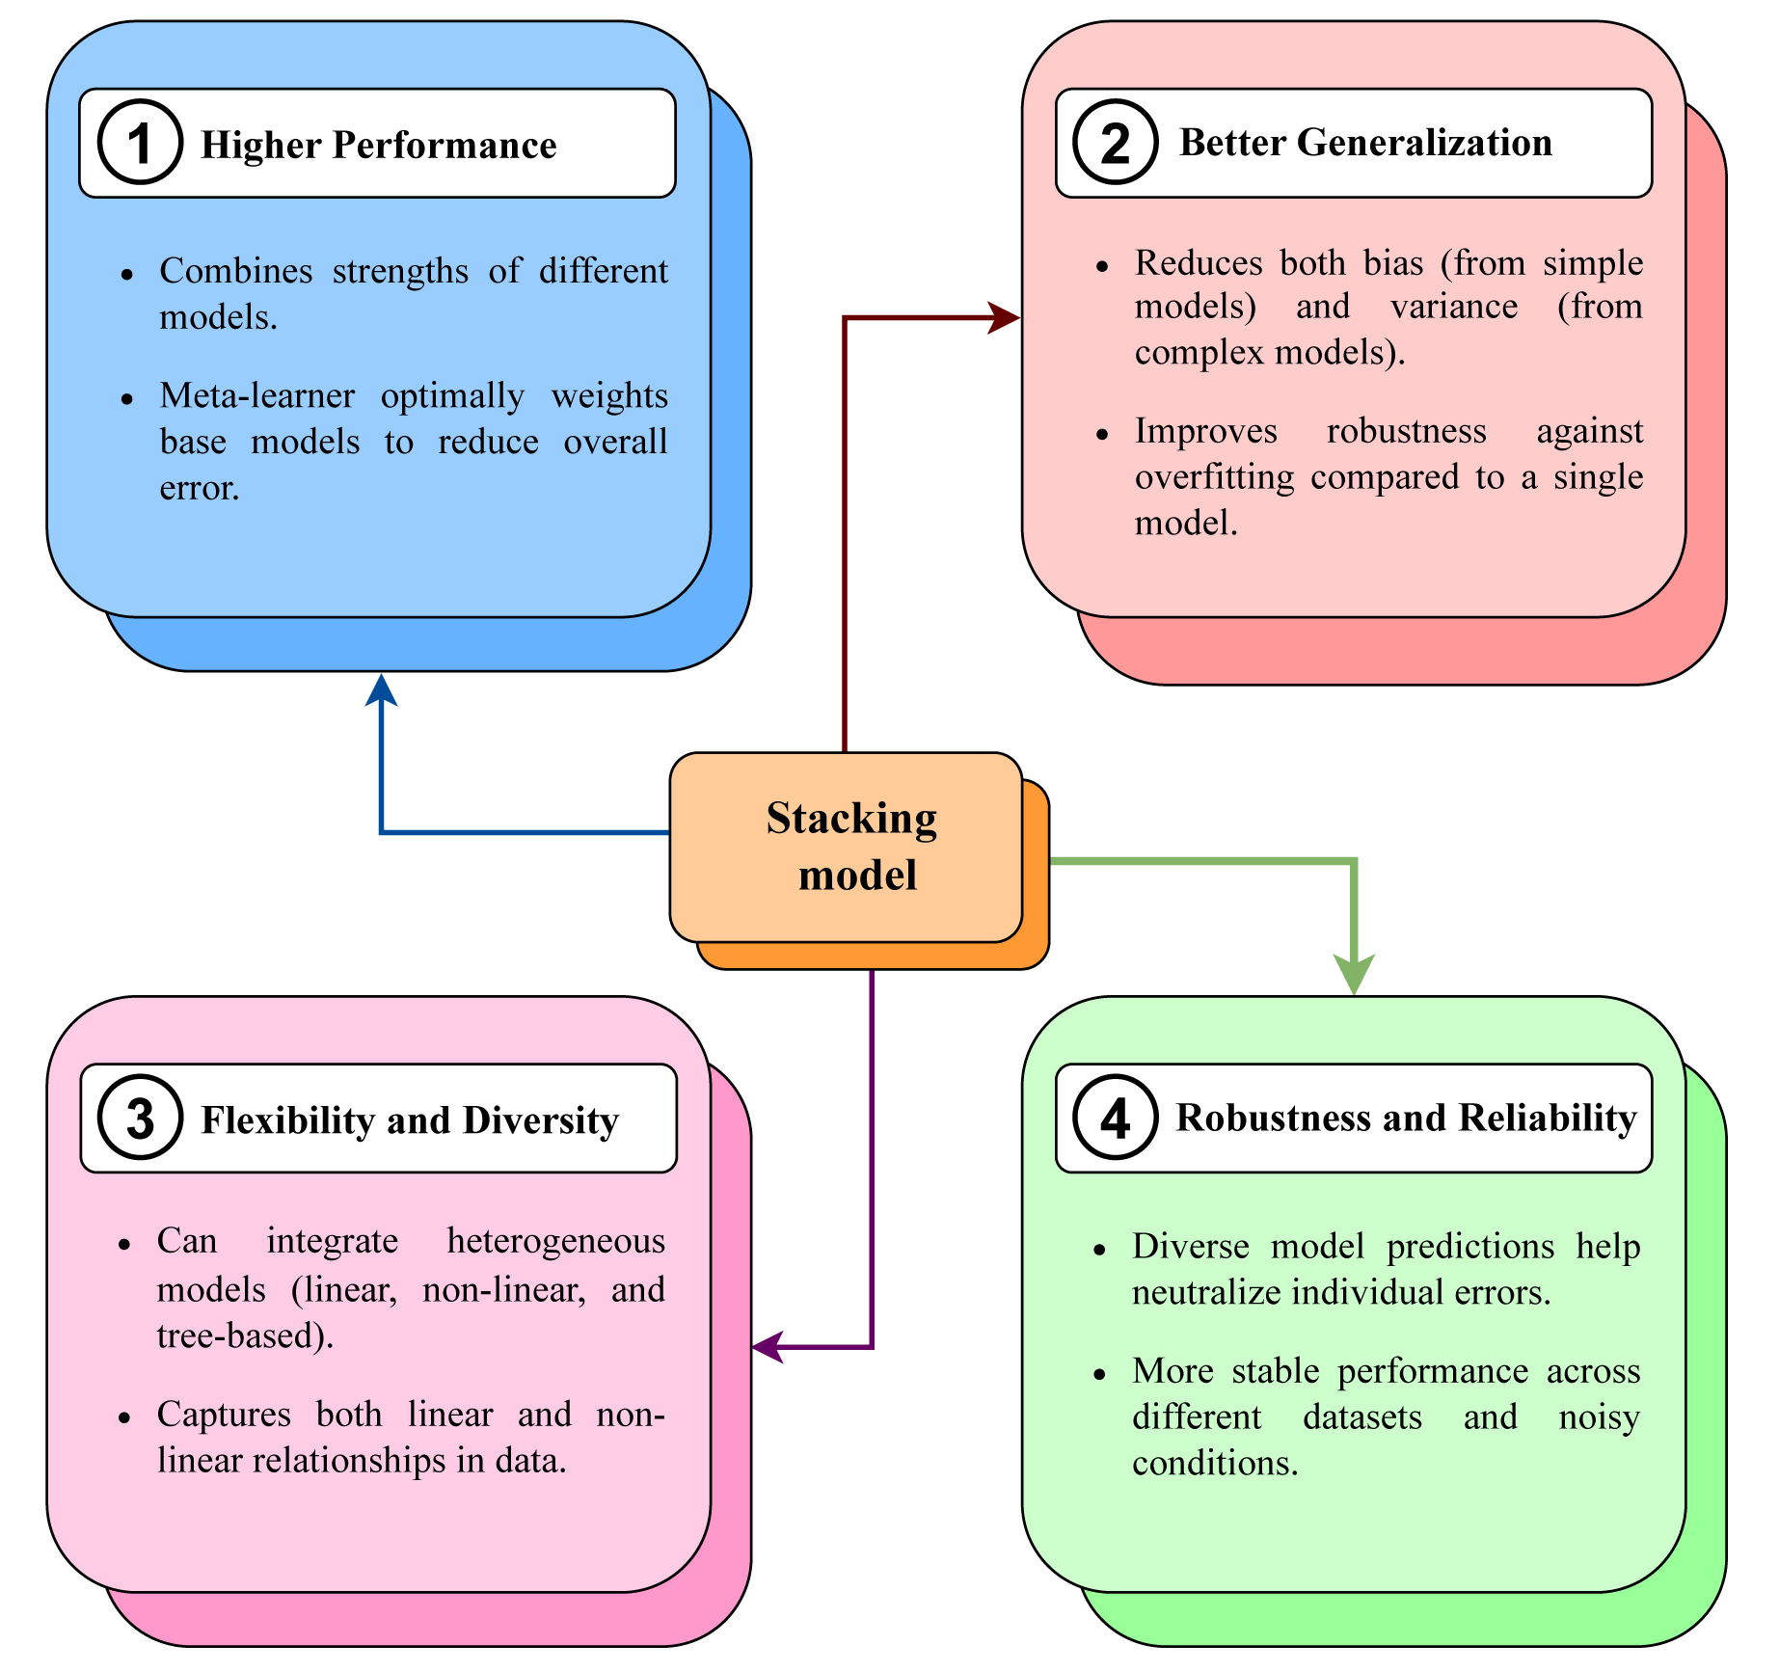
Figure S2. Rationality of choosing stacking model

