Additional file 1

Table 1S. The top 10 differentiated circRNAs ranking by Fold Change (FC) in four comparison groups
Rank |  | C1:Q1vsQ2 |  |  | C2:Q3vsQ4 |  |  |  | C3:Q1vsQ3 |  |  |  | C4:Q2vsQ4
 |  | ID (Alias) |  | FC | ID (Alias) |  | FC |  | ID (Alias) |  |  | FC | ID (Alias) |  | FC
Up-regulated Differentiation
1 |  | circ0001907 |  | 19.4 | circ0005418 |  | 38.8 |  | circ0072567 |  |  | 12.0 | circ0005154 |  | 17.3
2 |  | circ0008394 |  | 15.1 | circ0058048 |  | 27.4 |  | circ0047303 |  |  | 11.9 | circ0005720 |  | 16.9
3 |  | circ0001280 |  | 15.0 | circ0001333 |  | 25.1 |  | circ0000420 |  |  | 11.8 | circ0055940 |  | 16.7
4 |  | circ0000072 |  | 14.2 | circ0008732 |  | 15.9 |  | circ0001013 |  |  | 11.5 | circ0091024 |  | 15.7
5 |  | circ0000220 |  | 12.3 | circ0022392 |  | 15.0 |  | circ0030741 |  |  | 11.2 | circ0078328 |  | 15.1
6 |  | circ0077096 |  | 11.7 | circ0008460 |  | 12.3 |  | circ0030388 |  |  | 10.9 | circ0092375 |  | 15.0
7 |  | circ0071869 |  | 11.3 | circ0091024 |  | 11.4 |  | circ0000828 |  |  | 10.4 | circ0092300 |  | 14.9
8 |  | circ0000835 |  | 11.1 | circ0005777 |  | 11.2 |  | circ0092342 |  |  | 10.3 | circ0001414 |  | 14.8
9 |  | circ0072263 |  | 10.5 | circ0008139 |  | 11.1 |  | circ0088090 |  |  | 10.1 | circ0000942 |  | 14.5
10 |  | circ0000841 |  | 9.8 | circ0005838 |  | 10.7 |  | circ0050102 |  |  | 9.9 | circ0021727 |  | 14.0
Down-regulated Differentiation
1 | circ0050490 |  | -15.9 |  |  | circ0033024 |  | -14.2 |  | circ0084615 | -17.2 |  |  | circ0009061 | -29.9
2 | circ0069660 |  | -12.5 |  |  | circ0002807 |  | -11.2 |  | circ0000043 | -11.7 |  |  | circ0007759 | -22.4
3 | circ0037104 |  | -11.4 |  |  | circ0073568 |  | -10.9 |  | circ0001411 | -11.2 |  |  | circ0000154 | -20.2
4 | circ0004370 |  | -10.4 |  |  | circ0001556 |  | -10.4 |  | circ0007331 | -8.8 |  |  | circ0007108 | -19.1
5 | circ0083866 |  | -9.8 |  |  | circ0047285 |  | -7.8 |  | circ0008982 | -8.5 |  |  | circ0061721 | -17.7
6 | circ0008258 |  | -9.7 |  |  | circ0092363 |  | -7.7 |  | circ0088479 | -8.1 |  |  | circ0061276 | -17.5
7 | circ0029104 |  | -8.9 |  |  | circ0021569 |  | -7.7 |  | circ0002105 | -7.9 |  |  | circ0050486 | -16.0
8 | circ0020100 |  | -7.6 |  |  | circ0091104 |  | -7.5 |  | circ0008021 | -7.8 |  |  | circ0008902 | -15.7
9 | circ0005918 |  | -7.3 |  |  | circ0000630 |  | -7.3 |  | circ0088457 | -7.4 |  |  | circ0000841 | -15.5
10 | circ0008982 |  | -7.2 |  |  | circ0050486 |  | -7.2 |  | circ0037866 | -6.9 |  |  | circ0001811 | -15.1
C1:Q1 vsQ2 (CD28+CD8+T cells vs CD28-CD8+T cells in the elderly); C2:Q3 vs Q4 (CD28+CD8+T cells vs CD28-CD8+T cells in the young; C3=Q1 vs Q3 (CD28+CD8+T cells in the elderly vs the young); C4=Q2 vs Q4 (CD28-CD8+T cells in the elderly vs the young).
*FC=Fold Change

Table 2S: The RNA pooling and grouping protocol of the eight microarrays
Microarray Detection in the elderly subjects (Q1 and Q2 )
Q1 (3 microarrays) Q2 (3 microarrays)
Q1-1: | pooled RNAs of CD8+CD28-T cells from 6 old-old subjects | Q2-1: | pooled RNAs of CD8+CD28+T cells from the same 6 old-old subjects
Q1-2 | pooled RNAs of CD8+CD28-T cells from 7 middle-old subjects | Q2-2 | pooled RNAs of CD8+CD28+T cells from the same 7 middle-old subjects
Q1-3 | pooled RNAs of CD8+ CD28-T cells from 8 young-old subjects | Q2-3 | pooled RNAs of CD8+ CD28+T cells from the same 8 young-old subjects
Microarray Detection in the adult subjects(Q3 and Q4 )
Q3 (1 microarray) Q4 (1 microarray)
Q3 | pooled RNAs of CD8+ CD28-T cells from 8 adult controls | Q4 | pooled RNAs from CD8+CD28+T cells of 8 adult controls

Table 3S-1：Distribution of the Top 10% Degree of up-regulated miRNAs (Degree range=22-60, n=75）
Degree |  | Numbers |  | miRNAs list
60 | 1 |  | hsa-miR-136-5p
59 | 1 |  | hsa-miR-103a-2-5p
50 | 1 |  | hsa-miR-612
48 | 1 |  | hsa-miR-153-5p
44 | 1 |  | hsa-miR-22-5p
41 | 1 |  | hsa-miR-485-5p
40 | 2 |  | hsa-miR-335-3p，hsa-miR-1301-3p
38 | 2 |  | hsa-miR-665，hsa-miR-329-5p
37 | 1 |  | hsa-miR-29b-1-5p
36 | 2 |  | hsa-miR-627-3p，hsa-miR-141-5p
35 | 1 |  | hsa-miR-761
34 | 2 |  | hsa-miR-608，hsa-miR-145-5p
33 | 5 |  | hsa-miR-637，hsa-miR-661，hsa-miR-135b-5p，hsa-miR-30d-3p，hsa-miR-544a
32 | 3 |  | hsa-miR-298,hsa-miR-452-3p,hsa-miR-135a-5p
31 | 1 |  | hsa-miR-20b-3p
30 | 4 |  | hsa-miR-215-3p,hsa-miR-93-3p,hsa-miR-651-3p,hsa-miR-103a-3p
29 | 7 |  | hsa-miR-370-3p,hsa-miR-30b-3p,hsa-miR-670-3p,hsa-miR-660-3p,  hsa-miR-494-5p,hsa-miR-107,hsa-miR-877-3p,
28 | 4 |  | hsa-miR-138-5p,hsa-miR-518c-5p,hsa-miR-449c-5p,  hsa-miR-214-3p
27 | 7 |  | hsa-miR-181a-2-3p,hsa-miR-26b-3p,hsa-miR-185-3p,  hsa-miR-328-5p,hsa-miR-762,hsa-miR-152-5p,hsa-miR-338-3p
26 | 5 |  | hsa-miR-766-3p,hsa-miR-330-3p,hsa-miR-330-5p,hsa-miR-619-5p,  hsa-miR-509-5p
25 | 3 |  | hsa-miR-619-3p,hsa-miR-146a-3p,hsa-miR-548a-3p
24 | 3 |  | hsa-miR-17-3p,hsa-miR-203a-5p,hsa-miR-765
23 | 12 |  | hsa-miR-9-5p,hsa-miR-216a-3p,hsa-miR-182-5p,hsa-miR-653-3p,  hsa-miR-520a-5p,hsa-miR-29a-5p,hsa-miR-525-5p,hsa-miR-511-5p  hsa-miR-578,hsa-miR-1264,hsa-miR-130b-5p,hsa-miR-212-5p
22 | 5 |  | hsa-miR-29b-2-5p,hsa-miR-646,hsa-miR-432-5p,hsa-miR-429,  hsa-miR-891a-3p
Table3S-2：Distribution of the Top 10% Degree of down-regulated miRNAs (Degree range=28-81, n=80）
Degree | Numbers | miRNAs list
81 | 1 | hsa-miR-608
69 | 1 | hsa-miR-103a-2-5p
67 | 1 | hsa-miR-29b-1-5p
61 | 1 | hsa-miR-877-3p
59 | 2 | hsa-miR-138-5p,hsa-miR-1301-3p
57 | 2 | hsa-miR-22-5p,hsa-miR-141-5p
56 | 1 | hsa-miR-136-5p
53 | 1 | hsa-miR-612
52 | 1 | hsa-miR-660-3p
51 | 3 | hsa-miR-370-3p,hsa-miR-329-5p,hsa-miR-185-3p
50 | 2 | hsa-miR-335-3p,hsa-miR-544a
48 | 1 | hsa-miR-330-5p
46 | 4 | hsa-miR-215-3p,hsa-miR-646,hsa-miR-670-3p,hsa-miR-93-3p
45 | 1 | hsa-miR-485-5p
44 | 1 | hsa-miR-30b-3p,hsa-miR-762
43 | 2 | hsa-miR-29a-5p,hsa-miR-511-5p
42 | 1 | hsa-miR-424-5p
41 | 5 | hsa-miR-637,hsa-miR-766-3p,hsa-miR-627-3p,hsa-miR-578,hsa-miR-764
40 | 4 | hsa-miR-766-5p,hsa-miR-17-3p,hsa-miR-149-3p,hsa-miR-449c-5p
39 | 2 | hsa-miR-508-5p,hsa-miR-130b-5p
38 | 2 | hsa-miR-661,hsa-miR-26b-3p
37 | 2 | hsa-miR-761,hsa-miR-214-3p
36 | 4 | hsa-miR-9-5p,hsa-miR-328-5p,hsa-miR-452-5p,hsa-miR-558
35 | 1 | hsa-miR-135b-5p
34 | 4 | hsa-miR-647,hsa-miR-597-3p,hsa-miR-203a-5p,hsa-miR-153-5p
33 | 3 | hsa-miR-298,hsa-miR-338-3p,hsa-miR-145-5p
32 | 6 | hsa-miR-29b-2-5p,hsa-miR-518c-5p,hsa-miR-432-5p,hsa-miR-450b-5p,hsa-miR-422a,hsa-miR-19b-2-5p
31 | 1 | hsa-miR-30d-3p
30 | 6 | hsa-miR-765,hsa-miR-545-3p,hsa-miR-619-5p,hsa-miR-323a-5p,hsa-miR-135a-5p,hsa-miR-22-3p
29 | 9 | hsa-miR-665,hsa-miR-34c-5p,hsa-miR-34b-5p,hsa-miR-889-5p,hsa-miR-15a-5p,hsa-miR-494-5p,hsa-miR-149-5p,hsa-miR-105-5p,hsa-miR-382-5p
28 | 4 | hsa-miR-525-5p,hsa-miR-449b-5p,hsa-miR-452-3p,hsa-miR-197-3p

Table 4S. Five detailed annotation for the circRNA/miRNA interaction (circ100783 and its Top-5 predicted miRNA targets)

has-miR-338-3p VS has_circRNA_100783
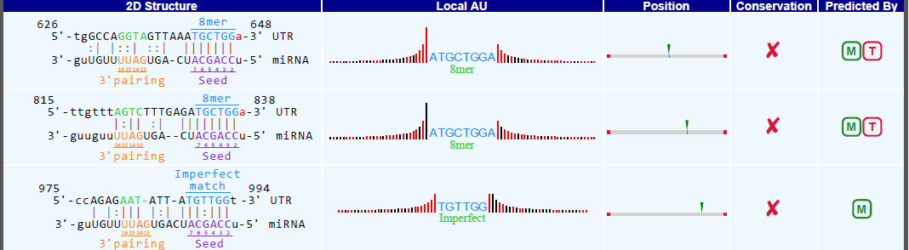
hsa-miR-30d-3p VS hsa_circRNA_100783
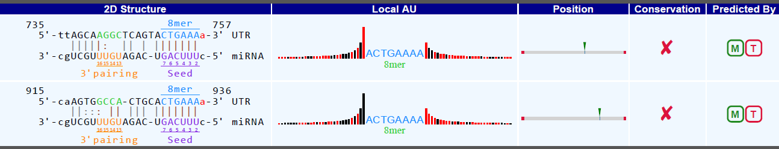
hsa-miR-107 VS hsa_circRNA_100783
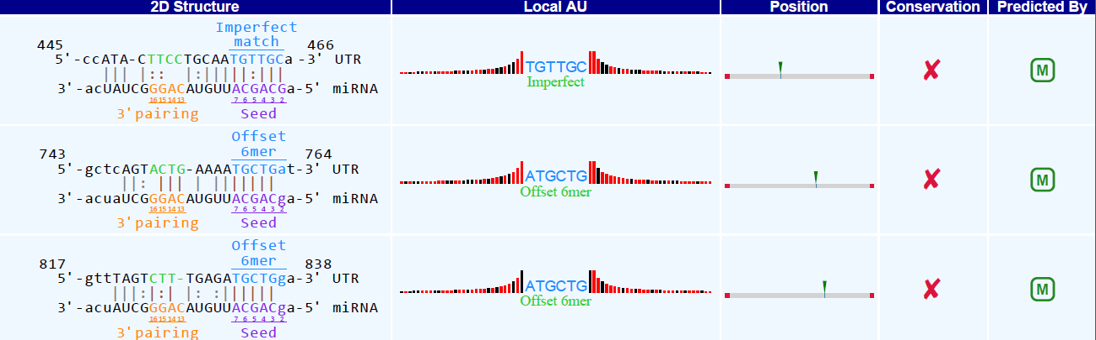
hsa-miR-103a-3p VS hsa_circRNA_100783
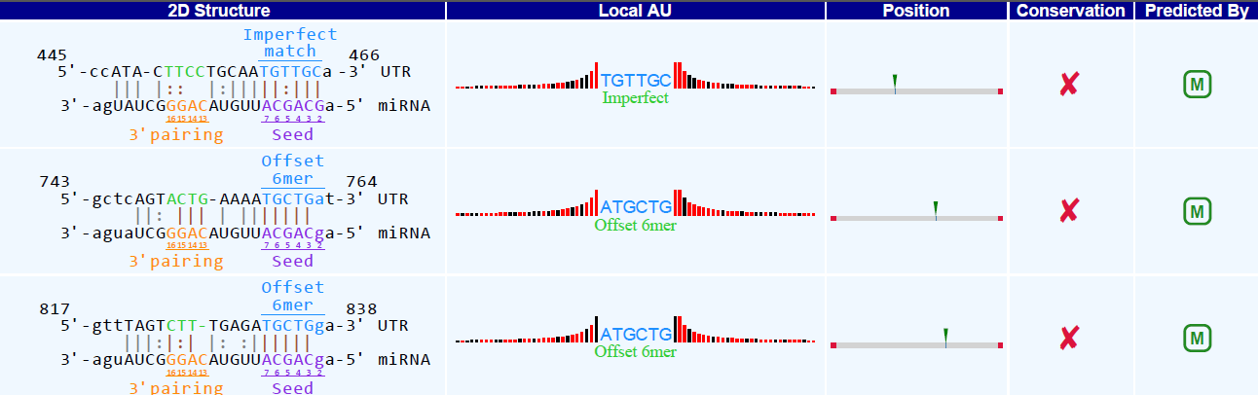
hsa-miR-17-3p VS hsa_circRNA_100783
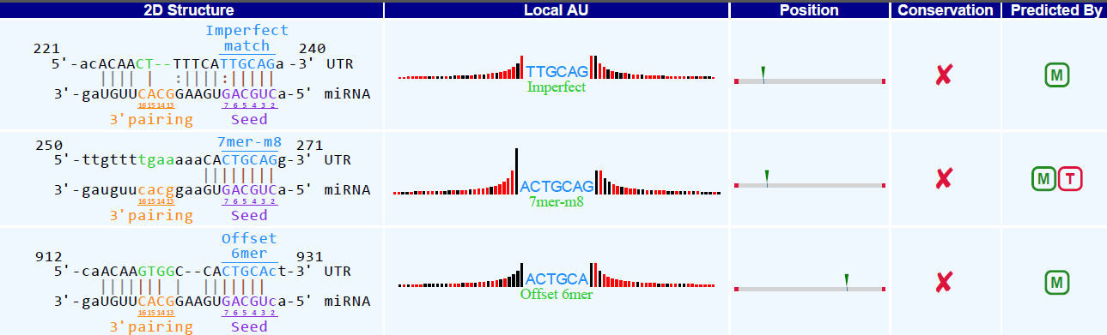

Table 5S.The detailed characteristicsof qRT-PCR for eight candidate circRNAs
Target name | Primer sequence | Annealing Temperature (℃) | Product length(bp)
Up-regulated circRNAs
hsa_circRNA_100550 | F:5’GCAAATCACCACCTGGAGTA3’  R:5’TTGGATTTCAGGCACATTCT3’ | 60 | 237
hsa_circRNA_100783 | F:5’CCATTTTGTGAAGCCATAGAC3’  R:5’CACATAGGTCCGTGGATAGTTT3’ | 60 | 236
hsa_circRNA_101328 | F:5’GGACGGCGTCACCAACCTA3’  R:5’GCACGCATTCTTTCTGGACAT3’ | 60 | 150
hsa_circRNA_102592 | F:5’ACGTGTACGCAGTGACCGAG3’  R:5’GAAGCTGCTTGTACGGGTTG3’ | 60 | 94
Down-regulated circRNAs
hsa_circRNA_100264 | F:5’GCCAGTCAGCACATTACAGAAG 3’  R:5’TTGCCTAGTATTTGATCCCCAT3’ | 60 | 223
hsa_circRNA_103741 | F:5’ACGATGCTTCATCCAGGTCT3’  R:5’ATACACAAGGAGGAACAAACACT3’ | 60 | 203
hsa_circRNA_104096 | F:5’ACATTTGTGATGATAGCCAGTCC 3’  R:5’AGGGTGCTCAGGTTGATTTTG3’ | 60 | 78
hsa_circRNA_101318 | F:5’AGTGTCGTCACCGTAGCCGTA3’  R:5’CTTCCAGCATGGCCTCAATC3’ | 60 | 168
Housekeeping gene
GAPDH(HUMAN) | F:5’GGGAAACTGTGGCGTGAT3’  R:5’GAGTGGGTGTCGCTGTTGA3’ | 60 | 299

