Additional file 1: Figure S1
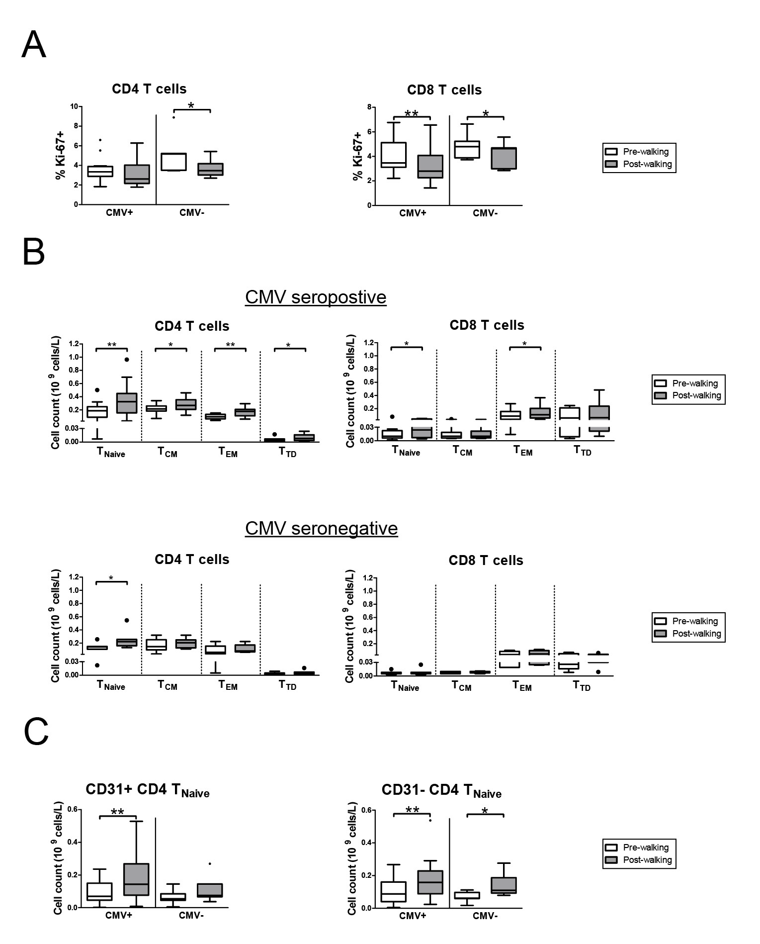

Figure S1. Exercise-induced T cell proliferation rates and T cell subset redistribution in CMV+ and CMV- subjects. (a) Rates of CD4 (left panel) and CD8 (right panel) proliferation before (Pre-Walking) and after exercise (Post-Walking) assessed by Ki-67 expression using flow-cytometry. Percentages of Ki-67 expressing cells within the CD4 and CD8 populations are shown. (b) Enumeration of CD4 and CD8 T cell differentiation subsets based on CD45RO and CCR7 expression Pre- and Post-Walking in CMV seropositive subjects (upper panel, n =13) and CMV seronegative subjects (lower panel, n = 7). Mean (+/- SEM) numbers (10⁹ cells/L) of naïve T cells (T_{Naïve}), central memory T cells (T_{CM}), effector memory T cells (T_{EM}) and terminally differentiated T cells (T_{TD}) are shown. (c) Mean (+/- SEM) numbers (10⁹ cells/L) of recent thymic emigrants defined as CD31+CD4+T_{Naïve} and the central naïve CD31-CD4+ T_{Naïve} subsets in CMV+ and CMV- subjects. Statistical significance by Wilcoxon signed rank test is indicated as * p<0.05, ** p<0.01.

