Additional file 2: Figure S2
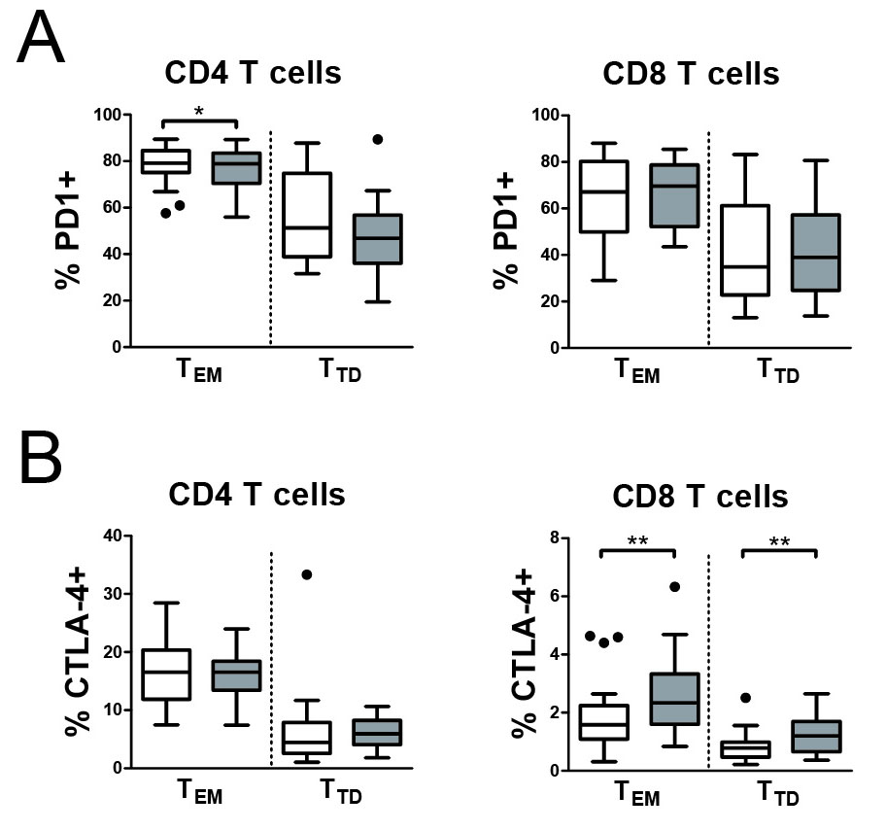
Figure S2. Exercise does not induce PD-1 and CTLA-4 on CD4 and CD8 memory T cells. (a) Percentages of PD-1 expressing cells in CD4 (left panel) and CD8 (right panel) effector memory T cells (T_{EM}) and terminally differentiated T cells (T_{TD}) pre- (white) and post-walking (grey). (b) Percentages of CTLA-4-expressing cells in CD4 (left panel) and CD8 (right panel) effector memory T cells (T_{EM}) and terminally differentiated T cells (T_{TD}) pre- (white) and post-walking (grey).

