Additional file 3; Figure S3

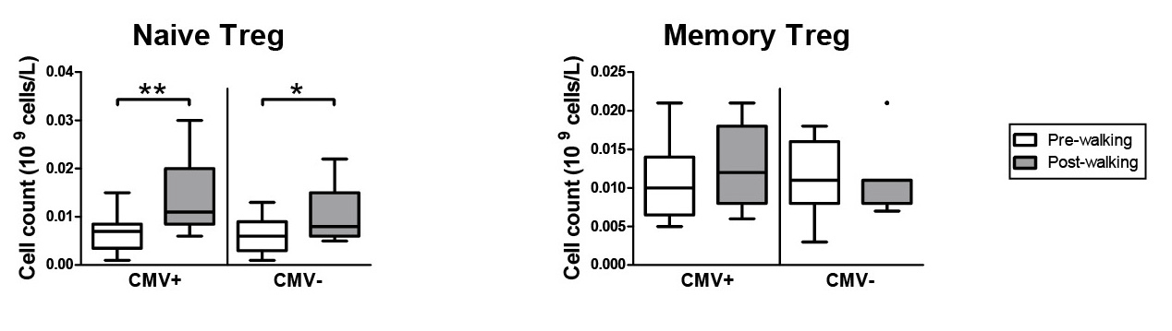

Figure S3. Exercise-induced mobilization of naïve Treg, but not memory Treg. (a) Mean (+/- SEM) numbers (10⁹ cells/L) of Naïve Treg and Memory Treg Pre-walking and Post-walking in CMV+ (n = 13) and CMV- (n = 7) subjects. Statistical significance by Wilcoxon signed rank test is indicated as *p<0.05 and ** p<0.01.

