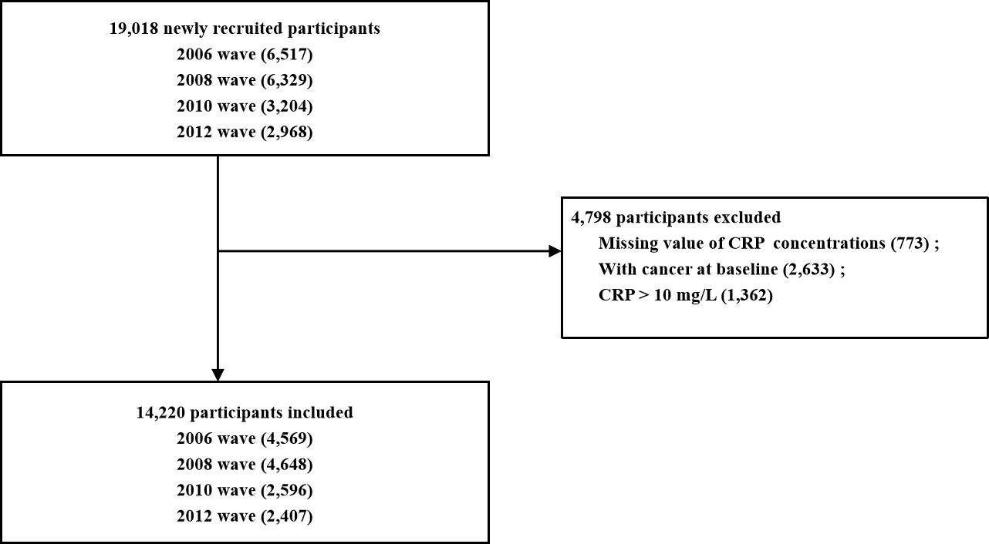

Figure S1. Flowchart of the participant enrolment

Additional file
Table S1. Role of potential mediators in explaining the association between each 1 mg/L increase in the hsCRP concentration and all-cause, cardiovascular and cancer mortality
Model | HRs (95% CI) of mortality
Model | All-cause mortality |  | Cardiovascular mortality |  | Cancer mortality
Model 2† | 1.08 (1.05-1.10) |  | 1.06 (1.02-1.10) |  | 1.10 (1.05-1.15)
Model 2+ hypertension | 1.07 (1.05-1.10) |  | 1.06 (1.02-1.09) |  | 1.10 (1.05-1.15)
Model 2+ diabetes | 1.08 (1.06-1.10) |  | 1.06 (1.03-1.10) |  | 1.10 (1.06-1.15)
Model 2+ heart disease | 1.08 (1.06-1.10) |  | 1.06 (1.03-1.10) |  | 1.10 (1.05-1.15)
Model 2+ stroke | 1.08 (1.05-1.10) |  | 1.06 (1.02-1.10) |  | 1.10 (1.05-1.15)
Model 2+ psychological problems | 1.08 (1.05-1.10) |  | 1.06 (1.02-1.10) |  | 1.10 (1.05-1.15)
Model 2+ pulmonary disorders | 1.07 (1.05-1.09) |  | 1.06 (1.02-1.09) |  | 1.10 (1.05-1.15)
Model 2+ ADL | 1.08 (1.06-1.10) |  | 1.06 (1.03-1.10) |  | 1.10 (1.05-1.15)
Model 2+ CES-D 8 | 1.08 (1.05-1.10) |  | 1.06 (1.02-1.10) |  | 1.10 (1.05-1.15)
Fully adjusted model‡ | 1.07 (1.05-1.10) |  | 1.06 (1.02-1.10) |  | 1.10 (1.05-1.15)
8-question Center for Epidemiologic Studies Depression Scale: (CES-D 8);
† adjusted for age, sex, race, educational level, current smoking status, alcohol consumption, regular exercise, body mass index (BMI), household income, total cholesterol (TC) concentration, high density lipoprotein-cholesterol (HDL-C) concentration, and hemoglobin A1c (HbA1c);
‡model 2 plus adjusted for CES-D 8 score, hypertension, heart disease, stroke, cancer, diabetes, pulmonary disorder, psychiatric problems, and limitations in activities of daily living (ADLs).
Table S2. Multivariable hazard ratios (HR [95% CI]) of mortality by quartiles of high-sensitivity C-reactive protein after excluding deaths during the first two years of follow-up
HsCRP quartiles (mg/L) | All-cause mortality |  | Cardiovascular mortality |  | Cancer mortality
Q1 (<0.76) | 1.00 (reference) |  | 1.00 (reference) |  | 1.00 (reference)
Q2 (0.76-1.50) | 1.03 (0.88-1.21) |  | 1.10 (0.84-1.44) |  | 1.02 (0.72-1.44)
Q3 (1.51-2.76) | 1.08 (0.92-1.27) |  | 1.11 (0.84-1.47) |  | 1.15 (0.81-1.63)
Q4 (>2.76) | 1.42 (1.21-1.65) |  | 1.37 (1.05-1.80) |  | 1.63 (1.16-2.28)
P for trend | <0.001 |  | <0.001 |  | <0.001
† Adjusted for age, sex, race, educational level, current smoking status, alcohol consumption, regular exercise, body mass index (BMI), household income, total cholesterol (TC) concentration, high density lipoprotein-cholesterol (HDL-C) concentration, and hemoglobin A1c (HbA1c).
Table S3. Multivariable hazard ratios (HR [95% CI]) of mortality by tertiles of high-sensitivity C-reactive protein
HsCRP tertiles (mg/L) | All-cause mortality |  | Cardiovascular mortality |  | Cancer mortality
Q1 (<1.14 mg/L) | 1.00 (reference) |  | 1.00 (reference) |  | 1.00 (reference)
Q2 (1.14-2.78 mg/L) | 1.13 (1.00-1.28) |  | 1.21 (0.99-1.49) |  | 1.18 (0.90-1.55)
Q3 (>2.78 mg/L) | 1.42 (1.26-1.60) |  | 1.46 (1.19-1.79) |  | 1.49 (1.14-1.95)
P for trend | <0.001 |  | <0.001 |  | <0.001
† Adjusted for age, sex, race, educational level, current smoking status, alcohol consumption, regular exercise, body mass index (BMI), household income, total cholesterol (TC) concentration, high density lipoprotein-cholesterol (HDL-C) concentration, and hemoglobin A1c (HbA1c).
Table S4 Multivariable hazard ratios (HR [95% CI]) of mortality by quintiles of high-sensitivity C-reactive protein
HsCRP quintiles (mg/L) | All-cause mortality |  | Cardiovascular mortality |  | Cancer mortality
Q1 (<0.71) | 1.00 (reference) |  | 1.00 (reference) |  | 1.00 (reference)
Q2 (0.71-1.37) | 1.063 (0.90-1.24) |  | 1.12 (0.85-1.47) |  | 1.04 (0.72-1.50)
Q3 (1.38-2.31) | 1.11 (0.95-1.30) |  | 1.18 (0.90-1.55) |  | 1.25 (0.88-1.77)
Q4 (2.32-4.17) | 1.29 (1.11-1.51) |  | 1.40 (1.07-1.82) |  | 1.36 (0.96-1.93)
Q5 (>4.17) | 1.54 (1.32-1.79) |  | 1.57 (1.21-2.04) |  | 1.72 (1.22-2.43)
P for trend | <0.001 |  | <0.001 |  | <0.001
† Adjusted for age, sex, race, educational level, current smoking status, alcohol consumption, regular exercise, body mass index (BMI), household income, total cholesterol (TC) concentration, high density lipoprotein-cholesterol (HDL-C) concentration, and hemoglobin A1c (HbA1c).
Table S5 Multivariable hazard ratios (HR [95% CI]) of mortality by clinical categories of high-sensitivity C-reactive protein
HsCRP categories (mg/L) | All-cause mortality |  | Cardiovascular mortality |  | Cancer mortality
<1 | 1.00 (reference) |  | 1.00 (reference) |  | 1.00 (reference)
1-3 | 1.12 (0.99-1.27) |  | 1.18 (0.96-1.46) |  | 1.24 (0.94-1.63)
>3 | 1.45 (1.28-1.65) |  | 1.44 (1.16-1.78) |  | 1.51 (1.13-2.01)
P for trend | < 0.001 |  | < 0.001 |  | < 0.001
†Adjusted for age, sex, race, educational level, current smoking status, current drinking status, regular exercise, body mass index (BMI), household income, total cholesterol (TC) concentration, and high density lipoprotein-cholesterol (HDL-C) concentration.

